**New Design of Materials, Order, and Thicknesses of an Aircraft Windshield Layers to Increase its Resistance Against Repeated Bird Impacts**

# Majid Rezaei1 Behrooz Arezoo*2 Saeed Ziaei-Rad3

1.* Ph.D. Student, Department of Mechanical Engineering, AmirKabir University of Technology, Tehran, Iran,

2. Professor, Department of Mechanical Engineering, AmirKabir University of Technology, Tehran, Iran, E-mail: [arezoo@aut.ac.ir](mailto:arezoo@aut.ac.ir).

3. Professor, Department of Mechanical Engineering, Isfahan University of Technology, Isfahan, Iran.

# Abstract

There are instances when an aircraft encounters a bird’s flock or faces a heavy hailstorm, causing the windshield to sustain consecutive impacts. Therefore, the investigation of windshield resistance against repeated impacts is crucial. In this research, various tests such as tensile, Split Hopkinson Pressure Bar (SHPB), and three-point bending are conducted to extract the mechanical properties of the materials used in a 5-layers windshield under high strain rates. Using this information, the bird impact on the windshield is simulated using the Smooth Particle Hydrodynamics (SPH) method, and the results are compared with real bird impact test outcomes, and the validation of this simulation is confirmed. The simulation of two consecutive bird strikes indicates the current windshield lacks sufficient resistance against successive dual impacts; in such scenarios, the second bird penetrates the windshield after breaking it and tearing the interlayer. Considering new materials and thicknesses for each windshield layer, a Taguchi experimental design method is employed to examine various layer arrangements with different materials and thicknesses. The configurations in which the windshield can withstand a maximum of three bird impacts in succession are identified. Subsequently, using the "the smaller, the better" criterion in the Taguchi optimization approach, the configuration that not only prevents bird penetration but also minimizes the maximum strain in the inner layer is selected as the desired outcome. Thus, a new 5-layer windshield with new materials and thicknesses is presented, which is resistant to the repeated collision of up to three birds, tearing in the interlayer and bird penetration does not happen.

# Keywords

Bird Impact, Aircraft Windshield, Smooth Particle Hydrodynamics (SPH), Finite Element Analysis (FEM)

1. **Introduction**

In certain instances, when an aircraft encounters a flock of birds, more than one bird may strike the windshield, causing damage. The nature of this collision can occur in two ways: simultaneous or repeated. This is contingent on the birds' flight pattern, which may include V-shaped formations, J-shaped formations, or a mass flight. In a mass movement, multiple birds can collide with the windshield simultaneously. While in a V-shaped or J-shaped flight pattern, it is possible for birds to hit the windshield successively (Jha et al., 2019; Lissaman & Shollenberger, 1970). Although the likelihood of multiple or repeated bird collisions is considerably lower compared to a single bird, it is worth noting that this scenario is not entirely improbable. While it may not be currently addressed in aviation standards, ongoing research in this field may lead to more comprehensive standards in the future.

In this supplementary file, certain research details, which are too voluminous to be included in the main article, are provided.

1. **SHPB Test Relations**

The Hopkinson test yields voltage as a function of time, which can be converted into stress and strain using relevant equations. Since the Hopkinson test is conducted at various velocities, the corresponding strain rate for each speed can be computed through mathematical formulas. While some of these relationships are briefly outlined here. It's worth noting that the output graph generated by the Hopkinson test exhibits significant fluctuations, attributed to the test's inherent nature. Consequently, the data has been subjected to filtering, resulting in the presentation of smooth, oscillation-free curves.

|  |  |
| --- | --- |
| $$σ_{s}\left(t\right)=\frac{EA}{A_{s}}ϵ_{t}\left(t\right)$$ | (1) |
| $$ϵ_{s}\left(t\right)=-\frac{2c_{0}}{l_{S}}\int_{0}^{t}{ϵ_{r}\left(t\right)dt}$$ | (2) |
| $${\dot{ϵ}}_{s}\left(t\right)=-\frac{{2c}_{0}}{l_{S}}\left(ϵ_{r}\left(t\right)\right)$$ | (3) |

Where $σ_{s}\left(t\right)$ is specimen stress, *E* is the elastic modulus of the bars, $A$ and $A_{s}$ are the cross section of the bars and specimen, respectively. $ϵ_{t}\left(t\right)$ is the strain of transmitted bar, $l_{S}$ and $c_{0}$ denote the specimen length and wave speed in the bar, respectively, and finally, the indices *r* and *t* refer to the reflected and transmitted waves, respectively (Siviour & Jordan, 2016; Khosravani & Weinberg, 2018).

1. **SHPB Test Validation**

The voltage-time graph resulting from the glass Hopkinson test is presented in Fig.1. The observed pulse shapes in both the incident and transmitted bars align with typical outcomes in Hopkinson tests. Furthermore, the time interval between the two graphs (two pulses) illustrates the temporal relationship between these bars, affirming the validity of the experimental test. Fig. 2 depicts the strain diagram over time (with removing the noises) in the incident and transmitted bars during the Hopkinson test of polycarbonate (PC) material. This diagram reveals the sequential occurrence of generated strains, including the influence of the return strain within the returning wave. These findings align with the diagrams documented in several scientific articles, including references (Song et al., 2007) & (Bagaria, 2019).

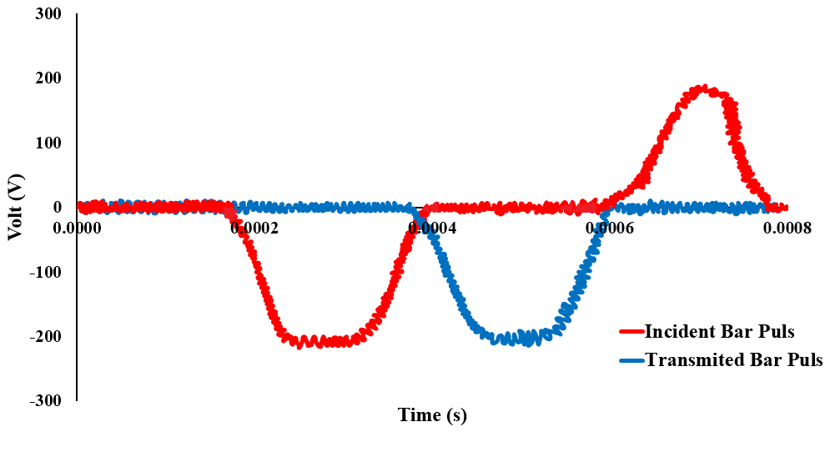

**Fig. 1. Output Pulses of Incident and Transmitted Bars in Glass Hopkinson Test**

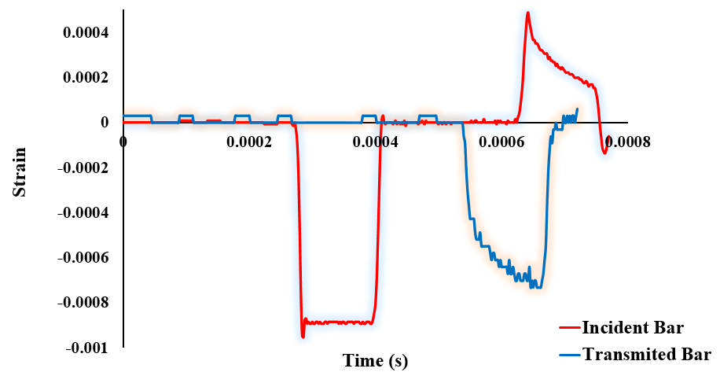

**Fig. 2. The Strain-Time Diagram of Incident and Transmitted Bars in PC Hopkinson Test**

1. **Mechanical Behavior of Interlayers (PU, PVB, SG)**

Polymeric materials such as polyurethane have nonlinear elastic properties, large displacements against force, and high strain rate dependence. This can be seen in the stress-strain diagram for different strain rates (Figure 4 of article). To describe the mechanical behavior of PU, PVB, and SG, the structural equation used should have two characteristics: First, it predicts the large non-linear deformation behavior, and second, it considers the dependence on the strain rate. In this research, a hyper-viscoelastic-plastic behavioral model is used.

1. *Hyperelastic model*:

The hyperelastic model is a constitutive model for perfectly elastic materials. The stress-strain relationship in this model is obtained from the strain energy density function. Hyperelastic material is a type of Cauchy elastic material. According to the results of the practical tests, the Ogden model has better compatibility with these results. Therefore, this model is used to describe the hyperelastic behavior of PU. This model expresses the strain energy function based on the elongation in the main stretches $λ_{1}$, $λ_{2}$ and $λ_{3 }$ according to the equation ($λ_{1}*λ_{2}*λ_{3}=1)$. For incompressible materials, the product of these values is equal to 1. In equation 4, Ogden's energy function is shown in three dimensions. In this relationship, ${\overline{λ}}_{l}$ are the deviatoric principal stretches, which are calculated according to equation 5 from the values of the principal stretches ($λ_{i}$). N expresses the order of the function and depends on the type of material. $J^{el}$ is the elastic volume change ratio and is equal to the gradient of the deformation matrix. The values of $α_{i}$, $μ_{i}$, and $D_{i}$ are the constants of the material (Li & Lua, 2009).

|  |  |
| --- | --- |
| $$U=\sum_{i=1}^{N}{\frac{2μ_{i}}{α_{i}^{2}}}\left({\overline{λ_{1}}}^{α_{i}}+{\overline{λ_{2}}}^{α_{i}}+{\overline{λ_{3}}}^{α_{i}}-3\right)+\sum_{i=1}^{N}{\frac{1}{D_{i}}{(J^{el}-1)}^{2i}}$$ | (4) |
| $${\overline{λ}}_{l}=J^{\frac{1}{3}}λ_{i}$$ | (5) |

1. *Viscoelastic model*:

Linear viscoelastic behavior is performed using viscoelastic models which generally consist of several linear springs and dampers that are connected in parallel or series. Maxwell and Kelvin-Voit are two famous models which are used to predict the behavior of linear viscoelasticity (Marques & Creus, 2012). As shown in **Fig 3**, in the Maxwell model, a damper is placed in series with a spring, and in the Kelvin-Voit model, the damper is placed in parallel with a spring. Kelvin's model can describe the creep behavior of real material and Maxwell's model provides a simple description of stress release in viscoelastic material.

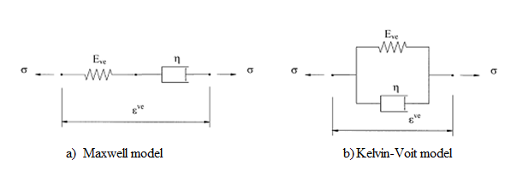

**Fig 3- schematic of a viscoelastic model: a) Maxwell model, b) Kelvin-Voit model (Marques & Creus, 2012)(Findley et al., 1977)**

To describe the linear viscoelastic behavior of PU, Maxwell's general model based on the Prony series is used. The equation which defines viscoelasticity uses a modulus that is a function of time, as follows (Eq.6):

|  |  |
| --- | --- |
| $$τ=G(t)\dot{γ}$$ | (6) |

where $G(t)$ is the stress relaxation modulus of the material. Ferry (Ferry, 1980) shows the same constitutive equation with the following notation:

|  |  |
| --- | --- |
| $$σ_{ij}\left(t\right)=\int_{-∞}^{∞}{G\left(t-t^{'}\right){\dot{γ}}_{ij}\left(t^{'}\right)dt'}$$ | (7) |

where:

$σ_{ij}$ = stress tensor

${\dot{γ}}_{ij}$ = strain rate tensor

$t^{'}$ = all the elapsed times that the integration must be carried out over all of them. This must be considered due to the material behavior during deformation. In the generalized Maxwell model, the contribution in relaxation modulus of each Maxwell element is given by (Eq.8):

|  |  |
| --- | --- |
| $$G_{i}(t)=G_{i}e^{\frac{-t}{τ_{i}}}$$ | (8) |

Where $G_{i}$ is the spring constant and $τ_{i}$ is the relaxation time of the element, defined by (Eq.9).

|  |  |
| --- | --- |
| $$τ_{i}=η_{i}/G_{i}$$ | (9) |

where $η_{i}$ is the dashpot constant. The relaxation modulus of the complete model is the sum of the relaxation moduli of all Maxwell elements connected in parallel, as follows (Eq.10):

|  |  |
| --- | --- |
| $$G(t)=\sum_{i}{G_{i}e^{\frac{-t}{τ_{i}}}}$$ | (10) |

When t → ∞ in the case of materials that have a solid-liked behavior, $G(t)$ approaches a finite value $G_{e}$. For liquid-like materials, $G(t)$ approaches zero (Ferry, 1980). In the case of structural adhesives, that become solid-like materials after the curing process, equation 10 can be rewritten as (Eq.11):

|  |  |
| --- | --- |
| $$G\left(t\right)=G_{e}+\sum_{i}{G_{i}e^{\frac{-t}{τ_{i}}}}$$ | (11) |

Equation 11 is also known as the Prony Series of the material and is useful to describe viscoelastic properties in computer-aided engineering software (Rezaei et al., 2024).

1. **Elastic-Plastic Behavior of PMMA and PC**

A linear isotropic elastic model is used to describe elastic behavior of materials:

|  |  |
| --- | --- |
| $$σ_{ij}=C_{ijkl }ε_{kl}^{e}$$ | (12) |

where $σ_{ij}$ and $ε_{kl}^{e}$ are stress and elastic strain tensors and $C_{ijkl }$ is the tensor of modulus of elasticity. An additive decomposition of total strain tensor is considered (Nasraoui et al., 2009):

|  |  |
| --- | --- |
| $$ε_{ij}=ε_{ij}^{e}+ε_{ij}^{p}$$ | (13) |

where $ε_{ij}^{p}$ are components of plastic strains. Von-Mises yield stress criterion is considered as below:

|  |  |
| --- | --- |
| $$f=\sqrt{\frac{3}{2}S_{ij}:S_{ij}}-σ_{y}=0$$ | (14) |

in which, $f$ is the yield function, $S_{ij}$ is the deviatoric stress tensor and $σ_{y}$ is the yield stress which depends on total and plastic strains at each point. An associated flow rule is used,

|  |  |
| --- | --- |
| $${dε}_{ij}^{p}=dλ\frac{∂f}{∂σ_{ij}}$$ | (15) |

n which $dλ$ is a differential multiplier. By taking the differential of equation 1 and substituting from equations 2 and 4, the following equation is derived (de Souza Neto et al., 2008):

|  |  |
| --- | --- |
| $$dσ_{ij}=C_{ijkl }(dε_{kl}-dλ\frac{∂f}{∂σ_{kl}})$$ | (16) |

Using equation (14) and after few mathematical manipulations, it can be concluded that:

|  |  |
| --- | --- |
| $$dσ_{ij}={C_{ijkl}^{ep}}_{ }dε_{kl}$$ | (17) |
| $${C_{ijkl}^{ep}=C_{ijkl}}_{ }-C_{ijmn}\frac{∂f}{∂σ_{mn}}\frac{\frac{∂f}{∂σ_{rs}}C_{rskl}}{A}$$ | (18) |
| $$A=\left(\frac{∂f}{∂σ_{ab}}\right)C_{abuv}\left(\frac{∂f}{∂σ_{uv}}\right)-(\frac{∂f}{∂p}){(\left(\frac{2}{3}\right)\left(\frac{∂f}{∂σ_{ab}}\right)\left(\frac{∂f}{∂σ_{ab}}\right))}^{\frac{1}{2}}$$ | (19) |
| $$p={{(\frac{2}{3}}_{ }{dε}_{kl}^{p}{dε}_{kl}^{p})}^{\frac{1}{2}}$$ | (20) |

1. **Polymers Material Parameters:**

The explanations related to the material model are provided here:

1. ***Poly methyl methacrylate (PMMA)***

Poly methyl methacrylate (PMMA) is a thermoplastic polymer with an amorphous structure usually available in the form of sheet or bar. Its various engineering applications are met in aeronautics, automotive and transportation industries, machinery equipment, as transparent shield structures against shocks or ballistic impacts. The demand for PMMA has been increased due to its relative low density and good transparency (de Souza Neto et al., 2008). PMMA is known as an organic glass. From the mechanical properties’ aspect, this polymer is used because of the higher impact resistance and better formability in comparison with ordinary glass. PMMA has high mechanical strength and limited elongation at break and does not shatter upon rupture. It is also one of the hardest thermoplastics, thus highly scratch resistant. PMMA is generally recognized for both its good mechanical properties (strength to crazing, and crack propagation) and its optical properties (M. Rezaei, 2015). **Table 1** shows mechanical and thermal properties of PMMA.

**Table 1- Mechanical properties of PMMA**

|  |  |
| --- | --- |
| Mechanical properties | Value |
| Density | 1.15 ‐ 1.19 g/cm3 |
| Young Modulus | 20 MPa |
| Tensile Strength, Ultimate | 47 ‐ 79 MPa |
| Elongation at Break | 1 ‐ 30 % |
| Tensile Modulus | 2.2 ‐ 3.8 GPa |

To model PMMA as an elastic-plastic material, a series of uniaxial tensile tests and SHPB tests in different strain rates are primarily performed at room temperatures (25 ºC). **Fig 4** shows the test specimen. Stress-strain curves at different strain rates are reported in article.

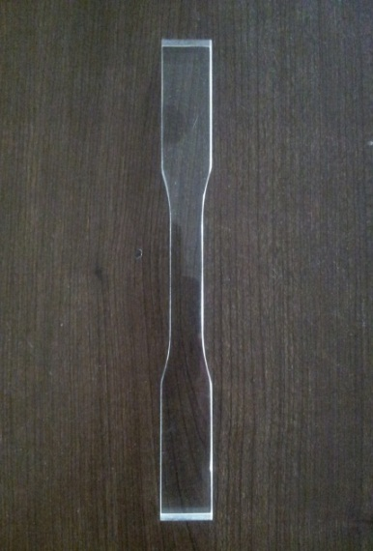

**Fig. 4- Tensile test specimen of PMMA**

1. ***Polycarbonate (PC)***

Polycarbonate is a type of thermoplastic polymer known for its exceptional transparency, high ductility, impact resistance, and lightweight properties. It finds extensive application in transparent components within aeronautical and aerospace systems, including aircraft windshields, canopies, and astronaut helmet visors. To design these products to meet the demands of complex operational conditions, a thorough grasp of the mechanical properties of polycarbonate is essential, taking into account factors such as strain rate, temperature, and even processing conditions. Given the limitations of experimental approaches, obtaining a comprehensive understanding of the mechanical behavior and evolution patterns of polycarbonate products under various loading conditions can be challenging. Therefore, the development of numerical modeling techniques holds great promise in addressing this issue. To obtain PC properties some uniaxial tensile and SHPB tests are performed. **Fig 5** illustrates PC tensile specimen. Stress-strain diagram of PC in different strain rates is shown in article. The obtain mechanical properties of PC are reported in **Table 2**. To model PMMA and PC mechanical behavior the elastic-plastic model is used.

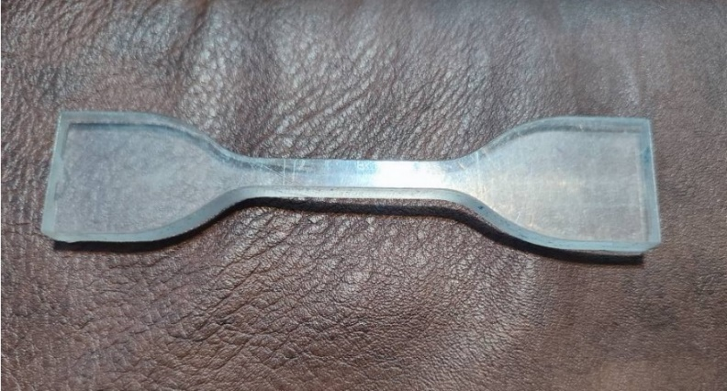

**Fig. 5- Tensile test specimen of PC**

**Table 2- Mechanical properties of PC**

|  |  |
| --- | --- |
| Mechanical properties | Value |
| Density | 1.2 ‐ 1.22 g/cm3 |
| Young Modulus | 2 MPa |
| Tensile Strength, Ultimate | 55 MPa |
| Elongation at Break | 80 ‐ 150 % |
| Poisson’s ratio | 0.37 |

1. **Pressure Different Test**

This test, conducted according to the IDS 136 standard, involves a pressure chamber capable of generating pressure inside and outside the cabin. This chamber is equipped with an automatic air pressure control system along with digital monitors. In this process, a data acquisition device **MGC Plus** along with **CATMAN v3.1** software is utilized. Special three-core cables from the HABIA company, Sweden, are used between the strain gauges and the data acquisition device. The advantage of using these three-core cables lies in mitigating the effects of noise, temperature variations, and cable length changes due to the presence of a compensator. **Fig 6** shows the pressure difference test device and its equipment. The stages of the test are as follows:

In this test, the pressure inside the chamber increases incrementally until it reaches the final pressure. 1: At each stage after the pressure stabilizes, strain values are recorded. 2: The chamber pressure is then released, and the test is repeated twice. 3: The average strain values at the final pressure are calculated.

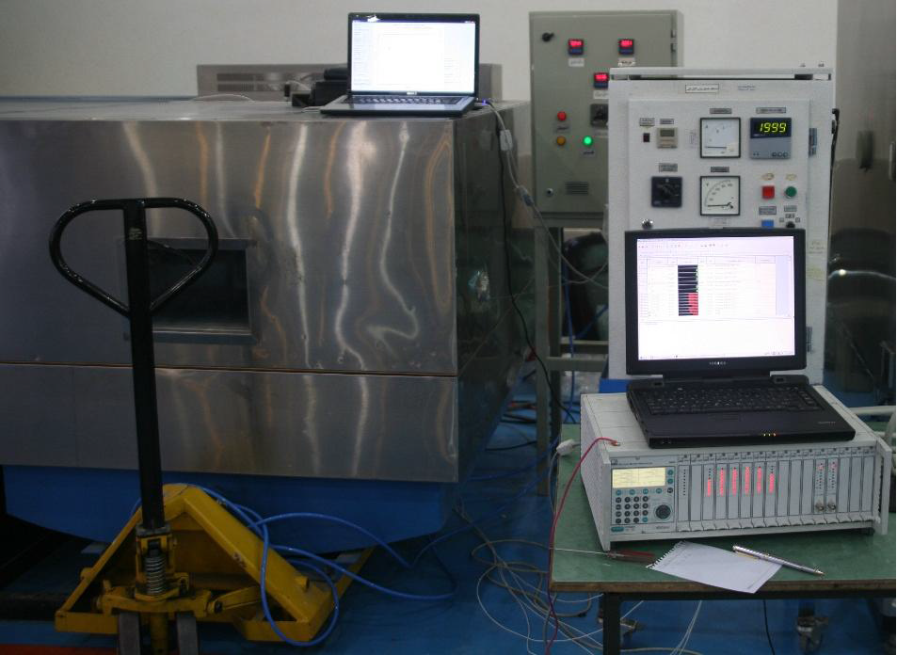

**Fig. 6- The Pressure Difference Test Device**

1. **Comparison of Experimental Tests Results and Simulation Ones:**

All practical experiments conducted on various polymers and glass are both calibrated and modeled in finite element software. The results are compared with the practical outcomes.

1. ***Glass:***

Some tests are performed for extracting the mechanical properties of glass include the three-point bending test and the Hopkinson pressure bar test. These tests are also simulated in finite element software to compare numerical and practical results. **Fig 7** illustrates the modeling of the three-point bending test in Abaqus software, considering the symmetry in geometry and loading, the symmetry constraint is applied in the X-direction. **Fig 8** displays the Von-Mises stress results in the glass. By extracting results from simulations and comparing them with practical test results, the accuracy of the utilized model can be assured. **Fig 9** shows stress results versus extension for different specimens in both practical tests and simulations. The results indicate the precision of the employed model in numerical solutions.

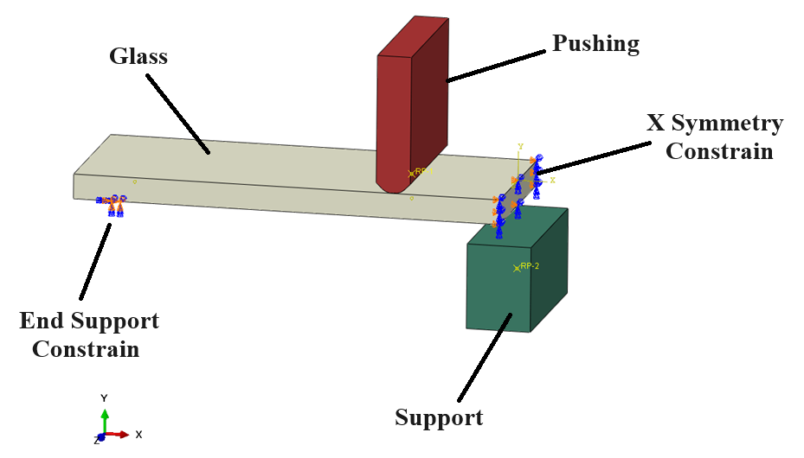

**Fig. 7- Three Point Bending Model in Abaqus**

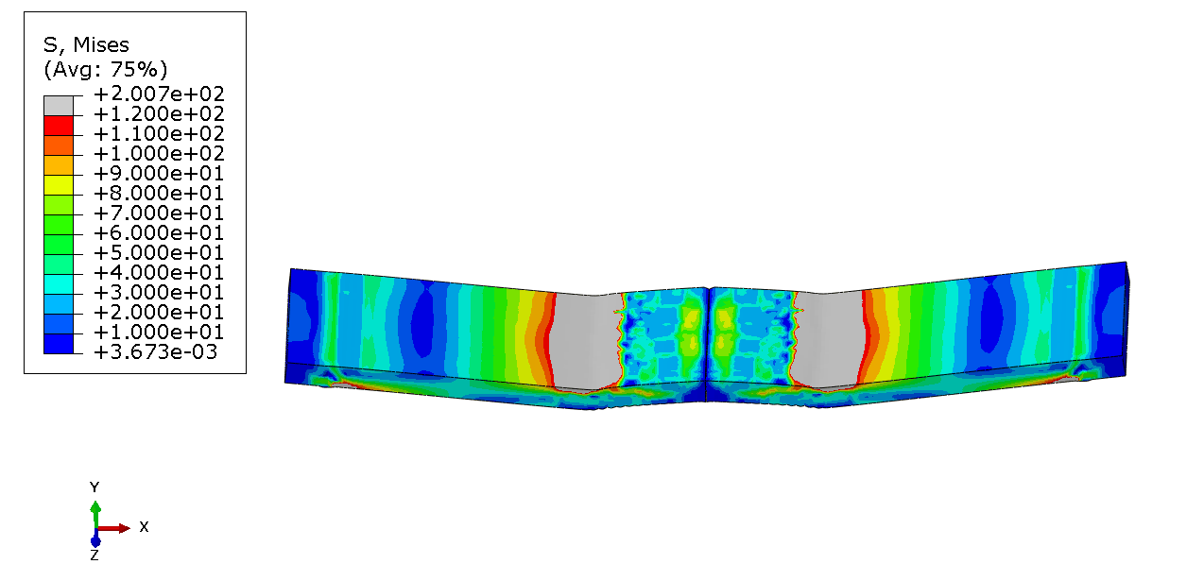

**Fig 8- Von Mises Stress Results of Glass in Three-Point Bending Test Simulation**

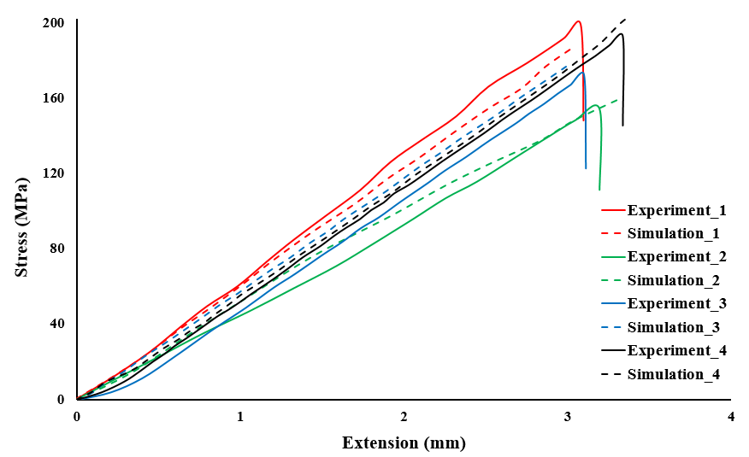

**Fig 9- Comparison of Stress-Extension Diagrams of Glass in Three-Point Bending Test and Simulation**

The results of the three-point bending test are utilized for low strain rates. However, at high strain rates, the material properties are obtained from the Hopkinson pressure bar test. To ensure the accuracy of the obtained results, these results are also simulated in finite element software. **Fig 10** illustrates the modeling of the components of the Hopkinson test in the software. Due to the axial symmetry of geometry and loading, an axisymmetric model is employed. The stress results in the glass specimen are depicted in **Fig 11**. In this way, the data related to this simulation is extracted and compared with the results of the practical test. The true stress-true strain diagrams are presented in **Fig 12**. As observed, comparing the simulation and practical test results confirms the validity of the behavioral model used for the glass.

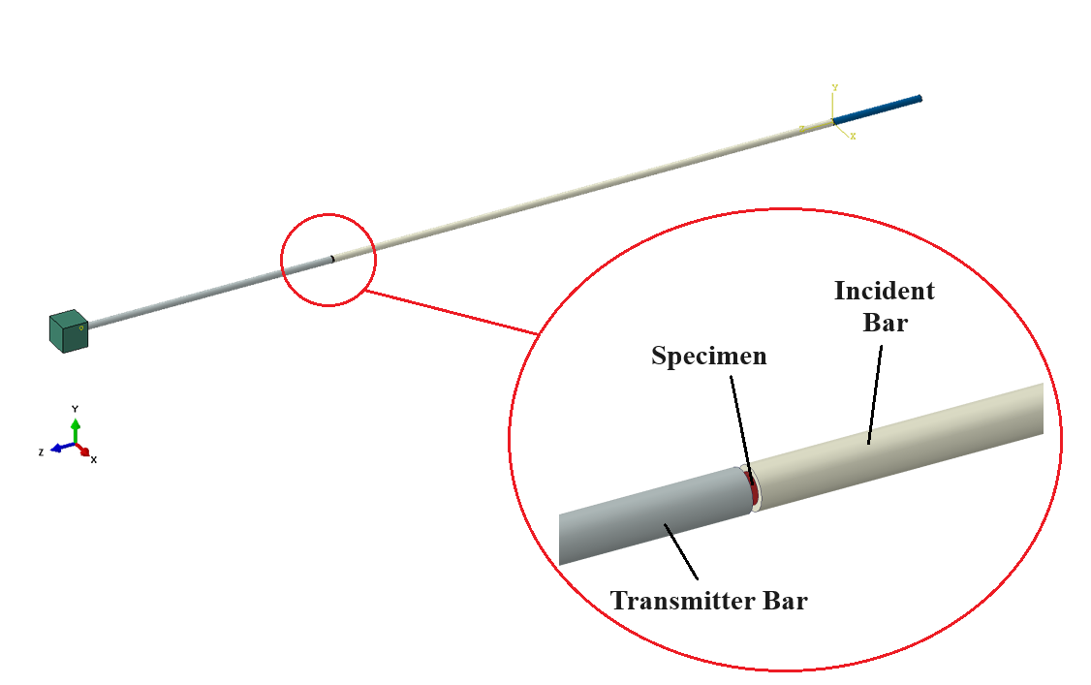

**Fig. 10- SHPB Model in Abaqus**

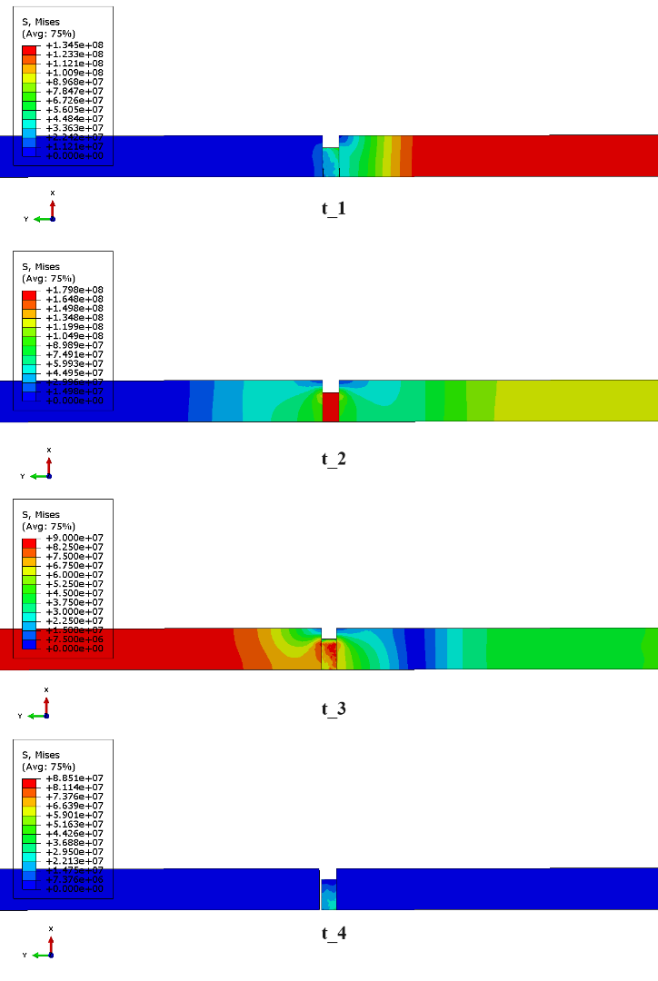

**Fig. 11- Stress Results of Glass in SHPB Axisymmetric Simulation Throw Time**

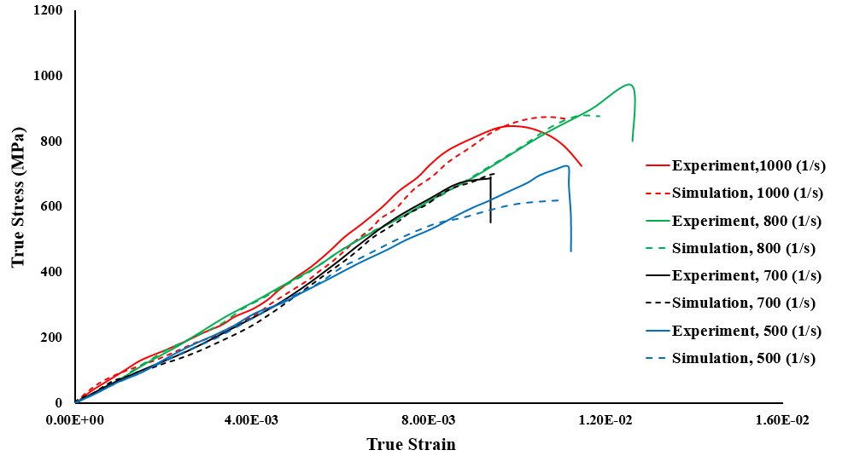

**Fig. 12- Comparison True Stress-True Strain Diagrams of Glass in SHPB Test and Simulations in Different Strain Rates**

1. ***Polymers***

After conducting simple tensile and Split-Hopkinson Pressure Bar (SHPB) tests on polymers, these tests are simulated in Abaqus software to ensure the accuracy of the results and the mechanical model used in the numerical solution. **Fig 13** illustrates the sample prepared for the simple tensile test, while **Fig 14** displays the result of the simple tension simulations for studied polymers. The samples are modeled according to the standards outlined in the article. This test is employed to extract stress-strain results at low strain rates, and the SHPB test is utilized for high strain rates. Subsequently, the extracted results are compared with practical test ones. The following figures (15 to 19) present the simulation and practical test results for each of the polymers used.

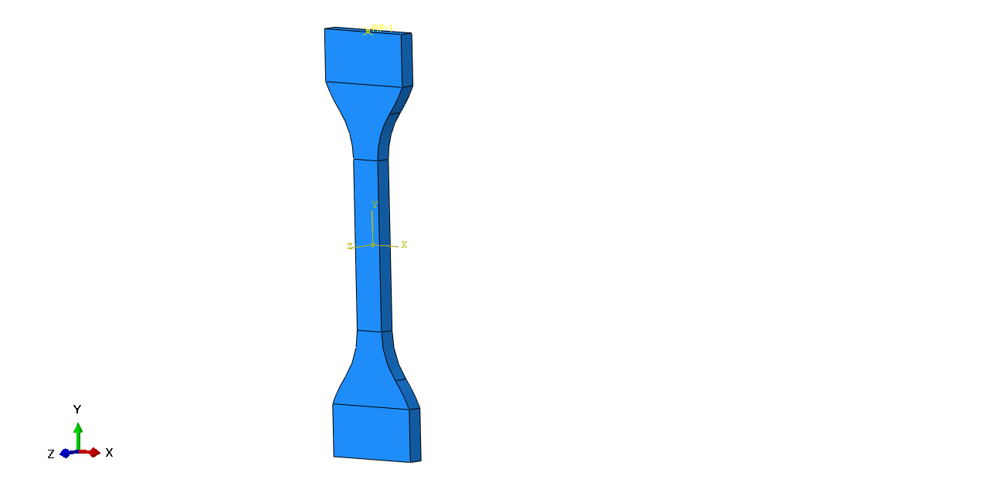

**Fig. 13 Symmetric Model of Polymer Specimen**

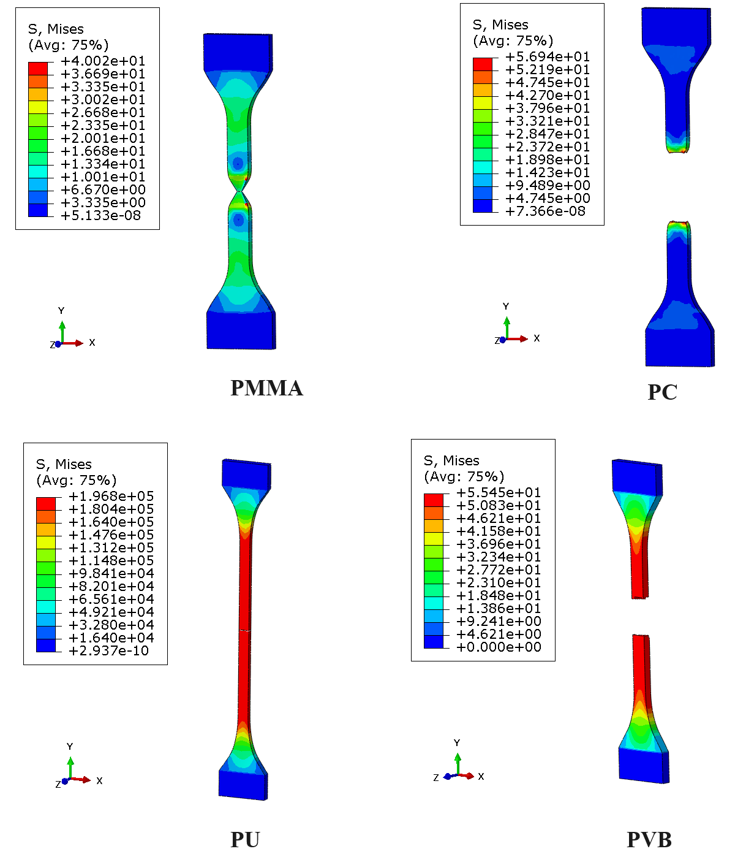

**Fig 14- Stress Results of Tensile Test Simulations**

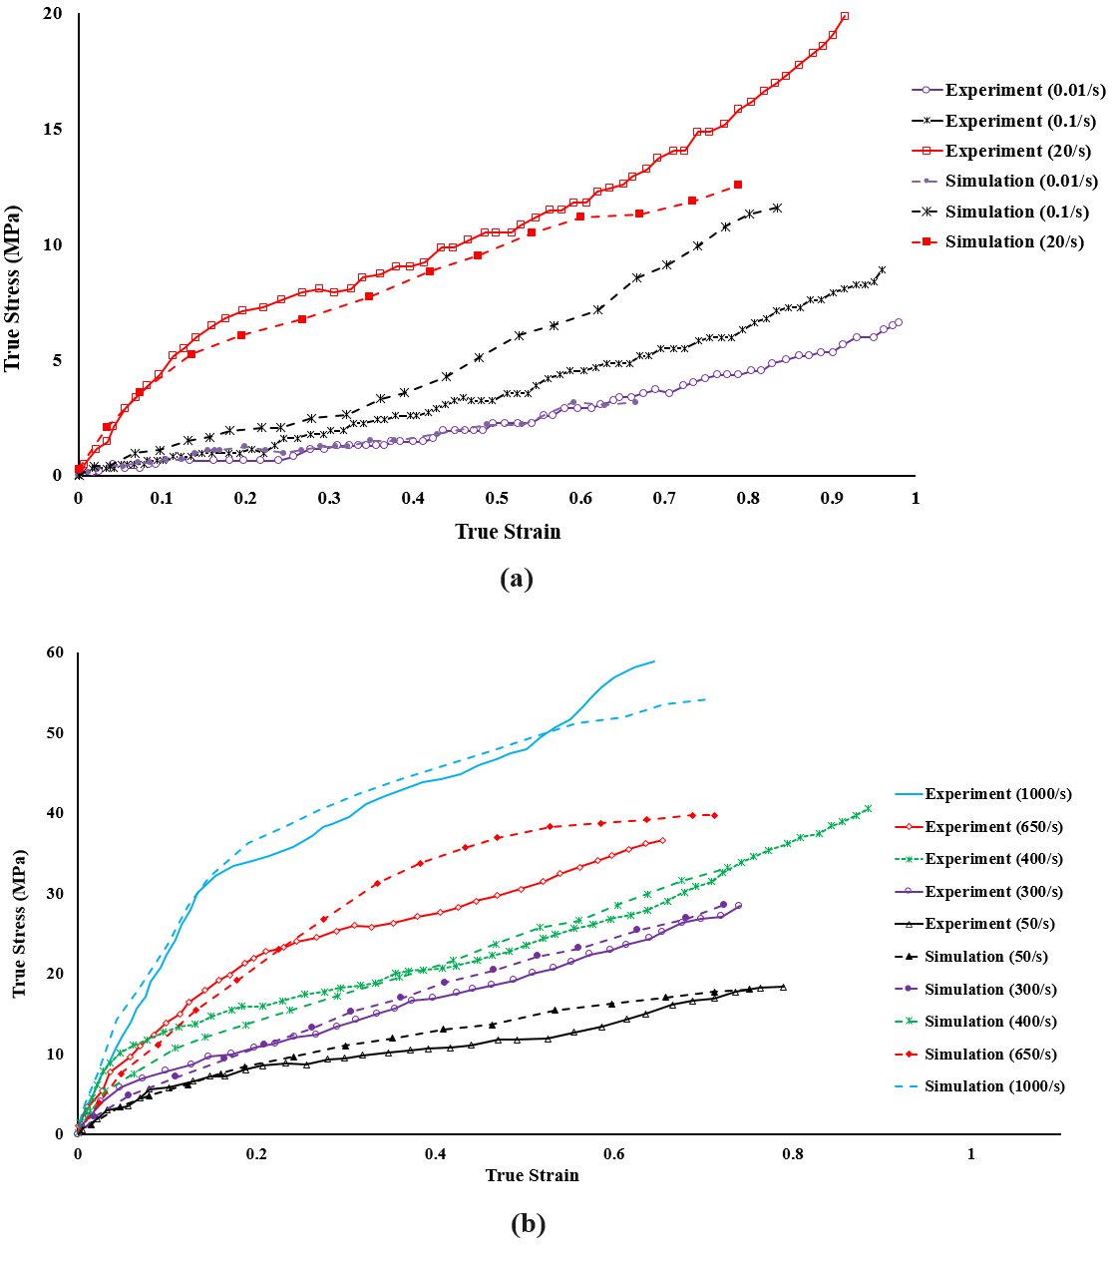

**Fig. 15- The Comparison between Experimental and Simulation Results of PU; a) Tensile Test, b) SHPB Test**

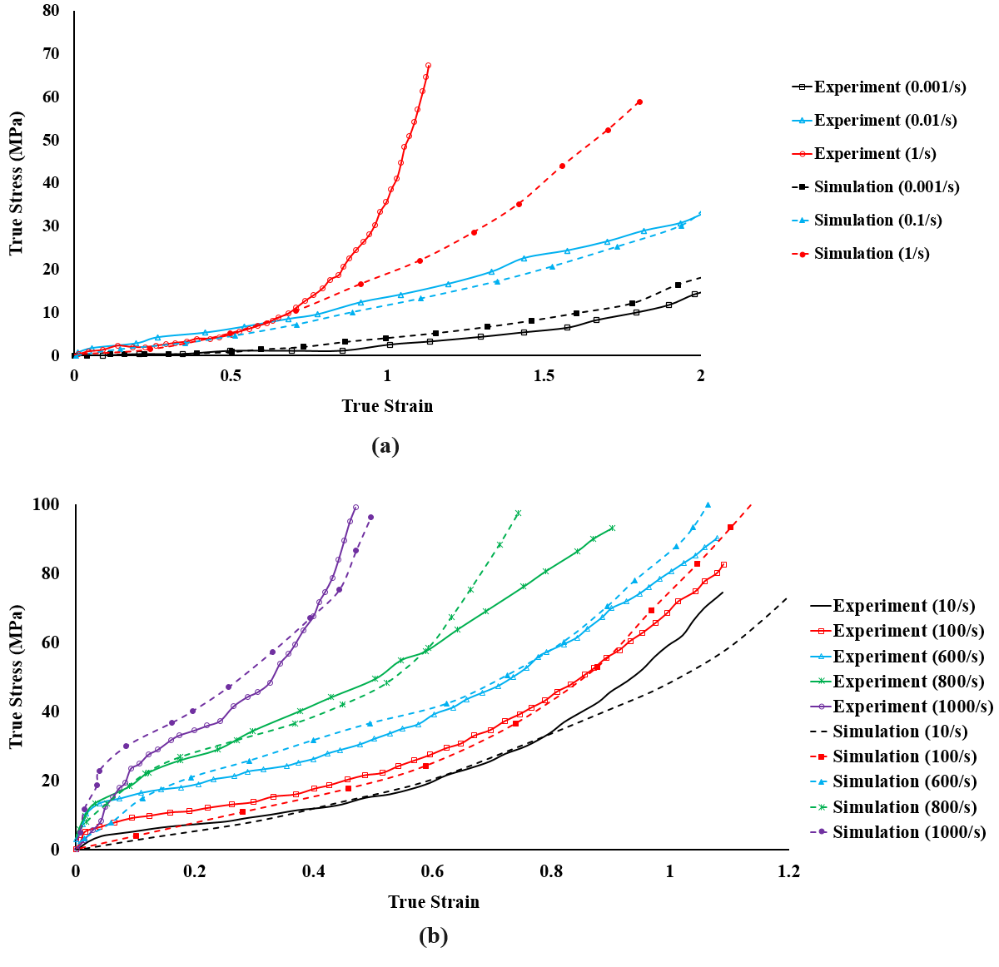

**Fig. 16- The Comparison between Experimental and Simulation Results of PVB; a) Tensile Test, b) SHPB Test**

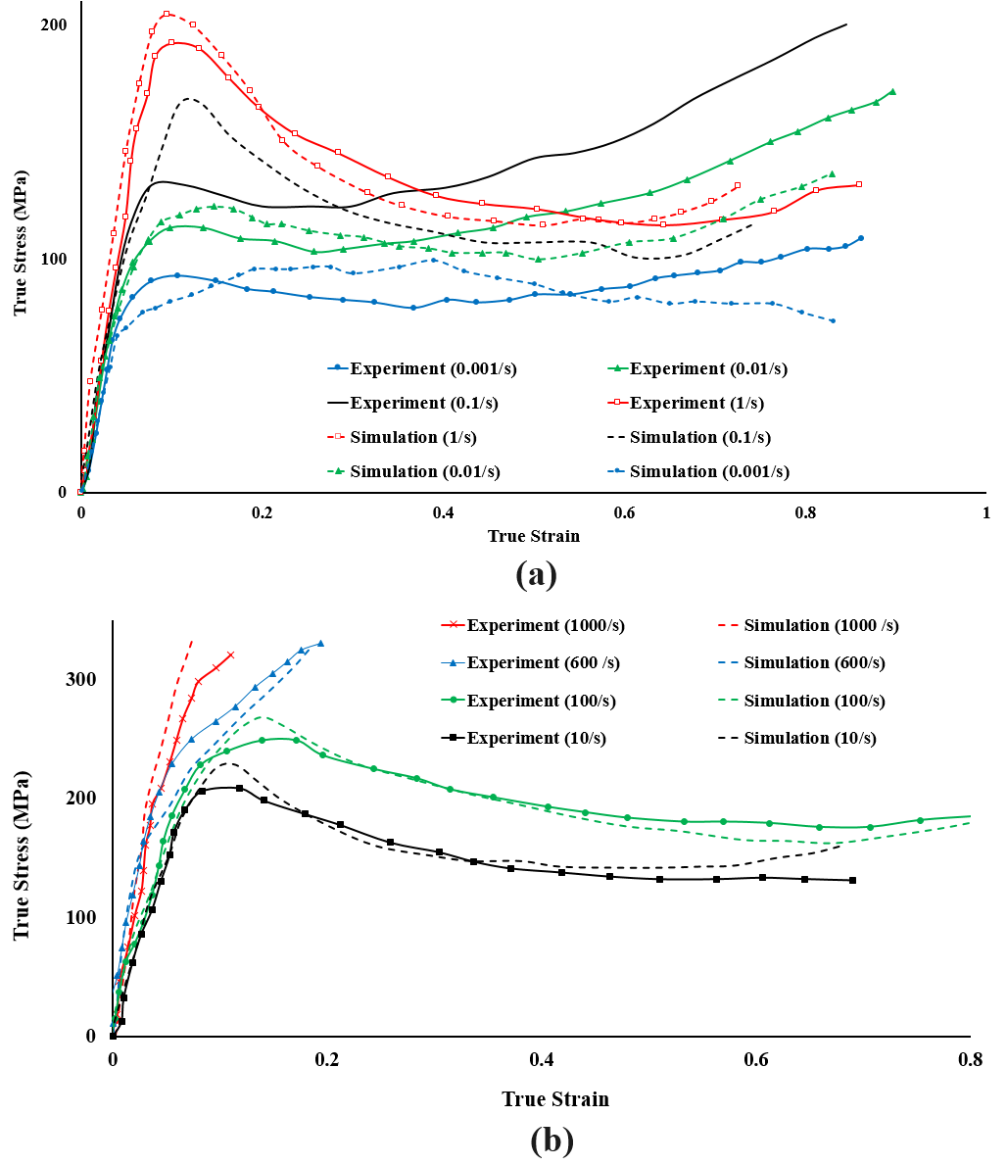

**Fig. 17- The Comparison between Experimental and Simulation Results of PMMA; a) Tensile Test, b) SHPB Test**

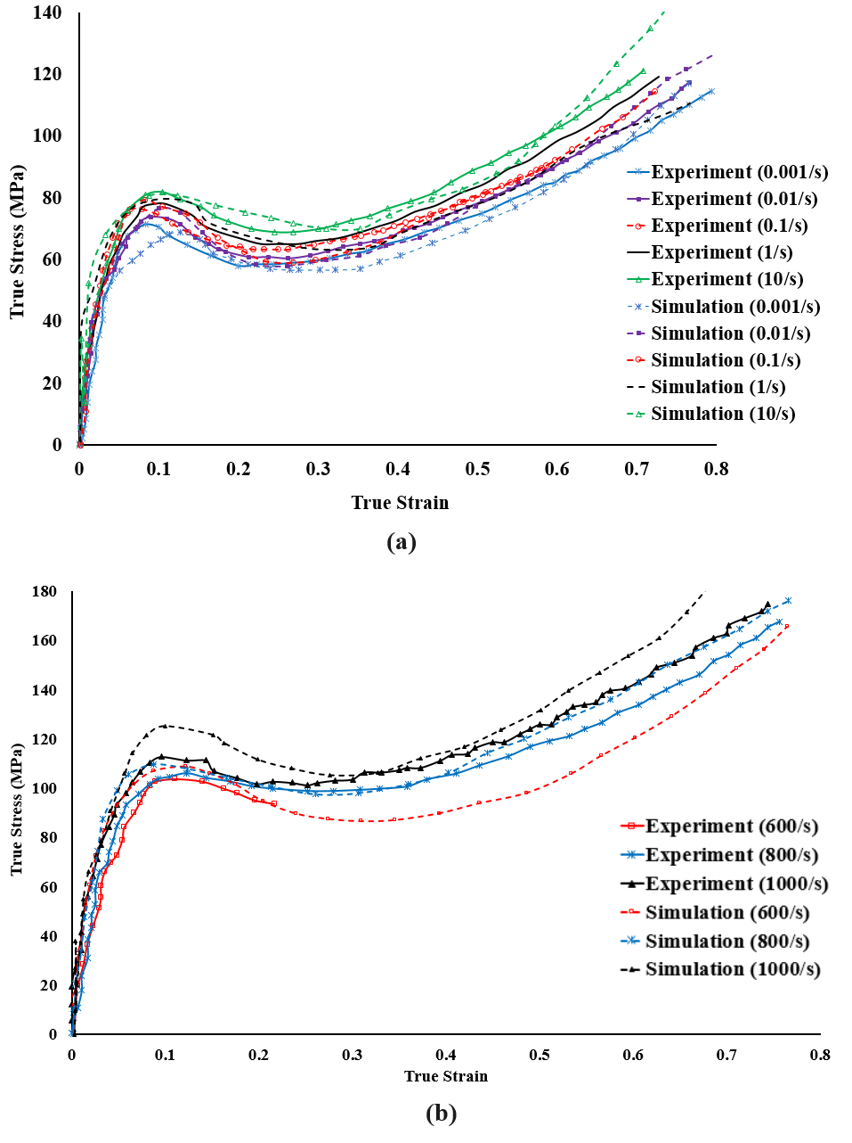

**Fig. 18- The Comparison between Experimental and Simulation Results of PC; a) Tensile Test, b) SHPB Test**

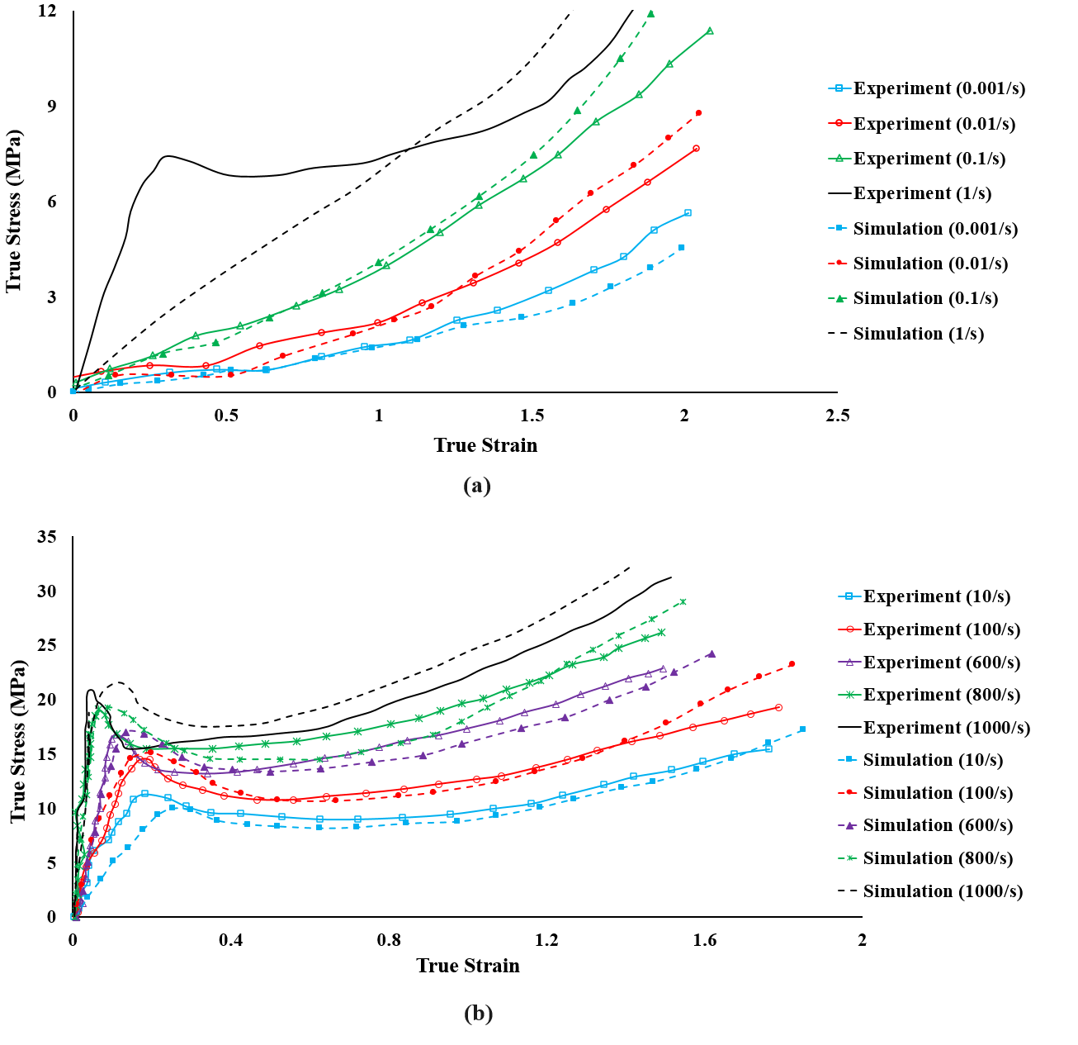

**Fig. 19- The Comparison between Experimental and Simulation Results of SG; a) Tensile Test, b) SHPB Test**

1. **Taguchi Test Design**

In the experimental design section using the Taguchi method, in the first stage, only the materials of the layers are investigated. For each layer, three different materials are considered. Therefore, according to the **Fig 20**, each layer can be made of three types of materials. Consequently, for each layer, there are three possibilities, and in general, for five layers, there can be $3^{5}=243$ possibilities. Due to the high number of possibilities, the Taguchi method reduces the required number of experiments by selecting an appropriate array.

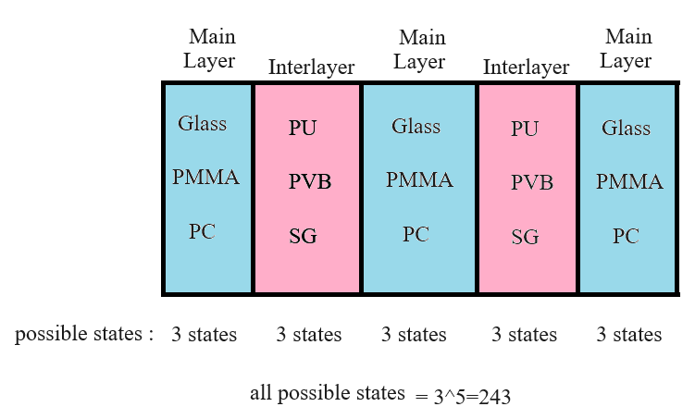

**Fig. 20- Possible States of Material Types in New Recommended Windshield**

The number of degrees of freedom for these experiments is 16. (DOF=3*5+1=16) Therefore, according to the Taguchi method, the smallest array that can be used is the $L_{16}$ array. On the other hand, by selecting the number of levels and factors in the Minitab software (as a design of experiments software), the suggested smallest array would be $L_{27}$. Therefore, the $L_{27}$ array is used for designing the experiment at the first stage. The utilized conditions in this experiment (factors and levels) are presented in the **Table 3.**

**Table 3- All 27 Possible States Designed by Taguchi in 1st Stage**

|  |  |  |  |  |  |
| --- | --- | --- | --- | --- | --- |
| **No. Of Simulation** | **Outer Layer** | **1st Interlayer** | **Middle Layer** | **2nd Interlayer** | **Inner Layer** |
| 1 | Glass | PU | Glass | PU | Glass |
| 2 | Glass | PU | Glass | PU | PC |
| 3 | Glass | PU | Glass | PU | PMMA |
| 4 | Glass | PVB | PC | PVB | Glass |
| 5 | Glass | PVB | PC | PVB | PC |
| 6 | Glass | PVB | PC | PVB | PMMA |
| 7 | Glass | SG | PMMA | SG | Glass |
| 8 | Glass | SG | PMMA | SG | PC |
| 9 | Glass | SG | PMMA | SG | PMMA |
| 10 | PC | PU | PC | SG | Glass |
| 11 | PC | PU | PC | SG | PC |
| 12 | PC | PU | PC | SG | PMMA |
| 13 | PC | PVB | PMMA | PU | Glass |
| 14 | PC | PVB | PMMA | PU | PC |
| 15 | PC | PVB | PMMA | PU | PMMA |
| 16 | PC | SG | Glass | PVB | Glass |
| 17 | PC | SG | Glass | PVB | PC |
| 18 | PC | SG | Glass | PVB | PMMA |
| 19 | PMMA | PU | PMMA | PVB | Glass |
| 20 | PMMA | PU | PMMA | PVB | PC |
| 21 | PMMA | PU | PMMA | PVB | PMMA |
| 22 | PMMA | PVB | Glass | SG | Glass |
| 23 | PMMA | PVB | Glass | SG | PC |
| 24 | PMMA | PVB | Glass | SG | PMMA |
| 25 | PMMA | SG | PC | PU | Glass |
| 26 | PMMA | SG | PC | PU | PC |
| 27 | PMMA | SG | PC | PU | PMMA |

In the second stage, the thickness values are examined, and according to the explanations in the article, three levels of thickness are considered for each main layer. As shown in the **Fig 21**, each layer can adopt one of the corresponding thickness values in each condition. Therefore, here we have three factors with three levels each, resulting in 27 possible combinations. However, the interlayer thickness is a function of the total thickness and the thickness of the main layers. Hence, each of these 27 combinations can itself have various sub-combinations. According to the provided information, in order to reduce the total number of experiments, it can be used the Taguchi method to reduce the 27 existing combinations to 9 combinations. As a result, the total number of experiments will also decrease. Now, all possible combinations are shown in **Table 4**. Therefore, 27 modes are selected for simulation.

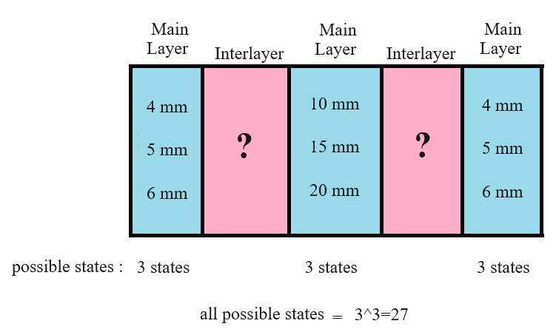

**Fig. 21- Possible States of Layer Thicknesses in New Recommended Windshield**

**Table 4- All 27 Possible States Designed by Taguchi in 2nd Stage**

|  |  |  |  |  |  |  |
| --- | --- | --- | --- | --- | --- | --- |
| **No. Of Simulation** | **Outer Layer Thickness (mm)** | **Middle Layer Thickness (mm)** | **Inner Layer Thickness (mm)** | **Both Interlayers Thicknesses (mm)** | **1st Interlayer Thickness (mm)** | **2nd Interlayer Thickness (mm)** |
| 1 | 4 | 10 | 4 | 12 | 2 | 10 |
| 3 | 9 |
| 4 | 8 |
| 5 | 7 |
| 6 | 6 |
| 7 | 5 |
| 8 | 4 |
| 9 | 3 |
| 10 | 2 |
| 2 | 4 | 15 | 5 | 6 | 2 | 4 |
| 3 | 3 |
| 4 | 2 |
| 3 | 4 | 20 | 6 | 0 | ---------- | ---------- |
| 4 | 5 | 10 | 5 | 10 | 2 | 8 |
| 3 | 7 |
| 4 | 6 |
| 5 | 5 |
| 6 | 4 |
| 7 | 3 |
| 8 | 2 |
| 5 | 5 | 15 | 6 | 4 | 2 | 2 |
| 6 | 5 | 20 | 4 | 1 | ---------- | ---------- |
| 7 | 6 | 10 | 6 | 8 | 2 | 6 |
| 3 | 5 |
| 4 | 4 |
| 5 | 3 |
| 6 | 2 |
| 8 | 6 | 15 | 4 | 5 | 2 | 3 |
| 3 | 2 |
| 9 | 6 | 20 | 5 | -1 | ---------- | ---------- |

**10. The Experiment of Two Consecutive Impacts**

Given that there is no device available that can provide immediate and consecutive impacts (at least for us), the test of consecutive impacts is carried out with a time interval of 120 seconds. It means, the time interval between the two impacts is 120 seconds, and this test, along with the corresponding simulation, is used for result validation. Two Consecutive bird impacts are done experimentally with the equipment explained in article. Then the displacement results are compared with simulation ones. The diagram below illustrates the displacement of the windshield's central point for two consecutive impacts in both simulation and experimental testing. It's worth mentioning that the time interval between the two impacts has been omitted from the graph.

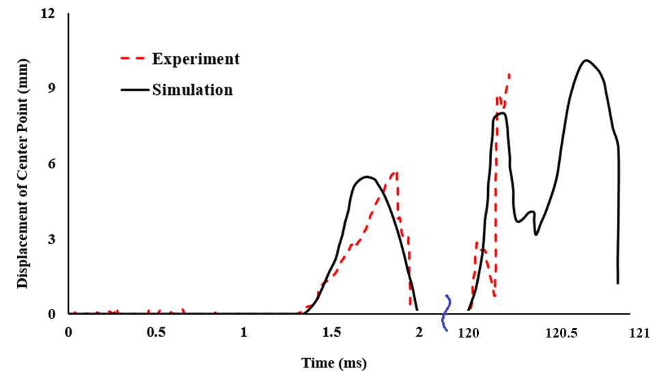

**Fig 22- Comparison of Experimental and Simulation Results of Two Successive Bird Impacts on Windshield**

1. **References:**

de Souza Neto, E. A., Perić, D., & Owen, D. R. J. (2008). Computational Methods for Plasticity. In *Computational Methods for Plasticity*. https://doi.org/10.1002/9780470694626

Ferry, J. D. (1980). Viscoelastic properties of polymers, 3rd edition. In *Wiley, New York*. https://www.wiley.com/en-sg/Viscoelastic+Properties+of+Polymers%2C+3rd+Edition-p-9780471048947

Findley, W. N., Lai, J. S., Onaran, K., & Christensen, R. M. (1977). Creep and Relaxation of Nonlinear Viscoelastic Materials With an Introduction to Linear Viscoelasticity. In *Journal of Applied Mechanics* (Vol. 44, Issue 2). https://doi.org/10.1115/1.3424077

Jha, A. K., Sathyamoorthy, S., & Prakash, V. (2019). Bird strike damage and analysis of UAV’s airframe. *Procedia Structural Integrity*, *14*, 416–428. https://doi.org/10.1016/j.prostr.2019.05.051

Khosravani, M. R., & Weinberg, K. (2018). A review on split Hopkinson bar experiments on the dynamic characterisation of concrete. *Construction and Building Materials*, *190*, 1264–1283. https://doi.org/10.1016/j.conbuildmat.2018.09.187

Li, C., & Lua, J. (2009). A hyper-viscoelastic constitutive model for polyurea. *Materials Letters*, *63*(11), 877–880. https://doi.org/10.1016/j.matlet.2009.01.055

Lissaman, P. B. S., & Shollenberger, C. A. (1970). Formation Flight of Birds. *Science*, *168*(3934), 1003–1005. https://doi.org/10.1126/science.168.3934.1003

Marques, S. P. C., & Creus, G. J. (2012). Computational viscoelasticity. *SpringerBriefs in Applied Sciences and Technology*, *9783642253102*, iv–v. https://doi.org/10.1007/978-3-642-25311-9

Nasraoui, M., Forquin, P., Siad, L., Rusinek, A., & Dossou, E. (2009). *Mechanical behaviour of PMMA: Influence of temperature and confining pressure*. *September*, 1103–1108. https://doi.org/10.1051/dymat/2009154

Rezaei, M., Hassanpour, K., (2015). Effect of material model in PMMA forming process; a Case study. *23rd Annual International Conference on Mechanical Engineering-ISME, Amirkabir University of Technology, Tehran, Iran*.

Rezaei, M., Arezoo, B., & Ziaei-rad, S. (2024). International Journal of Impact Engineering Redesign an aircraft windshield to improve its mechanical resistance against simultaneous bird impacts. *International Journal of Impact Engineering*, *184*(March 2023), 104811. https://doi.org/10.1016/j.ijimpeng.2023.104811

Siviour, C. R., & Jordan, J. L. (2016). High Strain Rate Mechanics of Polymers: A Review. *Journal of Dynamic Behavior of Materials*, *2*(1), 15–32. https://doi.org/10.1007/s40870-016-0052-8