[For SUPPLEMENTARY MATERIAL]
Tracking glass beads: communities and exchange relationships across the Atlantic in the seventeenth century
Heather Walder¹ [ORCID: 0000-0003-2312-245X] & Alicia L. Hawkins^{2,*} [ORCID 0000-0002-4173-9835]

¹ Department of Archaeology and Anthropology, University of Wisconsin – La Crosse, USA
² Department of Anthropology, University of Toronto Mississauga, Canada
* Author for correspondence ✉ alicia.hawkins@utoronto.ca
Received: 20 January 2023; Revised: 25 August 2023; Accepted: 13 October 2023

Detailed materials and methods
Glass bead chemical compositions obtained from minimally invasive or non-destructive analysis methods are the data used for this article. These compositional data (n = 1012 total samples) can be divided into two groups: data collected by the authors (including some previously published) and legacy compositions published by others.
For Group 1, primary data were collected by the authors, and some are previously published (Walder 2013, 2018, 2022; Walder et al. 2021; Hawkins & Walder 2022). The method used was laser ablation – inductively coupled plasma – mass spectrometry (LA-ICP-MS) at the Field Museum Elemental Analysis Facility and Laurentian University Harquail Earth Sciences Facility (HES) (n = 682 total compositions). For Group 2, legacy compositions, data were collected from LA-ICP-MS (n = 69) (Dussubieux 2009; Dussubieux & Gratuze 2012; Dussubieux & Karklins 2016) and instrumental neutron activation analysis (INAA) (n = 261) (Hancock et al. 1994, 1999, 2000; Sempowski et al. 2000; Karklins et al. 2002, 2015). See Table S2 below for a summary of samples. Notably, trace elements such as zirconium (Zr), hafnium (Hf) and niobium (Nb) were not obtained for INAA analyses, and Hf was not reported for some of the LA-ICP-MS samples obtained at the HES. However, Nb and Hf values are correlated and Nb values were used for trace element biplots to show compositional differences. The analytical procedures, limits of detection and other methodological considerations for LA-ICP-MS and INAA are well-published elsewhere (Walder et al. 2021).

Table S2. Summary of dataset. EAF = Field Museum Elemental Analysis Facility; HES = Laurentian University Harquail Earth Sciences.
 | Turquoise / Cu |  | Cobalt / Co |  | White / Sn |  | TOTALS
LA-ICP-MS samples by Walder and Hawkins | EAF | HES | EAF | HES | EAF | HES | EAF | HES | TOT
Western Great Lakes | 252 | 0 | 251 | 0 | 3 | 0 | 506 | 0 | 506
Wendake (S. Ontario) | 53 | 11 | 55 | 8 | 27 | 16 | 135 | 35 | 170
Netherlands | 0 | 2 | 0 | 2 | 0 | 2 | 0 | 6 | 6
TOTAL by authors LA-ICP-MS | 318 |  | 316 |  | 48 |  | 682 samples
OTHER ANALYSTS
INAA samples
Wendake (S. Ontario) | 26 |  | 0 |  | 111 |  | 137
Netherlands | 22 |  | 22 |  | 80 |  | 124
Total Other INAA | 48 |  | 22 |  | 191 |  | 261
LA-ICP-MS samples
Western Great Lakes | 0 |  | 1 |  | 0 |  | 1
France | 17 |  | 15 |  | 1 |  | 33
England | 0 |  | 19 |  | 7 |  | 26
Netherlands | 3 |  | 3 |  | 3 |  | 9
Total other LA-ICP-MS | 20 |  | 38 |  | 11 |  | 69
TOTAL ALL | 386 |  | 376 |  | 250 |  | 1012
Note: Because INAA data were not collected in consultation with First Nations descendants, we excluded all mortuary context beads (e.g. Ossossané ossuary) from legacy data.

Not all published glass bead compositions for the study region were included. To focus on Wendat/Wyandot exchange connections and population movement across the Great Lakes region c. AD 1600–1650, we restricted our dataset to beads produced before AD 1700, using two known recipe shifts. We excluded later, antimony (Sb) opacified white beads (Hancock et al. 1997) and we included only magnesium-low-phosphorus (Mg-low-P) pre-1700 compositions, as defined by Walder (2018). All of the beads fitting the later, post-1700 compositional subgroup (P-low-Mg) that were not included in the final comparative dataset (n = 110) were less than 2 parts per million (ppm) Hf, less than 50ppm Zr, in the potentially ‘Venetian’ silica source range (De Raedt et al. 2001) and came from later sites, such as French colonial Fort Michilimackinac and Fort St. Joseph.
This strategy of restricting the study dataset to pre-1700 beads based on their chemical compositions, rather than their archaeological contexts, allows comparison of potential heirloom beads made prior to AD 1700 but recovered from sites with later occupations (e.g. French colonial Fort Michilimackinac). For the French colony ship La Belle, which left France on 24 July 1684 and sank in 1686 off the coast of Texas (Bruseth et al. 2017), we included cobalt blue but not white beads. The shipwreck’s white beads were Sb-opacified, a shift which began from approximately AD 1625–1640 for archaeological sites in the Northeast; Sb-opacified beads had completely replaced tin- (Sn)-opacified white beads by c. AD 1675 (Sempowski et al. 2000). The cobalt-blue beads from La Belle fit the pre-AD 1700 sub-group (Walder 2022) and were included as comparisons for both the European production centres (from which the ship was likely provisioned) and to investigate connections to beads from Great Lakes region sites.
In glasshouses across Europe, different types of beads were produced, often with subtle variations in colour, opacity, shape, size and other attributes. Glass bead typologies (e.g. Kidd & Kidd 1970) use these attributes to assign beads to types and produce chronological seriations such as the Glass Bead Periods or GBPs (Kenyon & Kenyon 1983; Kenyon & Fitzgerald 1986; Fitzgerald et al. 1995). The dataset in this paper contains white, cobalt and turquoise-coloured glasses. For European samples, this includes production waste or scraps, not just finished beads. Cobalt or navy-blue glass (n = 376) contains cobalt (Co) at more than 300ppm with copper (Cu) at less than 0.65% and is generally translucent, and a few beads are coloured with both copper and cobalt. White beads (n = 140) are opaque and have Sn-opacified glass compositions. Turquoise glass compositions in the dataset are made with copper (Cu)-coloured glass, copper oxide (CuO) at 0.65% or greater, and may be translucent but sometimes are opacified with Sn to produce a ‘robin’s egg blue’ colour. The turquoise group includes reworked or refired glass fragments and pendants (n = 19) in addition to beads (Figure S1) for a total of 360 Cu-coloured glass compositions (beads, pendants, refired glass fragments).
These reworked turquoise glass compositions come from artefacts Indigenous people made by repurposing beads into pendants or other adornments (Walder 2013; Billeck 2016). An example of a refired glass fragment from the Zimmerman Site in north-central Illinois (Brown, J.A. 1961; Brown, M.K. 1975; Rohrbaugh et al. 1999) shows how beads obtained from multiple sources produced in different European locations were utilised in the interior. The white-appearing portion of this glass fragment (ZM_07) is Sn-opacified but contains 1.3% CuO, indicating it was made with a mix of turquoise and white beads, some of which were Sn-opacified and may have been heirlooms, based on the presence of Sn and the moderate Hf, Nb and Zr trace elements present (Hf=7.1ppm, Nb=5.3ppm, Zr=236ppm,). The blue portion (ZM_08) is Cu-coloured and fits the Mg-low-P pre-1700 subgroup for Cu-coloured beads from the Western Great Lakes and has low trace element values consistent with Venetian silica sources (Hf=0.5ppm, Nb=1.1ppm, Zr=13.7ppm). Both ZM_07 and ZM_08 are plotted with the AD 1660–1700 Western Great Lakes Cu-coloured group in this article.

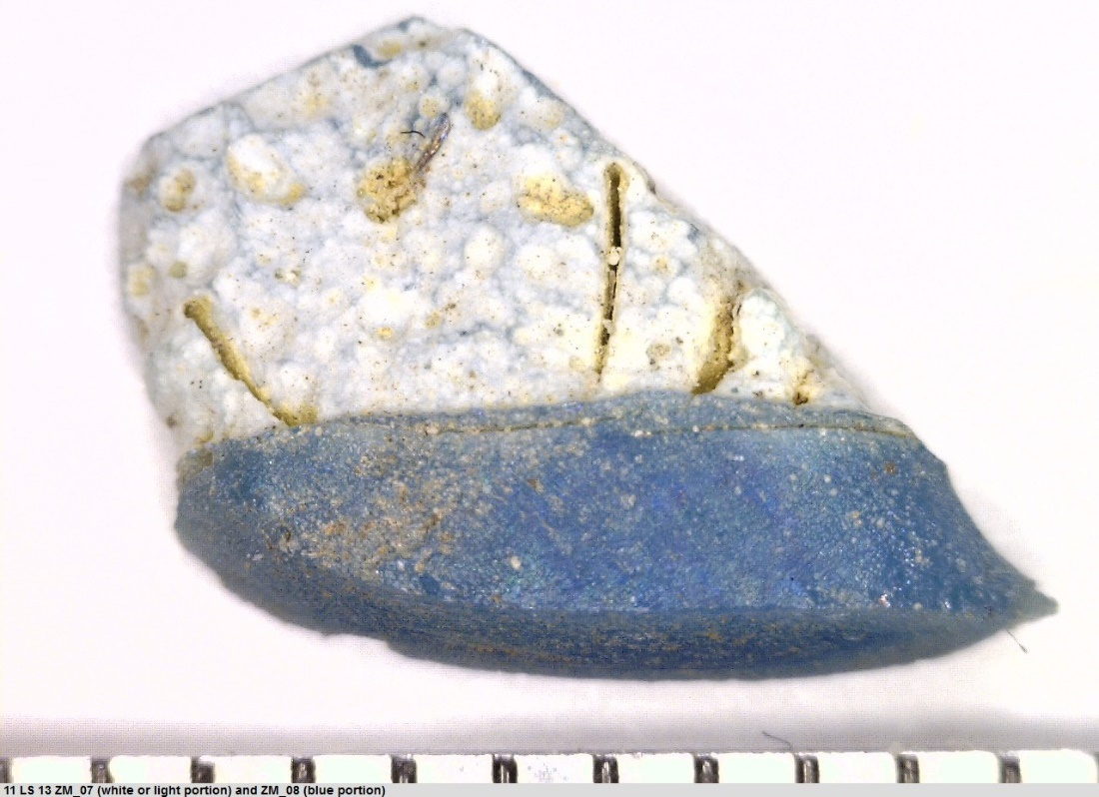
Figure S1. Refired glass object from the Zimmerman site (sample IDs ZM_07 and ZM_08). Scale in millimetres (figure by authors).

For this study, the most common Kidd and Kidd (1970) bead types in each colour category are as follows: turquoise: IIa31, IIa38, IIa40 and related types; cobalt: Ia19, IIa55, IIa56, IIa57 and related types; white: IIa13 or IIa14 and related types. In Figure 3, we have illustrated individual analysed beads from different sites, and here we list their sample ID and archaeological site: Type IIa40 = OS_20 (Ossossané village); IIa38 = GL_08 (Goose Lake Outlet#3 or ‘GLO#3’); IIa55 = TW_26 (Max Oné-Onti Gros-Louis, formerly Thomson Walker); IIa57 = GL_01 (GLO#3); IIa13 = GL_34 (GLO#3); IIa15 = GL_35 (GLO#3). We maintain that compositional, rather than typological, quantitative compositional analyses of glass bead assemblages are preferable when comparing large datasets, given the subjectivity of classifying beads according to visual assessments of their colour, opacity and other observable attributes. See the final compositional data tables for the assigned type for each bead in the dataset (Tables S3–S5).

References
Billeck, B. 2016. Ethnographic and historical evidence for glass pendant function in the Plains. Plains Anthropologist 61: 410–424. https://doi.org/10.1080/00320447.2016.1245963
Brown, J.A. (ed.) 1961. The Zimmerman Site., Springfield: Illinois State Museum.
Brown, M.K. 1975. The Zimmerman Site: further excavations at the Grand Village of Kaskaskia. Springfield: Illinois State Museum.
Bruseth, J.E., A. Borgens, B.M. Jones & E.D. Ray. (ed.) 2017. La Belle: the archaeology of a seventeenth-century vessel of New World colonization. College Station: Texas A & M University Press.
De Raedt, I., K. Janssens, J. Veeckman, L. Vincze, B. Vekemans & T.E. Jeffries. 2001. Trace analysis for distinguishing between Venetian and facon-de-Venise glass vessels of the 16th and 17th century. Journal of Analytical Atomic Spectrometry 16: 1012–17. https://doi.org/10.1039/B102597J
Dussubieux, L. 2009. Chemical investigation of some 17th-century French glass personal ornaments. Journal of Glass Studies 51: 95–110.
Dussubieux, L. & B. Gratuze. 2012. Chemical composition of 16th to 18th-century glass beads excavated in Paris. Beads Journal of the Society of Bead Researchers 24: 26–38.
Dussubieux, L. & K. Karklins. 2016. Glass bead production in Europe during the 17th century: elemental analysis of glass material found in London and Amsterdam. Journal of Archaeological Science: Reports 5: 574–89. https://doi.org/10.1016/j.jasrep.2015.12.018
Fitzgerald, W.R., D.H. Knight & A. Bain. 1995. Untanglers of matters temporal and cultural: glass beads and the Early Contact Period Huron Ball Site. Canadian Journal of Archaeology/Journal canadien d'archéologie 19: 117–38.
Hancock, R.G.V., A. Chafe & I. Kenyon. 1994. Neutron activation analysis of sixteenth- and seventeenth-century European blue glass trade beads from the Eastern Great Lakes area of North America. Archaeometry 36: 253–66.
Hancock, R.G.V., S. Aufreiter & I. Kenyon. 1997. European white glass trade beads as chronological and trade markers, in P. Vandiver, J.R. Druzick, J.F. Merkel & J. Stewart (ed.) Materials issues in art and archaeology V: 181–91. Pittsburg: Materials Research Society.
Hancock, R.G.V., S. Aufreiter, I. Kenyon & M. Latta. 1999. White glass beads from the Auger site, southern Ontario, Canada. Journal of Archaeological Science 26: 907–912. https://doi.org/10.1006/jasc.1997.0249
Hancock, R.G.V. et al. 2000. Non-destructive analysis of European cobalt blue glass trade beads. Journal of Radiaoanalytical and Nuclear Chemistry 244: 567–73.
Hawkins, A.L. & H. Walder. 2022. Characterizing glass recipes for distinctive polychrome glass bead types in Ontario, Canada, in L. Dussubieux & H. Walder (ed.) The elemental analysis of glass beads technology, chronology and exchange: 57–80. Leuven: Leuven University Press.
Karklins, K. et al. 2002. Analysis of glass beads and glass recovered from an early 17th-century glassmaking house in Amsterdam, in K.A. Jakes (ed.) Archaeological chemistry: 110–127. Washington, D.C.: American Chemical Society.
Karklins, K., L. Dussubieux & R.G.V. Hancock. 2015. A 17th-century glass bead factory at Hammersmith Embankment, London, England. Beads Journal of the Society of Bead Researchers 27: 16–24.
Kenyon, I. & W.R. Fitzgerald. 1986. Dutch glass beads in the Northeast: an Ontario perspective. Man in the Northeast 32: 1–34.
Kenyon, I. & T. Kenyon. 1983. Comments on 17th century glass trade beads from Ontario, in CF Hayes III (ed.) Proceedings of the 1982 Glass Trade Bead Conference: 59–74. Rochester (NY): Rochester Museum and Science Centre.
Kidd, K.E. & M.A. Kidd. 1970. A classification system for glass beads for the use of field archaeologists (Canadian Historic Sites: Occasional Papers in Archaeology and History). Ottawa: Department of Indian Affairs and Northern Development.
Rohrbaugh, C.L., L.J. Stelle, T.E. Emerson, G.R. Walz & J.T. Penman. 1999. The archaeology of the Grand Village of the Illinois. Report of the Grand Village Research Project, 1991–1996; Grand Village of the Illinois State Historic Site (11LS13), LaSalle County, Illinois. Urbana: Illinois Transportation Archaeology Research Program, University of Illinois-Urbana.
Sempowski, M.L., A.W. Nohe, J.F. Moreau, I. Kenyon, K. Karklins, S. Aufreiter & R.G.V. Hancock. 2000. On the transition from tin-rich to antimony-rich European white soda-glass trade beads for the Senecas of northeastern North America. Journal of Radioanalytical and Nuclear Chemistry 244: 559–66.
Walder, H. 2013. Laser ablation – inductively coupled plasma – mass spectrometry (LA-ICP-MS) analysis of refired glass pendants from the North American Upper Great Lakes, in R.A. Armitage & J.H. Burton (ed.) Archaeological chemistry 8: 365–96. New York: Oxford University Press.
– 2018. Small beads, big picture: chronology, exchange, and population movement assessed through compositional analyses of blue glass beads from the Upper Great Lakes. Historical Archaeology 52: 301–31. https://doi.org/10.1007/s41636-018-0100-4
– 2022. Seeking Indigenous trade networks of the midcontinent through glass beads from La Belle (41MG86), in T.D. Schneider & L.M. Panich (ed.) Archaeologies of Indigenous presence: 217–241. Gainesville: University Press of Florida.
Walder, H., J.A. Petrus, L. Dussubieux, R.G.V. Hancock & A.L. Hawkins. 2021. Comparing chemistries: inter-laboratory evaluation of glass bead compositional research in the Great Lakes Region. Archaeometry 63: 1236–54. https://doi.org/10.1111/arcm.12683

