 | Supplementary material for  Inselmann, L., J. Krüger, F. Schopper, L. Rahmstorf & Thomas Terberger. 2024. Warriors from the south? Arrowheads from the Tollense valley and Central Europe. Antiquity 98.  Author for correspondence ✉ leif@inselmann.net

Supplementary Figures S1–S5

Figure S1. Tollense valley. Flint arrowhead sticking in the find layer next to arm bones at site Weltzin 20. Photo: G. Lidke.
Figure S2. Tollense valley. Bronze arrowhead with wooden shaft from site Weltzin 28. Photo: J. Krüger.
Figure S3. Types of Bronze arrowheads according to Eckhardt (1996). The separation of types 4 B1/2 follows Dombrowsky (2014).
Type 1 (): A) barbed and tanged arrowhead with flat cross-section; B) tanged arrowhead with flat cross section and straight base; C) barbed, spurred and tanged arrowhead with flat cross-section; D) barbed, double spurred and tanged arrowhead with flat cross-section. Type 2 (): A) Barbed arrowhead with spherical tang and midrib; B) Arrowhead with spherical tang and midrib and straight base; C) Barbed spurred arrowhead with spherical tang and midrib; D) Barbed double spurred arrowhead with spherical tang and midrib. Type 3 (): A) Barbed arrowhead without tang; B) Arrowhead with straight base and without tang, with or without holes. Type 4 (): A) Socketed and barbed arrowhead; B) Socketed arrowhead with straight base (B1: with straight base; B2: with rhombic blade); C) Socketed spurred arrowhead; D) Socketed double spurred arrowhead; E) Socketed spurred arrowhead with shaft-ring. Type 5 (): A) Socketed arrowhead with oblong willow-leafed shape; B) Socketed with slender willow-leafed shape. Drawings: Leif Inselmann after Eckhardt 1996: 26‒31.
Figure S4. Origin of 4743 Bronze Age arrowheads recorded from the literature by country. For northeast Germany the aim was to record as completely as possible. Arrowheads were recorded almost completely for Poland and Moravia. For other regions (Lower Saxony, the Rhineland, southern Germany and other countries) no complete inventory is provided.
Figure S5. Distribution of Bronze Age flint arrowheads (Period III / other or unknown date). Map: Leif Inselmann.

Dombrowsky, A. 2014. Bronzezeitliche Metallfunde aus dem Gebiet der mittleren Tollense unter besonderer Berücksichtigung der Flussfunde, in D. Jantzen, J. Orschiedt, J. Piek & T. Terberger (ed.) Tod im Tollensetal. Forschungen zu den Hinterlassenschaften eines bronzezeitlichen Gewaltkonflikts in Mecklenburg-Vorpommern. Teil 1: Die Forschungen bis 2011: 131–80. Schwerin: Landesamt für Kultur und Denkmalpflege Mecklenburg-Vorpommern.

Eckhardt, H. 1996. Pfeil und Bogen. Eine archäologisch-technologische Untersuchung zu urnenfelder- und hallstattzeitlichen Befunden (Internationale Archäologie 21). Espelkamp: Leidorf.

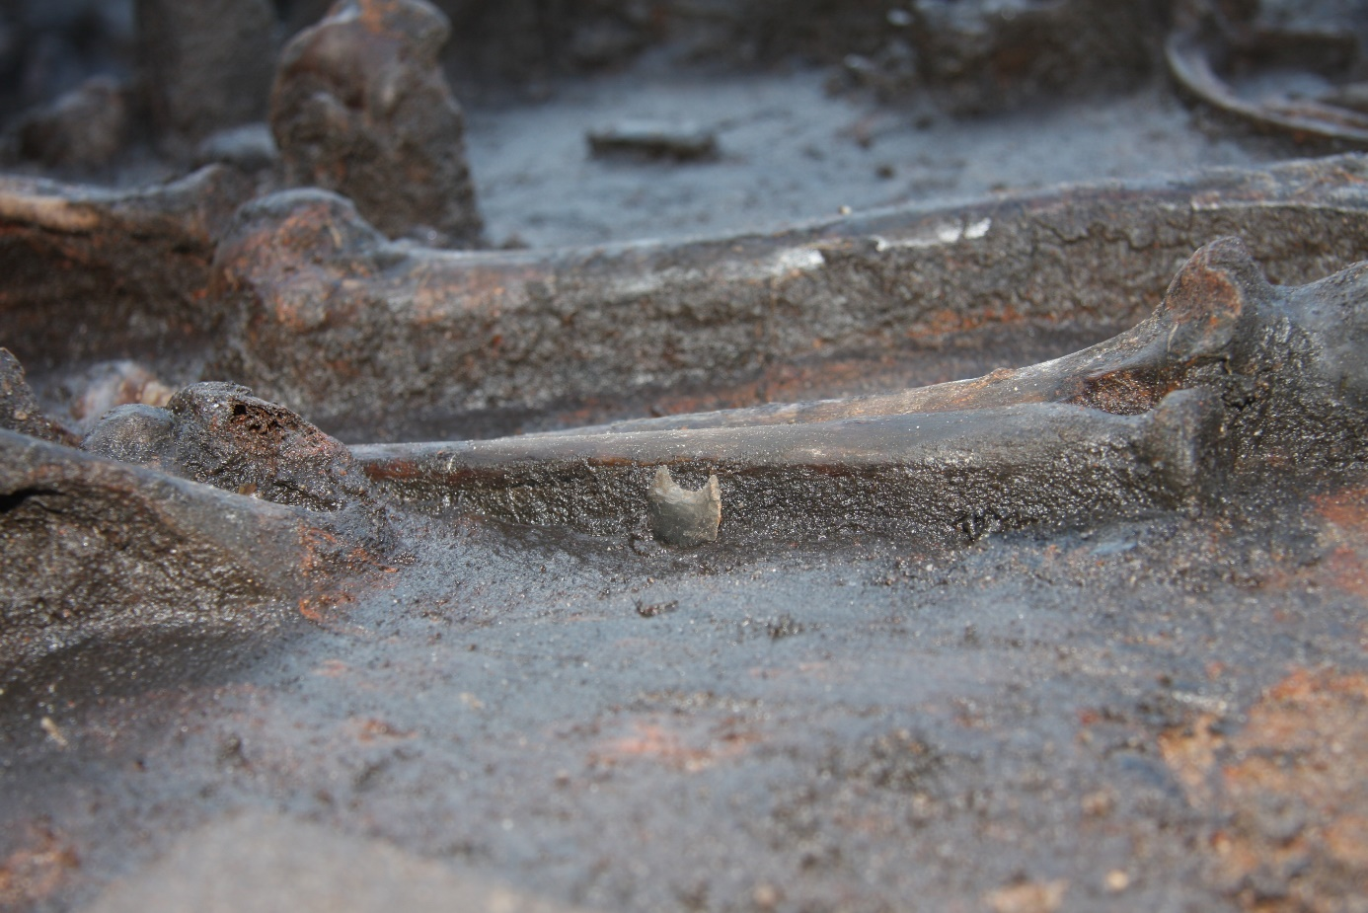
Figure S1

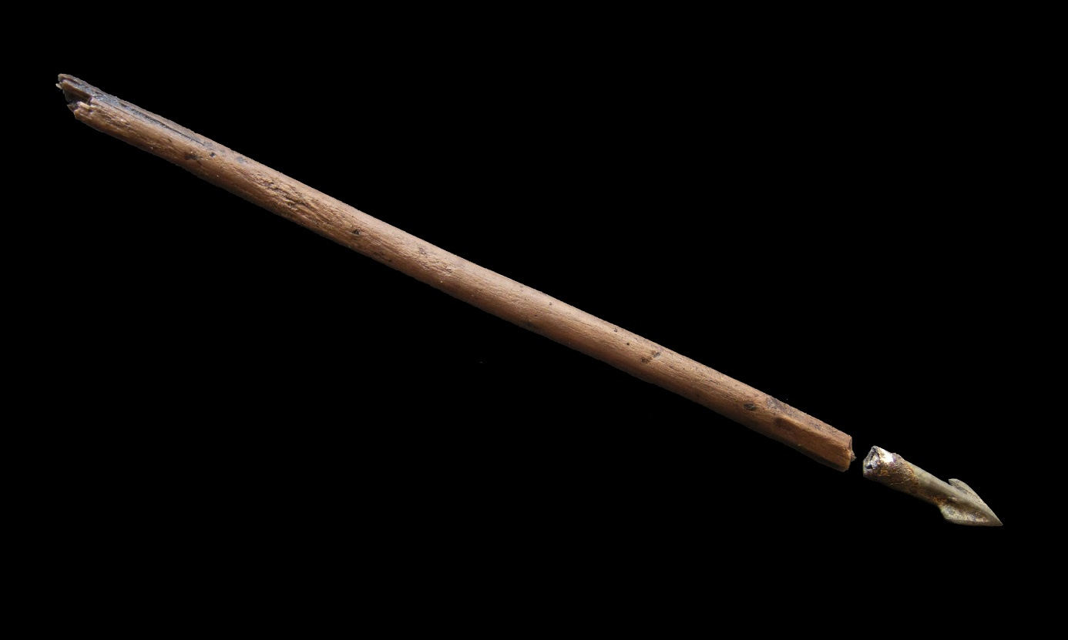
Figure S2

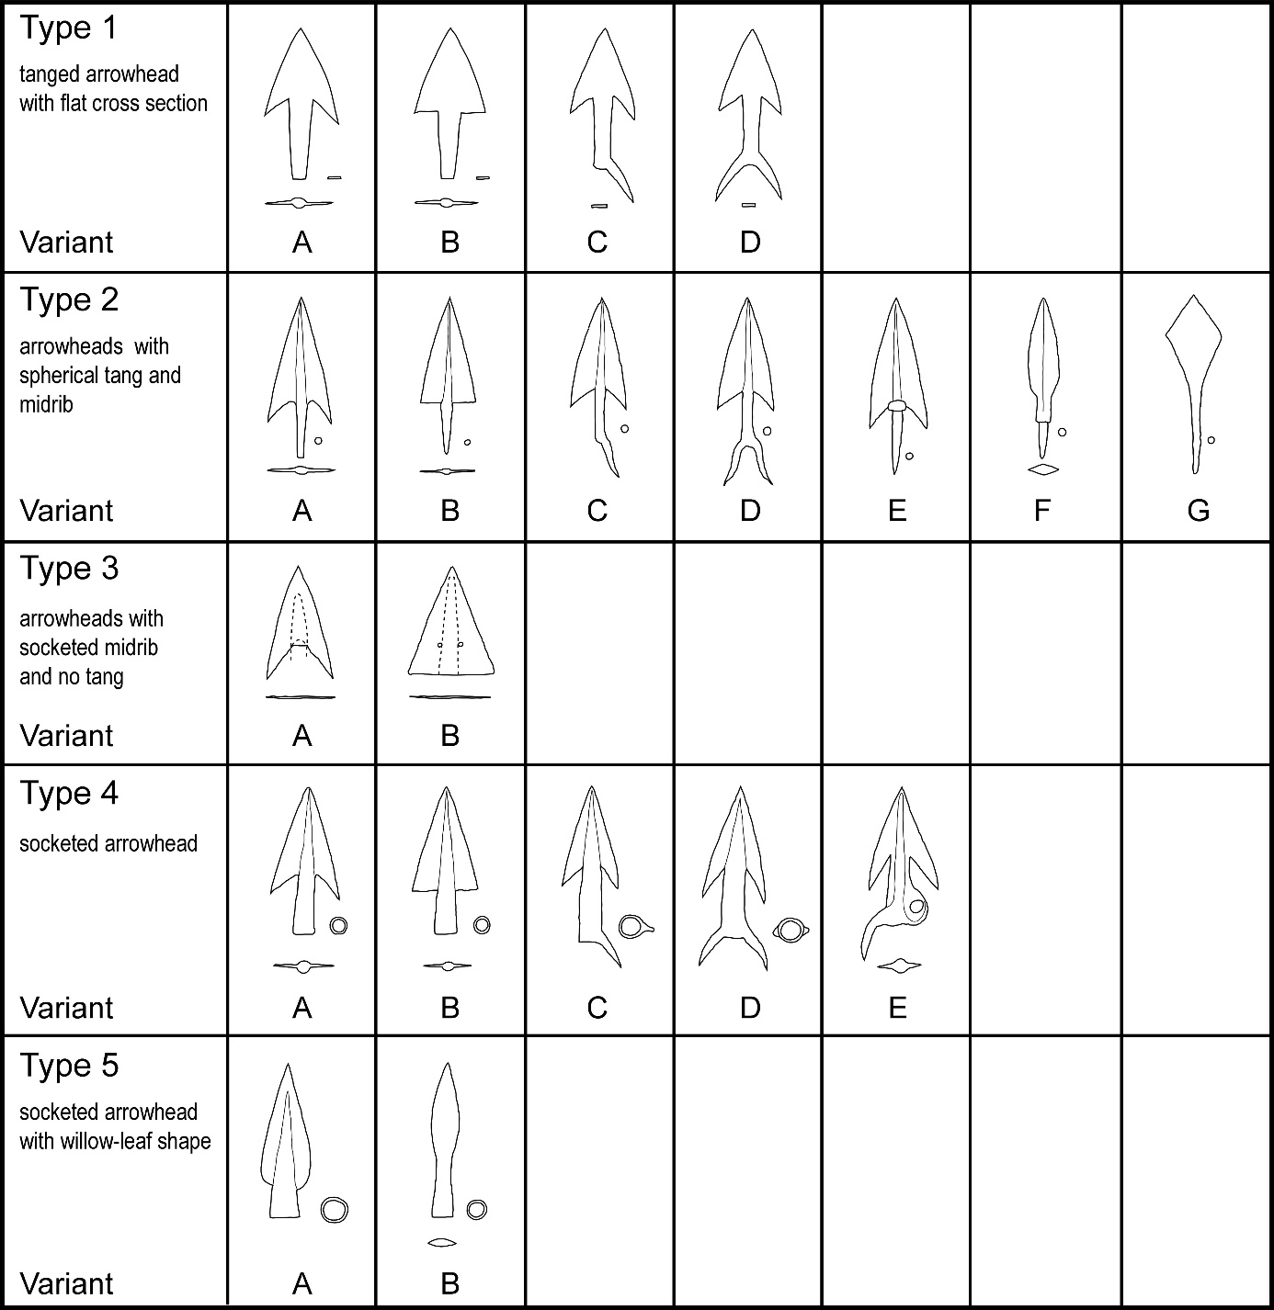

Figure S3
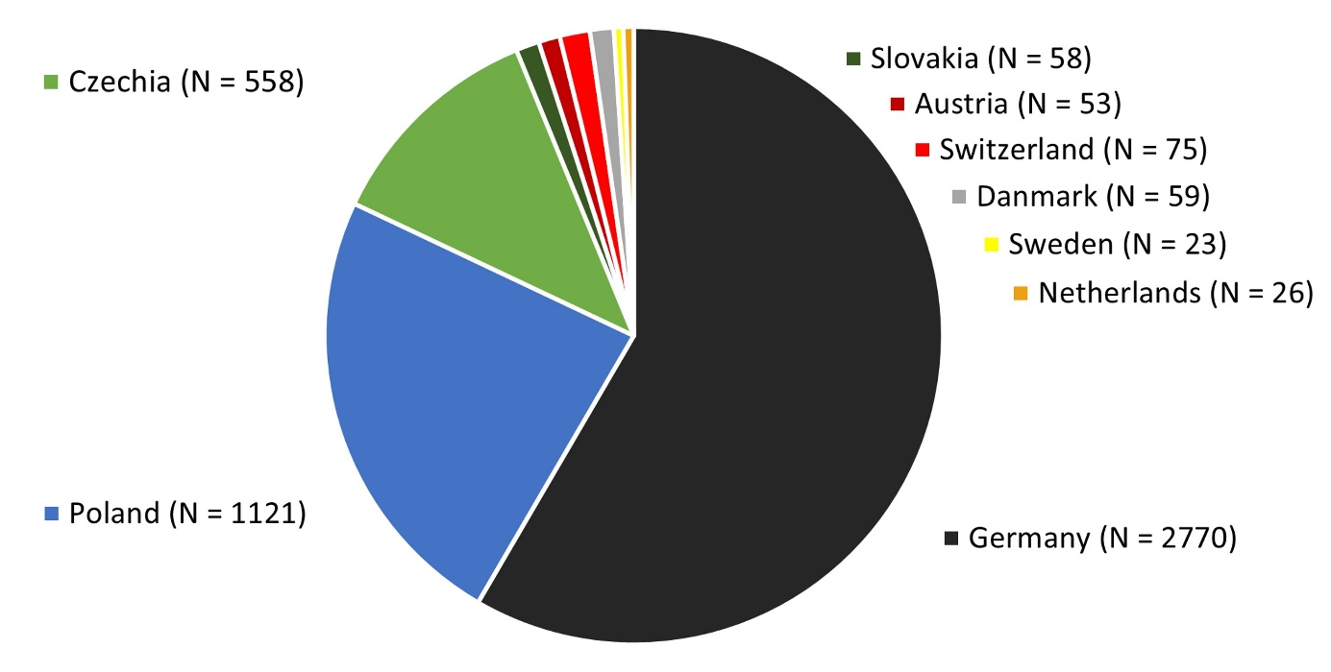
Figure S4

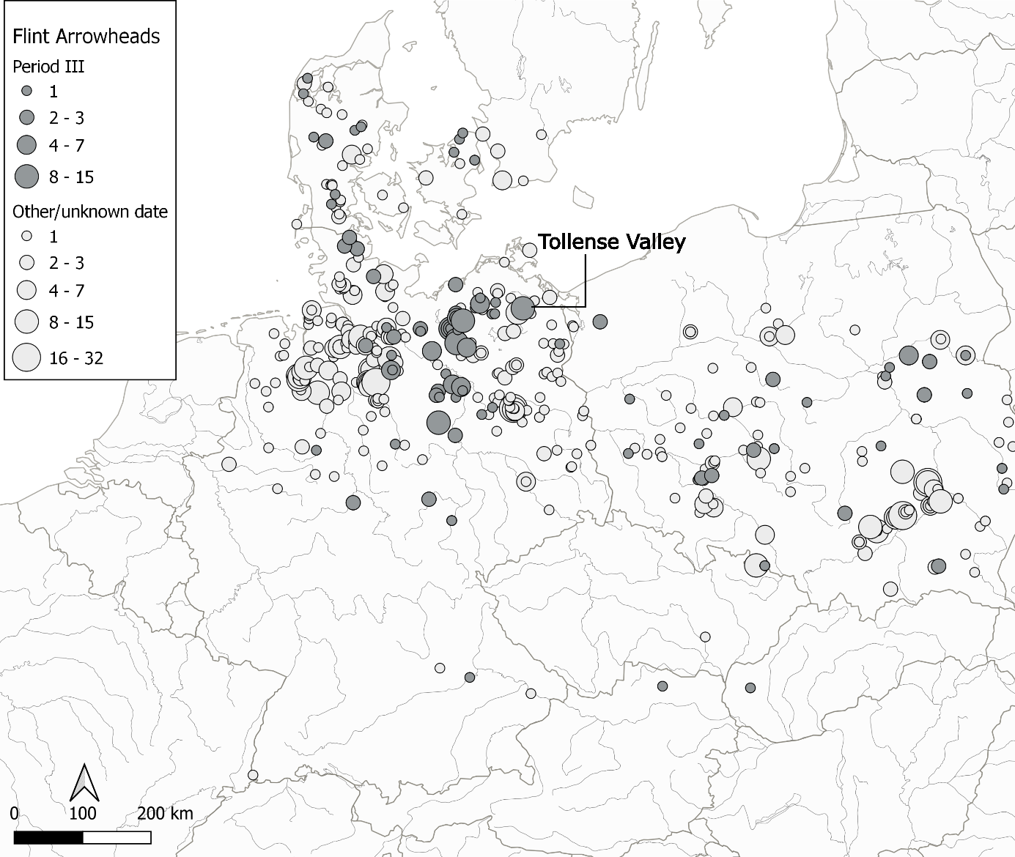
Figure S5

