|  |  |
| --- | --- |
|  | Supplementary material for  Benattia, H. *et al.* 2025.Rethinking late prehistoric Mediterranean Africa: architecture, farming and materiality at Kach Kouch, Morocco**.** *Antiquity* 99.  Author for correspondence ✉ hbenatme8@alumnes.ub.edu |

Bioarchaeological data sampling and floatation

Except for the surface layer (context 10), which was sampled through direct observation, all remaining layers at Kach Kouch were either dry sieved or floated. The stratigraphy at Kach Kouch consists of two main types of layers and contexts: on the one hand, fill of pits (mainly postholes and silos) and on the other hand, accumulation layers formed by the gradual accumulation of sediment and archaeological materials over time. The pit fills were entirely collected and transported to the lab for floatation, while the accumulation layers were systematically sampled by establishing a 1x1m grid and collecting a minimum of 20L of sediment from each square. A differential GPS was employed to record the precise location of each sample. The remaining sediment from the accumulation layers, which was not collected for floatation, was dry sieved on site using a 5mm mesh sieve.

The selected sediment was then transported to the field lab where it was processed using a floatation device (Figure S1). The device featured an inner sieve with a 1mm mesh where the soil was deposited and subsequently washed with water. Lighter bioarchaeological materials, such as charcoal, charred seeds and microfaunal remains, floated to the surface and were recovered using a 0.25mm mesh. These materials were subsequently dried, bagged and identified by species. Heavier materials that remained in the 1mm mesh were dried and later sorted and bagged according to material type (bone, pottery, chipped stone, metal, etc.).

Notably, despite the rigorous and systematic sediment sampling, no fish remains have yet been identified at Kach Kouch. While this absence could be explained by post-depositional processes, the recovery of more than 8000 terrestrial faunal remains suggests the lack of fish species is more likely related to cultural practices. Malacofaunal remains and wild botanic species (charcoal), which have already been studied, will be included in a forthcoming publication along with a more detailed analysis of the material culture and bioarchaeological assemblages.

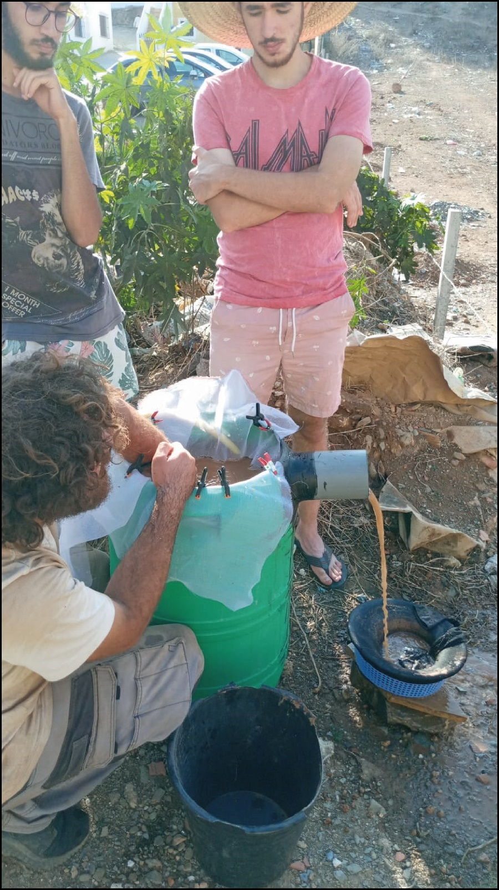

*Figure S1. Training of students in floatation techniques.*