SUPPLEMENTAL DATA

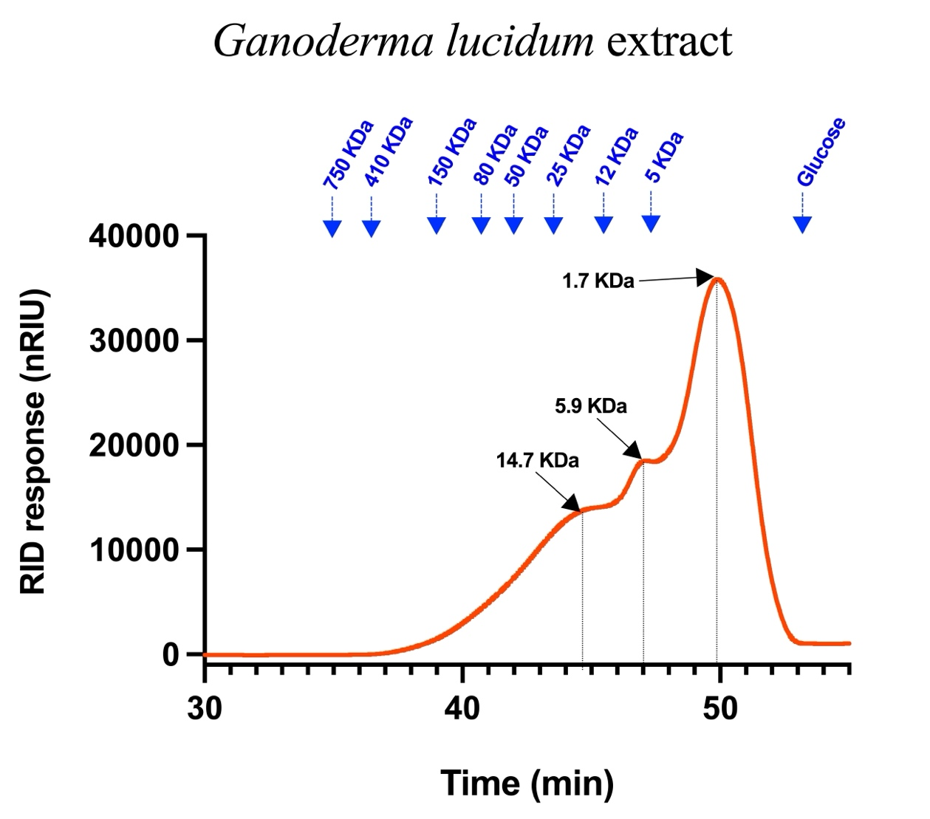

Figure S1A. Molecular weight distribution of polysaccharides from Ganoderma lucidum extract. High-Performance Size Exclusion Chromatography coupled to a refractive index detector (HPSEC-RID) was used to estimate the molecular weight distribution of Ganoderma lucidum extract used in the clinical trial. Blue arrows show the integrated peak of known molecular weight polysaccharide standards. The following equation achieved with the polysaccharide standards was used to determine the molecular weight of the integrated peaks (black arrows) from the Ganoderma lucidum extract (y = -5,6669x + 68,421; R² = 0,9979).

Table S1 - Percentage of β-glucans in Ganoderma lucidum extract used in the clinical trial.

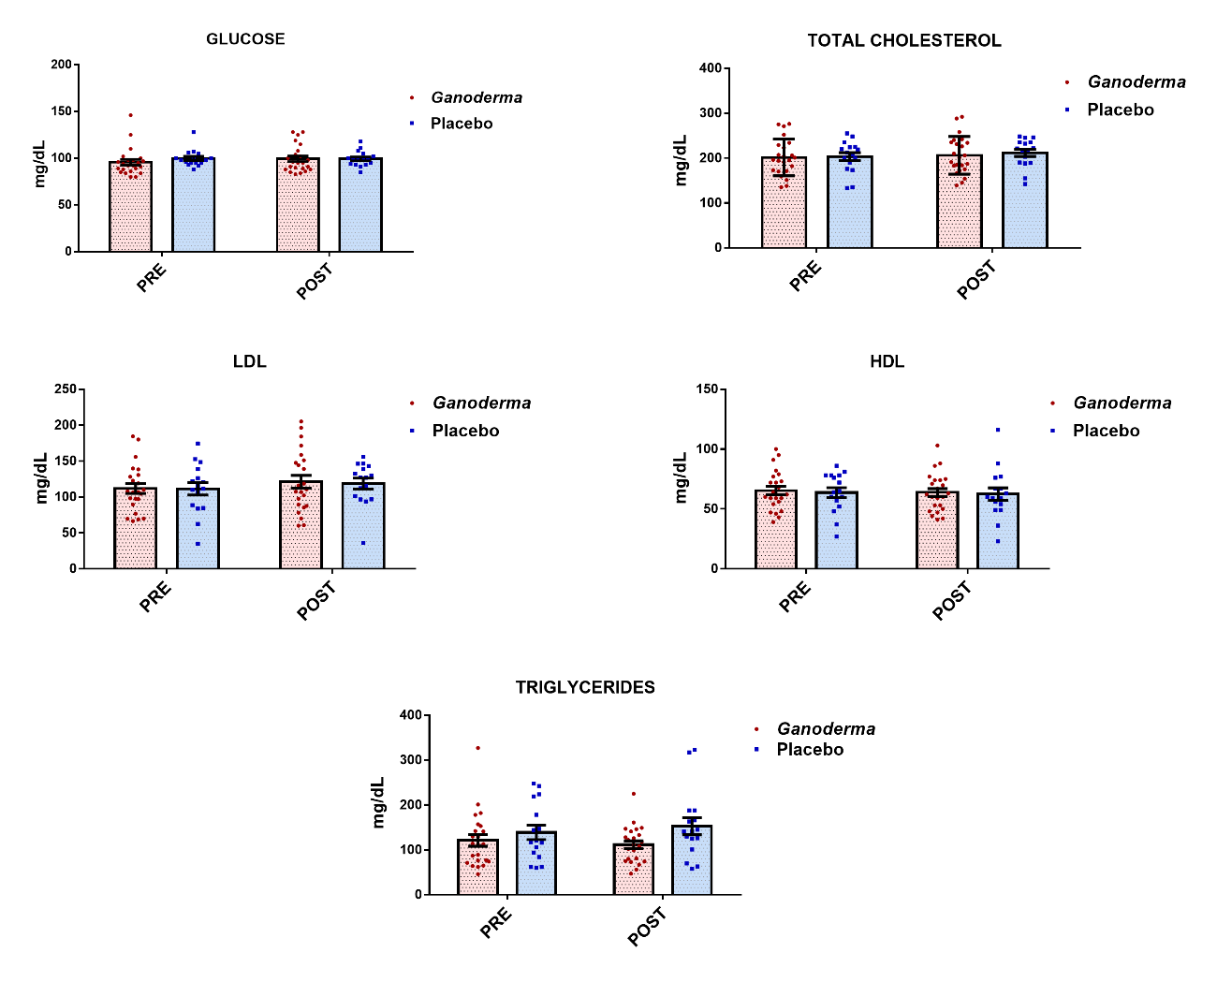
Figure S2 – Plasma concentration of glucose, total cholesterol, LDL-cholesterol, HDL-cholesterol, and triglycerides. The glucose and concentration of total cholesterol and fractions were determined in the plasma before (Pre) and after (Post) eight weeks of supplementation with placebo and Ganoderma. Values are presented as mean ± SEM. N = 23 for the Ganoderma group and N = 16 for the placebo group.

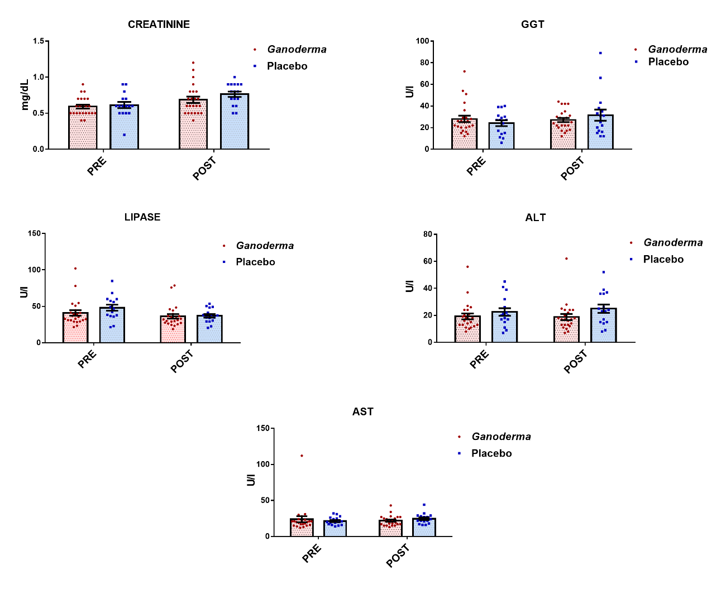
Figure S3- Plasma concentration of creatinine and gamma-glutamyl transferase (GGT), lipase, aspartate aminotransferase (AST) and alanine aminotransferase (ALT) enzyme activity. The creatinine concentration and enzyme activity were determined before (Pre) and after (Post) eight weeks of supplementation with placebo and Ganoderma. Values are presented as mean ± SEM. N = 23 for the Ganoderma group and N = 16 for the placebo group.

Hematological parameters
In relation to erythrocytes, leukocytes, lymphocytes, hemoglobin concentration and hematocrit percentage we did not find differences for both Placebo and Ganoderma groups in any of the evaluated periods (Figure S4).

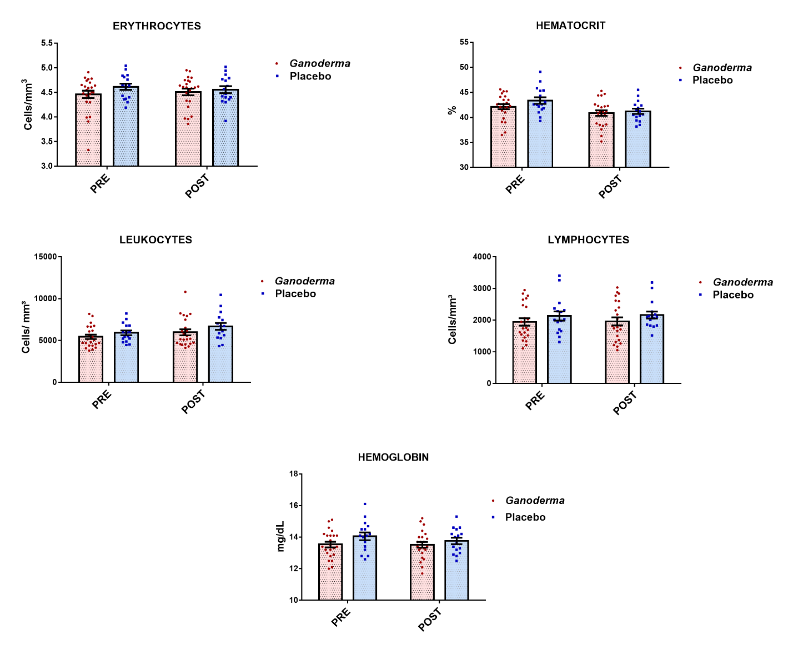
Figure S4- Hematological parameters. Blood count was performed before (Pre) and after (Post) supplementation with placebo or Ganoderma. The analyses were performed by flow cytometry (Sysmex XT 2000I). Values are presented as mean ± SEM. N = 23 for the Ganoderma group and N = 16 for the placebo group.

S5 - MATERIALS AND METHODS

S5.1- Lymphocyte Isolation
Blood samples were diluted in phosphate buffer saline (PBS) (1:1), and the resulting suspension (3 mL) layered onto Histopaque-1077 (6 mL) and centrifuged at 400 x g, for 30 min, at room temperature. Peripheral blood mononuclear cells were collected from the interphase. The remaining erythrocytes were lysed in a solution containing 150 mM NH₄Cl, 10 mM NaHCO₃, and 0.1 mM EDTA, pH 7.4. Cells were washed once with PBS and were maintained in RPMI-1640 medium supplemented with 10% fetal bovine serum (FBS), 100 U/mL penicillin, and 0.1 mg/mL streptomycin, pH 7.4, in sterile tissue culture flasks. The cells were maintained at 37°C in a humidified atmosphere, with 5% CO₂ and 95% air, to allow the monocytes to adhere to the plates to obtain a lymphocyte suspension with high purity (>98%). The lymphocytes were centrifuged at 400 x g, for 10 min, and then the supernatant was discarded. Cells were resuspended in PBS, counted in Neubauer chamber and the specific amount of cells was separated for the analyses.
S5.2- Evaluation of gene expression
Total RNA was extracted from lymphocyte using the Trizol reagent following the manufacturer’s protocol (Thermo Fisher Scientific, Waltham, MA) with DNase treatment. RNA concentration and purity were assessed using a NanoDrop spectrophotometer (Thermo Fisher Scientific) by measuring the absorbance at 260 and 280 nm. The purified RNA (1 μg) was transcribed into cDNA using the High-Capacity cDNA Reverse Transcription Kit (Thermo Fisher Scientific).
The real-time polymerase chain reaction (qPCR) assays were carried out in duplicate in the QuantStudioTM 3 equipment (ThermoFisher, USA) by using the Power SYBR™ Green PCR Master (ThermoFisher, USA), accordingly, to manufacture specifications. The sequences of the specific primers for the analysis of IL-35, TGF-β, Gata-3, T-bet, FoxP3, ROR-ɣT, β2M, IL-10, IL-6, IFN-γ, TNF-α, IL-2, and IL-17 gene expression were designed using information from the GeneBank public database of the National Center for Biotechnology Information (NCBI). These sequences are described in Table S2.

Table S2: Sequences of the primers used in the study.
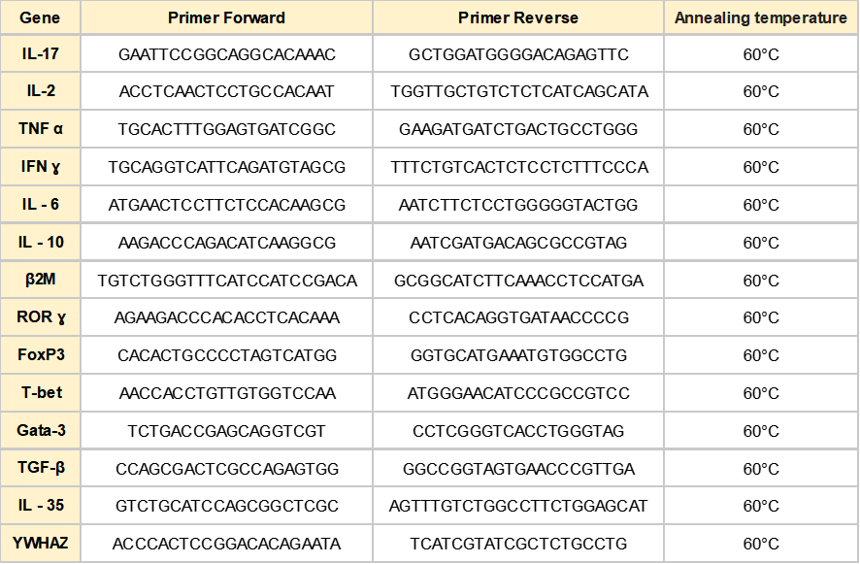
The relative quantification value of each target gene was expressed using the Ct comparative method with the 2^{-DDCT} formula^{1,2}.The β2M reference gene was chosen after GeNormTM analysis, as described by Vandesompele et al.³.

References
1. Livak, K. J. & Schmittgen, T. D. (2001) Analysis of relative gene expression data using real-time quantitative PCR and the 2(-Delta Delta C(T)) Method. Methods 25, 402–408.
2. Pfaffl, M. W. (2001) A new mathematical model for relative quantification in real-time RT-PCR. Nucleic Acids Res 29, e45.
3. Vandesompele, J. et al. (2002) Accurate normalization of real-time quantitative RT-PCR data by geometric averaging of multiple internal control genes. Genome Biology 3, research0034.1.

