Consistent effect of eating rate on food and energy intake

across 24 ad libitum meals

Lise A.J. Heuven^{a,b}, Marieke van Bruinessenª, Claudia S. Tangª, Markus Stieger^{a,b},
Marlou P. Lasschuijtª, Ciarán G. Fordeª

- Division of Human Nutrition and Health, Wageningen University & Research, P.O. Box 17, 6700 AA, Wageningen, The Netherlands
- Food Quality and Design group, Wageningen University & Research, P.O. Box 17, 6700 AA, Wageningen, The Netherlands

Table 1. Ingredients and pictures of the breakfast meals.
Fast Breakfasts | Slow breakfasts
1. Wrap sandwich, cake & chocolate milk  - 229 g Wraps (AH private label) with herb cream cheese (AH private label) and chicken fillet (AH private label);  - 222 g Cake roll hazelnut (Balconi);  - 456 g Chocolate milk (Chocomel).  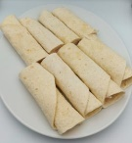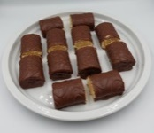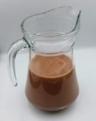 | 7. Cracker with saveloy, biscuits & quark  - 495 g Knackebröd (AH private label) with cream cheese (AH private label), cucumber, and saveloy (Stegeman);  - 177 g yoghurt-strawberry biscuits (Liga Belvita);  - 840 g Protein stracciatella quark (Lindahls).  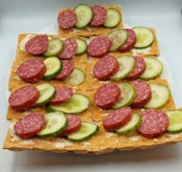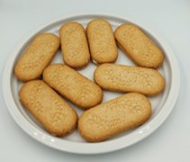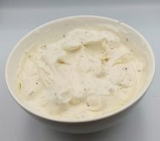
2. Pancakes, croissants & smoothie  - 425 g Banana pancakes (AH private label) with caramel syrup (Van Gilse)  - 234 g Mini croissants (AH private label)  - 850 g raspberry, blueberry smoothie with grains and dairy (Vifit)  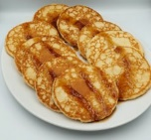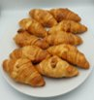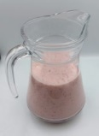 | 8. Quark with muesli, ginger bread & cookies  - 1050 grams skimmed stracciatella quark (Optimel) with fruits and nuts muesli (Holi);  - 300 g Spiced ginger bread (Peijnenburg);  - 160 g Mini Bastogne cookies (Lu).  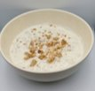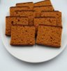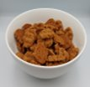
3. Egg sandwich & smoothie  - 900 g Whole wheat sandwich (AH private label) with ham (AH private label), egg salad (Johma) and lettuce;  - 500 g Strawberry, kiwi and banana smoothie with grians and dairy (Vifit)  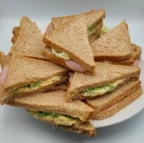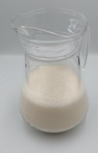 | 9. Chicken cheese bagel & fruit  - 866 g Sesame bagel (AH private label) with grilled chicken fillet (AH private label), 20+ cheese (Milner) and rucola;  - 640 g Pineapple, mango, apple and grape fruit mix (AH private label).  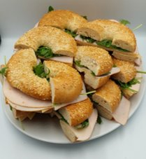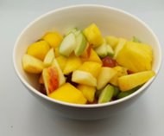
4. Peanut butter jelly sandwich & smoothie  - 900 g Whole-wheat sandwich (AH private label) with creamy peanut butter (skippy) and strawberry jam (AH private label);  - 600 g Orange and strawberry smoothie with grains (Coolbest)  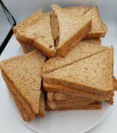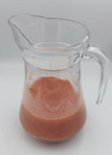 | 10. Peanut butter bagel & quark  - 632 g Sesame bagel (Ah private label) with creamy peanut butter (skippy);  - 870 g Skimmed strawberry quark (Optimel).  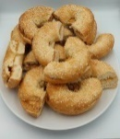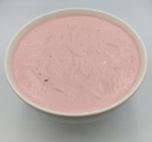
5. Chocolate cake, porridge & crepes  - 615 g Cinnamon oatmeal porridge (Quacker) with oatmilk (Oatly);  - 578 g Dutch pancakes (Jan) with strawberry jam (AH private label);  - Chocolate cakes (Milka).  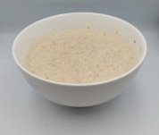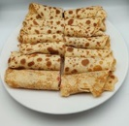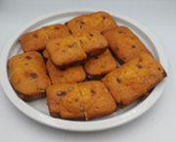 | 11. Honeyloop, rusks with jam & cookies  - 885 g Honeyloops (Kellogs) with soymilk (AH private label);  - 420 g Rusks (AH private label) with light margarine (Becel) and strawberry fruit spread (AH private label);  - 225g Chocolate chip cookies (AH private label).  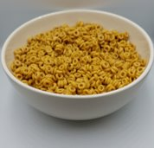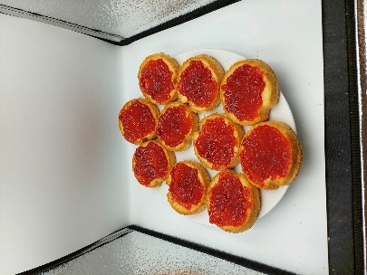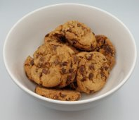
6. Cakes, apple sauce & smoothie  - 480 g Cupcakes (AH private label);  - 450 g zero sugar cinnamon apple sauce (AH private label);  - 600 g Forest fruit smoothie with grains (Coolbest)  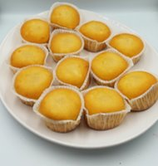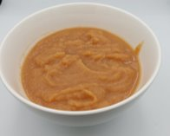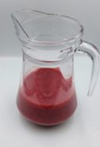 | 12. Quark with cruesli, oatmeal bar and fruitmix  - 750 g Skimmed vanilla quark (Optimel) with chocolate cruesli (Quacker);  - 280 g Oatmeal bars (Bolletje);  - 500 g Pineapple, mango, apple and grape fruit mix (AH private label).  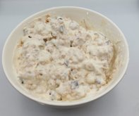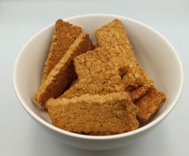

Table 2. Ingredients and pictures of the lunch meals.
Fast lunches | Slow lunches
1. Pasta bolognese, soft buns & soft salad  - 850 g Macaroni bolognese (Huuskes private label)  - 340 g White buns (AH private label) with herbal butter (Ah private label)  - 325 g Lettuce, tomato and naturel zero dressing (Remia)  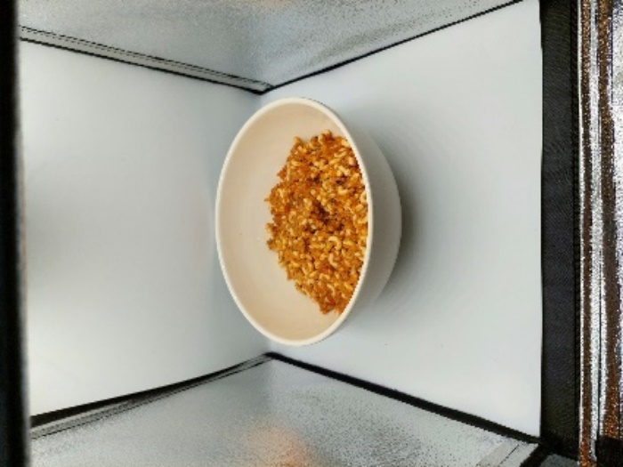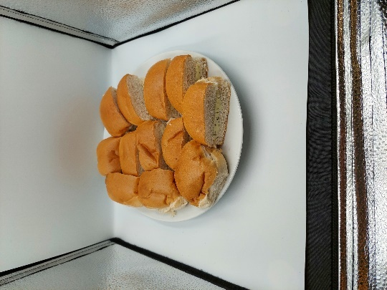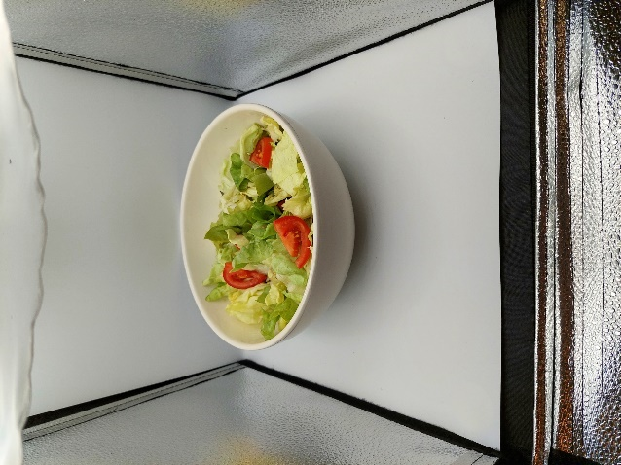 | 7. Spaghetti, hard buns & soft salad  - 840 g Spaghetti with vegetables (Huuskes private label)  - 390 g Hard buns (AH private label) with herbal butter (AH private label)  - 310 g Bell pepper, cucumber, carrot julienne and naturel zero dressing (Remia)  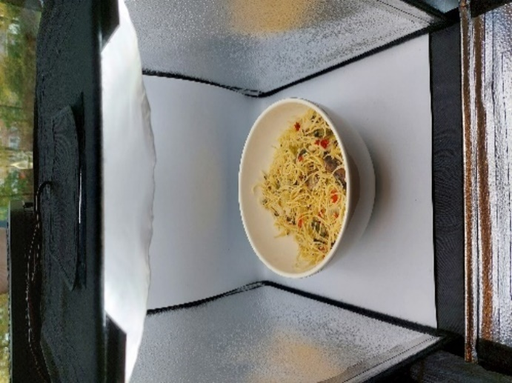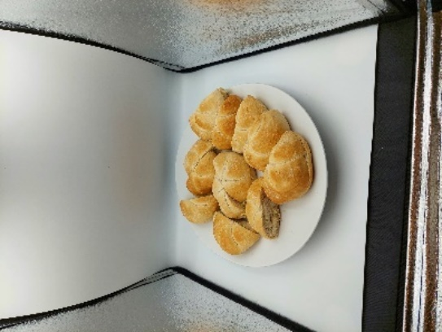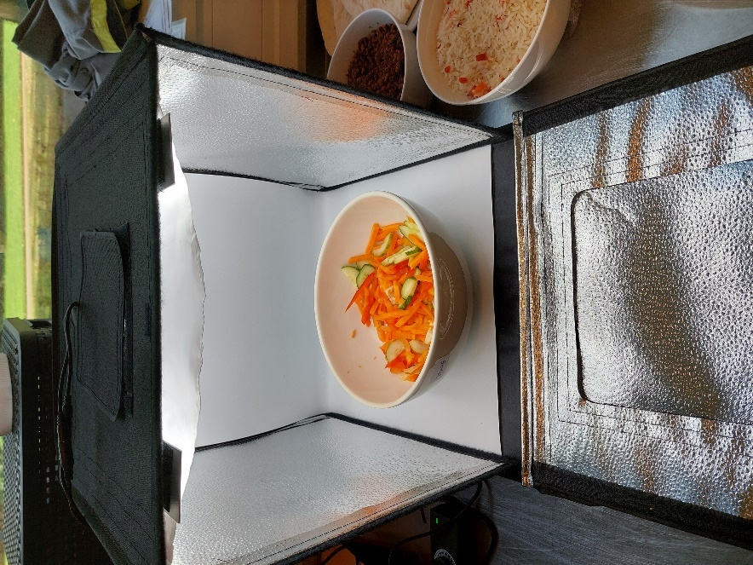
2. Tortillas, minced meat, rice & corn  - 350 g Vegan minced meat (AH private label)  - 420 g Garni rice (Huuskes private label)  - 265 g Corn mix (Bonduelle)  - 372 g Tortilla wrap (AH private label)  - 100 g Tomato ketchup (Heinz)  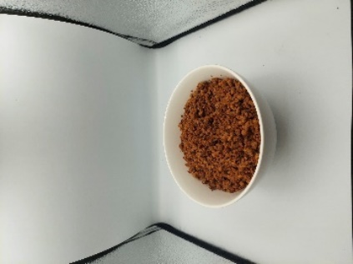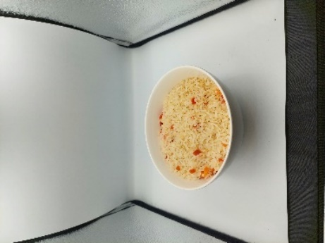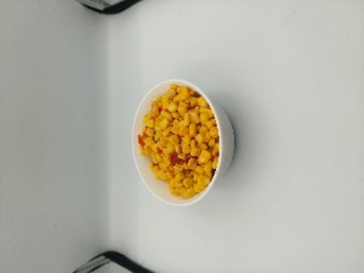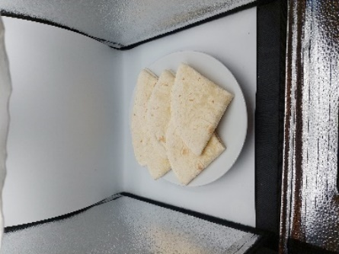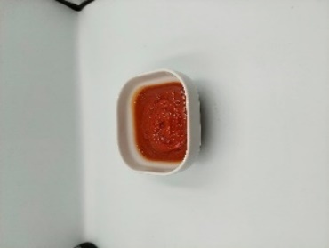 | 8. Chicken, rice, corn & chips  - 258 g Chicken drumsticks (AH private label)  - 350 g Nut rice (Lassie)  - 750 g Corn cob (AH private label)  - 150 g Nacho cheese chips (Doritos)  - 20 g Chunky salsa (Santa Maria  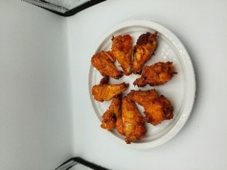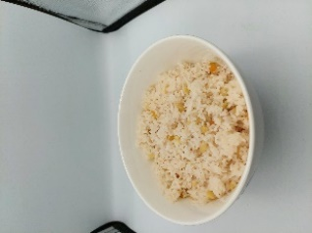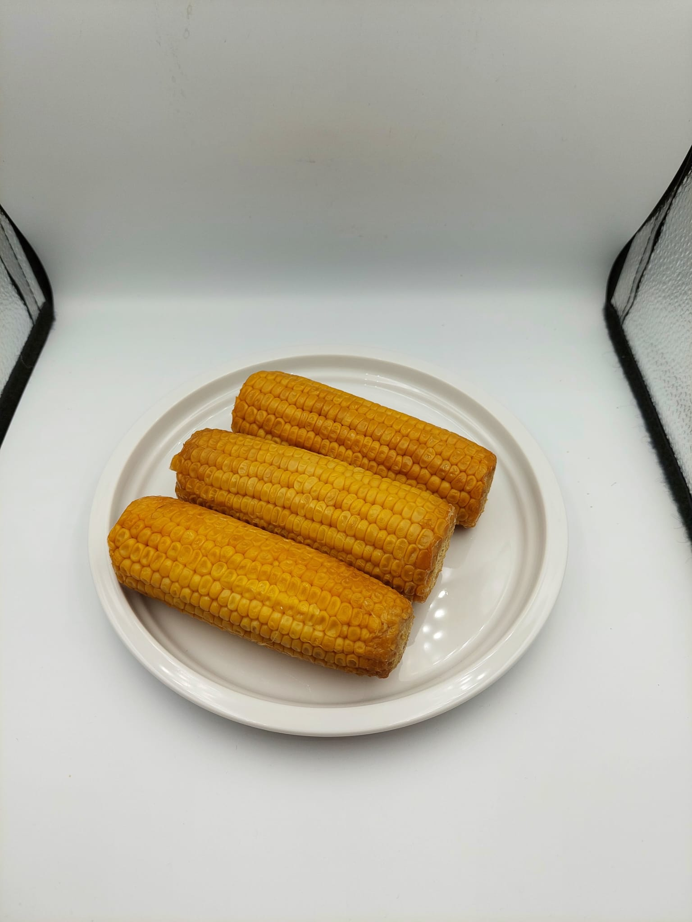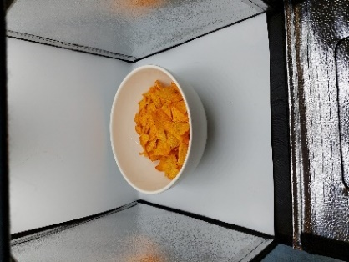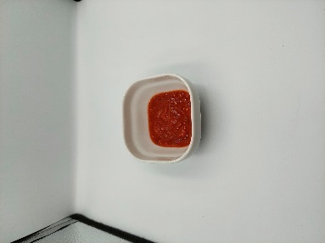
3. Mashed potato, vegetarian balls, spinach & corn mix  - 500 g Mashed potato (AH private label) with Italian hebrs (Euroma)  - 300 g Vegetarian balls (AH private label)  - 425 g Spinach a la crème (Iglo)  - 300 g Corn mexicana mix (Bonduelle)  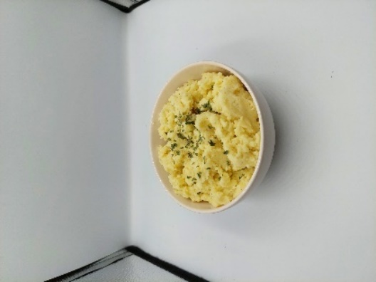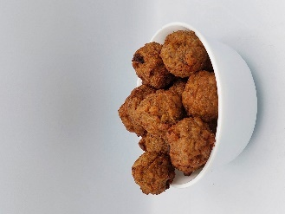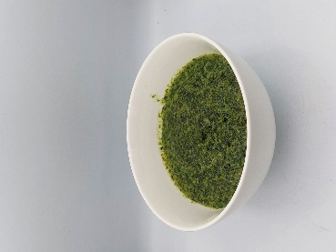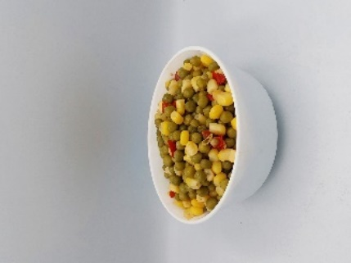 | 9. Baked potato, steamed chicken, beans and carrot  - 369 g Baked potatoes with garlic and rosemary (AH private label)  - 390 g Smoked chicken fillet (AH private label)  - 429 g Green beans with tandoori sauce (Patak’s)  - 335 g Carrot with twandoori sauce (Patak’s)  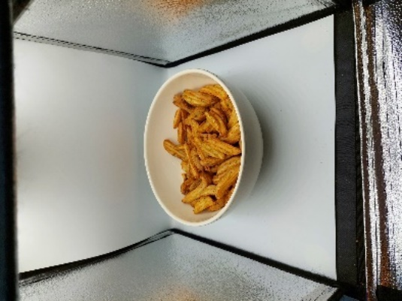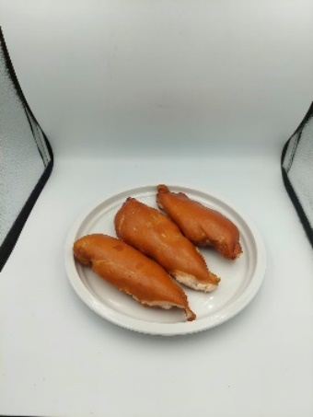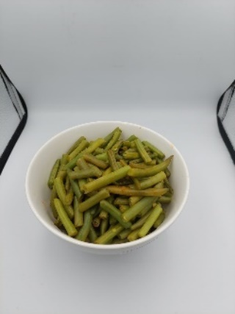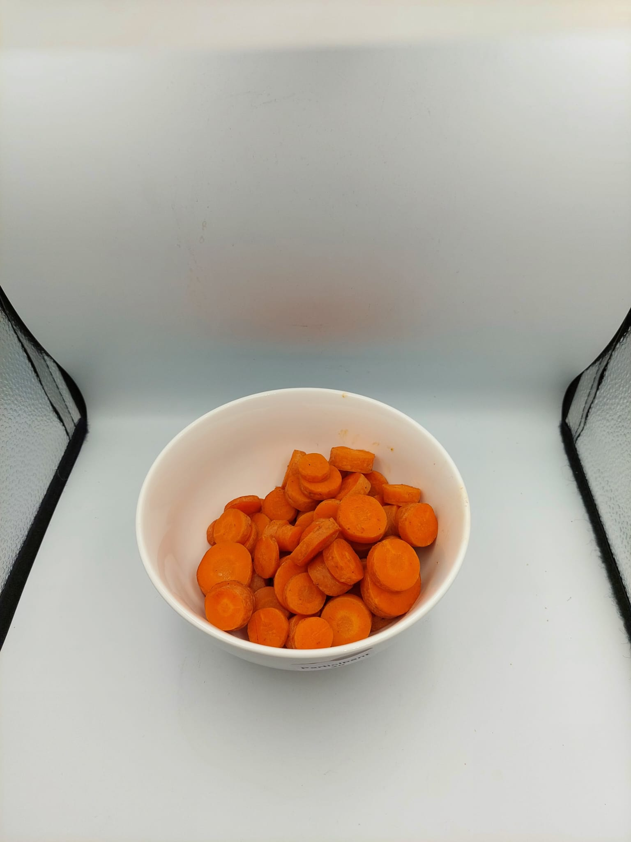
4. Kroket burger, tomato soup & soft salad  - 592 g Kroket burger (Mora)  - 639 g Spiced tomato soup (Unox) with liquid backing butter (Becel)  - 280 g Lettuce, tomato and naturel zero dressing (Remia)  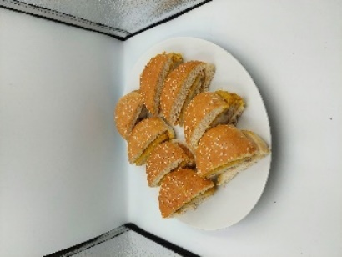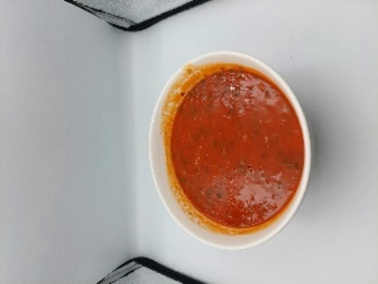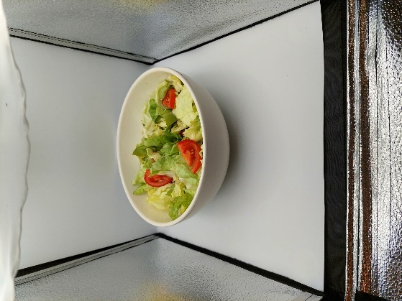 | 10. Hotdogs, chips & hard salad  - 1038 g Schnitt rolls (AH private label) with extra lean smoked sausage (Unox) and zero tomato ketchup (Heinz)  - 200 g Oven baked naturel chips (Lay’s)  - 465 g Bell pepper, cucumber, carrot julienne and naturel zero dressing (Remia)  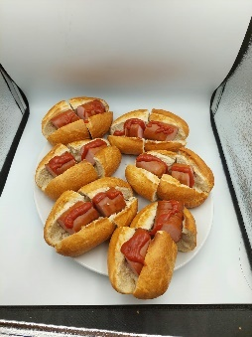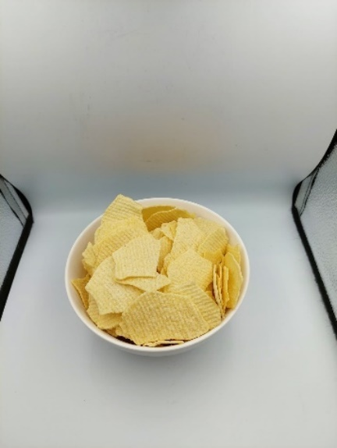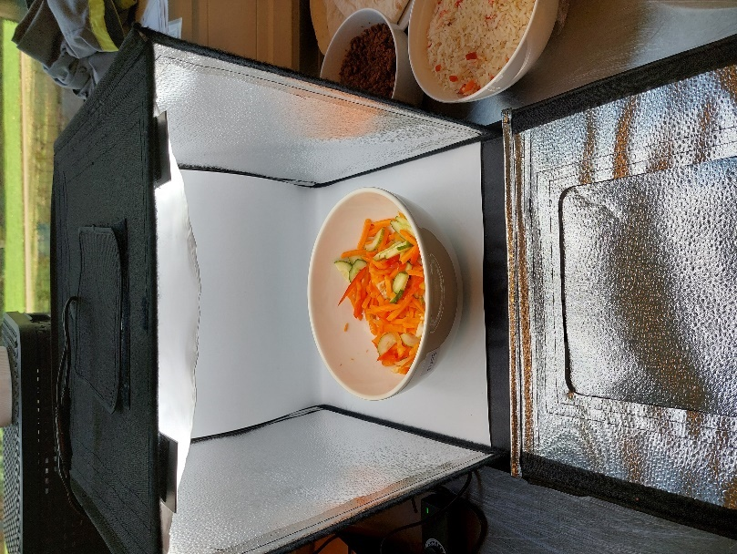
5. Hutspot  - 1460 g Hutspot with hachee (AH private label)  - 40 g Mustard (AH private label)  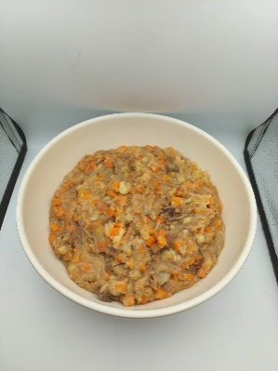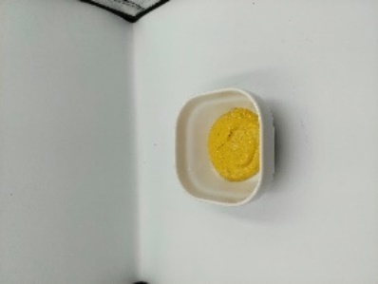 | 11. Sauerkraut dish  - 1502 g Rösti rounds (Aviko), spiced sauerkraut (AH private label), extra lean smoked sausage (Unox) and baked onions (Go Tan)  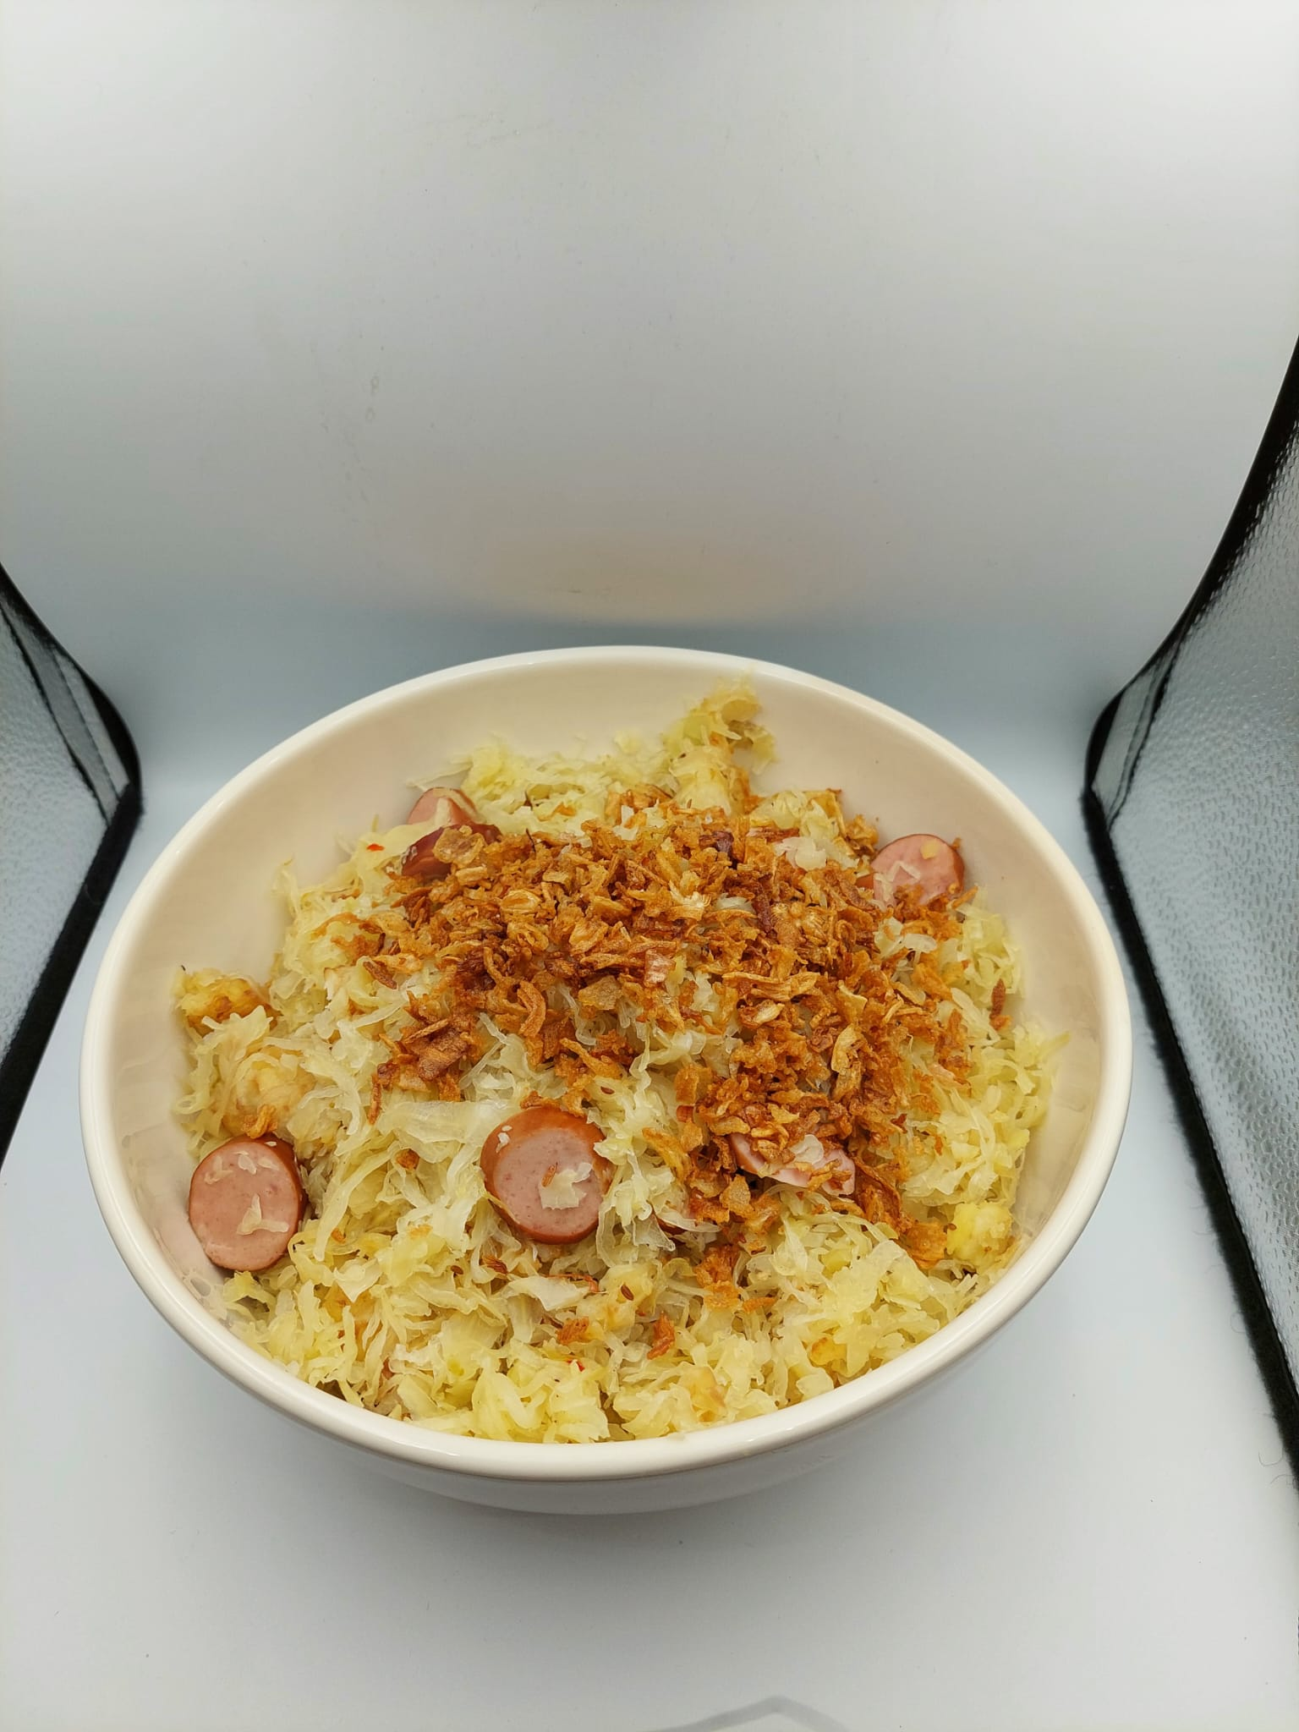
6. Quiche, mushroom soup & couscous salad  - 575 g Quiche Lorraine (AH private label)  - 348 g Mushroom soup (Unox) with liquid backing butter (Becel)  - 600 g Couscous salad with pesto (AH private label)  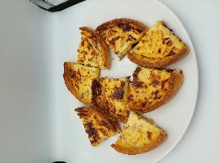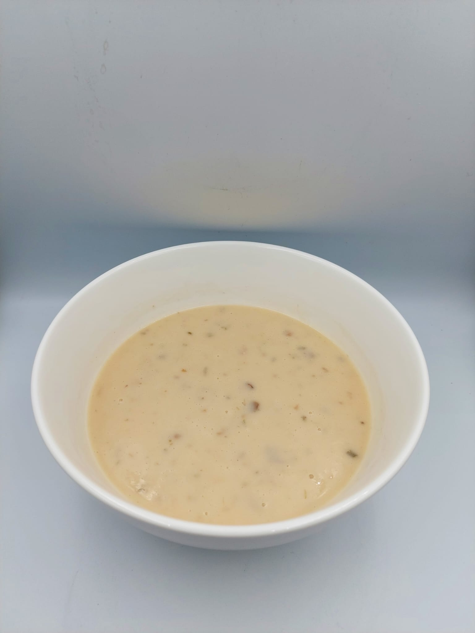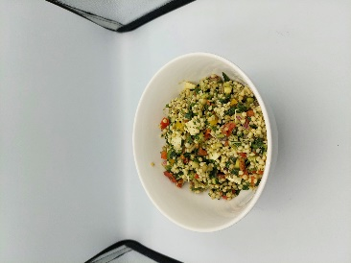 | 12. Tagliatelle, roasted bread & steamed vegetables  - 888 g Tagliatelle fungi (Iglo) with marinated steak (AH private label)  - 100 g Pan de ajo (Panetteria Di Sergio)  - 516 g Farmer vegetable mix (Iglo)  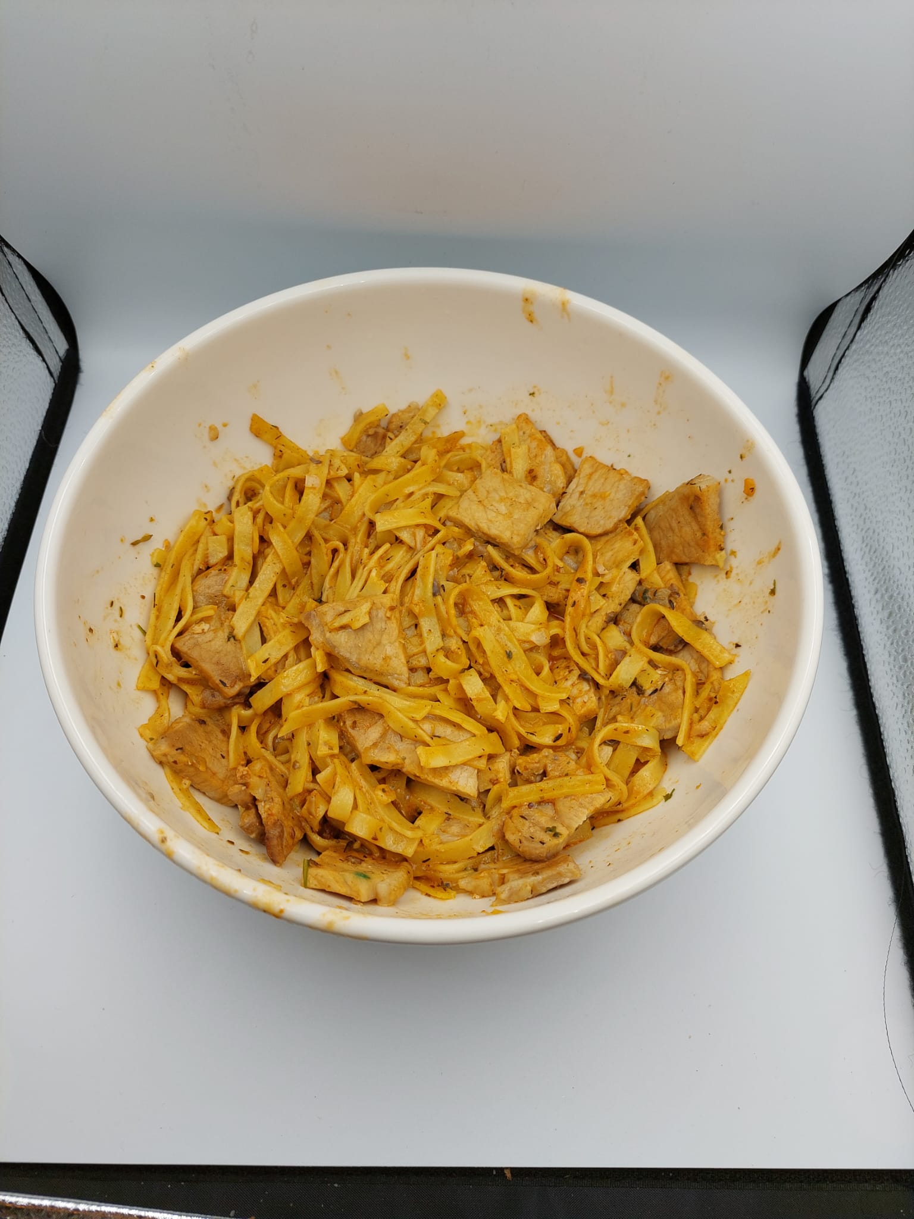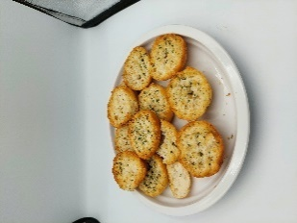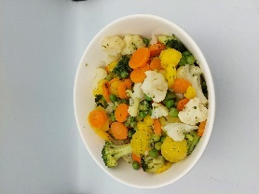

Table 3. Composition, liking and familiarity of served breakfast meals and lunch meals. Data are presented as mean ± SE.
Fast meals | Portion size (g) | Energy (kcal) | Energy density (kcal/g) | %EN Nova 4 | Liking | Familiarity | Slow meals | Portion size (g) | Energy (kcal) | Energy density (kcal/g) | %EN Nova 4 | Liking | Familiarity
Breakfasts
FB1 | 1508 | 2719 | 1.80 | 100 | 62 ± 4 | 2.7 ± 0.5 | SB1 | 1512 | 2751 | 1.82 | 99 | 66 ± 3 | 3.5 ± 0.4
FB2 | 1509 | 2741 | 1.82 | 100 | 73 ± 4 | 2.2 ± 0.4 | SB2 | 1510 | 2791 | 1.85 | 100 | 63 ± 5 | 2.3 ± 0.2
FB3 | 1508 | 2559 | 1.70 | 100 | 66 ± 4 | 2.8 ± 0.4 | SB3 | 1506 | 2563 | 1.70 | 85 | 76 ± 3 | 2.1 ± 0.2
FB4 | 1500 | 2774 | 1.85 | 78 | 61 ± 5 | 2.1 ± 0.2 | SB4 | 1502 | 2724 | 1.81 | 78 | 49 ± 3 | 3.1 ± 0.5
FB5 | 1508 | 3468 | 2.30 | 100 | 57 ± 6 | 2.7 ± 0.4 | SB5 | 1500 | 3441 | 2.29 | 100 | 60 ± 4 | 2.6 ± 0.5
FB6 | 1530 | 2803 | 1.83 | 100 | 61 ± 5 | 3.1 ± 0.4 | SB6 | 1530 | 2805 | 1.83 | 90 | 77 ± 3 | 2.1 ± 0.2
Lunches
FL1 | 1515 | 2283 | 1.51 | 98 | 66 ± 4 | 2.4 ± 0.2 | SL1 | 1508 | 2318 | 1.54 | 56 | 57 ± 4 | 3.1 ± 0.2
FL2 | 1507 | 2440 | 1.62 | 76 | 47 ± 6 | 3.3 ± 0.5 | SL2 | 1528 | 2732 | 1.79 | 79 | 63 ± 5 | 2.9 ± 0.4
FL3 | 1526 | 1477 | 0.97 | 85 | 54 ± 5 | 3.9 ± 0.4 | SL3 | 1514 | 1564 | 1.03 | 83 | 62 ± 4 | 2.5 ± 0.2
FL4 | 1511 | 2119 | 1.40 | 98 | 63 ± 3 | 3.2 ± 0.2 | SL4 | 1503 | 2913 | 1.94 | 96 | 60 ± 5 | 3.1 ± 0.4
FL5 | 1500 | 1426 | 0.95 | 97 | 51 ± 6 | 3.8 ± 0.6 | SL5 | 1502 | 1570 | 1.04 | 89 | 41 ± 5 | 5.0 ± 0.5
FL6 | 1522 | 2940 | 1.93 | 100 | 71 ± 3 | 3.9 ± 0.4 | SL6 | 1504 | 2517 | 1.67 | 84 | 73 ± 4 | 3.0 ± 0.2
FB, fast breakfasts. SB, slow breakfasts. FL, fast lunches. SL, slow lunches.
Table 4: Intraclass correlation coefficients (ICC) with 95% confidence interval for the oral-processing behaviours obtained with video annotation. An ICC <0.50 indicates poor consistency, 0.50-0.75 indicates moderate consistency, 0.75-0.90 indicates good consistency, and >0.90 indicates excellent consistency (Koo & Li, 2016).
Oral-processing behaviours | Breakfasts | Lunches
Bites | 0.996 (0.991; 1) | 1.000 (0.998; 1)
Chews | 0.999 (0.998; 1) | 1.000 (0.997; 1)
Sips | 1.000 (NA; NA) | 1.000 (1; 1)
Swallows | 0.957 (0.719; 0.995) | 0.999 (0.995; 1)
Meal duration | 0.990 (0.992; 1) | 1.000 (0.997; 1)
Meal oro-sensory exposure time | 0.920 (0.345; 0.992) | 0.998 (0.988; 1)
Water sip duration | 0.986 (0.887; 0.999) | 0.986 (0.868; 0.999)

Koo, T. K., & Li, M. Y. (2016). A guideline of selecting and reporting intraclass correlation coefficients for reliability research. Journal of chiropractic medicine, 15(2), 155-163.

Table 5. Microstructure of oral processing behaviour of the individual meals. Data are presented as mean ± SE.
 | ED consumed (kcal/g) | Meal eating rate (g/min) | Bite size ª (g) | Chews per bite ª | Number of chews ª (g⁻¹) | Chewing frequency ª (chews/s) | OSE time ª (min) | OSEg (s/g)
Breakfasts
FB1 | 1.9 ± 0.1 | 67 ± 6 | 17 ± 3 | 27 ± 4 | 1.8 ± 0.4 | 1.5 ± 0.1 | 8.1 ± 1.1 | 1.3 ± 0.3
FB2 | 1.8 ± 0.1 | 67 ± 6 | 14 ± 2 | 13 ± 3 | 1.1 ± 0.3 | 1.4 ± 0.1 | 6.5 ± 0.8 | 1.0 ± 0.4
FB3 | 1.4 ± 0.1 | 67 ± 6 | 17 ± 2 | 17 ± 4 | 1.2 ± 0.3 | 1.4 ± 0.1 | 6.8 ± 1.0 | 1.0 ± 0.2
FB4 | 1.3 ± 0.1 | 67 ± 7 | 15 ± 2 | 16 ± 2 | 1.2 ± 0.3 | 1.5 ± 0.1 | 6.5 ± 0.6 | 0.9 ± 0.2
FB5 | 2.1 ± 0.1 | 71 ± 7 | 16 ± 2 | 15 ± 1 | 1.1 ± 0.2 | 1.3 ± 0.1 | 5.3 ± 1.0 | 0.9 ± 0.2
FB6 | 1.4 ± 0.1 | 101 ± 10 | 20 ± 2 | 8 ± 1 | 0.4 ± 0.1 | 1.3 ± 0.1 | 3.3 ± 0.3 | 0.4 ± 0.1
SB1 | 2.0 ± 0.1 | 45 ± 3 | 11 ± 2 | 20 ± 2 | 2.0 ± 0.3 | 1.5 ± 0.1 | 8.9 ± 0.9 | 1.5 ± 0.2
SB2 | 1.5 ± 0.0 | 60 ± 5 | 17 ± 2 | 20 ± 2 | 1.3 ± 0.2 | 1.4 ± 0.1 | 6.8 ± 0.6 | 1.0 ± 0.1
SB3 | 1.4 ± 0.1 | 46 ± 3 | 11 ± 1 | 23 ± 4 | 2.0 ± 0.3 | 1.5 ± 0.1 | 10.9 ± 0.9 | 1.5 ± 0.2
SB4 | 1.6 ± 0.1 | 62 ± 6 | 13 ± 1 | 19 ± 3 | 1.8 ± 0.5 | 1.4 ± 0.1 | 7.0 ± 0.7 | 1.3 ± 0.3
SB5 | 2.3 ± 0.1 | 46 ± 3 | 9 ± 1 | 17 ± 2 | 1.9 ± 0.1 | 1.6 ± 0.1 | 7.5 ± 0.4 | 1.4 ± 0.1
SB6 | 1.4 ± 0.0 | 61 ± 3 | 15 ± 1 | 18 ± 1 | 1.2 ± 0.1 | 1.4 ± 0.1 | 8.4 ± 0.8 | 1.0 ± 0.1
Lunches
FL1 ^{b} | 1.5 ± 0.1 | 66 ± 5 | 10 ± 1 | 11 ± 2 | 1.1 ± 0.2 | 1.5 ± 0.1 | 8.8 ± 1.3 | 0.1 ± 0.1
FL2 ^{b} | 1.6 ± 0.1 | 46 ± 3 | 10 ± 1 | 17 ± 3 | 1.7 ± 0.3 | 1.5 ± 0.1 | 7.9 ± 0.7 | 1.3 ± 0.2
FL3 | 1.0 ± 0.0 | 65 ± 5 | 12 ± 2 | 13 ± 1 | 1.3 ± 0.3 | 2.0 ± 0.1 | 5.8 ± 0.6 | 1.0 ± 0.1
FL4 | 1.4 ± 0.1 | 62 ± 4 | 10 ± 1 | 10 ± 1 | 1.1 ± 0.2 | 1.4 ± 0.1 | 8.1 ± 0.5 | 1.0 ± 0.2
FL5 | 1.0 ± 0.0 | 79 ± 6 | 15 ± 2 | 12 ± 2 | 1.0 ± 0.3 | 1.5 ± 0.1 | 5.1 ± 0.8 | 0.9 ± 0.3
FL6 | 1.9 ± 0.0 | 65 ± 5 | 11 ± 2 | 11 ± 2 | 1.1 ± 0.2 | 1.5 ± 0.1 | 6.8 ± 0.6 | 1.0 ± 0.3
SL1 | 1.6 ± 0.1 | 44 ± 3 | 11 ± 1 | 16 ± 2 | 1.6 ± 0.3 | 1.5 ± 0.0 | 8.9 ± 1 | 1.3 ± 0.2
SL2 ^{b} | 2.1 ± 0.1 | 37 ± 2 | 5 ± 1 | 9 ± 1 | 1.7 ± 0.3 | 1.5 ± 0.1 | 10.3 ± 0.9 | 1.6 ± 0.2
SL3 | 1.3 ± 0.1 | 45 ± 3 | 9 ± 1 | 15 ± 2 | 2.1 ± 0.6 | 1.5 ± 0.1 | 9.1 ± 1.7 | 1.7 ± 0.6
SL4 | 1.7 ± 0.1 | 36 ± 2 | 8 ± 1 | 15 ± 1 | 2.3 ± 0.4 | 1.5 ± 0.1 | 11.1 ± 1.2 | 1.9 ± 0.3
SL5 | 1.0 ± 0.0 | 50 ± 4 | 10 ± 1 | 15 ± 2 | 1.7 ± 0.3 | 1.5 ± 0.1 | 6.5 ± 0.4 | 1.4 ± 0.3
SL6 | 1.7 ± 0.1 | 53 ± 3 | 11 ± 1 | 14 ± 2 | 1.3 ± 0.1 | 1.5 ± 0.1 | 9.4 ± 0.6 | 1.0 ± 0.1

FB, fast breakfasts. SB, slow breakfasts. FL, fast lunches. SL, slow lunches. OSE oro-sensory exposure. ED energy density.
ª Assessed from video coding (n=7).
^{b} Recoding of one video not succeeded (n=6).

Table 6. Average liking, familiarity, expected satiation, and pre and post-appetite ratings of the fast and slow breakfast and lunch meals. Data are presented as mean ± SE.
 | Fast breakfasts | Slow breakfasts | P | Fast lunches | Slow lunches | P
Pre-appetite ratings
Hunger | 62 ± 2 | 61 ± 2 | 0.54 | 64 ± 7 | 66 ± 7 | 0.28
Fullness | 11 ± 1 | 10 ± 1 | 0.45 | 23 ± 2 | 19 ± 2 | 0.03
Thirst | 65 ± 2 | 64 ± 2 | 0.83 | 56 ± 6 | 56 ± 6 | 0.91
Desire to eat | 52 ± 2 | 60 ± 3 | 0.42 | 66 ± 7 | 67 ± 7 | 0.45
Prospective consumption | 62 ± 2 | 62 ± 2 | 0.65 | 60 ± 6 | 63 ± 7 | 0.04
Post-appetite ratings
Hunger | 12 ± 2 | 15 ± 2 | 0.11 | 13 ± 1 | 16 ± 2 | 0.09
Fullness | 71 ± 2 | 72 ± 2 | 0.73 | 73 ± 8 | 69 ± 7 | 0.11
Thirst | 26 ± 2 | 38 ± 3 | <0.001 | 44 ± 5 | 49 ± 5 | 0.05
Desire to eat | 18 ± 2 | 18 ± 2 | 0.76 | 16 ± 2 | 17 ± 2 | 0.40
Prospective consumption | 18 ± 2 | 18 ± 2 | 0.80 | 17 ± 2 | 20 ± 2 | 0.15

Table 7. Indicated reasons of participants to stop eating. ¹Other includes: ‘I was bored with the texture’, ‘I ate the portion I would normally eat’, ‘only "unhealthy" foods are left’, ‘I want to eat the same amount as everyone else’, and ‘Enough time has passed since the start of the meal’.
Reason | Fast  breakfasts | Slow breakfasts | Fast lunches | Slow lunches
I was full | 59 (66%) | 52 (58%) | 55 (61%) | 50 (56%)
The food is no longer appealing to me | 13 (14%) | 9 (10%) | 14 (16%) | 11 (12%)
I was bored with the flavor | 5 (6%) | 5 (6%) | 9 (10%) | 10 (11%)
I have eaten the amount that I planned | 4 (4%) | 8 (9%) | 2 (2%) | 3 (3%)
Other¹ | 9 (10%) | 16 (18%) | 10 (11%) | 16 (18%)

Table 8. Beta coefficient of the repeated measures linear mixed effect model between sensory ratings of meal components and food intake (g).
 | β | P
Liking | 1.71 | <0.001
Flavour intensity | 0.27 | 0.13
Hardness | -1.01 | <0.001
Dryness | -1.41 | <0.001
Thickness ª | -0.16 | 0.64
ª Only for semi-solids and liquid components (n= 17 components).

