Effect of Ketamine on Anxiety: findings from the Ketamine for Adult Depression Study (KADS): Supplementary material
Supplementary Figure 1a: CONSORT Diagram from Loo C, Glozier N, Barton D, Baune BT, Mills NT, Fitzgerald P, et al. Br J Psychiatry. 2023; 223(6):533-41.
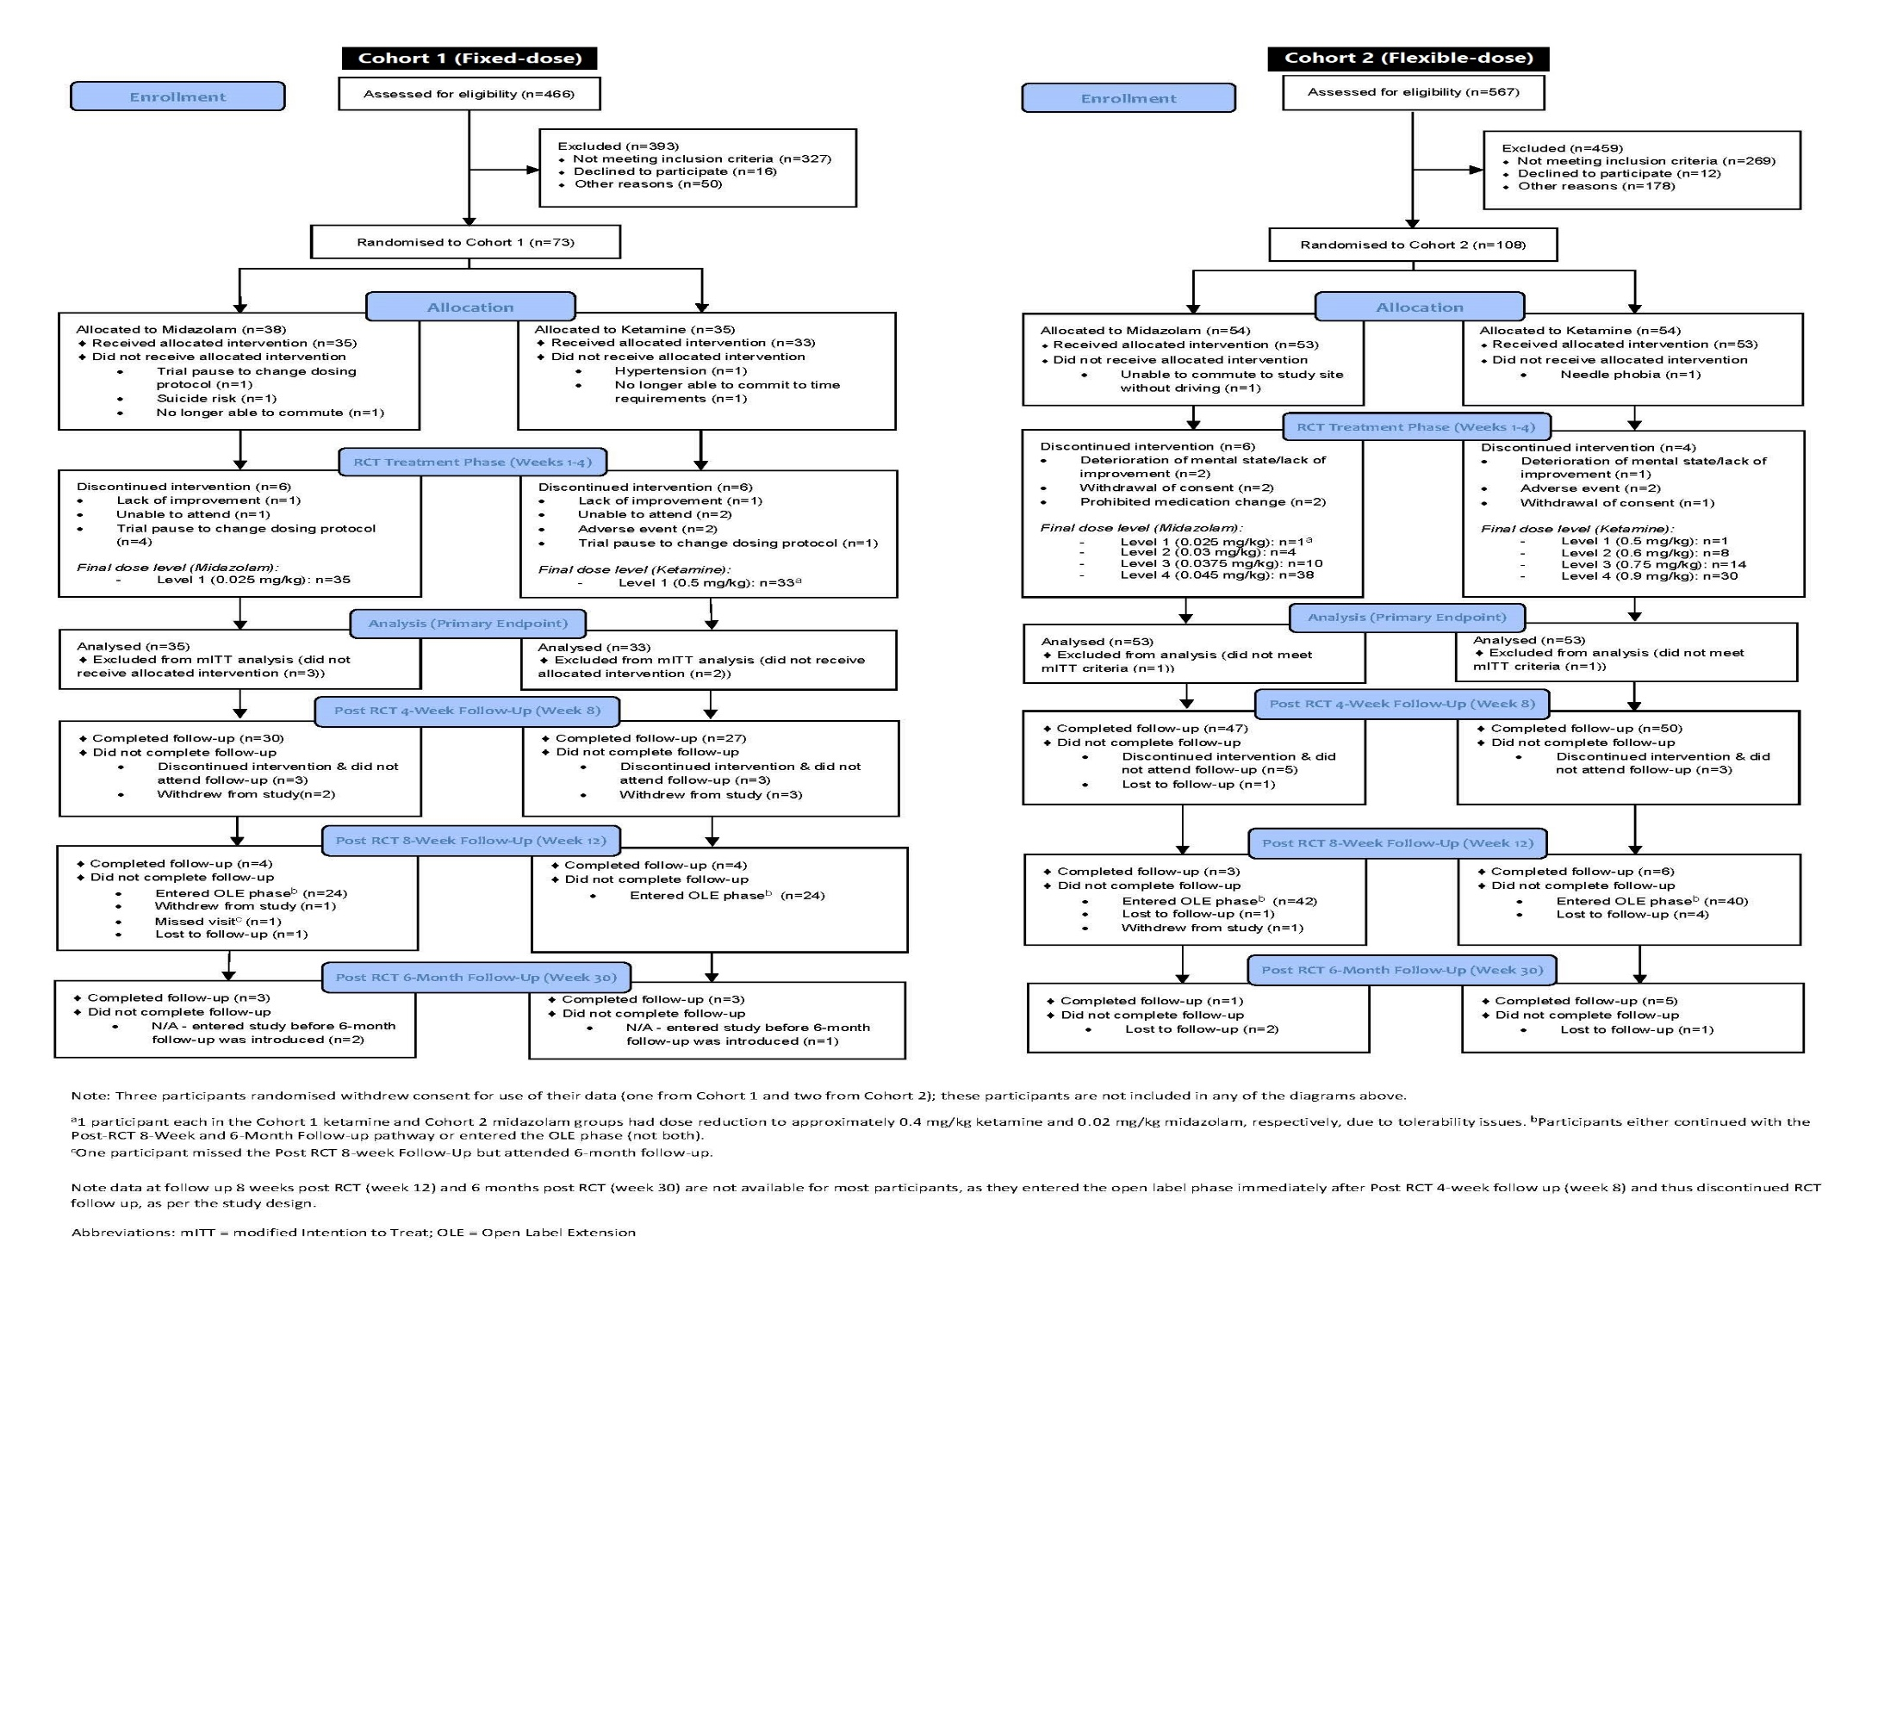
Supplementary Figure 1b: Flow diagram for numbers of study participants

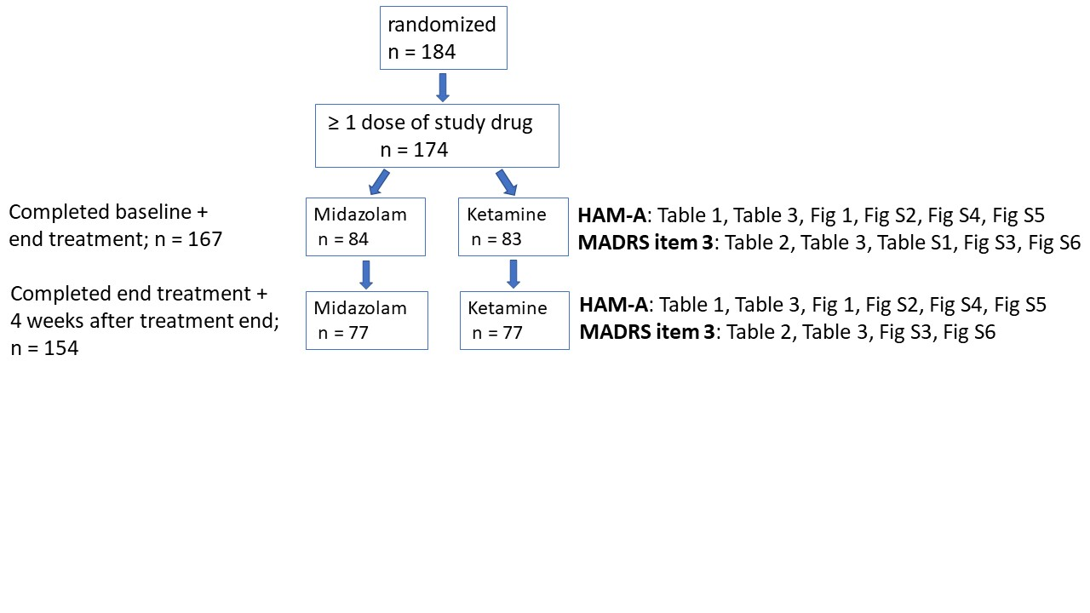

Supplementary Table 1: Change in median MADRS item 3 during RCT, combined cohorts
Treatment arm | Median MADRS item 3 at baseline | Median MADRS item 3 at end treatment
Midazolam (n=83) | 3 | 2
Ketamine (n=83) | 3 | 2
n = number of participants at end treatment visit

Supplementary Figure 2: Change in HAM-A baseline to 4 weeks after treatment end in midazolam and ketamine treatment groups – combined cohorts
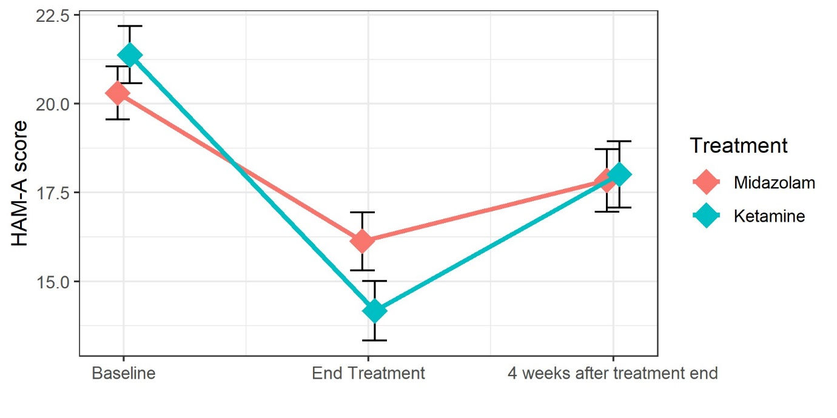
Ketamine treatment

Supplementary Figure 3a: Change in MADRS item 3 baseline to 4 weeks after treatment end in midazolam and ketamine treatment groups, cohort 2
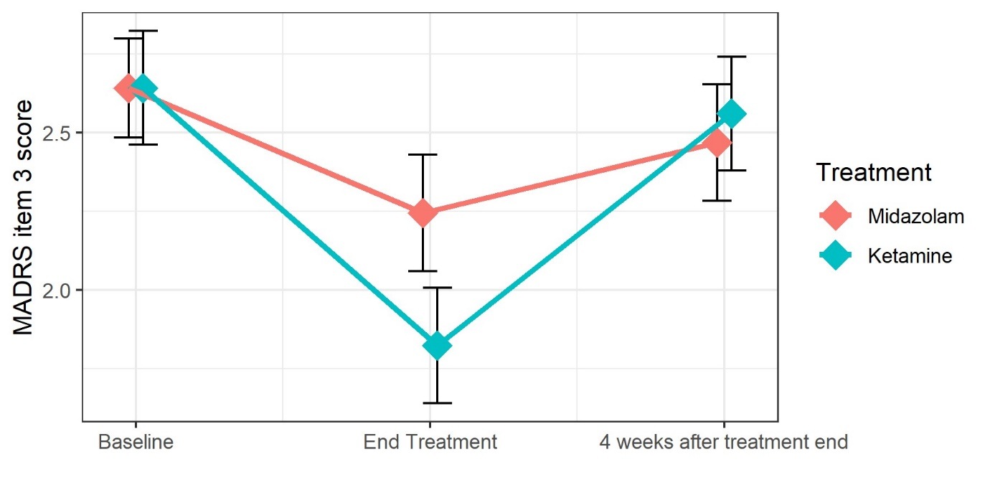
Ketamine treatment

Supplementary Figure 3b: Change in MADRS item 3 baseline to 4 weeks after treatment end in midazolam and ketamine treatment groups – combined cohorts
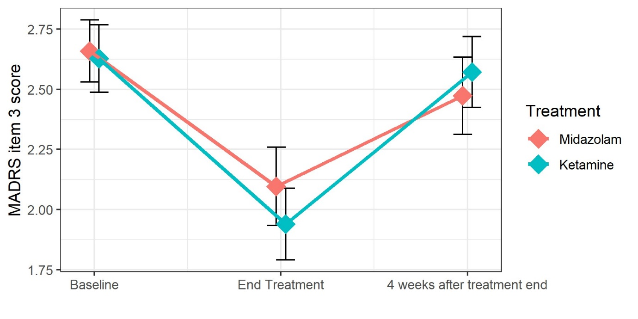
Ketamine treatment

Supplementary Figure 4: Change in HAM-A psychic factor baseline to 4 weeks after treatment end in midazolam and ketamine treatment groups – combined cohorts
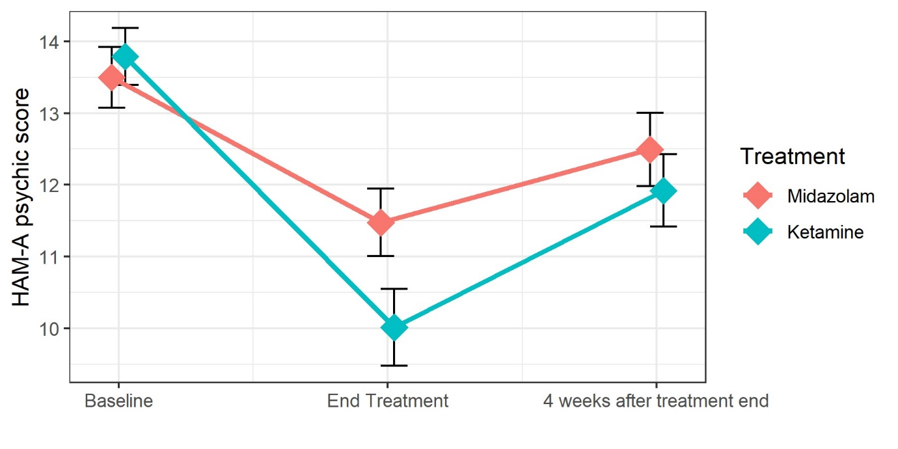
Ketamine treatment

Supplementary Figure 5: Change in HAM-A baseline to 4 weeks after treatment end in ketamine treatment group of cohort 1 and cohort 2
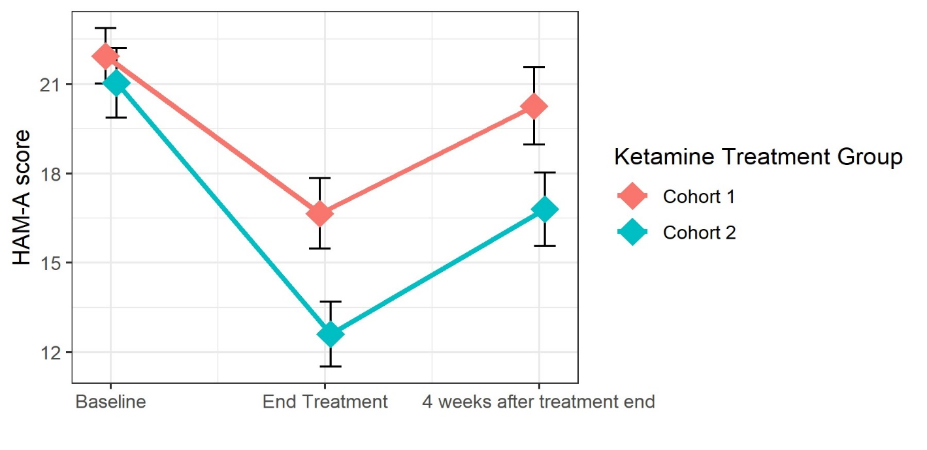
Ketamine treatment

