SUPPLEMENTARY MATERIAL
Epicuticular wax chemicals of Lablab purpureus subsp. bengalensis influence short-range attraction and oviposition responses in Aphis craccivora and Aphis gossypii
Sanoj Kumbhakar, Susmita Das and Anandamay Barik*
Ecology Research Laboratory, Department of Zoology, The University of Burdwan, Burdwan – 713 104, West Bengal, India
*e-mail: anandamaybarik@yahoo.co.in
* Corresponding author. Tel.: 0342 2634200; Fax: 0342 2634200

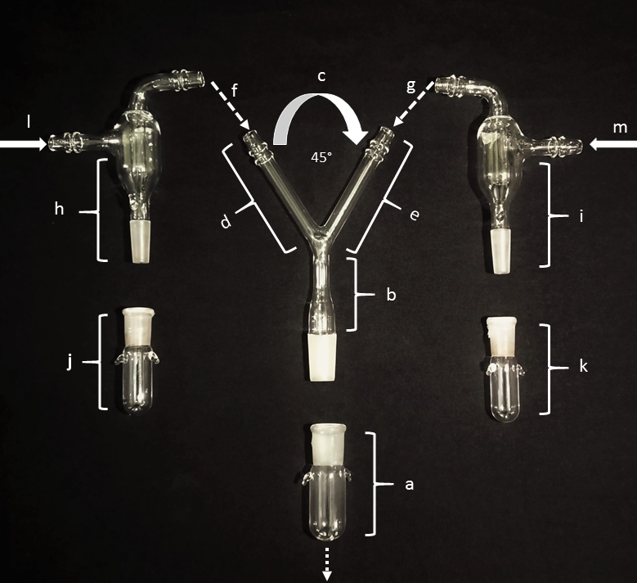
Supplementary Figure 1. The photograph showing different parts of the Y-tube olfactometer – a: porous glass vial; b: stem of olfactometer; c: Y junction; d & e: left and right arm of the olfactometer; h & i: adapters; j & k: left and right glass vials, respectively; f: solvent loaded air flow; g: test compound loaded air flow; l & m: clean air flow

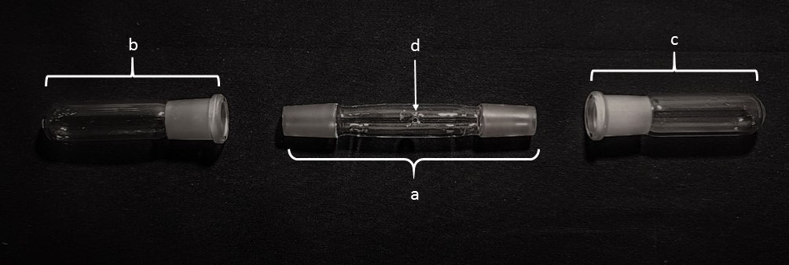

Supplementary Figure 2. The photograph showing different parts of the glass-made I-tube – a: main arm; b and c: left and right glass vials; d: hole.

Supplementary Table 1a. Individual synthetic alkane compounds present in one leaf equivalent surface wax of Lablab purpureus subsp. bengalensis used for olfactory bioassay and viviparity assay
Alkanes | Amount (µg)
Dodecane (n-C₁₂) | 4.57*
Tetradecane (n-C₁₄) | 16.95
Pentadecane (n-C₁₅) | 4.66
Hexadecane (n-C₁₆) | 39.87
Octadecane (n-C₁₈) | 25.59
Eicosane (n-C₂₀) | 24.52
Heneicosane (n-C₂₁) | 2.18
Docosane (n-C₂₂) | 12.93
Tricosane (n-C₂₃) | 14.36
Tetracosane (n-C₂₄) | 19.38
Pentacosane (n-C₂₅) | 36.66
Hexacosane (n-C₂₆) | 22.10
Heptacosane (n-C₂₇) | 25.82
Octacosane (n-C₂₈) | 14.90
Nonacosane (n-C₂₉) | 55.61
Triacontane (n-C₃₀) | 8.48
Hentriacontane (n-C₃₁) | 26.82
Dotriacontane (n-C₃₂) | 20.02
Tritriacontane (n-C₃₃) | 22.88
Tetratriacontane (n-C₃₄) | 11.11
Pentatriacontane (n-C₃₅) | 9.12

*: 25 g leaves or 27 leaves: 20.69 mg or 20690 µg surface waxes indicated presence of 11300.16 µg total identified alkanes, and subsequently, 123.42 µg dodecane was detected. Hence, 123.42/27 = 4.57 µg dodecane is present in one leaf equivalent surface wax.

Supplementary Table 1b. Individual synthetic free fatty acid compounds present in one leaf equivalent surface wax of Lablab purpureus subsp. bengalensis used for olfactory bioassay and viviparity assay
Fatty acids | Amount (µg)
Lauric acid (C12:0) | 6.14**
Tridecanoic acid (C13:0) | 5.98
Tetradecanoic acid (C14:0) | 6.13
Palmitoleic acid (C16:1) | 3.43
Heptadecanoic acid (C17:0) | 10.05
Linolenic acid (C18:3) | 17.87
Stearic acid (C18:0) | 2.35
Nonadecanoic acid (C19:0) | 18.82
Arachidic acid (C20:0) | 5.06
Heneicosanoic acid (C21:0) | 9.40
Docosanoic acid (C22:0) | 3.77

**: 25 g leaves or 27 leaves: 2.40 mg or 2400 µg surface waxes indicated presence of 2402.98 µg total identified free fatty acids, and subsequently, 165.74 µg lauric acid was detected. Hence, 165.74/27 = 6.14 µg lauric acid is present in one leaf equivalent surface wax.

Supplementary Table 2. Behavioral responses of Aphis craccivora females towards individual synthetic compound vs. the control solvent (petroleum ether) in the Y-tube olfactometer bioassay (N = 60 in each concentration bioassay)
Synthetic compounds | Concentration | χ2 | P values of
 | (µg/ml) | (df = 1) | insect responded
Tetradecane | 10 | 1.67 | 0.1967
 | 20 | 6.67 | 0.0098
 | 40 | 15.00 | 0.0001
Pentadecane | 2.5 | 1.07 | 0.3017
 | 5 | 5.40 | 0.0201
 | 10 | 15.00 | 0.0001
Tetracosane | 10 | 1.67 | 0.1967
 | 20 | 6.67 | 0.0098
 | 40 | 17.07 | 0.0001
Tridecanoic acid | 4 | 2.40 | 0.1213
 | 8 | 8.07 | 0.0045
 | 16 | 17.07 | 0.0001
Tetradecanoic acid | 3 | 1.67 | 0.1967
 | 6 | 4.27 | 0.0389
 | 12 | 15.00 | 0.0001
Heneicosanoic acid | 4 | 1.06 | 0.3017
 | 8 | 5.40 | 0.0201
 | 16 | 17.07 | 0.0001

Supplementary Table 3. Behavioral responses of Aphis gossypii females towards individual synthetic compound vs. the control solvent (petroleum ether) in the Y-tube olfactometer bioassay (N = 60 in each concentration bioassay)
Synthetic compounds | Concentration | χ2 | P values of
 | (µg/ml) | (df = 1) | insect responded
Tetradecane | 10 | 1.67 | 0.1967
 | 20 | 6.67 | 0.0098
 | 40 | 15.00 | 0.0001
Hexadecane | 25 | 1.07 | 0.3017
 | 50 | 8.07 | 0.0045
 | 100 | 17.07 | 0.0001
Docosane | 10 | 2.40 | 0.1213
 | 20 | 8.07 | 0.0045
 | 40 | 17.07 | 0.0001
Nonadecanoic acid | 15 | 2.40 | 0.1213
 | 30 | 8.07 | 0.0045
 | 60 | 17.07 | 0.0000
Arachidic acid | 2 | 1.07 | 0.3017
 | 4 | 3.27 | 0.0707
 | 8 | 15.00 | 0.0001

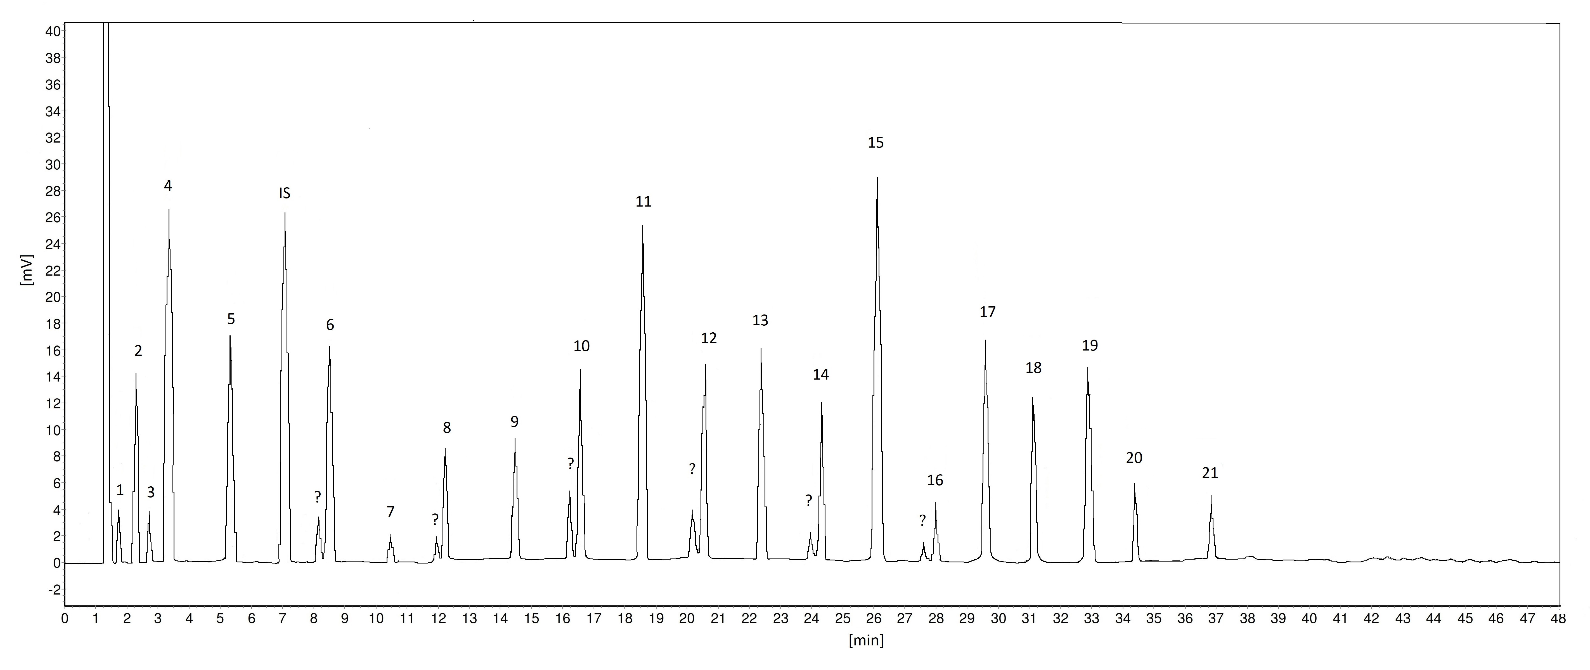
Supplementary Figure 3. Representative GC-FID chromatogram (SE-30) of n-alkanes identified from the leaf surface waxes of Lablab purpureus subsp. bengalensis. Identification of peaks: 1. Dodecane, 2. Tetradecane, 3. Pentadecane, 4. Hexadecane, 5. Octadecane, 6. Eicosane, 7. Heneicosane, 8. Docosane, 9. Tricosane, 10. Tetracosane, 11. Pentacosane, 12. Hexacosane, 13. Heptacosane, 14. Octacosane, 15. Nonacosane, 16. Triacontane, 17. Hentriacontane, 18. Dotriacontane, 19. Tritriacontane, 20. Tetratriacontane, and 21. Pentatriacontane. ? = Unidentified branched chain alkanes. IS: Internal Standard (nonadecane)

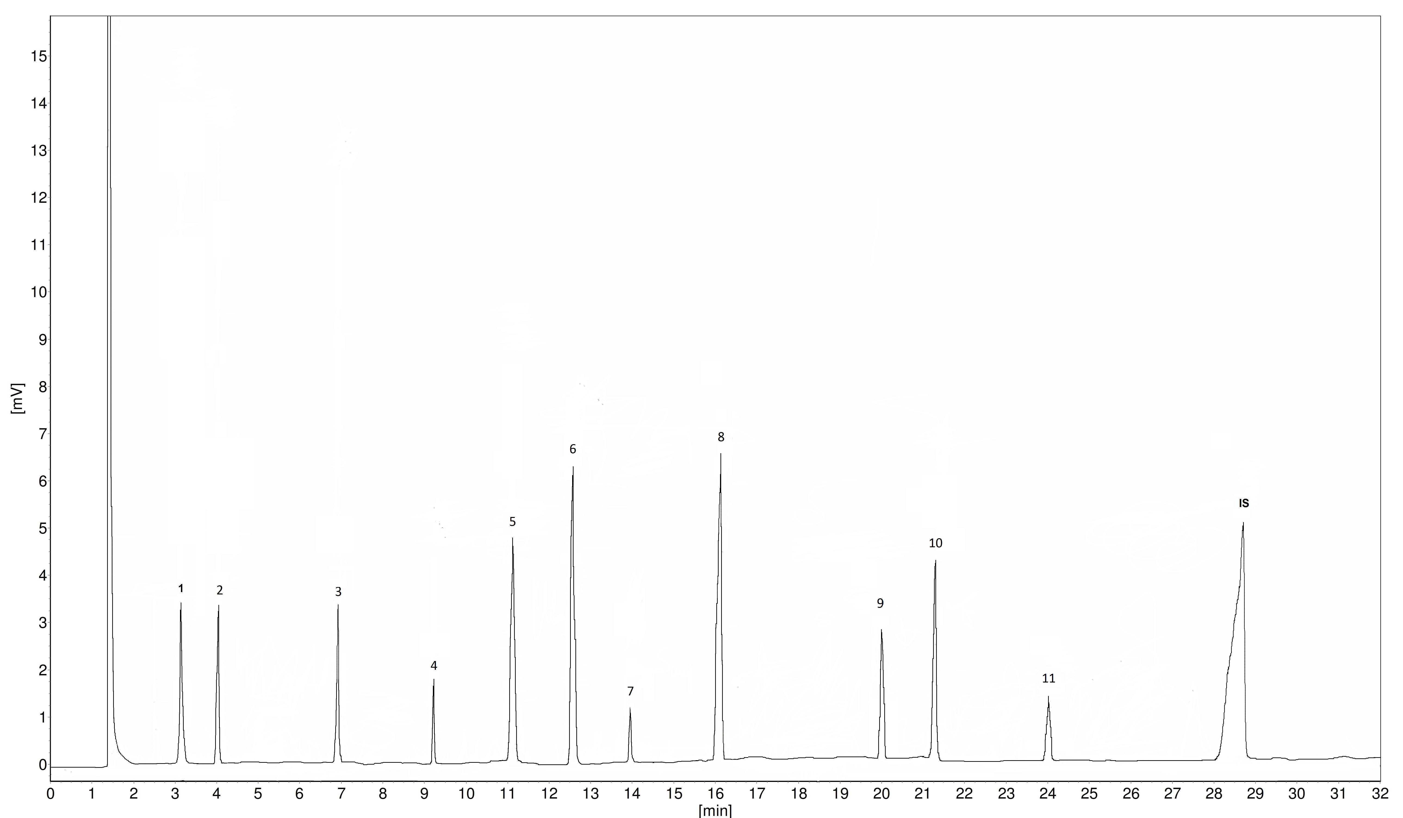

Supplementary Figure 4. Representative GC-FID chromatogram (SE-30) of free fatty acids identified from the leaf surface waxes of Lablab purpureus subsp. bengalensis 1. Identification of peaks: 1. Lauric acid, 2. Tridecanoic acid, 3. Tetradecanoic acid, 4. Palmitoleic acid, 5. Heptadecanoic acid, 6. Linolenic acid, 7. Stearic acid, 8. Nonadecanoic acid, 9. Arachidic acid, 10. Heneicosanoic acid and 12. Docosanoic acid. IS: Internal Standard (tricosanoic acid)

Supplementary Table 4. Viviparity assays of Aphis craccivora and A. gossypii females towards individual synthetic compounds comparable to the amounts present in one leaf equivalent surface wax of Lablab purpureus subsp. bengalensis vs. control solvent (petroleum ether) (N= 10 in each assay). (Individual synthetic compounds that served as oviposition stimulants are presented in Table 1)
Comparison |  |  | No. of insects laid nymphs |  |  | Non- |  | Nymphs laid |  |  | χ2 |  | P values
T1 | T2 | T1 |  | T2 | responders |  | T1 |  | T2 | (df = 1)
Viviparity assays of A. craccivora
Octadecane (25.59 µg) | Control solvent | 7 |  | 3 | 4 |  | 32 |  | 21 | 2.283 |  | 0.1308
Docosane (12.93 µg) | Control solvent | 5 |  | 5 | 5 |  | 28 |  | 22 | 0.720 |  | 0.3961
Pentacosane (36.66 µg) | Control solvent | 6 |  | 4 | 5 |  | 29 |  | 24 | 0.472 |  | 0.4921
Heptacosane (25.82 µg) | Control solvent | 7 |  | 3 | 4 |  | 32 |  | 22 | 1.85 |  | 0.1738
Dotriacontane (20.02 µg) | Control solvent | 5 |  | 5 | 7 |  | 27 |  | 25 | 0.077 |  | 0.7814
Tritriacontane (22.88 µg) | Control solvent | 7 |  | 3 | 6 |  | 31 |  | 22 | 1.528 |  | 0.2164
Linolenic acid (17.87 µg) | Control solvent | 6 |  | 4 | 6 |  | 28 |  | 22 | 0.72 |  | 0.3961
Nonadecanoic acid (18.82 µg) | Control solvent | 5 |  | 5 | 5 |  | 27 |  | 23 | 0.320 |  | 0.5716
Viviparity assays of A. gossypii
Pentacosane (36.66 µg) | Control solvent | 5 |  | 5 | 6 |  | 23 |  | 19 | 0.3810 |  | 0.5371
Heptacosane (25.82 µg) | Control solvent | 5 |  | 5 | 6 |  | 24 |  | 18 | 0.8571 |  | 0.3546
Nonacosane (55.61 µg) | Control solvent | 7 |  | 3 | 6 |  | 25 |  | 15 | 2.50 |  | 0.1138
Triacontane (8.48 µg) | Control solvent | 5 |  | 5 | 7 |  | 23 |  | 17 | 0.9 |  | 0.3428
Pentatriacontane (9.12 µg) | Control solvent | 6 |  | 4 | 4 |  | 26 |  | 16 | 2.381 |  | 0.1228
Tetradecanoic acid (6.13 µg) | Control solvent | 5 |  | 5 | 7 |  | 23 |  | 18 | 0.6098 |  | 0.4349

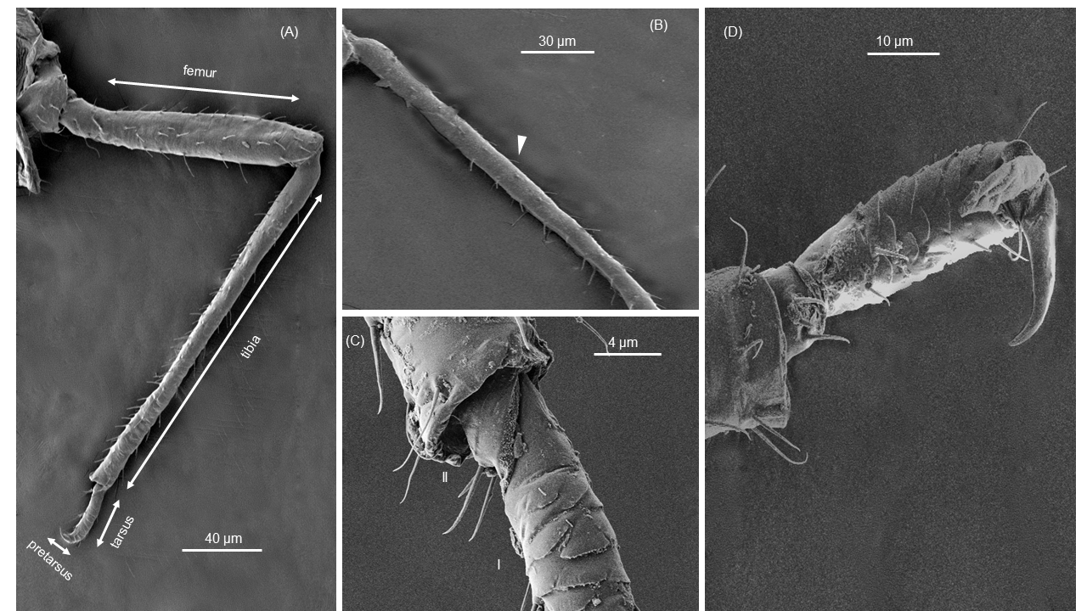
Supplementary Figure 5. SEM of foreleg on apterous Aphis craccivora: (a) foreleg general view, (b) tibia showing type I trichoid sensilla; (c) view of junction of tibia and tarsus I showing type I trichoid sensilla and (d) details of tarsus II showing type I trichoid sensilla.

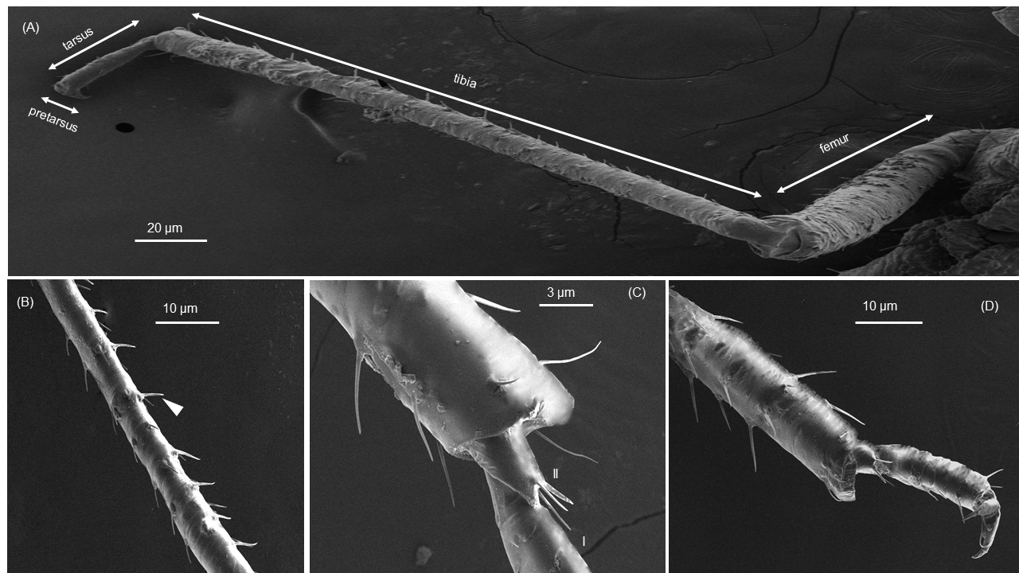

Supplementary Figure 6. SEM of foreleg on apterous Aphis gossypii: (a) foreleg general view, (b) tibia showing type I trichoid sensilla; (c) view of junction of tibia and tarsus I showing type I trichoid sensilla and (d) details of tarsus II showing type I trichoid sensilla.

