Supplementary material
Table 1S
P-values from permutation tests (10 000 permutation rounds) for Mahalanobis and Procrustes distances amongst different generations of continuous rearing using pupae of the alternative host Tenebrio molitor offered pupae of Diatraea saccharalis. Mahalanobis (normal font) and Procrustes (Italic font). Significant differences: P < 0.01.
Generations | F0 | F5 | F15
F5 | 4.07, P < 0.0001  0.01, P = 0.0011 | -
F15 | 3.79, P < 0.0001  0.01, P < 0.0001 | 2.73, P <0.0001  0.008, P=0.0903 | -
F30 | 4.02, P < 0.0001  0.01, P = 0.0006 | 3.24, P < 0.0001  0.01, P = 0.0016 | 2.93, P < 0.0001  0.01, P = 0.0012

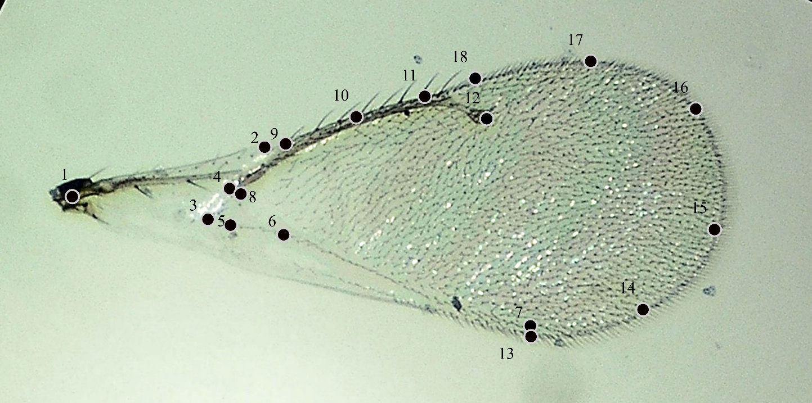

Fig. 1S Landmarks used in morphometric analysis of the forewing Tetrastichus howardi female.

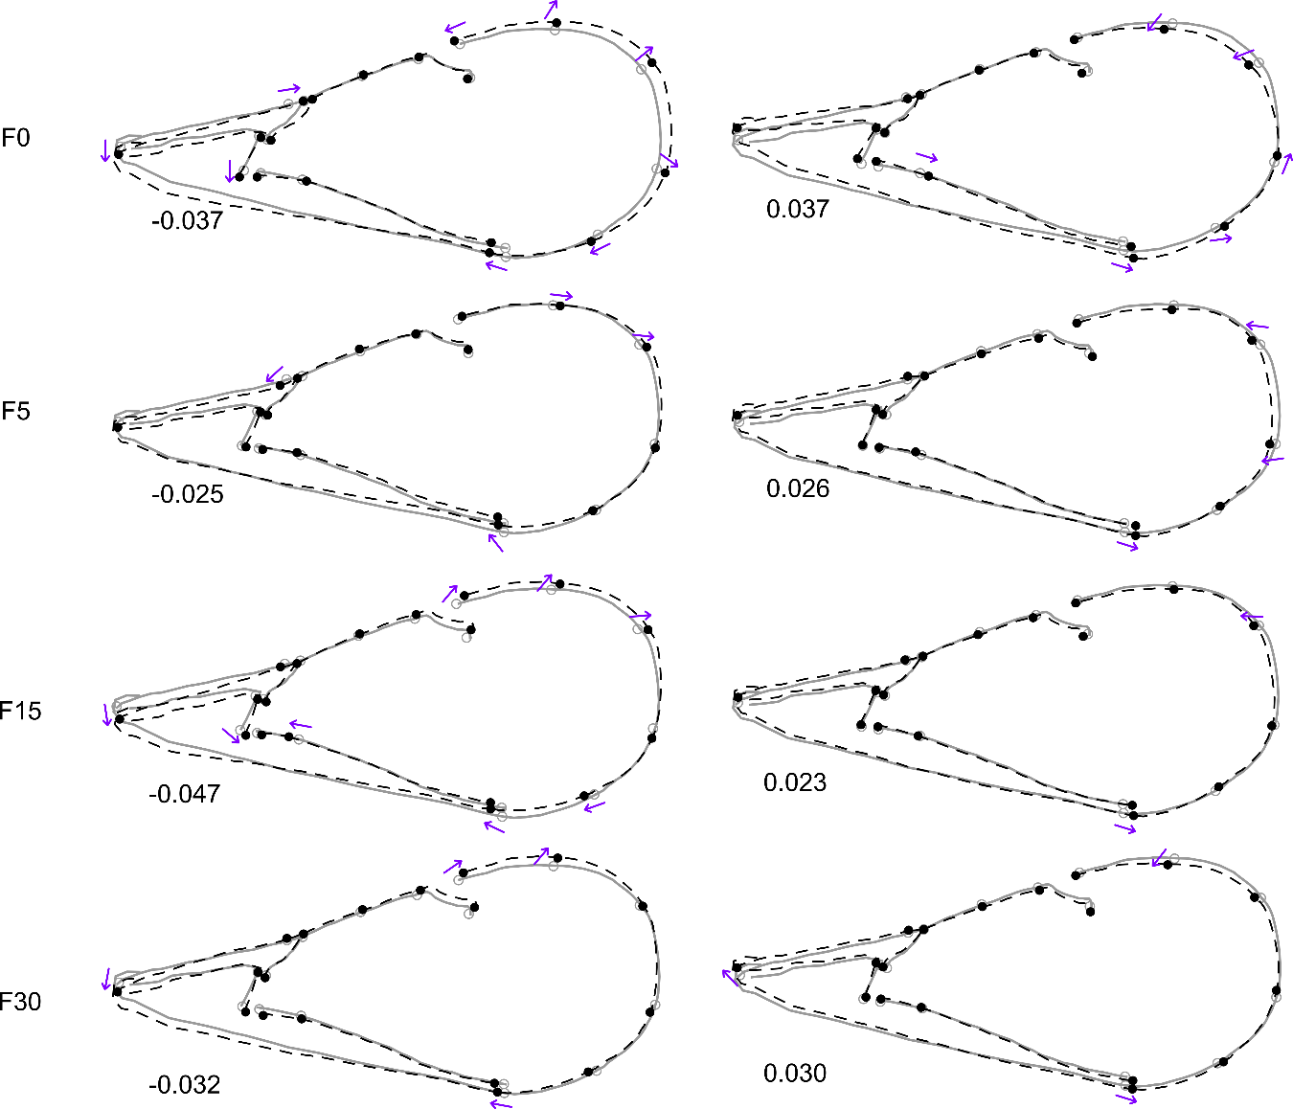
Fig. 2S Variation in the front wing shape of Tetrastichus howardi females assessed at F0, F5, F15, and F30 generation from 30 rearing generations using pupae of the alternative host, Tenebrio molitor. The left wings show changes in the shape portrayed by the lower negative extreme values and wings on the right show the changes in the shape portrayed by the higher positive extreme values at each generation. The dotted lines with black marks indicate the change in shape while the gray line indicate the average shape associated to PC1 on scale factor of 1.0

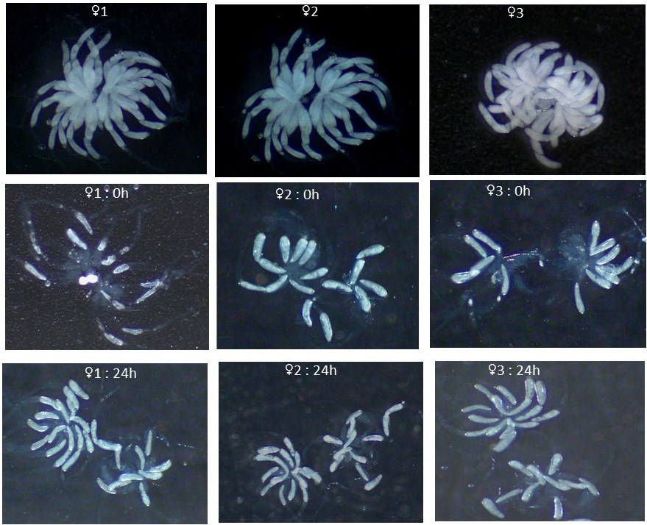
Fig. 3S Egg loading of Tetrastichus howardi as a function of oviposition in randomly dissected females 96 hours old before oviposition (♀1-♀3), females right after accomplishing one oviposition (♀1: 0h - ♀3: 0h), and females after 24 hours of resting post the first oviposition (♀1: 24h - ♀3: 24h).

