**Supplementary Figure 1**

**Detection of colonization of Bb025 in *Neoseiulus barkeri* (Acarina: Phytoseiidae)**

The colonization of Bb025 in *N. barkeri* was examined using a specific nested PCR technique. Fifty *N. barkeri* individuals were inoculated with Bb025 conidial suspension at a concentration of 1 × 108 conidia/mL. After 3days, the *N. barkeri* were collected, disinfected, and then DNA was extracted. The 0.05% Tween 80-treated *N. barkeri* and the Bb025-treated *N. barkeri* immediately disinfected served as the blank and negative control, respectively. Genomic DNAs of *B. bassiana* was extracted following the CTAB protocol. The ITS region of *B. bassiana* was isolated from *N. barkeri* tissues using a two-step nested PCR technique. The primers TS1-F/ITS-4 (5′-CTT GTT CGC TAT CGG TCT C-3′/5′-TCC GTA GGT GAACCT GCG G-3′) and Bb.fw/Bb.rv (5′-GAA CCT ACC TATCGT TGC TTC-3′/5′-ATT CGA GGT CAA CGT TCA G-3′) were selected as the first and second round primers, respectively, for the nested PCR reactions. The PCR reaction was performed in a total volume of 25 *μL*, consisting of 23 *μL* of T3 Super PCR Mix (TsingKe Biology Technology Co. Ltd), 0.5 *μL* of each primer,and 2 *μL* DNA template. The first round of the PCR reaction was conducted using the following settings: initial denaturing at 98°C for 2 min, followed by 35 cycles of denaturation at 98°C for 10 s, annealing at 61°C for 10 s, and extension at 72°C for 10 sec; with a final extension at 72°C for 2 min. The annealing step for the second round of PCR was set at 55°C for10 s, with the other steps the same as in the first round. Finally, agarose gel electrophoresis with a 2.5% gel concentration was used to visualize the PCR results.

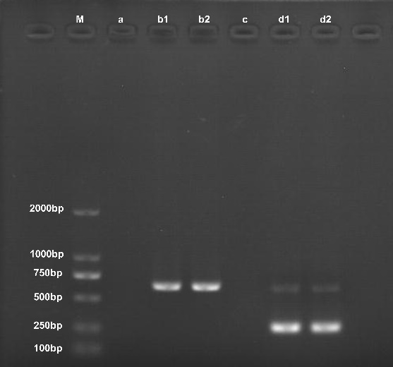

Fig. S1: Detection of colonization of Bb025 in *Neoseiulus barkeri*. M, 2 kb Plus DNA Ladder; a, blank control (*N. barkeri* treated with 0.05% Tween-80); b, amplification using fungal universal primer pair TS1-F/ITS-4; c, negative control (*N. barkeri* treated with *B. bassiana* and then immediately disinfected); d, Nested PCR using Bb.fw/ Bb.rv as inner primers gave amplification patterns identical to b.

The presence of *B. bassiana* in *N. barkeri* tissues was confirmed by detecting clear 224 bp products using the inner primer pairs Bb.fw/Bb.rv (Fig. S1 d1 and d2). In contrast, no fungal DNA signal was detected in the blank and negative control extracts (Fig. S1 a and c).