Supplementary figures

Figure S1
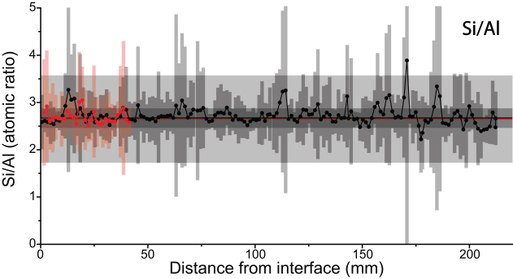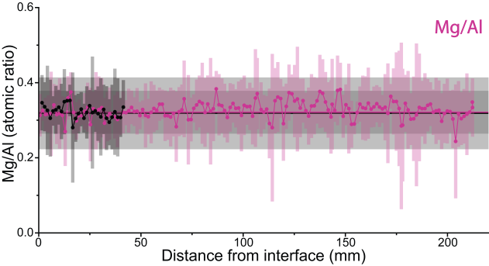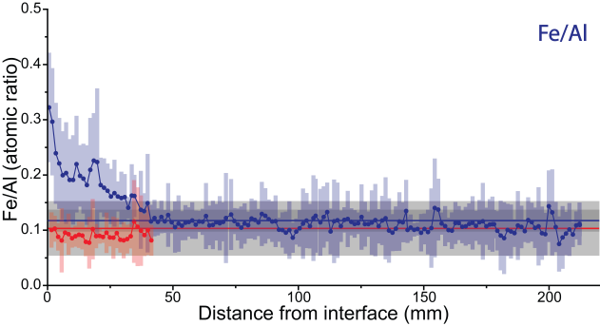
Figure S1: “Al-normalized” chemical profiles of major elements Si, Mg, and Fe in block BM-B-41-1 (long profile, ~220 mm) and block BM-B-41-2 (short profile, ~40 mm) from section 62. Horizontal lines and gray areas represent same data as in Figure 4 (i.e. reference and bulk values).

Figure S2
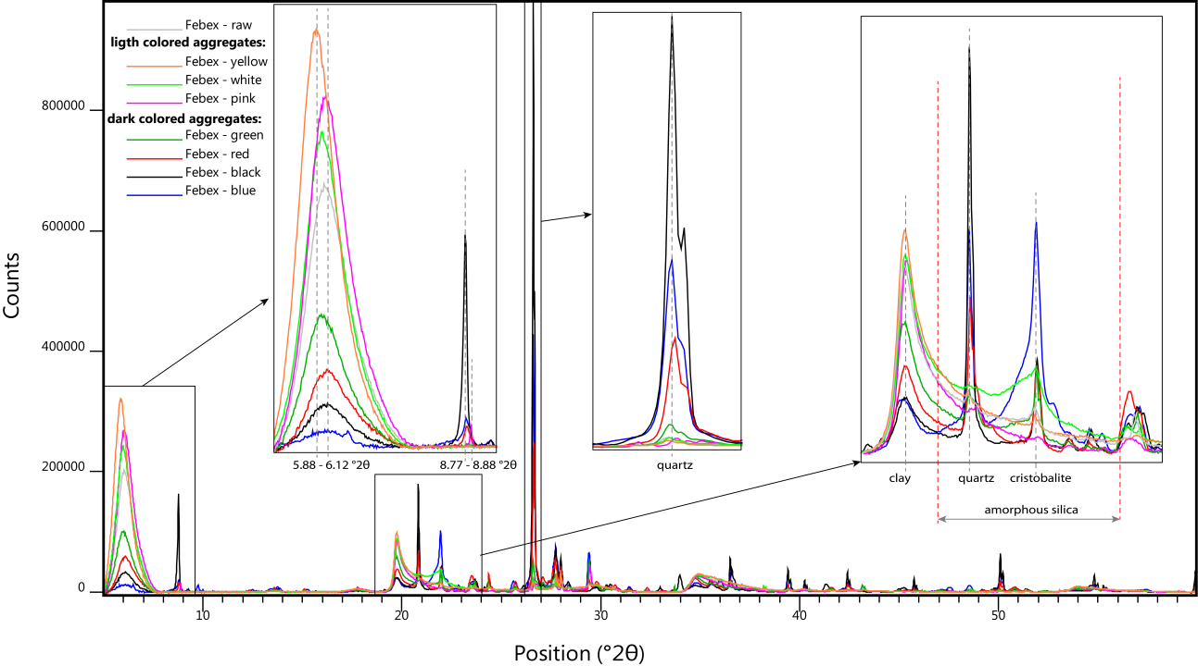
Figure S2: Diffractograms of the various colored aggregates isolated from FEBEX raw bentonite and the bulk raw material.

Figure S3
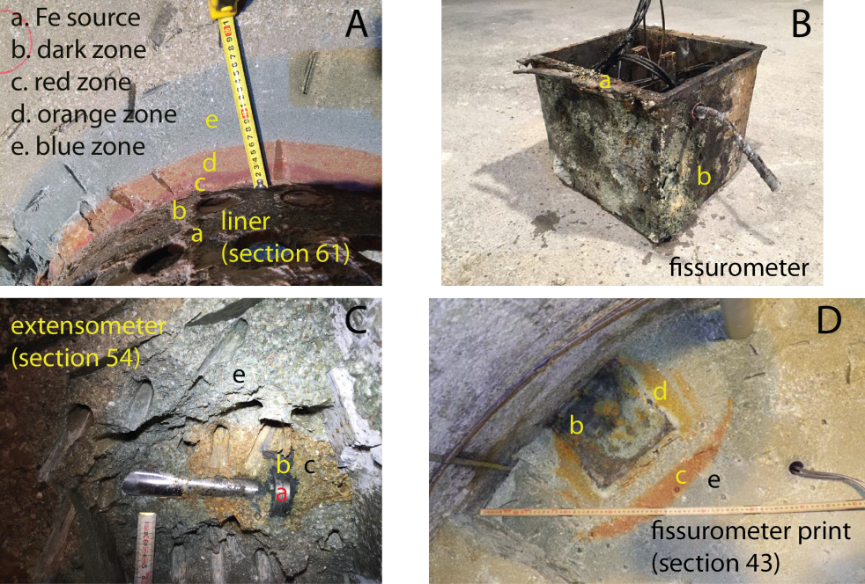
Figure S3: Colored corrosion halos observed around various steel components retrieved upon dismantling of the FEBEX experiment.

Figure S4

Figure S4: 300 K Mössbauer spectra of the raw FEBEX material and of 11 samples from block BM-B-41-1. The refined values of the hyperfine parameters are listed in Table S3 and Table S4.

Supplementary tables

Table S1 and S2

Table S1: Chemical composition of eighteen powdered FEBEX samples from block BM-B-41-1 determined by XRF (and ATG). Relative uncertainty on major elements is 5%.
Sample | R1 | R2 | R3 | R4 | R5 | R6 | O7 | O8 | O9 | OB10 | OB11 | B12 | B13 | B14 | B15 | B16 | B17 | B18
d (mm) | 2.5 | 8.2 | 13.9 | 19.6 | 25.3 | 31.0 | 36.6 | 42.3 | 48.0 | 53.7 | 59.4 | 65.1 | 70.8 | 76.5 | 82.2 | 87.9 | 93.5 | 99.2
%H₂O | 5.1 | 4.2 | 4 | 3.1 | 3.7 | 4.7 | 3.7 | 4.7 | 4.1 | 4.9 | 4.1 | 3.9 | 3.8 | 4.4 | 4.1 | 4.8 | 3.2 | 5.3
LOI | 8.1 | 7.9 | 8.1 | 8.1 | 8.1 | 8.1 | 8.2 | 8 | 8 | 8.1 | 8.1 | 8 | 8.2 | 8.3 | 8.3 | 8.2 | 8.2 | 8.2
Σ | 99.17 | 99.37 | 98.60 | 99.06 | 99.26 | 99.35 | 99.09 | 99.02 | 98.66 | 98.76 | 99.07 | 99.68 | 99.04 | 99.03 | 99.19 | 99.06 | 98.16 | 98.46
majors elements (in oxide wt%)
SiO₂ | 62.52 | 62.11 | 63.64 | 63.73 | 64.43 | 64.47 | 64.58 | 64.22 | 64.23 | 64.55 | 64.64 | 65.16 | 64.62 | 64.50 | 64.77 | 64.57 | 63.85 | 64.11
TiO₂ | 19.41 | 19.35 | 19.47 | 19.95 | 19.70 | 20.02 | 20.11 | 20.16 | 19.75 | 20.14 | 20.21 | 20.35 | 20.13 | 20.19 | 20.12 | 20.15 | 19.91 | 19.90
Al₂O₃ | 7.71 | 8.55 | 6.36 | 5.90 | 5.70 | 5.35 | 5.15 | 4.93 | 5.38 | 4.27 | 4.27 | 4.36 | 4.38 | 4.51 | 4.31 | 4.32 | 4.40 | 4.31
Fe₂O₃ | 4.51 | 4.52 | 4.57 | 4.66 | 4.57 | 4.67 | 4.69 | 4.69 | 4.70 | 4.75 | 4.90 | 4.89 | 4.85 | 4.85 | 4.87 | 4.89 | 4.84 | 4.83
MnO | 1.67 | 1.67 | 1.68 | 1.69 | 1.66 | 1.72 | 1.69 | 1.72 | 1.72 | 1.96 | 2.01 | 1.92 | 1.95 | 2.01 | 2.03 | 2.06 | 2.09 | 2.09
MgO | 1.73 | 1.60 | 1.35 | 1.58 | 1.61 | 1.52 | 1.29 | 1.56 | 1.27 | 1.46 | 1.47 | 1.38 | 1.43 | 1.35 | 1.45 | 1.44 | 1.43 | 1.57
CaO | 1.19 | 1.16 | 1.09 | 1.13 | 1.17 | 1.17 | 1.16 | 1.29 | 1.18 | 1.20 | 1.14 | 1.18 | 1.22 | 1.17 | 1.20 | 1.17 | 1.19 | 1.20
Na₂O | 0.27 | 0.25 | 0.27 | 0.26 | 0.26 | 0.26 | 0.26 | 0.28 | 0.25 | 0.26 | 0.26 | 0.26 | 0.28 | 0.27 | 0.26 | 0.26 | 0.27 | 0.27
TiO₂ | 0.05 | 0.04 | 0.05 | 0.04 | 0.05 | 0.05 | 0.05 | 0.05 | 0.05 | 0.05 | 0.05 | 0.04 | 0.05 | 0.05 | 0.05 | 0.05 | 0.05 | 0.05
P₂O₅ | 0.04 | 0.04 | 0.03 | 0.03 | 0.04 | 0.03 | 0.03 | 0.04 | 0.04 | 0.04 | 0.04 | 0.04 | 0.04 | 0.04 | 0.04 | 0.05 | 0.04 | 0.04
MnO | 62.52 | 62.11 | 63.64 | 63.73 | 64.43 | 64.47 | 64.58 | 64.22 | 64.23 | 64.55 | 64.64 | 65.16 | 64.62 | 64.50 | 64.77 | 64.57 | 63.85 | 64.11
Trace elements (in ppm)
Ba | 130 | 182 | 188 | 146 | 117 | 178 | 123 | 309 | 113 | 172 | 133 | 244 | 145 | 167 | 178 | 228 | 177 | 130
Cr | 10 | 18 | 17 | 15 | 14 | 8 | 14 | 17 | 12 | 20 | 13 | 9 | 17 | 10 | 10 | 10 | 13 | 14
Cu | 6 | 6 | 8 | 7 | 6 | 8 | 7 | 7 | 8 | 8 | 9 | 12 | 9 | 10 | 11 | 10 | 9 | 9
Nb | 12 | 15 | 12 | 15 | 13 | 13 | 13 | 13 | 14 | 14 | 13 | 14 | 14 | 14 | 13 | 15 | 15 | 14
Ni | 19 | 25 | 22 | 21 | 22 | 22 | 20 | 21 | 23 | 22 | 33 | 49 | 36 | 34 | 35 | 32 | 25 | 28
Pb | 30 | 30 | 26 | 28 | 30 | 31 | 32 | 33 | 36 | 36 | 38 | 40 | 40 | 39 | 39 | 38 | 36 | 39
Rb | 47 | 47 | 45 | 46 | 49 | 47 | 46 | 50 | 50 | 49 | 48 | 50 | 47 | 48 | 49 | 48 | 47 | 49
Sr | 180 | 183 | 184 | 188 | 187 | 191 | 189 | 199 | 191 | 202 | 199 | 208 | 199 | 204 | 204 | 211 | 213 | 212
V | 23 | 18 | 16 | 13 | 77 | 76 | 71 | 24 | 45 | 11 | 13 | 35 | 12 | 21 | 10 | 28 | 9 | 28
Y | 18 | 21 | 18 | 34 | 25 | 26 | 26 | 25 | 28 | 34 | 31 | 35 | 35 | 36 | 36 | 35 | 32 | 32
Zn | 70 | 70 | 68 | 71 | 70 | 74 | 72 | 73 | 74 | 74 | 77 | 77 | 77 | 77 | 76 | 77 | 75 | 75
Zr | 215 | 217 | 209 | 226 | 225 | 218 | 209 | 209 | 236 | 210 | 213 | 211 | 218 | 227 | 211 | 218 | 216 | 215
Sample identity: letters corresponds to the color of the bentonite sampled area (R = red, O = orange, B = blue G = green, OB = transition from orange to blue, BG = transition from blue to green, out = outer layer of the block), and number to the order of sampling, (starting from the from the interface)
d: approximate distance between the sampled layer and the interface
LOI: Loss On Ignition
%H₂O: water content measured at 105°C
Σ: sum of elements (excludes LOI and %H₂O)
Table S2: Chemical composition of fourteen powdered FEBEX samples determined by XRF (and ATG), including the raw material. Relative uncertainty on major elements is 5%.
Sample | B19 | B20 | B21 | B22 | BG23 | BG24 | BG25 | BG26 | BG27 | G28 | G29 | G30 | out | raw
d (mm) | 104.9 | 110.6 | 116.3 | 122.0 | 127.7 | 133.4 | 139.1 | 144.8 | 150.4 | 156.1 | 161.8 | 167.5 | 217.5 | -
%H₂O | 4.8 | 3.2 | 4 | 3.1 | 3.2 | 4.2 | 4.7 | 4.4 | 4.3 | 7.6 | 5.3 | 3 | 3.3 | 11
LOI | 8.4 | 8.1 | 8.2 | 8.6 | 8.2 | 8.5 | 8.4 | 8.5 | 8.2 | 8.5 | 8.4 | 8.3 | 8.5 | 8.8
Σ | 98.67 | 98.75 | 99.35 | 98.49 | 99.28 | 98.61 | 98.74 | 99.15 | 99.25 | 99.20 | 99.82 | 101.29 | 98.93 | 98.67
majors elements (in oxide wt%)
SiO₂ | 64.38 | 64.47 | 64.78 | 63.64 | 64.42 | 64.24 | 64.62 | 64.81 | 64.89 | 64.99 | 65.42 | 66.06 | 64.61 | 64.38
TiO₂ | 20.04 | 20.04 | 20.13 | 19.66 | 19.73 | 19.71 | 19.85 | 20.15 | 20.17 | 20.01 | 20.17 | 20.80 | 20.04 | 20.04
Al₂O₃ | 4.23 | 4.22 | 4.19 | 4.13 | 4.09 | 3.97 | 3.98 | 3.82 | 3.87 | 3.86 | 3.87 | 3.93 | 3.91 | 4.23
Fe₂O₃ | 4.85 | 4.84 | 4.87 | 4.80 | 4.84 | 4.77 | 4.84 | 4.93 | 4.94 | 4.87 | 5.00 | 5.01 | 4.98 | 4.85
MnO | 2.13 | 2.12 | 2.17 | 3.18 | 2.22 | 2.71 | 2.42 | 2.47 | 2.32 | 2.33 | 2.35 | 2.38 | 2.32 | 2.13
MgO | 1.40 | 1.35 | 1.51 | 1.40 | 2.34 | 1.54 | 1.36 | 1.34 | 1.44 | 1.48 | 1.37 | 1.42 | 1.39 | 1.40
CaO | 1.21 | 1.25 | 1.24 | 1.21 | 1.18 | 1.21 | 1.22 | 1.18 | 1.16 | 1.21 | 1.18 | 1.24 | 1.22 | 1.21
Na₂O | 0.26 | 0.27 | 0.27 | 0.26 | 0.27 | 0.26 | 0.26 | 0.27 | 0.27 | 0.26 | 0.26 | 0.27 | 0.26 | 0.26
TiO₂ | 0.05 | 0.05 | 0.05 | 0.07 | 0.05 | 0.04 | 0.05 | 0.05 | 0.05 | 0.05 | 0.05 | 0.05 | 0.05 | 0.05
P₂O₅ | 0.04 | 0.04 | 0.04 | 0.06 | 0.05 | 0.05 | 0.05 | 0.05 | 0.05 | 0.05 | 0.05 | 0.06 | 0.05 | 0.04
MnO | 64.38 | 64.47 | 64.78 | 63.64 | 64.42 | 64.24 | 64.62 | 64.81 | 64.89 | 64.99 | 65.42 | 66.06 | 64.61 | 64.38
Trace elements (in ppm)
Ba | 179 | 195 | 217 | 188 | 179 | 188 | 190 | 193 | 141 | 174 | 254 | 155 | 179 | 195
Cr | 15 | 16 | 13 | 18 | 15 | 12 | 16 | 14 | 10 | 19 | 18 | 6 | 15 | 16
Cu | 7 | 9 | 8 | 8 | 10 | 9 | 11 | 11 | 9 | 9 | 10 | 11 | 7 | 9
Nb | 13 | 14 | 12 | 13 | 13 | 12 | 14 | 15 | 13 | 13 | 13 | 14 | 13 | 14
Ni | 25 | 25 | 24 | 22 | 24 | 21 | 22 | 21 | 23 | 21 | 22 | 22 | 25 | 25
Pb | 34 | 32 | 37 | 35 | 38 | 34 | 35 | 39 | 33 | 35 | 37 | 36 | 34 | 32
Rb | 50 | 51 | 50 | 50 | 48 | 49 | 48 | 47 | 48 | 48 | 48 | 47 | 50 | 51
Sr | 218 | 223 | 228 | 237 | 229 | 235 | 238 | 236 | 239 | 239 | 238 | 239 | 218 | 223
V | 26 | 34 | 29 | 16 | 16 | 16 | 19 | 29 | 25 | 32 | 28 | 31 | 26 | 34
Y | 32 | 31 | 30 | 33 | 31 | 35 | 31 | 31 | 28 | 32 | 32 | 29 | 32 | 31
Zn | 75 | 73 | 74 | 74 | 75 | 73 | 75 | 74 | 75 | 76 | 75 | 75 | 75 | 73
Zr | 212 | 209 | 216 | 213 | 221 | 212 | 213 | 214 | 221 | 211 | 220 | 215 | 212 | 209
Sample identity: letters corresponds to the color of the bentonite sampled area (R = red, O = orange, B = blue G = green, OB = transition from orange to blue, BG = transition from blue to green, out = outer layer of the block), and number to the order of sampling, (starting from the from the interface)
d: average distance between the sampled layer and the interface
LOI: Loss On Ignition
%H₂O: water content measured at 105°C
Σ: sum of elements (excludes LOI and %H₂O)

Table S3 and S4
Table S3: refined values of Mössbauer parameters and doublet structural attributions for the raw FEBEX material and fives samples collected in block BM-B-41-1 (spectra shown in Figure 9 and S4). Uncertainties are 0.02 mm∙s⁻¹ for I.S., Q.S., 2ε, and F.W.H.M.; 0.5 T for B_{hf}, and 2% for the area.
300K |  |  |  |  |  | 77K
Hyperfine parameters |  |  |  |  | Attribution | Hyperfine parameters |  |  |  |  | Attribution
I.S. | F.W.H.M. | Q.S.  /2ε | B_{hf} | Area  (%) | Attribution | I.S. | F.W.H.M. | Q.S.  /2ε | B_{hf} | Area  (%) | Attribution
raw
1.20 | 0.50 | 2.35 |  | 4 | para-Fe(II) | 1.35 | 0.50 | 2.54 |  | 5 | para-Fe(II)
0.35 | 0.67 | 0.54 |  | 83 | para-Fe(III) | 0.46 | 0.71 | 0.56 |  | 75 | para-Fe(III)
0.45 | 0.90 | -0.20 | 28.8 | 13 | goethite | 0.47 | 1.07 | -0.25 | 48.6 | 11 | goethite
 |  |  |  |  |  | 0.53 | 0.69 | 0.06 | 55.0 | 9 | hematite
out (220 mm)
1.26 | 0.56 | 2.37 |  | 3 | para-Fe(II) | 1.26 | 0.5 | 2.76 |  | 5 | para-Fe(II)
0.34 | 2.00 | 0.55 |  | 46 | para-Fe(III) | 0.46 | 1.50 | 0.21 |  | 33 | para-Fe(III)
0.34 | 0.62 | 0.58 |  | 51 | para-Fe(III) | 0.46 | 0.56 | 0.59 |  | 51 | para-Fe(III)
 |  |  |  |  |  | 0.49 | 0.44 | -0.23 | 48.9 | 7 | goethite
 |  |  |  |  |  | 0.45 | 0.44 | 0.12 | 54.5 | 4 | hematite
G30 (168 mm)
1.26 | 0.56 | 2.37 |  | 8 | para-Fe(II) | 1.29 | 0.72 | 2.71 |  | 9 | para-Fe(II)
0.34 | 0.67 | 0.55 |  | 80 | para-Fe(III) | 0.46 | 0.73 | 0.57 |  | 81 | para-Fe(III)
0.32 | 0.70 | -0.20 | 34.2 | 7 | goethite | 0.47 | 0.46 | -0.20 | 48.9 | 4 | goethite
0.34 | 0.56 | -0.20 | 47.7 | 5 | hematite | 0.44 | 0.46 | 0.00 | 53.7 | 6 | hematite
BG25 (139 mm)
 |  |  |  |  |  | 1.27 | 0.4 | 2.85 |  | 4 | para-Fe(II)
 |  |  |  |  |  | 0.55 | 0.72 | 0.00 |  | 20 | para-Fe(III)
 |  |  |  |  |  | 0.47 | 0.62 | 0.58 |  | 62 | para-Fe(III)
 |  |  |  |  |  | 0.55 | 0.67 | -0.4 | 48.6 | 4 | goethite
 |  |  |  |  |  | 0.55 | 1.10 | 0.06 | 55.2 | 10 | hematite
B20 (111 mm)
1.32 | 0.50 | 2.27 |  | 14 | para-Fe(II) | 1.26 | 0.60 | 2.92 |  | 15 | para-Fe(II)
0.32 | 0.62 | 0.59 |  | 86 | para-Fe(III) | 0.46 | 0.64 | 0.56 |  | 75 | para-Fe(III)
 |  |  |  |  |  | 0.47 | 0.46 | -0.23 | 49.8 | 6 | goethite
 |  |  |  |  |  | 0.57 | 0.46 | 0.25 | 55.6 | 4 | hematite
B15 (82 mm)
1.17 | 0.67 | 2.57 |  | 16 | para-Fe(II) | 1.28 | 0.66 | 2.88 |  | 16 | para-Fe(II)
0.34 | 0.62 | 0.53 |  | 84 | para-Fe(III) | 0.47 | 0.66 | 0.56 |  | 74 | para-Fe(III)
 |  |  |  |  |  | 0.53 | 0.70 | -0.20 | 48.0 | 4 | goethite
 |  |  |  |  |  | 0.41 | 0.56 | 0.22 | 53.5 | 6 | hematite
I.S. = Isomer shift value relative to that of the α-Fe at 300 K. (mm∙s⁻¹)
F.W.H.M. = Full width of line at half of its maximum intensity. (mm∙s-¹)
Q.S./2ε = Quadrupolar splitting/quadrupolar shift
B_{hf} = Magnetic hyperfine field (T)
Table S4: refined values of Mössbauer parameters and doublet structural attributions for six samples collected in block BM-B-41-1 (spectra shown in Figures 9 and S4). Uncertainties are 0.02 mm∙s⁻¹ for I.S., Q.S., 2ε, and F.W.H.M.; 0.5 T for B_{hf}, and 2% for the area.
300K |  |  |  |  |  | 77K
Hyperfine parameters |  |  |  |  | Attribution | Hyperfine parameters |  |  |  |  | Attribution
I.S. | F.W.H.M. | Q.S.  /2ε | B_{hf} | Area  (%) | Attribution | I.S. | F.W.H.M. | Q.S.  /2ε | B_{hf} | Area  (%) | Attribution
OB11 (59 mm)
1.10 | 0.44 | 2.89 |  | 6 | para-Fe(II) | 1.20 | 0.50 | 3.05 |  | 6 | para-Fe(II)
0.36 | 0.73 | 0.57 |  | 94 | para-Fe(III) | 0.45 | 0.65 | 0.58 |  | 81 | para-Fe(III)
 |  |  |  |  |  | 0.40 | 0.50 | -0.21 | 42.7 | 3 | goethite
 |  |  |  |  |  | 0.44 | 0.50 | -0.26 | 49.3 | 4 | goethite
 |  |  |  |  |  | 0.34 | 0.50 | -0.05 | 54.0 | 6 | hematite
O9 (48 mm)
0.37 | 2.00 | 0.00 |  | 33 | para-Fe(III) | 1.26 | 0.36 | 2.80 |  | 4 | para-Fe(II)
0.35 | 0.52 | 0.52 |  | 57 | para-Fe(III) | 0.46 | 0.32 | 0.57 |  | 71 | para-Fe(III)
1.16 | 0.36 | 2.51 |  | 3 | para-Fe(II) | 0.50 | 0.71 | -0.23 | 45.0 | 4 | goethite
0.54 | 0.44 | -0.21 | 47.6 | 4 | goethite | 0.50 | 0.51 | -0.23 | 49.5 | 17 | goethite
0.51 | 0.44 | -0.20 | 50.8 | 3 | hematite | 0.46 | 0.50 | -0.04 | 55.0 | 4 | hematite
O7 (37 mm)
 |  |  |  |  |  | 1.26 | 0.40 | 2.81 |  | 3 | para-Fe(II)
0.31 | 3.00 | 0.00 |  | 19 | para-Fe(III) | 0.47 | 0.64 | 0.58 |  | 69 | para-Fe(III)
0.31 | 1.20 | 0.00 |  | 81 | para-Fe(III)
 |  |  |  |  |  | 0.49 | 0.47 | -0.22 | 49.2 | 12 | goethite
 |  |  |  |  |  | 0.49 | 0.47 | -0.22 | 46.0 | 4 | goethite
 |  |  |  |  |  | 0.47 | 0.49 | -0.15 | 52.8 | 12 | hematite
R4 (20 mm)
1.25 | 0.50 | 2.32 |  | 2 | para-Fe(II) | 1.32 | 0.50 | 2.76 |  | 4 | para-Fe(II)
0.34 | 0.66 | 0.56 |  | 53 | para-Fe(III) | 0.47 | 0.70 | 0.54 |  | 55 | para-Fe(III)
<0.43> |  | <-0.25> | <31.6> | 31 | goethite | 0.48 | 0.65 | -0.23 | 49.1 | 29 | goethite
0.38 | 0.59 | -0.20 | 49.3 | 14 | hematite | 0.51 | 0.49 | -0.11 | 52.9 | 12 | hematite
R1 (3 mm)
 |  |  |  |  |  | 1.45 | 0.40 | 2.55 |  | 2 | para-Fe(II)
 |  |  |  |  |  | 0.47 | 0.71 | 0.59 |  | 43 | para-Fe(III)
 |  |  |  |  |  | 0.49 | 0.52 | -0.24 | 49.3 | 48 | goethite
 |  |  |  |  |  | 0.47 | 0.37 | -0.11 | 53.0 | 7 | hematite
crust (first few hundreds of µm)
1.17 | 0.50 | 2.57 |  | 5 | para-Fe(II) | 1.24 | 0.71 | 2.74 |  | 8 | para-Fe(II)
0.36 | 0.58 | 0.63 |  | 41 | para-Fe(III) | 0.46 | 0.56 | 0.63 |  | 37 | para-Fe(III)
0.44 | 0.89 | -0.20 | 49.1 | 9 | goethite | 0.50 | 0.42 | -0.22 | 49.8 | 37 | goethite
<0.46> |  | <-0.30> | <30.2> | 45 | goethite | 0.50 | 0.64 | -0.23 | 48.1 | 18 | goethite
I.S. = Isomer shift value relative to that of the α-Fe at 300 K. (mm∙s⁻¹)
F.W.H.M = Full width of line at half of its maximum intensity. (mm∙s⁻¹)
Q.S./2ε = Quadrupolar splitting/quadrupolar shift
B_{hf} = Magnetic hyperfine field (T)
a. the shape of this spectra accounts for the presence of very fast relaxation phenomena.
Figure S1: “Al-normalized” chemical profiles of major elements Si, Mg, and Fe in block BM-B-41-1 (long profile, ~220 mm) and block BM-B-41-2 (short profile, ~40 mm) from section 62. Horizontal lines and grey areas represent same data as in Figure 4 (i.e. reference and bulk values).
Figure S2: Diffractograms of the various colored aggregates isolated from FEBEX raw bentonite and the bulk raw material.
Figure S3: Colored corrosion halos observed around various steel components retrieved upon dismantling of the FEBEX experiment.
Figure S4: 300 K Mössbauer spectra of the raw FEBEX material and of 11 samples from block BM-B-41-1. The refined values of the hyperfine parameters are listed in Table S3 and Table S4.

Table S1: Chemical composition of eighteen powdered FEBEX samples from block BM-B-41-1 determined by XRF (and ATG). Relative uncertainty on major elements is 5%.
Table S2: Chemical composition of fourteen powdered FEBEX samples determined by XRF (and ATG), including the raw material. Relative uncertainty on major elements is 5%.
Table S3: refined values of Mössbauer parameters and doublet structural attributions for the raw FEBEX material and fives samples collected in block BM-B-41-1 (spectra shown in Figure 9 and S4). Uncertainties are 0.02 mm∙s⁻¹ for I.S., Q.S., 2ε, and F.W.H.M.; 0.5 T for B_{hf}, and 2% for the area.
Table S4: refined values of Mössbauer parameters and doublet structural attributions for six samples collected in block BM-B-41-1 (spectra shown in Figure 9 and S4). Uncertainties are 0.02 mm∙s⁻¹ for I.S., Q.S., 2ε, and F.W.H.M.; 0.5 T for B_{hf}, and 2% for the area.

