Supporting information

SYNTHESIS, STRUCTURE AND FERROELECTRICITY OF KAOLINITE-p-AMINOBENZAMIDE INTERCALATION COMPOUND
SHUN-PING ZHAO¹*, YU GUO², MIAO-MIAO ZHU¹, JIE WANG¹, XIAO-LIANG FENG¹, QIAO QIAO³, AND HENG XU¹

¹Anhui Key Laboratory of Photoelectric-Magnetic Functional Materials, Anhui Key Laboratory of Functional Coordination Compounds, Institutes and School of Chemistry and Chemical Engineering, Anqing Normal University, Anqing 246011, P.R. China
² School of Physics and Electrical Engineering, Anqing Normal University, Anqing 246011, P.R. China
³ State Key Laboratory of Materials-Oriented Chemical Engineering and College of Chemistry and Molecular Engineering, Nanjing Tech University, Nanjing 210009, P. R. China

Email: zsp200109@163.com

Table S1 Comparison of optimized structural models
 | A model | B model
space group | P₁ | P₁
a, b, c(Å) | 5.35/9.79/14.50 | 5.35/ 9.75/ 14.50
α, β, γ(°) | 91.55/94.31/88.03 | 93.25/ 91.81/ 84.97
V(Å³) | 756.19 | 751.74
Intermolecular hydrogen bonds | N2-H…O_{(Al-sheet)}  N1-H…O_{(Si- sheet)}  N1-H…O1 | O1…H-O_{(Al-sheet)}  N2…H- O_{(Si- sheet)}  N1-H…O1
Table S2 optimized parameters of PABA molecular
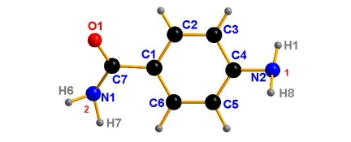 |  | A model | B model | crystal[1,2]
Bond length(Å) | C1-C7 | 1.466 | 1.502 | 1.490
Bond length(Å) | C7-O1 | 1.381 | 1.345 | 1.220
Bond length(Å) | C7-N1 | 1.446 | 1.427 | 1.353
Bond length(Å) | C4-N2 | 1.428 | 1.467 | 1.391
angle(degree) | ∠1 | 109.946 | 102.652 | 149.794
angle(degree) | ∠2 | 103.272 | 113.015 | 85.285
Torsion angle(degree) | H8-N2-C4-C5 | 33.009 | -3.891 | -47.645
Torsion angle(degree) | H1-N2-C4-C3 | -27.881 | 53.371 | -18.939
Torsion angle(degree) | O1-C7-C1-C2 | 17.530 | 36.199 | -25.468
Torsion angle(degree) | N1-C7-C1-C6 | 18.426 | 43.148 | -29.579
Torsion angle(degree) | H7-N1-C7-C1 | -2.624 | -17.776 | 32.721
Torsion angle(degree) | H6-N1-C7-O1 | -66.377 | 31.493 | -29.831
[1] Alléaume, M.,1967. Etude cristallographique de composés sulfamidés (Doctoral dissertation, Université de Bordeaux).
[2] Berkovitch-Yellin, Z., Van Mil, J., Addadi, L., Idelson, M., Lahav, M., Leiserowitz, L.,1985. Crystal morphology engineering by" tailor-made" inhibitors; a new probe to fine intermolecular interactions. J. Amer. Chem. Soc. 107(11), 3111-3122.
Fig.S1 Simulated and experimental XRD patterns of K-PABA.

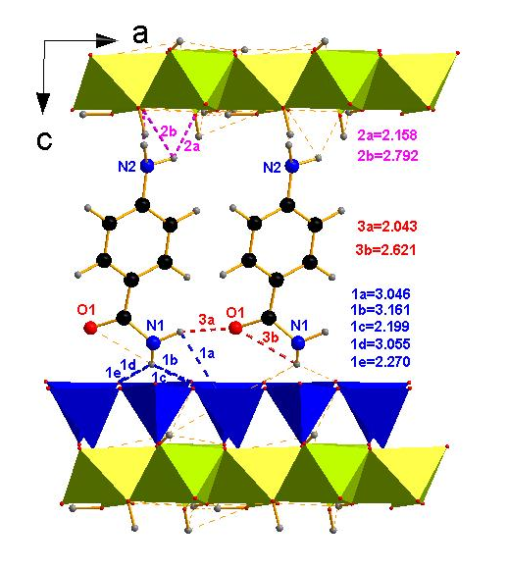
Fig.S2 The optimized structural model B of K-PABA viewed along b axis: the amino group closed to Al-sheet. Different hydrogen bonds are marked on the graph, 1 and 2 respectively refer to intermolecular hydrogen bonds formed in amino groups-kaolinite, amide groups-kaolinite, while 3 refers to intermolecular hydrogen bonds between PABA molecules.

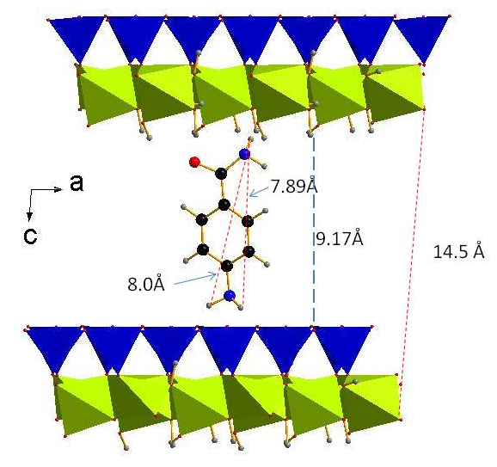
Fig.S3 Schematic diagram of molecular dimension

