Supplementary Materials

PHOTOREDUCTION OF METHYLVIOLOGEN IN SAPONITE CLAY : THE EFFECT OF ADSORPTION DENSITY OF THE METHYLVIOLOGEN ON THE REACTION EFFICIENCY

TAKUYA FUJIMURA¹*, TETSUYA SHIMADA^{2,3}, RYO SASAI¹ and SHINSUKE TAKAGI^{2,3}*

¹ Department of Materials Chemistry, Graduate School of Natural Science & Technology, Shimane University, 1060, Nishikawatsu-cho, Matsue, Shimane 690-8504, Japan
² Department of Applied Chemistry, Graduate School of Urban Environmental Sciences, Tokyo Metropolitan University, 1-1 Minami-ohsawa, Hachioji, Tokyo 192-0397, Japan
³ Center for Artificial Photosynthesis, Tokyo Metropolitan University, 1-1 Minami-osawa, Hachioji, Tokyo 192-0397, Japan
CONTENTS
Fig. S1. UV-Vis. absorption spectra of MV²⁺ aqueous solution (black dotted line), MV^{2+/}SSA complex dispersed in water (MV²⁺ adsorbed on exfoliated SSA, black broken line) and MV²⁺/SSA hybrid film (MV²⁺ was intercalated in stacked SSA sheet, black solid line).

Fig. S2. Cartoon of the co-planarization of MV²⁺ by adsorption on SSA surface.

Fig. S3. Fluorescence spectra of MV²⁺/SSA hybrid film. Loading level of MV²⁺ was set at 0.13% CEC (solid line) and 0.06% CEC (broken line), respectively.

Fig. S4. UV-Vis. absorption spectra of MV²⁺/SSA hybrid film (0.13% CEC) during UV irradiation (0 to 60 min).

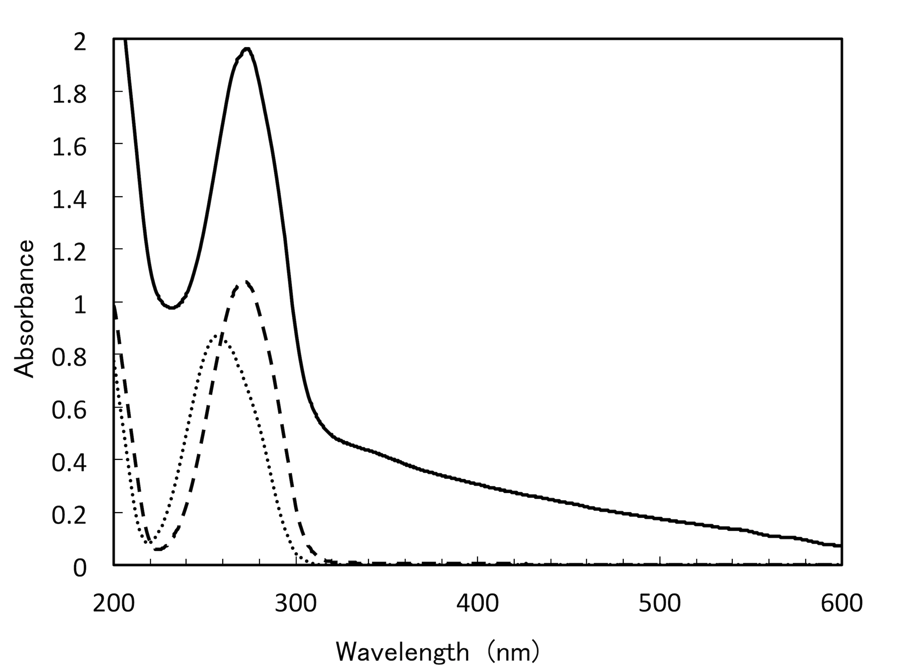
Figure S1. UV-Vis. absorption spectra of MV²⁺ aqueous solution (black dotted line), MV^{2+/}SSA complex dispersed in water (MV²⁺ adsorbed on exfoliated SSA, black broken line) and MV²⁺/SSA hybrid film (MV²⁺ was intercalated in stacked SSA sheet, black solid line).

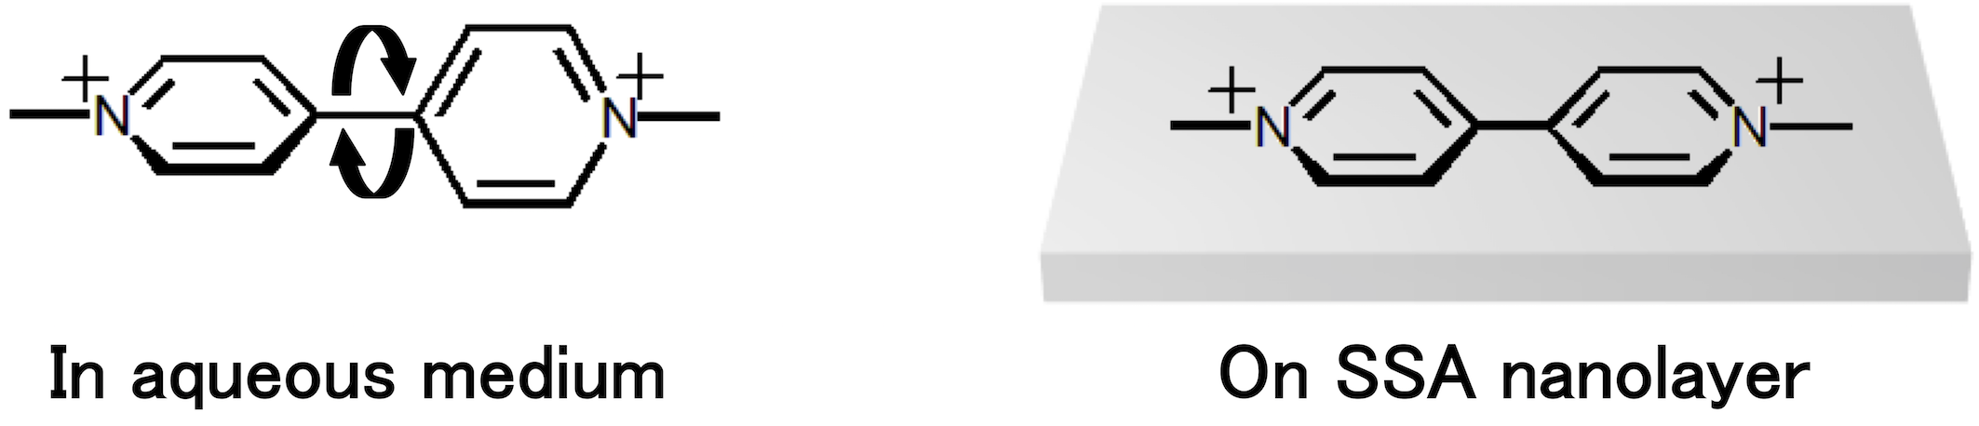
Figure S2. Cartoon of the co-planarization of MV²⁺ by adsorption on SSA surface.

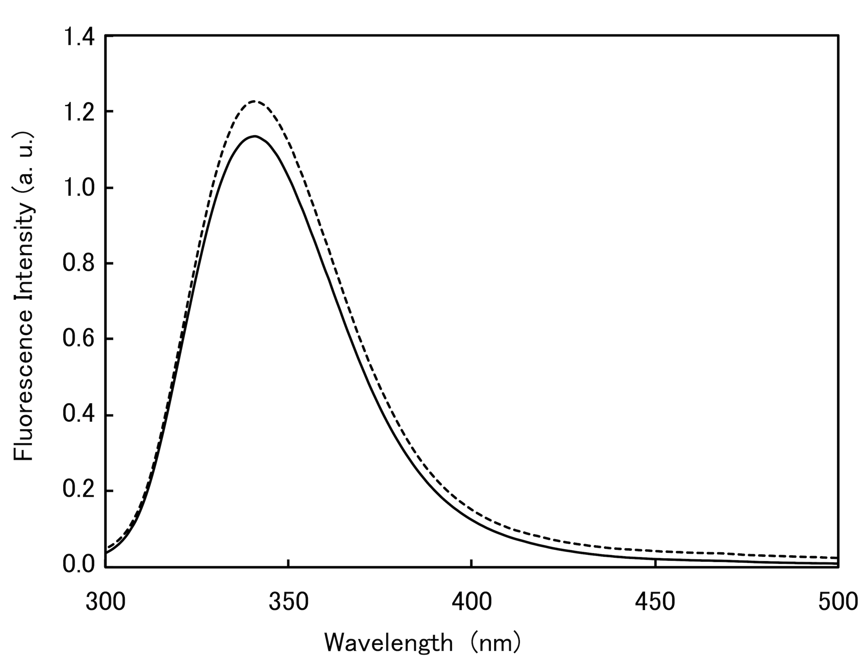
Figure S3. Fluorescence spectra of MV²⁺/SSA hybrid film. Loading level of MV²⁺ was set at 0.13% vs CEC (solid line) and 0.06% vs CEC (broken line), respectively.

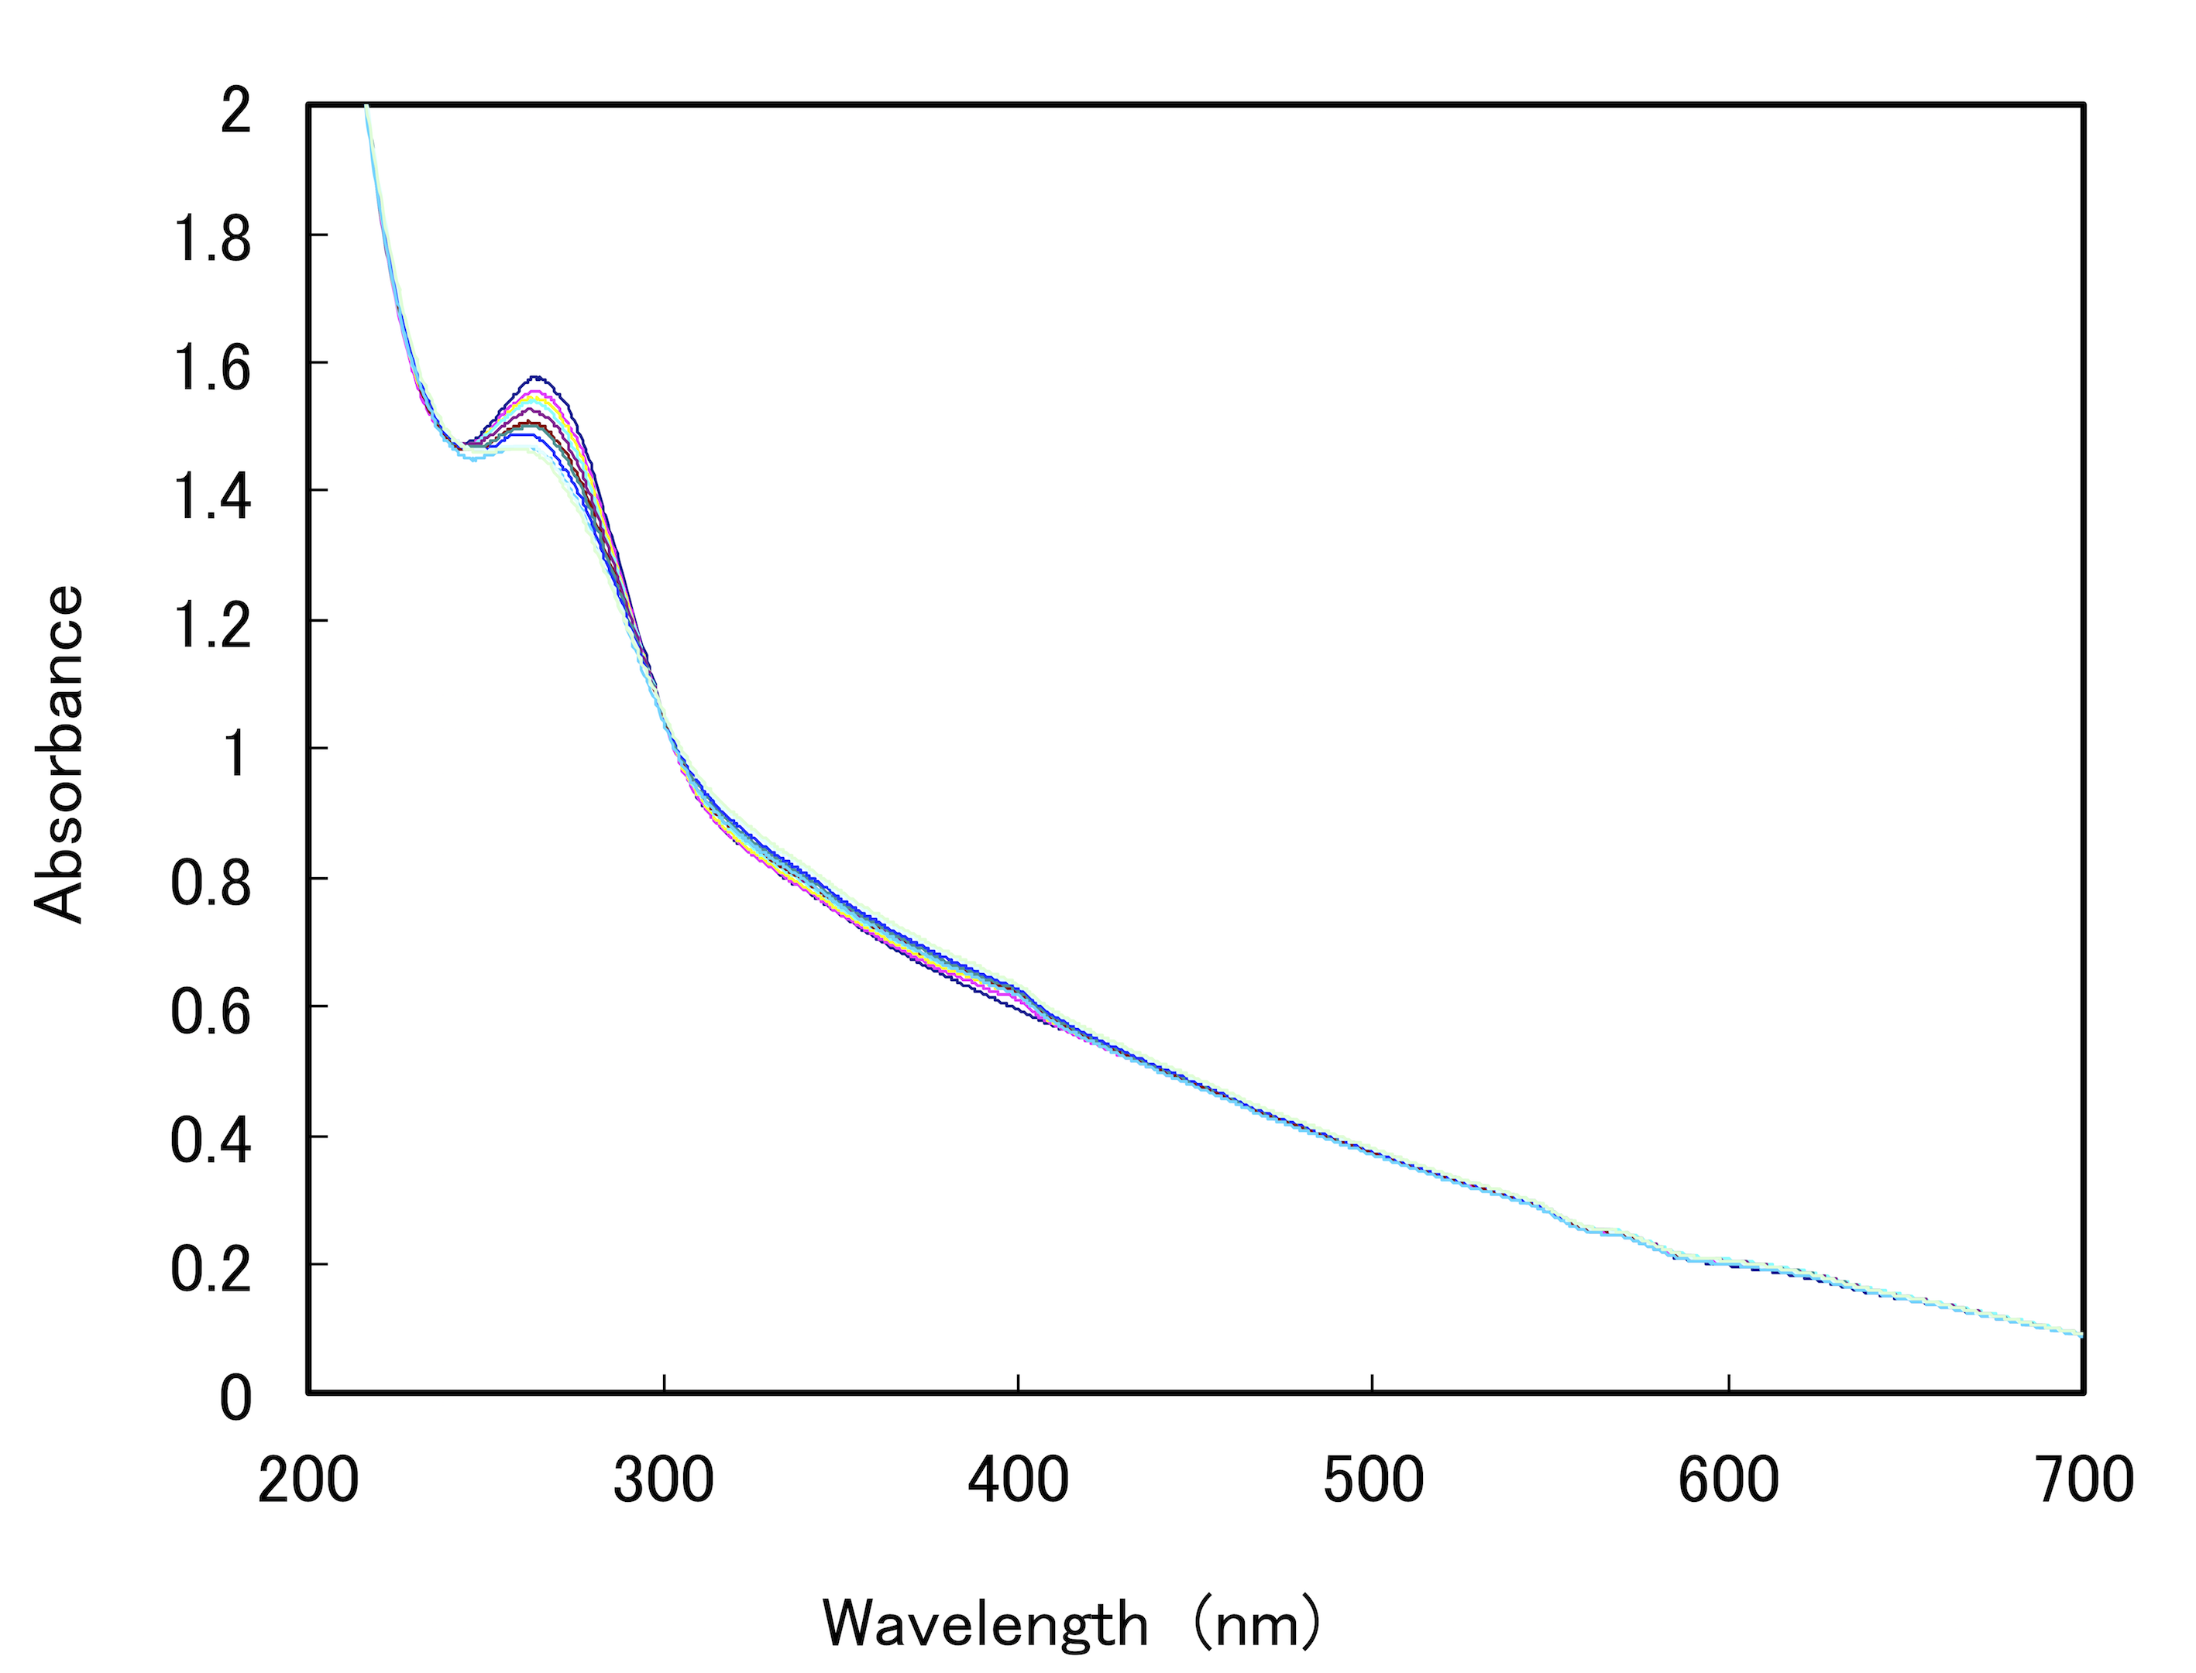
Figure S4. UV-Vis. absorption spectra of MV²⁺/SSA hybrid film (0.13% vs CEC) during UV irradiation (0 to 60 minitues).

