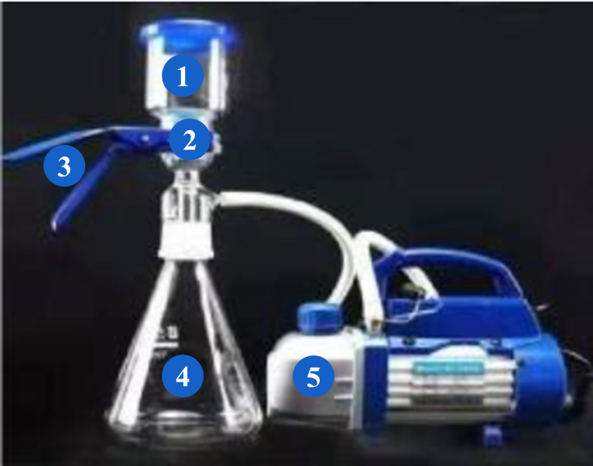 | 1- Funnel  2-0.45μm microporous membrane  3-Metal clamp  4- Flask  5-Vacuum pump
Fig. S1 Sand core filtration device

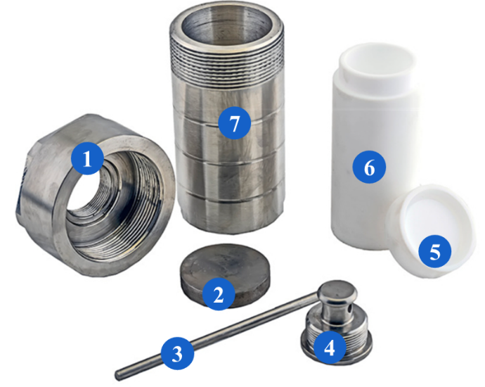 | 1-Lid of Stainless steel reactor  2-Stainless steel backing board  3-Stainless steel rod  4- Stainless steel reinforcing gland  5-Lid of PTFE reactor  6- PTFE reactor  7- Stainless steel reactor
Fig. S2 The high temperature stainless steel reactor

Fig. S3 The schematic diagram of asphaltene adsorbed on the mineral
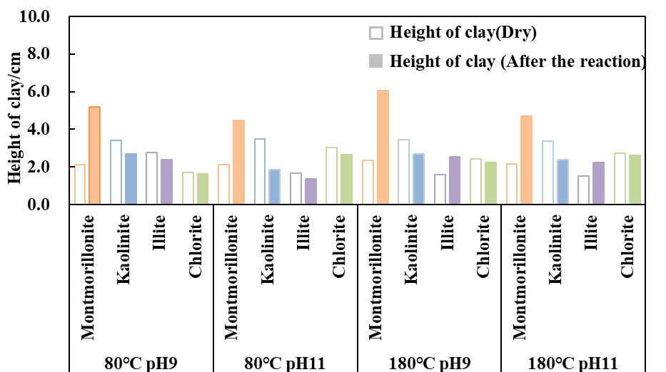
Fig. S4 Height of the clay minerals under various conditions

Table S1 The parameters of Fig. 7a
 |  | Value | Standard Error | t-Value | Prob>|t|
Quartz sand (60 mesh) | Intercept | 331.3714 | 17.9427 | 18.4683 | 0.0000
Quartz sand (60 mesh) | Slope | 0.2654 | 0.0452 | 5.8779 | 0.0020
Quartz sand (200 mesh) | Intercept | 120.0356 | 13.2983 | 9.0264 | 0.0003
Quartz sand (200 mesh) | Slope | 0.2622 | 0.0358 | 7.3306 | 0.0007
Montmorillonite (200 mesh) | Intercept | 2.3108 | 0.5057 | 4.5697 | 0.0060
Montmorillonite (200 mesh) | Slope | 0.0617 | 0.0095 | 6.4910 | 0.0013
Kaolinite (200 mesh) | Intercept | 9.3475 | 0.8766 | 10.6631 | 0.0001
Kaolinite (200 mesh) | Slope | 0.0561 | 0.0081 | 6.9311 | 0.0010
Illite (200 mesh) | Intercept | 48.3230 | 11.8667 | 4.0722 | 0.0096
Illite (200 mesh) | Slope | 0.3777 | 0.0336 | 11.2550 | 0.0001
Chlorite (200 mesh) | Intercept | 3.1734 | 0.5225 | 6.0740 | 0.0018
Chlorite (200 mesh) | Slope | 0.0620 | 0.0086 | 7.2284 | 0.0008
Table S2 The statistics of Fig. 7a
 | Quartz sand (60 mesh) | Quartz sand (200 mesh) | Montmorillonite (200 mesh) | Kaolinite (200 mesh) | Illite (200 mesh) | Chlorite (200 mesh)
Number of Points | 7 | 7 | 7 | 7 | 7 | 7
Degrees of Freedom | 5 | 5 | 5 | 5 | 5 | 5
Residual Sum of Squares | 6674.0118 | 3756.5911 | 6.0440 | 17.1383 | 3106.7610 | 6.5333
Pearson's r | 0.9347 | 0.9565 | 0.9455 | 0.9517 | 0.9808 | 0.9553
R-Square (COD) | 0.8736 | 0.9149 | 0.9357 | 0.9290 | 0.9674 | 0.8489
Adj. R-Square | 0.8483 | 0.8979 | 0.8727 | 0.8869 | 0.9544 | 0.8952
Table S3 The ANOVA of Fig. 7a
 |  | DF | Sum of Squares | Mean Square | F Value | Prob>F
Quartz sand (60 mesh) | Model | 1 | 46116.9727 | 46116.9727 | 34.5497 | 0.0020
Quartz sand (60 mesh) | Error | 5 | 6674.0118 | 1334.8024
Quartz sand (60 mesh) | Total | 6 | 52790.9846
Quartz sand (200 mesh) | Model | 1 | 40373.7013 | 40373.7013 | 53.7372 | 0.0007
Quartz sand (200 mesh) | Error | 5 | 3756.5911 | 751.3182
Quartz sand (200 mesh) | Total | 6 | 44130.2925
Montmorillonite (200 mesh) | Model | 1 | 50.9314 | 50.9314 | 42.1336 | 0.0013
Montmorillonite (200 mesh) | Error | 5 | 6.0440 | 1.2088
Montmorillonite (200 mesh) | Total | 6 | 56.9754
Kaolinite (200 mesh) | Model | 1 | 164.6665 | 164.6665 | 48.0406 | 0.0010
Kaolinite (200 mesh) | Error | 5 | 17.1383 | 3.4277
Kaolinite (200 mesh) | Total | 6 | 181.8048
Illite (200 mesh) | Model | 1 | 78709.7855 | 78709.7855 | 126.6750 | 0.0001
Illite (200 mesh) | Error | 5 | 3106.7610 | 621.3522
Illite (200 mesh) | Total | 6 | 81816.5465
Chlorite (200 mesh) | Model | 1 | 68.2729 | 68.2729 | 52.2496 | 0.0008
Chlorite (200 mesh) | Error | 5 | 6.5333 | 1.3067
Chlorite (200 mesh) | Total | 6 | 74.8063
Table S4 The parameters of Fig. 7b
 |  | Value | Standard Error | t-Value | Prob>|t|
Quartz sand (60 mesh) | Intercept | 202.0866 | 23.3165 | 8.6671 | 0.0003
Quartz sand (60 mesh) | Slope | 0.2070 | 0.0605 | 3.4201 | 0.0188
Quartz sand (200 mesh) | Intercept | 43.0438 | 2.3072 | 18.6560 | 0.0000
Quartz sand (200 mesh) | Slope | 0.0646 | 0.0087 | 7.4438 | 0.0007
Montmorillonite (200 mesh) | Intercept | 0.8707 | 0.0426 | 20.4385 | 0.0000
Montmorillonite (200 mesh) | Slope | 0.0085 | 0.0062 | 1.3645 | 0.2306
Kaolinite (200 mesh) | Intercept | 1.0733 | 0.0693 | 15.4954 | 0.0000
Kaolinite (200 mesh) | Slope | 0.0376 | 0.0047 | 8.0101 | 0.0005
Illite (200 mesh) | Intercept | 4.2405 | 0.4242 | 9.9963 | 0.0002
Illite (200 mesh) | Slope | 0.0682 | 0.0071 | 9.6022 | 0.0002
Chlorite (200 mesh) | Intercept | 0.7147 | 0.0491 | 14.5588 | 0.0000
Chlorite (200 mesh) | Slope | 0.0238 | 0.0062 | 3.8161 | 0.0124
Table S5 The statistics of Fig. 7b
 | Quartz sand (60 mesh) | Quartz sand (200 mesh) | Montmorillonite (200 mesh) | Kaolinite (200 mesh) | Illite (200 mesh) | Chlorite (200 mesh)
Number of Points | 7 | 7 | 7 | 7 | 7 | 7
Degrees of Freedom | 5 | 5 | 5 | 5 | 5 | 5
Residual Sum of Squares | 11381.0141 | 112.9191 | 0.0350 | 0.1079 | 4.1101 | 0.0508
Pearson's r | 0.8370 | 0.9577 | 0.5209 | 0.9632 | 0.9739 | 0.8628
R-Square (COD) | 0.7553 | 0.9172 | 0.7540 | 0.7556 | 0.8956 | 0.9486
Adj. R-Square | 0.6407 | 0.9007 | 0.1256 | 0.9133 | 0.9383 | 0.6933
Table S6 The ANOVA of Fig. 7b
 |  | DF | Sum of Squares | Mean Square | F Value | Prob>F
Quartz sand (60 mesh) | Model | 1 | 26624.3791 | 26624.3791 | 11.6968 | 0.0188
Quartz sand (60 mesh) | Error | 5 | 11381.0141 | 2276.2028
Quartz sand (60 mesh) | Total | 6 | 38005.3932
Quartz sand (200 mesh) | Model | 1 | 1251.3601 | 1251.3601 | 55.4096 | 0.0007
Quartz sand (200 mesh) | Error | 5 | 112.9191 | 22.5838
Quartz sand (200 mesh) | Total | 6 | 1364.2791
Montmorillonite (200 mesh) | Model | 1 | 0.0130 | 0.0130 | 1.8619 | 0.2306
Montmorillonite (200 mesh) | Error | 5 | 0.0350 | 0.0070
Montmorillonite (200 mesh) | Total | 6 | 0.0480
Kaolinite (200 mesh) | Model | 1 | 1.3845 | 1.3845 | 64.1610 | 0.0005
Kaolinite (200 mesh) | Error | 5 | 0.1079 | 0.0216
Kaolinite (200 mesh) | Total | 6 | 1.4924
Illite (200 mesh) | Model | 1 | 75.7912 | 75.7912 | 92.2022 | 0.0002
Illite (200 mesh) | Error | 5 | 4.1101 | 0.8220
Illite (200 mesh) | Total | 6 | 79.9013
Chlorite (200 mesh) | Model | 1 | 0.1479 | 0.1479 | 14.5628 | 0.0124
Chlorite (200 mesh) | Error | 5 | 0.0508 | 0.0102
Chlorite (200 mesh) | Total | 6 | 0.1987
Table S7 The parameters of Fig. 8a
 |  | Value | Standard Error | t-Value | Prob>|t|
Quartz sand (60 mesh) | Intercept | 200.0165 | 25.1126 | 7.9648 | 0.0005
Quartz sand (60 mesh) | Slope | 6.2630 | 0.0592 | 105.8294 | 0.0000
Quartz sand (200 mesh) | Intercept | 155.7049 | 10.6927 | 14.5617 | 0.0000
Quartz sand (200 mesh) | Slope | 0.6497 | 0.0278 | 23.3922 | 0.0000
Montmorillonite (200 mesh) | Intercept | 22.8970 | 8.3817 | 2.7318 | 0.0412
Montmorillonite (200 mesh) | Slope | 0.4477 | 0.0240 | 18.6210 | 0.0000
Kaolinite (200 mesh) | Intercept | 25.9598 | 6.2369 | 4.1623 | 0.0088
Kaolinite (200 mesh) | Slope | 0.7103 | 0.0155 | 45.7701 | 0.0000
Illite (200 mesh) | Intercept | 64.8197 | 7.4379 | 8.7148 | 0.0003
Illite (200 mesh) | Slope | 1.0873 | 0.0182 | 59.6395 | 0.0000
Chlorite (200 mesh) | Intercept | 25.4224 | 7.1930 | 3.5343 | 0.0167
Chlorite (200 mesh) | Slope | 0.5058 | 0.0177 | 28.5381 | 0.0000
Table S8 The statistics of Fig. 8a
 | Quartz sand (60 mesh) | Quartz sand (200 mesh) | Montmorillonite (200 mesh) | Kaolinite (200 mesh) | Illite (200 mesh) | Chlorite (200 mesh)
Number of Points | 7 | 7 | 7 | 7 | 7 | 7
Degrees of Freedom | 5 | 5 | 5 | 5 | 5 | 5
Residual Sum of Squares | 13060.0123 | 2398.1972 | 1614.5079 | 897.4346 | 1200.1857 | 1200.9475
Pearson's r | 0.9998 | 0.9955 | 0.9929 | 0.9988 | 0.9993 | 0.9969
R-Square (COD) | 0.9996 | 0.9909 | 0.9903 | 0.9988 | 0.9992 | 0.9963
Adj. R-Square | 0.9995 | 0.9891 | 0.9829 | 0.9971 | 0.9983 | 0.9927
Table S9 The ANOVA of Fig. 8a
 |  | DF | Sum of Squares | Mean Square | F Value | Prob>F
Quartz sand (60 mesh) | Model | 1 | 29254100.0000 | 29254100.0000 | 11199.8714 | 1.4E-09
Quartz sand (60 mesh) | Error | 5 | 13060.0123 | 2612.0025
Quartz sand (60 mesh) | Total | 6 | 29267200.0000
Quartz sand (200 mesh) | Model | 1 | 262456.1832 | 262456.1832 | 547.1948 | 2.7E-06
Quartz sand (200 mesh) | Error | 5 | 2398.1972 | 479.6394
Quartz sand (200 mesh) | Total | 6 | 264854.3804
Montmorillonite (200 mesh) | Model | 1 | 111963.8950 | 111963.8950 | 346.7431 | 8.2E-06
Montmorillonite (200 mesh) | Error | 5 | 1614.5079 | 322.9016
Montmorillonite (200 mesh) | Total | 6 | 113578.4029
Kaolinite (200 mesh) | Model | 1 | 376007.4192 | 376007.4192 | 2094.9016 | 9.4E-08
Kaolinite (200 mesh) | Error | 5 | 897.4346 | 179.4869
Kaolinite (200 mesh) | Total | 6 | 376904.8537
Illite (200 mesh) | Model | 1 | 853781.7914 | 853781.7914 | 3556.8737 | 2.5E-08
Illite (200 mesh) | Error | 5 | 1200.1857 | 240.0371
Illite (200 mesh) | Total | 6 | 854981.9772
Chlorite (200 mesh) | Model | 1 | 195615.8874 | 195615.8874 | 814.4231 | 9.9E-07
Chlorite (200 mesh) | Error | 5 | 1200.9475 | 240.1895
Chlorite (200 mesh) | Total | 6 | 196816.8349
Table S10 The parameters of Fig. 8b
 |  | Value | Standard Error | t-Value | Prob>|t|
Quartz sand (60 mesh) | Intercept | 207.3681 | 29.2335 | 7.0935 | 0.0009
Quartz sand (60 mesh) | Slope | 2.5643 | 0.0690 | 37.1622 | 0.0000
Quartz sand (200 mesh) | Intercept | 113.8163 | 12.7957 | 8.8949 | 0.0003
Quartz sand (200 mesh) | Slope | 0.6735 | 0.0320 | 21.0803 | 0.0000
Montmorillonite (200 mesh) | Intercept | 14.8691 | 3.1523 | 4.7169 | 0.0053
Montmorillonite (200 mesh) | Slope | 0.1824 | 0.0133 | 13.7066 | 0.0000
Kaolinite (200 mesh) | Intercept | 25.7601 | 7.9468 | 3.2416 | 0.0229
Kaolinite (200 mesh) | Slope | 0.4133 | 0.0222 | 18.6043 | 0.0000
Illite (200 mesh) | Intercept | 72.9262 | 6.4822 | 11.2503 | 0.0001
Illite (200 mesh) | Slope | 0.2973 | 0.0181 | 16.4508 | 0.0000
Chlorite (200 mesh) | Intercept | 20.3701 | 4.7526 | 4.2861 | 0.0078
Chlorite (200 mesh) | Slope | 0.2383 | 0.0148 | 16.1012 | 0.0000
Table S11 The statistics of Fig. 8b
 | Quartz sand (60 mesh) | Quartz sand (200 mesh) | Montmorillonite (200 mesh) | Kaolinite (200 mesh) | Illite (200 mesh) | Chlorite (200 mesh)
Number of Points | 7 | 7 | 7 | 7 | 7 | 7
Degrees of Freedom | 5 | 5 | 5 | 5 | 5 | 5
Residual Sum of Squares | 17930.8232 | 3495.6113 | 228.3608 | 1459.8942 | 913.5904 | 526.4574
Pearson's r | 0.9982 | 0.9944 | 0.9870 | 0.9929 | 0.9909 | 0.9905
R-Square (COD) | 0.9964 | 0.9903 | 0.9741 | 0.9858 | 0.9819 | 0.9811
Adj. R-Square | 0.9957 | 0.9867 | 0.9689 | 0.9829 | 0.9782 | 0.9773
Table S12 The ANOVA of Fig. 8b
 |  | DF | Sum of Squares | Mean Square | F Value | Prob>F
Quartz sand (60 mesh) | Model | 1 | 4952595.1308 | 4952595.1308 | 1381.0284 | 2.66E-07
Quartz sand (60 mesh) | Error | 5 | 17930.8232 | 3586.1646
Quartz sand (60 mesh) | Total | 6 | 4970525.9539
Quartz sand (200 mesh) | Model | 1 | 310676.4537 | 310676.4537 | 444.3807 | 4.45E-06
Quartz sand (200 mesh) | Error | 5 | 3495.6113 | 699.1223
Quartz sand (200 mesh) | Total | 6 | 314172.0650
Montmorillonite (200 mesh) | Model | 1 | 8580.5077 | 8580.5077 | 187.8717 | 3.71E-05
Montmorillonite (200 mesh) | Error | 5 | 228.3608 | 45.6722
Montmorillonite (200 mesh) | Total | 6 | 8808.8685
Kaolinite (200 mesh) | Model | 1 | 101059.9126 | 101059.9126 | 346.1207 | 8.26E-06
Kaolinite (200 mesh) | Error | 5 | 1459.8942 | 291.9788
Kaolinite (200 mesh) | Total | 6 | 102519.8068
Illite (200 mesh) | Model | 1 | 49448.9377 | 49448.9377 | 270.6297 | 1.51E-05
Illite (200 mesh) | Error | 5 | 913.5904 | 182.7181
Illite (200 mesh) | Total | 6 | 50362.5281
Chlorite (200 mesh) | Model | 1 | 27296.4864 | 27296.4864 | 259.2469 | 1.68E-05
Chlorite (200 mesh) | Error | 5 | 526.4574 | 105.2915
Chlorite (200 mesh) | Total | 6 | 27822.9438
Table S13 The parameters of Fig. 9a
 |  | Value | Standard Error | t-Value | Prob>|t|
Quartz sand (60 mesh) | Intercept | -5.1318 | 0.0269 | -190.7853 | 7.51E-11
Quartz sand (60 mesh) | Slope | 0.8266 | 0.0054 | 152.4539 | 2.30E-10
Quartz sand (200 mesh) | Intercept | -3.6197 | 0.0334 | -108.3711 | 1.27E-09
Quartz sand (200 mesh) | Slope | 0.6790 | 0.0069 | 97.9810 | 2.10E-09
Montmorillonite (200 mesh) | Intercept | -0.3051 | 0.0356 | -8.5682 | 3.57E-04
Montmorillonite (200 mesh) | Slope | 0.5887 | 0.0128 | 45.8707 | 9.30E-08
Kaolinite (200 mesh) | Intercept | -1.6510 | 0.0411 | -40.1959 | 1.80E-07
Kaolinite (200 mesh) | Slope | 0.7402 | 0.0116 | 63.8155 | 1.79E-08
Illite (200 mesh) | Intercept | -2.0416 | 0.0879 | -23.2396 | 2.75E-06
Illite (200 mesh) | Slope | 0.4378 | 0.0189 | 23.1685 | 2.79E-06
Chlorite (200 mesh) | Intercept | -0.7080 | 0.0717 | -9.8742 | 1.82E-04
Chlorite (200 mesh) | Slope | 0.6578 | 0.0253 | 26.0241 | 1.57E-06
Table S14 The statistics of Fig. 9a
 | Quartz sand (60 mesh) | Quartz sand (200 mesh) | Montmorillonite (200 mesh) | Kaolinite (200 mesh) | Illite (200 mesh) | Chlorite (200 mesh)
Number of Points | 7 | 7 | 7 | 7 | 7 | 7
Degrees of Freedom | 5 | 5 | 5 | 5 | 5 | 5
Residual Sum of Squares | 0.0016 | 0.0029 | 0.0183 | 0.0094 | 0.0268 | 0.0627
Pearson's r | 0.9999 | 0.9997 | 0.9988 | 0.9994 | 0.9954 | 0.9963
R-Square (COD) | 0.9998 | 0.9995 | 0.9976 | 0.9988 | 0.9908 | 0.9927
Adj. R-Square | 0.9997 | 0.9994 | 0.9972 | 0.9985 | 0.9889 | 0.9912

Table S15 The ANOVA of Fig. 9a
 |  | DF | Sum of Squares | Mean Square | F Value | Prob>F
Quartz sand (60 mesh) | Model | 1 | 7.2036 | 7.2036 | 23242.1824 | 2.30E-10
Quartz sand (60 mesh) | Error | 5 | 0.0016 | 0.0003
Quartz sand (60 mesh) | Total | 6 | 7.2052
Quartz sand (200 mesh) | Model | 1 | 5.6136 | 5.6136 | 9600.2666 | 2.10E-09
Quartz sand (200 mesh) | Error | 5 | 0.0029 | 0.0006
Quartz sand (200 mesh) | Total | 6 | 5.6165
Montmorillonite (200 mesh) | Model | 1 | 7.6821 | 7.6821 | 2104.1250 | 9.30E-08
Montmorillonite (200 mesh) | Error | 5 | 0.0183 | 0.0037
Montmorillonite (200 mesh) | Total | 6 | 7.7003
Kaolinite (200 mesh) | Model | 1 | 7.6343 | 7.6343 | 4072.4237 | 1.79E-08
Kaolinite (200 mesh) | Error | 5 | 0.0094 | 0.0019
Kaolinite (200 mesh) | Total | 6 | 7.6437
Illite (200 mesh) | Model | 1 | 2.8742 | 2.8742 | 536.7794 | 2.79E-06
Illite (200 mesh) | Error | 5 | 0.0268 | 0.0054
Illite (200 mesh) | Total | 6 | 2.9010
Chlorite (200 mesh) | Model | 1 | 8.4914 | 8.4914 | 677.2560 | 1.57E-06
Chlorite (200 mesh) | Error | 5 | 0.0627 | 0.0125
Chlorite (200 mesh) | Total | 6 | 8.5541
Table S16 The parameters of Fig. 9b
 |  | Value | Standard Error | t-Value | Prob>|t|
Quartz sand (60 mesh) | Intercept | -4.3528 | 0.1272 | -34.2098 | 4.01E-07
Quartz sand (60 mesh) | Slope | 0.7609 | 0.0260 | 29.3217 | 8.65E-07
Quartz sand (200 mesh) | Intercept | -3.1541 | 0.0926 | -34.0574 | 4.10E-07
Quartz sand (200 mesh) | Slope | 0.8153 | 0.0205 | 39.7777 | 1.89E-07
Montmorillonite (200 mesh) | Intercept | 0.0716 | 0.0436 | 1.6428 | 1.61E-01
Montmorillonite (200 mesh) | Slope | 1.1015 | 0.0335 | 32.8568 | 4.91E-07
Kaolinite (200 mesh) | Intercept | -0.0726 | 0.0535 | -1.3564 | 2.33E-01
Kaolinite (200 mesh) | Slope | 0.9413 | 0.0332 | 28.3352 | 1.03E-06
Illite (200 mesh) | Intercept | -1.1383 | 0.0856 | -13.2949 | 4.30E-05
Illite (200 mesh) | Slope | 0.7432 | 0.0290 | 25.6197 | 1.69E-06
Chlorite (200 mesh) | Intercept | 0.3807 | 0.0440 | 8.6558 | 3.40E-04
Chlorite (200 mesh) | Slope | 0.8236 | 0.0281 | 29.3225 | 8.65E-07
Table S17 The statistics of Fig. 9b
 | Quartz sand (60 mesh) | Quartz sand (200 mesh) | Montmorillonite (200 mesh) | Kaolinite (200 mesh) | Illite (200 mesh) | Chlorite (200 mesh)
Number of Points | 7 | 7 | 7 | 7 | 7 | 7
Degrees of Freedom | 5 | 5 | 5 | 5 | 5 | 5
Residual Sum of Squares | 0.0374 | 0.0241 | 0.0402 | 0.0536 | 0.0543 | 0.0522
Pearson's r | 0.9971 | 0.9984 | 0.9977 | 0.9969 | 0.9962 | 0.9971
R-Square (COD) | 0.9942 | 0.9968 | 0.9954 | 0.9937 | 0.9909 | 0.9917
Adj. R-Square | 0.9931 | 0.9962 | 0.9945 | 0.9926 | 0.9909 | 0.9931
Table S18 The ANOVA of Fig. 9b
 |  | DF | Sum of Squares | Mean Square | F Value | Prob>F
Quartz sand (60 mesh) | Model | 1 | 6.4273 | 6.4273 | 859.7589 | 8.65E-07
Quartz sand (60 mesh) | Error | 5 | 0.0374 | 0.0075
Quartz sand (60 mesh) | Total | 6 | 6.4646
Quartz sand (200 mesh) | Model | 1 | 7.6183 | 7.6183 | 1582.2675 | 1.89E-07
Quartz sand (200 mesh) | Error | 5 | 0.0241 | 0.0048
Quartz sand (200 mesh) | Total | 6 | 7.6424
Montmorillonite (200 mesh) | Model | 1 | 8.6789 | 8.6789 | 1079.5664 | 4.91E-07
Montmorillonite (200 mesh) | Error | 5 | 0.0402 | 0.0080
Montmorillonite (200 mesh) | Total | 6 | 8.7191
Kaolinite (200 mesh) | Model | 1 | 8.6031 | 8.6031 | 802.8834 | 1.03E-06
Kaolinite (200 mesh) | Error | 5 | 0.0536 | 0.0107
Kaolinite (200 mesh) | Total | 6 | 8.6567
Illite (200 mesh) | Model | 1 | 7.1287 | 7.1287 | 656.3682 | 1.69E-06
Illite (200 mesh) | Error | 5 | 0.0543 | 0.0109
Illite (200 mesh) | Total | 6 | 7.1830
Chlorite (200 mesh) | Model | 1 | 8.9758 | 8.9758 | 859.8107 | 8.65E-07
Chlorite (200 mesh) | Error | 5 | 0.0522 | 0.0104
Chlorite (200 mesh) | Total | 6 | 9.0280
Table S19 The parameters of Fig. 10a
 |  | Value | Standard Error | t-Value | Prob>|t|
Quartz sand (60 mesh) | Intercept | -3.3727 | 0.2805 | -12.0227 | 7.02E-05
Quartz sand (60 mesh) | Slope | 0.2432 | 0.0559 | 4.3533 | 7.34E-03
Quartz sand (200 mesh) | Intercept | -3.6069 | 0.1854 | -19.4559 | 6.62E-06
Quartz sand (200 mesh) | Slope | 0.5808 | 0.0379 | 15.3370 | 2.14E-05
Montmorillonite (200 mesh) | Intercept | -1.0255 | 0.0767 | -13.3716 | 4.19E-05
Montmorillonite (200 mesh) | Slope | 0.2701 | 0.0172 | 15.7135 | 1.90E-05
Kaolinite (200 mesh) | Intercept | -1.2627 | 0.1233 | -10.2410 | 1.52E-04
Kaolinite (200 mesh) | Slope | 0.2448 | 0.0267 | 9.1651 | 2.59E-04
Illite (200 mesh) | Intercept | -2.1763 | 0.2214 | -9.8291 | 1.86E-04
Illite (200 mesh) | Slope | 0.3182 | 0.0456 | 6.9759 | 9.31E-04
Chlorite (200 mesh) | Intercept | -1.1735 | 0.0925 | -12.6904 | 5.40E-05
Chlorite (200 mesh) | Slope | 0.2750 | 0.0201 | 13.6552 | 3.78E-05
Table 20S The statistics of FIG 11a
 | Quartz sand (60 mesh) | Quartz sand (200 mesh) | Montmorillonite (200 mesh) | Kaolinite (200 mesh) | Illite (200 mesh) | Chlorite (200 mesh)
Number of Points | 7 | 7 | 7 | 7 | 7 | 7
Degrees of Freedom | 5 | 5 | 5 | 5 | 5 | 5
Residual Sum of Squares | 0.1670 | 0.0806 | 0.0313 | 0.0667 | 0.1354 | 0.0393
Pearson's r | 0.8895 | 0.9895 | 0.9900 | 0.9715 | 0.9523 | 0.9869
R-Square (COD) | 0.7912 | 0.9792 | 0.9802 | 0.9438 | 0.9068 | 0.9739
Adj. R-Square | 0.7495 | 0.9750 | 0.9762 | 0.9326 | 0.8882 | 0.9687
Table S21 The ANOVA of Fig. 10a
 |  | DF | Sum of Squares | Mean Square | F Value | Prob>F
Quartz sand (60 mesh) | Model | 1 | 0.6328 | 0.6328 | 18.9510 | 7.34E-03
Quartz sand (60 mesh) | Error | 5 | 0.1670 | 0.0334
Quartz sand (60 mesh) | Total | 6 | 0.7998
Quartz sand (200 mesh) | Model | 1 | 3.7930 | 3.7930 | 235.2228 | 2.14E-05
Quartz sand (200 mesh) | Error | 5 | 0.0806 | 0.0161
Quartz sand (200 mesh) | Total | 6 | 3.8736
Montmorillonite (200 mesh) | Model | 1 | 1.5436 | 1.5436 | 246.9155 | 1.90E-05
Montmorillonite (200 mesh) | Error | 5 | 0.0313 | 0.0063
Montmorillonite (200 mesh) | Total | 6 | 1.5749
Kaolinite (200 mesh) | Model | 1 | 1.1202 | 1.1202 | 83.9985 | 2.59E-04
Kaolinite (200 mesh) | Error | 5 | 0.0667 | 0.0133
Kaolinite (200 mesh) | Total | 6 | 1.1869
Illite (200 mesh) | Model | 1 | 1.3182 | 1.3182 | 48.6634 | 9.31E-04
Illite (200 mesh) | Error | 5 | 0.1354 | 0.0271
Illite (200 mesh) | Total | 6 | 1.4536
Chlorite (200 mesh) | Model | 1 | 1.4666 | 1.4666 | 186.4639 | 3.78E-05
Chlorite (200 mesh) | Error | 5 | 0.0393 | 0.0079
Chlorite (200 mesh) | Total | 6 | 1.5059
Table S22 The parameters of Fig. 10b
 |  | Value | Standard Error | t-Value | Prob>|t|
Quartz sand (60 mesh) | Intercept | -3.1983 | 0.2285 | -13.9943 | 3.35E-05
Quartz sand (60 mesh) | Slope | 0.3349 | 0.0458 | 7.3102 | 7.50E-04
Quartz sand (200 mesh) | Intercept | -2.9917 | 0.1506 | -19.8709 | 5.96E-06
Quartz sand (200 mesh) | Slope | 0.4895 | 0.0308 | 15.9212 | 1.78E-05
Montmorillonite (200 mesh) | Intercept | -1.2529 | 0.0504 | -24.8715 | 1.96E-06
Montmorillonite (200 mesh) | Slope | 0.4571 | 0.0122 | 37.4591 | 2.55E-07
Kaolinite (200 mesh) | Intercept | -1.1620 | 0.0440 | -26.4158 | 1.45E-06
Kaolinite (200 mesh) | Slope | 0.2985 | 0.0098 | 30.4478 | 7.17E-07
Illite (200 mesh) | Intercept | -2.9489 | 0.1008 | -29.2575 | 8.74E-07
Illite (200 mesh) | Slope | 0.5984 | 0.0213 | 28.1193 | 1.07E-06
Chlorite (200 mesh) | Intercept | -1.2965 | 0.0595 | -21.8068 | 3.76E-06
Chlorite (200 mesh) | Slope | 0.4048 | 0.0137 | 29.6561 | 8.17E-07
Table S23 The statistics of Fig. 10b
 | Quartz sand (60 mesh) | Quartz sand (200 mesh) | Montmorillonite (200 mesh) | Kaolinite (200 mesh) | Illite (200 mesh) | Chlorite (200 mesh)
Number of Points | 7 | 7 | 7 | 7 | 7 | 7
Degrees of Freedom | 5 | 5 | 5 | 5 | 5 | 5
Residual Sum of Squares | 0.1171 | 0.0556 | 0.0151 | 0.0102 | 0.0292 | 0.0199
Pearson's r | 0.9563 | 0.9903 | 0.9982 | 0.9973 | 0.9969 | 0.9972
R-Square (COD) | 0.9144 | 0.9807 | 0.9964 | 0.9946 | 0.9937 | 0.9943
Adj. R-Square | 0.8973 | 0.9768 | 0.9957 | 0.9936 | 0.9925 | 0.9932
Table S24 The ANOVA of Fig. 10b
 |  | DF | Sum of Squares | Mean Square | F Value | Prob>F
Quartz sand (60 mesh) | Model | 1 | 1.2514 | 1.2514 | 53.4395 | 7.50E-04
Quartz sand (60 mesh) | Error | 5 | 0.1171 | 0.0234
Quartz sand (60 mesh) | Total | 6 | 1.3685
Quartz sand (200 mesh) | Model | 1 | 2.8197 | 2.8197 | 253.4831 | 1.78E-05
Quartz sand (200 mesh) | Error | 5 | 0.0556 | 0.0111
Quartz sand (200 mesh) | Total | 6 | 2.8754
Montmorillonite (200 mesh) | Model | 1 | 4.2339 | 4.2339 | 1403.1825 | 2.55E-07
Montmorillonite (200 mesh) | Error | 5 | 0.0151 | 0.0030
Montmorillonite (200 mesh) | Total | 6 | 4.2490
Kaolinite 200 mesh) | Model | 1 | 1.8919 | 1.8919 | 927.0675 | 7.17E-07
Kaolinite 200 mesh) | Error | 5 | 0.0102 | 0.0020
Kaolinite 200 mesh) | Total | 6 | 1.9021
Illite (200 mesh) | Model | 1 | 4.6187 | 4.6187 | 790.6959 | 1.07E-06
Illite (200 mesh) | Error | 5 | 0.0292 | 0.0058
Illite (200 mesh) | Total | 6 | 4.6479
Chlorite (200 mesh) | Model | 1 | 3.4909 | 3.4909 | 879.4869 | 8.17E-07
Chlorite (200 mesh) | Error | 5 | 0.0199 | 0.0040
Chlorite (200 mesh) | Total | 6 | 3.5107

