Comparison of pretreatment methods for organic-matter removal and their effects on the hydrogen isotope (δ²H) composition of kaolinite

Arpita Samanta^{1,}*, M. K. Bera², Sruthi P. Sreenivasan², and Anindya Sarkar²

Supplementary Material

Following Ledoux & White (1964; Figure S1), the [A] site is supposed to contain 2 OH– ions in 7.13 Å, so a total of ((2000/7)*2 = ) 572 OH– ions are present in a 0.2 μm-sized clay crystal. Similarly, the [B] site will contain a total of ((2000/8.92)*6=) 1346 OH– ions in a 0.2 μm-sized clay crystal. A total of ((2000²/(7.13*8.92))*8=) 503148 OH– ions should be found in the [C] and [D] sites of the 0.2 μm-sized clay crystal. The ratio of ‘outer hydroxyl,’ i.e. combined [A] and [B], to ‘inner-surface hydroxyls,’ i.e. combined [C] and [D], would be [{(2*572)+(2*1346)}:[503148-{(2*572)+(2*1346)]] ≈ 1:130. Now a complete exchange of the kaolinite’s outer hydroxyl ions by H₂O₂ having a δ²H value of −235‰ and Na₂S₂O₈-treated kaolinite δ²H value of ~−53‰ would only change the δ²H values of the clay by ~−1.4‰.

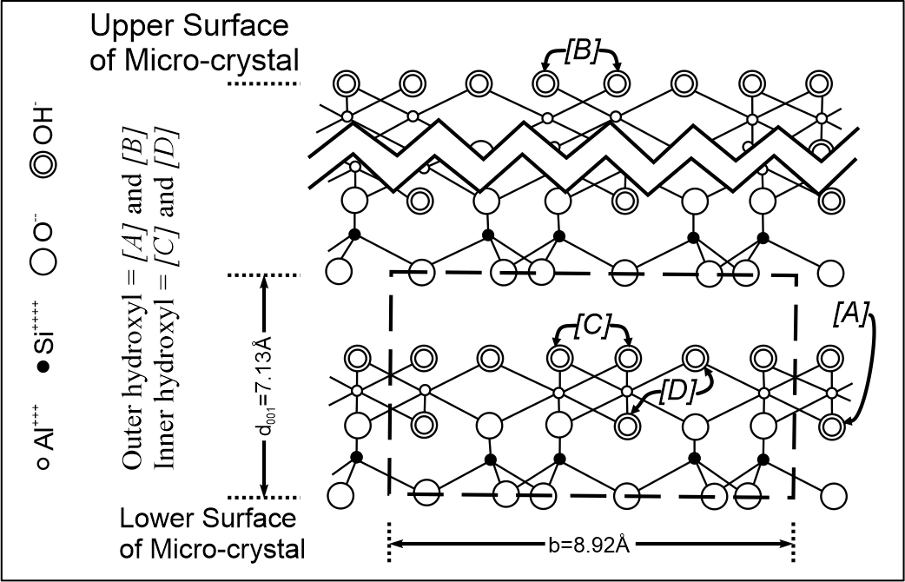

Figure S1: Projection of the kaolinite crystal structure on the (100) plane (modified after Ledoux & White, 1964)

