Supplementary Data:
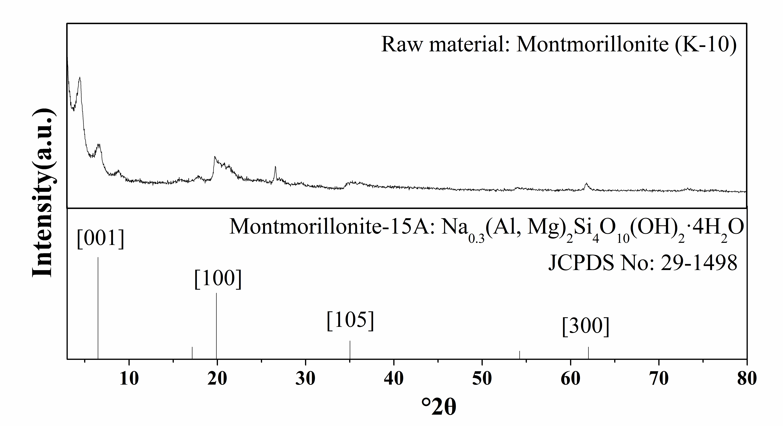
Figure S1. The XRD spectra of raw material montmorillonite.
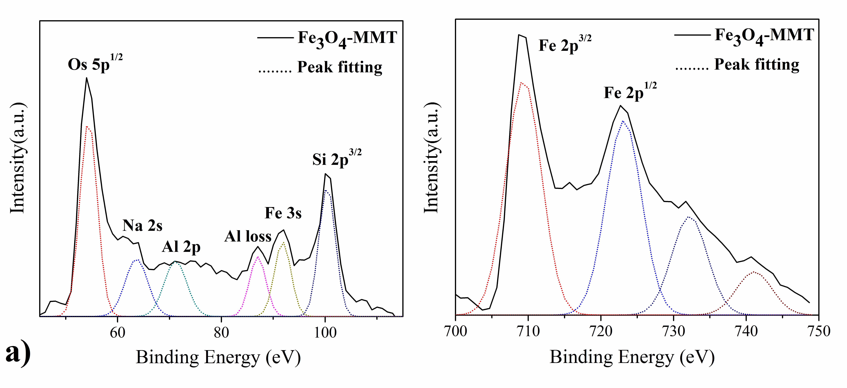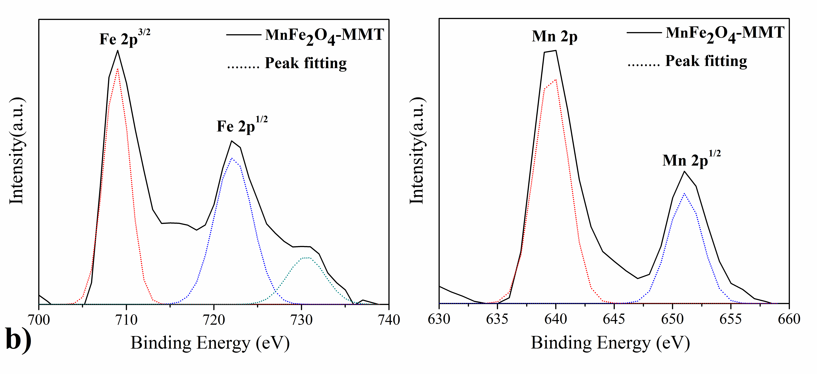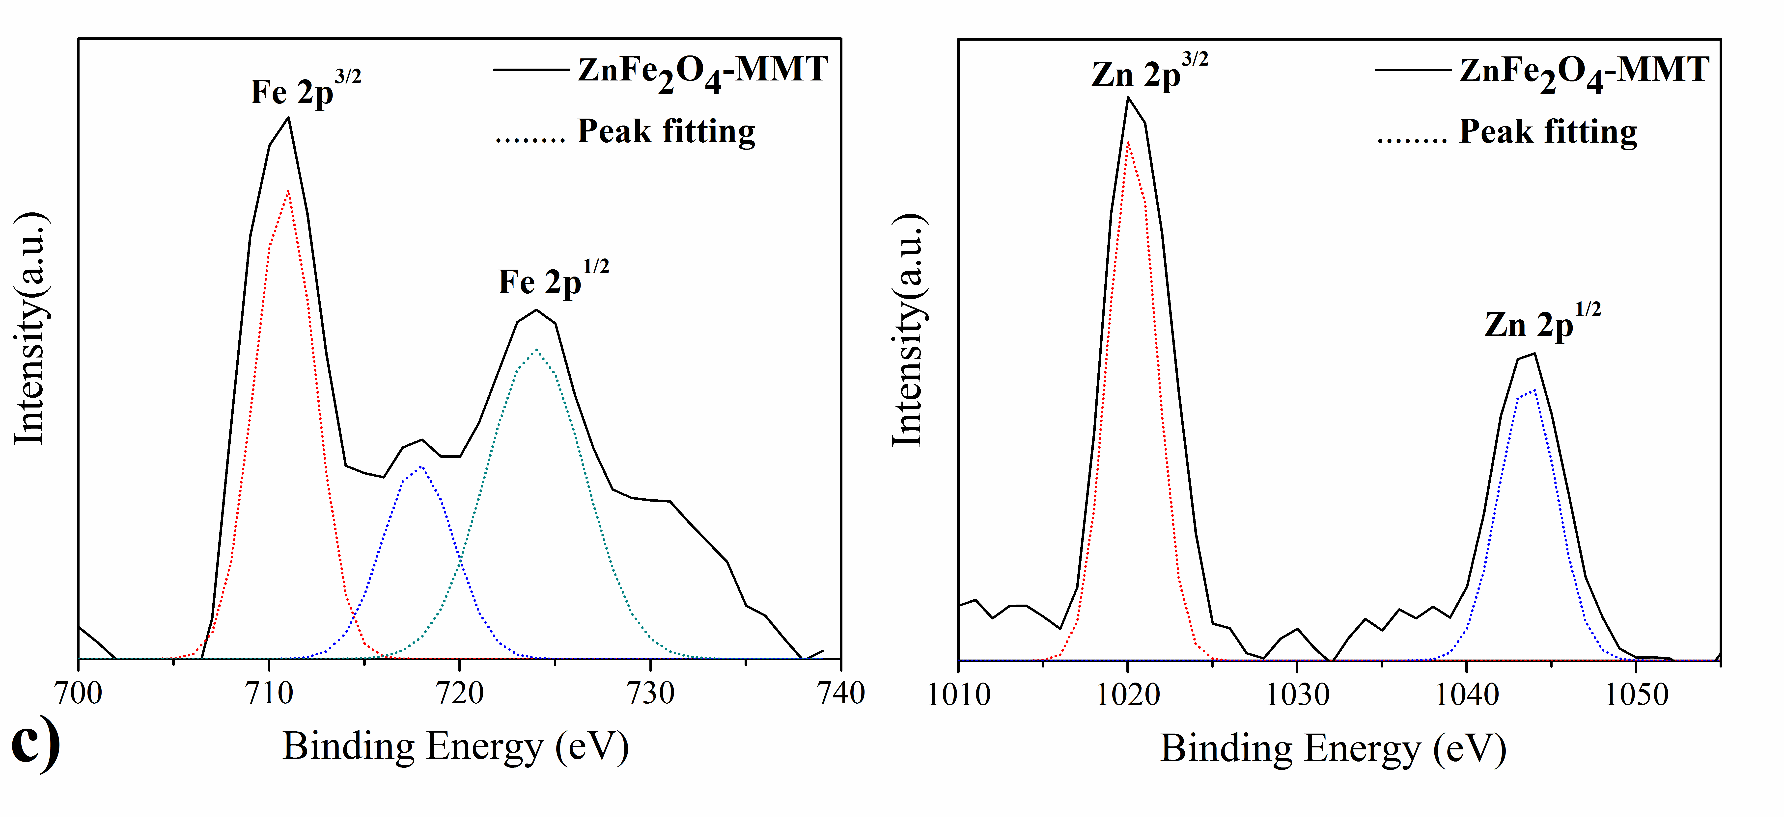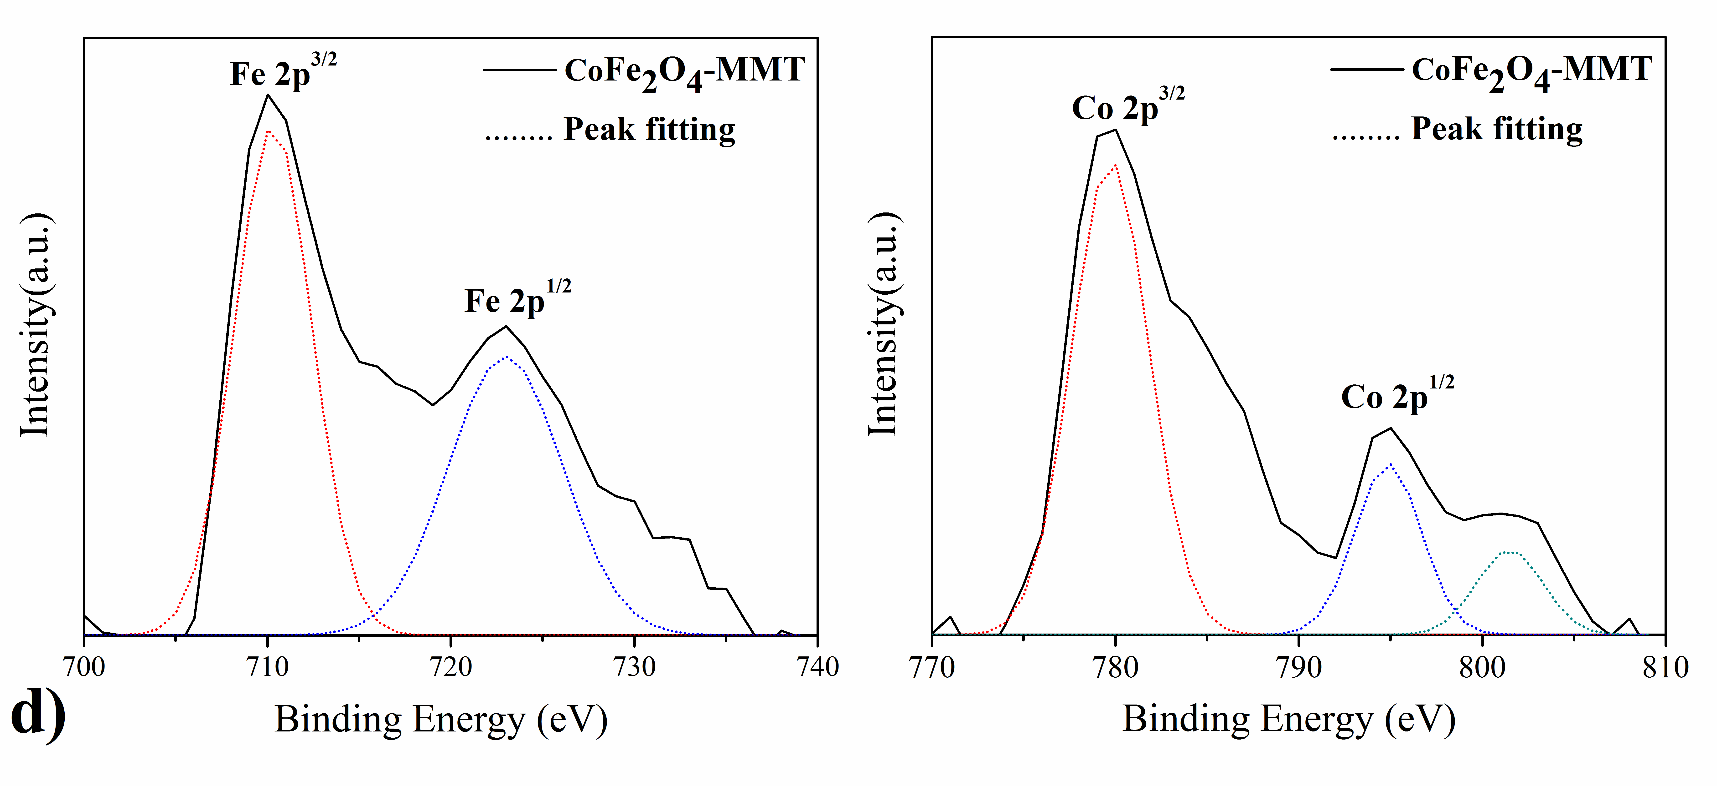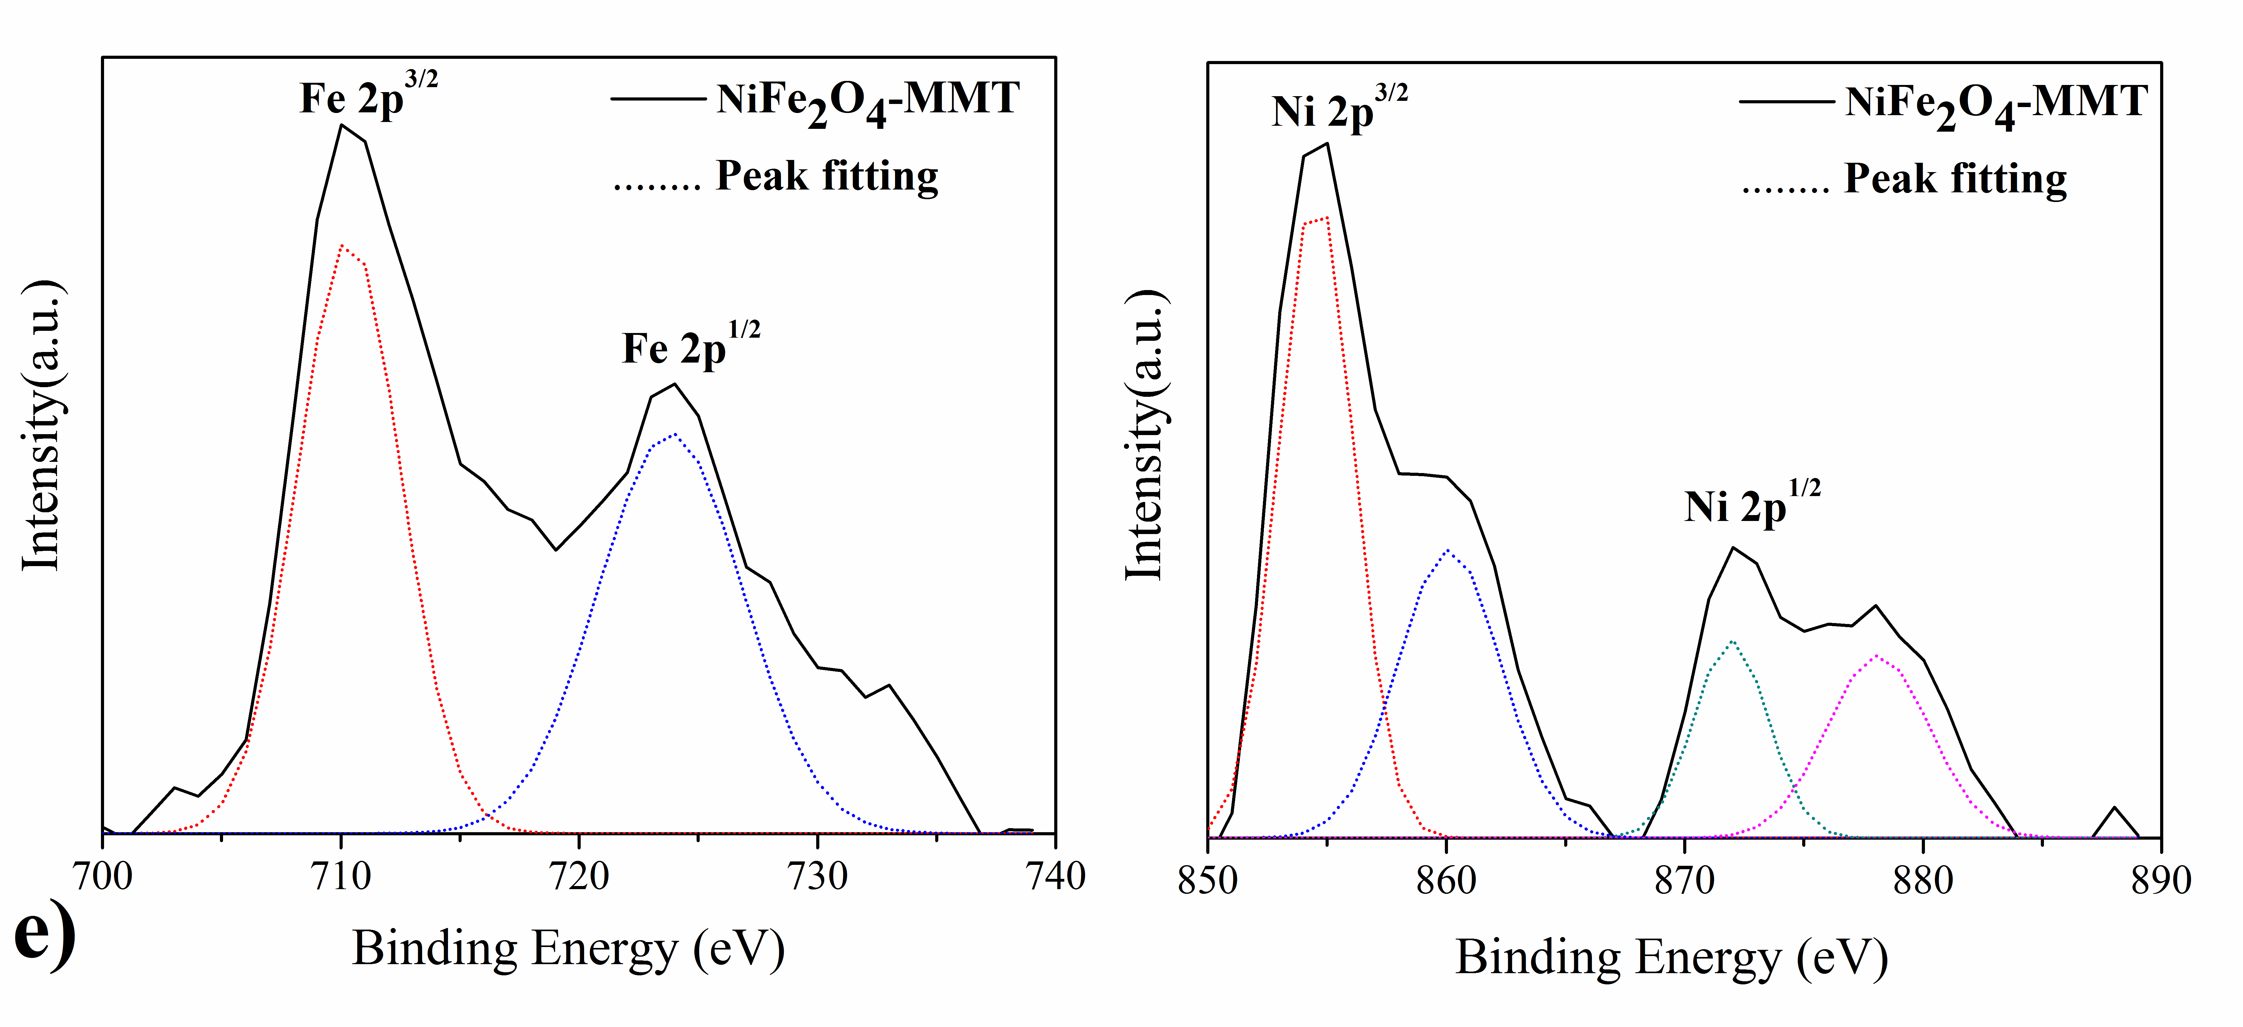
Figure S2. The XPS spectras and the peak-fitting data of MFe₂O₄-montmorillonite. a) Fe₃O₄-montmorillonite. b) MnFe₂O₄-montmorillonite. c) ZnFe₂O₄-montmorillonite. d) CoFe₂O₄-montmorillonite. e) NiFe₂O₄-montmorillonite.

Table S1. The actual adsorption capacities and the metal ion removal rate of MFe₂O₄-montmorillonite adsorbent in the initial ions concentration of 60 mg·g⁻¹.
MFe₂O₄-montmorillonite |  | the actual adsorption capacity  (C₀=60 mg·L⁻¹) | X^{n+} Removal rate | MFe₂O₄-montmorillonite |  | the actual adsorption capacity  (C₀=60 mg·L⁻¹) | X^{n+} Removal rate
Ions | M | qe(mg·g⁻¹) | % | Ions | M | qe(mg·g⁻¹) | %
UO₂²⁺ | Fe | 28.4 | 28.4 | Mn²⁺ | Fe | 68.0 | 68.0
UO₂²⁺ | Mn | 25.4 | 25.4 | Mn²⁺ | Mn | 28.9 | 28.9
UO₂²⁺ | Zn | 40.8 | 40.8 | Mn²⁺ | Zn | 70.6 | 70.6
UO₂²⁺ | Co | 21.8 | 21.8 | Mn²⁺ | Co | 69.7 | 69.7
UO₂²⁺ | Ni | 43.4 | 43.4 | Mn²⁺ | Ni | 70.8 | 70.8
Cr³⁺ | Fe | 84.3 | 84.3 | Ni²⁺ | Fe | 74.5 | 74.5
Cr³⁺ | Mn | 74.2 | 74.2 | Ni²⁺ | Mn | 66.2 | 66.2
Cr³⁺ | Zn | 89.2 | 89.2 | Ni²⁺ | Zn | 75.7 | 75.7
Cr³⁺ | Co | 85.1 | 85.1 | Ni²⁺ | Co | 75.1 | 75.1
Cr³⁺ | Ni | 82.6 | 82.6 | Ni²⁺ | Ni | 61.5 | 61.5
Rb⁺ | Fe | 15.1 | 15.1 | Zn²⁺ | Fe | 53.6 | 53.6
Rb⁺ | Mn | 13.4 | 13.4 | Zn²⁺ | Mn | 45.6 | 45.6
Rb⁺ | Zn | 15.1 | 15.1 | Zn²⁺ | Zn | 46.9 | 46.9
Rb⁺ | Co | 14.8 | 14.8 | Zn²⁺ | Co | 55.2 | 55.2
Rb⁺ | Ni | 16.2 | 16.2 | Zn²⁺ | Ni | 56.6 | 56.6
Sr²⁺ | Fe | 36.4 | 36.4 | Cd²⁺ | Fe | 21.6 | 21.6
Sr²⁺ | Mn | 53.9 | 53.9 | Cd²⁺ | Mn | 18.6 | 18.6
Sr²⁺ | Zn | 35.7 | 35.7 | Cd²⁺ | Zn | 26.5 | 26.5
Sr²⁺ | Co | 56.3 | 56.3 | Cd²⁺ | Co | 22.9 | 22.9
Sr²⁺ | Ni | 31.4 | 31.4 | Cd²⁺ | Ni | 25.8 | 25.8

