SUPPLEMENTARY INFORMATION
Insights into glyphosate adsorption in aqueous solutions using Zn-Al layered double oxide
Emanoel Hottes¹, Glauco Favilla Bauerfeldt¹, Clarissa Oliveira da Silvaª, Rosane Nora Castro¹, Marcelo Hawrylak Herbst^{1,}*
¹Instituto de Química, Universidade Federal Rural do Rio de Janeiro, Seropédica, RJ, Brazil

*E-mail: herbst@ufrrj.br
Fig. S1. FTIR/ATR spectrum of pristine glyphosate

Fig. S2. ³¹P CP-MAS for glyphosate: a pristine and b glyphosate/Zn₂Al-LDO

Fig. S3. ¹³C CP-MAS for glyphosate: a pristine and b glyphosate/Zn₂Al-LDO.

Fig. S4. Langmuir isotherm linear model at a 25 °C, b 35 °C, and c 45 °C
Increase the size of the text in the axes.
In the axis labels, replace the periods in the units with spaces. Change C_{e} to C_{e}
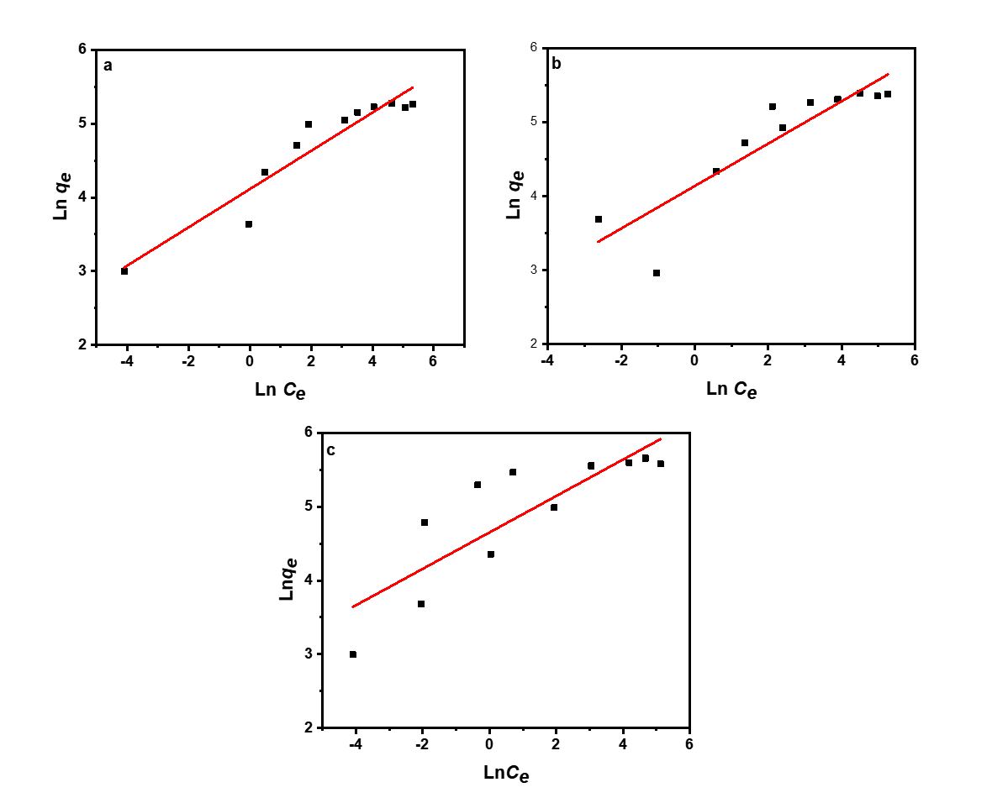
Fig. S5. Freundlich isotherm linear model at a 25°C, b 35°C, and c 45°C
Change C_{e} to C_{e} and q_{e} to q_{e}

Fig. S6. Temkin isotherm linear model at a 25°C, b 35°C, and c 45°C

Increase the size of the text in the axes. Change C_{e} to C_{e} and q_{e} to q_{e}

The Langmuir linear equation is as follows:

$$\frac{C_{e}}{q_{e}}=\frac{C_{e}}{Q_{max}}+\frac{1}{K_{L}Q_{max}}$$

where q_{e} (μg g⁻¹) is the equilibrium adsorption amount; C_{e} (μg mL⁻¹) is the equilibrium concentration; q_{max} (μg mg⁻¹) is the maximum amount adsorbed; and K_{L} is the equilibrium adsorption constant (Langmuir, 1918; Tan & Hameed, 2017; Rosset et al., 2020).

The linearized Freundlich equation is described as follows:

$$lnq_{e}=lnK_{f}+\frac{1}{n}lnC_{e}$$

where, q_{e} (μg mg⁻¹) is the equilibrium adsorption amount; C_{e} (μg mL^{–1}) is the equilibrium concentration; and K_{f} is the equilibrium adsorption constant (Freundlich, 1907; Tan & Hameed, 2017; Rosset et al., 2020). The linearized Temkin equation can be described as follows:

$$q_{e}=BlnA+BlnC_{e}$$

where, A and B are Temkin constants; q_{e} (μg mg^{–1}) is the equilibrium adsorption amount; and C_{e} (μg mL⁻¹) is the equilibrium concentration (Tan & Hameed, 2017; Rosset et al., 2020).

References

Abdellaoui, K., Pavlovic, I., Bouhent, M., Benhamou, A., & Barriga, C. (2017). A comparative study of the amaranth azo dye adsorption/desorption from aqueous solutions by layered double hydroxides. Applied Clay Science, 143, 142–150.

Aisawa, S., Takahashi, S., Ogasawara, W., Umetsu, Y., & Narita, E. (2001). Direct intercalation of amino acids into layered double hydroxides by coprecipitation. Journal of Solid State Chemistry, 62, 52–62.

Dabizha, A. & Kersten, M. (2022) Aqueous solubility of Zn incorporated into Mg-Al-layered double hydroxides. Clays and Clay Minerals, 70, 34–47.

Freundlich, H. (1907). Über die adsorption in lösungen. Zeitschrift für physikalische Chemie, 57(1), 385-470.

Giles, C.H. & Smith, D. (1973). A general treatment and classification of the solute adsorption isotherm. Department of Mathematics, University of Strathdyde, Glasgow G1, Scotland, 47, 755–765.

Langmuir, I. (1918). The adsorption of gases on plane surfaces of glass, mica and platinum. Journal of the American Chemical society, 40(9), 1361-1403.

Li, Y., Bi, H.Y., Li, H., & Jin, Y.S. (2016). Adsorption of Cu(II) on rhamnolipid-layered double hydroxide nanocomposite. Clays and Clay Minerals, 64, 560–570.

Pachayappan, L. & Kamath, P.V. (2019). Effect of Hydration on Polytypism and Disorder in the Sulfate-Intercalated Layered Double Hydroxides of Li and Al. Clays and Clay Minerals, 67, 154–162.

Rosset, M., Weidlich, L., Edith, G., & Hidalgo, N. (2019). Adsorbents derived from hydrotalcites for the removal of diclofenac in wastewater. Applied Clay Science, 175, 150–158.

Rosset, M., Weidlich, L., Perez-Lopez, O.W., & Amaral, L. (2020). Effect of concentration in the equilibrium and kinetics of adsorption of acetylsalicylic acid on ZnAl layered double hydroxide. Journal of Environmental Chemical Engineering, 8, 103991.

Tan, K.L. & Hameed, B.H. (2017). Insight into the adsorption kinetics models for the removal of contaminants from aqueous solutions. Journal of the Taiwan Institute of Chemical Engineers, 74, 25–48.

Zubair, M., Daud, M., McKay, G., Shehzad, F., & Al-Harthi, M.A. (2017). Recent progress in layered double hydroxides ( LDH )-containing hybrids as adsorbents for water remediation. Applied Clay Science, 143, 279–292.

