Supplementary Information
Influence of mineral composition and firing temperature on the micro- and mesoporosity of replicate archaeological ceramics
Jan-Michael C. Cayme^{a,*}, Rasmus Palm^{a,b}, Peeter Somelar^{c}, Signe Vahurª, Ivo Leitoª, Ester Oras^{a,d,e}
ª Institute of Chemistry, University of Tartu, Ravila 14A, 50411, Tartu, Estonia
^{b} Department of Applied Physics, KTH Royal Institute of Technology, SE-106 91 Stockholm, Sweden
^{c} Department of Geology, University of Tartu, Ravila 14A, 50411, Tartu, Estonia
^{d} Department of Archaeology, University of Tartu, Jakobi 2, 51014, Tartu, Estonia
^{e} Swedish Collegium for Advanced Study (SCAS), Linneanum, Thunbergsvägen 2, 752 38, Uppsala, Sweden
*Corresponding author: E-mail: jan-michael.cayme@ut.ee

Table S1 Mass percentage of mineral components in the unfired raw materials and fired briquettes using quantitative XRD

Raw Materials/ Fired Briquettes | Mass Ratios |  |  | 2:1 group | Kaolinite | Quartz | K-feldspar | Plagioclase | Hematite | Calcite | Dolomite | Anatase | Amphibole | Portlandite | Lime | Larnite | Merwinite | Brownmillerite
 | % Clay | % Sand | % Chalk
RC- 1 | 100 | - | - | 51.4 | 14.2 | 26.6 | 2.9 |  | 4.0 |  |  | 0.8
RC-2 | 100 | - | - | 48.4 | 14.2 | 28.9 | 3.4 |  | 4.0 | tr. |  | 0.6
RC-3 | 100 | - | - | 49.1 | 13.8 | 29.6 | 2.9 |  | 4.1 |  |  | tr.
WC-1 | 100 | - | - | 15.8 | 73.6 | 3.8 | 6.7
WC-2 | 100 | - | - | 18.3 | 73.8 | 2.7 | 5.2
WC-3 | 100 | - | - | 18.6 | 73.3 | 2.6 | 5.4
CH-1 | - | - | 100 |  |  | tr. |  |  |  | 98.8 | 0.9
CH-2 | - | - | 100 |  |  | tr. |  |  |  | 98.8 | 1.0
CH-3 | - | - | 100 |  |  | tr. |  |  |  | 98.8 | 0.9
S-1 | - | 100 | - | 4.0 |  | 74.6 | 9.5 | 7.3 |  | tr. | 3.0 |  | 1.1
S-2 | - | 100 | - | 6.2 | tr. | 73.8 | 7.7 | 7.2 |  | tr. | 3.7 |  | 1.0
S-3 | - | 100 | - | 5.9 | tr. | 73.8 | 6.9 | 8.3 |  | tr. | 3.8 |  | 0.9
RC600-S1 | 15 | 85 | - | 9.8 |  | 71.2 | 9.5 | 5.7 | 0.6 | 1.4 | 1.8
RC600-S2 | 20 | 80 | - | 10.3 |  | 69.6 | 9.2 | 6.0 | 0.9 | 1.8 | 2.2
RC600-S3 | 25 | 75 | - | 9.9 |  | 69.6 | 9.6 | 6.5 | 1.1 | 1.2 | 2.2
RC600-S4 | 50 | 50 | - | 21.8 |  | 61.7 | 5.1 | 5.3 | 1.3 | 1.3 | 2.5 |  | 1.1
RC600-S5 | 75 | 25 | - | 44.7 |  | 42.9 | 3.4 | 4.0 | 3.3 | 0.7 | 1.0
RC600-S6 | 100 | 0 | - | 55.3 |  | 34.8 | 1.6 | 2.5 | 3.9 | 1.4 | tr.
RC800-S1 | 15 | 85 | - | 4.7 |  | 78.1 | 10.1 | 6.1 | tr. | tr. | tr.
RC800-S2 | 20 | 80 | - | 5.3 |  | 75.8 | 10.5 | 6.5 | 0.6 | 0.7 | tr.
RC800-S3 | 25 | 75 | - | 13.8 |  | 71.4 | 6.9 | 6.2 | 0.8 | tr. | tr.
RC800-S4 | 50 | 50 | - | 18.0 |  | 64.7 | 7.3 | 6.9 | 1.8 | 0.8 | 0.6
RC800-S5 | 75 | 25 | - | 38.1 |  | 50.4 | 3.8 | 3.9 | 2.3 | 0.6 | 0.8
RC800-S6 | 100 | 0 | - | 56.4 |  | 32.6 | 1.2 | 3.3 | 3.9 |  | 1.0 | 1.5
RC600-CH1 | 20 | 32 | 48 | 5.9 |  | 31.7 | 6.4 |  | 1.5 | 51.9 | 2.6
RC600-CH2 | 25 | 30 | 45 | 6.0 |  | 32.7 | 4.2 | 3.6 | 1.9 | 49.1 | 2.3
RC600-CH3 | 50 | 20 | 30 | 22.2 |  | 32.7 | 3.6 | 2.8 | 2.7 | 34.6 | 1.3
RC600-CH4 | 75 | 10 | 15 | 38.9 |  | 32.9 | 3.9 | 2.7 | 3.9 | 16.7 | 1.1
RC600-CH5 | 90 | 5 | 5 | 39.4 |  | 38.7 | 5.9 | 5.5 | 2.1 | 7.6 | 0.8
RC800-CH1 | 20 | 32 | 48 | 3.5 |  | 38.2 | 5.8 | 4.6 | 2.4 | 0.6 |  |  |  | 16.2 | 6.8 | 18.2 | 2.8 | 1.0
RC800-CH2 | 25 | 30 | 45 | 3.5 |  | 41.3 | 5.5 | 4.5 | 1.3 | 1.0 |  |  |  | 18.5 | 4.7 | 16.7 | 1.2 | 1.9
RC800-CH3 | 50 | 20 | 30 | 18.7 |  | 43.0 | 5.7 | 5.0 | 3.5 | 1.0 |  |  |  | 6.3 | 3.8 | 10.4 | 1.9 | tr.
RC800-CH4 | 75 | 10 | 15 | 31.9 |  | 42.9 | 6.0 | 5.4 | 4.1 | 0.7 |  |  |  | 1.8 | 1.6 | 4.3 | 1.3
RC800-CH5 | 90 | 5 | 5 | 46.5 |  | 38.2 | 3.4 | 3.5 | 4.2 | 0.6 |  |  |  |  | 1.5 | 1.4 | 0.6
WC600-S1 | 15 | 85 | - | 3.6 |  | 74.7 | 8.4 | 8.0 |  | 1.2 | 2.9 |  | 1.2
WC600-S2 | 20 | 80 | - | 10.5 |  | 70.9 | 6.7 | 7.0 |  | 1.5 | 2.5 |  | 0.9
WC600-S3 | 25 | 75 | - | 12.0 |  | 67.4 | 6.8 | 7.7 |  | 1.5 | 3.8 |  | 0.8
WC600-S4 | 50 | 50 | - | 19.0 |  | 61.7 | 5.7 | 7.5 |  | 1.5 | 2.7 |  | 1.8
WC600-S5 | 75 | 25 | - | 37.1 |  | 47.1 | 6.7 | 5.4 |  |  | 3.7
WC600-S6 | 100 | 0 | - | 65.7 |  | 19.3 | 8.9 | 2.6 |  |  | 1.7
WC800-S1 | 15 | 85 | - | 2.9 |  | 76.1 | 8.5 | 7.6 |  |  |  |  | 4.3 | tr. | 0.6
WC800-S2 | 20 | 80 | - | 10.6 |  | 68.4 | 13.6 | 6.5 |  |  |  |  |  | tr. | 0.8
WC800-S3 | 25 | 75 | - | 11.9 |  | 65.7 | 15.7 | 5.8 |  |  |  |  |  |  | 0.8
WC800-S4 | 50 | 50 | - | 15.4 |  | 57.6 | 19.0 | 7.4 |  |  |  |  |  |  | 0.7
WC800-S5 | 75 | 25 | - | 25.3 |  | 46.5 | 20.0 | 7.7 |  |  |  |  |  |  | 0.5
WC800-S6 | 100 | 0 | - | 53.2 |  | 20.4 | 20.2 | 5.1 |  |  |  |  |  |  | 0.7
WC600-CH1 | 20 | 32 | 48 | 5.6 |  | 29.3 | 5.7 | 5.2 |  | 51.7 | 2.5
WC600-CH2 | 25 | 30 | 45 | 7.8 |  | 31.2 | 3.1 | 4.5 |  | 51.0 | 2.4
WC600-CH3 | 50 | 20 | 30 | 17.8 |  | 26.9 | 3.6 | 3.6 |  | 45.1 | 3.0
WC600-CH4 | 75 | 10 | 15 | 39.3 |  | 21.6 | 5.1 | 1.2 |  | 31.5 | 1.3
WC600-CH5 | 90 | 5 | 5 | 54.6 |  | 23.9 | 5.7 | 1.9 |  | 12.5 | 1.4
WC800-CH1 | 20 | 32 | 48 | 3.6 |  | 43.2 | 6.7 | 5.9 |  | 1.4 | 0.9 |  |  | 17.3 | 9.6 | 10.1 | 1.3
WC800-CH2 | 25 | 30 | 45 | 4.5 |  | 40.2 | 8.3 | 5.4 |  | 1.4 | tr. |  |  | 15.9 | 12.5 | 9.9 | 1.0
WC800-CH3 | 50 | 20 | 30 | 10.1 |  | 39.7 | 9.2 | 6.2 |  | 1.6 | tr. |  |  | 6.5 | 18.2 | 7.5 | tr.
WC800-CH4 | 75 | 10 | 15 | 33.7 |  | 35.3 | 9.9 | 7.3 |  | tr. |  |  |  | 1.1 | 8.8 | 3.2 | tr.
WC800-CH5 | 90 | 5 | 5 | 45.3 |  | 28.9 | 10.8 | 9.2 |  |  |  |  |  | tr. | 2.9 | 2.4

The raw materials are RC (illite and mixed layered illite-smectite) clay, WC (kaolinite) clay, CH (chalk), and S (sand). The raw materials were tested in triplicates or three different preparations of unoriented powder, labelled as 1, 2, and 3, respectively. The numbers 600 and 800 in the briquette codes denote firing temperatures at 600°C and 800°C. The percentage weight amount of clay and tempers used to make the reference pottery briquettes are also shown in the table. Trace amounts are denoted by “tr.”.

Table S2 Surface area and pore volume parameters obtained from the N₂ adsorption data for samples of the reference pottery briquettes
Fired Briquettes | Specific surface area |  |  | Specific Pore volume
 | S_{BET}  (m² g⁻¹) | S_{NLDFT}  (m² g⁻¹) | S_{micro}  (%) | V_{0.95}  (mm³ g⁻¹) | V_{NLDFT}  (mm³ g⁻¹) | V_{micro}  (%)
RC with sand temper at 600°C
RC600-S1 | 5.3 | 4.3 | 62 | 9.7 | 5.0 | 22
RC600-S2 | 7.6 | 8.4 | 59 | 14 | 9.3 | 18
RC600-S3 | 8.3 | 9.4 | 60 | 15 | 10 | 18
RC600-S4 | 18 | 20 | 57 | 33 | 23 | 17
RC600-S5 | 30 | 35 | 55 | 56 | 40 | 16
RC600-S6 | 40 | 46 | 51 | 75 | 57 | 16
RC with sand temper at 800°C
RC800-S1 | 5.4 | 5.5 | 48 | 11 | 7.3 | 14
RC800-S2 | 7.7 | 9.5 | 49 | 15 | 13 | 13
RC800-S3 | 9.0 | 10 | 51 | 18 | 13 | 14
RC800-S4 | 18 | 22 | 50 | 35 | 28 | 14
RC800-S5 | 25 | 32 | 50 | 52 | 42 | 13
RC800-S6 | 35 | 44 | 48 | 74 | 59 | 13
WC with sand temper at 600°C
WC600-S1 | 1.7 | 2.1 | 58 | 3.8 | 2.8 | 16
WC600-S2 | 2.2 | 2.6 | 61 | 4.9 | 3.4 | 17
WC600-S3 | 2.6 | 3.0 | 61 | 5.5 | 3.9 | 18
WC600-S4 | 4.6 | 5.7 | 54 | 10 | 8.0 | 15
WC600-S5 | 6.3 | 8.1 | 56 | 15 | 11 | 15
WC600-S6 | 8.6 | 11 | 53 | 20 | 16 | 14
WC with sand temper at 800°C
WC800-S1 | 2.3 | 2.8 | 55 | 4.8 | 3.7 | 16
WC800-S2 | 2.9 | 3.5 | 55 | 5.8 | 4.6 | 16
WC800-S3 | 3.2 | 4.1 | 54 | 6.6 | 5.3 | 16
WC800-S4 | 4.6 | 5.8 | 52 | 10 | 8.2 | 14
WC800-S5 | 6.3 | 8.0 | 54 | 14 | 11 | 15
WC800-S6 | 8.2 | 10 | 51 | 19 | 15 | 14
RC with chalk and sand tempers at 600°C
RC600-CH1 | 6.1 | 6.2 | 57 | 11 | 7.7 | 21
RC600-CH2 | 7.0 | 6.5 | 68 | 13 | 6.5 | 22
RC600-CH3 | 16 | 15 | 70 | 30 | 15 | 23
RC600-CH4 | 26 | 31 | 62 | 52 | 34 | 18
RC600-CH5 | 29 | 35 | 62 | 58 | 39 | 18
RC with chalk and sand tempers at 800°C
RC800-CH1 | 6.3 | 7.6 | 52 | 14 | 11 | 16
RC800-CH2 | 5.4 | 6.4 | 56 | 13 | 8.5 | 17
RC800-CH3 | 7.2 | 8.5 | 56 | 17 | 11 | 14
RC800-CH4 | 15 | 19 | 53 | 34 | 24 | 13
RC800-CH5 | 26 | 31 | 54 | 54 | 38 | 14
WC with chalk and sand tempers at 600°C
WC600-CH1 | 2.6 | 2.1 | 66 | 4.6 | 2.4 | 24
WC600-CH2 | 2.6 | 2.6 | 63 | 5.1 | 3.3 | 22
WC600-CH3 | 4.5 | 5.2 | 57 | 9.3 | 7.0 | 17
WC600-CH4 | 6.0 | 6.8 | 57 | 14 | 9.4 | 16
WC600-CH5 | 7.0 | 9.0 | 53 | 17 | 13 | 14
WC with chalk and sand tempers at 800°C
WC800-CH1 | 7.0 | 8.4 | 49 | 19 | 13 | 13
WC800-CH2 | 6.7 | 8.0 | 51 | 17 | 12 | 14
WC800-CH3 | 8.2 | 10 | 51 | 16 | 13 | 16
WC800-CH4 | 10 | 13 | 48 | 20 | 16 | 14
WC800-CH5 | 8.3 | 10 | 51 | 19 | 15 | 14

Fig. S1 N₂ adsorption isotherms with p/p° in log scale (symbols) and with the fits to the NLDFT model for pillared clays (dashed lines) of the reference pottery briquettes obtained at 77K. The labels denote the following: RC (illite and illite-smectite) clay, WC (kaolinite clay), CH (chalk), and S (sand). The number 600 and 800 in the briquette codes are the firing temperatures at 600°C and 800°C. The mass ratios corresponding to the briquette codes are seen in Table 1
Appendix 1
Repeatability and uncertainties of the N₂ adsorption values. The repeatability and precision of the N₂ adsorption values reported in this study was verified by utilizing one briquette, RC600-S4 (50% illite and illite-smectite clay: 50% sand ratio) and prepared in triplicates. Each triplicate was measured in the N₂ porosimeter two times (2x), producing a total of 6 additional sets of data. The same methodology and experimental parameters used in this study were employed for the repeatability and uncertainty experiments.
Three NLDFT models developed for oxides and for cylindrical pores were applied to the isotherm data and the results were compared with each other (Fig. A1). These models are: (1) pillard clays (Pore Size Distribution, PSD, of pillared clays and the NLDFT model preferred in this study, (2) oxides strong potential (PSD of oxides and Na, Ca, K exchanged zeolite), and (3) Oxides Tarazona (PSD of oxides and H and NH exchanged zeolites). Results show that the isotherm of RC600-S4 fits well with the three models and the repeat measurements are almost equivalent.
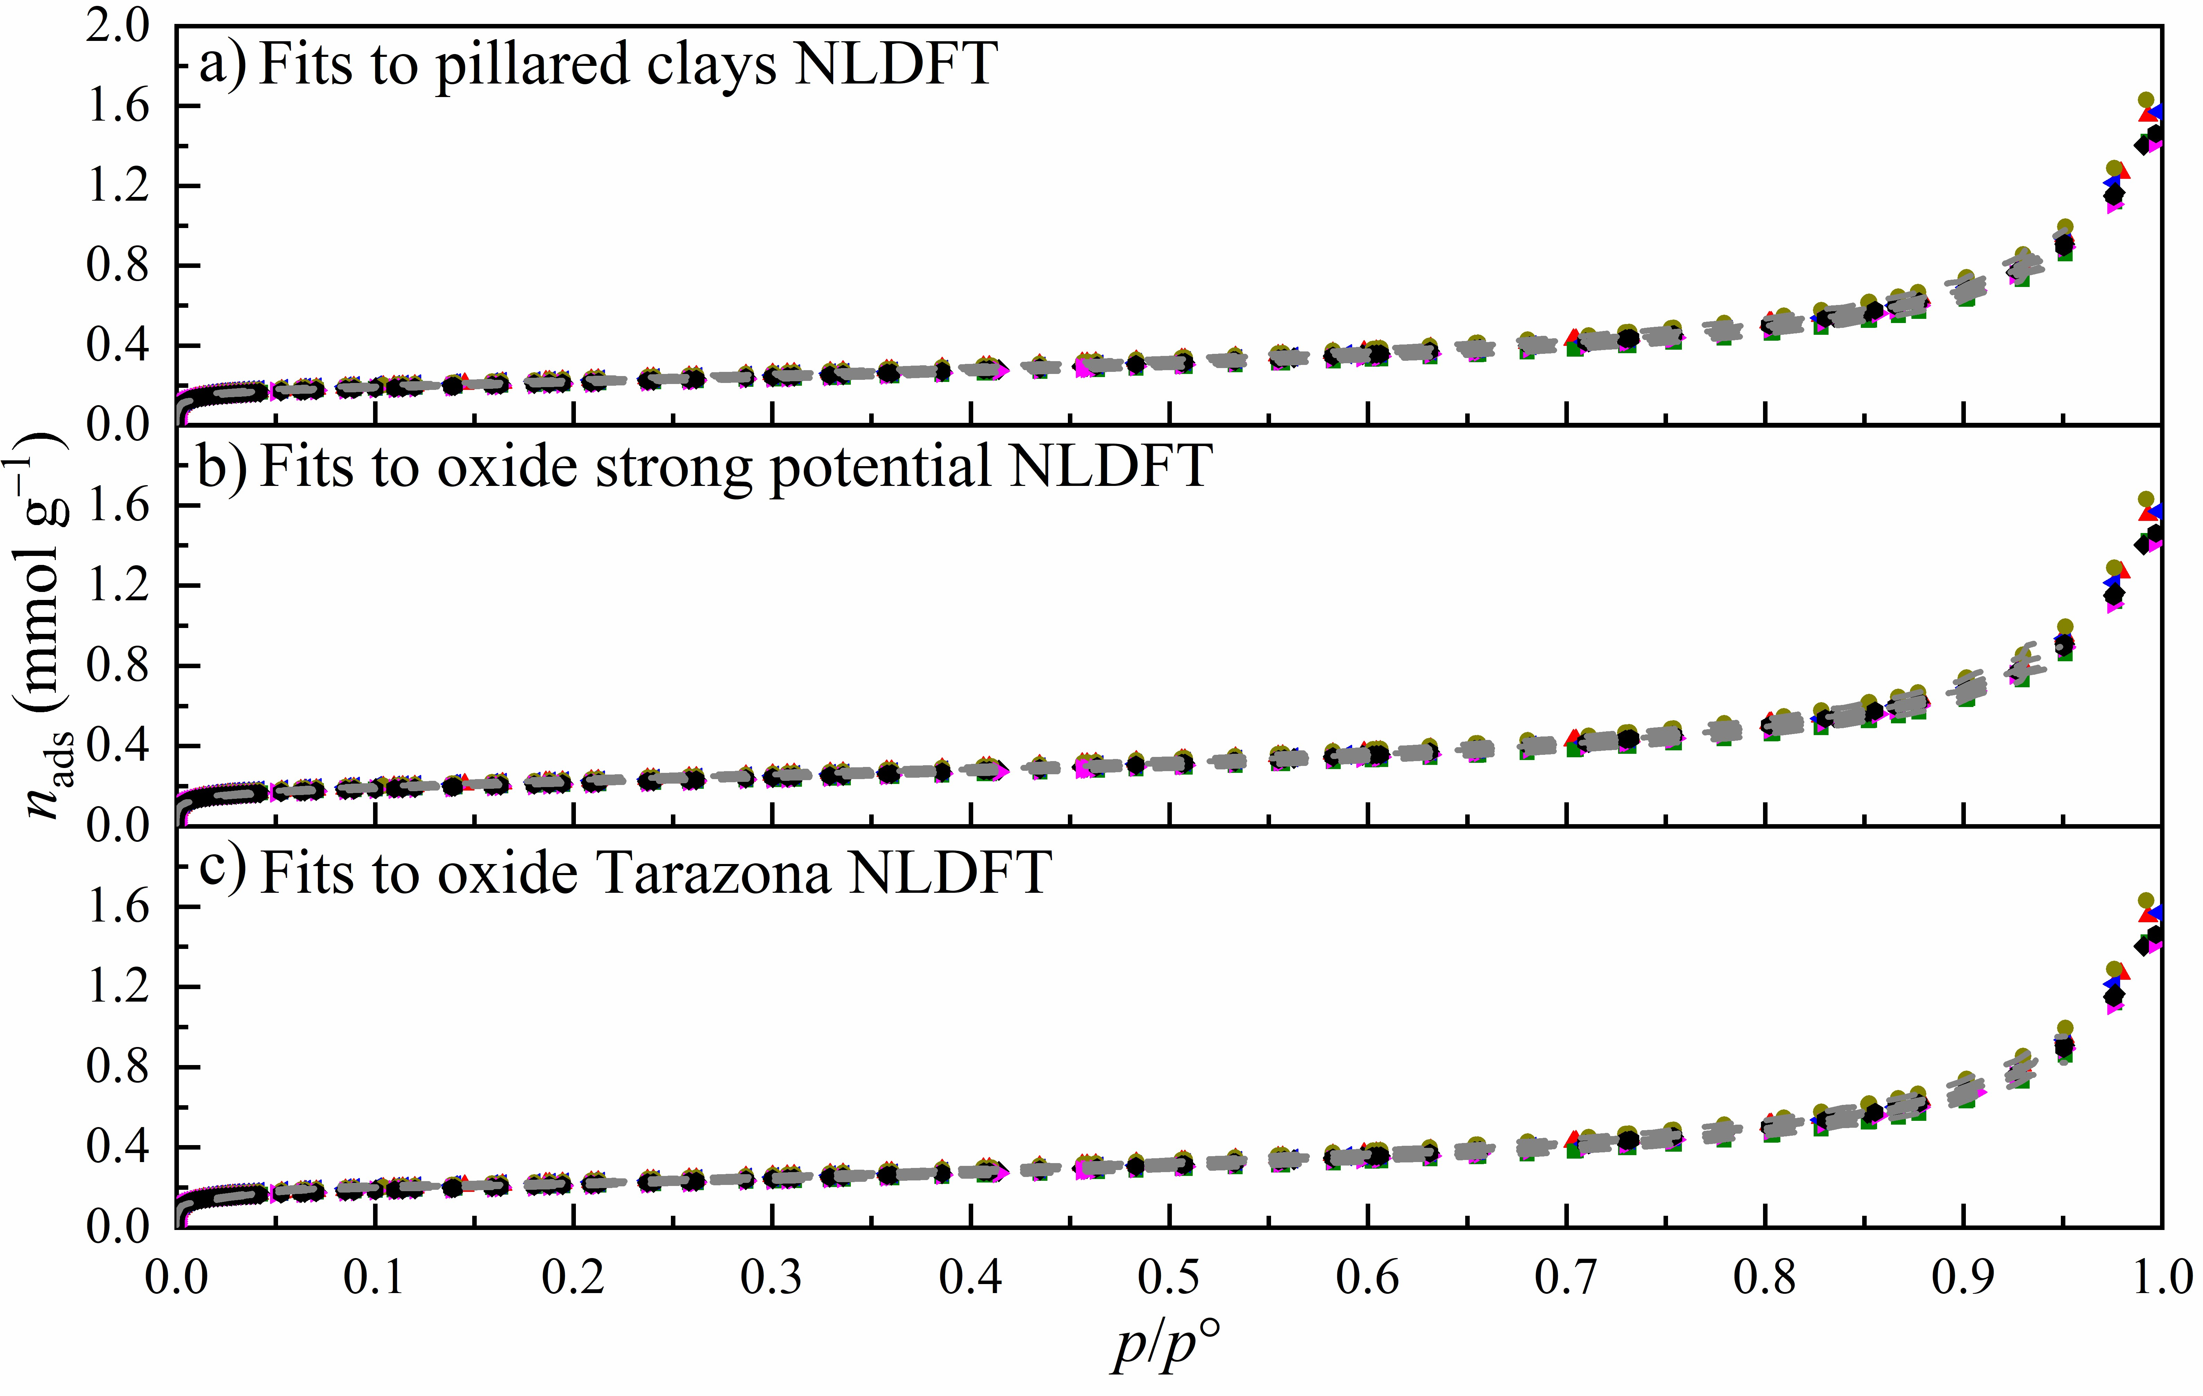
Fig. A1 N₂ adsorption isotherms with p/p° in linear scale (symbols) and with fits to the NLDFT model for pillared clays (dashed lines) (a), to the NLDFT model for oxide with strong potential (b), and to the NLDFT model for oxide Tarazona (c) of the 7 RC600-S4 briquettes obtained at 77 K.
For the pore size distribution, the pillared clay NLDFT model yielded the lowest root-mean square (RMS) error and the highest roughness at equivalent regularization compared to the other models. Furthermore, the distribution and separation of pore sizes were better compared to the other models (Fig. A2). Hence, the pillared clay model is the most appropriate model to use, and it established that the values reported were repeatable.
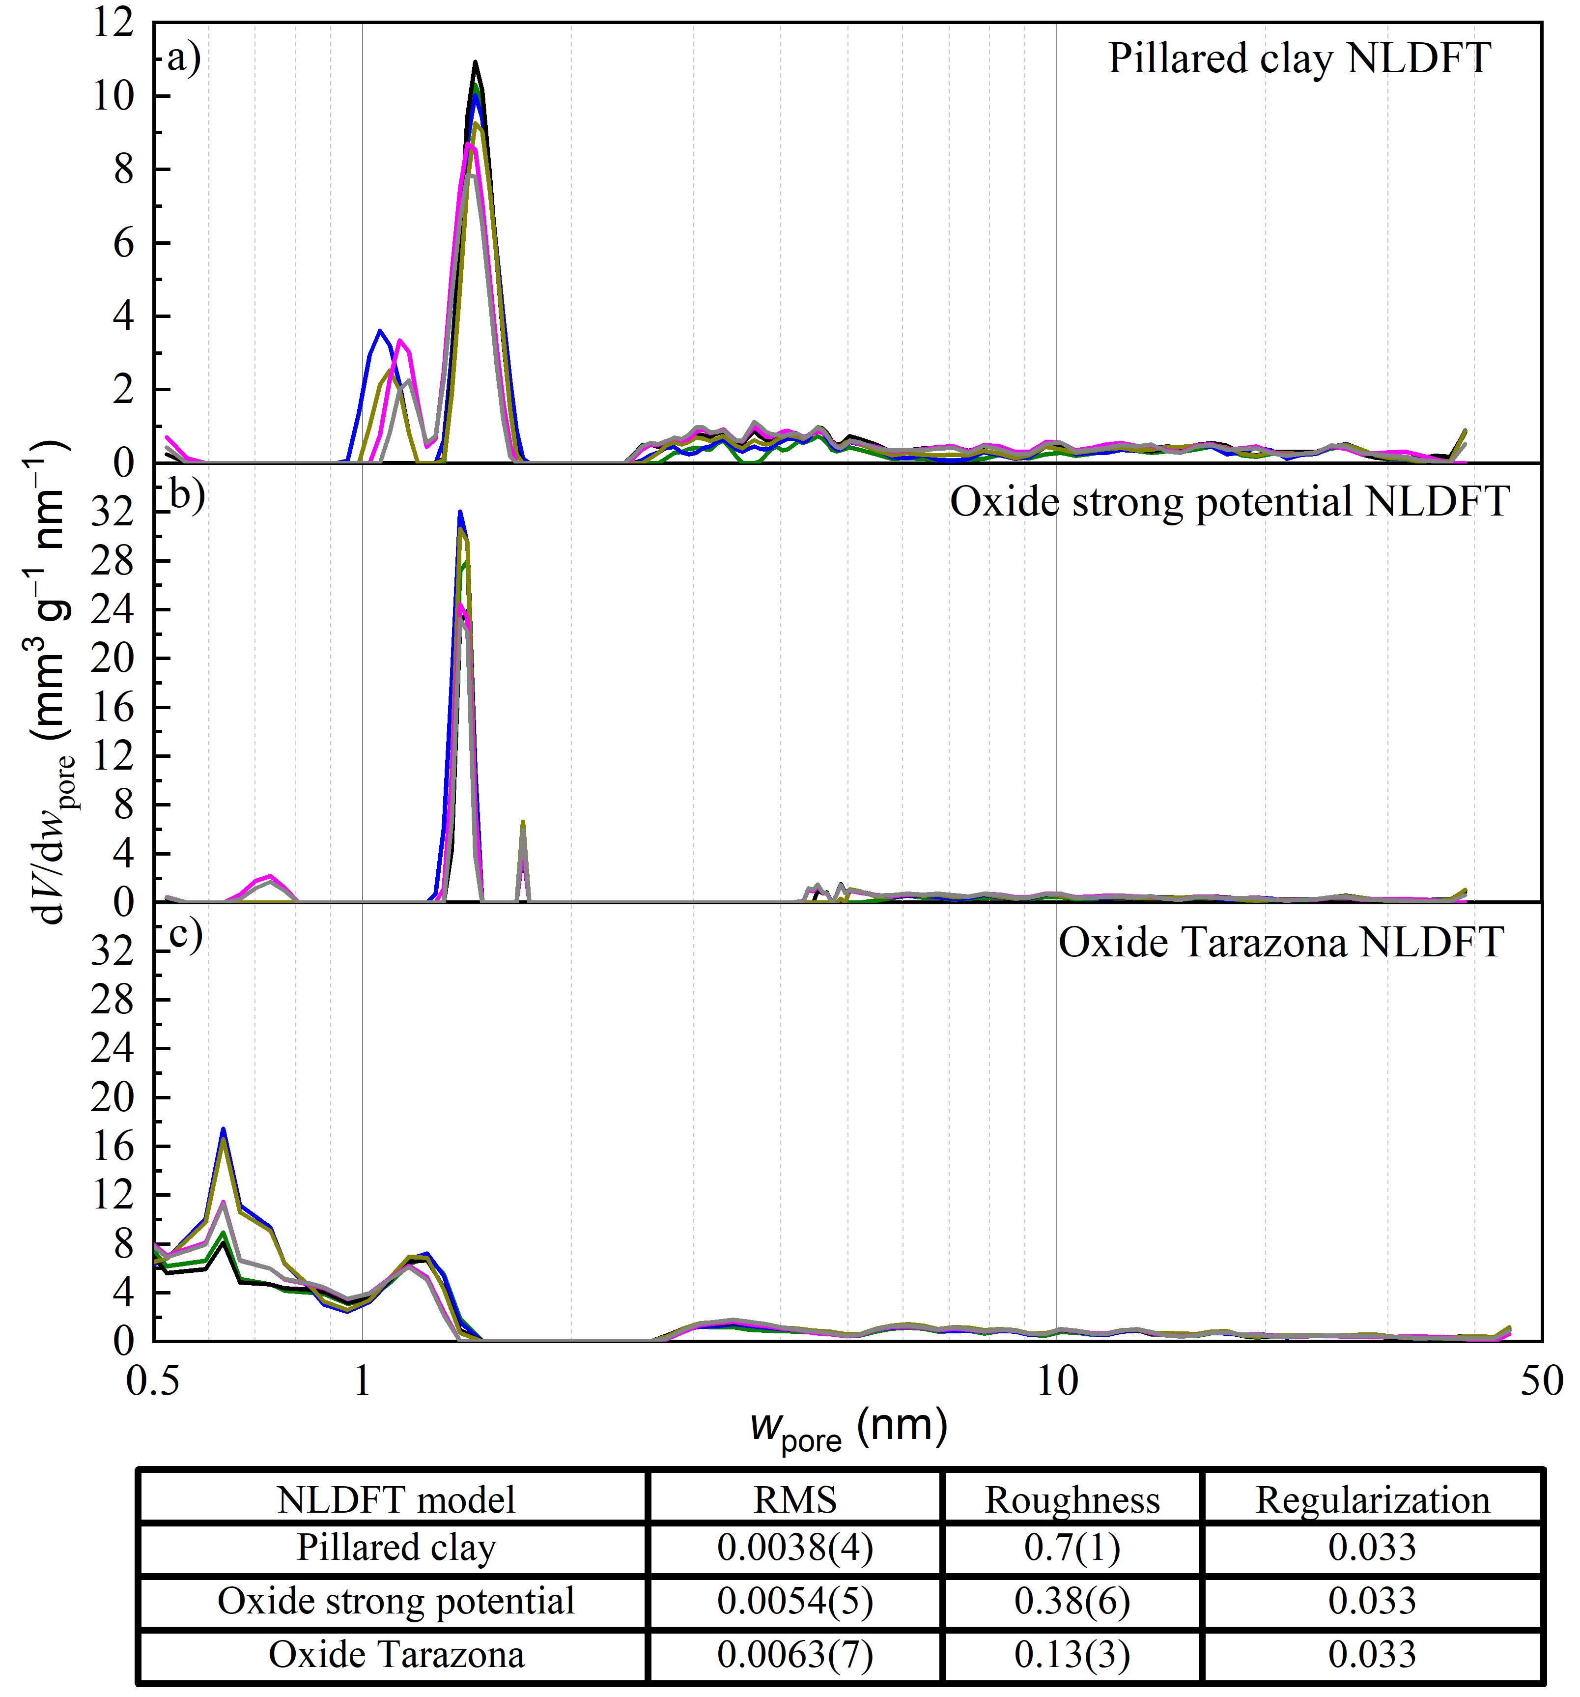
Fig. A2 Pore size distributions obtained by applying the pillared clay NLDFT model (a), the oxide strong potential NLDFT model (b), and the oxide Tarazona NLDFT model (c) to the N₂ adsorption isotherm data of RC600-S4 6 repeat measurements obtained at 77 K. The root-mean square (RMS), roughness, and regularization parameters obtained from fitting all three NLDFT models is presented in the Table.
From the 6 repeat measurements with 3 separately prepared briquettes using RC600-S4, standard deviations of main parameters were calculated and tabulated (Table A1). The relative standard deviations for the S_{micro} and V_{micro} were 12.5% and 8.0%, respectively, and smaller than the S_{NLDFT} and V_{NLDFT} values. From these standard deviations an appraisal to the precision of the obtained parameters in the whole set as a relative standard deviation value to each parameter was obtained.
Table A1 Example of standard deviations of obtained parameters between separately prepared briquette samples
NLDFT model | S_{BET}  m² g⁻¹ | S_{BET} relative standard deviation as % | V_{0.95}  cm³ g⁻¹ | V_{0.95}  relative standard deviation as % | S_{NLDFT}  m² g⁻¹ | S_{NLDFT}  relative standard deviation as % | V_{NLDFT}  cm³ g⁻¹ | V_{NLDFT}  relative standard deviation as %
Pillared clay | 17.5 (7) | 4.0 | 0.032 (1) | 4.6 | 11 (2) | 17 | 0.016 (3) | 22
Where: S_{BET} - BET theory based specific surface area calculated from N₂ isotherm; V_{0.95} - Pore volume calculated from adsorbed amount of N₂ at p/p° = 0.95; S_{NLDFT} - Specific surface obtained from applying the NLDFT model to the N₂ adsorption isotherm; V_{NLDFT} - Pore volume obtained from applying the NLDFT model to the N₂ adsorption isotherm
Appendix 2
Correlation graphs of S_{BET} and V_{0.95} with the added clay. Despite the NLDFT model’s usefulness, the pillared clays NLDFT model does not represent the investigated material’s exact porous structure, hence, the pore size distributions obtained were not perfectly accurate, even though they are precise (Thommes et al., 2015). The specific surface area values, S_{BET} and S_{NLDFT}, and specific pore volume values, V_{0.95} and V_{NLDFT}, exhibited diverging values across the method of calculation, up to a maximum difference of 26% (see WC800-CH4 briquette) and 67% (see RC600-CH2 and RC600-CH3 briquettes) for the specific surface area and specific pore volume, respectively (see Table 2). The volume differences (V_{0.95} consistently larger than V_{NLDFT}) were due mainly to differences in the probed porosity, where V_{0.95} corresponds to pores with widths up to 41 nm and V_{NLDFT} to pores with widths up to 35 nm. The differences in the surface area values can be attributed to the BET method yielding misrepresentative results for some materials (Sing, 2001) and to the NLDFT model being specific to pillared clays, which have an artificial porosity different in character from that expected for the obtained briquettes. Thus, the results from these two approaches were used in parallel to obtain possible ranges of surface area and pore volume values to be compared with the various compositions and firing conditions. The correlations of the porosity parameters S_{BET} and V_{0.95} with the initial clay content (Figs. A3 and A4) are very nearly the same as the correlations of S_{NLDFT} and V_{NLDFT} (Figs. 5 and 6). That and the fact that many of the correlation cefficients are close to unity are evidence that the calculated parameters are precise enough that, for example, some small effects of different firing temperatures, may be reliably interpreted.

Fig. A3 Graph of the clay mass fraction (%) used to make the briquettes vs. the pore volume (S_{BET})

Fig. A4 Graph of the clay mass fraction (%) used to make the briquettes vs. the pore volume (V_{0.95})

