**Modification of the cation exchange population and CEC values of reacted bentonites of the third retrieved package of the alternative buffer material (ABM-5) experiment operated at up to 250°C**

R. Dohrmann1*,2, J. Groeger-Trampe1, and S. Kaufhold2

1 Landesamt für Bergbau, Energie und Geologie (LBEG), Stilleweg 2, D-30655 Hannover, Germany

2 Bundesanstalt für Geowissenschaften und Rohstoffe (BGR), Stilleweg 2, D-30655 Hannover, Germany

* Corresponding author: Reiner Dohrmann; Email: [reiner.dohrmann@lbeg.niedersachsen.de](mailto:reiner.dohrmann@lbeg.niedersachsen.de)

**Supplemental data**

Table S1. Overview per block of the ECs, sum of ECs, “sum-CEC”, and CEC values (meq/100 g) for all ABM-5 samples including reference (REF) samples (averages of two analyses) using the Cu-trien5xcalcite method. The following blocks were fractured and could not be sampled (n.a.) at all distances: 1 cm, 5 cm, 8 cm – #3, #4, #6, #9, #12, #24, #27.

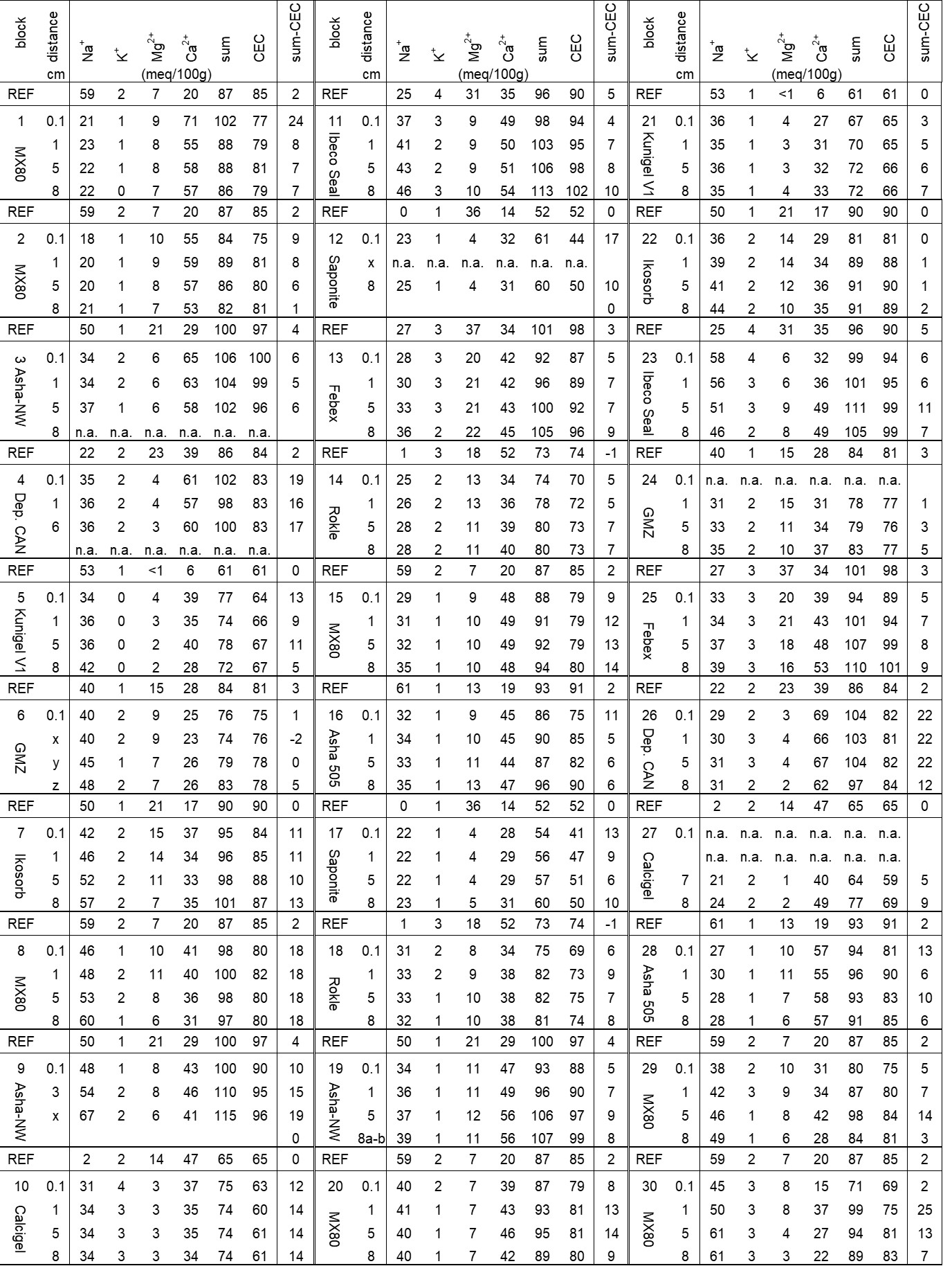

Table S2. Overview per parameter for the ECs, sum of ECs, ‘sum-CEC’, CEC, and Cl– values (meq/100 g) for all ABM-5 samples including reference (REF) samples (averages of two analyses) using the Cu-trien5xcalcite method. The following blocks were fractured and could not be sampled at all distances: 1 cm, 5 cm, 8 cm – #3, #4, #6, #9, #12, #24, #27. *: average values except #3, #4, #6, #9, #12, #24, #27.

