Association of STAT1 gene with milk fat and protein yield in Holstein Friesian crossbred cattle maintained in the sub-tropical climate of India

Anika Sharma, Simarjeet Kaur, Jaspreet Singh Arora and Neeraj Kashyap

SUPPLEMENTARY FILE

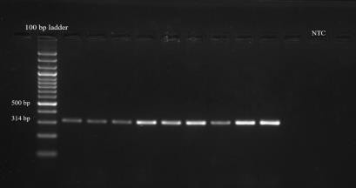**Figure S1**: Agarose gel (2%) showing bands at 314 bp of STAT1 PCR products along with a Non-Template Control (NTC)

**Figure S2:** PCR-RFLP pattern of STAT1 gene

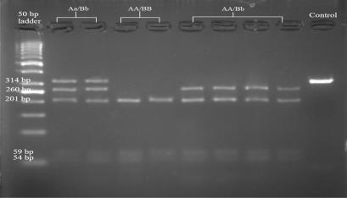

**Figure S3:** Clustal Omega alignment results of the two SNPs with the reported NCBI sequence of STAT1 gene

