# Supplementary Material



**Figure S1:** Trophic level decomposition of functional groups of the Ecopath model with relative flow of each group per trophic level (available as interactive plot)

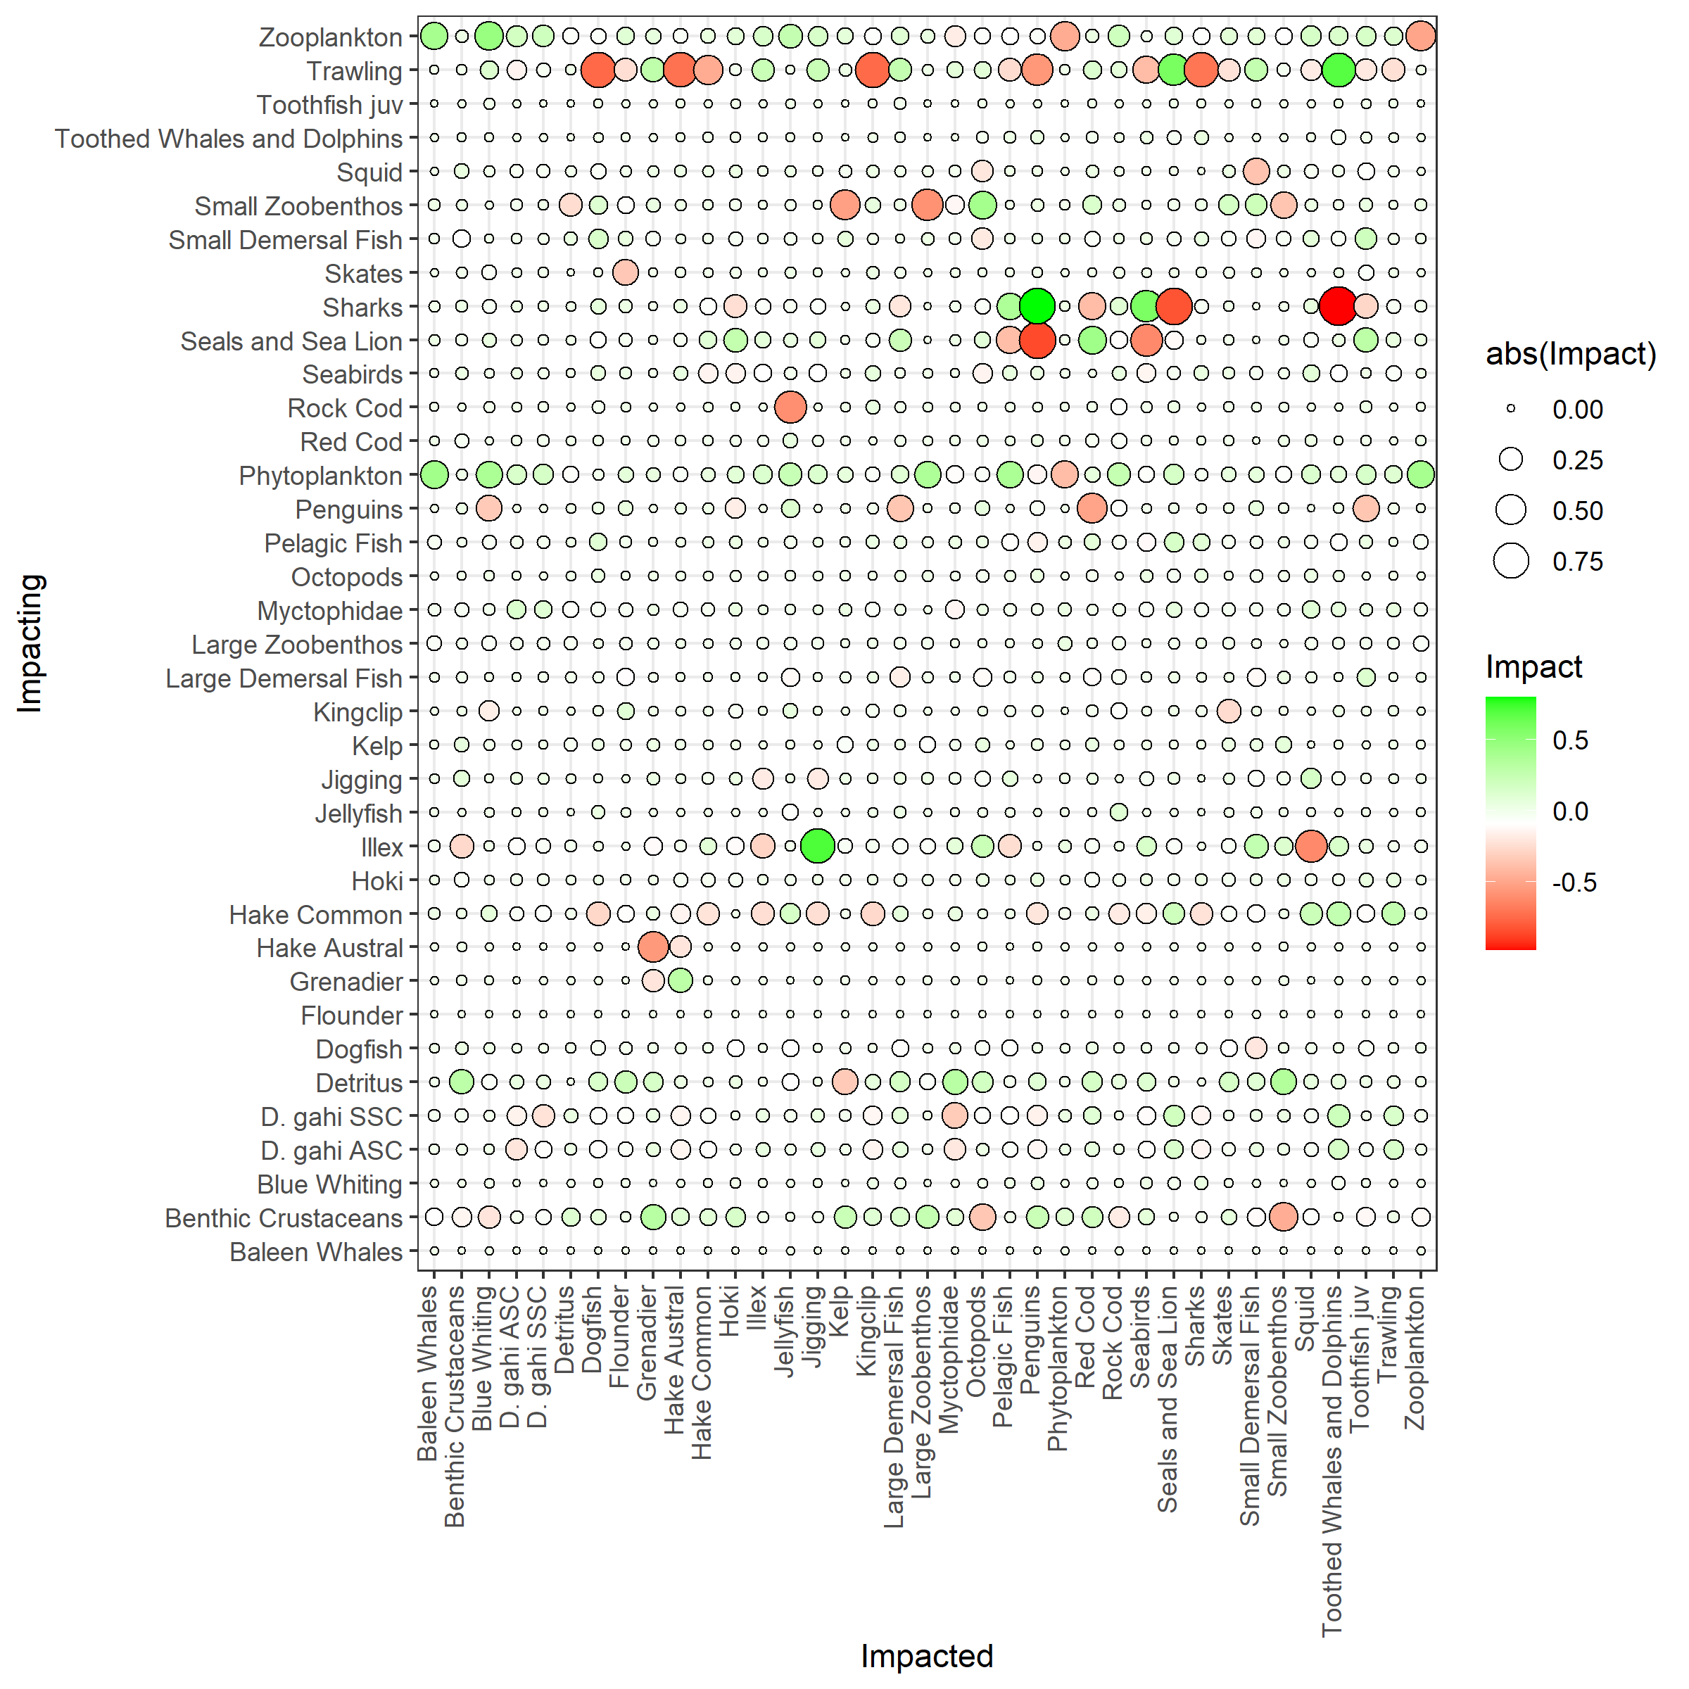**Figure S2:** Positive and negative impacts of all groups on each other, derived from the mixed trophic impacts routine from the Ecopath model; green = positive impacts, red = negative impacts, size = absolute impact

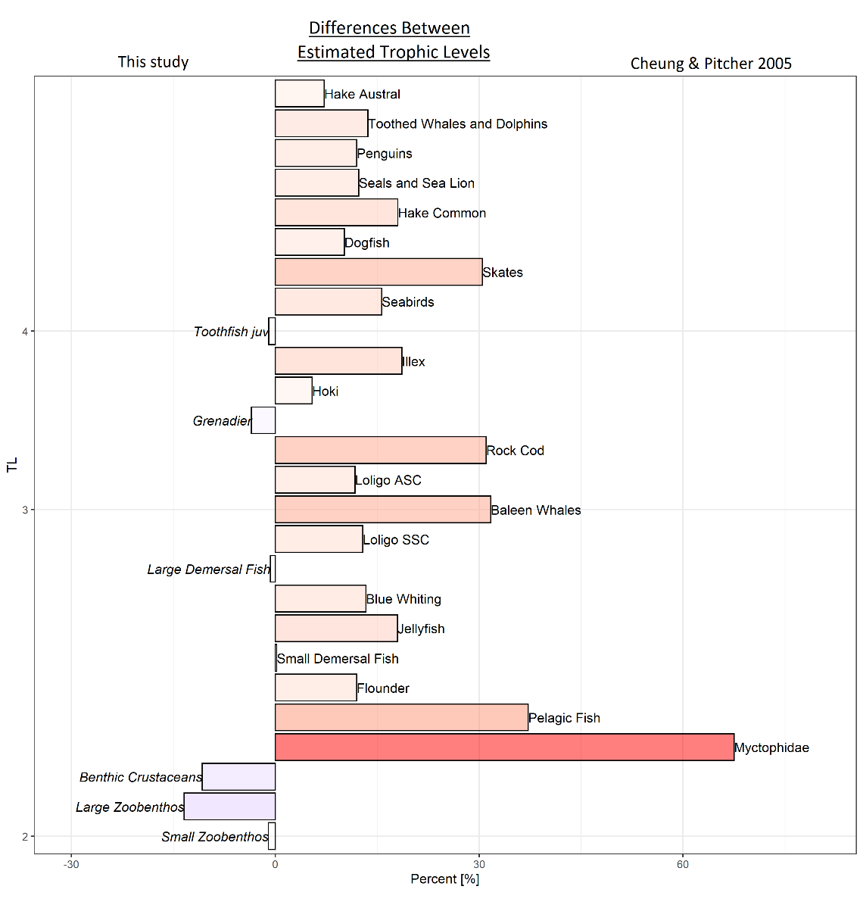

**Figure S3:** Difference (in%) in trophic level between the Ecopath model (this study) and the model by Cheung & Pitcher (2005). Differences are ordered according to trophic level values (bottom low, top high).

**Table S1: Number of samples per month for the stable isotope groups**

|  |  |  |  |  |  |  |  |  |  |  |
| --- | --- | --- | --- | --- | --- | --- | --- | --- | --- | --- |
| **Month** | **Benthic M. gregaria** | **Birds** | **Omnivorous** | **Omnivorous(benthic)** | **POM** | **Piscivorous** | **Primary Producer** | **Top Predators** | **Zooplanktivorous** | **Zooplankton** |
| 1 | - | - | 108 | - | - | - | - | - | - | - |
| 2 | 5 | 2 | 284 | 2 | 1 | 3 | 3 | 3 | 3 | 13 |
| 3 | - | 5 | 36 | 3 | - | 5 | - | - | - | - |
| 4 | 1 | 2 | 103 | 8 | - | 7 | - | - | - | - |
| 5 | - | - | 16 | 5 | - | 14 | - | - | - | - |
| 6 | - | 1 | 16 | - | - | - | - | - | - | - |
| 7 | 11 | - | 316 | 29 | - | 34 | 7 | - | 6 | - |
| 8 | - | 2 | - | - | - | - | - | - | - | - |
| 9 | - | 12 | 27 | 10 | - | 6 | - | - | - | 4 |
| 10 | 2 | 6 | 112 | 13 | - | 5 | 2 | - | - | - |
| 11 | - | - | 22 | 6 | - | 5 | - | - | - | 2 |

***Table S2: Diet Matrix (separate file)***

**Table S3:** Initial production (P/B), consumption (Q/B) and ecotrophic efficiency (EE) values for the Ecopath model

|  |  |  |  |
| --- | --- | --- | --- |
| **Functional Group** | **P/B** | **Q/B** | **EE** |
| Algae | 7.526 |  | 0.251 |
| Baleen Whales | 0.840 | 10.365 | 0.308 |
| Bathydemersal | 0.045 | 0.658 |  |
| Benthic crustaceans | 2.241 | 10.944 | 0.937 |
| Blue Whiting | 0.399 | 13.081 | 0.759 |
| Corals | 6.168 |  | 0.895 |
| Demersal fish | 1.170 | 4.950 | 0.303 |
| Detritus |  |  | 0.219 |
| Discards |  |  | 0.487 |
| Dogfish | 0.412 | 5.818 | 0.965 |
| Flatfish | 0.952 | 7.868 | 0.753 |
| Flounder | 0.962 | 36.222 |  |
| Grenadier | 1.055 | 2.344 | 0.990 |
| Hake austral | 0.297 | 1.385 | 0.983 |
| Hake common | 0.574 | 2.686 | 0.859 |
| Hoki | 1.297 | 2.505 | 0.888 |
| Illex | 1.161 | 4.996 | 0.747 |
| Jellyfish | 7.360 | 25.851 | 0.520 |
| Kingclip | 0.435 | 11.923 | 0.714 |
| Krill | 4.219 | 21.678 | 0.735 |
| Large bathydemersal fish | 0.525 | 3.419 | 0.682 |
| large bathypelagic fish | 0.300 | 2.000 | 0.610 |
| Large Demersal | 0.307 | 29.149 |  |
| Large demersal fish | 0.799 | 5.233 | 0.737 |
| Large pelagic fish | 0.500 | 2.500 | 0.950 |
| Large zoobenthos | 1.668 | 10.922 | 0.864 |
| Loligo | 1.172 | 4.964 | 0.904 |
| Myctophidae | 1.227 | 9.420 | 0.642 |
| Pelagic fish | 0.890 | 7.713 | 0.500 |
| Penguins | 4.000 | 80.000 | 0.001 |
| Phytoplankton | 124.041 |  | 0.429 |
| Red Cod | 0.543 | 2.184 | 0.854 |
| Rock Cod | 0.570 | 21.321 | 0.980 |
| Seabirds | 1.707 | 81.816 | 0.217 |
| Seals and sea lion | 0.317 | 16.954 | 0.284 |
| Sharks | 0.435 | 3.866 | 0.590 |
| Skates | 0.369 | 2.740 | 0.592 |
| small bathydemersal fish | 1.320 | 12.000 | 0.950 |
| Small demersal | 0.770 | 17.780 | 0.843 |
| Small pelagic fish | 1.218 | 19.766 | 0.727 |
| Small zoobenthos | 3.303 | 11.719 | 0.728 |
| Squid | 3.084 | 16.368 | 0.817 |
| Toothed whales & dolphins | 0.525 | 10.463 | 0.136 |
| Toothfish | 0.562 | 3.489 | 0.950 |
| Zooplankton | 25.015 | 93.617 | 0.775 |

**Table S4**: Landings and Discards used for the Ecopath model (in t per km2)

|  |  |  |  |  |  |  |  |
| --- | --- | --- | --- | --- | --- | --- | --- |
|  |  | **Landings** | | | **Discards** | | |
|  | **Group name** | **Trawling** | **Jigging** | **Total** | **Trawling** | **Jigging** | **Total** |
| 1 | *Baleen Whales* | - | - | - | 0 | 0 | 0 |
| 2 | *Benthic Crustaceans* | - | - | - | 0.0002 | - | 0.0002 |
| 3 | *Blue Whiting* | 0.0003 | - | 0.0003 | - | - | - |
| 4 | *Dogfish* | - | - | - | 0.0004 | - | 0.0004 |
| 5 | *Flounder* | - | - | - | - | - | - |
| 6 | *Grenadier* | 0.0006 | - | 0.0006 | 0.0003 | - | 0.0003 |
| 7 | *Hake Austral* | 0.0003 | - | 0.0003 | - | - | - |
| 8 | *Hake Common* | 0.2172 | - | 0.2172 | 0.0004 | - | 0.0004 |
| 9 | *Hoki* | 0.0382 | - | 0.0382 | 0.0004 | - | 0.0004 |
| 10 | *Illex* | - | 0.3451 | 0.3451 | - | - | - |
| 11 | *Jellyfish* | - | - | - | - | - | - |
| 12 | *Kelp* | - | - | - | - | - | - |
| 13 | *Kingclip* | 0.0082 | - | 0.0082 | 0.0001 | - | 0.0001 |
| 14 | *Large Demersal Fish* | - | - | - | 0.0003 | - | 0.0003 |
| 15 | *Large Zoobenthos* | - | - | - | - | - | - |
| 16 | *D. gahi ASC* | 0.15 | - | 0.15 | 0.0001 | - | 0.0001 |
| 17 | *D. gahi SSC* | 0.1547 | - | 0.1547 | 0.0001 | - | 0.0001 |
| 18 | *Myctophidae* | - | - | - | - | - | - |
| 19 | *Octopods* | - | - | - | - | - | - |
| 20 | *Pelagic Fish* | 0.0038 | - | 0.0038 | 0.0001 | - | 0.0001 |
| 21 | *Penguins* | - | - | - | - | - | - |
| 22 | *Phytoplankton* | - | - | - | - | - | - |
| 23 | *Red Cod* | 0.0071 | - | 0.0071 | 0.0001 | - | 0.0001 |
| 24 | *Rock Cod* | 0.0013 | - | 0.0013 | 0.0027 | - | 0.0027 |
| 25 | *Seabirds* | - | - | - | - | - | - |
| 26 | *Seals and Sea Lion* | - | - | - | - | - | - |
| 27 | *Sharks* | - | - | - | - | - | - |
| 28 | *Skates* | 0.0067 | - | 0.0067 | 0.0004 | - | 0.0004 |
| 29 | *Small Demersal Fish* | - | - | - | - | - | - |
| 30 | *Small Zoobenthos* | 0.0001 | - | 0.0001 | - | - | - |
| 31 | *Squid* | - | - | - | - | - | - |
| 32 | *Toothed Whales and Dolphins* | - | - | - | - | - | - |
| 33 | *Toothfish juv* | 0.0014 | - | 0.0014 | - | - | - |
| 34 | *Zooplankton* | - | - | - | 0.0001 | - | 0.0001 |
| 35 | *Detritus* | - | - | - | - | - | - |
| 36 | *Sum* | 0.5899 | 0.3451 | 0.935 | 0.0059 | - | 0.0059 |

**Table S5:** Niche overlap [%] of each functional group and contrasting group on a 95% alpha level, based on δ13C and δ15N values

|  |  |  |
| --- | --- | --- |
| **Group** | **Contrast** | **Niche overlap prob.** |
| Birds | Mgregaria | 13.52 |
| Birds | Omnivorous | 65.79 |
| Birds | Omnivorous(benthic) | 8.91 |
| Birds | Piscivorous | 37.16 |
| Birds | PrimaryProducer | 0.04 |
| Birds | Zooplanktivorous | 8.28 |
| Birds | Zooplankton | 0.54 |
| Mgregaria | Birds | 30.27 |
| Mgregaria | Omnivorous | 36.87 |
| Mgregaria | Omnivorous(benthic) | 51.82 |
| Mgregaria | Piscivorous | 22.43 |
| Mgregaria | PrimaryProducer | 17.01 |
| Mgregaria | Zooplanktivorous | 2.89 |
| Mgregaria | Zooplankton | 2.43 |
| Omnivorous | Mgregaria | 56.58 |
| Omnivorous | Birds | 99.19 |
| Omnivorous | Omnivorous(benthic) | 39.04 |
| Omnivorous | Piscivorous | 52.72 |
| Omnivorous | PrimaryProducer | 0.99 |
| Omnivorous | Zooplanktivorous | 60.83 |
| Omnivorous | Zooplankton | 8.8 |
| Omnivorous(benthic) | Mgregaria | 34.59 |
| Omnivorous(benthic) | Birds | 10.76 |
| Omnivorous(benthic) | Omnivorous | 14.44 |
| Omnivorous(benthic) | Piscivorous | 26.24 |
| Omnivorous(benthic) | PrimaryProducer | 0.12 |
| Omnivorous(benthic) | Zooplanktivorous | 0.04 |
| Omnivorous(benthic) | Zooplankton | 0.01 |
| Piscivorous | Mgregaria | 21.52 |
| Piscivorous | Birds | 85.14 |
| Piscivorous | Omnivorous | 59.02 |
| Piscivorous | Omnivorous(benthic) | 38.58 |
| Piscivorous | PrimaryProducer | 0.02 |
| Piscivorous | Zooplanktivorous | 1.51 |
| Piscivorous | Zooplankton | 0.14 |
| Primary Producer | Mgregaria | 30.25 |
| Primary Producer | Birds | 0.21 |
| Primary Producer | Omnivorous | 2.72 |
| Primary Producer | Omnivorous(benthic) | 0.65 |
| Primary Producer | Piscivorous | 0.12 |
| Primary Producer | Zooplanktivorous | 21.68 |
| Primary Producer | Zooplankton | 65.16 |
| Zooplanktivorous | Mgregaria | 3.27 |
| Zooplanktivorous | Birds | 9.54 |
| Zooplanktivorous | Omnivorous | 21.15 |
| Zooplanktivorous | Omnivorous(benthic) | 0.05 |
| Zooplanktivorous | Piscivorous | 1.16 |
| Zooplanktivorous | PrimaryProducer | 4.78 |
| Zooplanktivorous | Zooplankton | 41.49 |
| Zooplankton | Mgregaria | 2.97 |
| Zooplankton | Birds | 1.2 |
| Zooplankton | Omnivorous | 7.02 |
| Zooplankton | Omnivorous(benthic) | 0 |
| Zooplankton | Piscivorous | 0.23 |
| Zooplankton | PrimaryProducer | 15.25 |
| Zooplankton | Zooplanktivorous | 64.09 |

**Table S6:** ANOVA Group comparisons δ15N versus sex for each species, Df = Degrees of freedom, mean sum of squares, F statistic and p-value

|  |  |  |  |  |  |  |
| --- | --- | --- | --- | --- | --- | --- |
| **Species** |  | **Df** | **Sum Sq** | **Mean Sq** | **F value** | **p-val** |
| *Bathyraja albomaculata* | Sex | 1 | 0.151 | 0.1508 | 0.166 | 0.691 |
|  | Residuals | 12 | 10.915 | 0.9096 |  |  |
| *Bathyraja brachyurops* | Sex | 1 | 0.418 | 0.4183 | 0.396 | 0.535 |
|  | Residuals | 24 | 25.375 | 1.0573 |  |  |
| *Cottoperca gobio* | Sex | 1 | 0.027 | 0.0268 | 0.026 | 0.875 |
|  | Residuals | 16 | 16.713 | 1.0446 |  |  |
| *Dipturus lamillai* | Sex | 1 | 0.806 | 0.8063 | 1.698 | 0.215 |
|  | Residuals | 13 | 6.172 | 0.4748 |  |  |
| *Dissostichus eleginoides* | Sex | 1 | 0.06 | 0.0597 | 0.039 | 0.848 |
|  | Residuals | 8 | 12.24 | 1.5298 |  |  |
| *Doryteuthis gahi* | Sex | 1 | 0.76 | 0.7624 | 0.729 | 0.394 |
|  | Residuals | 264 | 276.23 | 1.0463 |  |  |
| *Genypterus blacodes* | Sex | 1 | 0.0111 | 0.0111 | 0.033 | 0.861 |
|  | Residuals | 7 | 2.3388 | 0.3341 |  |  |
| *Illex argentinus* | Sex | 1 | 5.78 | 5.775 | 1.555 | 0.238 |
|  | Residuals | 11 | 40.85 | 3.714 |  |  |
| *Macruronus magellanicus* | Sex | 1 | 0.592 | 0.5923 | 1.056 | 0.323 |
|  | Residuals | 13 | 7.294 | 0.561 |  |  |
| *Merluccius hubbsi* | Sex | 1 | 0.778 | 0.7785 | 0.536 | 0.479 |
|  | Residuals | 11 | 15.972 | 1.452 |  |  |
| *Moroteuthopsis ingens* | Sex | 1 | 2.532 | 2.531 | 1.28 | 0.278 |
|  | Residuals | 13 | 25.711 | 1.978 |  |  |
| *Patagonotothen ramsayi* | Sex | 1 | 0.032 | 0.0318 | 0.035 | 0.854 |
|  | Residuals | 29 | 26.613 | 0.9177 |  |  |
| *Puffinus griseus* | Sex | 1 | 0.0575 | 0.05752 | 0.264 | 0.622 |
|  | Residuals | 8 | 1.7458 | 0.21822 |  |  |
| *Salilota australis* | Sex | 1 | 1.84 | 1.842 | 0.855 | 0.367 |
|  | Residuals | 18 | 38.77 | 2.154 |  |  |
| *Schroederichthys bivius* | Sex | 1 | 6.907 | 6.907 | 9.766 | 0.00653 |
|  | Residuals | 16 | 11.316 | 0.707 |  |  |
| *Squalus acanthias* | Sex | 1 | 1.79 | 1.793 | 0.453 | 0.52 |
|  | Residuals | 8 | 31.7 | 3.963 |  |  |
| *Thalassarche melanophrys* | Sex | 1 | 0.172 | 0.1719 | 0.218 | 0.649 |
|  | Residuals | 12 | 9.444 | 0.787 |  |  |

**Table S7:** Linear model estimates for δ15N vs. log(weight) and δ13C vs. log(weight); Estimate, Standard error, F-statistic, t value, p value and adjusted r-square

|  |  |  |  |  |  |  |  |  |  |  |  |  |
| --- | --- | --- | --- | --- | --- | --- | --- | --- | --- | --- | --- | --- |
|  | δ13C | | | | | | δ15N | | | | | |
| **Species** | **Estimate** | **Std. Error** | **F** | **t value** | **p-val** | **adj.r2** | **Estimate** | **Std. Error** | **F** | **t value** | **p-val** | **adj.r2** |
| *Bathyraja albomaculata* | -17.172 | 0.653 | 2.898 | -26.292 | <0.001 | 0.137 | 10.476 | 0.627 | 29.951 | 16.700 | <0.001 | 0.707 |
|  | 0.162 | 0.095 |  | 1.702 | 0.117 |  | 0.501 | 0.091 |  | 5.473 | <0.001 |  |
| *Bathyraja brachyurops* | -17.536 | 0.479 | 2.014 | -36.623 | <0.001 | 0.046 | 10.714 | 0.673 | 20.532 | 15.910 | <0.001 | 0.482 |
|  | 0.103 | 0.073 |  | 1.419 | 0.171 |  | 0.464 | 0.103 |  | 4.531 | <0.001 |  |
| *Cottoperca gobio* | -18.654 | 0.563 | 0.926 | -33.111 | <0.001 | -0.004 | 11.112 | 0.489 | 36.367 | 22.739 | <0.001 | 0.651 |
|  | 0.098 | 0.102 |  | 0.962 | 0.349 |  | 0.533 | 0.088 |  | 6.031 | <0.001 |  |
| *Dipturus lamillai* | -17.743 | 0.847 | 0.837 | -20.950 | <0.001 | -0.012 | 13.486 | 1.985 | 0.466 | 6.793 | <0.001 | -0.040 |
|  | 0.096 | 0.105 |  | 0.915 | 0.377 |  | 0.169 | 0.247 |  | 0.683 | 0.507 |  |
| *Dissostichus eleginoides* | -21.157 | 1.297 | 4.264 | -16.308 | <0.001 | 0.266 | 10.261 | 1.346 | 6.279 | 7.626 | <0.001 | 0.370 |
|  | 0.393 | 0.190 |  | 2.065 | 0.073 |  | 0.494 | 0.197 |  | 2.506 | 0.037 |  |
| *Doryteuthis gahi* | -19.086 | 0.216 | 0.052 | -88.178 | <0.001 | -0.004 | 11.807 | 0.256 | 10.683 | 46.114 | <0.001 | 0.035 |
|  | 0.013 | 0.058 |  | 0.227 | 0.820 |  | 0.225 | 0.069 |  | 3.268 | 0.001 |  |
| *Genypterus blacodes* | -17.417 | 1.066 | 0.104 | -16.334 | <0.001 | -0.111 | 17.694 | 0.899 | 2.334 | 19.684 | <0.001 | 0.129 |
|  | 0.048 | 0.147 |  | 0.322 | 0.756 |  | -0.190 | 0.124 |  | -1.528 | 0.165 |  |
| *Illex argentinus* | -21.464 | 0.402 | 34.179 | -53.361 | <0.001 | 0.689 | 8.648 | 1.128 | 14.444 | 7.667 | <0.001 | 0.473 |
|  | 0.478 | 0.082 |  | 5.846 | <0.001 |  | 0.871 | 0.229 |  | 3.801 | 0.002 |  |
| *Macruronus magellanicus* | -18.203 | 0.928 | 0.153 | -19.617 | <0.001 | -0.064 | 11.836 | 1.561 | 1.395 | 7.581 | <0.001 | 0.027 |
|  | 0.060 | 0.154 |  | 0.391 | 0.702 |  | 0.307 | 0.260 |  | 1.181 | 0.259 |  |
| *Merluccius hubbsi* | -21.427 | 1.172 | 9.538 | -18.281 | <0.001 | 0.437 | 10.676 | 1.481 | 11.381 | 7.207 | <0.001 | 0.486 |
|  | 0.538 | 0.174 |  | 3.088 | 0.011 |  | 0.743 | 0.220 |  | 3.374 | 0.007 |  |
| *Moroteuthopsis ingens* | -19.495 | 0.866 | 0.454 | -22.500 | <0.001 | -0.035 | 9.850 | 1.497 | 1.393 | 6.580 | <0.001 | 0.024 |
|  | -0.090 | 0.134 |  | -0.674 | 0.511 |  | 0.273 | 0.231 |  | 1.180 | 0.256 |  |
| *Patagonotothen ramsayi* | -20.517 | 0.280 | 52.891 | -73.333 | <0.001 | 0.604 | 10.875 | 0.350 | 20.333 | 31.071 | <0.001 | 0.362 |
|  | 0.455 | 0.063 |  | 7.273 | <0.001 |  | 0.353 | 0.078 |  | 4.509 | <0.001 |  |
| *Puffinus griseus* | -10.860 | 16.566 | 0.253 | -0.656 | 0.531 | -0.090 | 44.528 | 27.566 | 1.327 | 1.615 | 0.145 | 0.035 |
|  | -1.213 | 2.410 |  | -0.503 | 0.628 |  | -4.620 | 4.011 |  | -1.152 | 0.283 |  |
| *Salilota australis* | -19.707 | 0.230 | 67.651 | -85.623 | <0.001 | 0.769 | 11.239 | 0.605 | 38.276 | 18.572 | <0.001 | 0.651 |
|  | 0.314 | 0.038 |  | 8.225 | <0.001 |  | 0.622 | 0.101 |  | 6.187 | <0.001 |  |
| *Schroederichthys bivius* | -17.211 | 0.453 | 2.760 | -38.025 | <0.001 | 0.094 | 11.950 | 0.721 | 9.784 | 16.575 | <0.001 | 0.341 |
|  | 0.129 | 0.078 |  | 1.661 | 0.116 |  | 0.387 | 0.124 |  | 3.128 | 0.006 |  |
| *Squalus acanthias* | -16.036 | 5.072 | 0.215 | -3.162 | 0.016 | -0.109 | 15.767 | 4.986 | 0.109 | 3.163 | 0.016 | -0.125 |
|  | -0.325 | 0.701 |  | -0.464 | 0.657 |  | -0.228 | 0.689 |  | -0.330 | 0.751 |  |
| *Thalassarche melanophrys* | 2.662 | 13.291 | 2.609 | 0.200 | 0.845 | 0.110 | 15.276 | 19.470 | 0.007 | 0.785 | 0.448 | -0.083 |
|  | -2.543 | 1.574 |  | -1.615 | 0.132 |  | -0.199 | 2.306 |  | -0.086 | 0.933 |  |