Supplement for:
“Trying to name what doesn’t change: Neural nonresponse to Cognitive Therapy for depression”

Table of Content
Supplement 1. Consort diagram 2
Supplement 2. Demographics and clinical features of samples 3
Supplement 3. Details on calculating voxelwise Cohen’s d values 4
Supplement 4. Results for positive words 5
Supplement 5. Results for neutral words 9
Supplement 6. Mixed-effects analysis 16

Supplement 1. Consort diagram 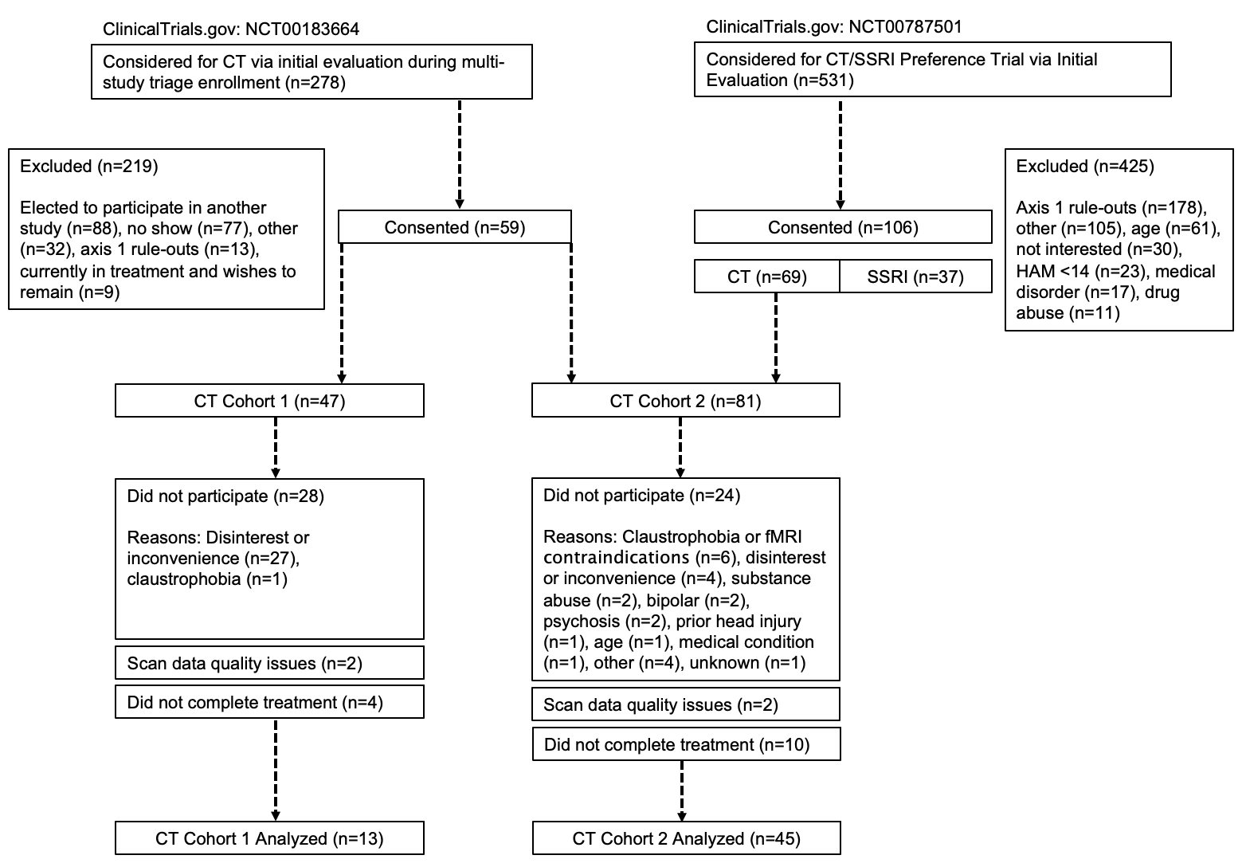

Supplement 2. Demographics and clinical features of samples
 | Patient Sample (n = 58) | Control Sample (n = 34)
Gender | Female (n = 41, 70.69%) | Female (n = 22, 64.71%)
Age | 36.12 (10.20) years | 35.06 (9.63) years
Ethnicity | Caucasian (n = 47, 81.03%)  Non-Caucasian (n = 11, 18.97%) | Caucasian (n = 28, 82.35%)  Non-Caucasian (n = 6, 17.65%)
Education | 15.77 (2.15) years | 16.03 (2.21) years
Beck Depression Inventory - II (BDI-II)* | Pre Treatment: 30.63 (8.21)  Post Treatment: 11.75 (9.50) | Time 1: 1.15 (1.67)  Time 2: 3.00 (4.66)
Depressive episodes | 3.21 (1.96) | NA
Comorbid Psychiatric Conditions | Agoraphobia (n = 1, 1.72%)  Anxiety NOS (n = 1, 1.72%)  Cannabis Abuse (n = 1, 1.72%)  Dysthymic Disorder (n = 3, 5.17%)  Generalized Anxiety Disorder (n = 2, 3.45%)  Post-Traumatic Stress Disorder (n = 1, 1.72%)  Social Anxiety Disorder (n = 10, 17.24%)  Specific Phobia (n = 2, 3.45%) | NA
Note. Means for age, education, number of depressive episodes, and BDI-II scores are followed by standard deviations in parentheses. Patient sample education (n=56), number of depressive episodes (n=53). Control sample Time 1 BDI-II (n=33), Time 2 BDI-II (n=33). Patients and controls did not differ on demographic variables. *Patients and controls differed on depression symptoms, with the patients reporting greater depression symptoms both before (t(64.89) -26.41, p < .001) and after treatment (t(87.54) -5.88, p < .001). (Equal variances could not be assumed for BDI-II scores; variances were un-pooled and degrees of freedom corrected).

Supplement 3. Details on calculating voxelwise Cohen’s d values
To calculate voxelwise Cohen’s d for conjunction analyses, we used a custom MATLAB script to first calculate voxelwise t values for all contrasts (defined in the preceding section). The custom MATLAB script allowed restriction of effect size estimates to voxels that had good coverage in the sample and also allowed the inclusion of a covariate, data collection scanner (two scanners). To calculate effect size estimates for voxels with good coverage, effect size was only calculated for a voxel if it had functional data for more than 50% of the sample. To address the covariate of site, we ran voxelwise regressions, with % signal change regressed on site. We converted betas from voxelwise regressions into within-subjects or between-subjects t values, saved in the original space of the functional images. The custom MATLAB script also saved voxelwise Ns, used for conversion of t values into Cohen’s d. We calculated voxelwise Cohen’s d for contrasts of interest with AFNI’s 3dcalc function (within-subjects [d=t*$\sqrt{1/n}$]; between-subjects [d=t*$\sqrt{1/n1 +1/n2}$ ];(Lakens, 2013)), which provided Cohen’s d maps for all contrasts.

Supplement 4. Results for positive words
Nonresponse
One cluster centered at the left middle frontal gyrus (11,718.75mm³) -17, 22, 50 (MNI for all coordinates) met contrast criteria for nonresponse and survived cluster-thresholding (Figure S4.1). MDD patients showed greater activation of the nonresponse cluster relative to control participants, which did not decrease after CBT (Figure S4.2).

Biomarkers
R² changes from incorporating depression symptom residuals (BDI-II) to a whole-brain regression (neural reactivity regressed on site) ranged from 0 to 0.18 in the non-response cluster, suggesting minimal prognostic value (Figure S4.1).

Figure S4.1. Nonresponse cluster for positive words
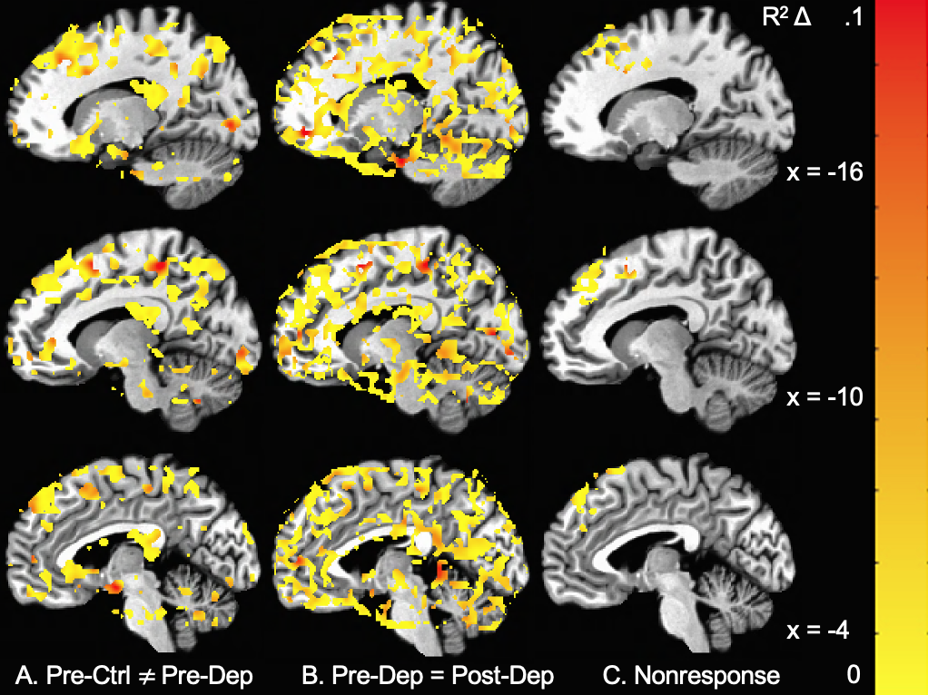
Note. A. Pre-Ctrl ≠ Pre-Dep represents brain areas where control participants differed (d > .24) from depressed patients prior to treatment. B. Pre-Dep = Post-Dep represents brain areas where a practical absence of effect (d < .05) was observed when comparing depressed patients prior to and after treatment. C. Nonresponse represents areas that met both A and B effect size criteria and survived cluster thresholding (> 263 voxels [AFNI’s NN3, 2-sided]). Coloring represents whole-brain regression R2 Δ values on neural reactivity to negative words at the pre-treatment scan as predicted by residual BDI-II scores above and beyond scanner (i.e., extent to which the region acts as a predictor of treatment response); the overall low values suggest the nonresponse cluster is minimally associated with either clinical change or change in activity in association with treatment.

Figure S4.2. Individual averages for nonresponse cluster for positive words
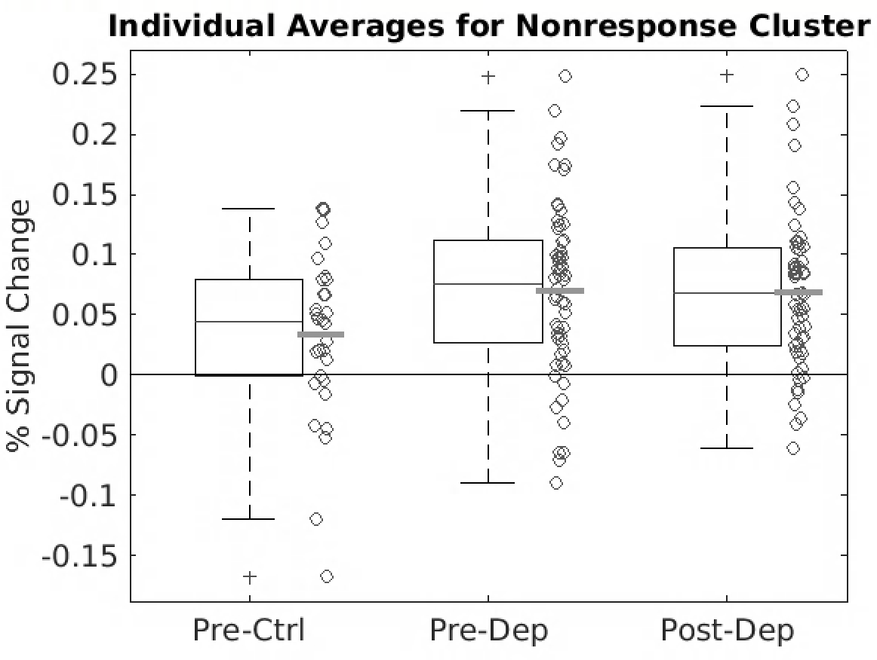
Note. Individual mean reactivity averages of the nonresponse cluster for control participants (Pre-Ctrl) and MDD patients prior to and after CBT (Pre-Dep, Post-Dep)

Change mechanisms
No areas that met contrast criteria for a change mechanism (remediation or compensatory) survived cluster-thresholding.

A priori regions of interest
The application of nonresponse and change mechanism a priori criteria to the bilateral, functionally defined DLPFC (Siegle et al., 2012) resulted in two clusters within the DLPFC that exhibits nonresponse qualities (Figure S4.3). The nonresponse clusters were centered at 37, 39, 32 (1,968.75mm³) and -36, 33, 36 (1,437.50mm³). The application of nonresponse and change mechanism criteria to the bilateral amygdala resulted in one cluster (Figure S4.4) that exhibits nonresponse qualities centered in the left amygdala at -23, -3, -24 (750mm³). No clusters within the sgACC survived cluster correction for either nonresponse or change mechanisms.

Figure S4.3. Clusters within the bilateral DLPFC meeting criteria for nonresponse
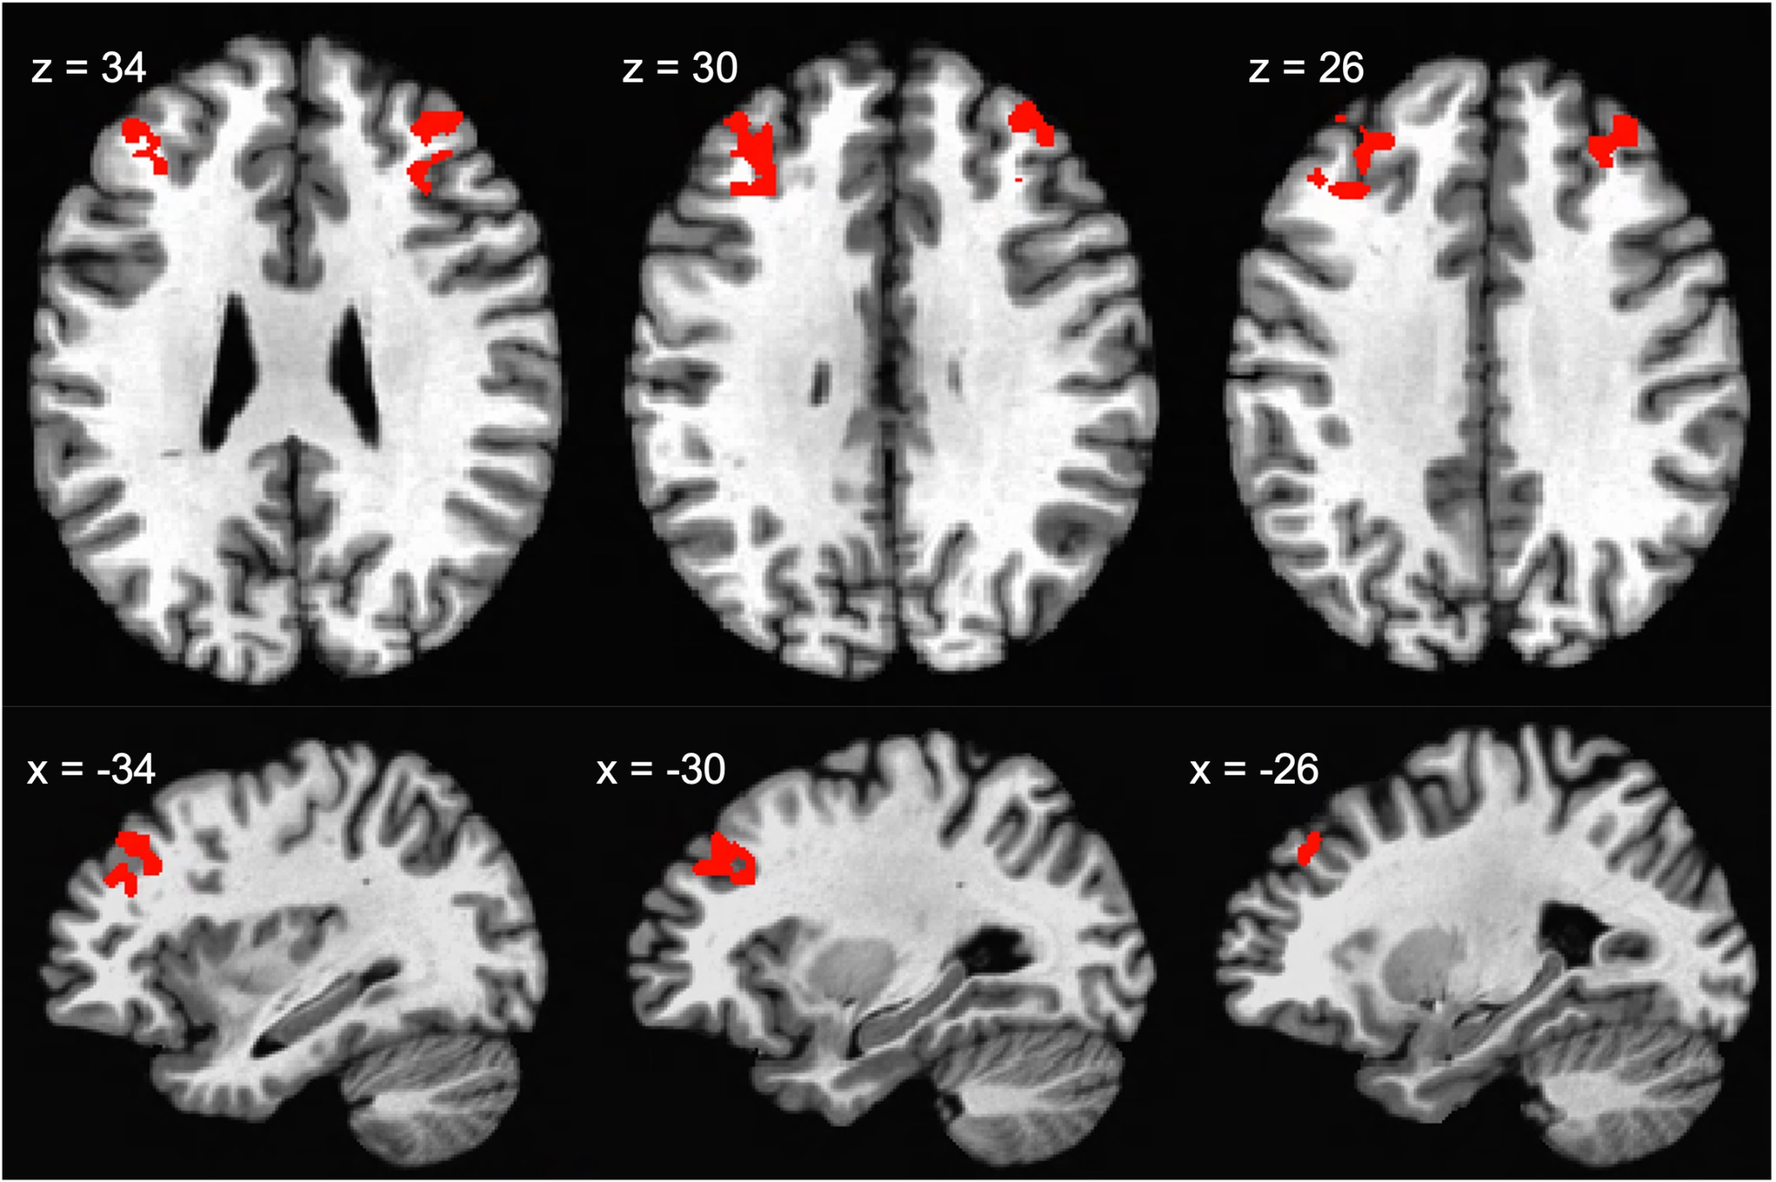
Note. The red clusters are dorsolateral prefrontal cortex subregions that met criteria for nonresponse (pre-depressed ≠ pre-control * pre-depressed = post-depressed [≠ corresponds to d > .24 and = corresponds to d < .05]) and met cluster correction.

Figure S4.4. Amygdala cluster meeting criteria for nonresponse
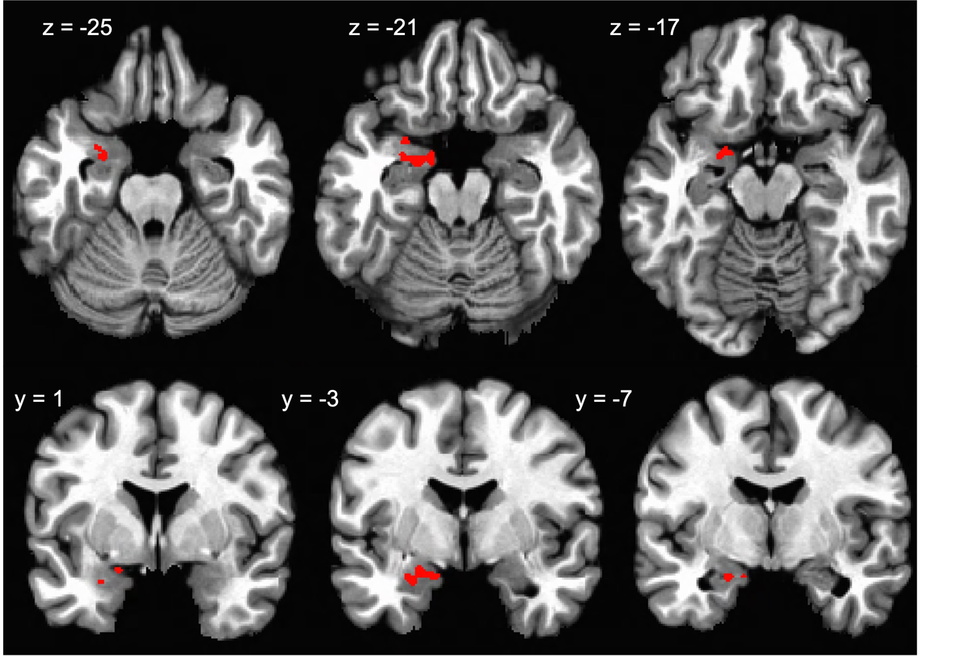
Note. The red cluster is an amygdala subregion that met criteria for nonresponse (pre-depressed ≠ pre-control * pre-depressed = post-depressed [≠ corresponds to d > .24 and = corresponds to d < .05]) and met cluster correction.

Supplement 5. Results for neutral words
Nonresponse
One large and diffuse cluster centered within the right thalamus at 11, -17, 2 (50,562.50mm³) met contrast criteria for nonresponse and survived cluster-thresholding (Figure S5.1). MDD patients showed less activation of the nonresponse cluster relative to control participants, which did not increase after CBT (Figure S5.2).

Biomarkers
R² changes from incorporating depression symptom residuals (BDI-II) to a whole-brain regression (neural reactivity regressed on site) ranged from 0 to 0.20 in the non-response cluster, suggesting minimal prognostic value (Figure S5.1).

Figure S5.1. Nonresponse cluster for neutral words
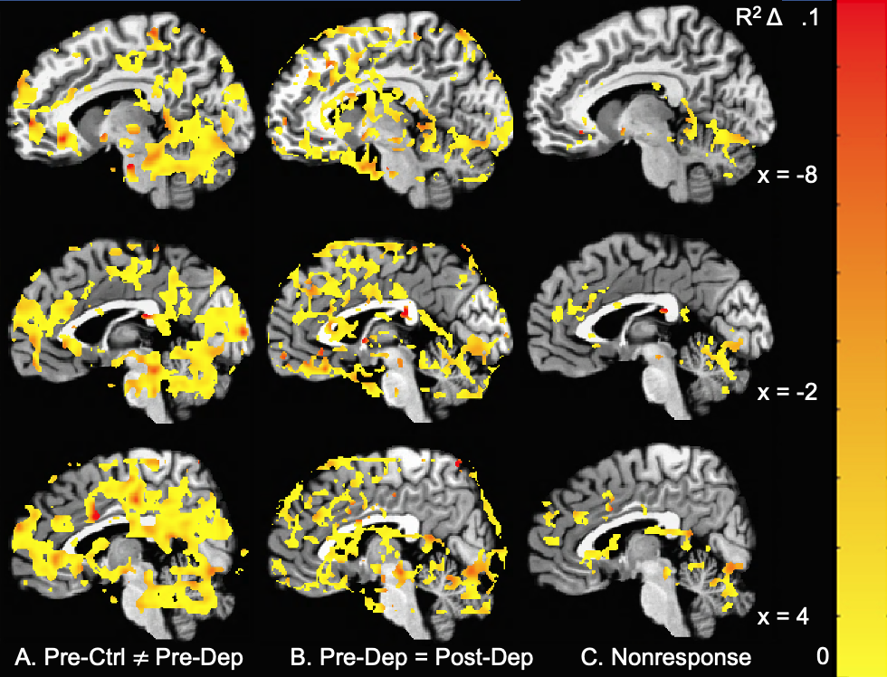
Note. A. Pre-Ctrl ≠ Pre-Dep represents brain areas where control participants differed (d > .24) from depressed patients prior to treatment. B. Pre-Dep = Post-Dep represents brain areas where a practical absence of effect (d < .05) was observed when comparing depressed patients prior to and after treatment. C. Nonresponse represents areas that met both A and B effect size criteria and survived cluster thresholding (> 262 voxels [AFNI’s NN3, 2-sided]). Coloring represents whole-brain regression R2 Δ values on neural reactivity to negative words at the pre-treatment scan as predicted by residual BDI-II scores above and beyond scanner (i.e., extent to which region predicts treatment response)

Figure S5.2. Individual averages for nonresponse cluster for neutral words
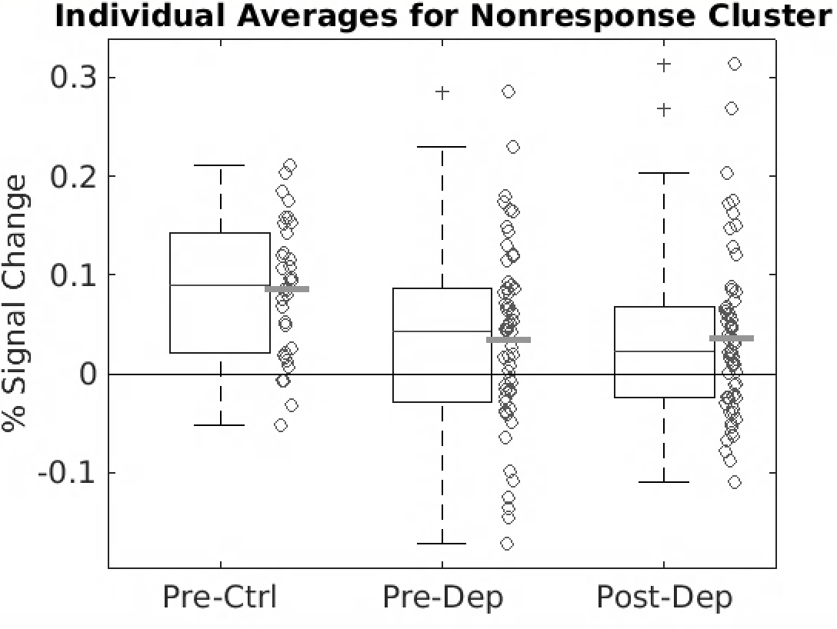Note. 2a. Individual mean reactivity averages of the nonresponse cluster for control participants (Pre-Ctrl) and MDD patients prior to and after CBT (Pre-Dep, Post-Dep)

Change Mechanisms
Three clusters met a priori contrast criteria for a remediation-based change mechanism and survived cluster-thresholding (Table S5.1; Figure S5.3). Prior to treatment, MDD patients exhibited less reactivity to neutral stimuli in posterior and prefrontal cortical regions than the control participants. Reactivity within these clusters increased after CBT for the MDD group (Figure S5.4). No areas that met contrast criteria for a compensatory change mechanism survived cluster-thresholding.
Normalization
For brain regions suggesting a remediation-based change mechanism, some portions of clusters exhibited normalization following CBT; effect sizes (d) ranged from 0-.5 for differences between post-treatment depressed patients (Figure S5.3).

Table S5.1. Coordinates for change mechanism clusters in response to neutral words
Centroid location | Size (mm³) | x | y | z
Right posterior cingulate cortex | 87,750 | 2 | -41 | 13
Left middle occipital gyrus | 4,500 | -24 | -80 | 25
Left superior medial gyrus | 2,906.25 | -4 | 63 | 21
Note. Coordinates are cluster centroids reported in MNI space

Figure S5.3. Change mechanism clusters for neutral words
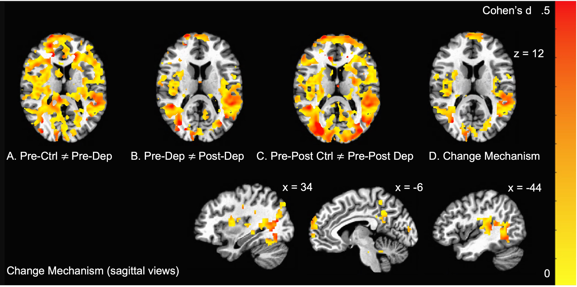
Note. A. Pre-Ctrl ≠ Pre-Dep represents brain areas where control participants differed (d > .24) from depressed patients prior to treatment. B. Pre-Dep ≠ Post-Dep represents brain areas where depressed patients prior to and after treatment differed (d > .24). C. Pre-Post Ctrl ≠ Pre-Post Dep represents brain areas where pre-post estimates differed (d > .24) between control participants and depressed patients. D. Change Mechanism represents brain areas that met all prior criteria (A, B, C) and survived cluster thresholding (> 92 voxels [AFNI’s NN3, 2-sided]). Coloring represents d estimates (contrast of post-treatment depressed patients and never-depressed control participants), showing some instances in which effect sizes suggest normalization occurs

Figure S5.4. Individual averages for change mechanism clusters for neutral words
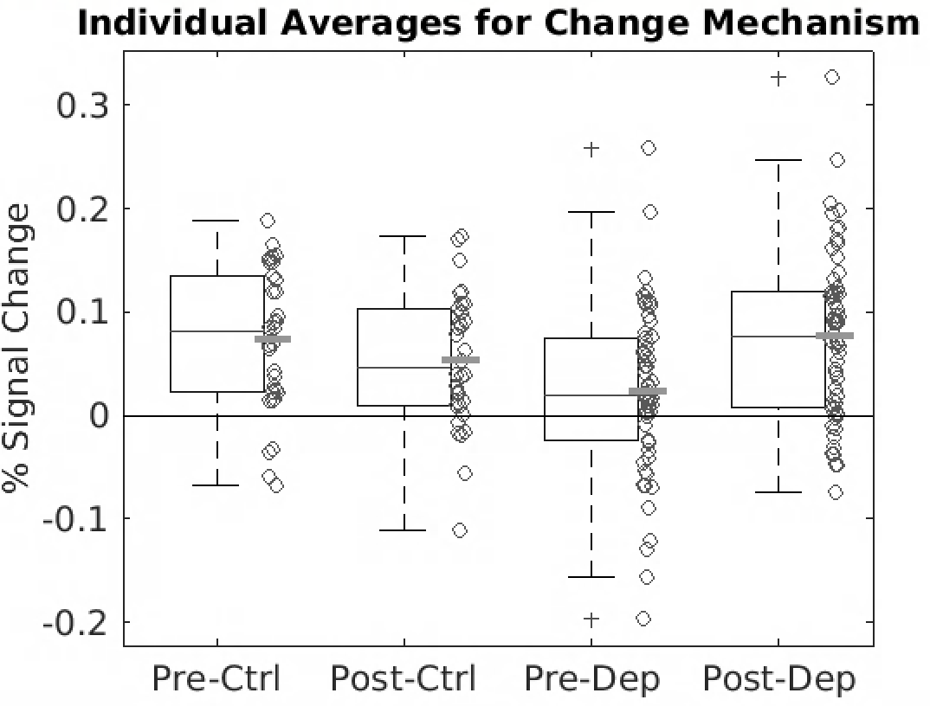
Note. Individual mean reactivity averages of the change mechanism regions (all clusters) for pre and post assessments for both control participants (Pre-Ctrl, Post-Ctrl) and MDD patients (Pre-Dep, Post-Dep)

A priori regions of interest
The application of nonresponse and change mechanism a priori criteria to the bilateral, functionally defined DLPFC (Siegle et al., 2012) resulted in two clusters within the DLPFC that exhibited nonresponse qualities and one that exhibited change mechanism qualities (Figure S5.5). The nonresponse clusters were centered at 33, 29, 37 (2,062.50mm³) and -40, 45, 14 (1,468.75mm³) and the change mechanism cluster was centered at 27, 60, 12 (937.50mm³). The application of nonresponse and change mechanism criteria to the bilateral amygdala resulted in one cluster within the left amygdala exhibiting nonresponse qualities centered at -20, 1, -26 (437.50mm³), see Figure S5.6. When applying nonresponse and change mechanism criteria to the sgACC, one nonresponse cluster centered at -4, 21, -3 (125mm³) survived cluster thresholding, see Figure S5.7.

Figure S5.5. Clusters within the bilateral dorsolateral prefrontal cortex meeting criteria for nonresponse or change mechanism
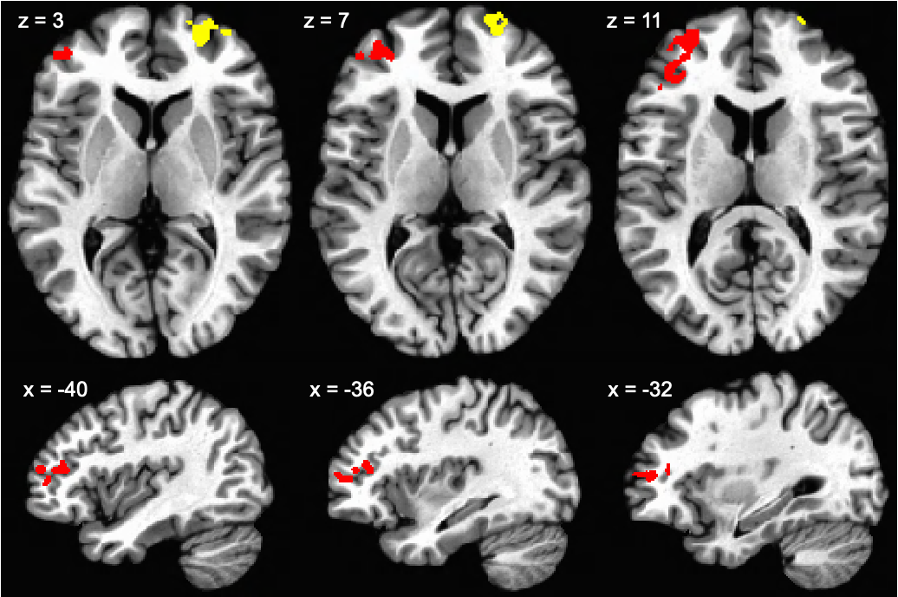
Note. Yellow represents a subregion of the dorsolateral prefrontal cortex that met criteria for a change mechanism (pre-depressed ≠ pre-control * pre-depressed ≠ post-depressed * pre-post depressed ≠ pre-post control [≠ corresponds to d > 0.24]) and survived cluster correction. Red represents a subregion within the dorsolateral prefrontal cortex that met criteria for nonresponse (pre-depressed ≠ pre-control * pre-depressed = post-depressed [≠ corresponds to d > .24 and = corresponds to d < .05]) and met cluster correction.
Figure S5.6. Amygdala cluster meeting criteria for nonresponse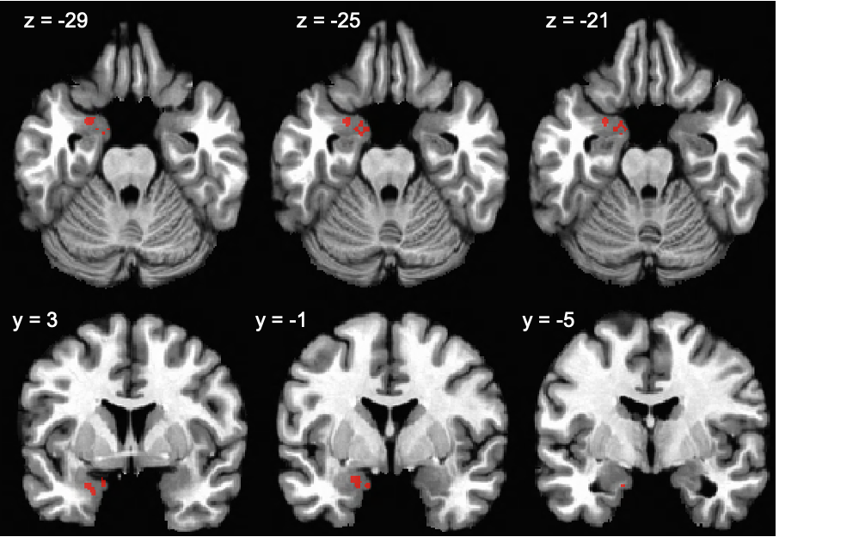
Note. The red cluster is an amygdala subregion that met criteria for nonresponse (pre-depressed ≠ pre-control * pre-depressed = post-depressed [≠ corresponds to d > .24 and = corresponds to d < .05]) and met cluster correction.

Figure S5.7. Cluster within the subgenual anterior cingulate cortex meeting criteria for nonresponse
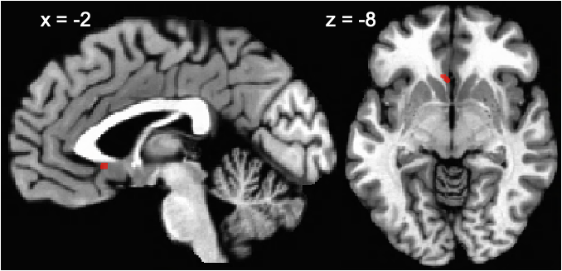
Note. The red cluster represents a subgenual anterior cingulate cortex subregion that met criteria for nonresponse (pre-depressed ≠ pre-control * pre-depressed = post-depressed [≠ corresponds to d > .24 and = corresponds to d < .05]) and met cluster correction.

Supplement 6. Mixed-effects analysis
To examine whether study findings were specific to negative stimuli, we conducted a 2 (Group: Depressed, Controls) x 2 (Time: Pre, Post) x 3 (Valence: Negative, Positive, Neutral) mixed-effects analysis using AFNI’s 3dMVM. Within the mixed-effects analysis, we conducted valence-specific general linear tests (GLT) for each criterion in the conjunction analyses. To allow for a comparison with main paper results, we converted GLT t values to Cohen’s d and overlaid GLT results on study findings for negative stimuli, see Figure S6.1 (Nonresponse) and Figure S6.2 (Change Mechanism).

Figure S6.1. Application of mixed-effects general linear tests to nonresponse criteria
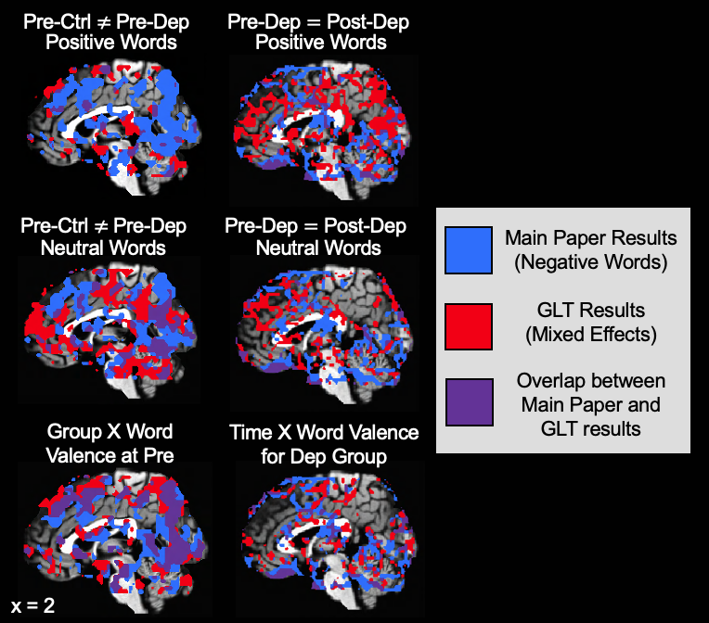
Note. GLT refers to a general linear test. Pre-Ctrl ≠ Pre-Dep represents brain areas where control participants differed (d > .24) from depressed patients prior to treatment. B. Pre-Dep = Post-Dep represents brain areas where a practical absence of effect (d < .05) was observed when comparing depressed patients prior to and after treatment. For interaction terms, variable levels are: group (depressed patients and control participants), time (pre- and post-treatment), and valence (negative, positive, neutral). Group X World Valence at Pre shows interaction effects (d > .24). Time x Word Valence for Dep Group shows an absence of interaction effects (d < .05).

Figure S6.2. Application of mixed-effects general linear tests to change mechanism criteria
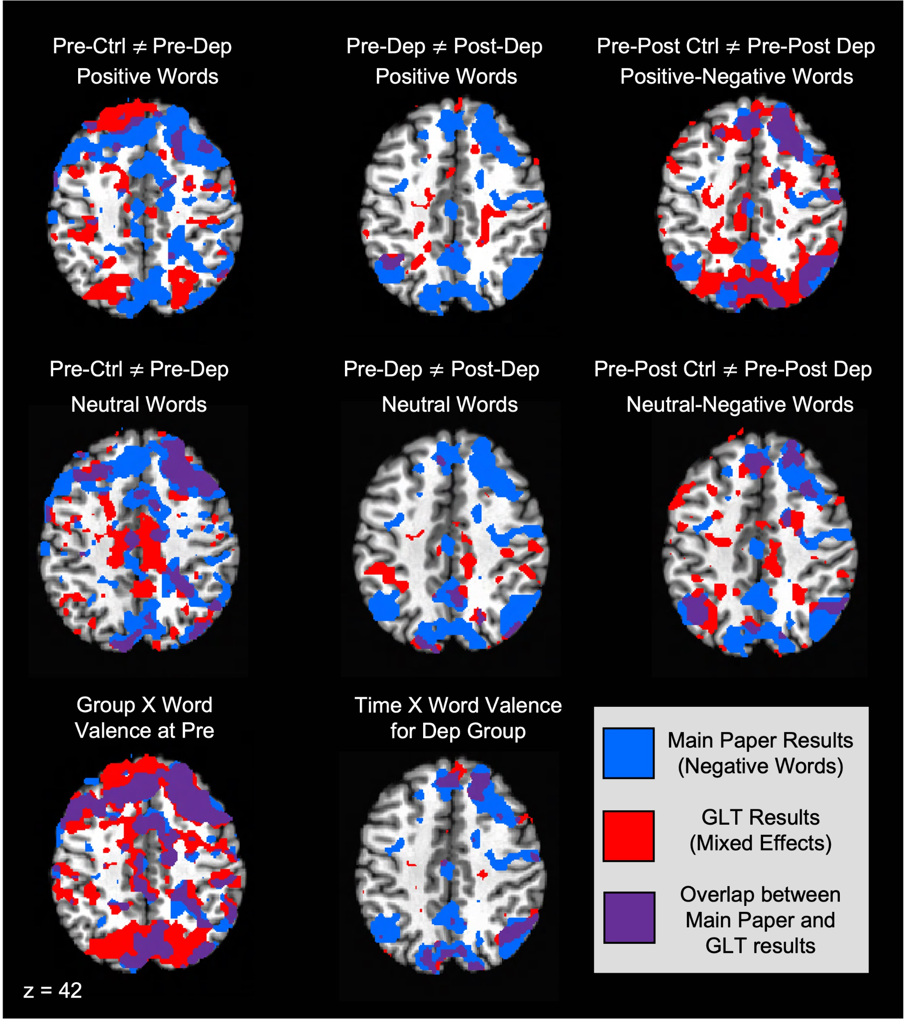
Note. GLT refers to a general linear test. Pre-Ctrl ≠ Pre-Dep represents brain areas where control participants differed (d > .24) from depressed patients prior to treatment. Pre-Dep ≠ Post-Dep represents brain areas where depressed patients prior to and after treatment differed (d > .24). Pre-Post Ctrl ≠ Pre-Post Dep represents brain areas where pre-post estimates differed (d > .24) between control participants and depressed patients. For interaction terms, variable levels are: group (depressed patients and control participants), time (pre- and post-treatment), and valence (negative, positive, neutral). Group X Word Valence at Pre and Time X Word Valence for Dep group show areas of interaction effects (d > .24).

References
Lakens, D. (2013). Calculating and reporting effect sizes to facilitate cumulative science: A practical primer for t-tests and ANOVAs. Frontiers in Psychology, 4, 863. https://doi.org/10.3389/fpsyg.2013.00863

