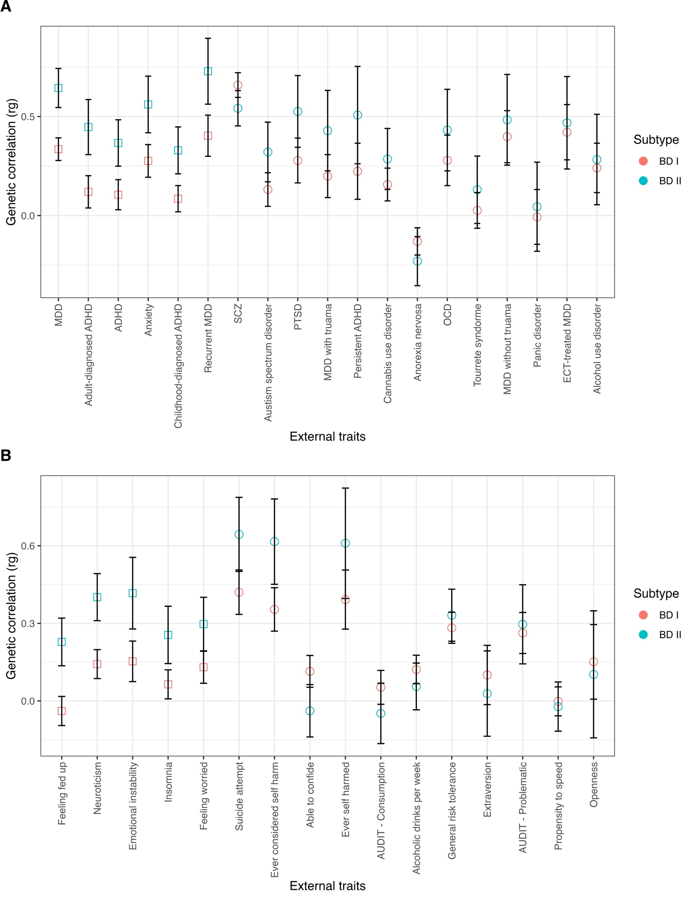

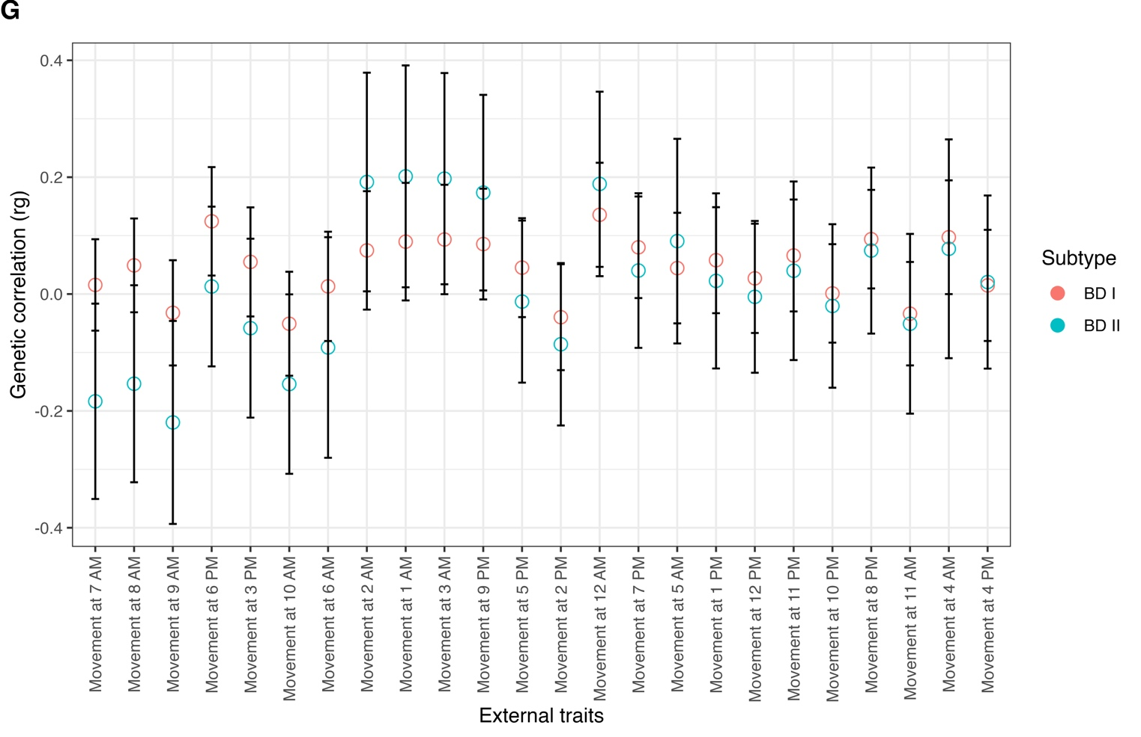

**Supplementary Figure 1. Genetic correlations for BD I and II across 98 external traits.** Traits sorted left to right by ascending $χ^{2}$ difference *p*-values. Error bars depict 95% confidence intervals. Squares represent significant divergences between BD I and II that surpass a Bonferroni corrected significance threshold of 5.10E-4 (.05/98 traits). Circles represent insignificant differences between BD subtypes. Each letter represents a set of traits from the following domains: **(A)** Psychiatric disorders, **(B)** Psychiatric symptoms and personality traits, **(C)** Cognitive traits and educational attainment, **(D)** Brain measures, **(E)** Medical diseases and physical health, **(F)** Interpersonal and social functioning, and **(G)** 24-hour accelerometer data.

**Supplementary Figure 2. Significant genetic correlations for the broad BD construct.** Error bars depict 95% confidence intervals. All depicted traits surpassed a Bonferroni corrected significance threshold of 5.10E-4 (.05/98 traits).

*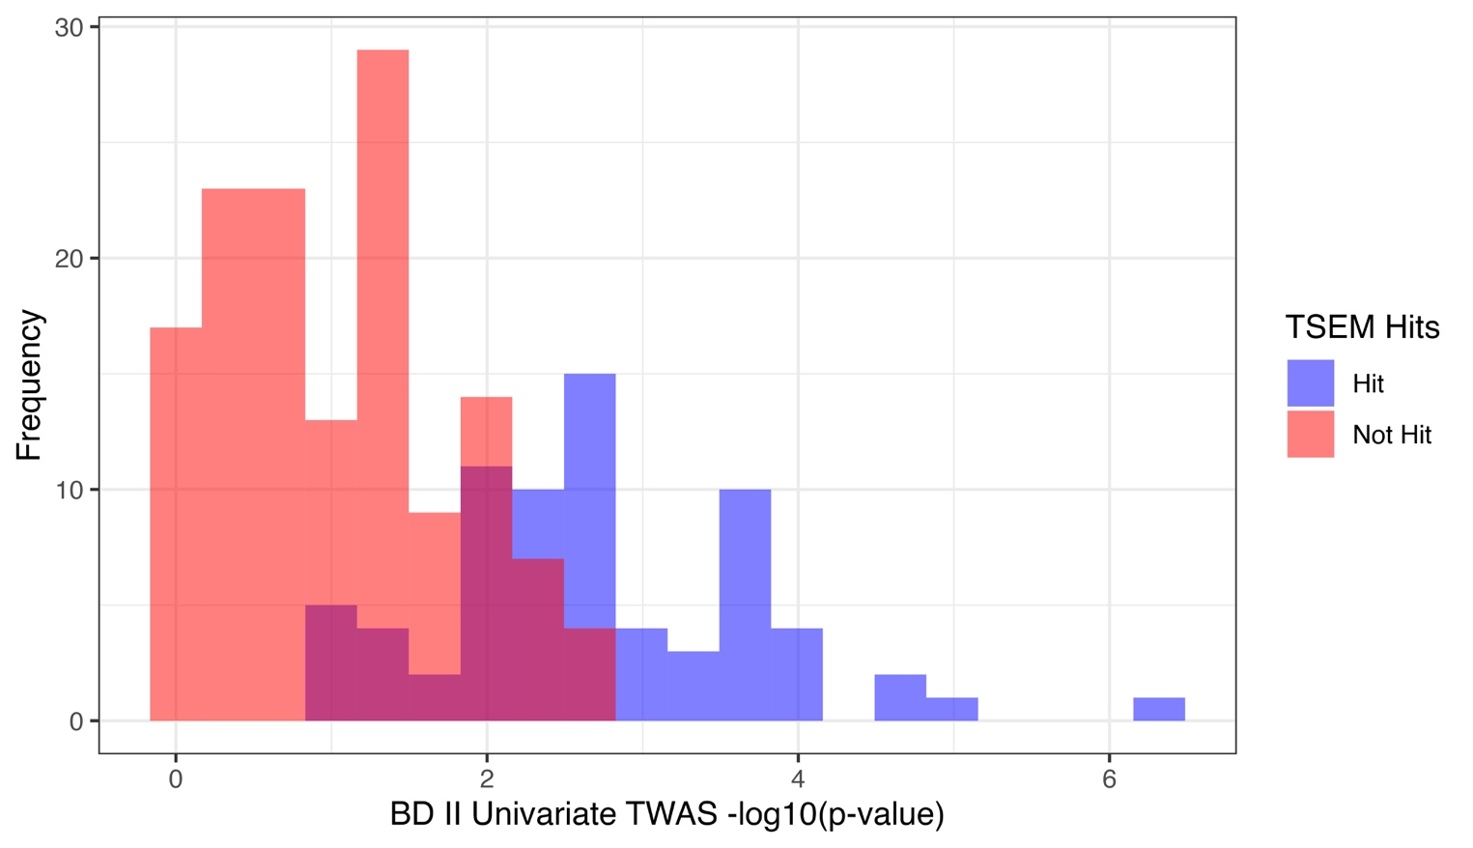***Supplementary Figure 3. BD II -log10(*p*-values) for BD I TWAS hits.** Blue bars represent BD II univariate TWAS *p*-values for BD I gene expression hits that are T-SEM gene expression hits. Red bars represent BD II univariate TWAS *p*-values for BD I gene expression hits not T-SEM gene expression hits.