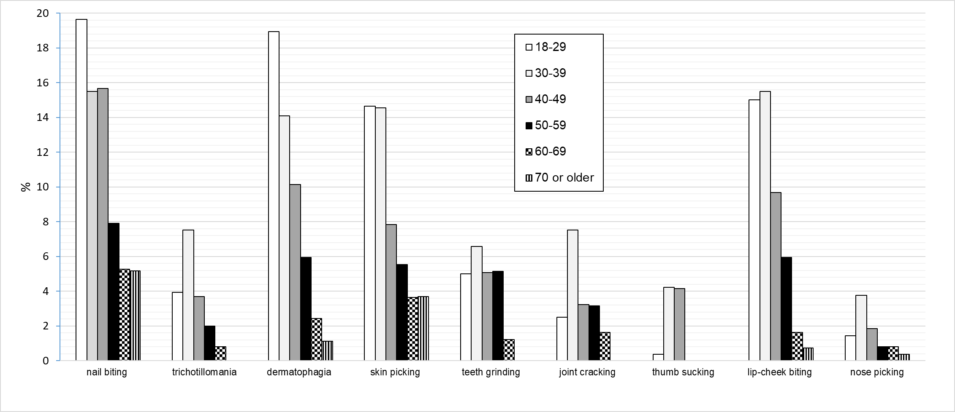
Figure 1. Prevalence of BFRDs across the lifespan

