Supplementary materials

Contents
Table S1 - Overview of depression and anxiety measures per cohort | 2
Table S2 - ICD codes of cancer outcomes | 3-4
Table S3 - Overview of health behaviors available in each cohort | 5
Table S4 - Overview of covariates used in the maximally adjusted model in each cohort | 6
Figure S1 - Theoretical framework of multiple mediator model using cohorts with information on all health behaviors | 7
Table S5 - Mediation of sedentary behavior, sleep quality and sleep duration in the associations of depression and anxiety with lung cancer in multiple mediator model | 8
Table S6 - Mediation of sedentary behavior, sleep quality and sleep duration in the associations of depression and anxiety with smoking-related cancers in multiple mediator model | 9
Supplementary text - Mediation of health behaviors in the associations of depression and anxiety with overall cancer and breast, prostate, colorectal, and alcohol-related cancers | 10-11
Tables S7-10 - Mediation of health behaviors in the association of depression and anxiety with overall cancer risk | 12-15
Tables S11-14 - Mediation of health behaviors in the association of depression and anxiety with breast cancer risk | 16-19
Tables S15-18 - Mediation of health behaviors in the association of depression and anxiety with prostate cancer risk | 20-23
Tables S19-22 - Mediation of health behaviors in the association of depression and anxiety with colorectal cancer risk | 24-27
Tables S23-26 - Mediation of health behaviors in the association of depression and anxiety with alcohol-related cancers risk | 28-31
Table S27 - Mediation of categorial variables of smoking, physical inactivity, alcohol use and BMI in the associations of depression and anxiety with lung cancer | 32-33
Table S28 - Mediation of categorial variables of smoking, physical inactivity, alcohol use and BMI in the associations of depression and anxiety with smoking-related cancers | 34-35

Table S1 Overview of depression and anxiety measures per cohort
Cohort | Depression symptoms | Anxiety symptoms | Depression diagnosis | Anxiety diagnosis
ALSPAC | Edinburgh post-natal depression scale | Crown Crisp Experiential Index | Scores of 11 or above | Scores of 8 or above
Atlantic PATH | PHQ9 | GAD7 | Scores of 10 or above | Scores of 10 or above
CARTaGENE | PHQ9 | GAD7 | Scores of 10 or above | Scores of 10 or above
ELSA | 8-item CES-D (with yes/no responses) | No measure | 3 or more “yes” | No measure
HELIUS | PHQ10 (a variant of PHQ9) | No measure | Scores of 10 or above | No measure
HUNT2 | HADS depression subscale | HADS anxiety subscale | Scores of 10 or above | Scores of 10 or above
HUNT3 | HADS depression subscale | HADS anxiety subscale | Scores of 10 or above | Scores of 10 or above
LASA | CES-D | Either HADS score, or CIDI items | DIS | Either CIDI or HADS scores of 11 or above
Lifelines | MINI items add up | No measure | MINI | MINI
NESDA | IDS | BAI | CIDI | CIDI
OHS | Depression subscale of the PHQ4 | Anxiety subscale of the PHQ4 | Scores of 3 or above | Scores of 3 or above
RS1 | CES-D | No measure | SCAN | CIDI
RS2 | CES-D | HADS anxiety subscale | SCAN | CIDI
ERS3 | CES-D | HADS anxiety subscale | SCAN | HADS scores of 10 or above
UCC-SMART-2 | PHQ9 | No measure | Scores of 10 or above | No measure
UHP 1 | SCL | SCL | No measure/validated cut-off | No measure/validated cut-off
UHP 2 | PHQ9 | GAD7 | Scores of 10 or above | Scores or 10 or above
WH-II | CES-D (original 20 item) | No measure | Scores of 16 or above | No measure
BAI, Beck’s Anxiety Inventory; CES-D, Center for Epidemiological Studies Depression; CIDI, Composite International Diagnosis Interview; GAD7, General Anxiety Disorder-7; HADS, Hospital Anxiety and Depression Scale; IDS, Inventory of Depressive Symptomatology; MINI, Mini-international Neuropsychiatric Interview; PHQ 4/9/10, Patient Health Questionnaire (4/9/10 items); SCL, Symptoms Checklist
Table S2 ICD codes of cancer outcomes
 | ICD-10 description | ICD-10 codes | ICD-O-3 codes (description) | ICD-9 codes
Overall Cancer | Malignant neoplasms | C00-C97 |  | 140-208
Breast Cancer | Breast | C50 | C50.0 – C50.9 (there’s no C50.7) | 174
Lung cancer | Bronchus and lung | C34 | C34.0 – C34.3, C34.8, C34.9 | 162
Colorectal cancer | Colon | C18 | C18.0 – C18.9 | 153
 | Rectosigmoid junction | C19 | C19.9 | 154
 | Rectum | C20 | C20.9 | 154
Prostate cancer | Prostate | C61 | C61.9 | 185
Alcohol-related cancers | Tongue  Other and unspecified parts of tongue  Gum  Floor of mouth  Palate  Other and unspecified parts of mouth | C01  C02  C03  C04  C05  C06 | C01.9 (base of tongue, NOS)  C02.0 – C02.4 + C02.8 – C02.9 (Other and unspecified parts of the tongue)  C03.0, C03.1, C03.9 (Gum)  C04.0, C04.1, C04.8, C04.9 (Floor of mouth)  C05.0 – C05.2, C05.8, C05.9 (Palate)  C06.0 – C06.2, C06.8, C06.9 (other and unspecified parts of mouth) | 141, 143, 144, 145
 | Tonsil | C09 | C09.0, C09.1, C09.8, C09.9 (Tonsil) | 146
 | Oropharynx | C10 | C10.0 – C10.4, C10.8, C10.9 (Oropharynx) | 146
 | Piriform sinus  Hypopharynx | C12  C13  C14 | C12.9 (Pyriform Sinus)  C13.0-C13.2, C13.8, C13.9 (Hypopharynx)  C14.0, C14.2, C14.8 (Other and ill-defined sites in lip, oral cavity and pharynx including overlapping and waldeyer ring) | 148-149
 | Oesophagus | C15 | C15.0 – C15.5, C15.8, C15.9 | 150
 | Liver and intrahepatic bile ducts | C22 | C22.0, C22.1 | 155
 | Larynx | C32 | C32.0-C32.3, C32.8, C32.9 | 161
 | Breast | C50 | C50.0 – C50.9 (there’s no C50.7) | 174, 175
 | Colorectal | C18  C19  C20 | C18.0 – C18.9 (Colon)  C19.9 (Rectosigmoid junction)  C20.9 (Rectum) | 153, 154
Smoking related cancers | Tongue  Other and unspecified parts of tongue  Gum  Floor of mouth  Palate  Other and unspecified parts of mouth | C01  C02  C03  C04  C05  C06 | C01.9 (base of tongue, NOS)  C02.0 – C02.4 + C02.8 – C02.9 (Other and unspecified parts of the tongue)  C03.0, C03.1, C03.9 (Gum)  C04.0, C04.1, C04.8, C04.9 (Floor of mouth)  C05.0 – C05.2, C05.8, C05.9 (Palate)  C06.0 – C06.2, C06.8, C06.9 (other and unspecified parts of mouth) | 141, 143, 144, 145
 | Tonsil | C09 | C09.0, C09.1, C09.8, C09.9 (Tonsil) | 146
 | Oropharynx  Nasopharynx | C10  C11 | C10.0 – C10.4, C10.8, C10.9 (Oropharynx)  C11.0-C11.3, C11.8, C11.9 (Nasopharynx) | 146, 147
 | Piriform sinus  Hypopharynx | C12  C13  C14 | C12.9 (Pyriform Sinus)  C13.0-C13.2, C13.8, C13.9 (Hypopharynx)  C14.0, C14.2, C14.8 (Other and ill-defined sites in lip, oral cavity and pharynx including overlapping and waldeyer ring) | 148, 149
 | Oesophagus | C15 | C15.0 – C15.5, C15.8, C15.9 | 150
 | Stomach | C16 | C16.0 – C16.9 (no C16.7) | 151
 | Colorectal | C18  C19  C20 | C18.0 – C18.9 (Colon)  C19.9 (Rectosigmoid junction)  C20.9 (Rectum) | 153, 154
 | Liver and intrahepatic bile ducts | C22 | C22.0, C22.1 | 155
 | Pancreas | C25 | C25.0-C25.4, C25.7-C25.9 | 157
 | Nasal cavity | C30 | C30.0 (do not include C30.1 - middle ear) | 160.0
 | Accessory sinuses | C31 | C31.0-C31.9 | 160.2-160.9
 | Larynx | C32 | C32.0-C32.3, C32.8, C32.9 | 161
 | Bronchus and lung | C34 | C34.0 – C34.3, C34.8, C34.9 | 162
 | Cervix uteri | C53 | C53.0 (endocervix), C53.1 (exocervix), C53.8 (overlapping lesion of cervix uteri), C53.9 (Cervix uteri) | 180
 | Ovary | C56 | C56 | 183
 | Kidney, excluding renal pelvis | C64 | C64.9 | 189.0
 | Renal pelvis | C65 | C65.9 | 189.1
 | Ureter | C66 | C66.9 | 189.2
 | Bladder | C67 | C67.0 – C67.9 | 188
 | Myeloid leukaemia | C92 | C42.1 | 205
From “Psychosocial factors and cancer incidence (PSY‐CA): Protocol for individual participant data meta‐analyses,” by van Tuijl et al., 2021, Brain and Behavior, 11:e2340, p 7 (Table 2), https://doi.org/10.1002/brb3.2340. Printed with permission from the authors.

Table S3 Overview of health behaviors available in each cohort
Cohort | Smoking | Alcohol | BMI | Physical activity | Sedentary behavior | Sleep quality | Sleep duration
ALSPAC | x | x |  | Leisure time PA at 18 weeks of pregnancy¹
Atlantic PATH | x | x | x | IPAQ¹ | IPAQ³ | One question⁴ | x
CARTaGENE | x | x | x | IPAQ¹ | IPAQ³ | One question⁴ | x
ELSA | x | x |  | Leisure time PA²
HELIUS | x | x | x | SQUASH¹ |  |  | x
HUNT2 | x | x | x | Leisure time PA² | daily hours spent sitting |  | x
HUNT3 | x | x | x | Leisure time PA² | daily hours spent sitting | Three questions⁵
LASA | x | x | x | LAPAQ¹ |  | SPS⁶ | x
Lifelines | x | x | x | SQUASH¹ | daily hours spent watching TV |  | x
NESDA | x | x | x | IPAQ¹ | IPAQ³ | IRS | x
OHS | x | x | x | IPAQ¹ | IPAQ³ | Three questions⁷ | x
RS1 | x | x | x |  |  | PSQI | x
RS2 | x | x | x |  |  | PSQI | x
RS3 | x | x | x | LAPAQ¹ |  | PSQI | x
UCC-SMART-2 | x | x | x | CPAI¹
UHP 1 | x | x | x | SQUASH¹ |  | SPS⁶
UHP 2 | x | x | x | SQUASH¹
WH-II | x | x | x | Leisure time PA¹ |  | SPS⁸ | x
Total number | 18 | 18 | 16 | 16 | 7 | 11 | 12
¹Metabolic Equivalent Total hours per week
²Hours per week
³Weighted hours spent sitting per day based on the last seven days (including week days and weekend)
⁴One question: difficulties falling asleep or maintaining sleep
⁵Three questions: difficulties falling asleep, difficulties maintaining sleep during the night, and waking up in the morning feeling tired
⁶Three items: difficulties falling asleep, difficulties maintaining sleep during the night, and waking up too early in the morning
⁷Three questions: difficulties falling asleep or maintaining sleep, snoring, and stopping breathing
⁸Four items: difficulties falling asleep, difficulties maintaining sleep during the night, waking up too early in the morning, and nonrestorative sleep

CPAI, Cambridge Physical Activity Index; LAPAQ, LASA Physical Activity Questionnaire; IPAQ, International Physical Activity Questionnaire; IRS, Insomnia rating Scale; PA, Physical Activity; PSQI, Pittsburgh Sleep Quality Index; SPS, Sleep Problem Scale; SQUASH, Short QUestionnaire to ASsess Health-enhancing physical activity

Table S4 Overview of covariates used in the maximally adjusted model in each cohort
Cohort | Anti-depressant use | Family history of cancer¹ | Oral contraceptive pill use² | Menopausal status² | Menarche age² | Parity²
ALSPAC | x |  | Ever |  | x | x
Atlantic PATH | x | Overall, breast, colorectal, lung, prostate | Ever | x | x | x
CARTaGENE | x | Overall, breast, colorectal, lung, prostate | Years | x | x | x
ELSA |  |  |  | x
HELIUS | x |  | Ever | x | x | x
HUNT 2 |  | Overall | Ever | x | x | x
HUNT 3 |  | Overall | Ever | x | x | x
LASA | x |  |  |  | x | x
Lifelines | x | Overall, breast, colorectal, lung, prostate | Ever | x | x | x
NESDA | x |  | Baseline | x |  | x
OHS | x | Overall, breast, colorectal, lung, prostate |  | x | x | x
RS1 | x | Overall, breast, colorectal, lung, prostate | Ever | x |  | x
RS2 | x | Overall, breast, colorectal, lung, prostate | Ever | x |  | x
RS3 | x |  | Ever | x |  | x
UCC-SMART-2 | x |  | Years | x |  | x
UHP 1 |  |  | Ever | x |  | x
UHP 2 | x |  | Baseline | x |  | x
Whitehall-II | x |  | Ever | x
¹When predicting breast, colorectal, lung or prostate cancer, information about a family history of these specific cancers was used were available. If not available, family history of Overall cancer was used
²Used in maximum models predicting breast cancer only. For oral contraceptive pill use, a preference was given for total number of years used, ever use (yes/no), and use at baseline (yes/no)

Depression/Anxiety
Cancer
Smoking
a1
b1
c’
Physical activity

Alcohol use
BMI
a2
a3
a4
b2
b3
b4
Sedentary behaviour*
Sleep quality*
Sleep duration*
a5

a6
a7
b5
b6
b7

Figure S1 Theoretical framework of multiple mediator model using cohorts with information on all health behaviors
*In this analysis, we focus only on mediation by sedentary behavior, sleep quality and sleep duration, while controlling for other health behaviors
Table S5 Mediation of sedentary behavior, sleep quality and sleep duration in the associations of depression and anxiety with lung cancer in multiple mediator model
Depression symptoms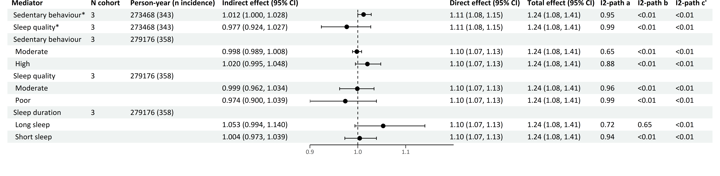
Depression diagnosis
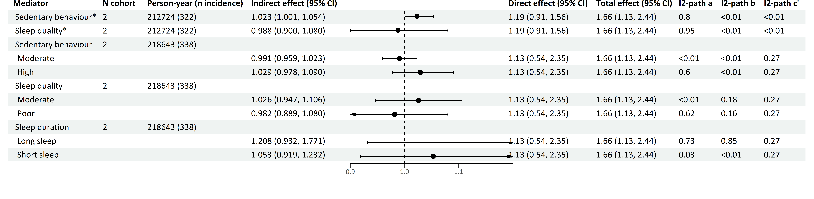
Anxiety symptoms

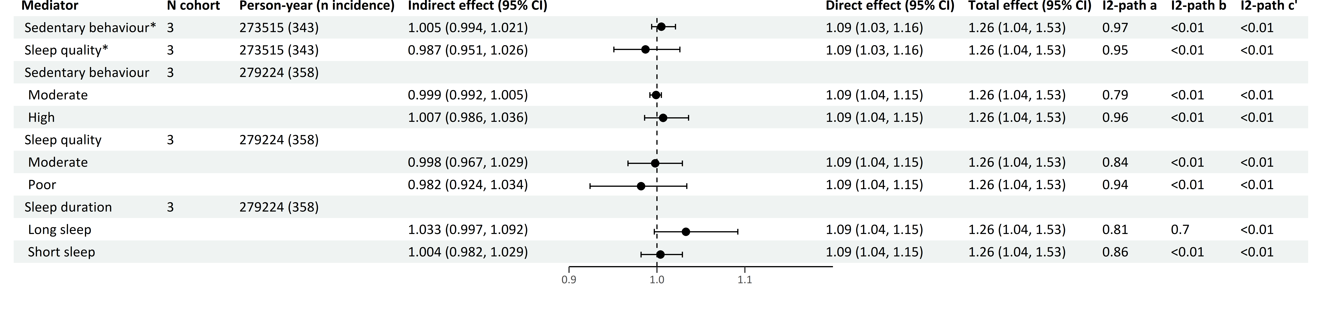Anxiety diagnosis
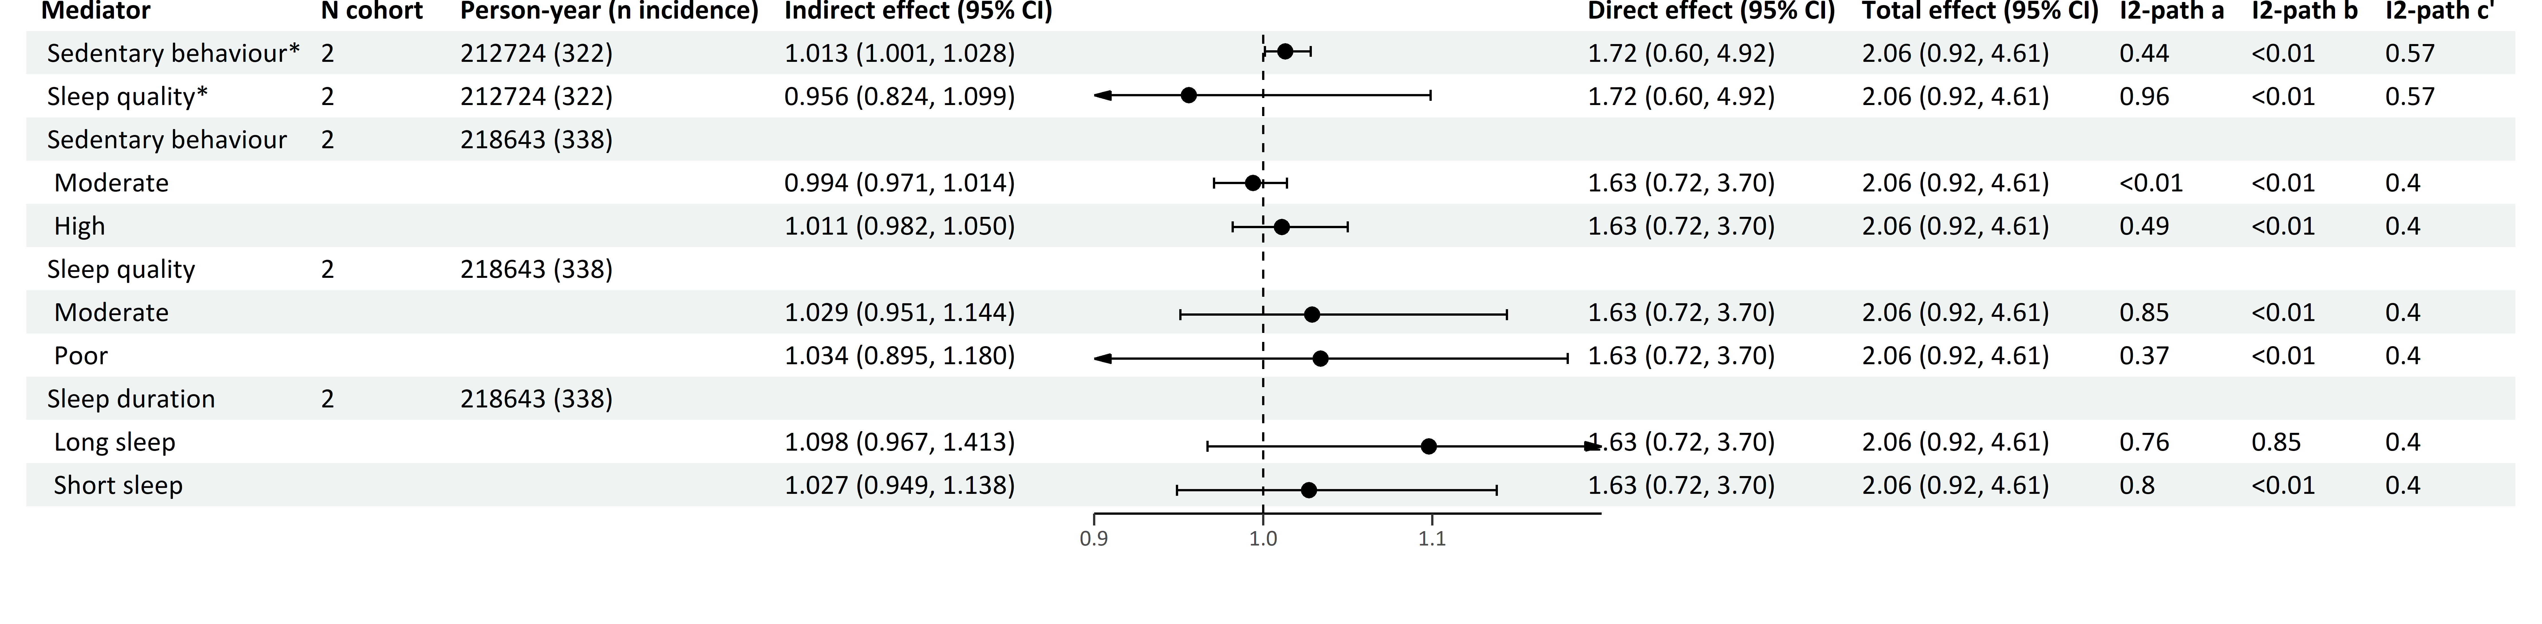
*continuous variables
Effects are Hazard Ratios.
The forest plot refers to the indirect effect of the mediator.
Multiple mediator model includes cohorts with information on all seven health behaviors.
Models adjusted for smoking, physical activity, alcohol use, BMI, birth year, sex, education, country of origin, anti-depressant use and family history of cancer.

Table S6 Mediation of sedentary behavior, sleep quality and sleep duration in the associations of depression and anxiety with smoking-related cancers in multiple mediator model
Depression symptoms
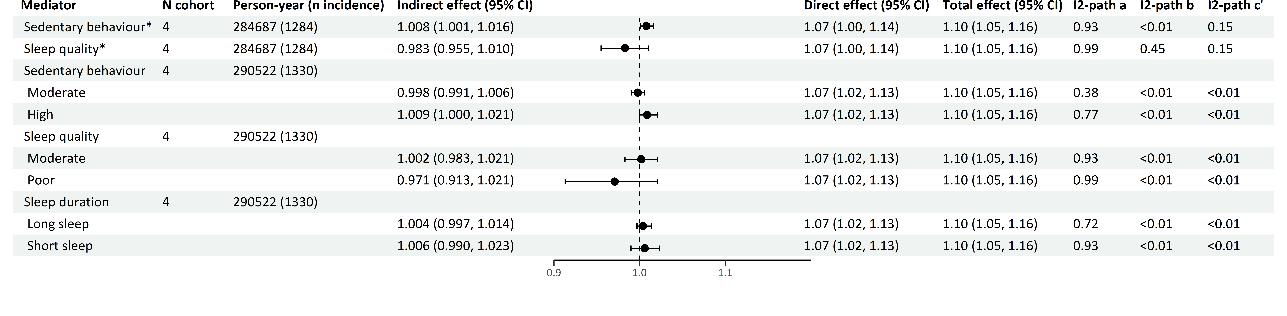
Depression diagnosis
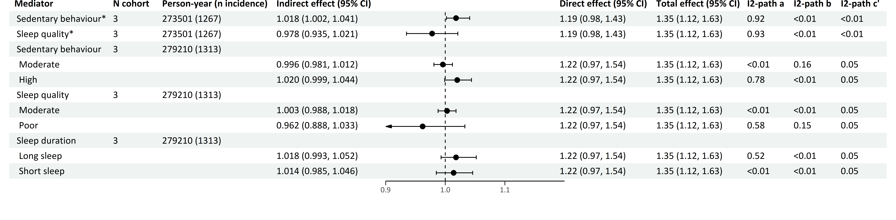
Anxiety symptoms
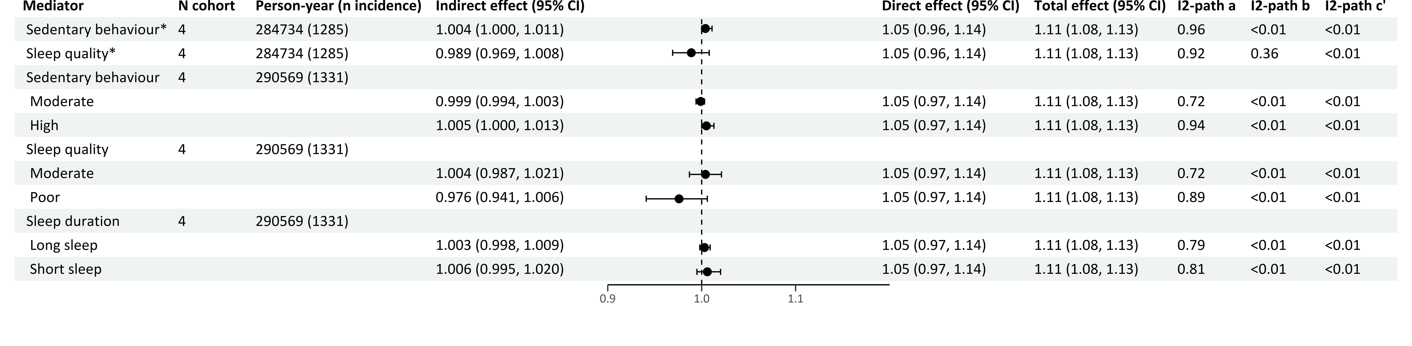
Anxiety diagnosis
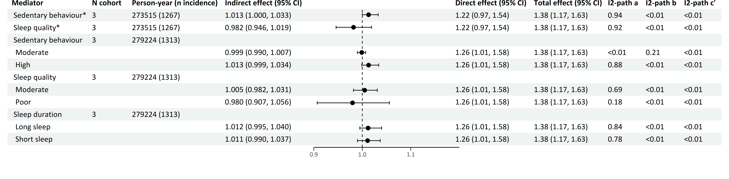
*continuous variables
Effects are Hazard Ratios.
The forest plot refers to the indirect effect of the mediator.
Multiple mediator model includes cohorts with information on all seven health behaviors.
Models adjusted for smoking, physical activity, alcohol use, BMI, birth year, sex, education, country of origin, anti-depressant use and family history of cancer.
Supplementary text. Mediation of health behaviors in the associations of depression and anxiety with overall cancer and breast, prostate, colorectal, and alcohol-related cancers
For overall cancer (supplementary tables S7-10), in single mediator models, smoking (HRs range 1.01 to 1.03) and a higher BMI (HRs range 1.001 to 1.01) mediated the associations of depression (symptoms and diagnosis) and anxiety (symptoms and diagnosis) with overall cancer risk. Alcohol use also mediated the associations among drinkers (HRs range 1.002 to 1.01). These mediating effects remained similar in multiple mediator models. Physical inactivity mediated the association between depression and anxiety symptoms and overall cancer in the single mediator models, but its mediating effect attenuated in the multiple mediator models. Additionally, exploratory analyses showed mediating effects of sedentary behavior in the associations of depression and anxiety with overall cancer risk in both single and multiple mediator models (HRs range 1.001 to 1.01).
For breast cancer (supplementary tables S11-14), in single mediator models, smoking mediated the associations of depression symptoms and anxiety (symptoms and diagnosis) with breast cancer, but its mediating effects attenuated and were not significant in multiple mediator models. Among drinkers, there were some signals of alcohol use mediating the associations between depression (symptoms and diagnosis) and breast cancer, although not fully consistently so across single and multiple mediator models. Despite a trend, mediating effects of physical inactivity and BMI were not significant.
For prostate cancer (supplementary tables S15-18), we observed inconsistent mediation patterns, with path a and path b showing different directions. Individuals with more depression symptoms or depression or anxiety diagnoses were more physically inactive, which in turn was related to a lower risk of prostate cancer in single mediator models, but not in multiple mediator models. Exploratory analyses showed that individuals with more depression symptoms or a depression diagnosis smoked more, which in turn was related to a lower risk of prostate cancer in single and multiple mediator models (HRs range 0.97 to 0.99).
For colorectal cancer (supplementary tables S19-22), in both single and multiple mediator models, smoking mediated the association of depression (symptoms and diagnosis) and anxiety diagnosis with colorectal cancer (HRs range 1.01 to 1.02), and physical inactivity (HR 1.01) was a mediator for depression symptoms and a higher BMI (HRs range 1.004 to 1.01) for depression (symptoms and diagnosis) in relation to colorectal cancer. Alcohol use mediated the associations between depression symptoms and anxiety diagnosis and colorectal cancer among drinkers in single mediator models, but not in multiple mediator model. Exploratory analyses showed that sedentary behavior mediated the association between anxiety diagnosis and colorectal cancer in both single and multiple mediator models (HR 1.01).
For alcohol-related cancers (supplementary tables S23-26), alcohol use mediated the associations of depression (symptoms and diagnosis) and anxiety (symptoms and diagnosis) with alcohol-related cancers among alcohol drinkers in both single and multiple mediator models (HRs range 1.003 to 1.01). Exploratory analyses also showed such robust mediating effects of smoking (HRs range 1.01 to 1.02) and a higher BMI (HRs range 1.001 to 1.01). Physical inactivity robustly mediated the associations of depression and anxiety symptoms with alcohol-related cancers (HRs 1.001 and 1.003, respectively). Additionally, sedentary behavior was a mediator in the associations of depression (symptoms and diagnosis) and anxiety (symptoms and diagnosis) in single, but not in multiple mediator models.

Table S7 Mediation of health behaviors in the association of depression symptoms with overall cancer risk
Single mediator model
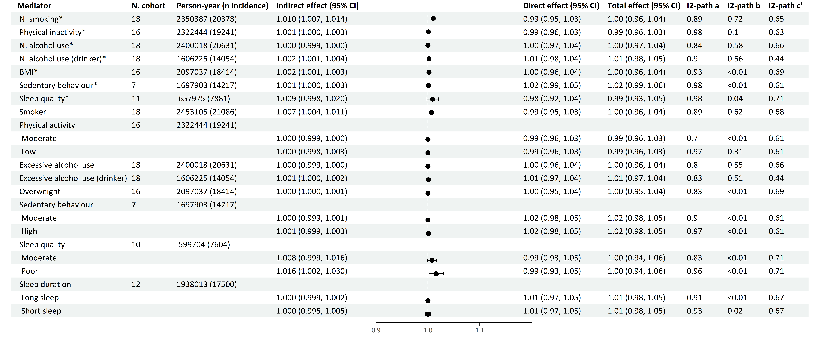
Multiple mediator model 1
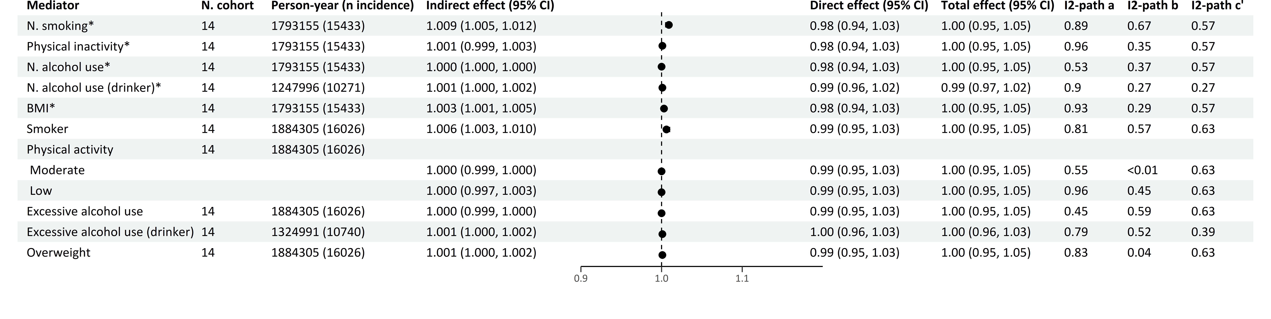
Multiple mediator model 2
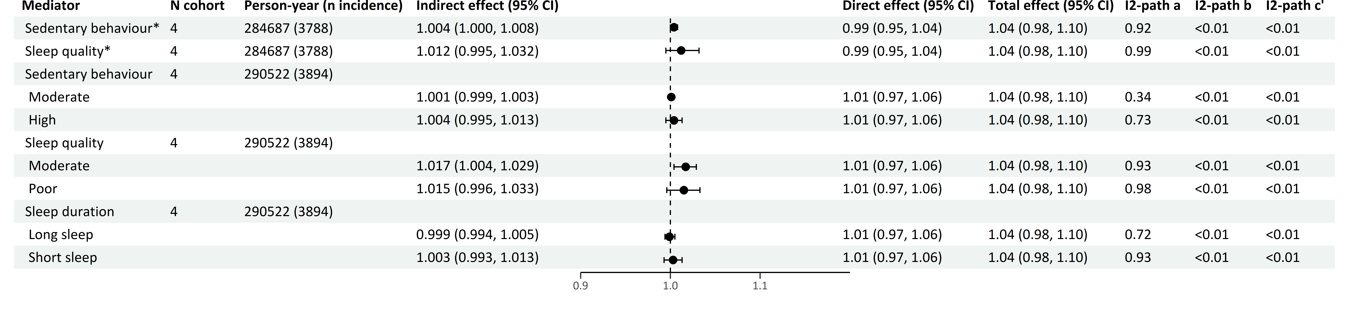*continuous variables
Effects are Hazard Ratios.
The forest plot refers to the indirect effect of the mediator.
Multiple mediator model 1 includes and focuses on the effects of the four main health behaviors (smoking, physical inactivity, alcohol use and BMI).
Multiple mediator model 2 includes all seven health behaviors (smoking, physical inactivity, alcohol use, BMI, sedentary behavior, sleep quality and sleep duration), and focuses on the effects of the last three health behaviors.
Models adjusted for smoking, physical activity, alcohol use, BMI, birth year, sex, education, country of origin, anti-depressant use and family history of cancer.
Table S8 Mediation of health behaviors in the association of depression diagnosis with overall cancer risk
Single mediator model
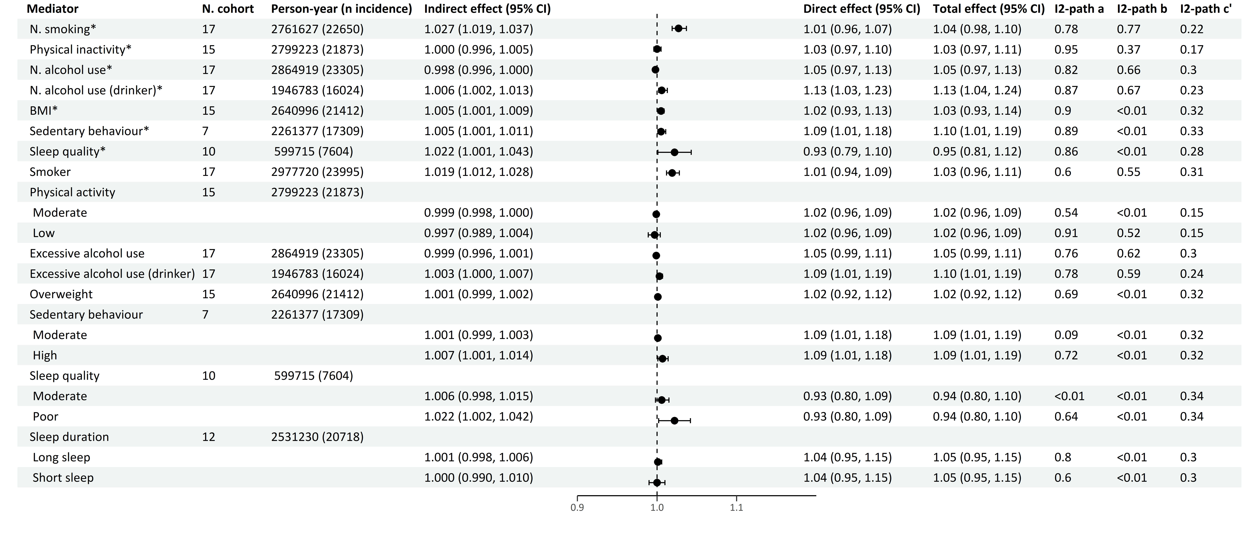
Multiple mediator model 1
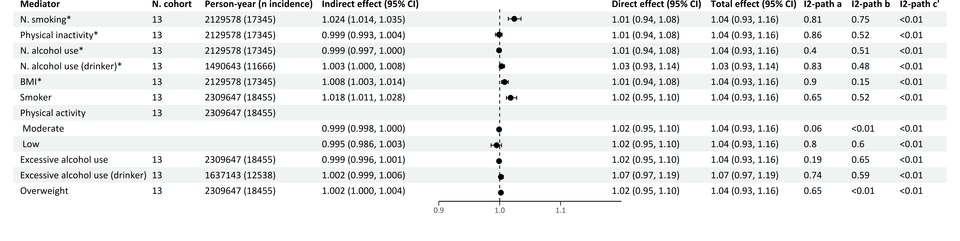
Multiple mediator model 2
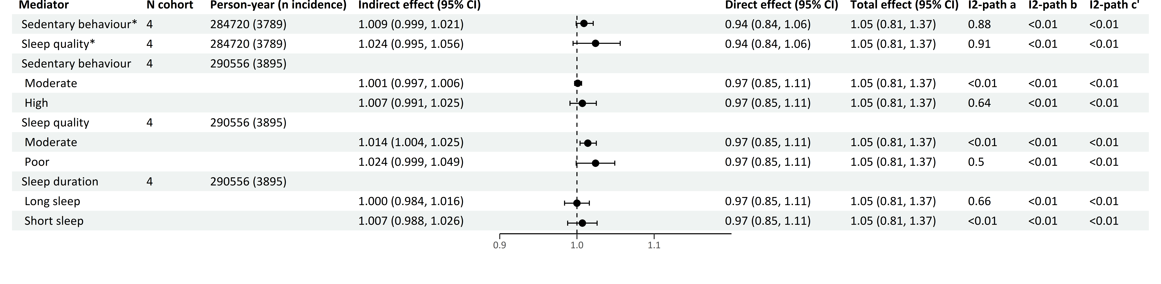
*continuous variables
Effects are Hazard Ratios.
The forest plot refers to the indirect effect of the mediator.
Multiple mediator model 1 includes and focuses on the effects of the four main health behaviors (smoking, physical inactivity, alcohol use and BMI).
Multiple mediator model 2 includes all seven health behaviors (smoking, physical inactivity, alcohol use, BMI, sedentary behavior, sleep quality and sleep duration), and focuses on the effects of the last three health behaviors.
Models adjusted for smoking, physical activity, alcohol use, BMI, birth year, sex, education, country of origin, anti-depressant use and family history of cancer.

Table S9 Mediation of health behaviors in the association of anxiety symptoms with overall cancer risk
Single mediator model
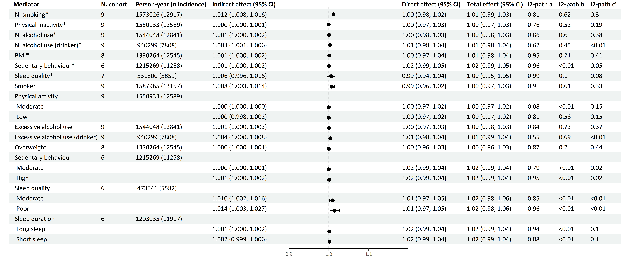
Multiple mediator model 1
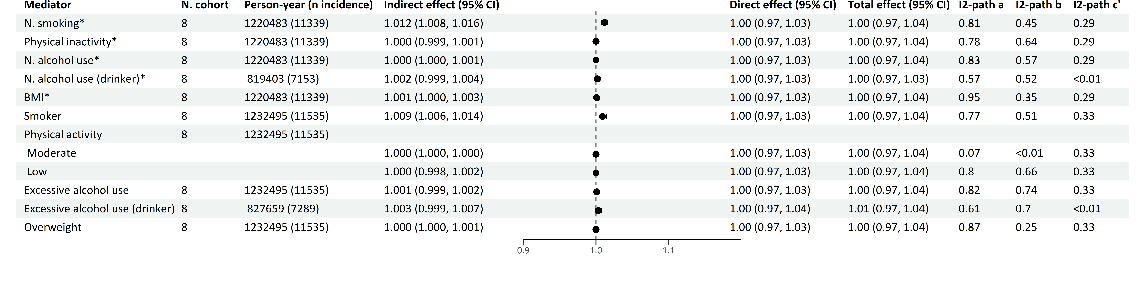
Multiple mediator model 2
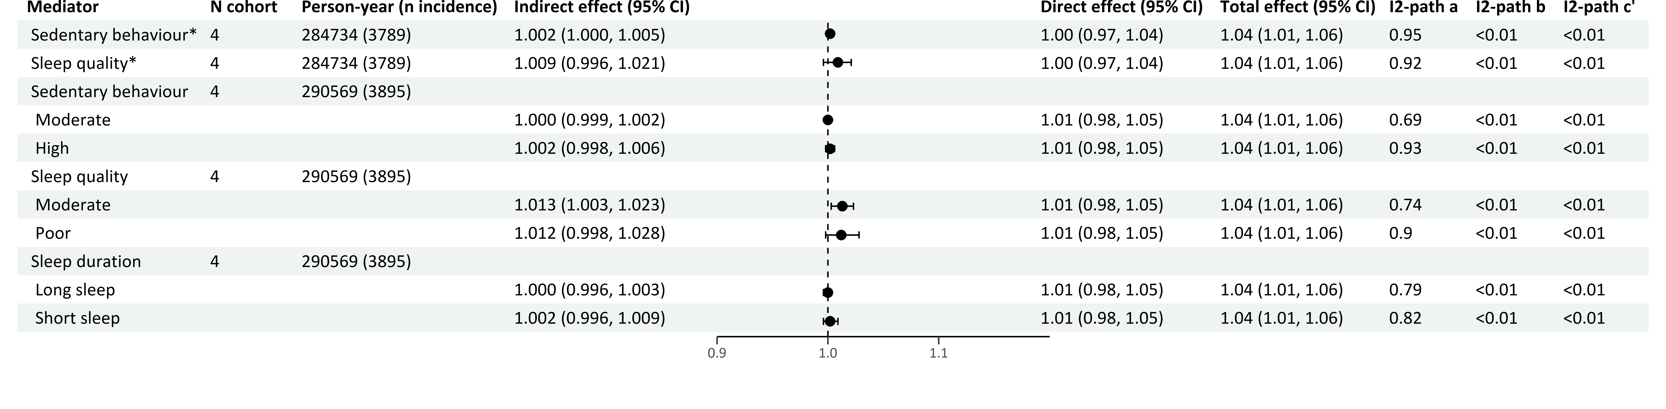
*continuous variables
Effects are Hazard Ratios.
The forest plot refers to the indirect effect of the mediator.
Multiple mediator model 1 includes and focuses on the effects of the four main health behaviors (smoking, physical inactivity, alcohol use and BMI).
Multiple mediator model 2 includes all seven health behaviors (smoking, physical inactivity, alcohol use, BMI, sedentary behavior, sleep quality and sleep duration), and focuses on the effects of the last three health behaviors.
Models adjusted for smoking, physical activity, alcohol use, BMI, birth year, sex, education, country of origin, anti-depressant use and family history of cancer.
Table S10 Mediation of health behaviors in the association of anxiety diagnosis with overall cancer risk
Single mediator model
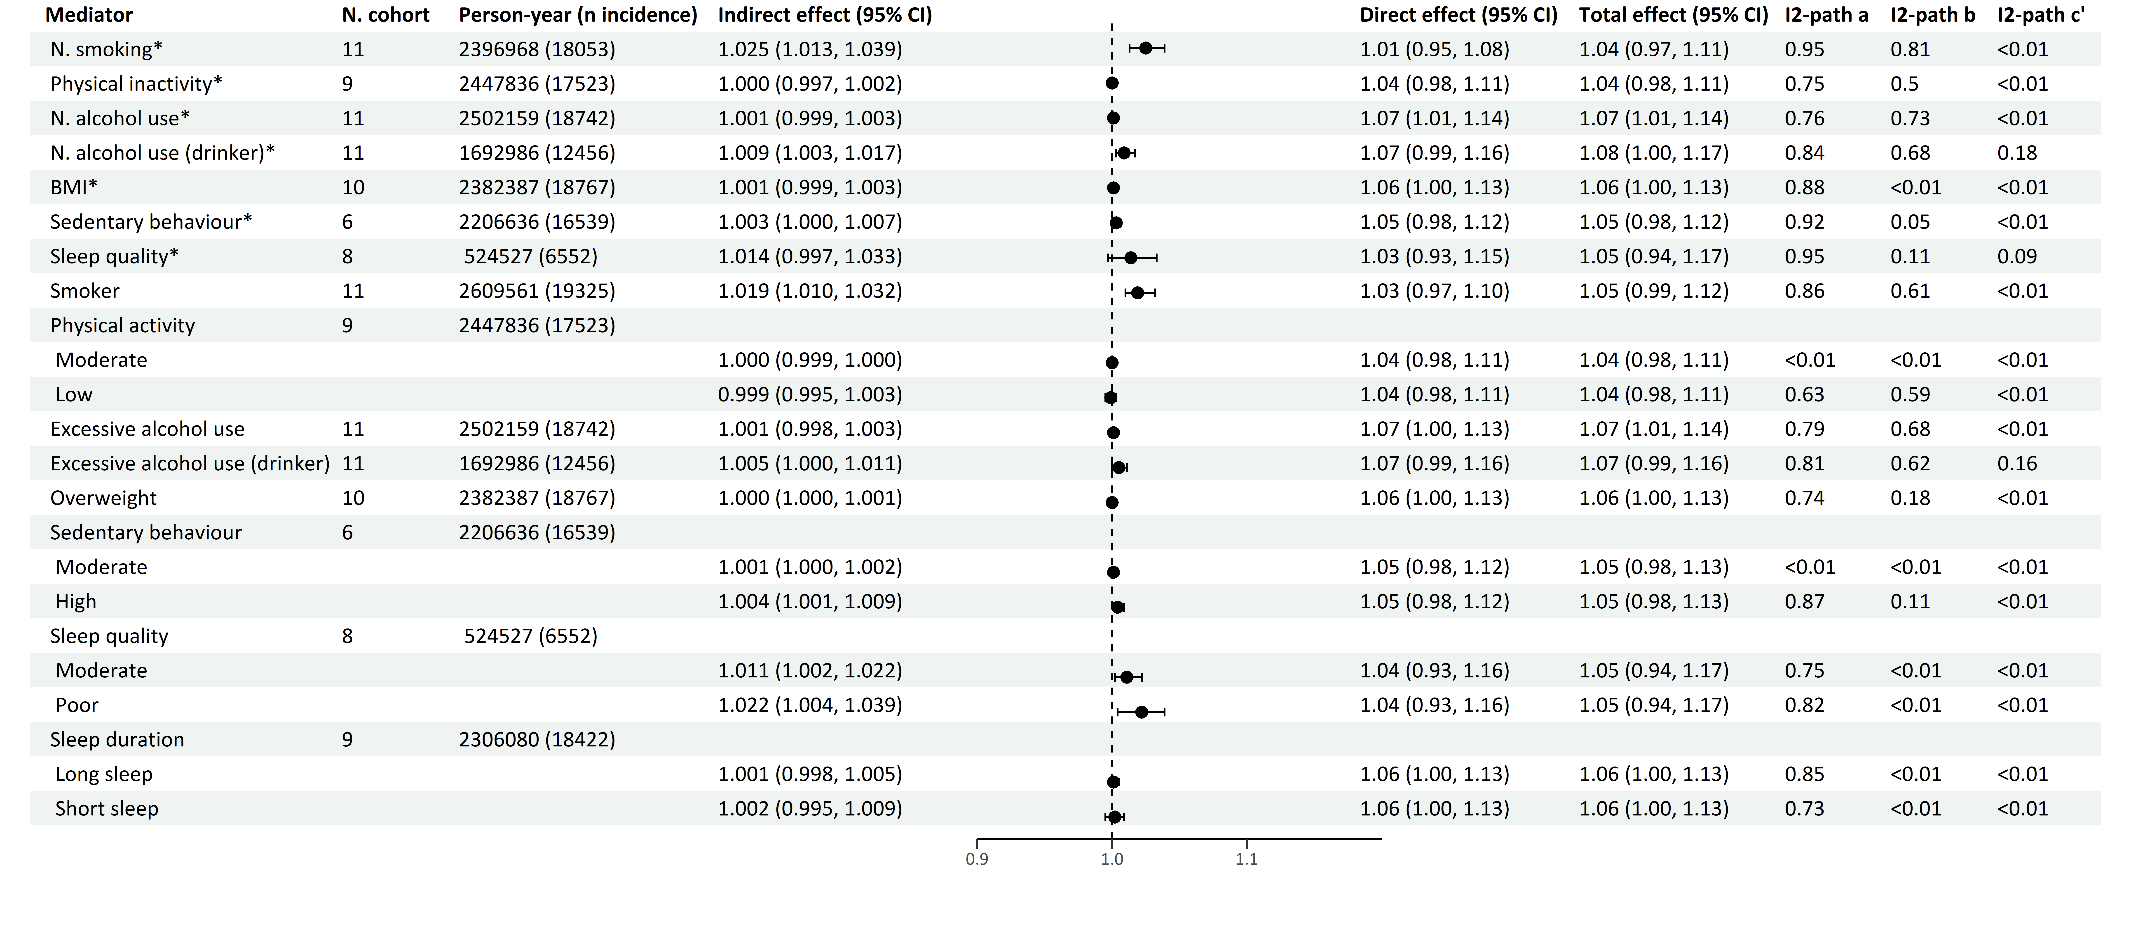
Multiple mediator model 1
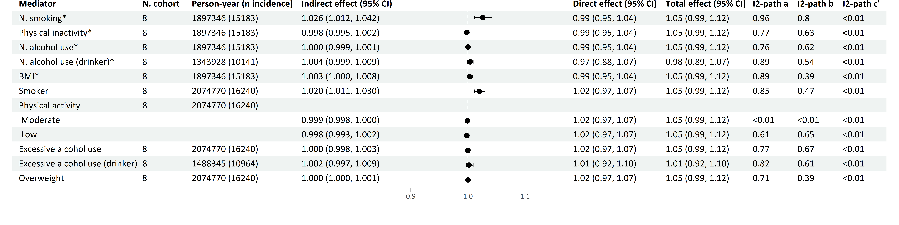
Multiple mediator model 2
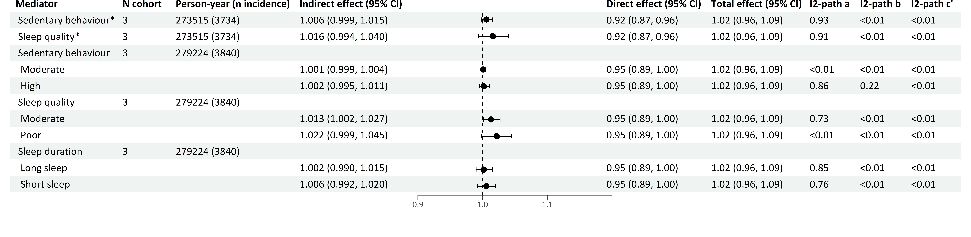
*continuous variables
Effects are Hazard Ratios.
The forest plot refers to the indirect effect of the mediator.
Multiple mediator model 1 includes and focuses on the effects of the four main health behaviors (smoking, physical inactivity, alcohol use and BMI).
Multiple mediator model 2 includes all seven health behaviors (smoking, physical inactivity, alcohol use, BMI, sedentary behavior, sleep quality and sleep duration), and focuses on the effects of the last three health behaviors.
Models adjusted for smoking, physical activity, alcohol use, BMI, birth year, sex, education, country of origin, anti-depressant use and family history of cancer.

Table S11 Mediation of health behaviors in the association of depression symptoms with breast cancer
Single mediator model
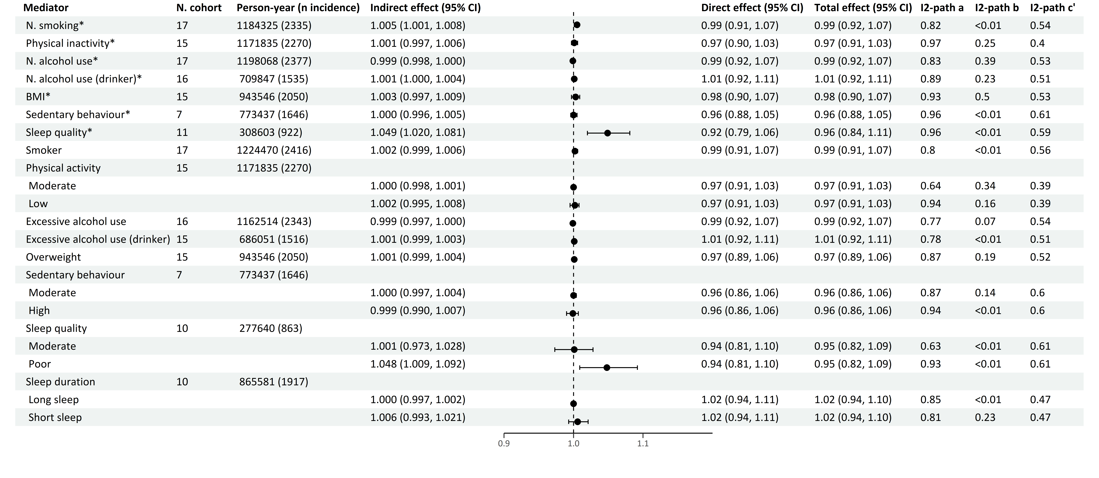
Multiple mediator model 1
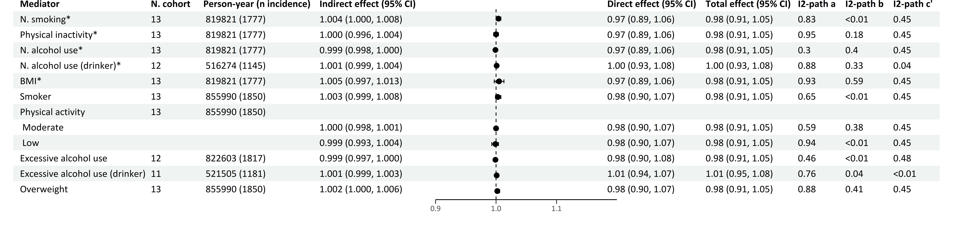
Multiple mediator model 2
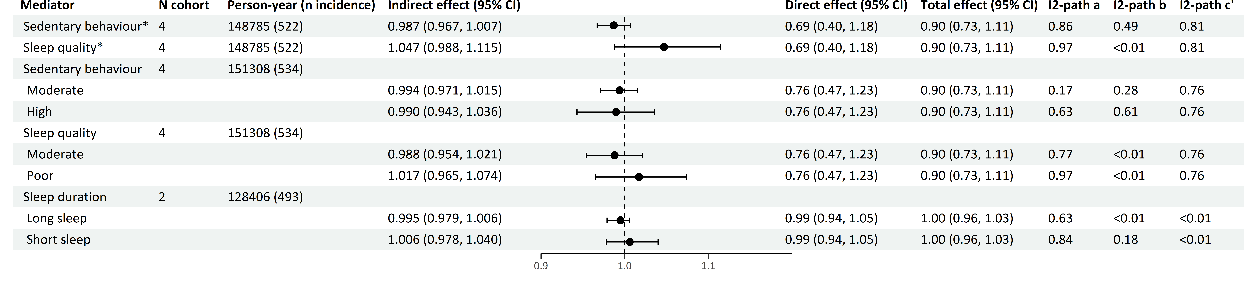
*continuous variables
Effects are Hazard Ratios.
The forest plot refers to the indirect effect of the mediator.
Multiple mediator model 1 includes and focuses on the effects of the four main health behaviors (smoking, physical inactivity, alcohol use and BMI).
Multiple mediator model 2 includes all seven health behaviors (smoking, physical inactivity, alcohol use, BMI, sedentary behavior, sleep quality and sleep duration), and focuses on the effects of the last three health behaviors.
Models adjusted for smoking, physical activity, alcohol use, BMI, birth year, sex, education, country of origin, anti-depressant use, family history of cancer, parity, menarche age, menopausal status and oral contraceptive use.
Table S12 Mediation of health behaviors in the association of depression diagnosis with breast cancer
Single mediator model
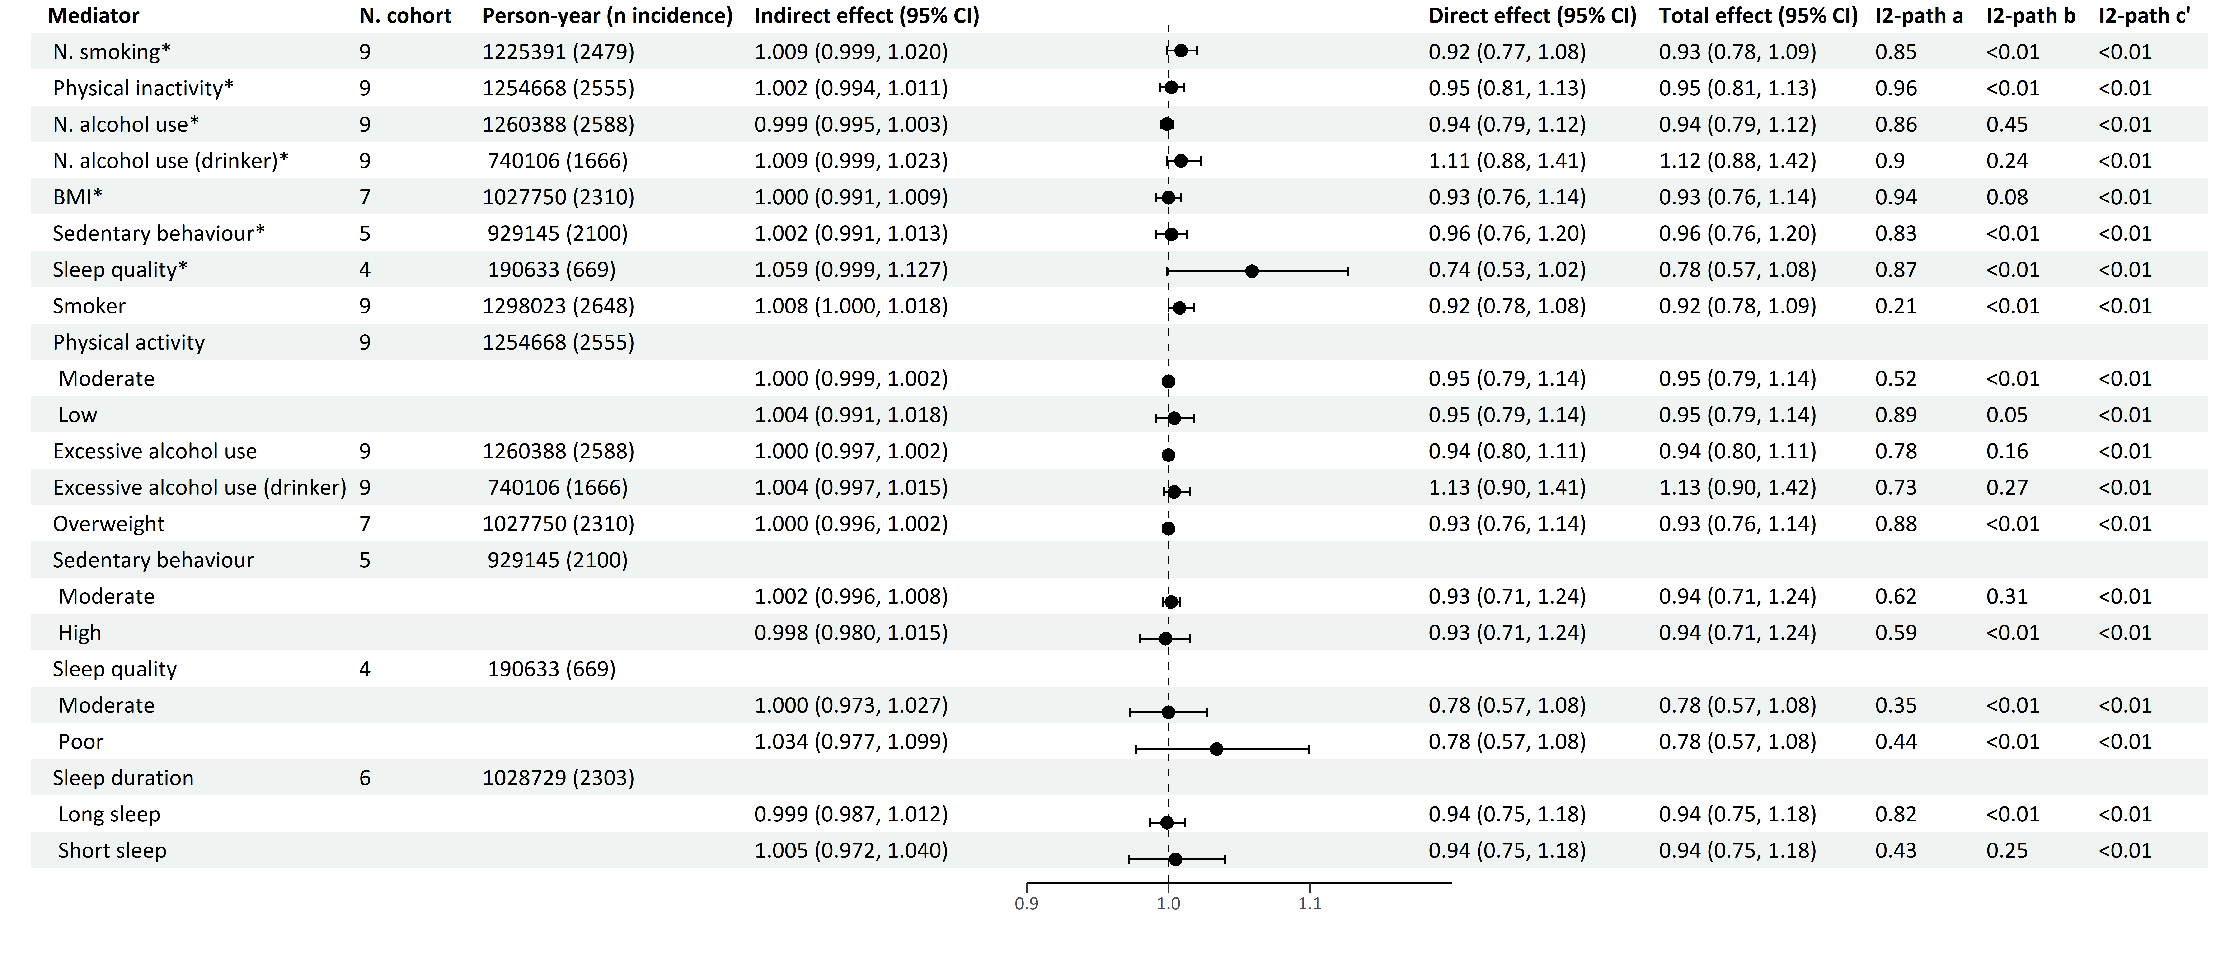
Multiple mediator model 1
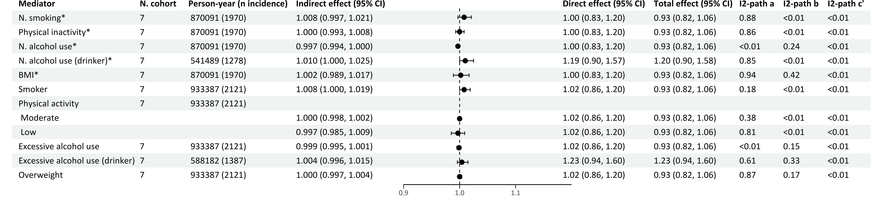
Multiple mediator model 2
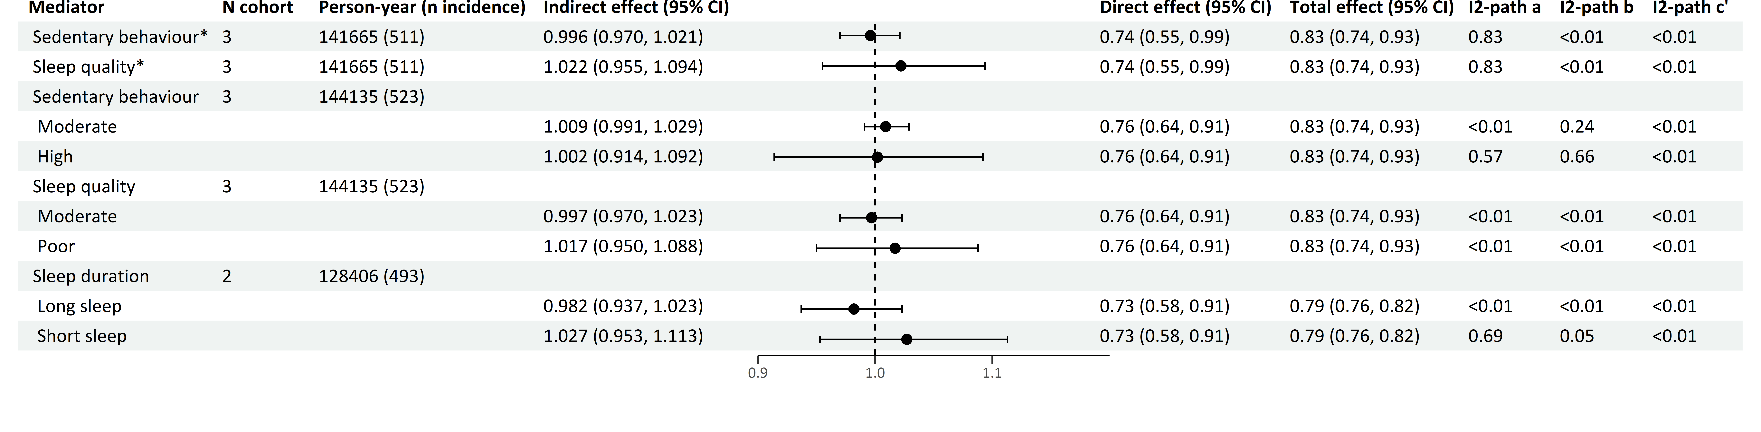
*continuous variables
Effects are Hazard Ratios.
The forest plot refers to the indirect effect of the mediator.
Multiple mediator model 1 includes and focuses on the effects of the four main health behaviors (smoking, physical inactivity, alcohol use and BMI).
Multiple mediator model 2 includes all seven health behaviors (smoking, physical inactivity, alcohol use, BMI, sedentary behavior, sleep quality and sleep duration), and focuses on the effects of the last three health behaviors.
Models adjusted for smoking, physical activity, alcohol use, BMI, birth year, sex, education, country of origin, anti-depressant use, family history of cancer, parity, menarche age, menopausal status, and oral contraceptive use.

Table S13 Mediation of health behaviors in the association of anxiety symptoms with breast cancer
Single mediator model
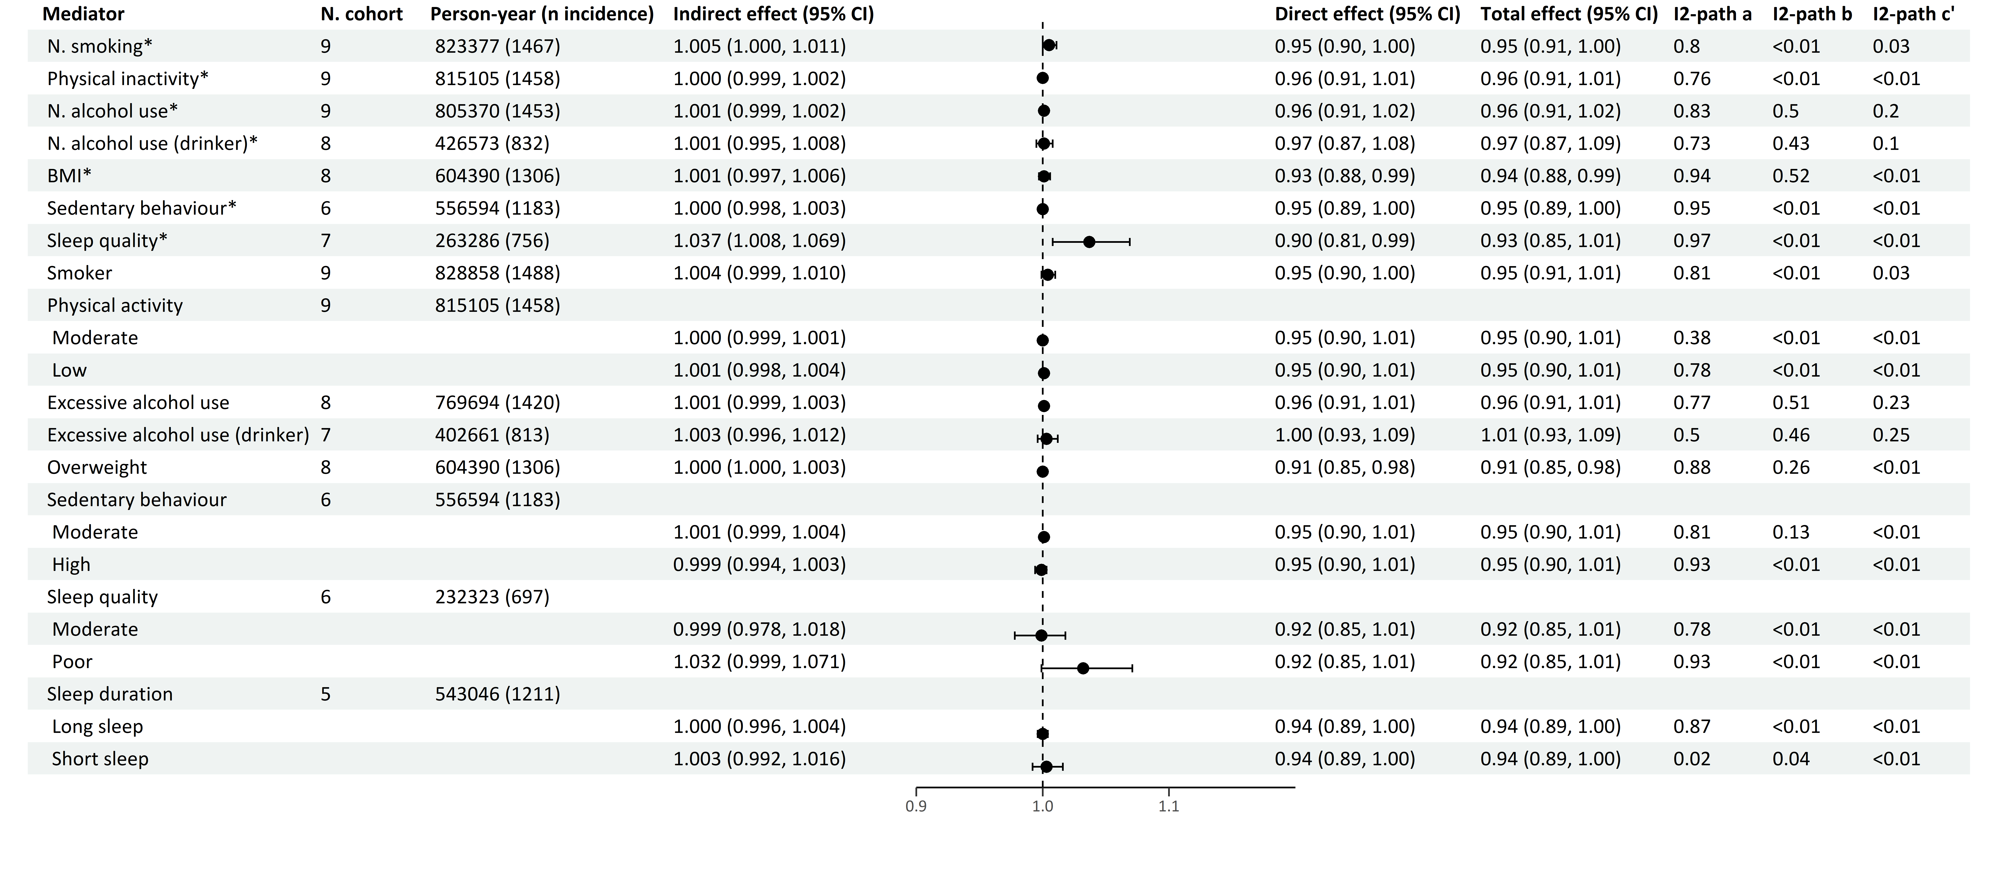
Multiple mediator model 1
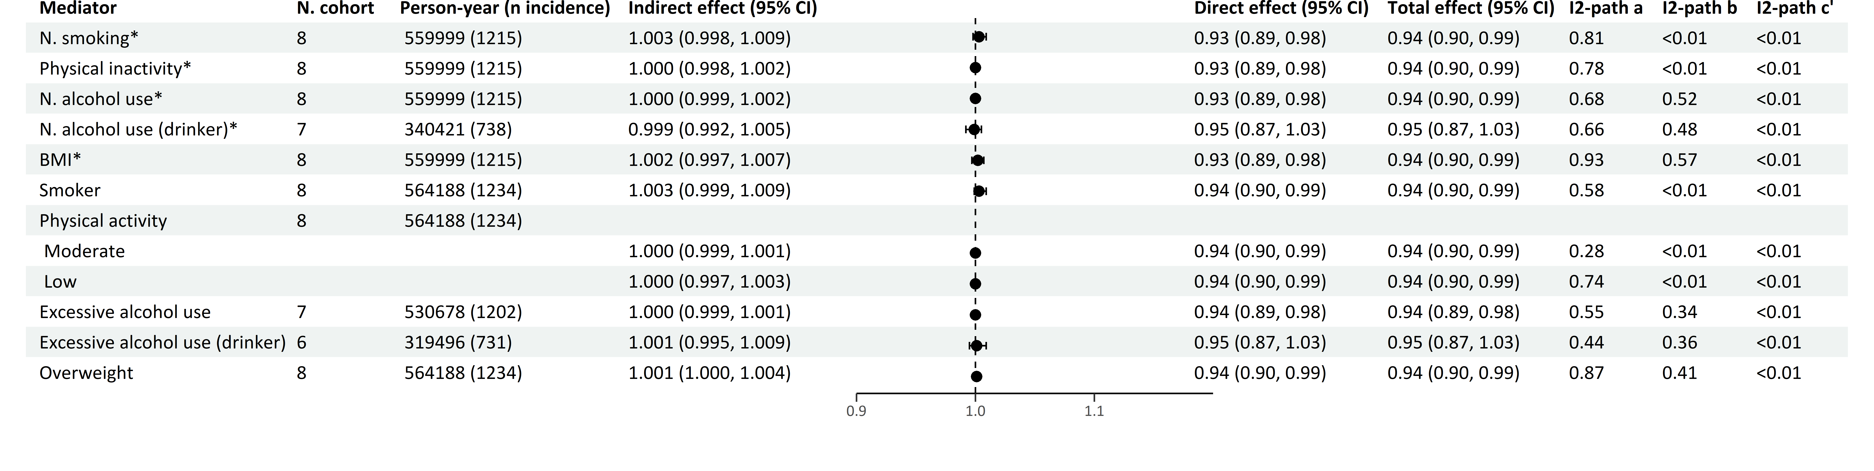
Multiple mediator model 2
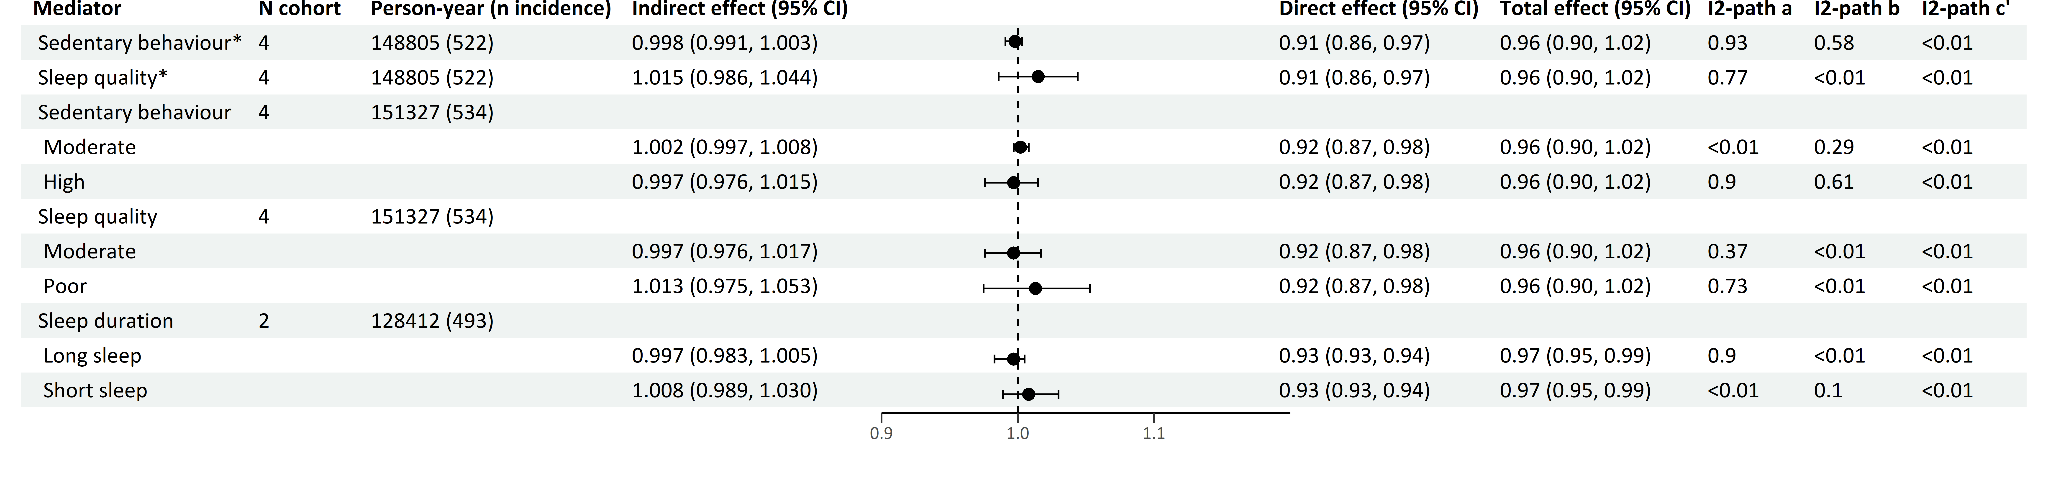
*continuous variables
Effects are Hazard Ratios.
The forest plot refers to the indirect effect of the mediator.
Multiple mediator model 1 includes and focuses on the effects of the four main health behaviors (smoking, physical inactivity, alcohol use and BMI).
Multiple mediator model 2 includes all seven health behaviors (smoking, physical inactivity, alcohol use, BMI, sedentary behavior, sleep quality and sleep duration), and focuses on the effects of the last three health behaviors.
Models adjusted for smoking, physical activity, alcohol use, BMI, birth year, sex, education, country of origin, anti-depressant use, family history of cancer, parity, menarche age, menopausal status, and oral contraceptive use.
Table S14 Mediation of health behaviors in the association of anxiety diagnosis with breast cancer
Single mediator model
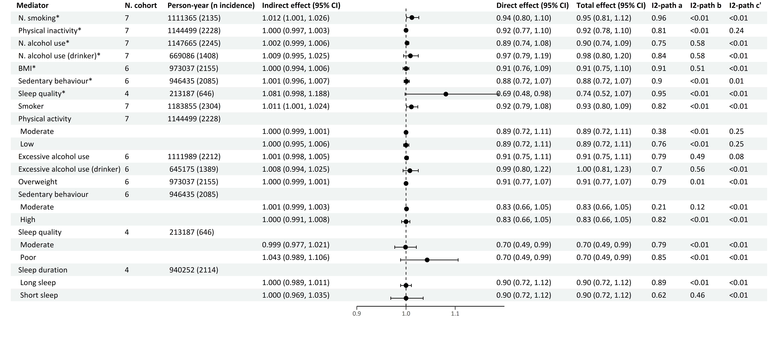
Multiple mediator model 1
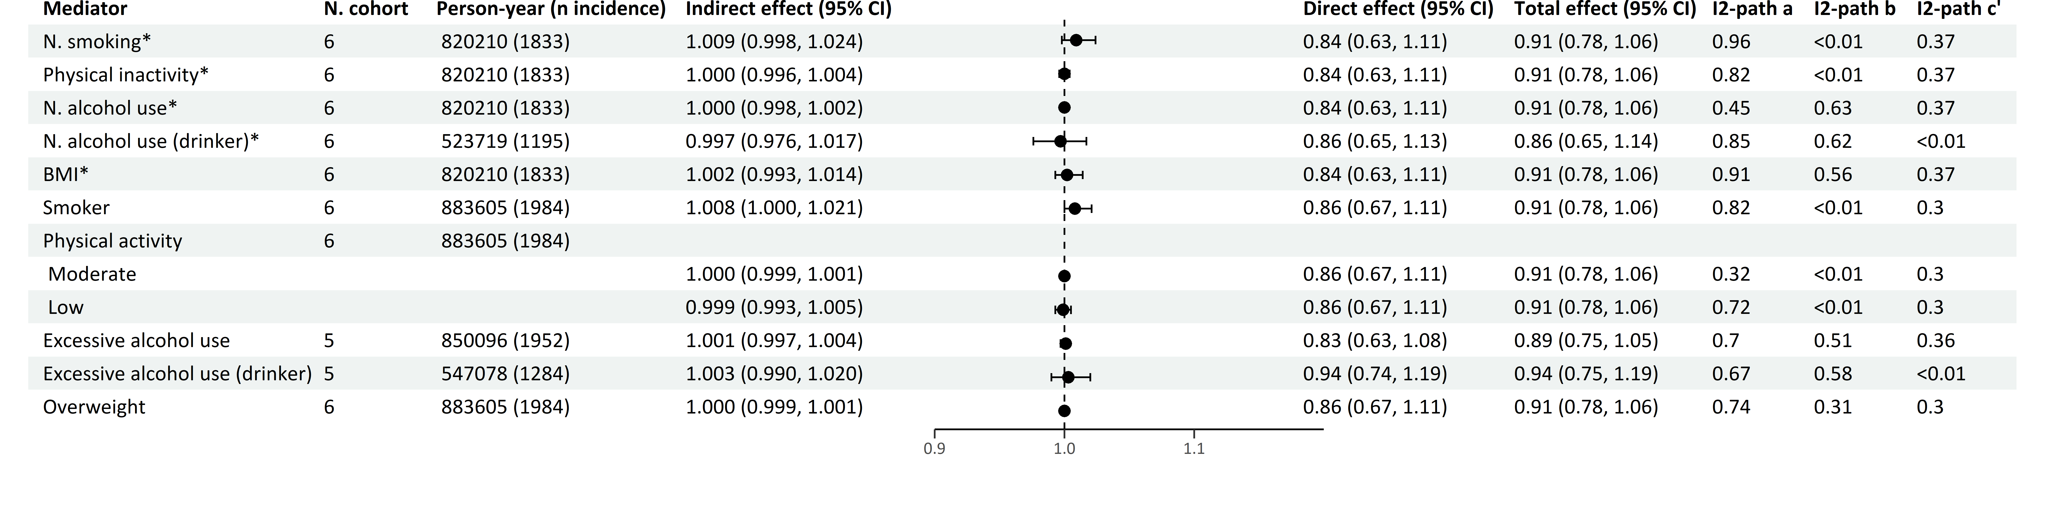
Multiple mediator model 2
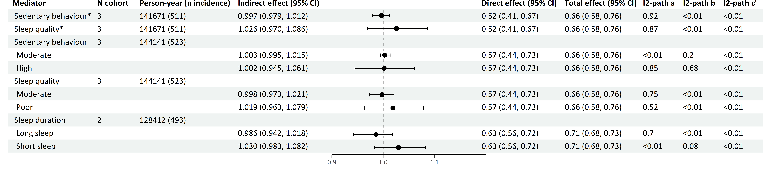
*continuous variables
Effects are Hazard Ratios.
The forest plot refers to the indirect effect of the mediator.
Multiple mediator model 1 includes and focuses on the effects of the four main health behaviors (smoking, physical inactivity, alcohol use and BMI).
Multiple mediator model 2 includes all seven health behaviors (smoking, physical inactivity, alcohol use, BMI, sedentary behavior, sleep quality and sleep duration), and focuses on the effects of the last three health behaviors.
Models adjusted for smoking, physical activity, alcohol use, BMI, birth year, sex, education, country of origin, anti-depressant use, family history of cancer, parity, menarche age, menopausal status, and oral contraceptive use.

Table S15 Mediation of health behaviors in the association of depression symptoms with prostate cancer
Single mediator model
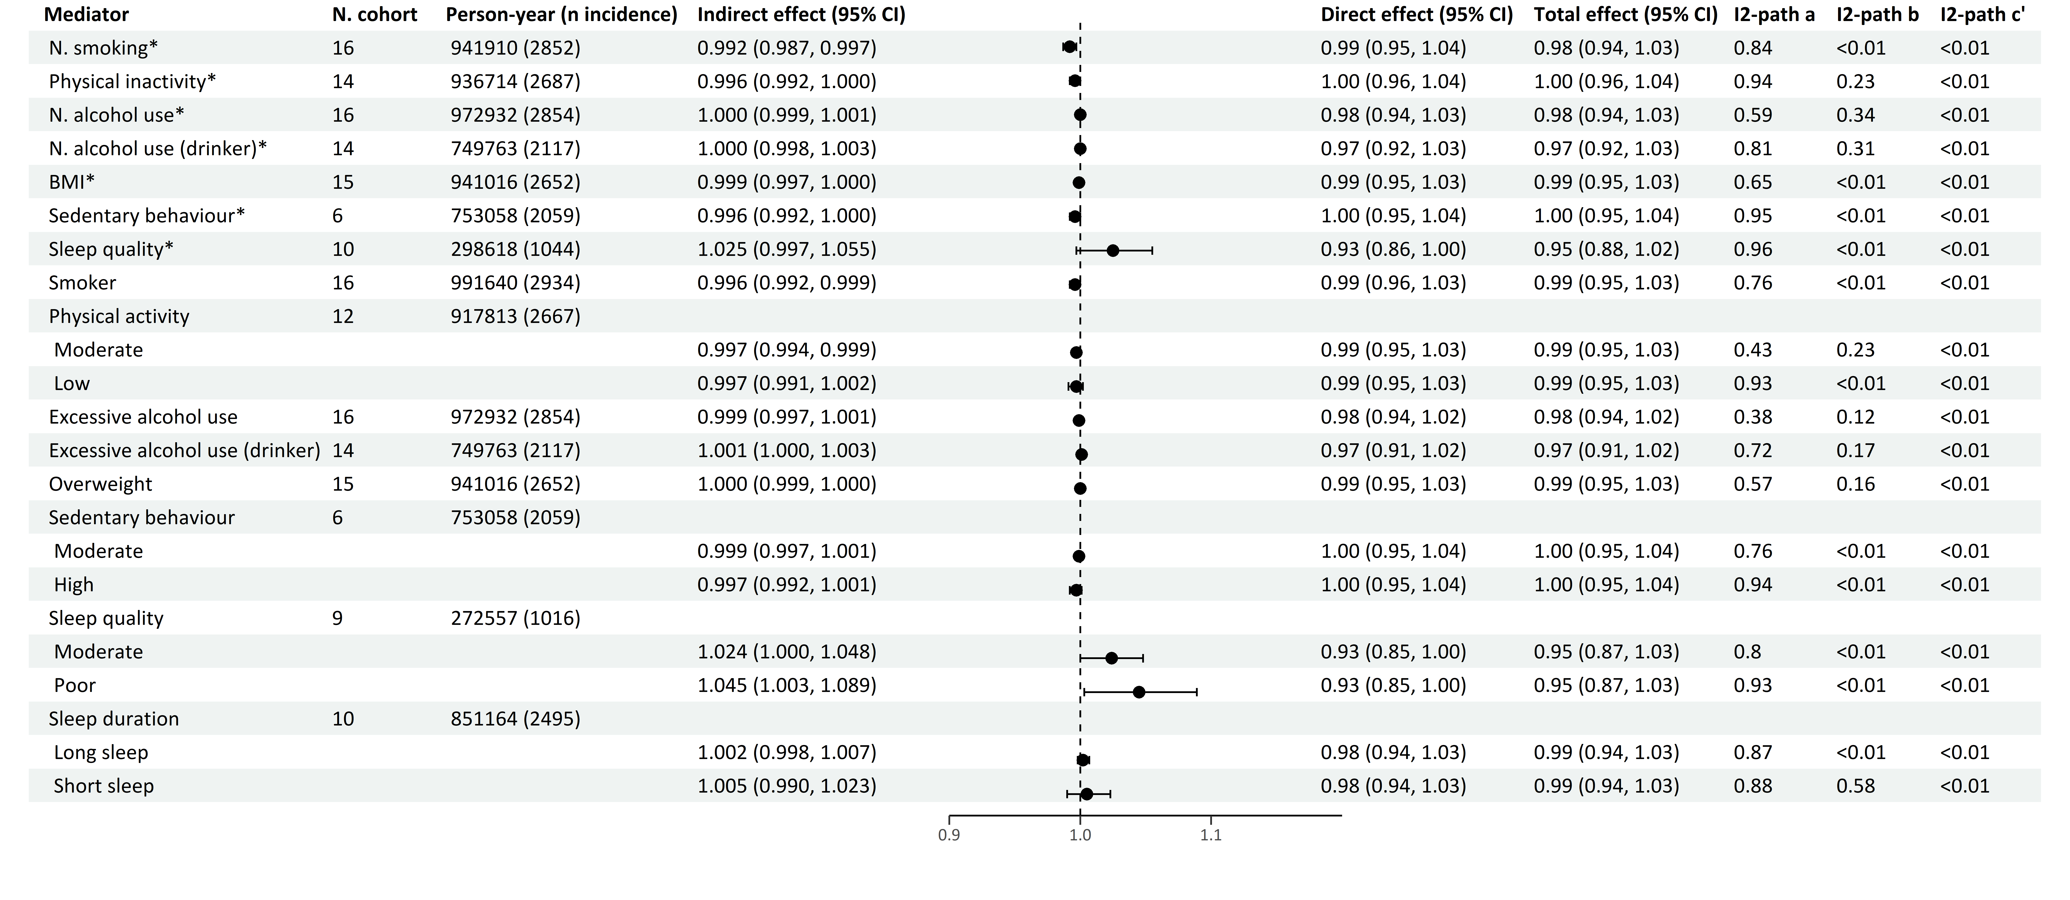
Multiple mediator model 1
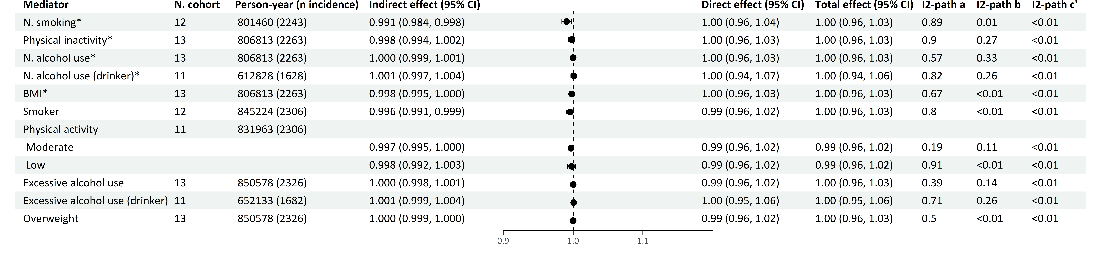
Multiple mediator model 2
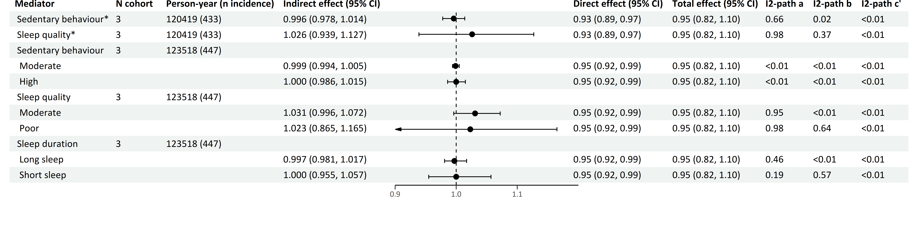

*continuous variables
Effects are Hazard Ratios.
The forest plot refers to the indirect effect of the mediator.
Multiple mediator model 1 includes and focuses on the effects of the four main health behaviors (smoking, physical inactivity, alcohol use and BMI).
Multiple mediator model 2 includes all seven health behaviors (smoking, physical inactivity, alcohol use, BMI, sedentary behavior, sleep quality and sleep duration), and focuses on the effects of the last three health behaviors.
Models adjusted for smoking, physical activity, alcohol use, BMI, birth year, sex, education, country of origin, anti-depressant use and family history of cancer.
Table S16 Mediation of health behaviors in the association of depression diagnosis with prostate cancer
Single mediator model
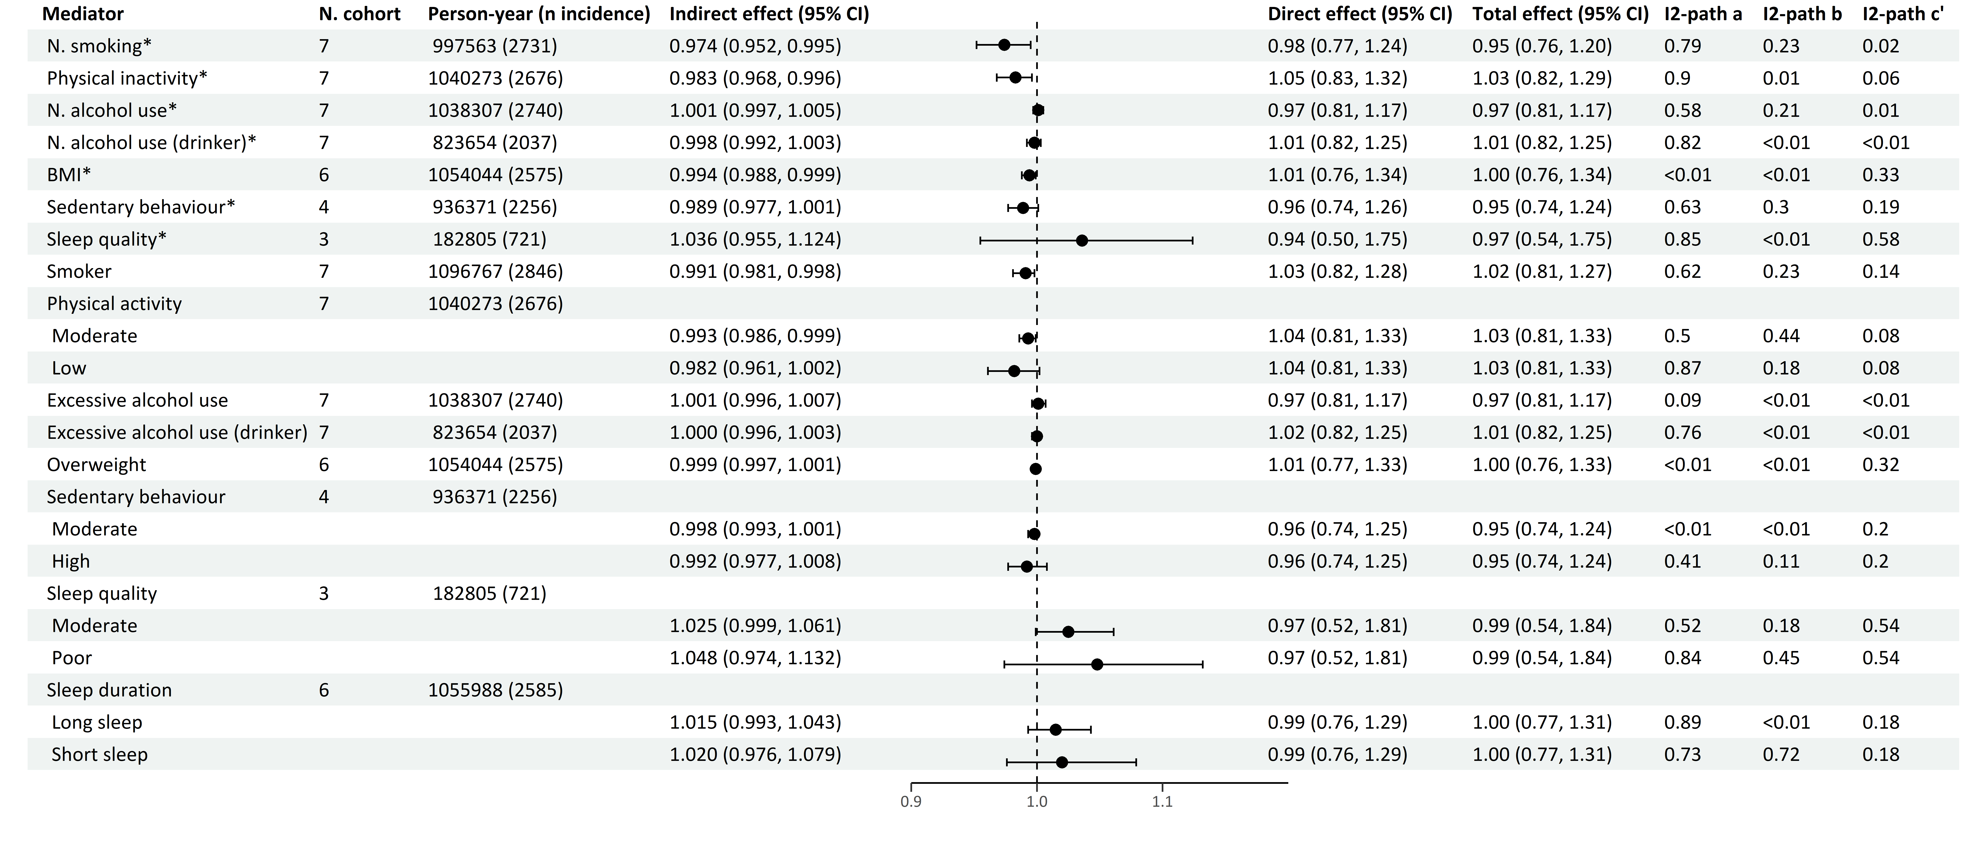
Multiple mediator model 1
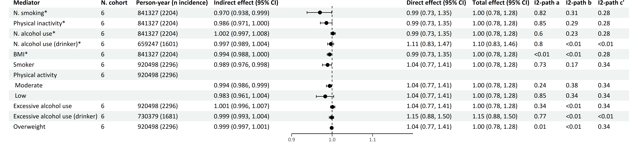
Multiple mediator model 2
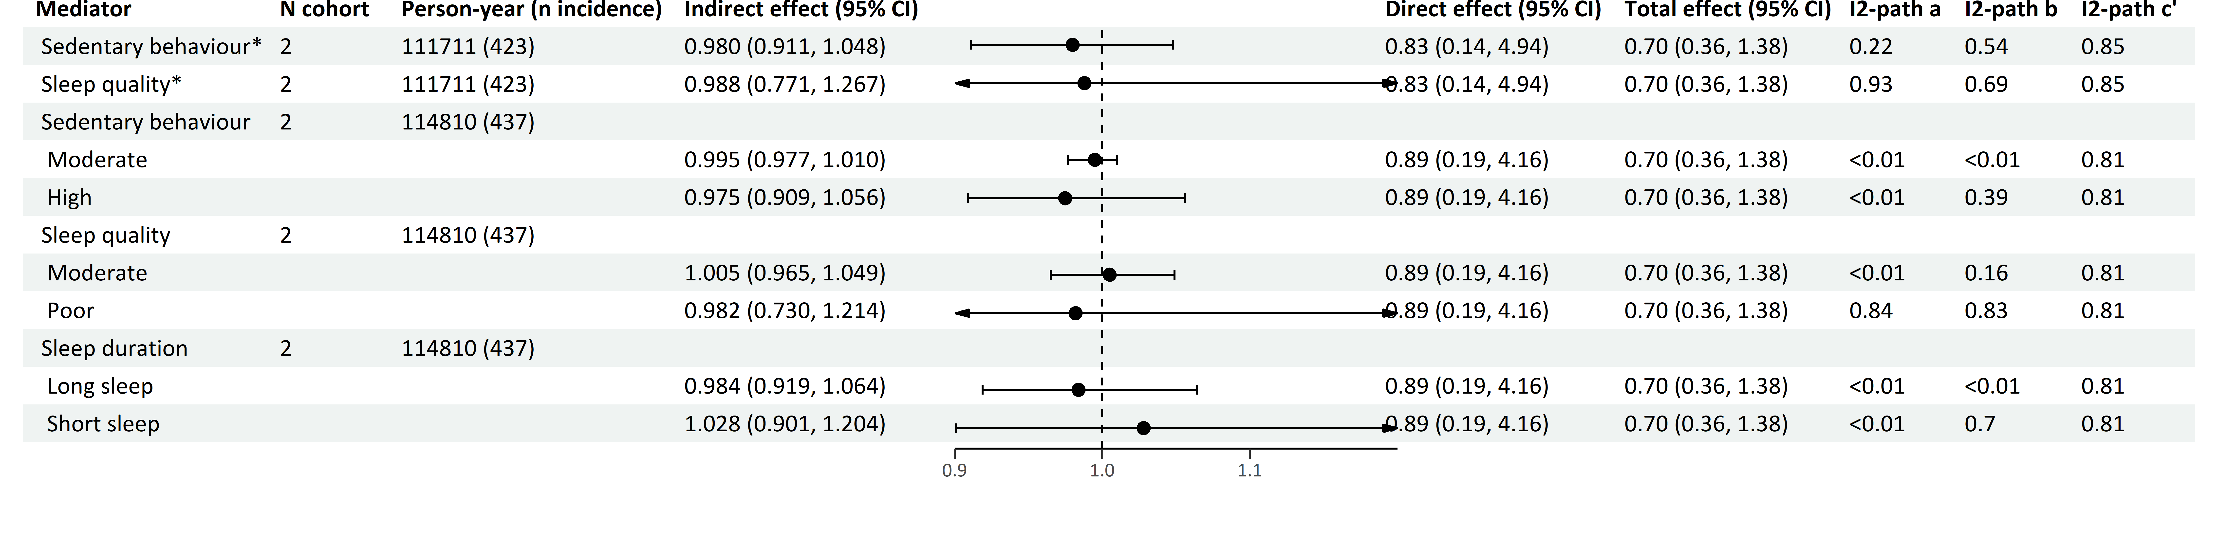
*continuous variables
Effects are Hazard Ratios.
The forest plot refers to the indirect effect of the mediator.
Multiple mediator model 1 includes and focuses on the effects of the four main health behaviors (smoking, physical inactivity, alcohol use and BMI).
Multiple mediator model 2 includes all seven health behaviors (smoking, physical inactivity, alcohol use, BMI, sedentary behavior, sleep quality and sleep duration), and focuses on the effects of the last three health behaviors.
Models adjusted for smoking, physical activity, alcohol use, BMI, birth year, sex, education, country of origin, anti-depressant use and family history of cancer.

Table S17 Mediation of health behaviors in the association of anxiety symptoms with prostate cancer
Single mediator model
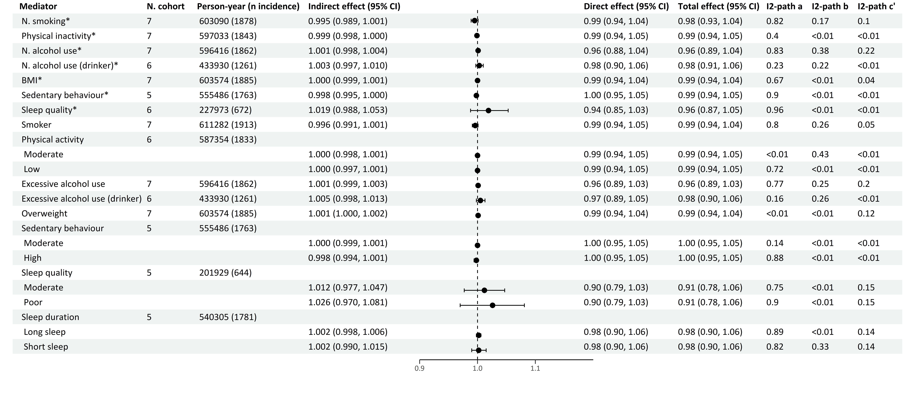
Multiple mediator model 1
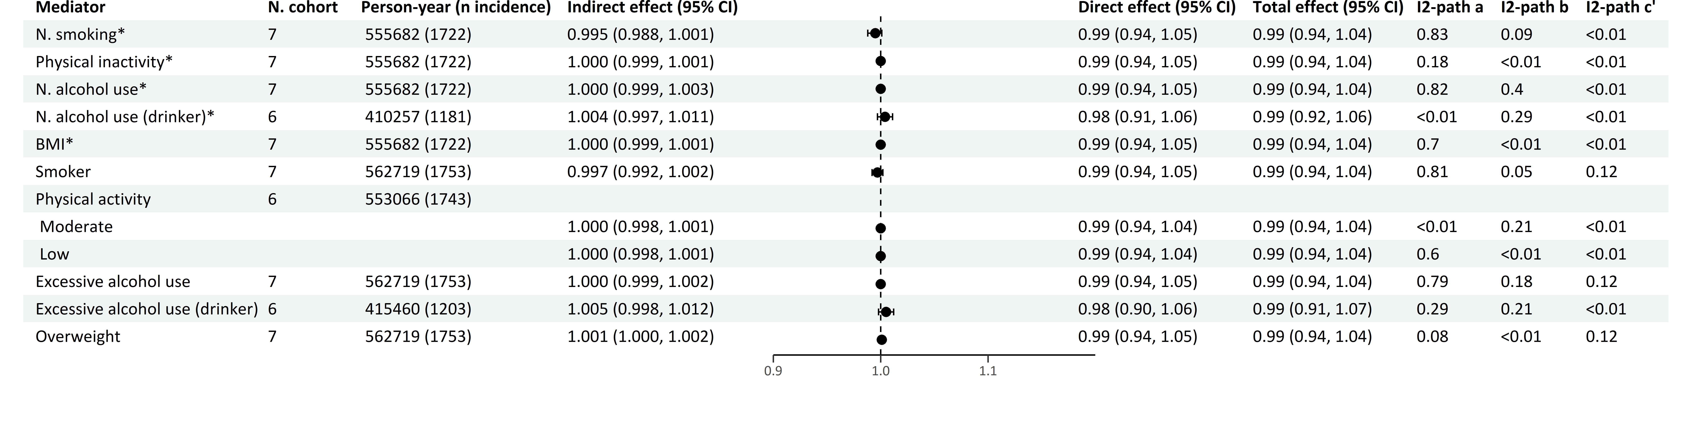
Multiple mediator model 2
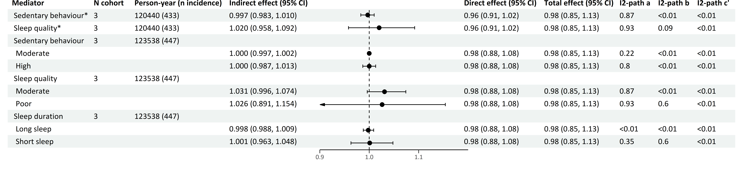
*continuous variables
Effects are Hazard Ratios.
The forest plot refers to the indirect effect of the mediator.
Multiple mediator model 1 includes and focuses on the effects of the four main health behaviors (smoking, physical inactivity, alcohol use and BMI).
Multiple mediator model 2 includes all seven health behaviors (smoking, physical inactivity, alcohol use, BMI, sedentary behavior, sleep quality and sleep duration), and focuses on the effects of the last three health behaviors.
Models adjusted for smoking, physical activity, alcohol use, BMI, birth year, sex, education, country of origin, anti-depressant use and family history of cancer.
Table S18 Mediation of health behaviors in the association of anxiety diagnosis with prostate cancer
Single mediator model
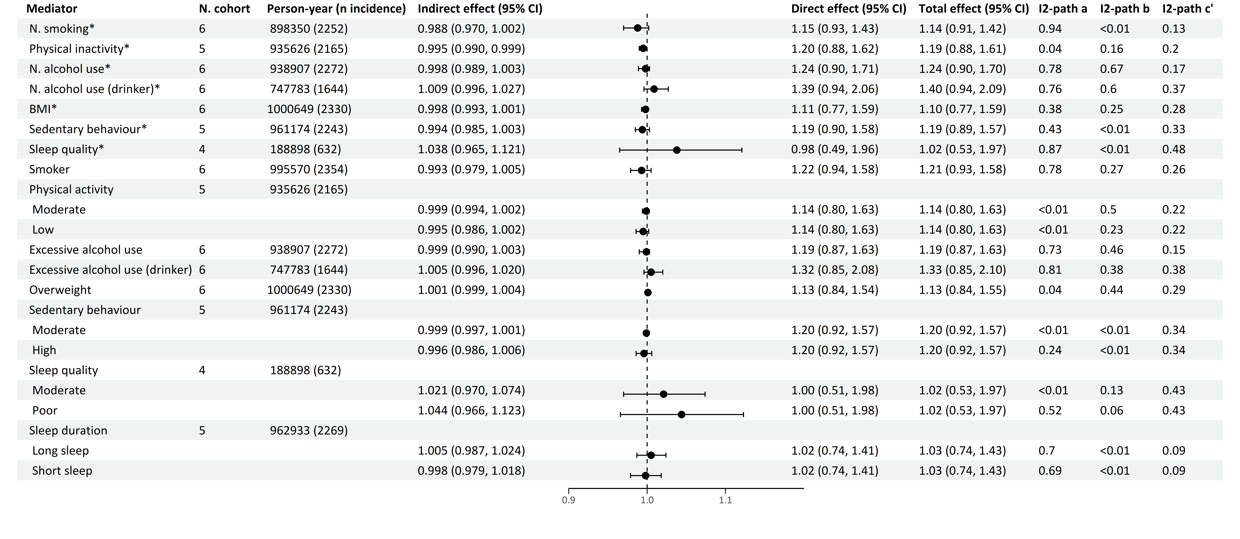
Multiple mediator model 1
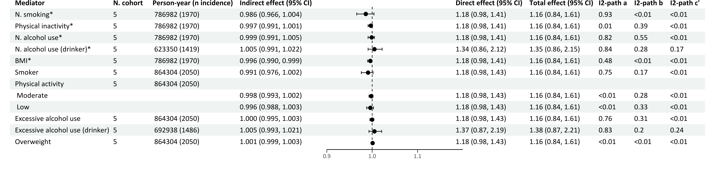
Multiple mediator model 2
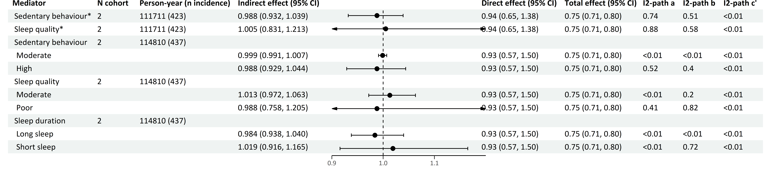
*continuous variables
Effects are Hazard Ratios.
The forest plot refers to the indirect effect of the mediator.
Multiple mediator model 1 includes and focuses on the effects of the four main health behaviors (smoking, physical inactivity, alcohol use and BMI).
Multiple mediator model 2 includes all seven health behaviors (smoking, physical inactivity, alcohol use, BMI, sedentary behavior, sleep quality and sleep duration), and focuses on the effects of the last three health behaviors.
Models adjusted for smoking, physical activity, alcohol use, BMI, birth year, sex, education, country of origin, anti-depressant use and family history of cancer.

Table S19 Mediation of health behaviors in the association of depression symptoms with colorectal cancer
Single mediator model
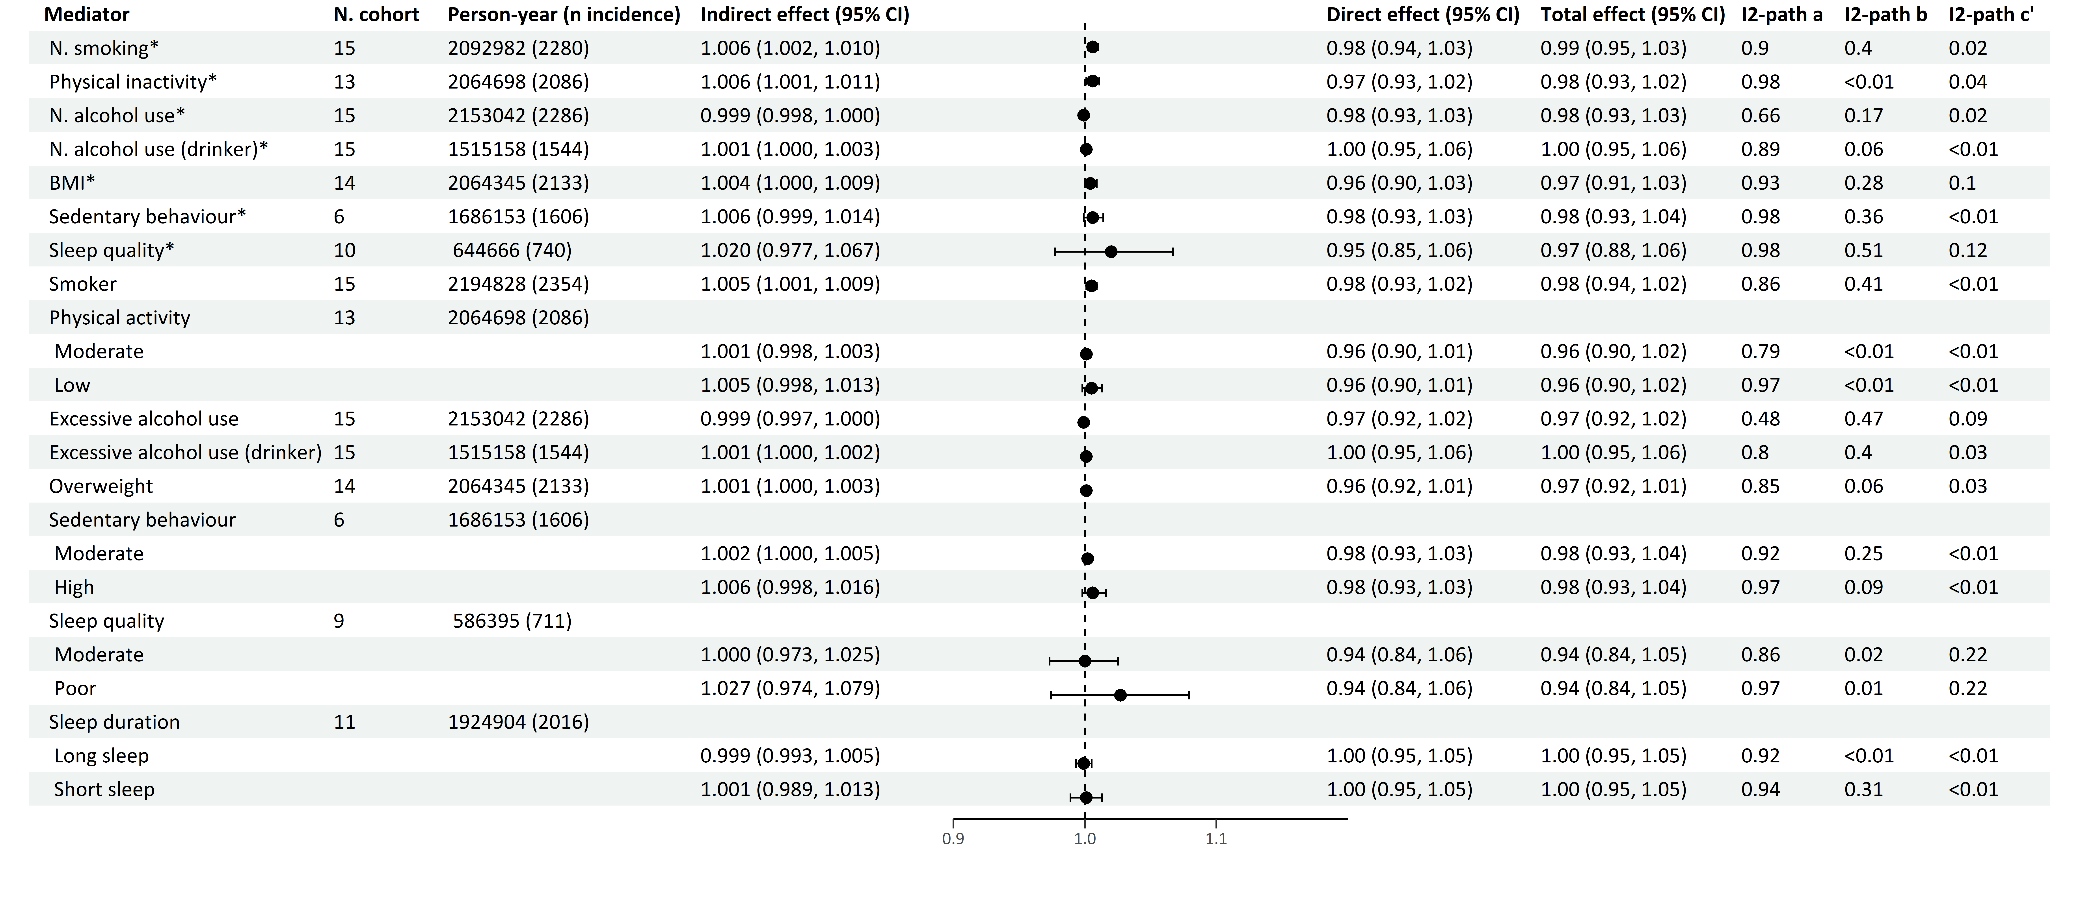
Multiple mediator model 1
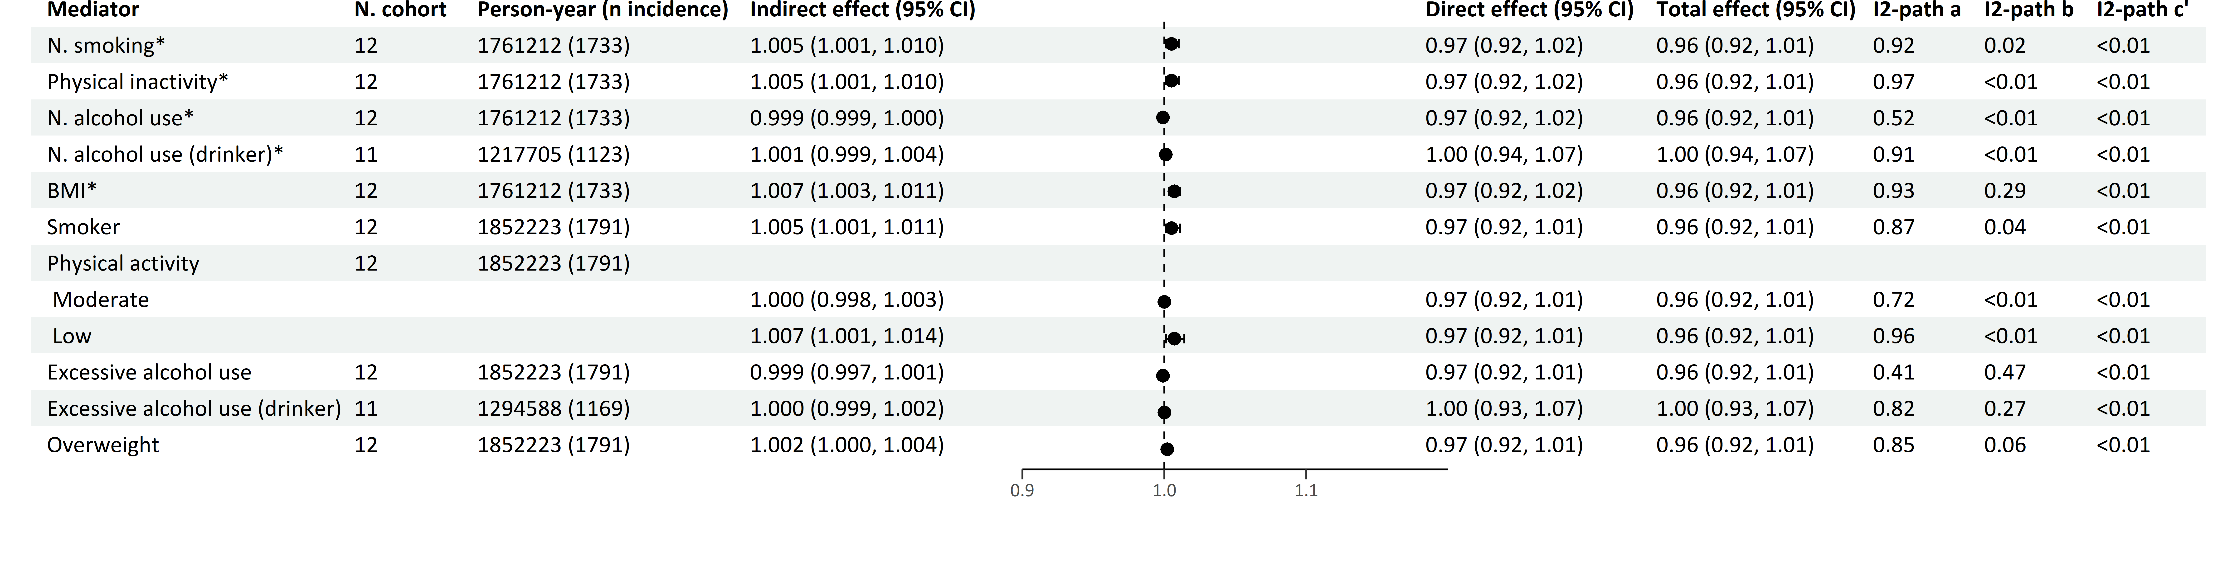
Multiple mediator model 2
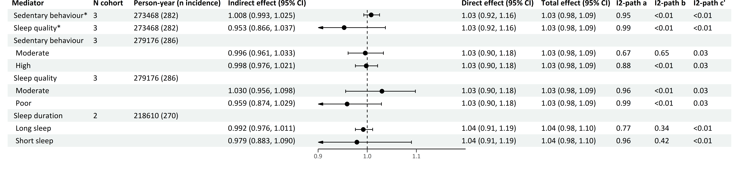

*continuous variables
Effects are Hazard Ratios.
The forest plot refers to the indirect effect of the mediator.
Multiple mediator model 1 includes and focuses on the effects of the four main health behaviors (smoking, physical inactivity, alcohol use and BMI).
Multiple mediator model 2 includes all seven health behaviors (smoking, physical inactivity, alcohol use, BMI, sedentary behavior, sleep quality and sleep duration), and focuses on the effects of the last three health behaviors.
Models adjusted for smoking, physical activity, alcohol use, BMI, birth year, sex, education, country of origin, anti-depressant use and family history of cancer.
Table S20 Mediation of health behaviors in the association of depression diagnosis with colorectal cancer
Single mediator model
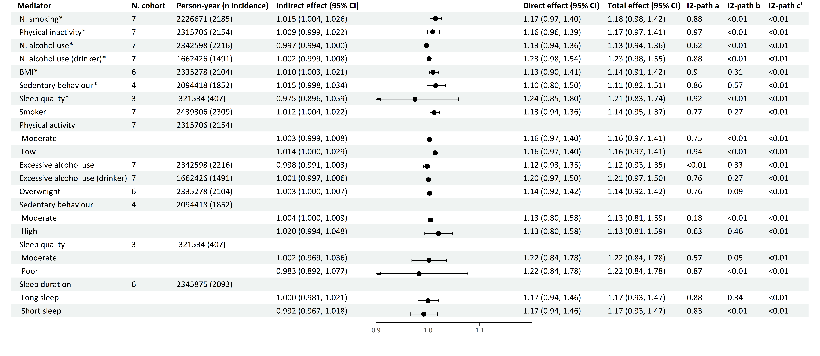
Multiple mediator model 1
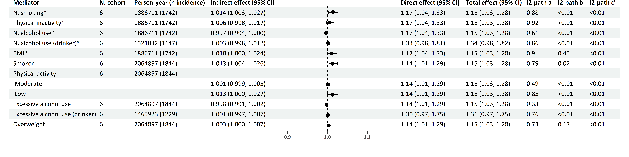
Multiple mediator model 2
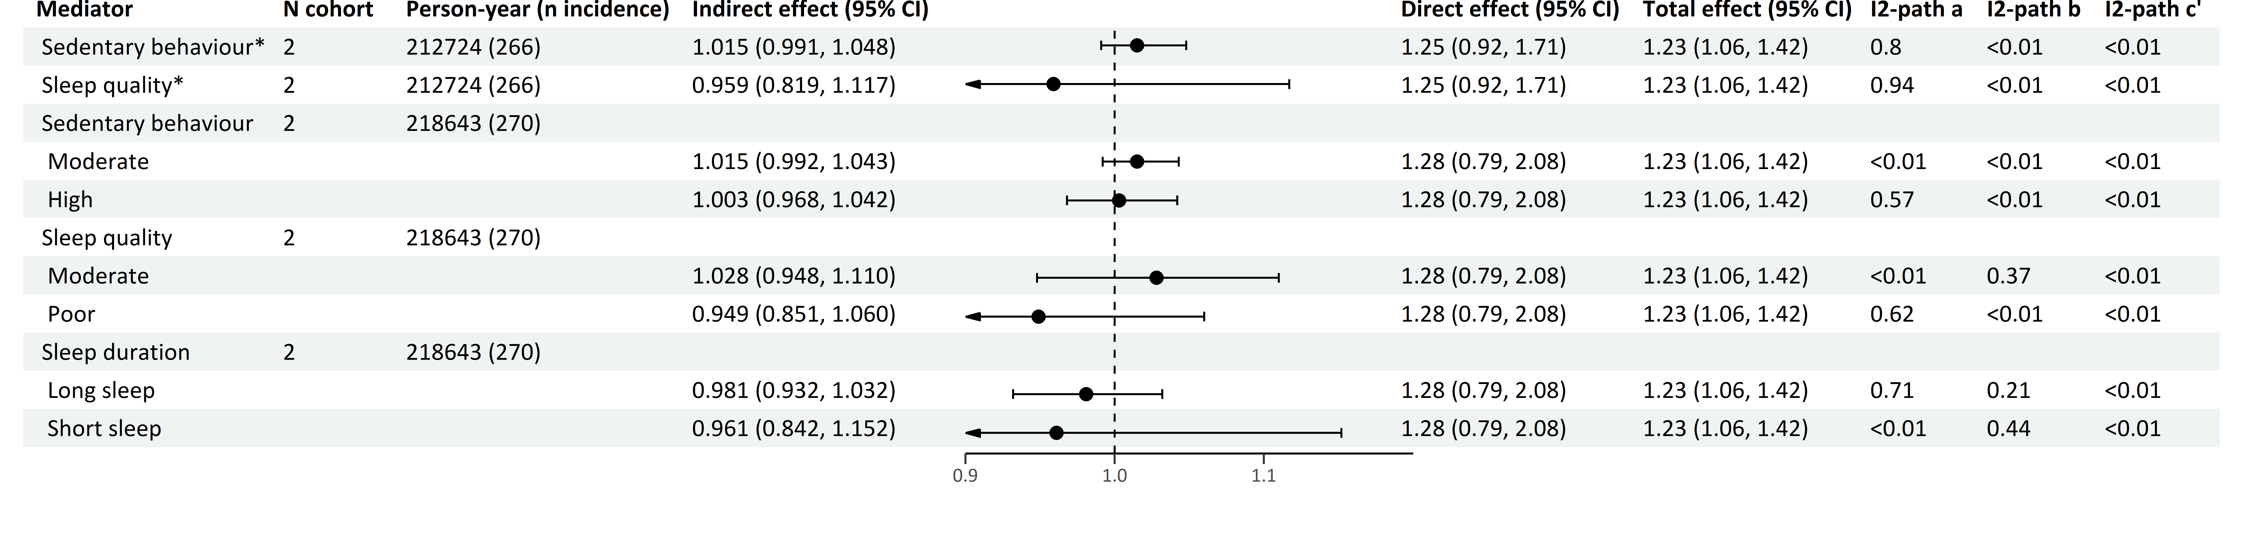
*continuous variables
Effects are Hazard Ratios.
The forest plot refers to the indirect effect of the mediator.
Multiple mediator model 1 includes and focuses on the effects of the four main health behaviors (smoking, physical inactivity, alcohol use and BMI).
Multiple mediator model 2 includes all seven health behaviors (smoking, physical inactivity, alcohol use, BMI, sedentary behavior, sleep quality and sleep duration), and focuses on the effects of the last three health behaviors.
Models adjusted for smoking, physical activity, alcohol use, BMI, birth year, sex, education, country of origin, anti-depressant use and family history of cancer.

Table S21 Mediation of health behaviors in the association of anxiety symptoms with colorectal cancer
Single mediator model
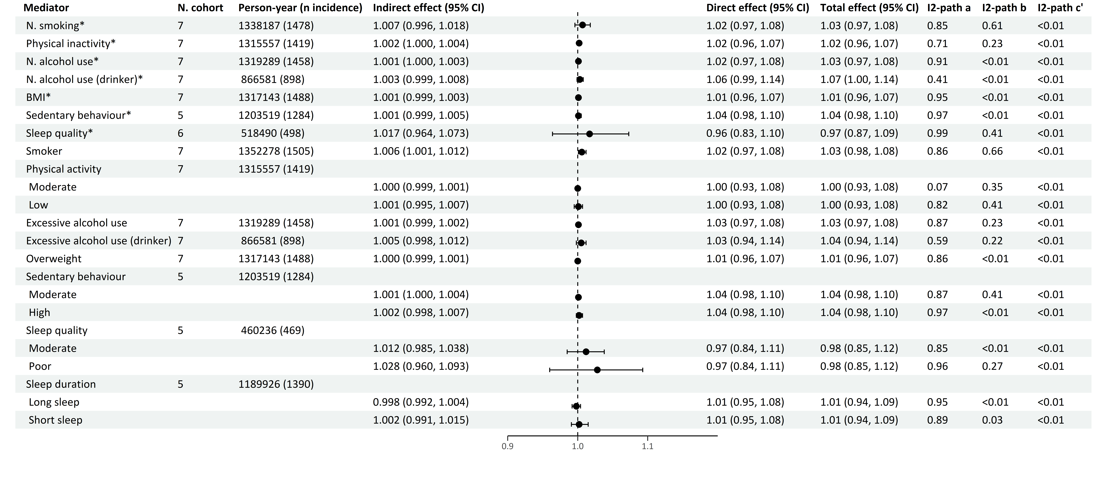
Multiple mediator model 1
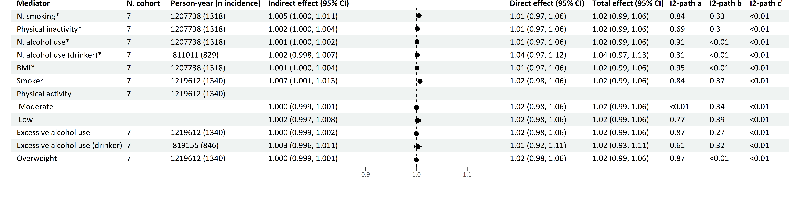
Multiple mediator model 2
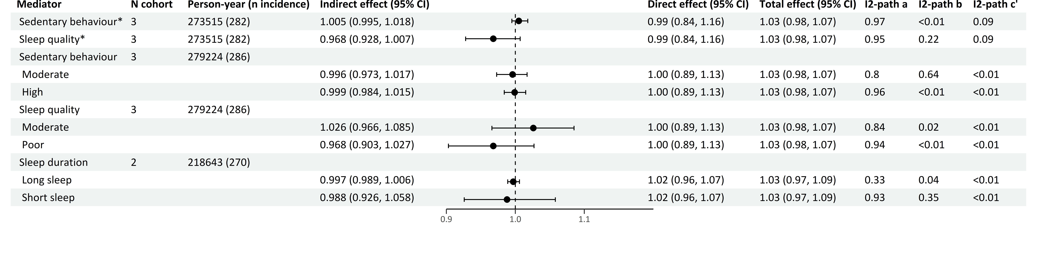
*continuous variables
Effects are Hazard Ratios.
The forest plot refers to the indirect effect of the mediator.
Multiple mediator model 1 includes and focuses on the effects of the four main health behaviors (smoking, physical inactivity, alcohol use and BMI).
Multiple mediator model 2 includes all seven health behaviors (smoking, physical inactivity, alcohol use, BMI, sedentary behavior, sleep quality and sleep duration), and focuses on the effects of the last three health behaviors.
Models adjusted for smoking, physical activity, alcohol use, BMI, birth year, sex, education, country of origin, anti-depressant use and family history of cancer.
Table S22 Mediation of health behaviors in the association of anxiety diagnosis with colorectal cancer
Single mediator model
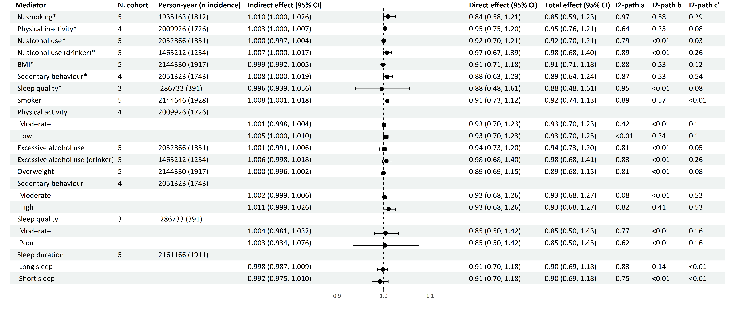
Multiple mediator model 1
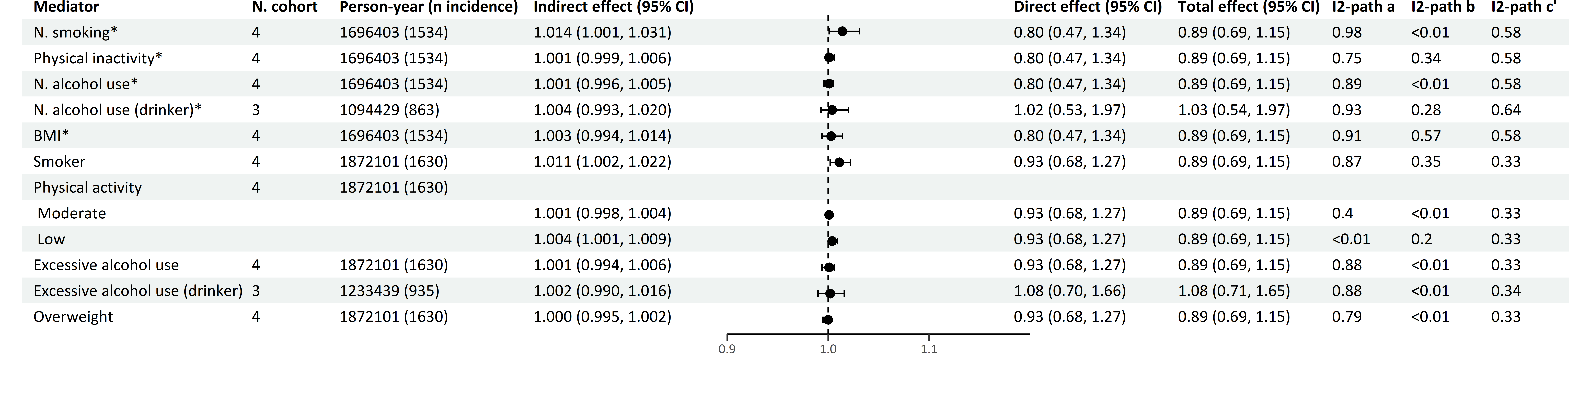
Multiple mediator model 2
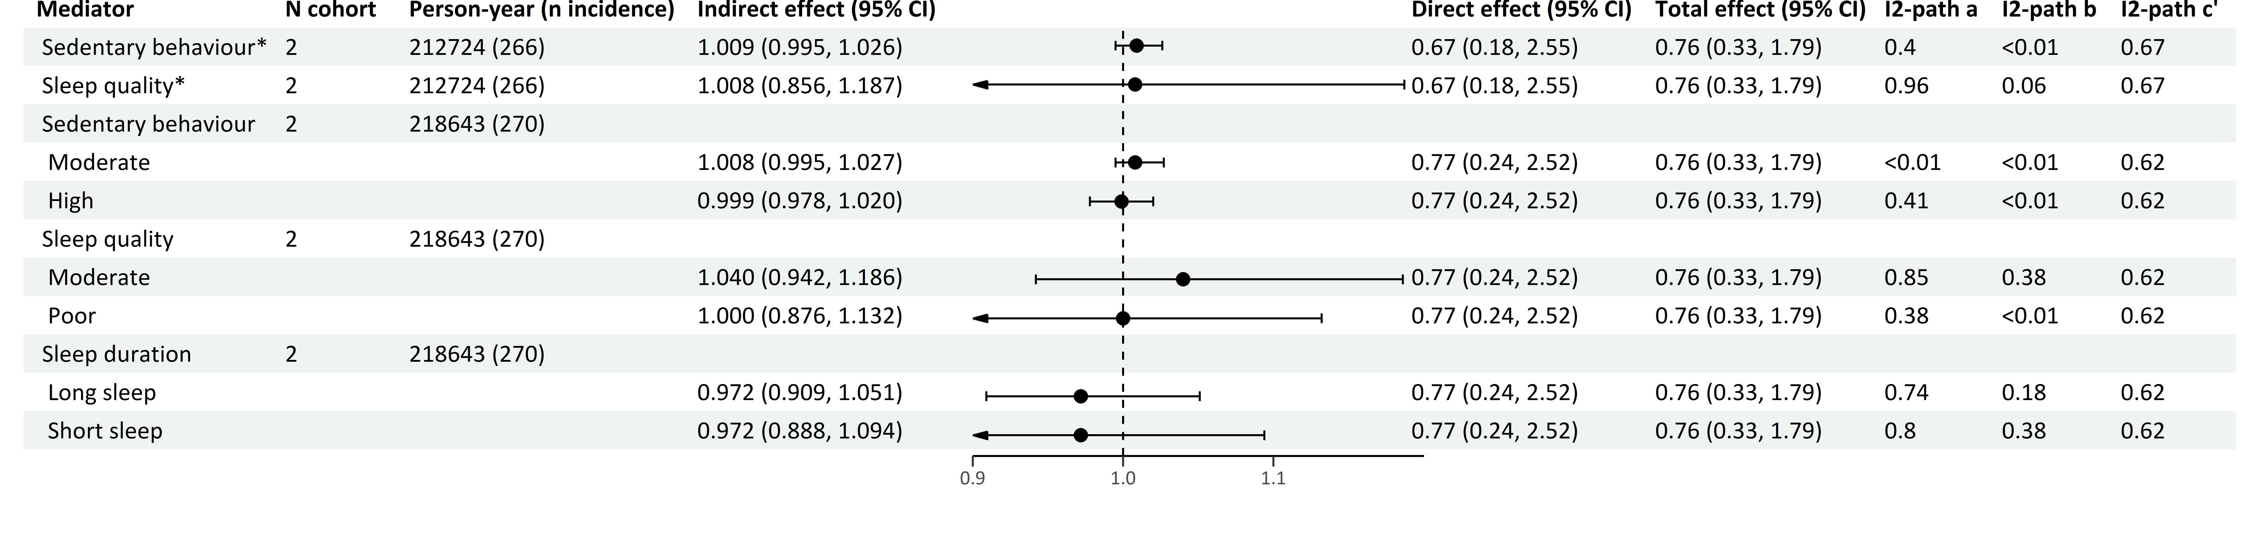
*continuous variables
Effects are Hazard Ratios.
The forest plot refers to the indirect effect of the mediator.
Multiple mediator model 1 includes and focuses on the effects of the four main health behaviors (smoking, physical inactivity, alcohol use and BMI).
Multiple mediator model 2 includes all seven health behaviors (smoking, physical inactivity, alcohol use, BMI, sedentary behavior, sleep quality and sleep duration), and focuses on the effects of the last three health behaviors.
Models adjusted for smoking, physical activity, alcohol use, BMI, birth year, sex, education, country of origin, anti-depressant use and family history of cancer.

Table S23 Mediation of health behaviors in the association of depression symptoms with alcohol-related cancers
Single mediator model
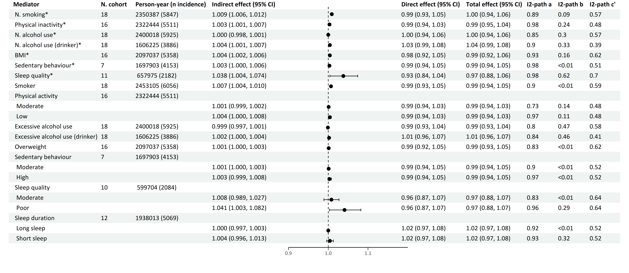
Multiple mediator model 1
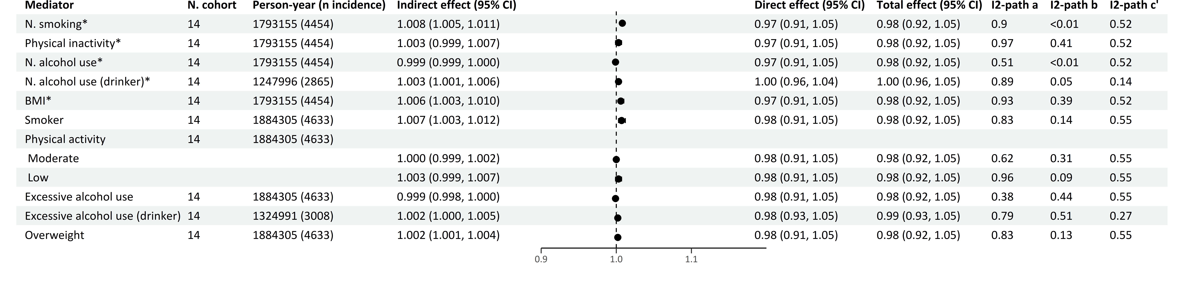
Multiple mediator model 2
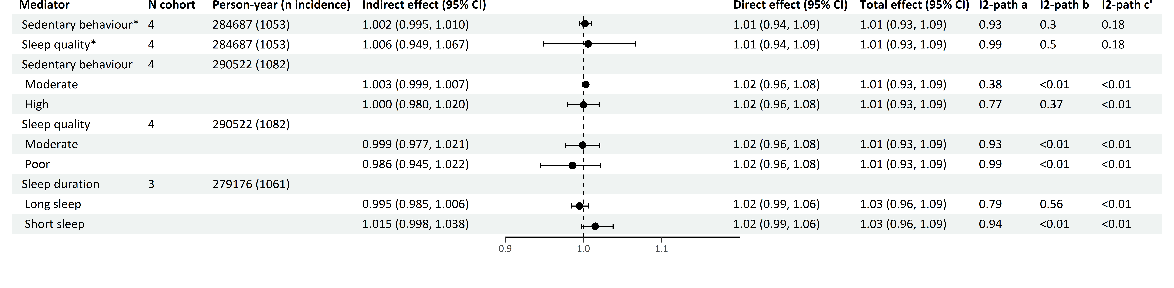

*continuous variables
Effects are Hazard Ratios.
The forest plot refers to the indirect effect of the mediator.
Multiple mediator model 1 includes and focuses on the effects of the four main health behaviors (smoking, physical inactivity, alcohol use and BMI).
Multiple mediator model 2 includes all seven health behaviors (smoking, physical inactivity, alcohol use, BMI, sedentary behavior, sleep quality and sleep duration), and focuses on the effects of the last three health behaviors.
Models adjusted for smoking, physical activity, alcohol use, BMI, birth year, sex, education, country of origin, anti-depressant use and family history of cancer.
Table S24 Mediation of health behaviors in the association of depression diagnosis with alcohol-related cancers
Single mediator model
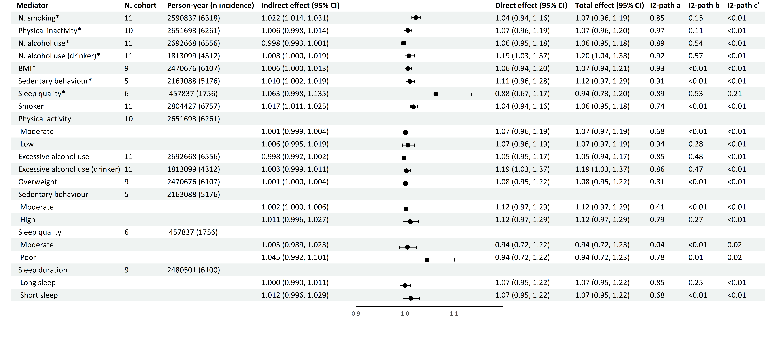
Multiple mediator model 1
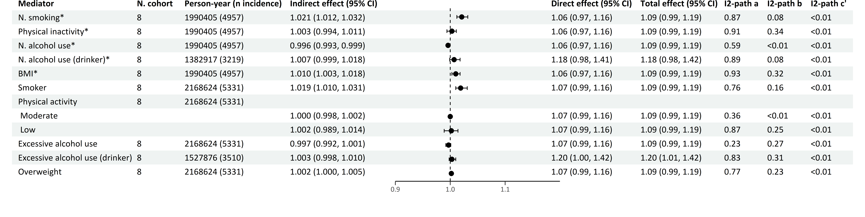
Multiple mediator model 2
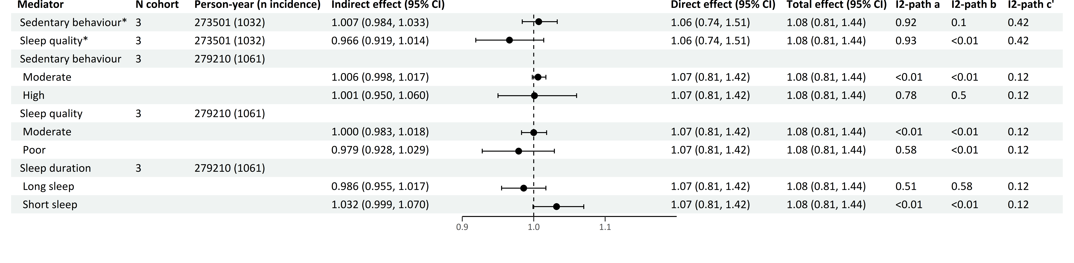
*continuous variables
Effects are Hazard Ratios.
The forest plot refers to the indirect effect of the mediator.
Multiple mediator model 1 includes and focuses on the effects of the four main health behaviors (smoking, physical inactivity, alcohol use and BMI).
Multiple mediator model 2 includes all seven health behaviors (smoking, physical inactivity, alcohol use, BMI, sedentary behavior, sleep quality and sleep duration), and focuses on the effects of the last three health behaviors.
Models adjusted for smoking, physical activity, alcohol use, BMI, birth year, sex, education, country of origin, anti-depressant use and family history of cancer.

Table S25 Mediation of health behaviors in the association of anxiety symptoms with alcohol-related cancers
Single mediator model
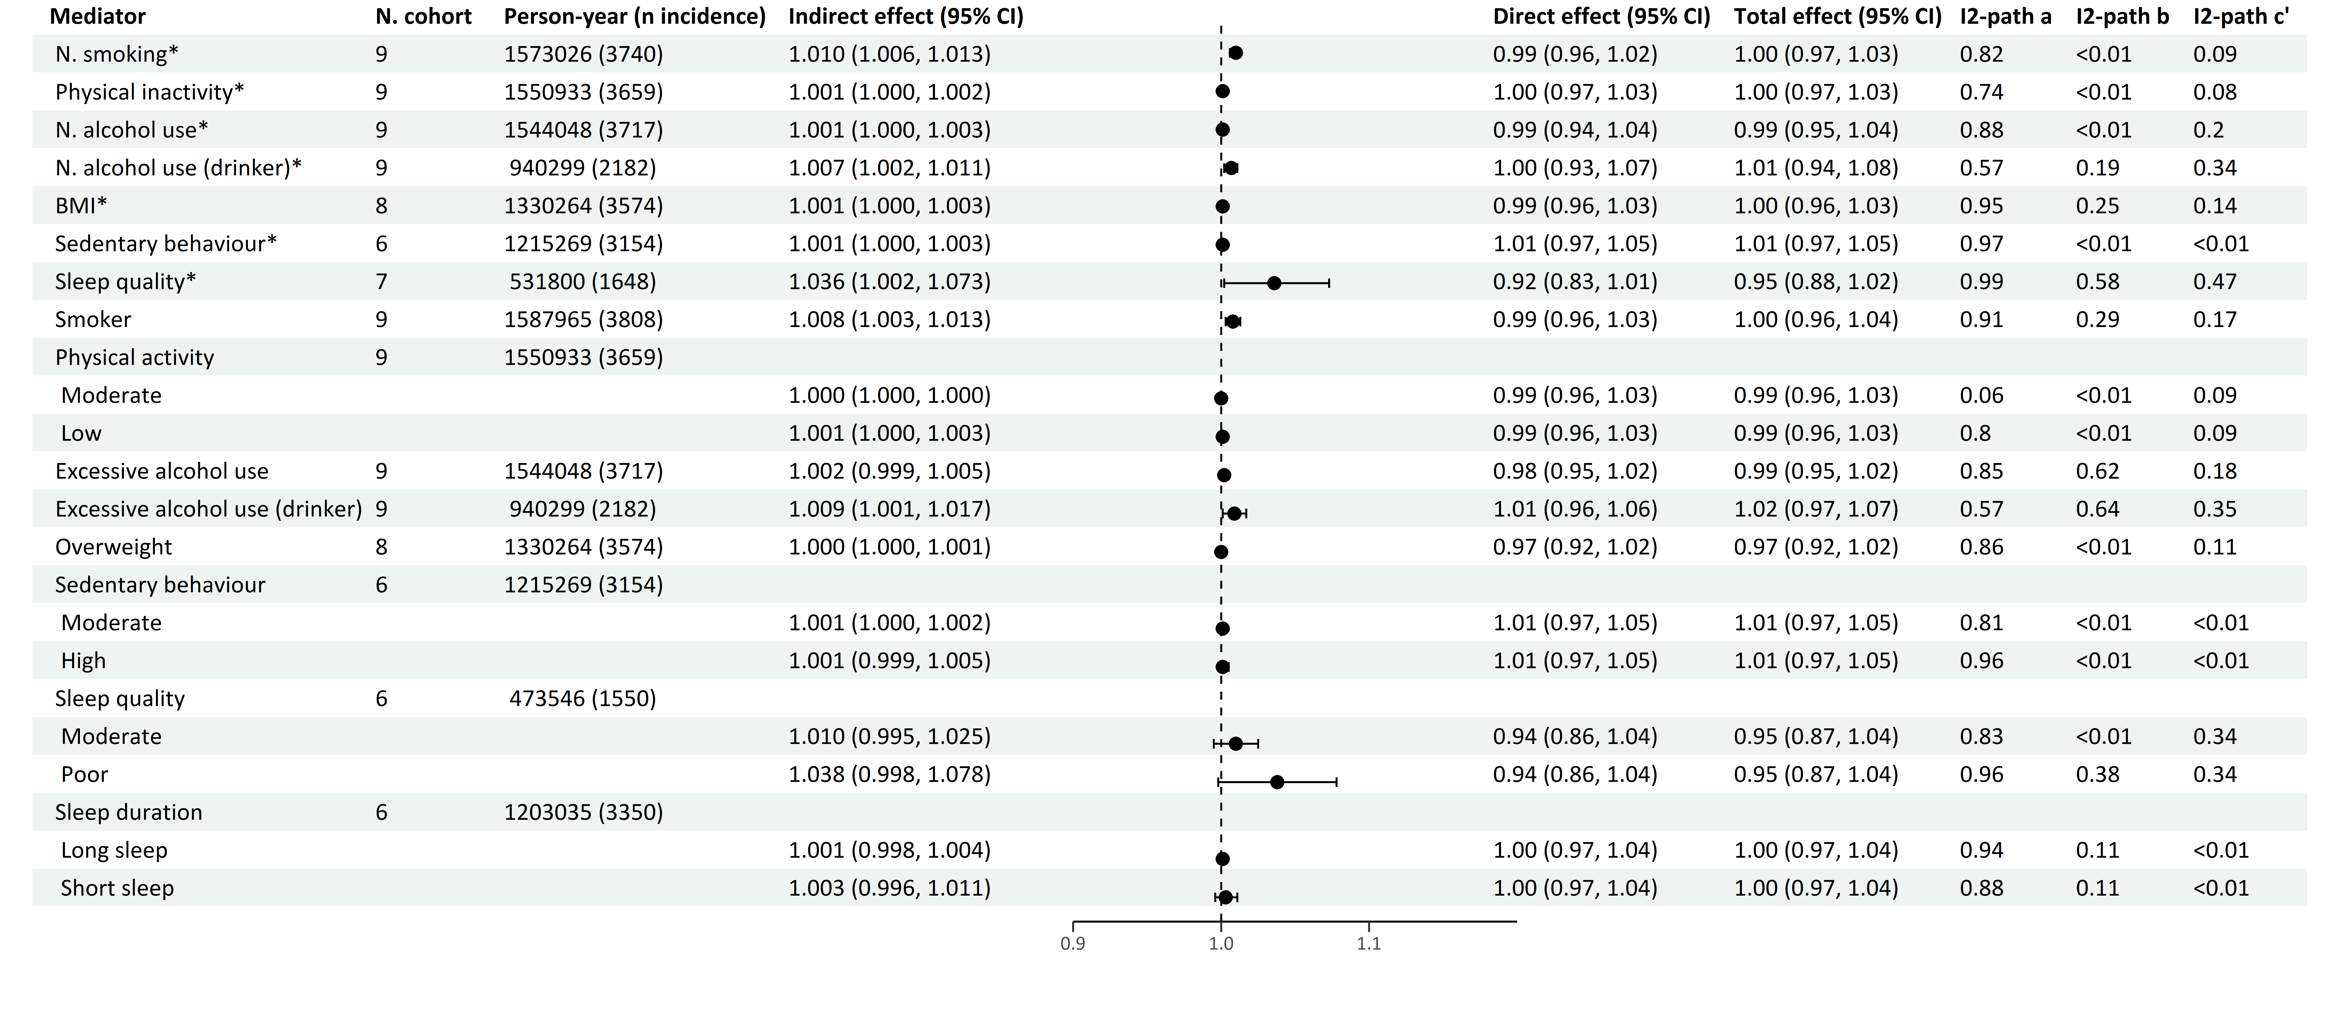
Multiple mediator model 1
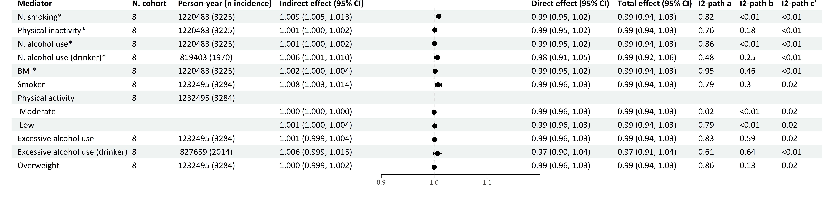
Multiple mediator model 2
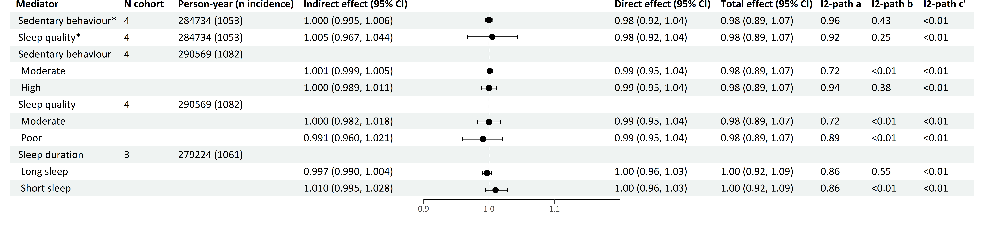
*continuous variables
Effects are Hazard Ratios.
The forest plot refers to the indirect effect of the mediator.
Multiple mediator model 1 includes and focuses on the effects of the four main health behaviors (smoking, physical inactivity, alcohol use and BMI).
Multiple mediator model 2 includes all seven health behaviors (smoking, physical inactivity, alcohol use, BMI, sedentary behavior, sleep quality and sleep duration), and focuses on the effects of the last three health behaviors.
Models adjusted for smoking, physical activity, alcohol use, BMI, birth year, sex, education, country of origin, anti-depressant use and family history of cancer.
Table S26 Mediation of health behaviors in the association of anxiety diagnosis with alcohol-related cancers
Single mediator model
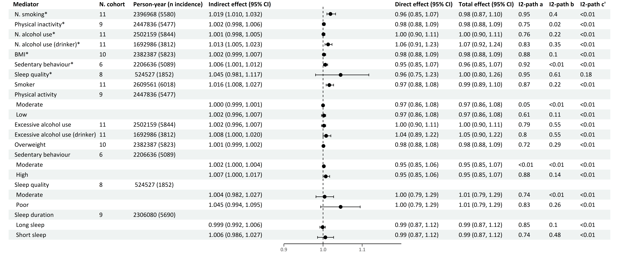
Multiple mediator model 1
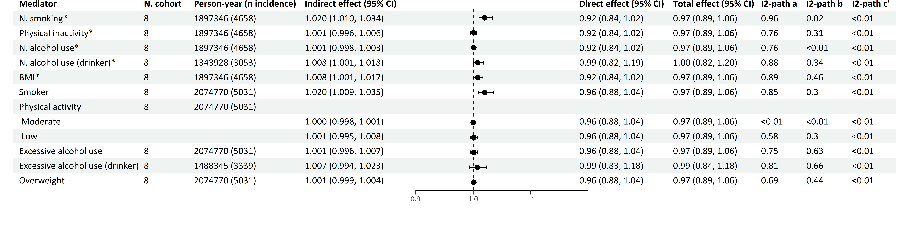
Multiple mediator model 2
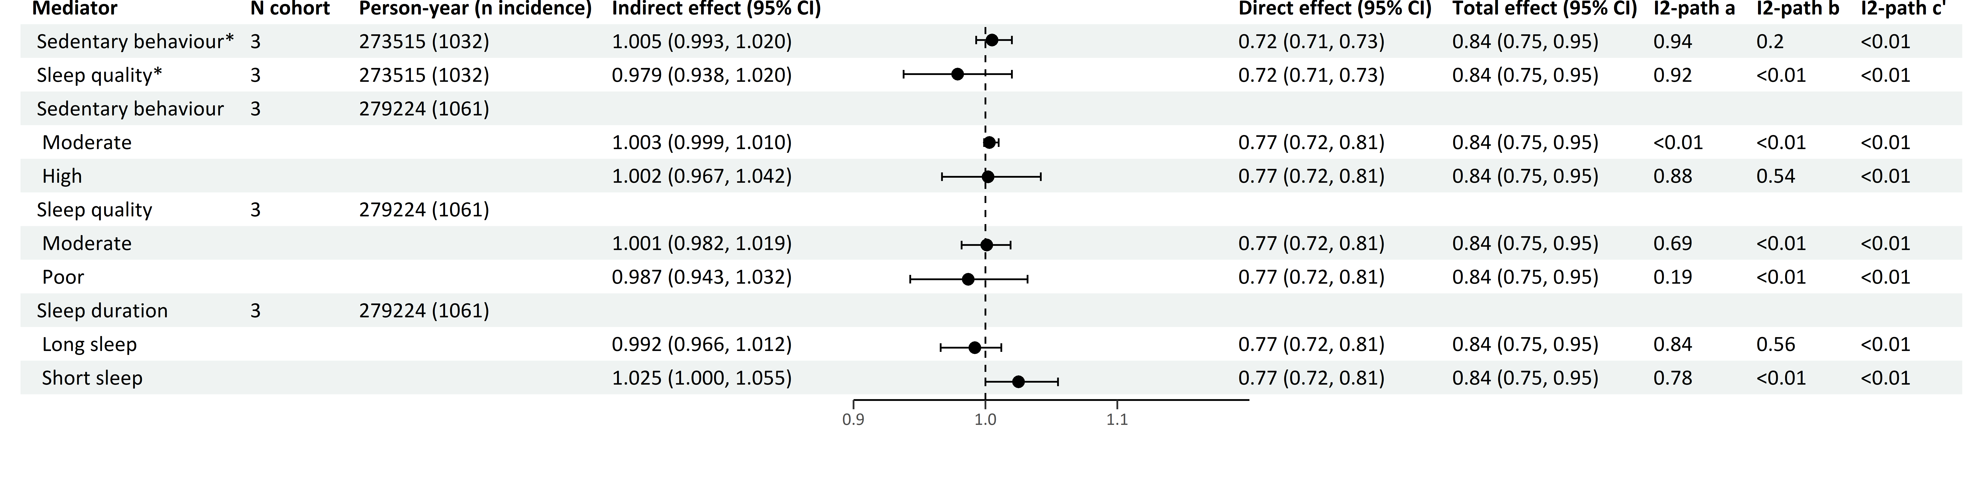
*continuous variables
Effects are Hazard Ratios.
The forest plot refers to the indirect effect of the mediator.
Multiple mediator model 1 includes and focuses on the effects of the four main health behaviors (smoking, physical inactivity, alcohol use and BMI).
Multiple mediator model 2 includes all seven health behaviors (smoking, physical inactivity, alcohol use, BMI, sedentary behavior, sleep quality and sleep duration), and focuses on the effects of the last three health behaviors.
Models adjusted for smoking, physical activity, alcohol use, BMI, birth year, sex, education, country of origin, anti-depressant use and family history of cancer.

Table S27 Mediation of categorial variables of smoking, physical inactivity, alcohol use and BMI in the associations of depression and anxiety with lung cancer
Depression symptoms
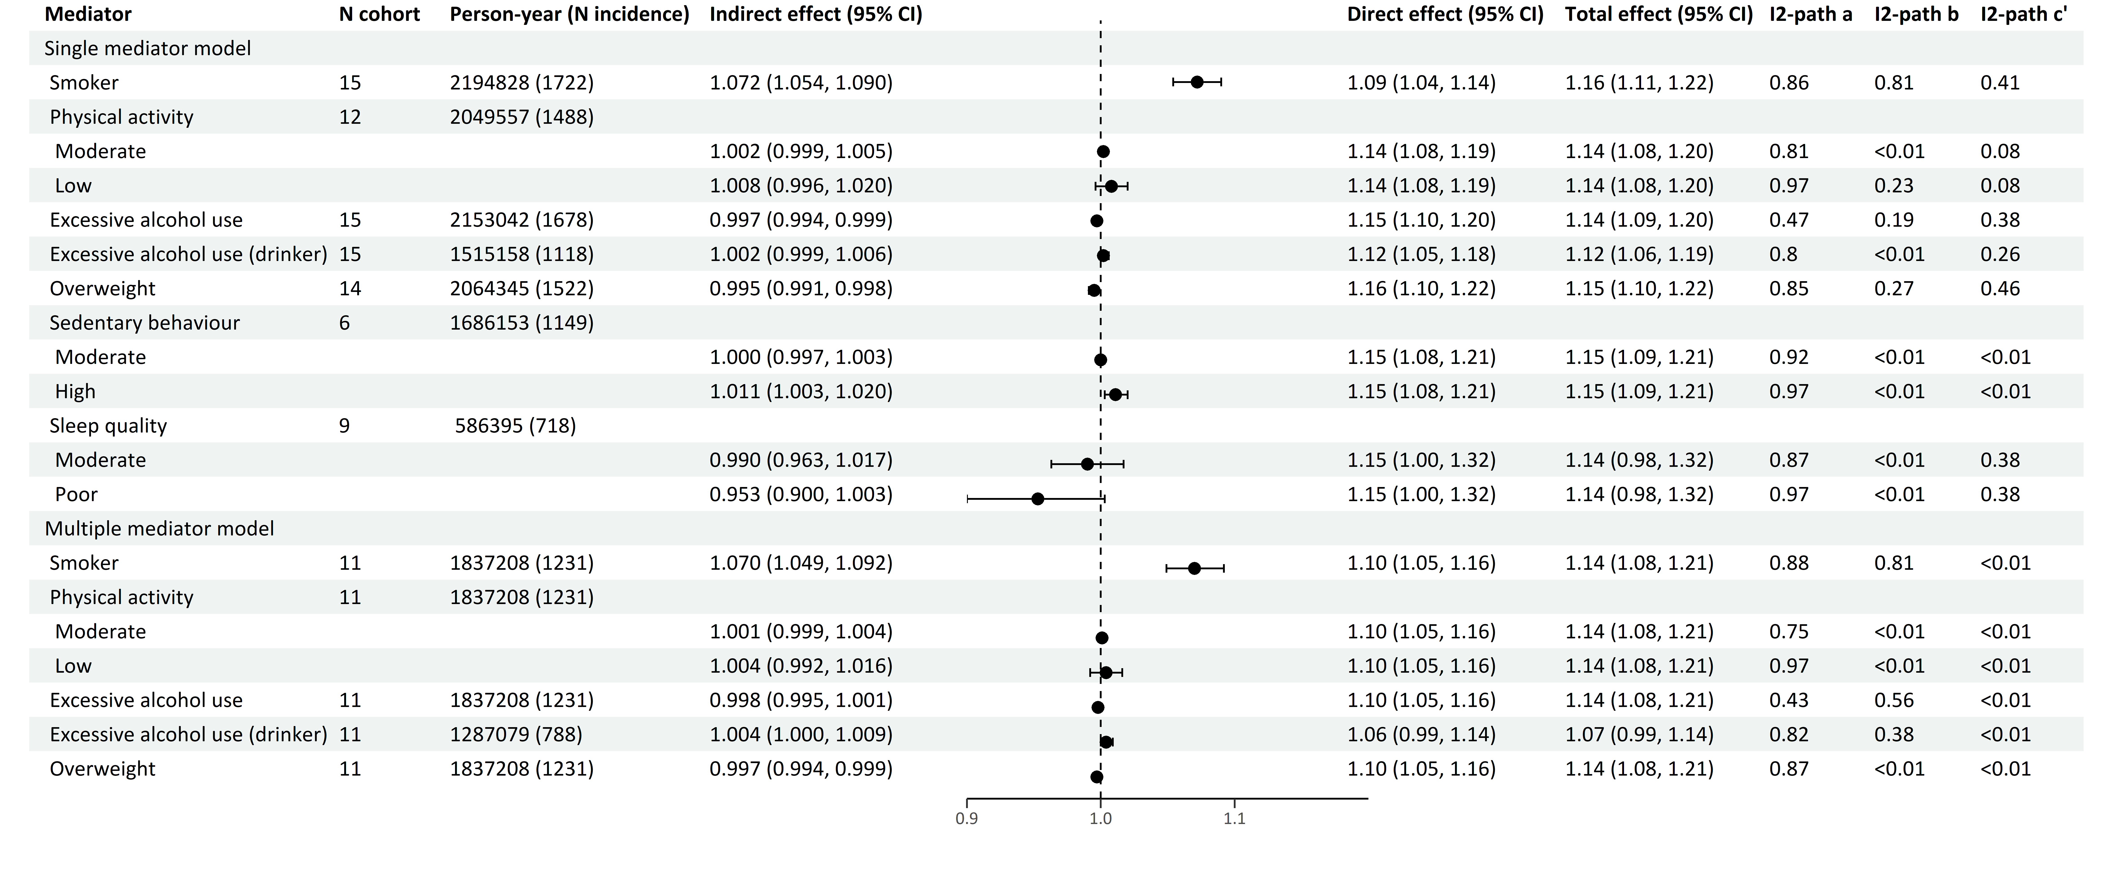
Depression diagnosis
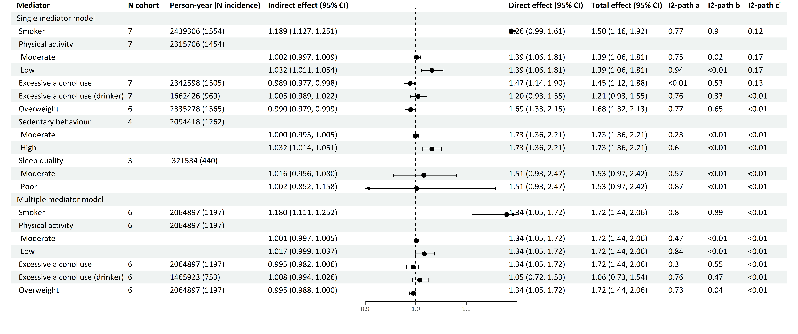
Anxiety symptoms
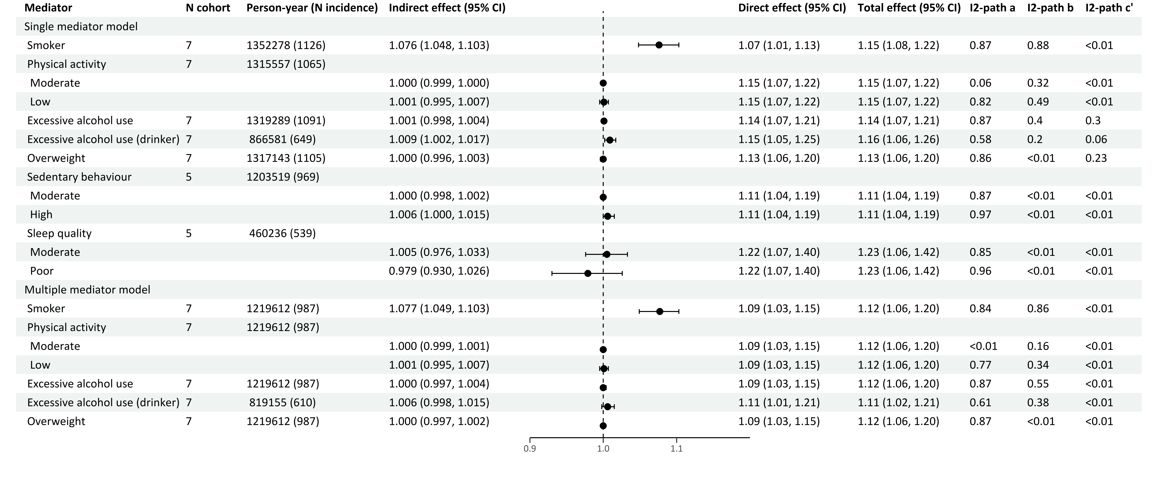
Anxiety diagnosis
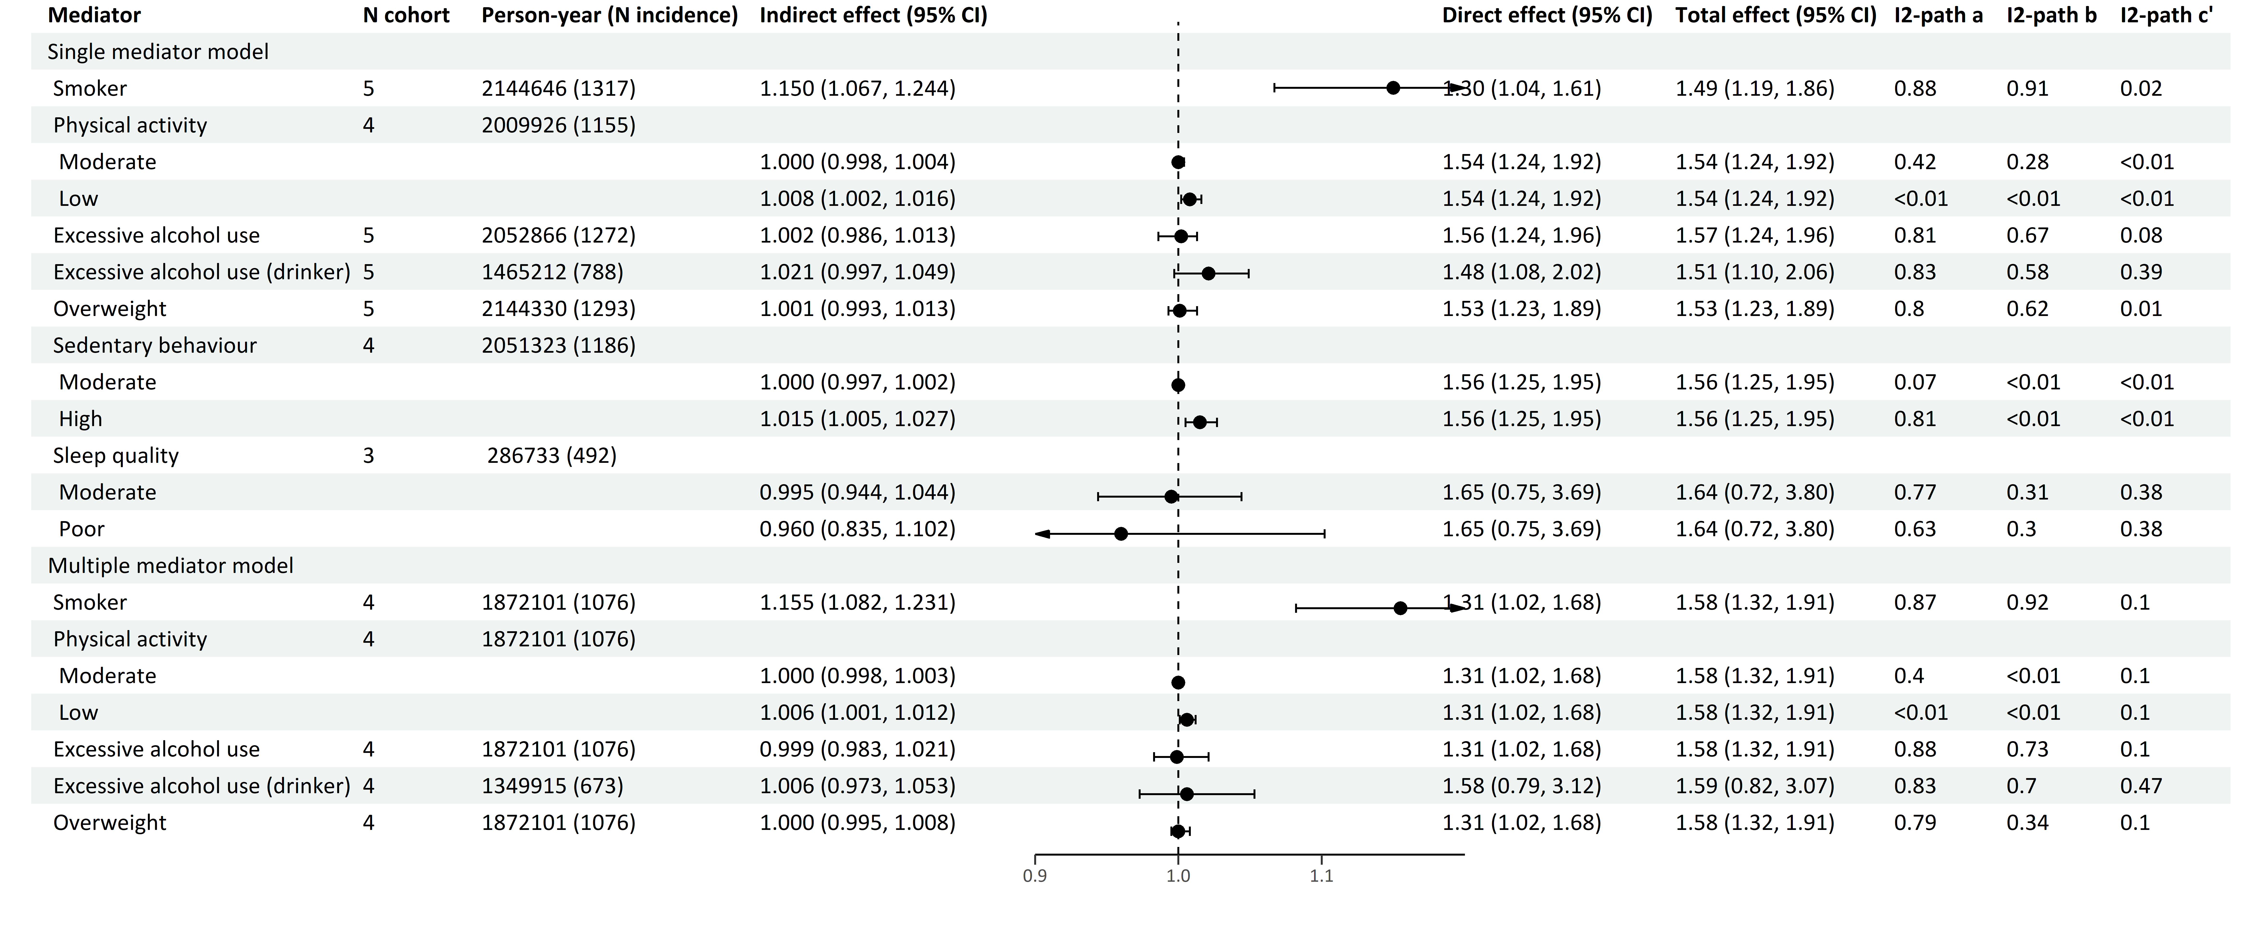
Effects are Hazard Ratios.
The forest plot refers to the indirect effect of the mediator.
Multiple mediator model includes cohorts with all information on smoker, physical activity, excessive alcohol use and overweight.
Models adjusted for birth year, sex, education, country of origin, anti-depressant use and family history of cancer.

Table S28 Mediation of categorial variables of smoking, physical inactivity, alcohol use and BMI in the associations of depression and anxiety with smoking-related cancers
Depression symptoms
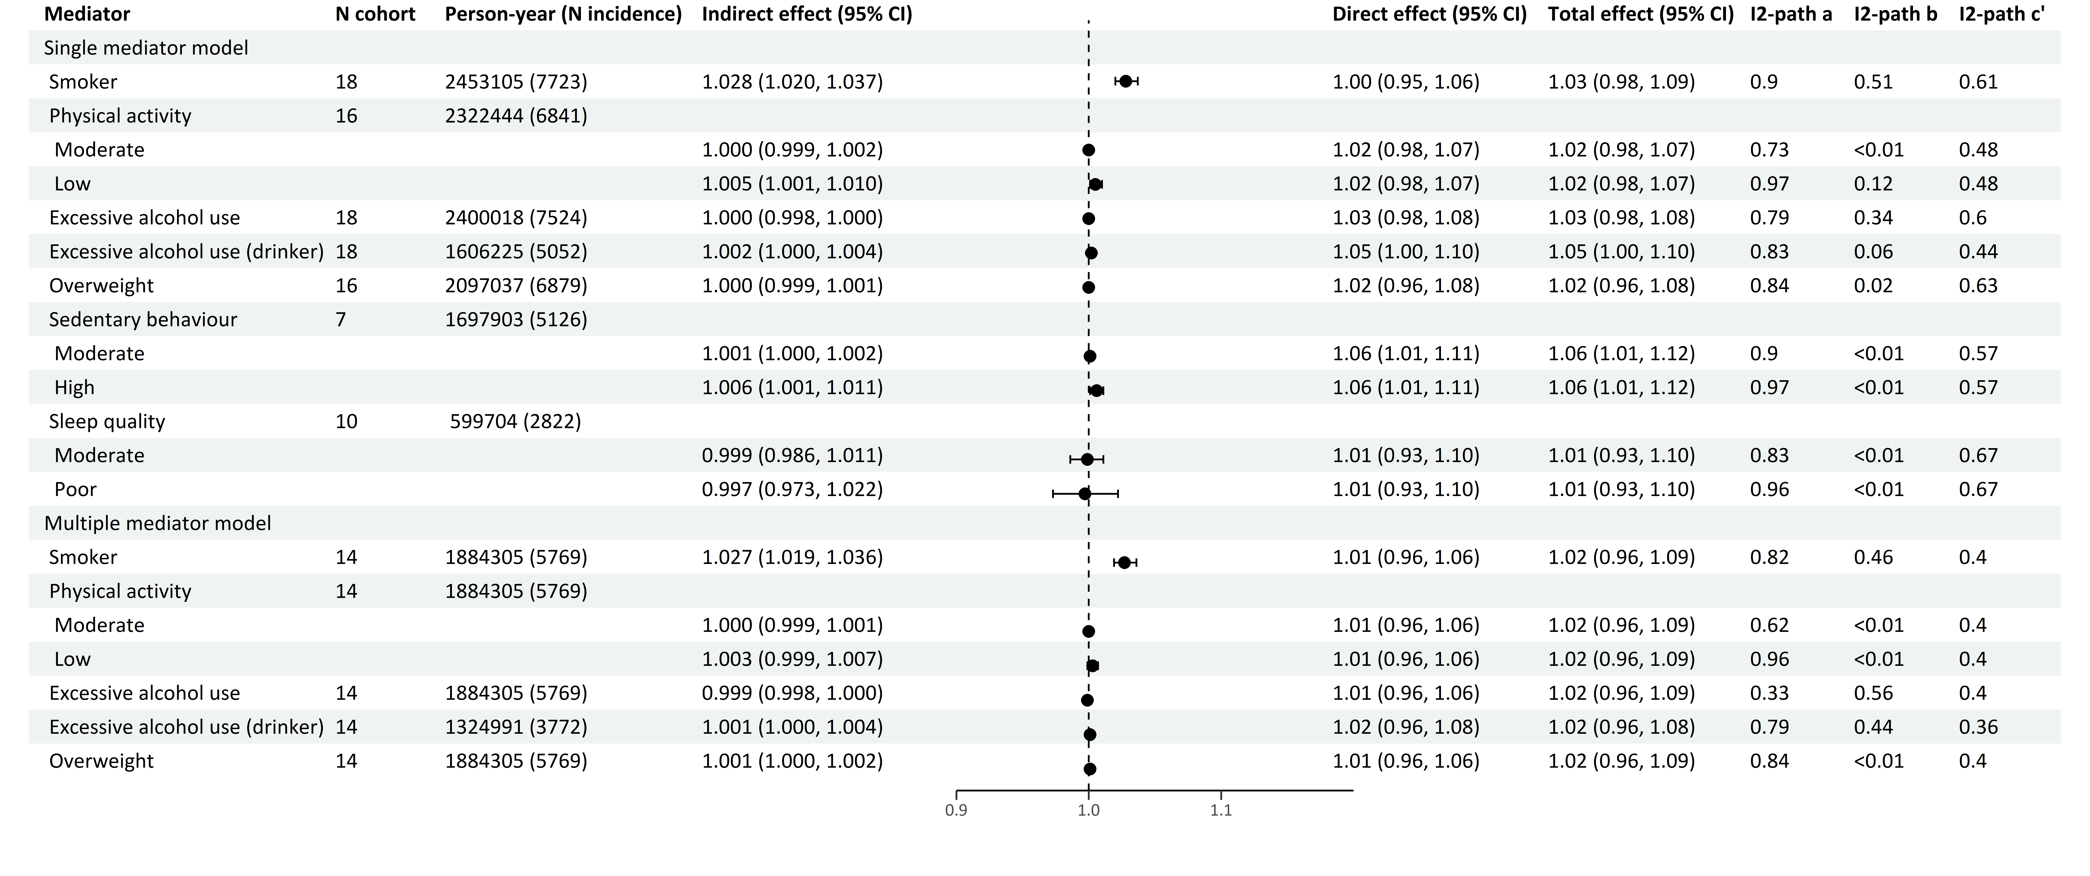
Depression diagnosis
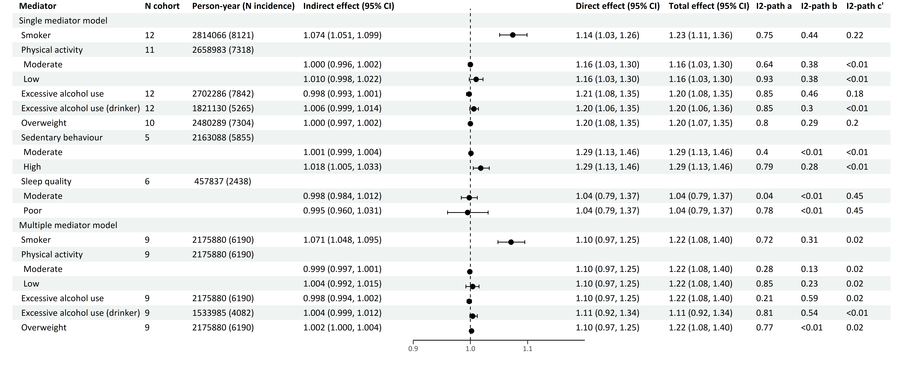
Anxiety symptoms
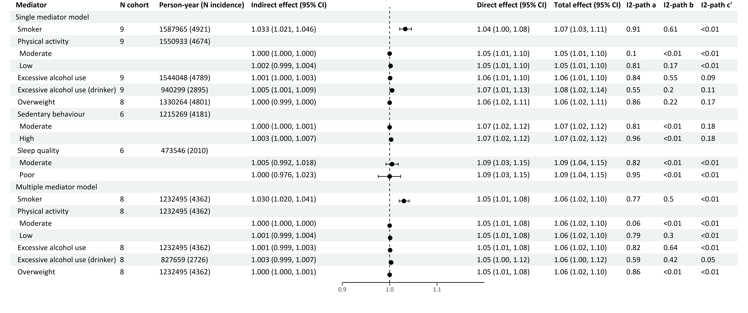
Anxiety diagnosis
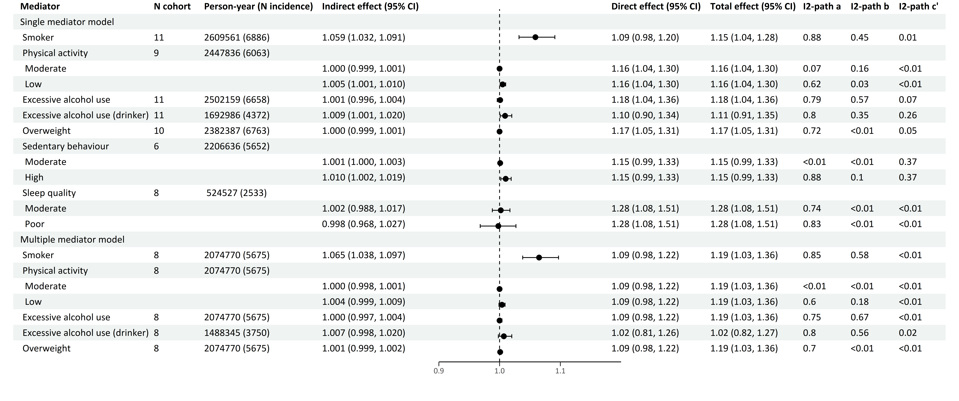
Effects are Hazard Ratios.
The forest plot refers to the indirect effect of the mediator.
Multiple mediator model includes cohorts with all information on smoker, physical activity, excessive alcohol use and overweight.
Models adjusted for birth year, sex, education, country of origin, anti-depressant use and family history of cancer.

