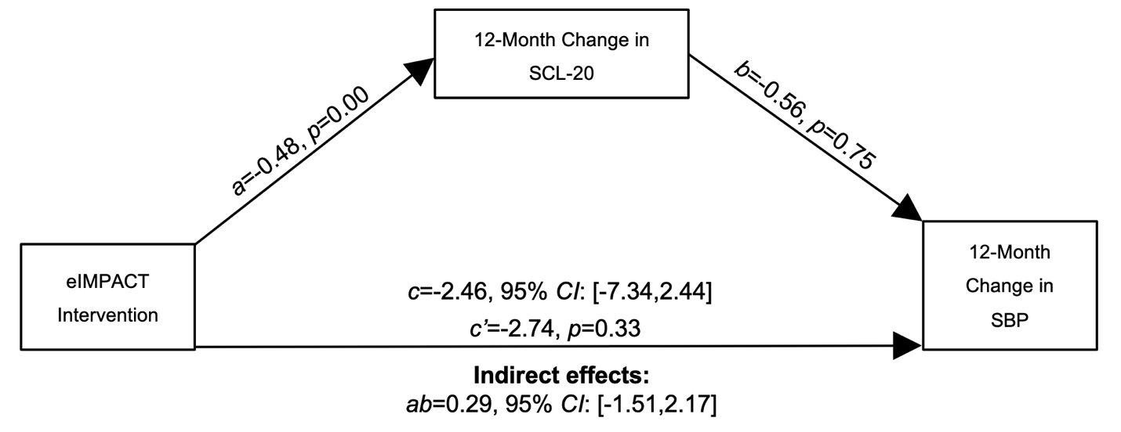

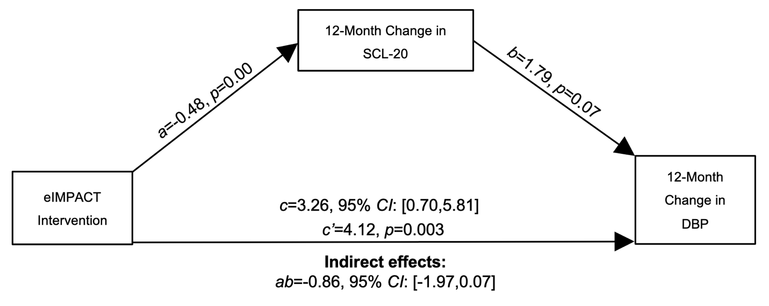

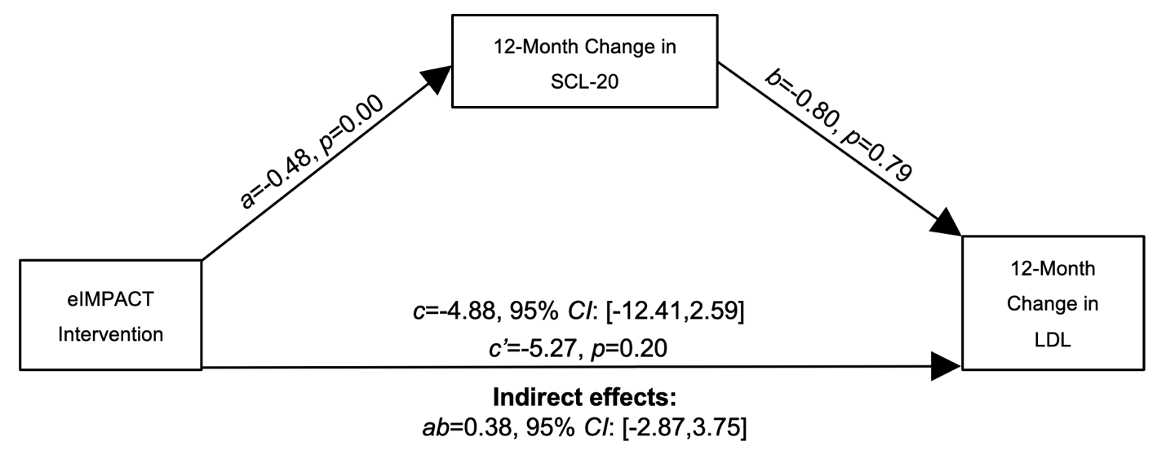
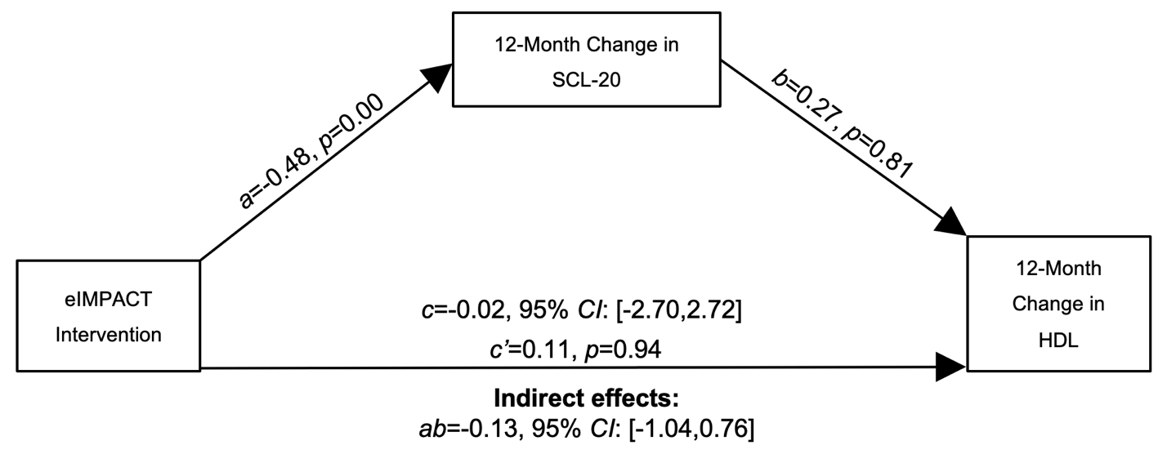

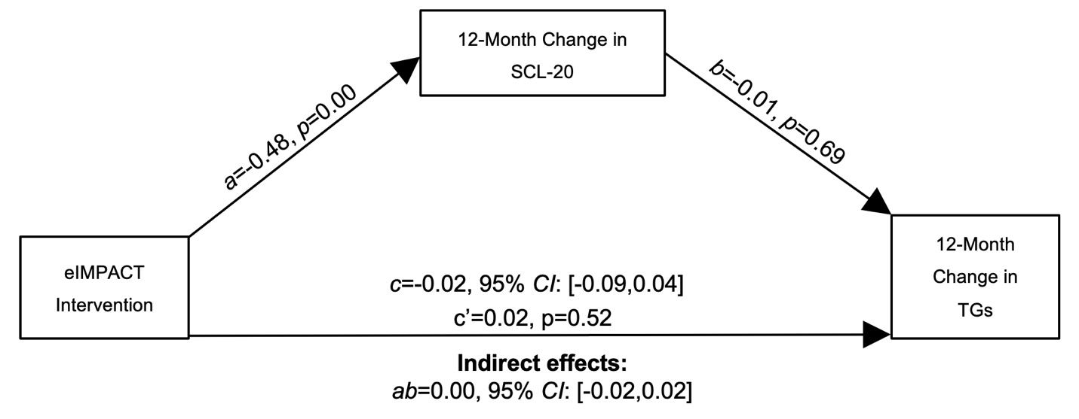
Supplemental Fig. 2. Unadjusted Mediation Model Examining Depressive Symptoms as a Mediator of the eIMPACT Intervention Effects on Traditional CVD Risk Factors. Full information maximum likelihood was used to handle missing data. SCL-20 = Hopkins Symptom Checklist-20; SBP = systolic blood pressure; DBP = diastolic blood pressure; LDL-C = low-density lipoprotein cholesterol; HDL-C = high-density lipoprotein cholesterol; TGs = triglycerides.

