Supplementary Table 1: Description of studies and cross-sectional data from participant samples (total n=767)
Study | Sample size | Measures |  |  |  | Details
 |  | Questionnaire | Sedentary behaviour | Exercise motivation | Mental/ physical health
Vancampfort et al¹ | 56 | IPAQ | - | BREQ-2 | - | Country: Belgium  Diagnosis: First Episode Psychosis (n=56)  Sex: Female (n=20); Male (n=36)  Demographics (males and females respectively)  Age: M=25.0 (SD=3.7) and M=23.7 (SD=3.9) years  BMI: M=23.3 (SD=4.1) and 24.4 (SD=4.1) kg/m²
Vancampfort et al^{2,3} | 165 | IPAQ | - | BREQ-2 | - | Country: Belgium  Diagnoses: Major depressive disorder (n=96); Bipolar disorder (n=69)  Sex: Female (n=105); Male (n=60)  Demographics  Age: M=45.6 (SD=14.2) years  BMI: M=25.2 (SD=5.0) kg/m²
Vancamfort et al⁴ | 48 | SIMPAQ | - | BREQ-3 | - | Country: Uganda  Diagnosis: Psychotic disorder (n=48)  Sex: Female (n=24); Male (n=24)  Demographics  Age: M=33.3 (SD=9.6) years  BMI: M=21.8 (SD=2.9) kg/m²
Vancampfort et al⁵ | 50 | SIMPAQ | - | BREQ-3 | - | Country: Uganda  Male (n=50)  Diagnoses: Alcohol use disorder  Demographics  Age: M=33.0 (SD=10.7) years  BMI: M=21.8 (SD=2.9) kg/m²
Seymour et al (n=94)⁶  (some results unpublished) | 239 | 2PAQ | - | BREQ-3 | Medical screen; K6 | Country: Australia  Sex: Female (n=142); Male (n=97)  Diagnoses: Psychotic disorder (n=69); Affective disorder (n=131); Anxiety disorder (n=10); Other (n=11)  Demographics  Age: M=41.5 (SD=8.6) years  BMI: M=35.6 (SD=12.9) kg/m²
Korman et al⁷ | 13 | SIMPAQ | SIMPAQ | BREQ-2 | Medical screen; BPRS | Country: Australia  Sex: Female (n=4); Male (n=9)  Diagnoses: Psychotic disorder (n=12); Affective disorder (n=1)  Demographics  Age: M=32.3 (SD=8.1) years  BMI: M=28.0 (SD=4.9) kg/m²
Williams et al⁸ | 40 | IPAQ  Accelerometry | IPAQ_SF  Accelerometry | BREQ-2 | - | Country: England  Sex: Female (n=22); Male (n=18)  Diagnoses: Psychotic disorder (n=31); Affective disorder (n=6); missing (n=3)  Demographics  Age: M=43.3 (SD=8.2) years  BMI: M=32.4 (SD=6.6) kg/m²
Korman et al⁹ | 42 | SIMPAQ  Accelerometry | SIMPAQ  Accelerometry | BREQ-2 | Medical screen; BPRS | Country: Australia  Sex: Female (n=9); Male (n=33)  Diagnoses: Psychotic disorder (n=39); Affective disorder (n=3); Substance use disorder (n=1)  Demographics  Age: M=33.3 (SD=9.4) yrs  BMI: M=29.3 (SD=6.5) kg/m²
Chapman et al¹⁰ (results unpublished) | 69 | SIMPAQ  Accelerometry | SIMPAQ  Accelerometry | BREQ-3 | Medical screen; K6 | Country: Australia  Sex: Female (n=27); Male (n=42)  Diagnoses: Psychotic disorder (n=43); Affective disorder (n=18); Other (n=8)  Demographics  Age: M=35.9 (SD=10.5) years  BMI: M=31.9 (SD=7.9) kg/m²
Korman et al (unpublished) | 49 | SIMPAQ  Accelerometry | SIMPAQ  Accelerometry | BREQ-3 | Medical screen; BPRS | Country: Australia  Sex: Female (n=13); Male (n=36)  Diagnoses: Psychotic disorder (n=46); Affective disorder (n=3)  Demographics  Age: M=32.8 (SD=10.4) years  BMI: M=32.2 (SD=8.2) kg/m²

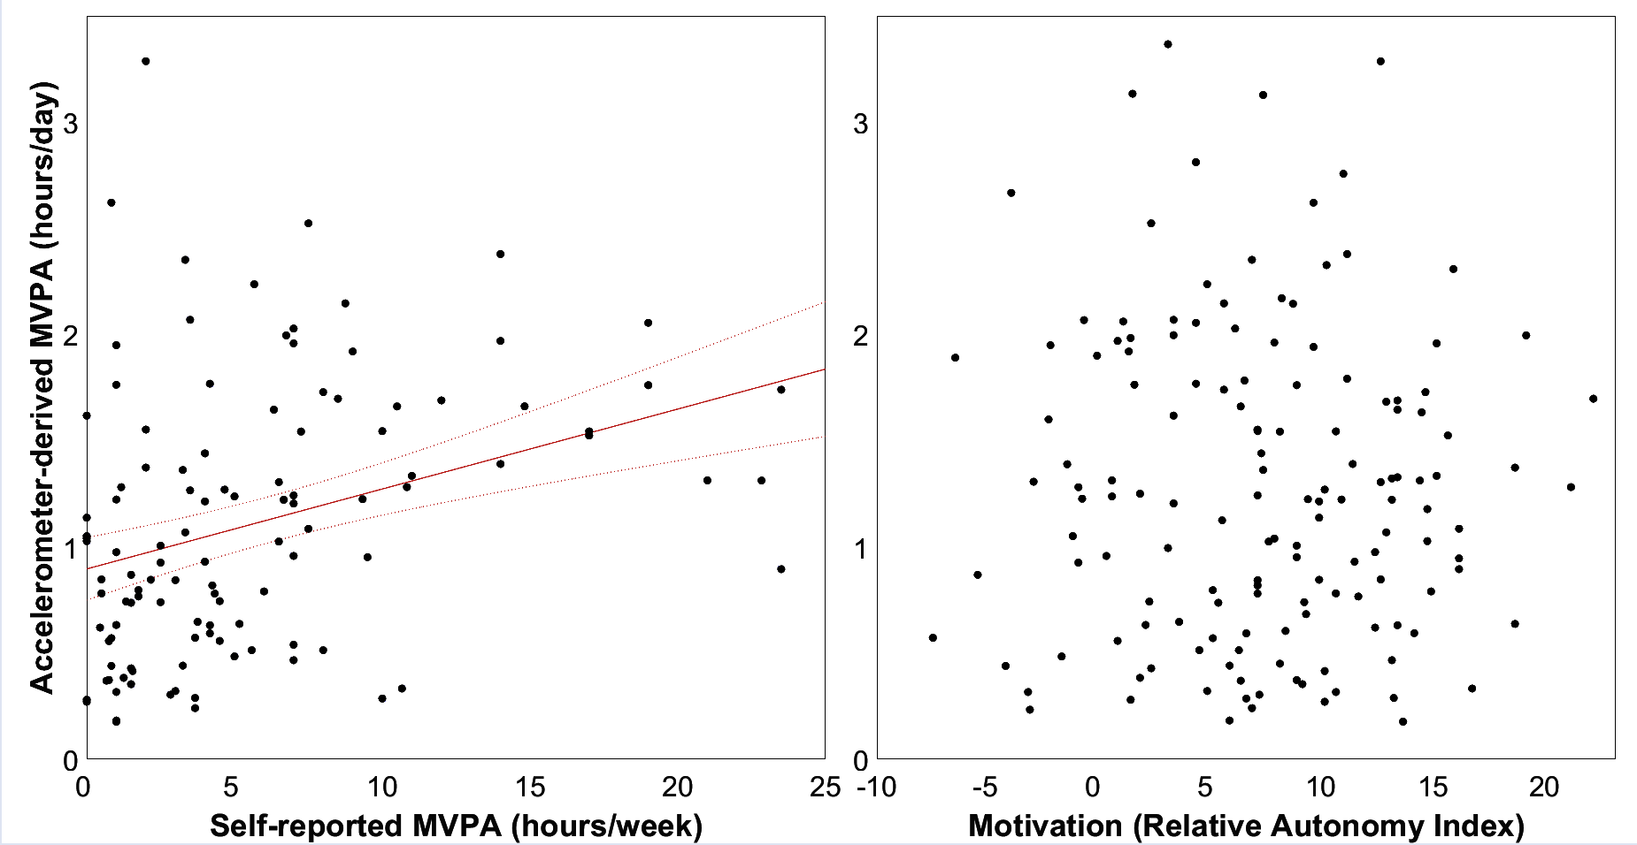

Supplementary Figure 1: Accelerometer-derived moderate-to-vigorous physical activity (MVPA; n=137) was correlated with self-reported MVPA (r=0.406, p<0.001; left panel), but not Relative Autonomy Index (p=0.44; right panel). The regression of accelerometer-derived MVPA against self-reported MVPA is plotted with the standard error of the mean (left).
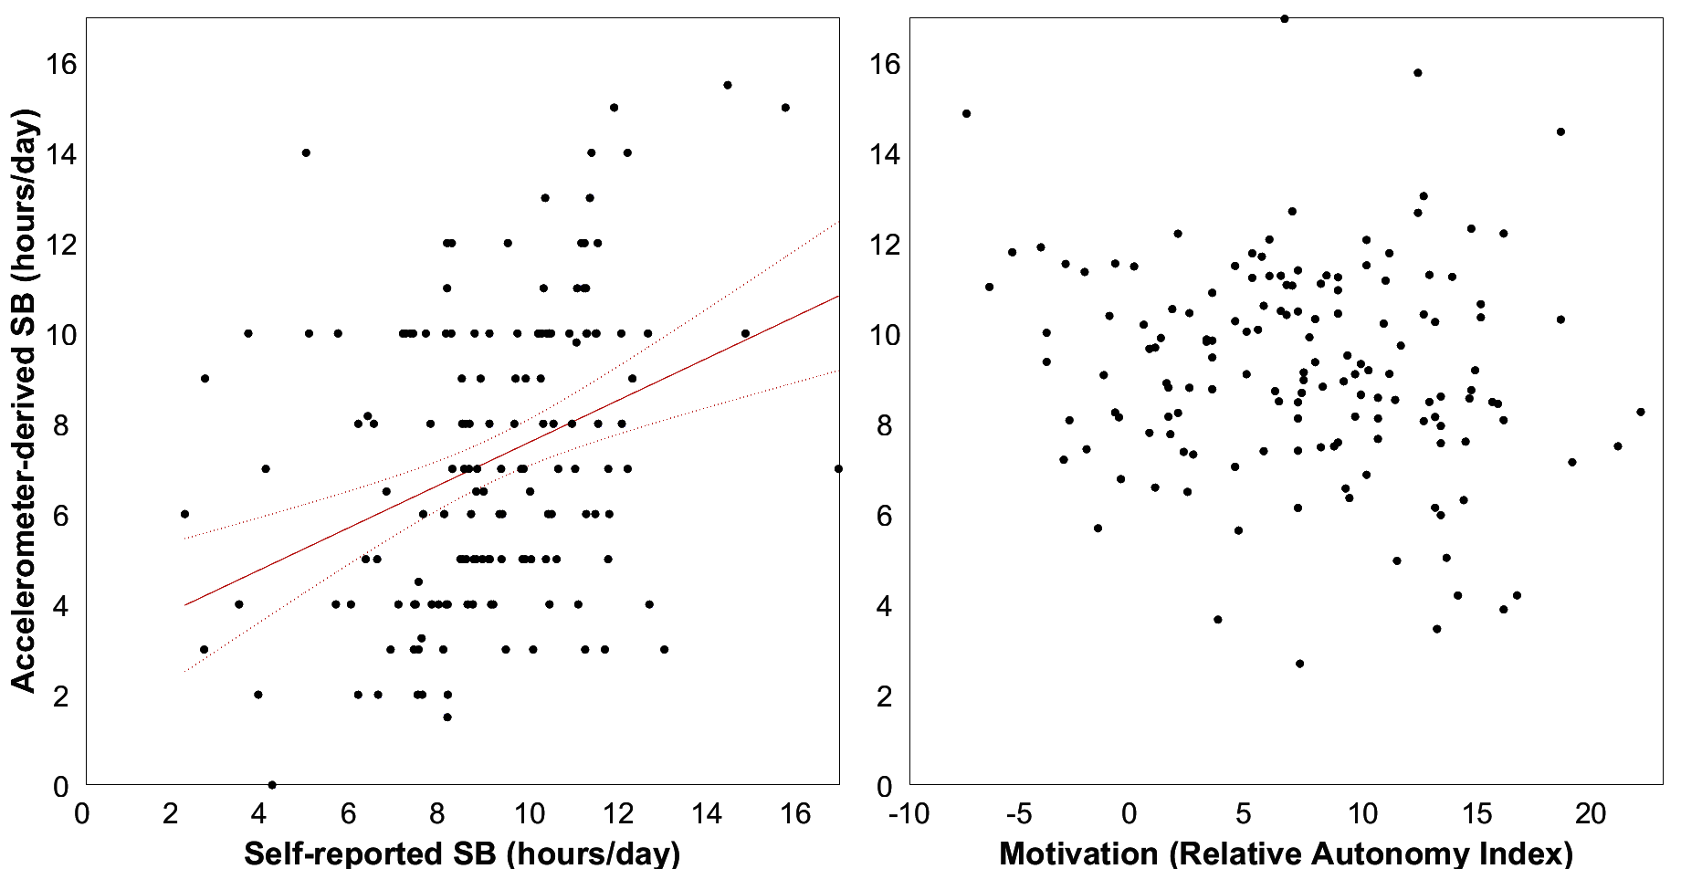

Supplementary Figure 2: Accelerometer-derived sedentary behaviour (SB; n=139) was correlated with self-reported SB (r=0.347, p<0.001; left panel), but not Relative Autonomy Index (p=0.09; right panel). The regression of accelerometer-derived SB against self-reported SB is plotted with the standard error of the mean (left).

1. Vancampfort D, De Hert M, Broderick J, et al. Is autonomous motivation the key to maintaining an active lifestyle in first‐episode psychosis? Early Interv Psychiatry. 2018;12(5):821-827.
2. Vancampfort D, Moens H, Madou T, et al. Autonomous motivation is associated with the maintenance stage of behaviour change in people with affective disorders. Psychiatry Res. 2016;240:267-271.
3. Vancampfort D, Madou T, Moens H, et al. Could autonomous motivation hold the key to successfully implementing lifestyle changes in affective disorders? A multicentre cross sectional study. Psychiatry Res. 2015;228(1):100-106.
4. Vancampfort D, De Hert M, Probst M, et al. Interest, competence, appearance, fitness and social relatedness as motives for physical activity in Ugandan outpatients with psychosis. Ment Health Phys Act. 2017;13:94-99.
5. Vancampfort D, Van Damme T, Probst M, et al. Motives for physical activity in the adoption and maintenance of physical activity in men with alcohol use disorders. Psychiatry Res. 2018;261:522-526.
6. Seymour J, Pratt G, Patterson S, et al. Changes in self-determined motivation for exercise in people with mental illness participating in a community-based exercise service in Australia. Health Soc Care Comm. 2021;30(5):e1611-e1624.
7. Korman NH, Shah S, Suetani S, et al. Evaluating the feasibility of a pilot exercise intervention implemented within a residential rehabilitation unit for people with severe mental illness: GO HEART:(Group Occupational Health Exercise and Rehabilitation Treatment). Front Psychiatry. 2018;9:343.
8. Williams J, Stubbs B, Richardson S, et al. ‘Walk this way’: results from a pilot randomised controlled trial of a health coaching intervention to reduce sedentary behaviour and increase physical activity in people with serious mental illness. BMC psychiatry. 2019;19(1):287.
9. Korman N, Fox H, Skinner T, et al. Feasibility and Acceptability of a Student-Led Lifestyle (Diet and Exercise) Intervention Within a Residential Rehabilitation Setting for People With Severe Mental Illness, GO HEART (Group Occupation, Health, Exercise And Rehabilitation Treatment). Front Psychiatry. 2020;11:319.
10. Chapman JJ, Suetani S, Siskind D, et al. Protocol for a randomised controlled trial of interventions to promote adoption and maintenance of physical activity in adults with mental illness. BMJ open. 2018;8(9):e023460.

