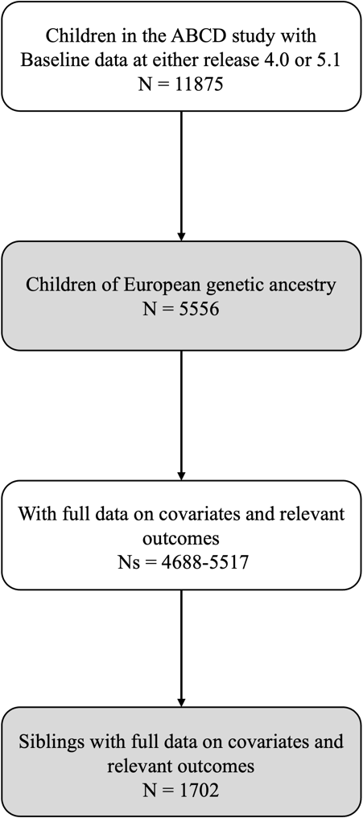

Supplemental Figure 1. ABCD Study (Baseline) Analytic Sample Size Flowchart for the Present Study.

