Supplement Table 1. Mass parameters and MRM transitions for Aripiprazole and Dehydroaripiprazole
Analytes | MRM Transition |  | Function
Aripiprazole | 448.2→285.1 | Quantification
 | 448.2→98.1 | Qualification
Aripiprazole -d8 | 456.2→293.1 | Quantification
 | 456.2→106.1 | Qualification
Dehydroaripiprazole | 446.1→285.1 | Quantification
 | 446.1→98.1 | Qualification
Dehydroaripiprazole -d8 | 454.2→293.1 | Quantification
 | 454.2→106.1 | Qualification

Supplement Table 2. Comparison of plasma concentration-dose ratios between our study and previous studies
 | C/D of ARI | C/D of DARI | C/D of ARI+DARI
Our Study | 17.79±7.23 ng/mL/mg | 6.27±2.09 ng/mL/mg | 24.07±8.70 ng/ml/mg
Rafaniello 2018 | 16.41±10.26 ng/mL/mg
Molden 2006 | 11.57 ng/mL/mg | 4.02 ng/mL/mg | 15.59 ng/ml/mg
Jönsson 2019 | 11.99 ng/mL/mg
Lin 2011 | 14.80±6.00 ng/mL/mg | 6.10±2.40 ng/mL/mg
Kim 2008 | 16.50±7.00 ng/mL/mg | 5.30±1.90 ng/mL/mg
Nakamura 2009 | 12.60±4.90 ng/mL/mg | 5.70±1.90 ng/mL/mg
Kirschbaum 2008 | 11.40±7.30 ng/mL/mg | 4.00±4.00 ng/mL/mg
Citrome 2005 | 7.90±2.70 ng/mL/mg | 3.40±0.90 ng/mL/mg
Abbreviations: C/D, Concentration-to-dose ratio; ARI, aripiprazole; DARI, dehydroaripiprazole
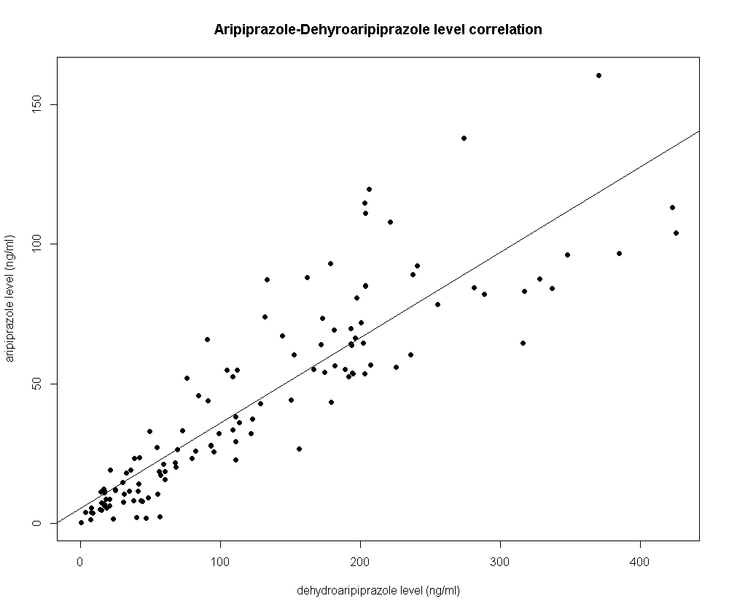
Supplement Figure 1. Scatter plot of dehydroaripiprazole/aripiprazole serum drug levels with regression lines

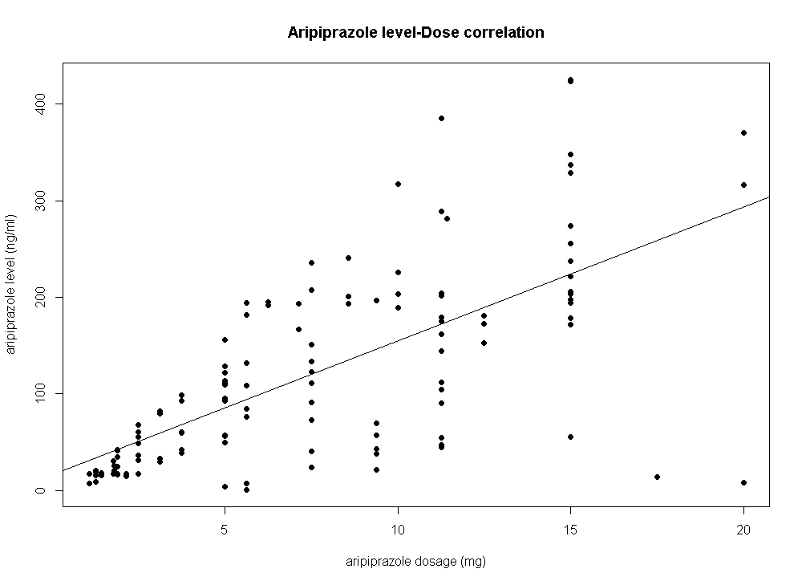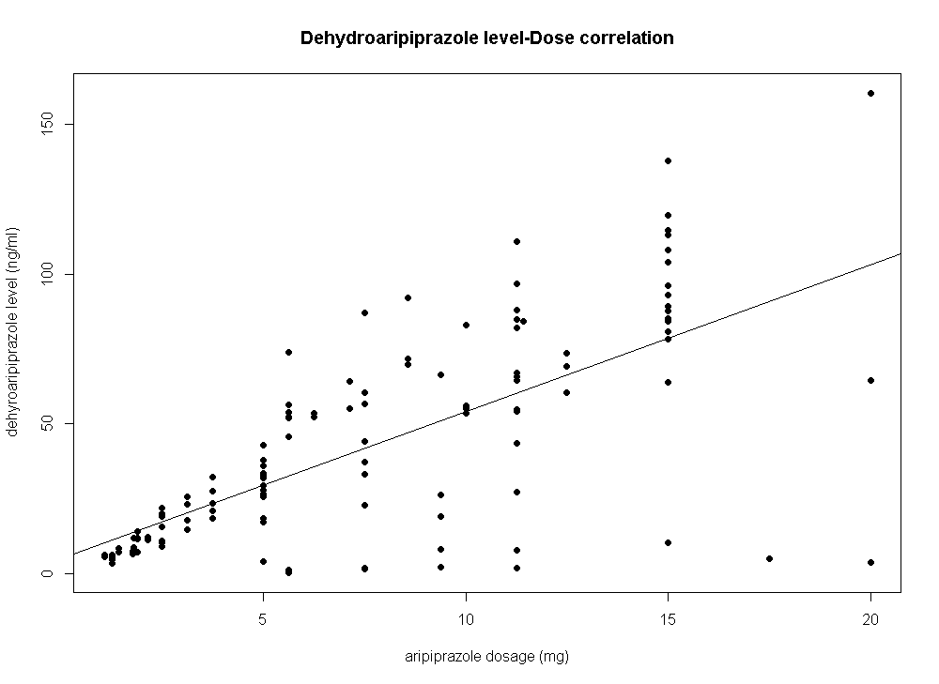
Supplement Figure 2: Left: Scatter plot of aripiprazole dose and serum aripiprazole concentration with regression line before exclusion of outliers; Right: Scatter plot of aripiprazole dose and serum dehydroaripiprazole concentration with regression line before exclusion of outliers

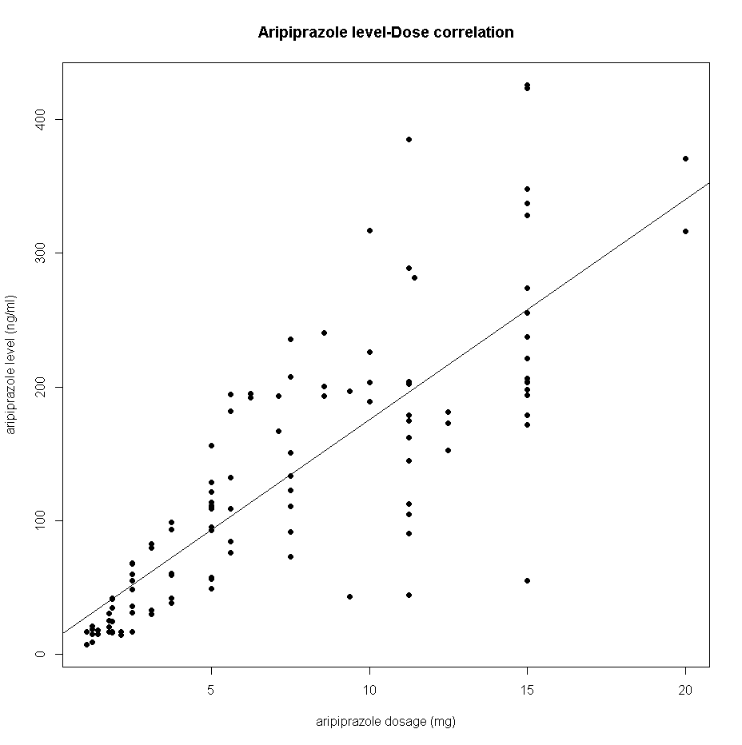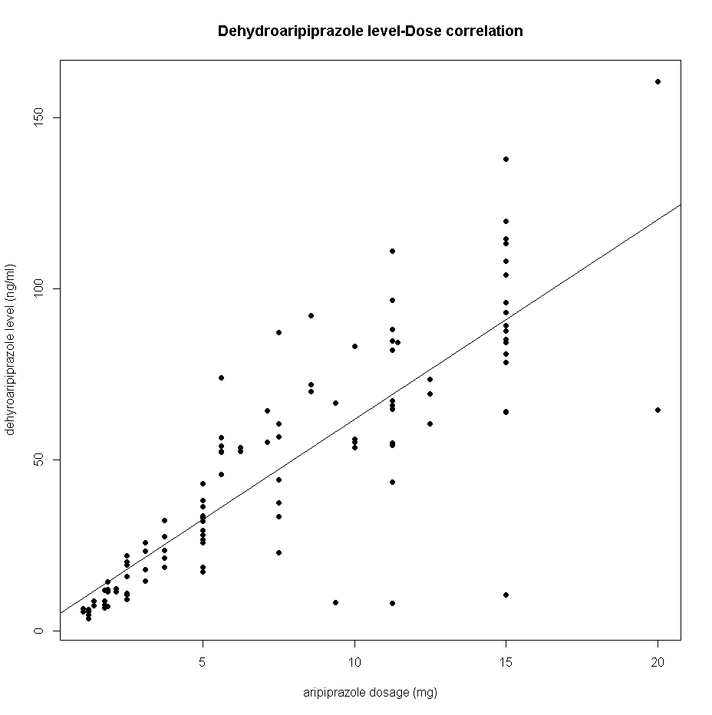

Supplement Figure 3. Scatter plots. Left: Scatter plot of aripiprazole dose and serum aripiprazole concentration with a regression line; Right: Scatter plot of aripiprazole dose and serum dehydroaripiprazole concentration with a regression line

