**Supplemental Table 1:** Descriptives of continuous screening measures(N=4,002)

|  |  |  |  |  |  |
| --- | --- | --- | --- | --- | --- |
|  | Number of items | Response levels per item | Mean (SD) | range | alpha |
| **Problematic substance use**a | | Six items with different scoring: |  |  |  |
| Tobacco | 5 | 1. Use = 0 (never),2,3,4,6 (daily)  2. Craving = 0 (never),3,4,5,6 (daily)  3. Problemsb = 0 (never), 4,5,6,7 (daily)  4. Interferenceb=0 (never),5,6,7,8 (daily)  5. Concern and 6. control = 0 (never),3 (lifetime),6 (current) | 5.2 (8.1) | 0-31 | 0.87 |
| Alcohol | 6 | 5.0 (6.1) | 0-39 | 0.77 |
| Cannabis | 6 | 1.5 (4.8) | 0-39 | 0.87 |
| Sedatives | 6 | 1.4 (4.7) | 0-39 | 0.87 |
| Prescription stimulants | 6 | 0.7 (3.5) | 0-39 | 0.88 |
| Prescription opioid painkillers | 6 | 0.6 (3.3) | 0-39 | 0.89 |
| **Problematic addictive behaviors** | |  |  |  |  |
| Gamblingc | 9 | 0-3 (Never-almost always) | 0.9 (2.5) | 0-27 | 0.91 |
| Gamingd | 7 | 1-5 (Never-very frequently) | 10.8 (5.1) | 7-35 | 0.91 |
| Compulsive sexual behaviore | 6 | 0-4 (Never/very infrequently – very frequently) | 4.1 (4.7) | 0-24 | 0.88 |
| Pornographyf | 12 | 0-5 (Never true – true almost always) | 5.1 (9.0) | 0-60 | 0.95 |
| Internetg | 20 | 0-5 (Not relevant/never – all the time) | 24.2 (16.3) | 0-100 | 0.95 |
| Smartphoneh | 10 | 1-6 (Completely disagree-completely agree) | 24.9 (11.4) | 10-60 | 0.91 |
| Social mediai | 6 | 1-5 (Very infrequently – very frequently) | 12.1 (5.8) | 6-30 | 0.91 |
| **Mental Health Issues** |  |  |  |  |  |
| Post-traumatic stressj | 20 | 0-4 (never-very much) | 21.2 (17.5) | 0-80 | 0.96 |
| Anxietyk | 7 | 0-3 (never-almost every day) | 5.1 (5.2) | 0-21 | 0.93 |
| Depressionl | 9 | 0-3 (never-almost every day) | 5.9 (5.6) | 0-27 | 0.90 |

a Alcohol, Smoking and Substance Involvement Screening Test (ASSIST) 3.1 score; the "problems" and "interference" items were only asked to those with use in the past three months

b not included for tobacco

c Problem Gambling Severity Index (PGSI)

d Game Addiction Scale (GAS)

e Bergen-Yale Sex Addiction Scale (BYSAS)

f Problematic Pornography Use Scale (PPUS)

g Internet Addiction Test (IAT)

h Smartphone Addiction Scale-short version (SAS-SV)

i Bergen Social Media Addiction Scale (BSMAS)

j Post-traumatic stress disorder (PTSD) DSM-5 version Checklist (PCL-5)

k Generalized Anxiety Disorder 7 (GAD-7)

l Patient Health Questionnaire 9 (PHQ-9)

**Supplemental Table 2.** Zero-order correlation between problematic substance use, other addictive behaviors, and PTSD, anxiety, and depression scores

|  |  |  |  |  |  |  |  |  |  |  |  |  |  |  |  |
| --- | --- | --- | --- | --- | --- | --- | --- | --- | --- | --- | --- | --- | --- | --- | --- |
|  | Tobacco | Alcohol | Cannabis | Prescription sedatives | Prescription stimulants | Prescription opioids | Gambling | Sexual behavior | Pornography | Internet | Electronic gaming | Smartphone | Social media | PTSD | Anxiety |
| Alcohol | 0.38 |  |  |  |  |  |  |  |  |  |  |  |  |  |  |
| Cannabis | 0.33 | 0.30 |  |  |  |  |  |  |  |  |  |  |  |  |  |
| Prescription sedatives | 0.16 | 0.25 | 0.22 |  |  |  |  |  |  |  |  |  |  |  |  |
| Prescription stimulants | 0.13 | 0.20 | 0.21 | 0.29 |  |  |  |  |  |  |  |  |  |  |  |
| Prescription opioids | 0.11 | 0.24 | 0.23 | 0.35 | 0.25 |  |  |  |  |  |  |  |  |  |  |
| Gambling | 0.25 | 0.36 | 0.23 | 0.24 | 0.28 | 0.28 |  |  |  |  |  |  |  |  |  |
| Sexual behavior | 0.21 | 0.33 | 0.25 | 0.18 | 0.15 | 0.13 | 0.33 |  |  |  |  |  |  |  |  |
| Pornography | 0.19 | 0.29 | 0.25 | 0.17 | 0.17 | 0.14 | 0.40 | 0.73 |  |  |  |  |  |  |  |
| Internet | 0.15 | 0.27 | 0.19 | 0.19 | 0.18 | 0.15 | 0.34 | 0.44 | 0.43 |  |  |  |  |  |  |
| Electronic gaming | 0.15 | 0.28 | 0.17 | 0.19 | 0.18 | 0.18 | 0.37 | 0.34 | 0.34 | 0.47 |  |  |  |  |  |
| Smartphone | 0.16 | 0.23 | 0.18 | 0.18 | 0.15 | 0.12 | 0.27 | 0.36 | 0.30 | 0.69 | 0.37 |  |  |  |  |
| Social media | 0.16 | 0.24 | 0.18 | 0.17 | 0.16 | 0.12 | 0.29 | 0.35 | 0.31 | 0.71 | 0.37 | 0.74 |  |  |  |
| PTSD | 0.16 | 0.22 | 0.19 | 0.26 | 0.20 | 0.18 | 0.26 | 0.28 | 0.22 | 0.49 | 0.34 | 0.52 | 0.53 |  |  |
| Anxiety | 0.15 | 0.19 | 0.17 | 0.25 | 0.16 | 0.16 | 0.21 | 0.19 | 0.19 | 0.44 | 0.33 | 0.47 | 0.47 | 0.72 |  |
| Depression | 0.16 | 0.21 | 0.20 | 0.27 | 0.19 | 0.19 | 0.23 | 0.23 | 0.25 | 0.48 | 0.35 | 0.46 | 0.47 | 0.70 | 0.80 |

**Supplemental Figure 1.** Networks of *Model 1*: problematic substance use and anxiety, depression, and PTSD

B. Cross-category edges, connecting substances and other mental health problems

A. All edges

**Supplemental Table 3.** Cross-category edge strengths for *Model 1*: between problematic substance use and PTSD, anxiety, and depression scores

|  |  |  |  |
| --- | --- | --- | --- |
|  | *PTSD* | *Anxiety* | *Depression* |
| Tobacco | 0.015 | 0.014 | 0.007 |
| Alcohol | 0.060 | 0.000 | 0.016 |
| Cannabis | 0.015 | 0.000 | 0.045 |
| Prescription sedatives | 0.041 | 0.021 | 0.062 |
| Prescription stimulants | 0.059 | 0.000 | 0.012 |
| Prescription opioid painkillers | 0.014 | 0.000 | 0.025 |

**Supplemental Figure 2.** Networks of *Model 2*: problematic addictive behaviors and anxiety, depression, and PTSD

B. Cross-category edges, connecting behaviors and other mental health problems

A. All edges

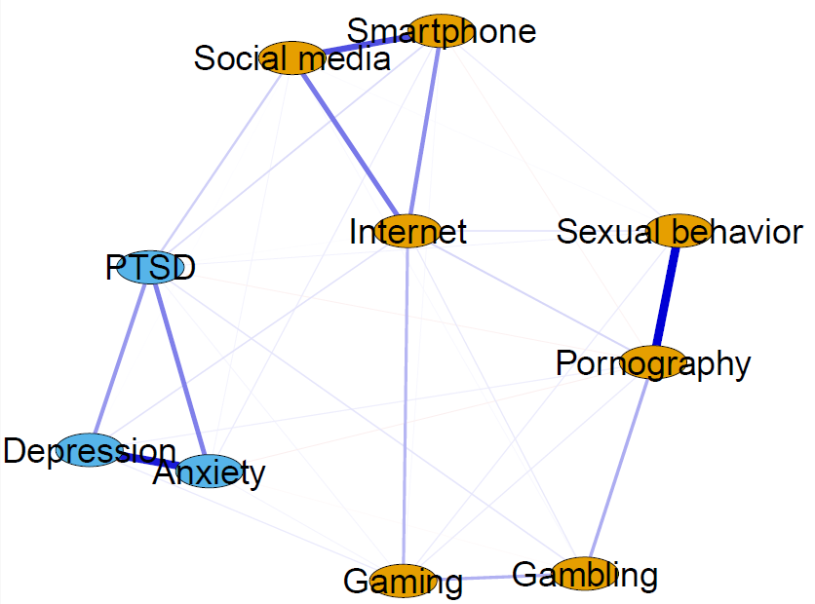

**Supplemental Table 4.** Cross-category edge strengths for *Model 2*: between problematic addictive behaviors and PTSD, anxiety, and depression scores

|  |  |  |  |
| --- | --- | --- | --- |
|  | *PTSD* | *Anxiety* | *Depression* |
| Gambling | 0.066 | -0.013 | 0.000 |
| Compulsive sexual behavior | 0.035 | 0.000 | 0.000 |
| Pornography | -0.034 | -0.040 | 0.043 |
| Internet | 0.008 | 0.000 | 0.071 |
| Electronic gaming | 0.028 | 0.029 | 0.052 |
| Smartphone | 0.090 | 0.049 | 0.000 |
| Social media | 0.121 | 0.030 | 0.006 |

**Supplemental Figure 3.** Networks of *Model 3A*: problematic substance use and other addictive behaviors

B. Cross-category edges, connecting substances and other behaviors

A. All edges

**Supplemental Table 5.** Cross-category edge strengths for *Model 3A*: between problematic substance use and other addictive behavior scores

|  |  |  |  |  |  |  |
| --- | --- | --- | --- | --- | --- | --- |
|  | *Tobacco* | *Alcohol* | *Cannabis* | *Prescription sedatives* | *Prescription stimulants* | *Prescription opioids* |
| Gambling | 0.080 | 0.140 | 0.008 | 0.038 | 0.135 | 0.120 |
| Compulsive sexual behavior | 0.016 | 0.101 | 0.043 | 0.014 | 0.000 | 0.000 |
| Pornography | 0.000 | 0.000 | 0.052 | 0.000 | 0.000 | 0.000 |
| Internet | 0.000 | 0.013 | 0.000 | 0.008 | 0.009 | 0.000 |
| Electronic gaming | 0.000 | 0.070 | 0.000 | 0.032 | 0.025 | 0.029 |
| Smartphone | 0.018 | 0.000 | 0.013 | 0.030 | 0.000 | 0.000 |
| Social media | 0.000 | 0.026 | 0.013 | 0.000 | 0.017 | 0.000 |

**Supplemental Table 6.** Cross-category edge strengths for *Model 3B*: between problematic substance use, other addictive behaviors, and PTSD, anxiety, and depression scores

|  |  |  |  |  |  |  |  |  |  |
| --- | --- | --- | --- | --- | --- | --- | --- | --- | --- |
|  | Tobacco | Alcohol | Cannabis | Prescription sedatives | Prescription stimulants | Prescription opioids | PTSD | Anxiety | depression |
| Gambling | 0.079 | 0.141 | 0.006 | 0.034 | 0.134 | 0.120 | 0.017 | 0.000 | 0.000 |
| Compulsive sexual behavior | 0.015 | 0.102 | 0.042 | 0.010 | 0.000 | 0.000 | 0.009 | 0.000 | 0.002 |
| Pornography | 0.000 | 0.000 | 0.053 | 0.000 | 0.000 | 0.000 | 0.000 | -0.019 | 0.003 |
| Internet | 0.000 | 0.010 | 0.000 | 0.000 | 0.000 | 0.000 | 0.007 | 0.000 | 0.074 |
| Electronic gaming | 0.000 | 0.069 | 0.000 | 0.008 | 0.020 | 0.024 | 0.029 | 0.018 | 0.053 |
| Smartphone | 0.011 | 0.000 | 0.004 | 0.000 | 0.000 | 0.000 | 0.092 | 0.049 | 0.000 |
| Social media | 0.000 | 0.023 | 0.002 | 0.000 | 0.000 | -0.009 | 0.120 | 0.027 | 0.011 |
| PTSD | 0.006 | 0.006 | 0.004 | 0.037 | 0.044 | 0.006 |  | | |
| Anxiety | 0.008 | 0.000 | 0.000 | 0.019 | 0.000 | 0.000 |
| Depression | 0.000 | 0.000 | 0.034 | 0.059 | 0.004 | 0.017 |