SUPPLEMENTARY FILE 2
Detailed analysis of the bulk element composition and physico–chemical properties.
In terms of chemical composition, slaty metamorphosed argillites that directly underlie Batagay RTS (Fig.SI 1) are enriched by Al₂O₃ (17.3%), Fe₂O₃ (9.0%), MgO (2.7%), MnO (1.5%) and TiO₂ (1.3%) in comparison with the sedimentary permafrost deposits. Argillites have comparable contents of CaO, K₂O, Na₂O and P₂O₅ and less SiO₂ (52.7%) than the overlying deposits (69.4%).
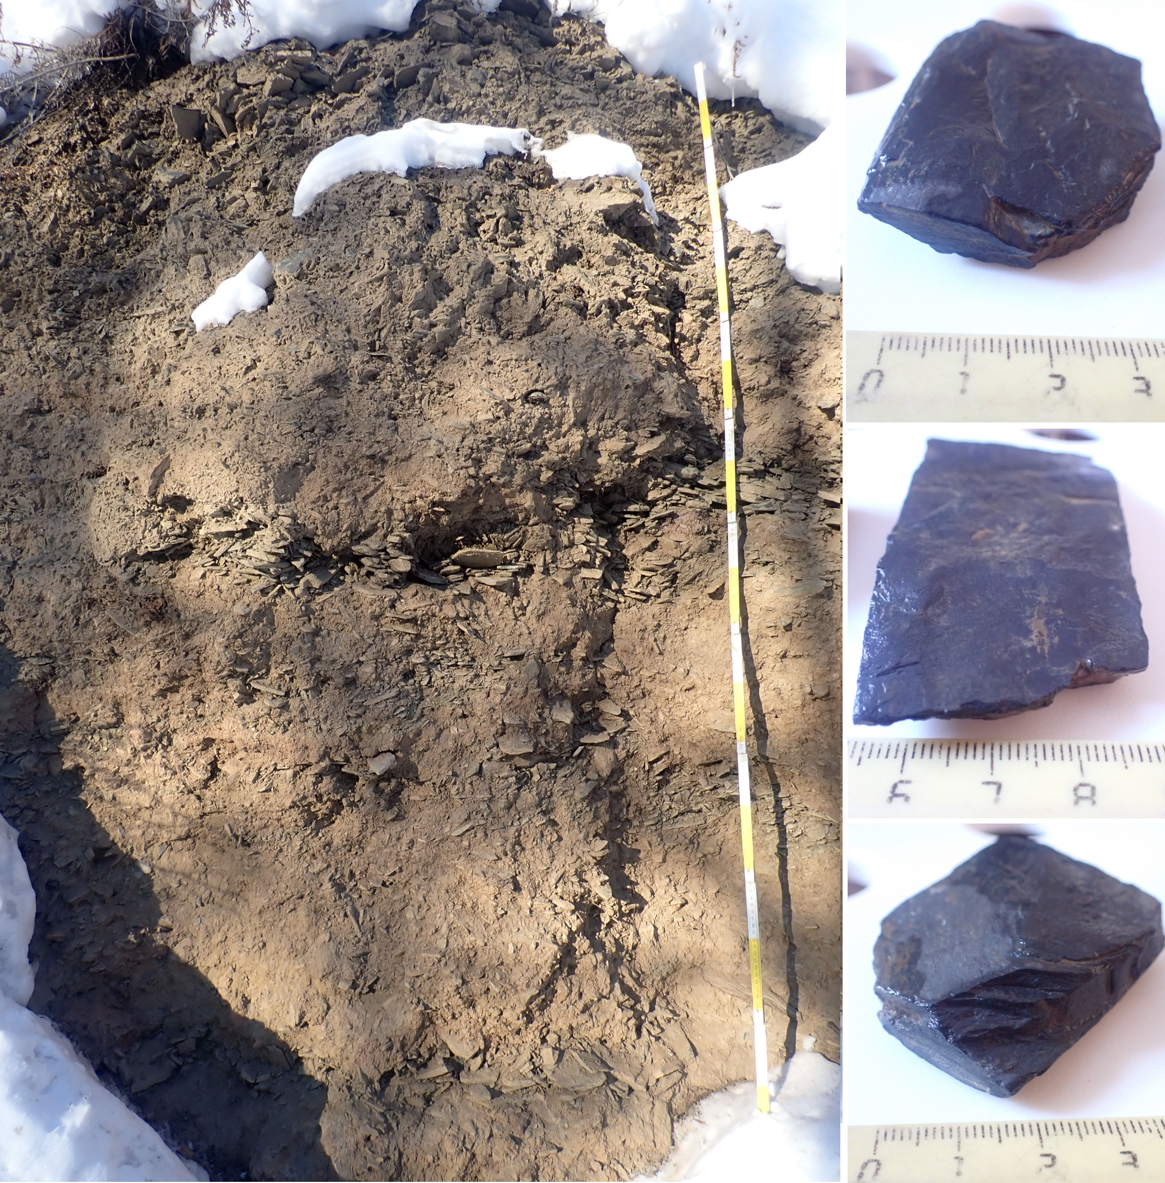
Fig. SI 1. Talus slope material (left) and cleaned metamorphic schistose argillites (right) at the col crest on the south-east slope of the Khatyngnakh Mountain, near Batagay RTS (red cross on the Fig. 1b). The measuring line has coloured 10-cm intervals.

Elemental associations.
The chemical composition of the Batagay RTS deposits suggests 3 major elemental associations in the correlogram field ordered by hierarchical clustering (Fig. SI 2). They are centered around (1) plagioclase-related CaO and MgO, closely linked to Fe and Ti oxides, water pH and Pb, and weak relation to P₂O₅, MnO, LOI and S; (2) K-feldspar-related K₂O with Ga and V, most other metals, and Fe-Ti-Mn oxides; and (3) an organic matter cluster, including C, N, C:N ratio and LOI, with associated P₂O₅ and S.
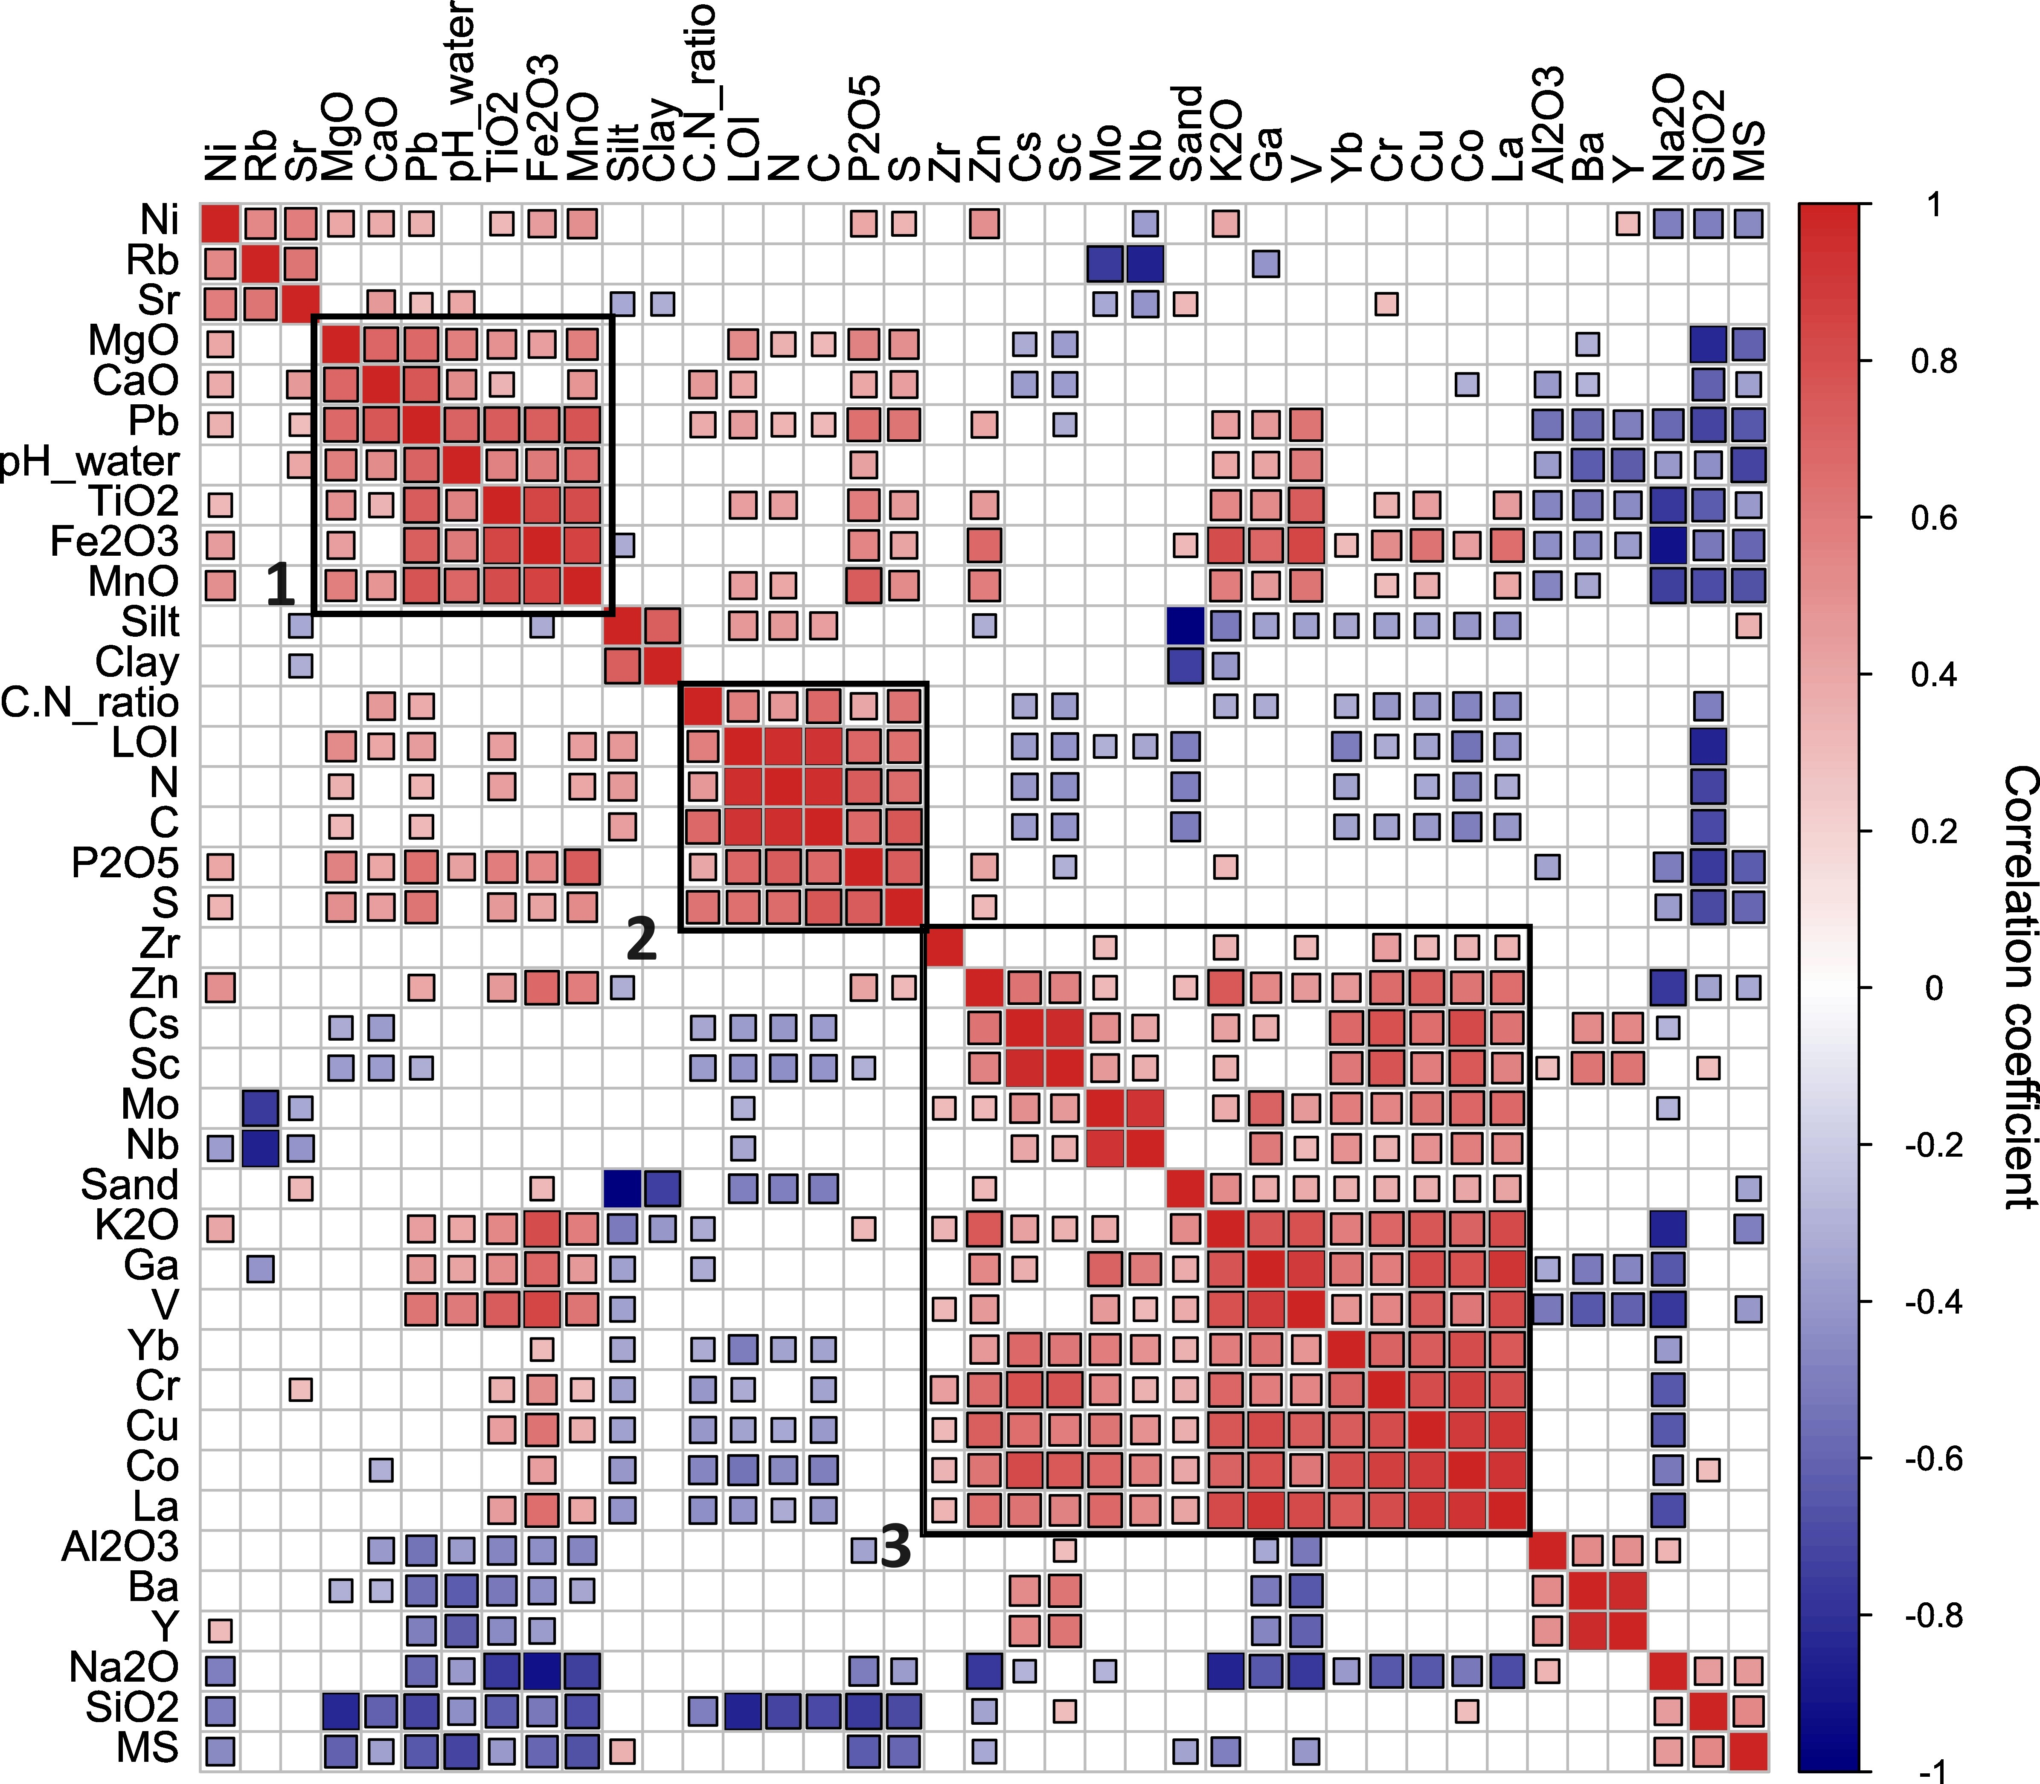
Fig. SI 2. Correlogram of physico–chemical properties of the Batagay RTS deposits, ordered by hierarchical clustering; only correlations with p < 0.01 are retained.
Notably, SiO₂ and Na₂O do not cluster within any major elemental association and correlate negatively to the K-Fe-Ti group (Na₂O) and CaO-Pb-LOI group (SiO₂), with positive correlation to magnetic susceptibility only. Al₂O₃ associates with Ba and Y, and all show negative correlation with pH, i.e., conforms to their abundance in soil-like units.
Plagioclase- and orthoclase-associated major elements (CaO/K₂O and NaO/K₂O, respectively) show insignificant to negative linear correlations. The silt and clay content is negatively correlated with SiO₂, Fe₂O₃ and K₂O, whereas the sand content positively correlates with these major oxides (not shown). Fe₂O₃ shows a strong positive correlation with MnO, TiO₂ and K₂O, r = 0.85, 0.84 and 0.81, respectively, with p-values below 0.001.
La/Sc and Zr/Sc ratios, shown on Fig. SI 3a, are widely used in assessing sediment provenance, because of the relatively low mobility of trace elements during sedimentary processes, as well as La and Zr enrichment in felsic rocks and Sc enrichment in mafic igneous rocks (Cai et al., 2008). We infer sediment provenance from felsic material, which is consistent with the presented data and previous publications (Murton et al., 2023), although the ratios plot slightly more towards mafic igneous rocks for modern and buried soils. Zr enrichment in unit 4 samples implies increased sedimentary sorting (Tugulan et al., 2016).
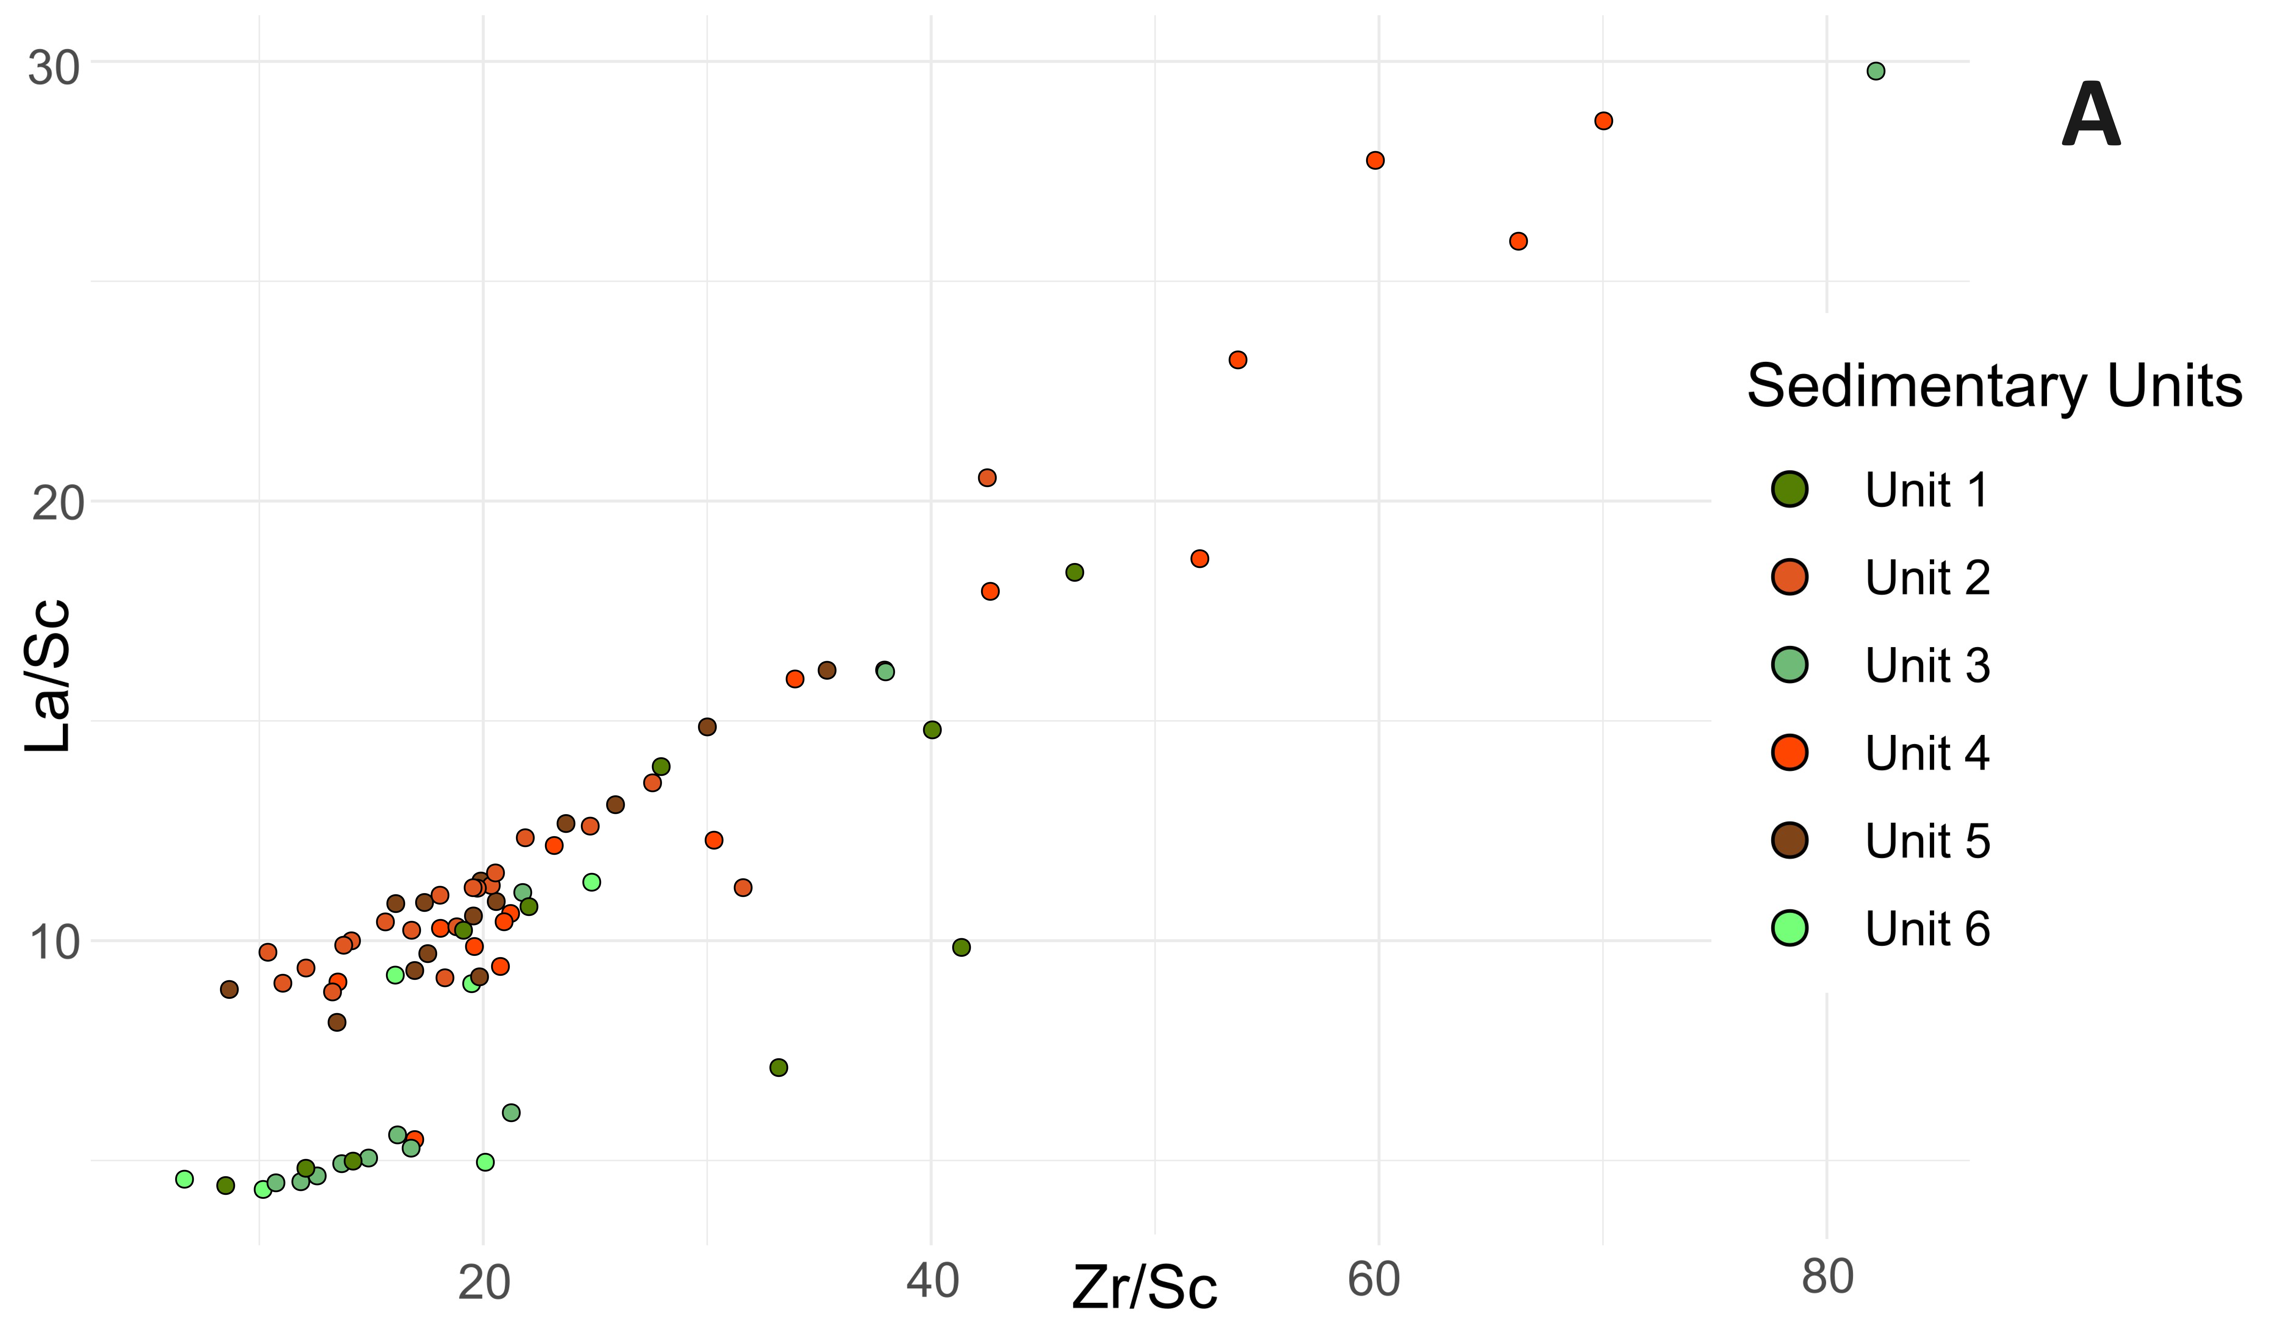
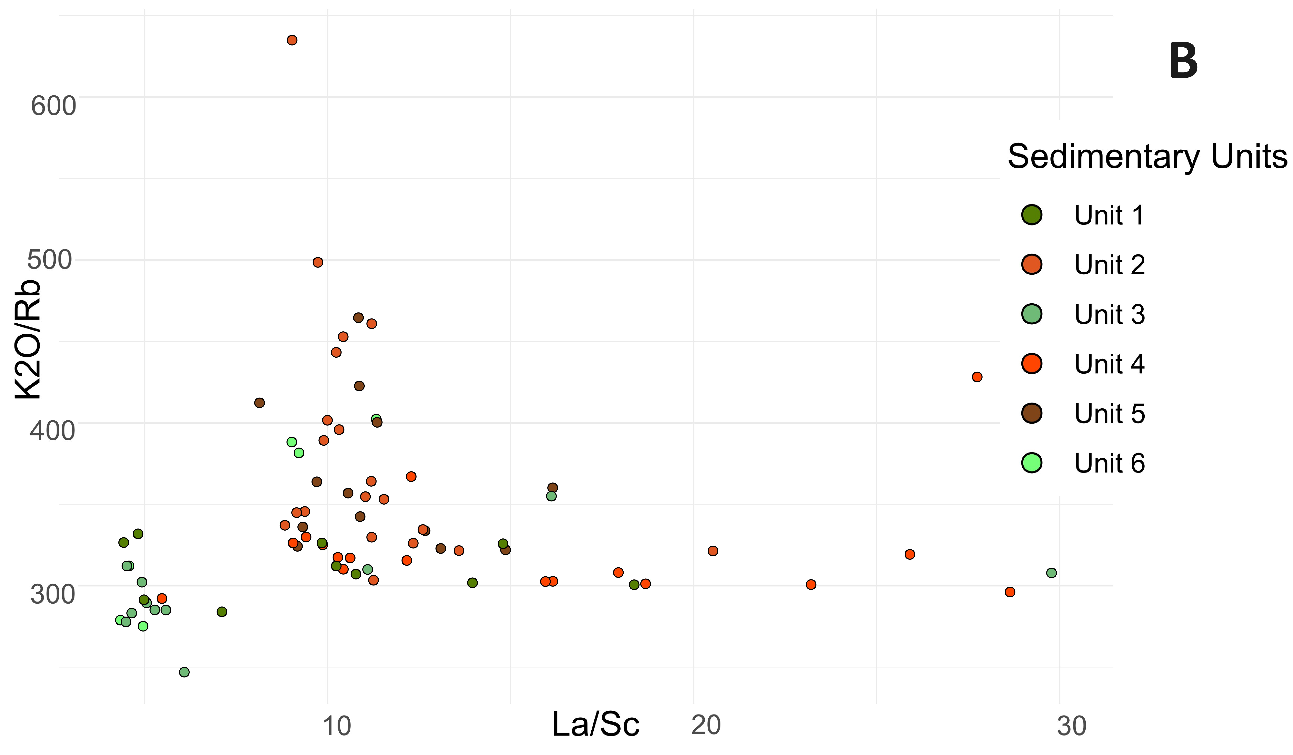
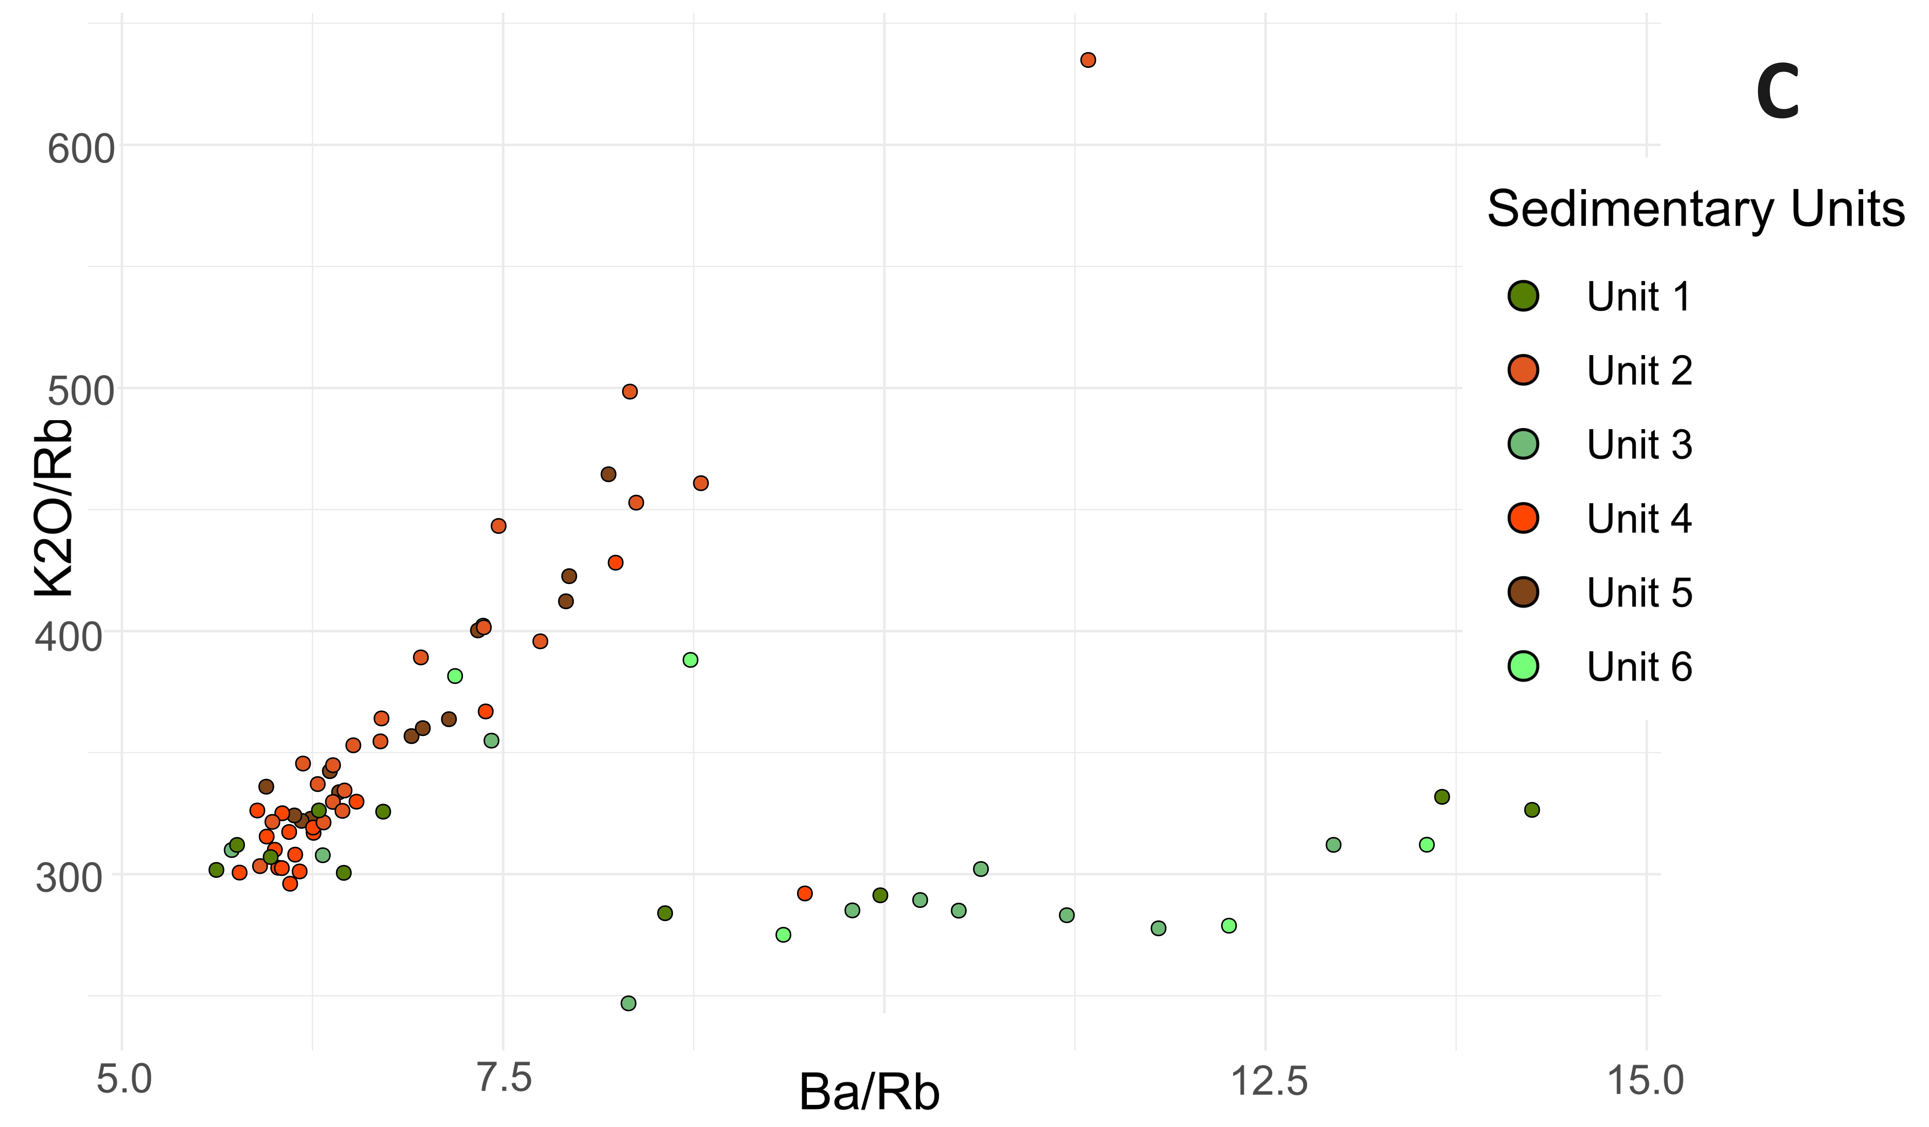
Fig. SI 3. Elemental ratios in the six sedimentary units of the Batagay megaslump: (a) Sc-normalized Zr/La; (b) La/Sc vs K₂O/Rb; (c) Rb-normalized Ba/K₂O.
Along the same lines, the K₂O/Rb ratio plotted against La/Sc ratio (Fig. SI 3b), indicates decreasing K/Rb due to progressive biochemical weathering, when Rb bonds more strongly than K in silicate minerals (Kabata-Pendias and Mukherjee, 2007). The Rb-normalized Ba/K₂O ratio (Fig. SI 3c) reflects the difference in geochemical behavior of two important nutrient-like elements, considering K substitution for Ba during pedogenesis, and relatively higher rates of Ba accumulation in soils during weathering of K-feldspars, since Ba in soils has relatively low mobility.
Principal Component Analysis.
The first four principal components (dimensions) obtained by the Cattell-Nelson-Gorsuch test explain slightly over 80% of variance within the physico–chemical properties of Batagay RTS deposits (Fig. SI 4). Principal component 1 is dominated by K₂O and associates, and relates to the sand content, which in turn may imply the intensity of cryogenic weathering and soil development processes as major differentiating factors; depletion in Na₂O is also notable. Principal component 2 is related to organic matter accumulation (LOI, C, N, C:N ratio) and associated contributors (P₂O₅, S), and CaO and MgO. Principal component 3 yields contributions of substitute elements (Rb, Sr) and sorption-dependent elements (Ni, Y, Ba). Principal component 4 is directly linked to the fine particle content, in association with Mo and Nb.
The lower and upper sand from units 2 and 5 occupy the central and lower left sectors of the PCA biplot, supporting their relation to principal component 1 and important coarse fraction (sand) contribution. Organic-rich ice-complex deposits of unit 4 plot in the upper sector, corresponding to principal component 2, which is controlled by the contribution from organic matter. Modern soils and paleosols occupy the central lower left section of this graph, but show important scatter across the biplot with wider elliptic scatter contours, reflecting both their higher content of fine particles (which have an important role for sorption processes) and their internal heterogeneity. 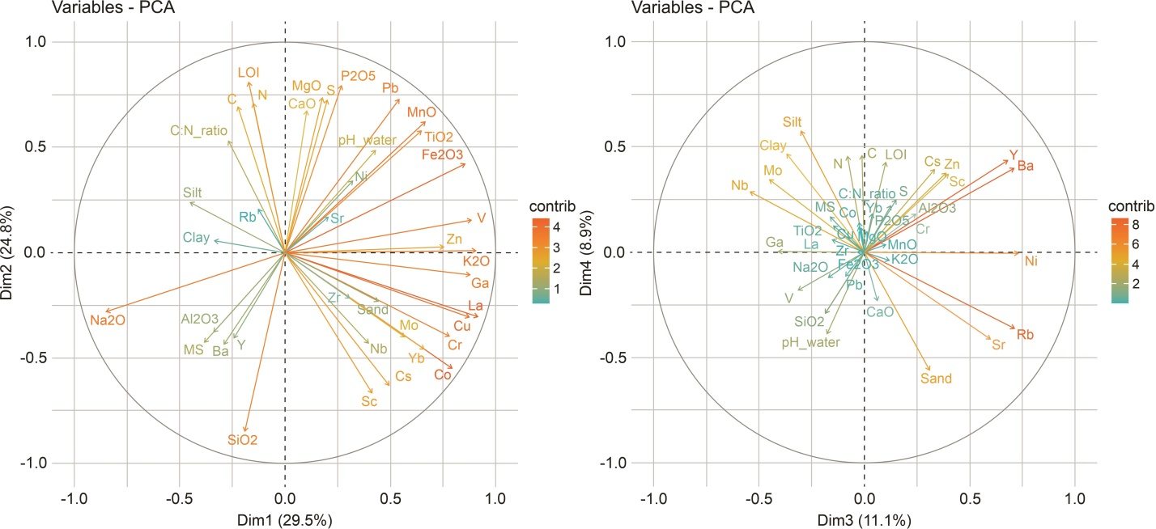
Fig. SI 4. Contribution-graded principal components from PCA of the Batagay RTS dataset: principal components 1 and 2 (left); principal components 3 and 4 (right).

References
Cai, G., Guo, F., Liu, X., Sui, S., Li, C., Zhao, L., 2008. Geochemistry of Neogene sedimentary rocks from the Jiyang basin, North China Block: The roles of grain size and clay minerals. Geochemical Journal 42, 381–402. https://doi.org/10.2343/geochemj.42.381
Kabata-Pendias, A., Mukherjee, A.B., 2007. Trace elements from soil to human. Springer-Verlag Berlin Heidelberg.
Murton J., Opel T., Wetterich S. et al., 2023. Batagay megaslump: A review of the permafrost deposits, Quaternary environmental history, and recent development. Permafrost and Periglacial Processes 34, 399-416. https://doi.org/10.1002/ppp.2194
Tugulan, L.C., Duliu, U.G., Bojar, A.-V., Dumitras, D., Zinicovskaia, I., Culicov, O.A., Frontasyeva, M.V., 2016. On the geochemistry of the Late Quaternary loess deposits of Dobrogea (Romania). Quaternary International 399, 100-110. https://doi.org/10.1016/j.quaint.2015.06.062

