**Supplements materials**

**Possibilities and limitations of new radiocarbon dating for the Maucallacta site, dep. Arequipa, Peru**

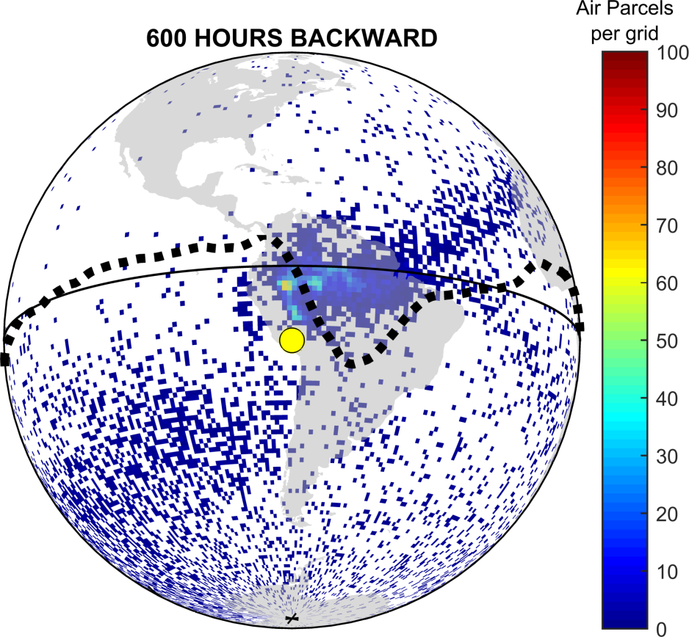

Figure S.1. HYSPLIT backward trajectory analysis results for Maucallacta (yellow dot). Air parcel density arriving to Maucallacta settlements. The colorbar scale indicates the total number of air parcels located on each pixel grid (1º x 1º) in: hour -600 (top to bottom panels) during the study period (ONDJFM, 1949 to 2019). The dashed black line shows the mean temporal shape of the TLPB, where confluence air parcels from the NH and SH (Hua et al., 2021).

Table S.1. List of samples from the area of Maucallacta.

|  |  |  |
| --- | --- | --- |
| Excavation unit | Description | BP |
| Basural 1  capas 2,3,6  Basural 2  capas 2,4-6 | This group includes dating of carbon samples, coming from organic material burned during ceremonies. Some carbon fragments may originate from much older objects, resulting in dating such as that observed in layer 3 of Basural 1. The numbers given indicate the specific layers in stratigraphic order | Basural 1  2) 125 ±65(Gd-15997)  3) 930 ±70(Gd-15007)  6) 265 ±45(Gd-12936)  Basural 2  2) 555 ±30 (GdC-671)  4) 585 ±45 (GdC-667)  5) 545 ±60(GdS-1345)  6) 440 ±40(GdS-1346 |
| Basural 2  capas 1-6 | Samples from camelid bone fragments selected from layers 1-6 of Basural 2. The numbers given indicate the specific layers in stratigraphic order. | 1.1) 406 ±19 (UGAMS-58652)  1.2) 392 ±17 (UGAMS-58653)  2.1) 441 ±16 (UGAMS-58654)  3.1) 564 ±18 (UGAMS-58655)  4.1) 456 ±17 (UGAMS-58656)  5.1) 532 ±16 (UGAMS-58657)  6.1) 464 ±18 (UGAMS-58658) |
| Platform 1  ushnu  floors 1,2 | Charcoal samples from layers associated with Platform floors. Sample GdA- 2666 was taken from borehole A, from the upper side of the platform level (floor) 1, on which it the ushnu was constructed.  GdA- 2667 is a sample from survey A, taken from the original floor layer (floor 2) of the platform. Gd-12926 is a sample from borehole B, taken next to the wall west of ushnu, also associated with floor 2. | 1) 415 ±30 (GdA-2666)  2) 555 ±30 (GdA-2667)  2.1) 410 ±45 (Gd-12926) |
| Chullpa 1 | Selected fragments of long bones belonging to 3 individuals were dated. | 1) 425 ±30 (GdA-2663)  2) 440 ±30 (GdA-2664)  3) 380 ±30 (GdA-2665) |
| Kallanka  floors 1-3 | Charcoal samples selected for dating come three youngest stratigraphic levels (floors) of the building. In total more than 20 levels were recorded. | 1) 240 ±70 (GdS-1356)  2) 525 ±40 (GdS-1355)  2.1) 520 ±30(GdS- 2694)  3) 560 ±30 (GdC- 673) |
| Plaza 7  Muestras de los  recintos D y F | House D: Two charcoal samples. GdC- 669 was associated with Chuquibamba ceramics found in layer 3.  House F: This structure probably had a function of a warehouse and/or workshop, with many half copper products present on its surface. Two charcoal samples were taken from layers 2 and 3, respectively. | House D:  1) 510 ±40 (GdC-669)  2) 380 ±25 (GdC-677)  House F:  2) 285 ±40 (GdS 1348)  3) 290 ±40 (GdS 1347) |
| Mausoleo | Gd-12928 is a fragment of wood found on the surface of the altar. Gd-12927 is a charcoal sample collected from a vessel found inside of the altar beneath a hole for liquid offerings. Charcoal sample Gd-19002 was taken from the floor layer of the vestibule and GdC-675 was comes from a rectangular hearth in front of the altar, where pieces of charcoal have been found. coming most likely from burnt offerings. | 1) 475 ±40 (Gd-12928)  2) 380 ±45 (Gd-12927)  3) 400 ±60 (Gd-19002)  4) 360 ±25 (GdC-675) |

# OxCal Modelling Results

### Basural I, version 2

OxCal script for Basural I site,

Options()

{

Resolution=1;

};

Plot()

{

Curve("IntCal20","intcal20.14c");

Curve("SHCal20","shcal20.14c");

// SHCal20/IntCal curve mixing 25/75% ±11% - normal distribution

// Curve proportion model calculated by Santiago Ancapichun

// The test of normality of the data (Shapiro-Wilk) does not allow us to reject the hypothesis of normality of the data

// We therefore assume that the SHCal20/IntCal20 share data are described by a normal distribution

// with an expected value of 75% with a standard deviation of 11%.

// The share of curves calculated from the analysis of atmospheric data for the period 1945-2019

// for Maucallacta geographical coordinates

//

Mix_Curve("Mixed","IntCal20","SHCal20",75,11);

// version 2

//

Sequence("Basural I")

{

Boundary("Start", R_Date("Gd-19007_Capa_3",930,70));

R_Date("Gd-12936_Capa_6",265,45);

R_Date("Gd-15997_Capa_2",125,65);

Boundary("End", C_Date("Limit for the youngest date",1600,5));

};

Axis(1000,2000);

};

Table S.2. Results of OxCal modelling for Basural I site.

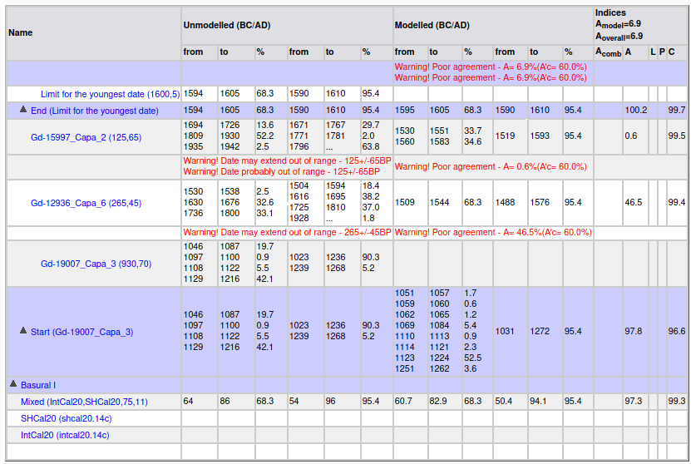

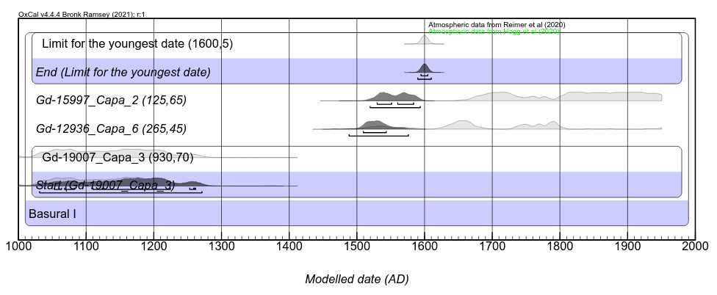Fig. S.2. Results of OxCal modelling for Basural I site.

### Basural II, version 2

OxCal script for Basural II site,

Options()

{

Resolution=1;

};

Plot()

{

Curve("IntCal20","intcal20.14c");

Curve("SHCal20","shcal20.14c");

// SHCal20/IntCal curve mixing 25/75% ±11% - normal distribution

// Curve proportion model calculated by Santiago Ancapichun

// The test of normality of the data (Shapiro-Wilk) does not allow us to reject the hypothesis of normality of the data

// We therefore assume that the SHCal20/IntCal20 share data are described by a normal distribution

// with an expected value of 75% with a standard deviation of 11%.

// The share of curves calculated from the analysis of atmospheric data for the period 1945-2019

// for Maucallact geographical coordinates

//

Mix_Curve("Mixed","IntCal20","SHCal20",75,11);

// version 2

//

Sequence("Basural II")

{

Boundary("Start");

Phase("Capa 6")

{

R_Date("GdS-1346_Capa_6",440,40);

R_Date("sample_6.1",464,18);

};

Phase("Capa 5")

{

R_Date("GdS-1345_Capa_5",545,60);

R_Date("sample_5.1",532,16);

};

Phase("Capa 4")

{

R_Date("Gd-667_Capa_4",585,45);

R_Date("sample_4.1",456,17);

};

// Phase("Capa 3") mixed layer?

//{

// R_Date("sample_3.1",564,18);

// };

Phase("Capa 2")

{

R_Date("Gd-671_Capa_2",555,30);

R_Date("sample_2.1",441,16);

};

Phase("Capa 1")

{

R_Date("Sample 1.1",406,19);

R_Date("Sample 1.2",392,17);

};

Boundary("End", C_Date("granica",1600,5));

};

Axis(1100,1250);

};

Table S.3. Results of OxCal modelling for Basural II site.

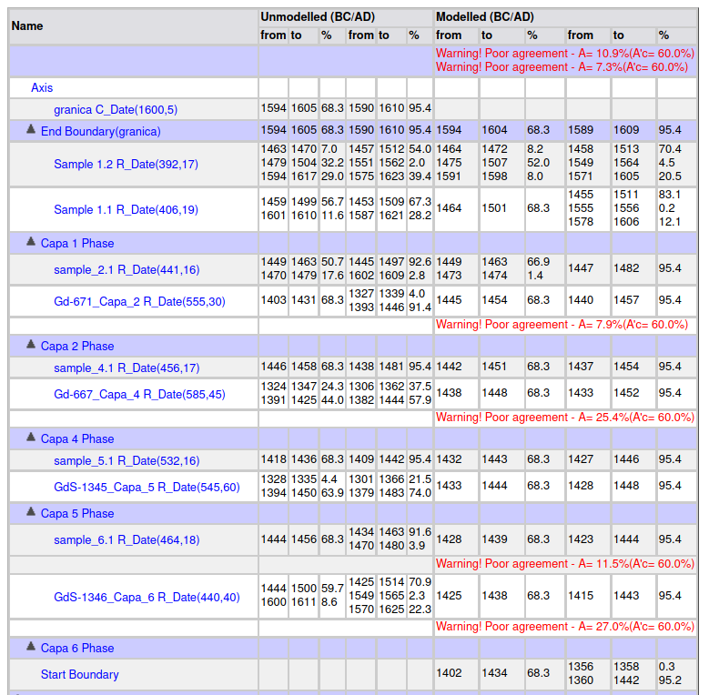

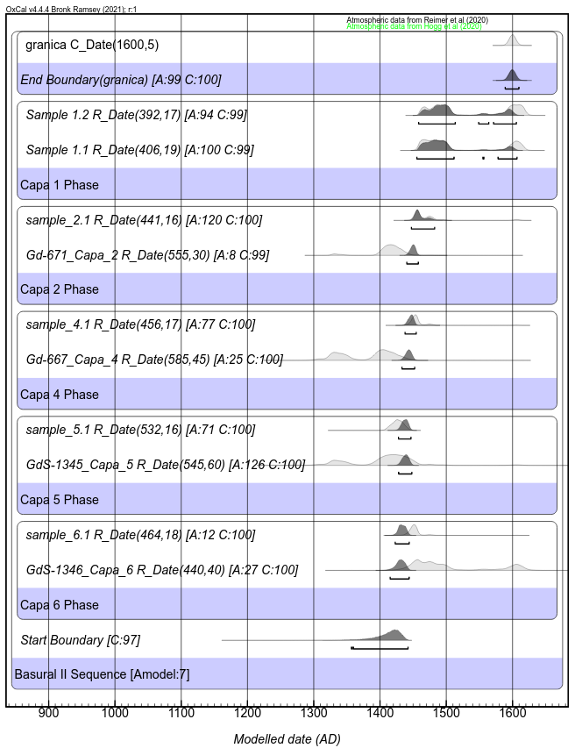

Fig. S.3. Results of OxCal modelling for Basural II site.

### Platform 1, version 2

OxCal script for Platform 1 site,

Options()

{

Resolution=1;

};

Plot()

{

Curve("IntCal20","intcal20.14c");

Curve("SHCal20","shcal20.14c");

// SHCal20/IntCal curve mixing 25/75% ±11% - normal distribution

// Curve proportion model calculated by Santiago Ancapichun

// The test of normality of the data (Shapiro-Wilk) does not allow us to reject the hypothesis of normality of the data

// We therefore assume that the SHCal20/IntCal20 share data are described by a normal distribution

// with an expected value of 75% with a standard deviation of 11%.

// The share of curves calculated from the analysis of atmospheric data for the period 1945-2019

// for Maucallact geographical coordinates

//

Mix_Curve("Mixed","IntCal20","SHCal20",75,11);

// version 3

Sequence("Platform 1 ushnu")

{

Boundary("start");

//Platform ushnu:

Phase("Floor 2")

{

R_Date("GdA-2667",555,30);

//la muestra del sondeo A, tomada de capa que era probablemente del primer nivel del piso original de la plataforma.

R_Date("Gd–12926",410,45);

//la muestra del sondeo B, tomada directamente al lado del muro del lado oeste del ushnu.

};

R_Date("GdA-2666",415,30);

//la muestra del sondeo A, tomada del lado superior del nivel de la plataforma, sobre ello ha sido construido el ushnu.

Boundary("end", C_Date("location of the city", 1567,1));

};

};

Table S.4. Results of OxCal modelling for Platform 1 site.

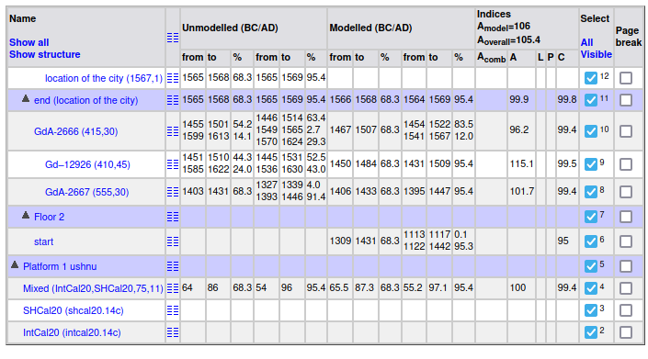

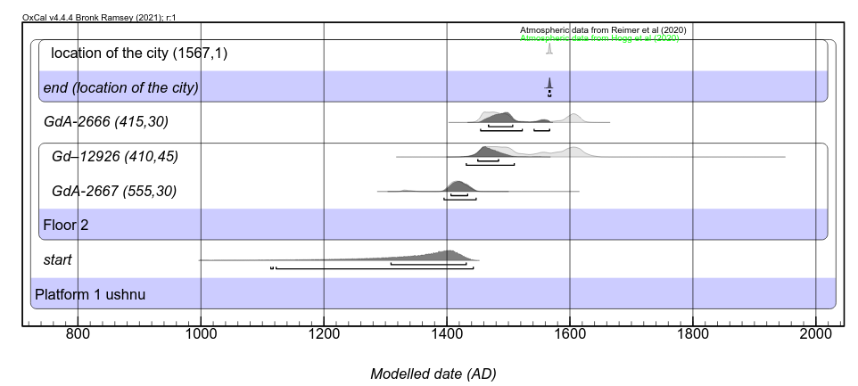

Fig. S.4. Results of OxCal modelling for Platform 1 site.

### Chullpa, version 2

OxCal script for Chullpa site,

Options()

{

Resolution=1;

};

Plot()

{

Curve("IntCal20","intcal20.14c");

Curve("SHCal20","shcal20.14c");

// SHCal20/IntCal curve mixing 25/75% ±11% - normal distribution

// Curve proportion model calculated by Santiago Ancapichun

// The test of normality of the data (Shapiro-Wilk) does not allow us to reject the hypothesis of normality of the data

// We therefore assume that the SHCal20/IntCal20 share data are described by a normal distribution

// with an expected value of 75% with a standard deviation of 11%.

// The share of curves calculated from the analysis of atmospheric data for the period 1945-2019

// for Maucallact geographical coordinates

//

Mix_Curve("Mixed","IntCal20","SHCal20",75,11);

// version 2

Sequence("Chullpa")

{

Boundary("start");

R_Date("GdA-2664", 440, 30);

R_Date("Gd-2663",425,30);

R_Date("GdA-2665", 380, 30);

Boundary("end", C_Date("granica", 1600, 5));

};

};

Table S.5. Results of OxCal modelling for Chullpa site.

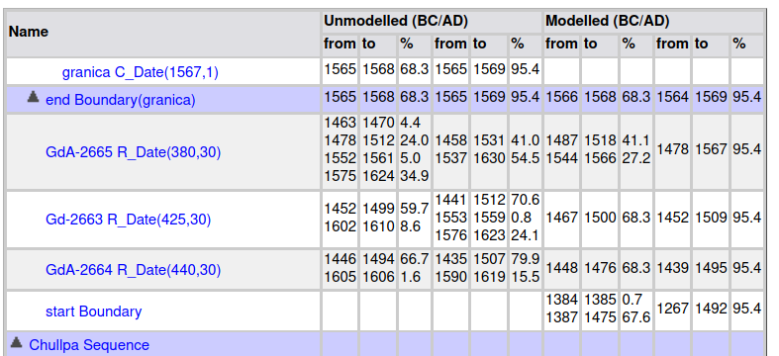

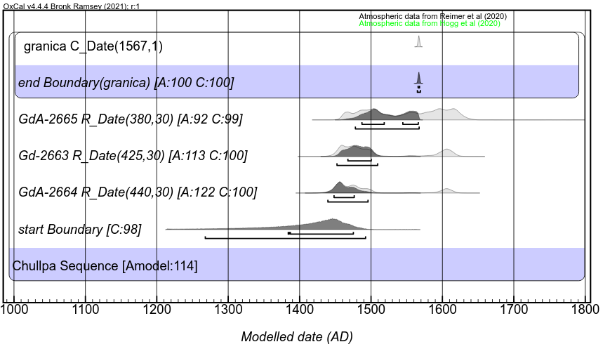

Fig. S.5. Results of OxCal modelling for Chullpa site.

### Kallanka, version 2

OxCal script for Kallanka site,

Options()

{

Resolution=1;

};

Plot()

{

Curve("IntCal20","intcal20.14c");

Curve("SHCal20","shcal20.14c");

// SHCal20/IntCal curve mixing 25/75% ±11% - normal distribution

// Curve proportion model calculated by Santiago Ancapichun

// The test of normality of the data (Shapiro-Wilk) does not allow us to reject the hypothesis of normality of the data

// We therefore assume that the SHCal20/IntCal20 share data are described by a normal distribution

// with an expected value of 75% with a standard deviation of 11%.

// The share of curves calculated from the analysis of atmospheric data for the period 1945-2019

// for Maucallact geographical coordinates

//

Mix_Curve("Mixed","IntCal20","SHCal20",75,11);

// version 2

Sequence("Kallanka")

{

Boundary("start");

R_Date("GdC- 673",560, 30);

Phase("2")

{

R_Date("GdS-2694",520, 30);

R_Date("GdS-1355",525, 40);

};

R_Date("GdS-1356",240, 70);

Boundary("end", C_Date("granica", 1600, 5));

};

};

Table S.6. Results of OxCal modelling for Kallanka site.

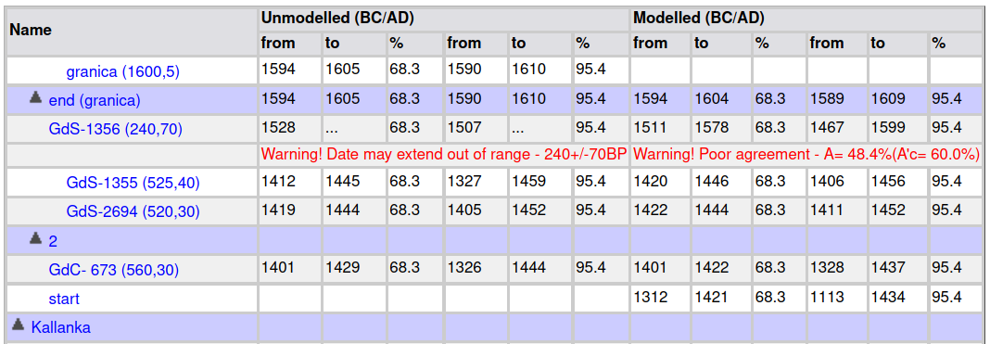

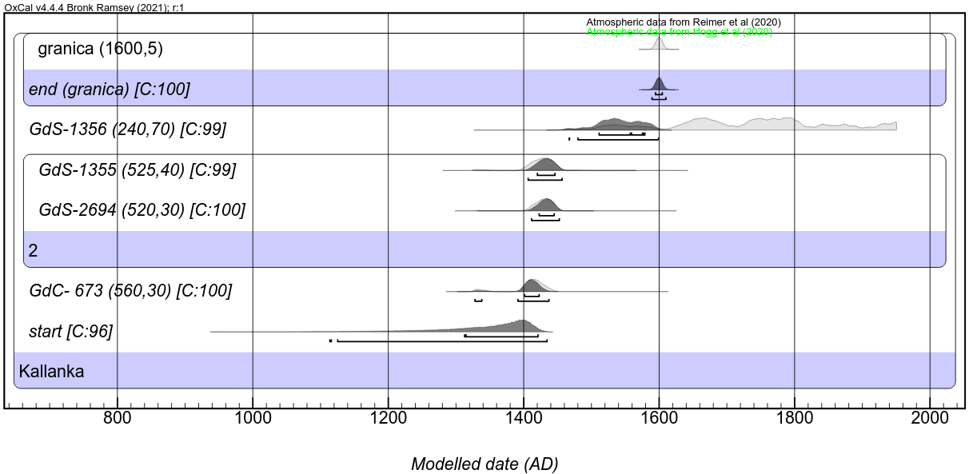

Fig. S.6. Results of OxCal modelling for Kallanka site.

### Plaza 7, version 2

OxCal script for Plaza 7 site,

Options()

{

Resolution=1;

};

Plot()

{

Curve("IntCal20","intcal20.14c");

Curve("SHCal20","shcal20.14c");

// SHCal20/IntCal curve mixing 25/75% ±11% - normal distribution

// Curve proportion model calculated by Santiago Ancapichun

// The test of normality of the data (Shapiro-Wilk) does not allow us to reject the hypothesis of normality of the data

// We therefore assume that the SHCal20/IntCal20 share data are described by a normal distribution

// with an expected value of 75% with a standard deviation of 11%.

// The share of curves calculated from the analysis of atmospheric data for the period 1945-2019

// for Maucallact geographical coordinates

//

Mix_Curve("Mixed","IntCal20","SHCal20",75,11);

// version 2

Phase("Plaza 7")

{

Sequence("Plaza 7 site D")

{

Boundary("Plaza 7 site D - start");

R_Date("GdC-669", 510, 40);

R_Date("GdC-677", 380, 25);

Span("Plaza 7 site D interval");

Boundary("Plaza 7 site D - end", C_Date("granica", 1600,5));

};

Sequence("Plaza 7 site F")

{

Boundary("Plaza 7 site F - start");

R_Date("GdS-1347, Capa 3",290 ,40);

R_Date("GdS-1348, Capa 2",285, 40);

Boundary("Plaza 7 site F -end",C_Date("granica", 1600,5));

};

};

};

Table S.7. Results of OxCal modelling for Plaza 7 site.

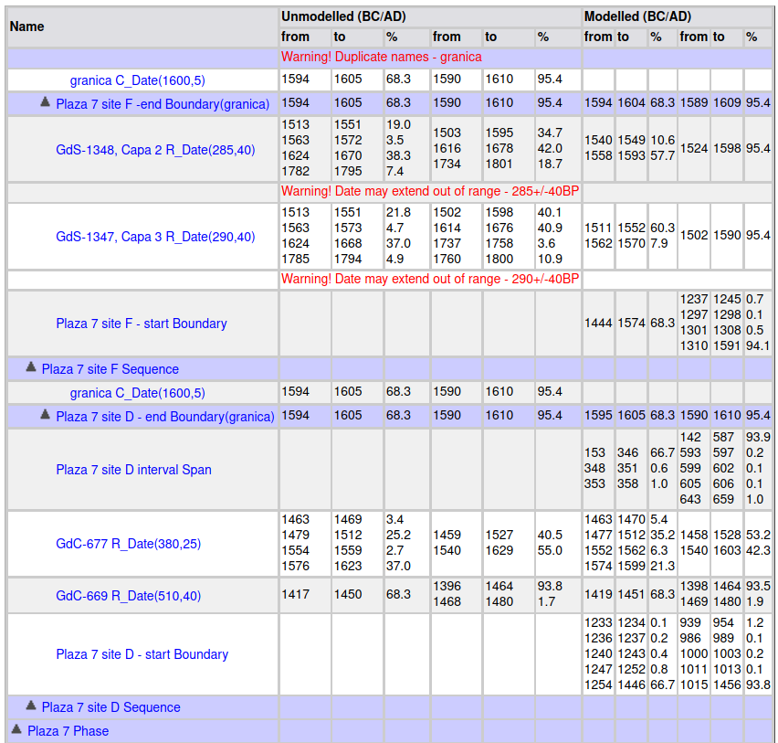

Fig. S.7. Results of OxCal modelling for Plaza 7 site.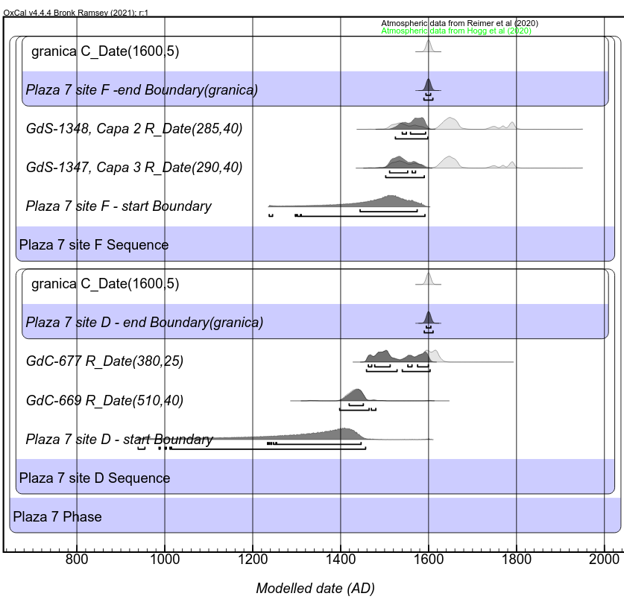

### Mausoleo, version 2

OxCal script for Mausoleo site,

Options()

{

Resolution=1;

};

Plot()

{

Curve("IntCal20","intcal20.14c");

Curve("SHCal20","shcal20.14c");

// SHCal20/IntCal curve mixing 25/75% ±11% - normal distribution

// Curve proportion model calculated by Santiago Ancapichun

// The test of normality of the data (Shapiro-Wilk) does not allow us to reject the hypothesis of normality of the data

// We therefore assume that the SHCal20/IntCal20 share data are described by a normal distribution

// with an expected value of 75% with a standard deviation of 11%.

// The share of curves calculated from the analysis of atmospheric data for the period 1945-2019

// for Maucallact geographical coordinates

//

Mix_Curve("Mixed","IntCal20","SHCal20",75,11);

// version 2

Phase("Mausoleo 7")

{

Sequence("Sequence 2")

{

Boundary("Phase 2 - start");

Phase("Phase 2.1")

{

R_Date("Gd-12928",475, 40);

R_Date("Gd-19002",400, 60);

R_Date("Gd-12927",380, 45);

};

R_Date("GdC-675",360, 25);

Boundary("Phase 2 - stop", C_Date("granica", 1600,5));

};

};

};

Table S.8. Results of OxCal modelling for Mausoleo site.

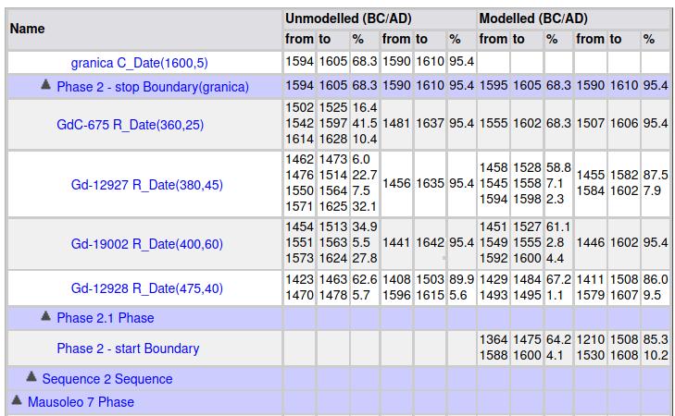

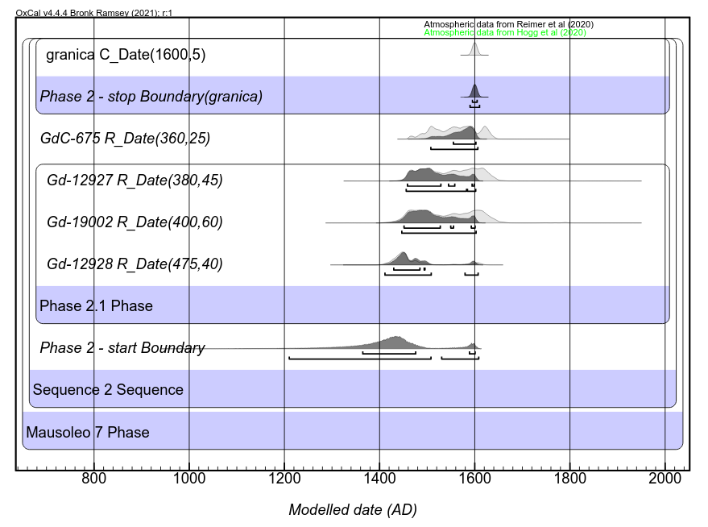

Fig. S.8. Results of OxCal modelling for Mausoleo site.