Supplementary Online Material

Borsko jezero
Figure S1 – Borsko jezero (photo A. Kapuran)
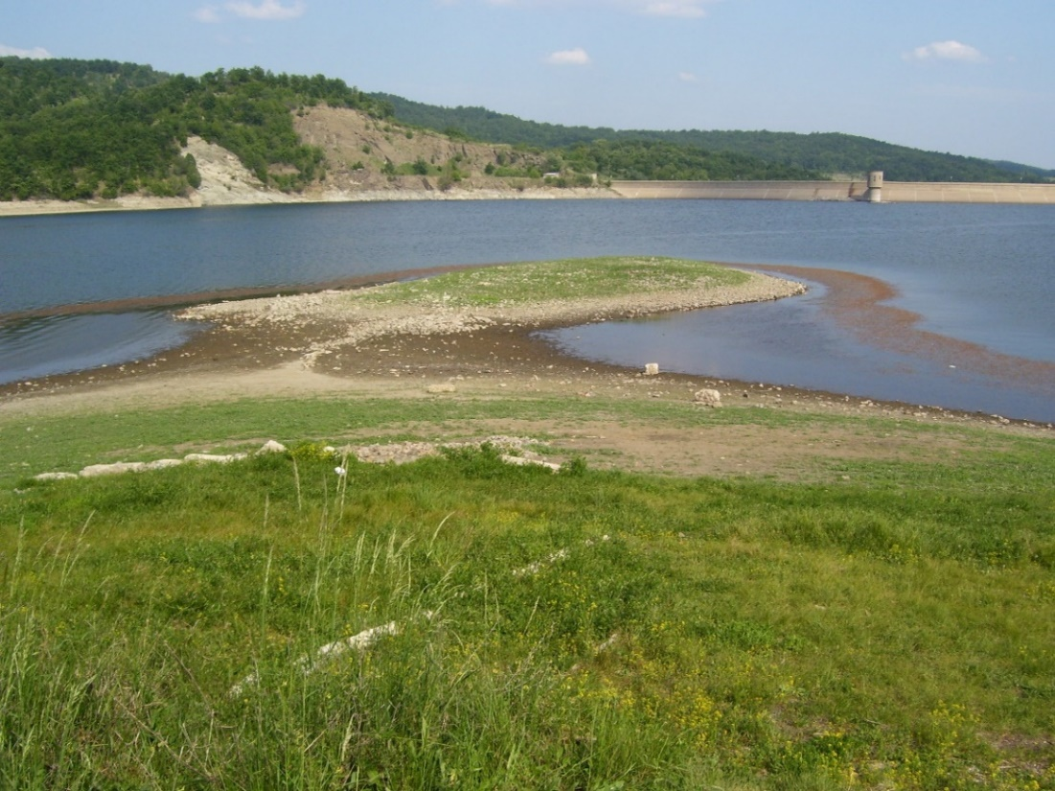
Figure S2 – Borsko jezero necropolis (Kapuran et al. 2011)
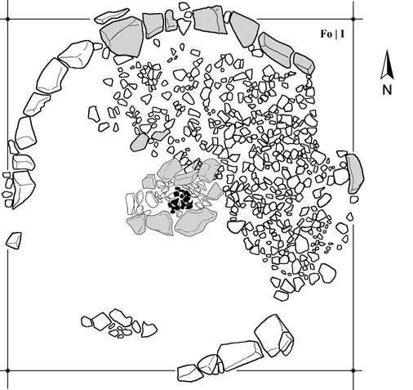

Figure S3 – Borsko jezero, graves 12, 17,18 (drawings: A. Kapuran, without scale)

Figure S4 – Borsko jezero, grave 2/2002 with grave goods (drawings: A Kapuran, without scale)

Kriveljski kamen
Figure S5 – Kriveljski kamen, graves 1, 2, 3 ,4

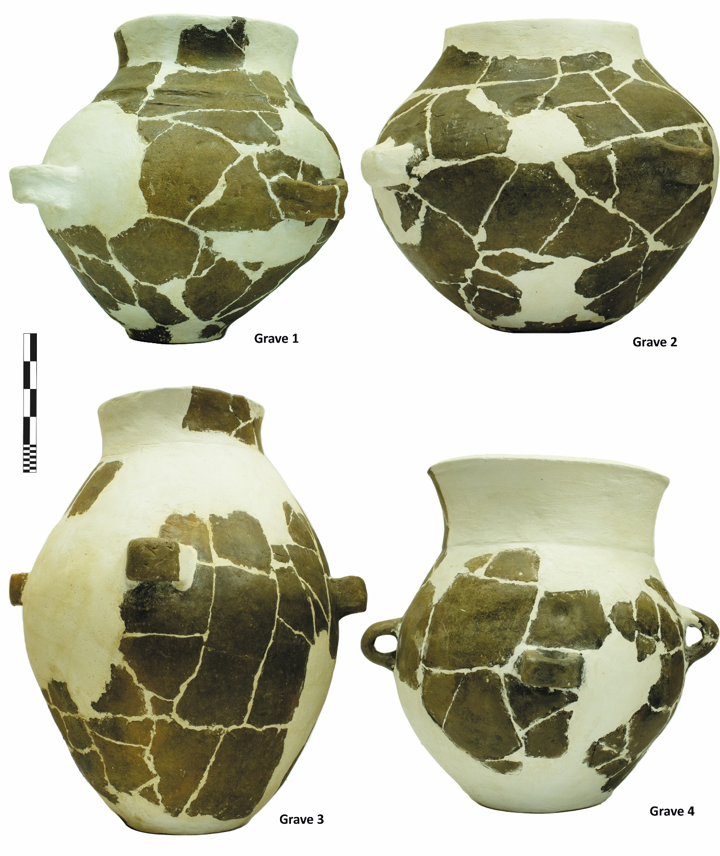

Figure S6 – Kriveljski kamen, grave 3 in situ (photo A. Kapuran)
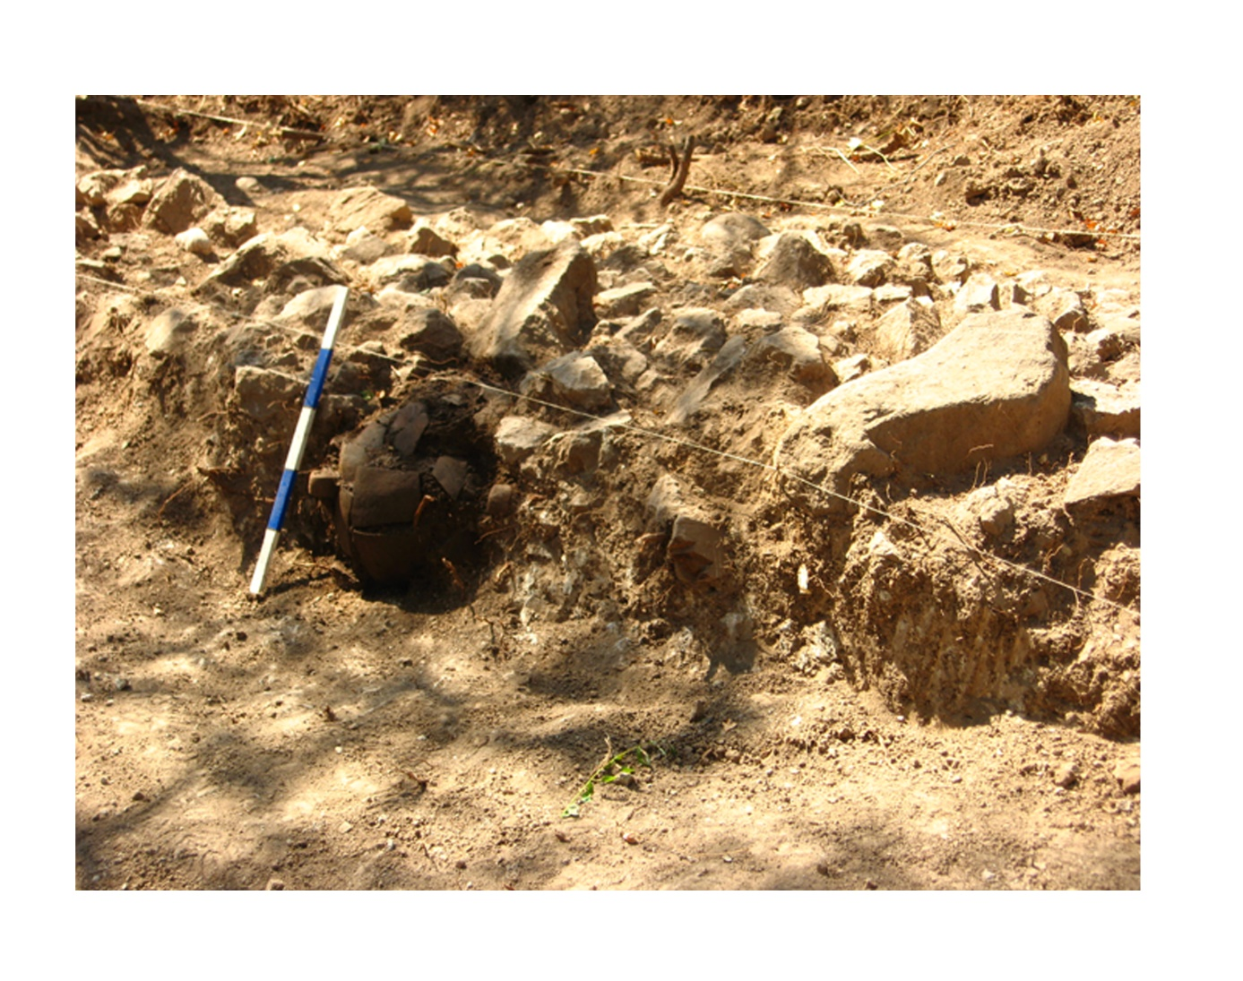

Šoka Lu Patran
Figure S7 – Šoka Lu Patran, graves 1 and 2 (drawings: A. Kapuran)

Magura
Figure S8 – Magura, grave 59 (Lazić 1994)

Figure S9 – Magura, grave 63 (Lazić 1994)
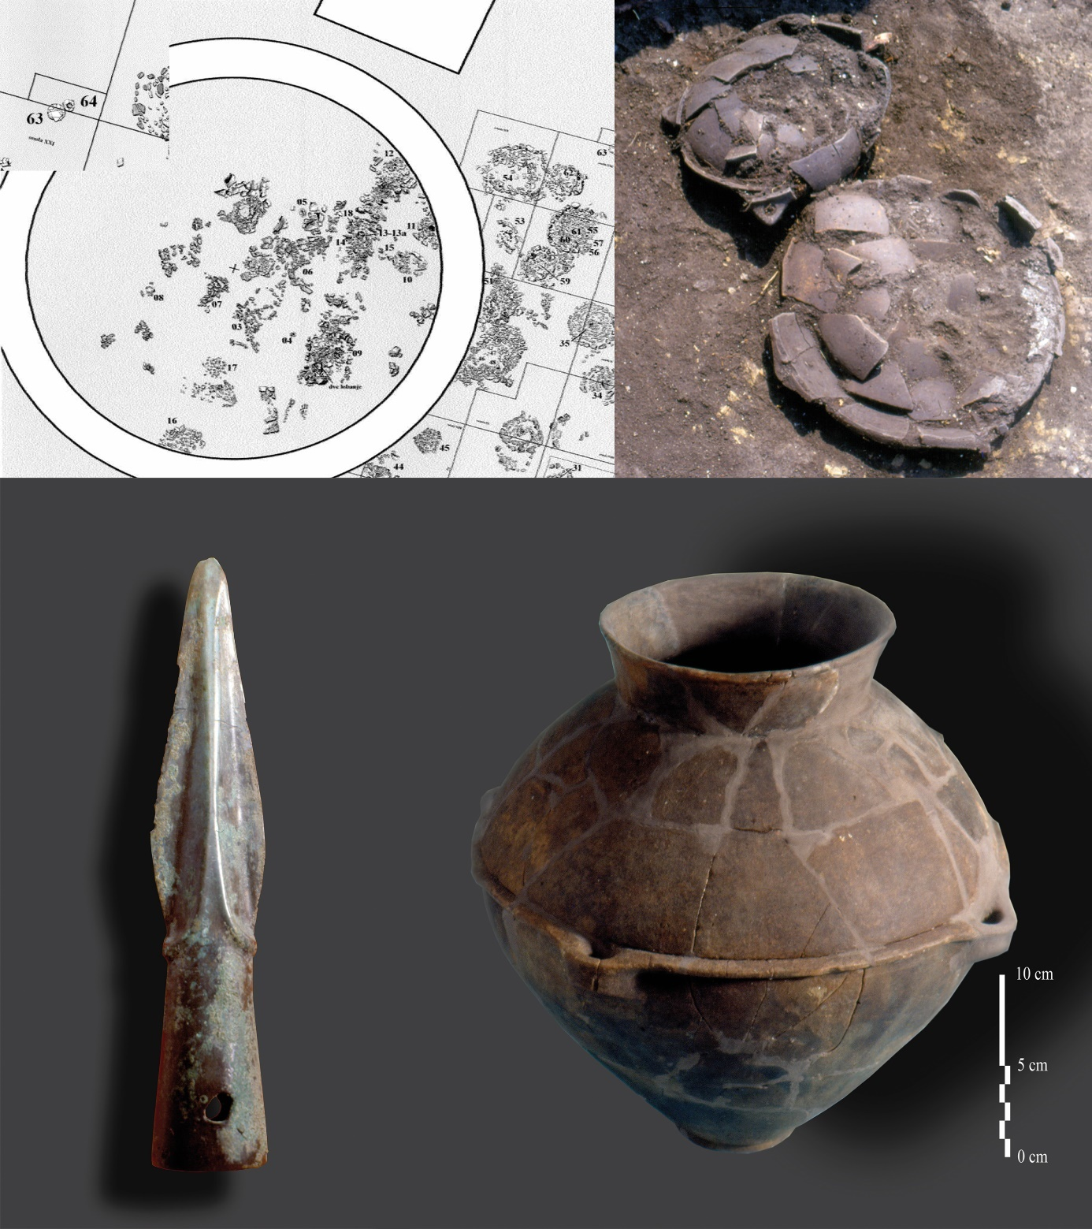

Trnjane
Figure S10 – Trnjane, plane of the necropolis with stone constructions and schematic plane with age groups (Kapuran et al. 2020)
Figure S11 – Plane with trenches in settlement and necropolis in Trnjane (Kapuran et al. 2020)

Ružana
Figure S12 – Reconstruction of copper smelting object from Ružana (Kapuran et al. 2016)
Figure S13 – Furnace floor in Ružana (Kapuran et al. 2016)

Čoka Njica
Figure S14a – Čoka Njica, remains of the furnace, post holes and find concentrations in trench 3, Pl. 5 (photo: T. Urban)
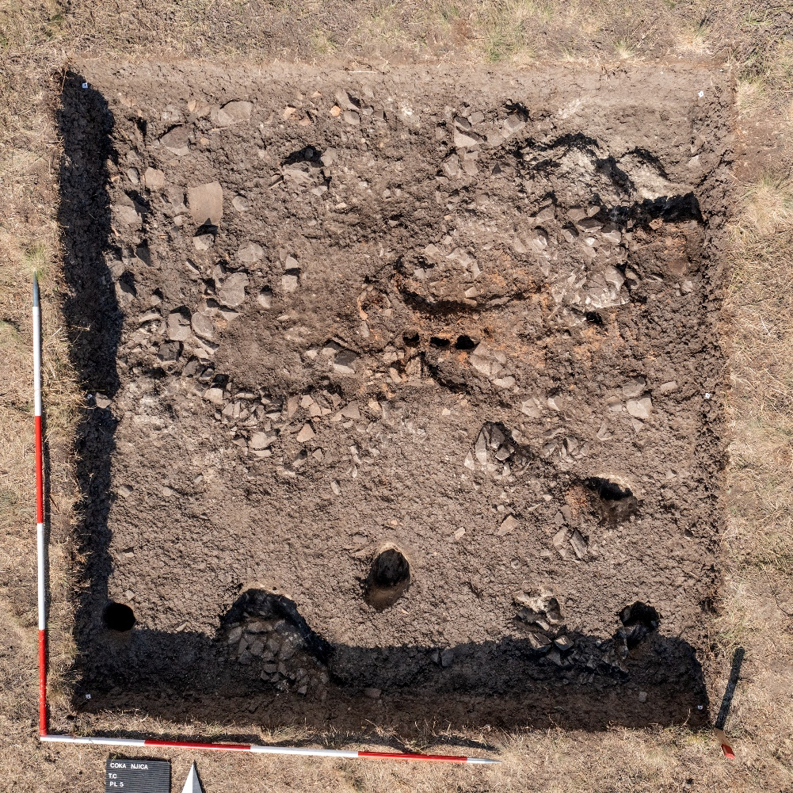
Figure S14b – Čoka Njica, GIS drawings of Pl. 5 (drawing: M. Konrad)

Hajdučka Česma

Figure S15 – Cremated bone fragments from graves in Hajdučka Česma (photo: I. M. Petschko)
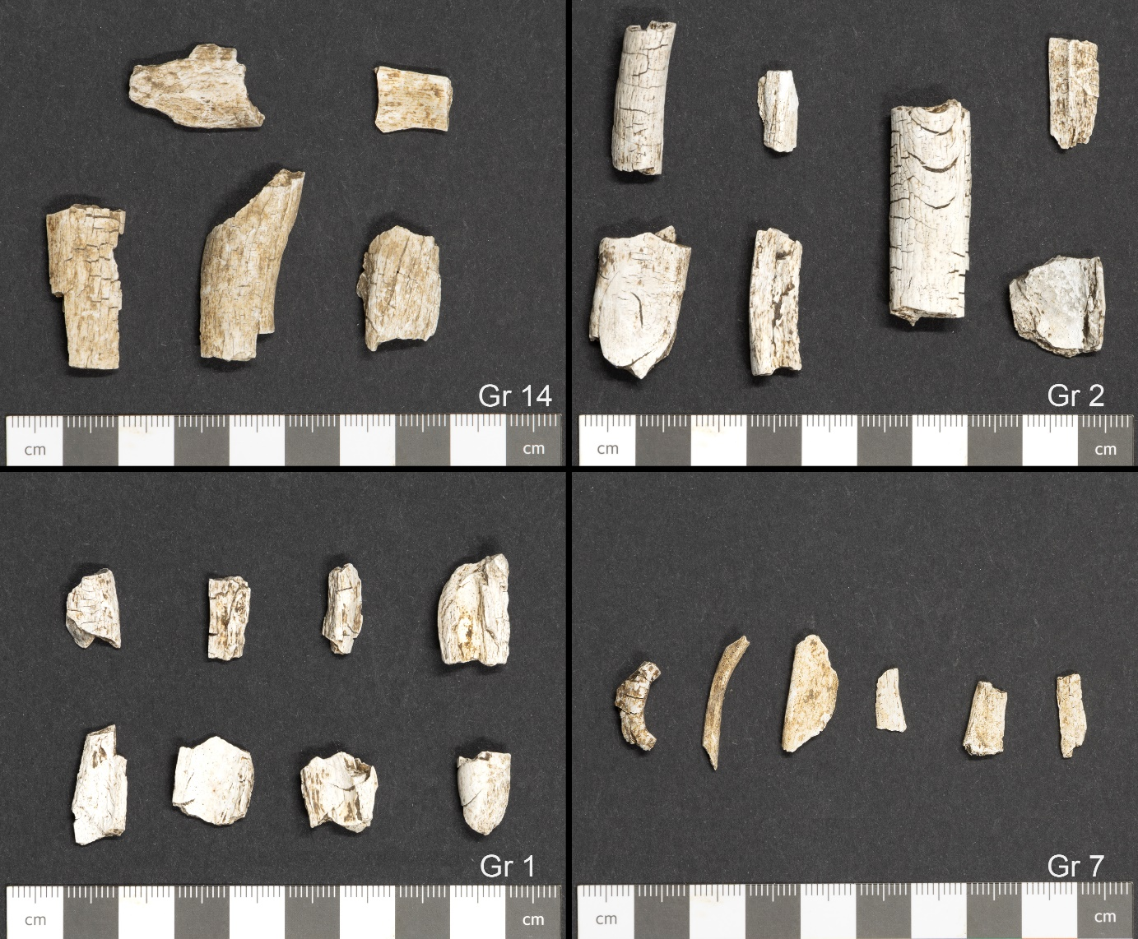

Bayesian Modelling
Figure S16 – Curve plot of individual calibrated dates from Hajdučka Česma and Borsko Jezero. Note limitation on resolution due a plateau and wiggles in the calibration curve during the 19th to 18th centuries BC.
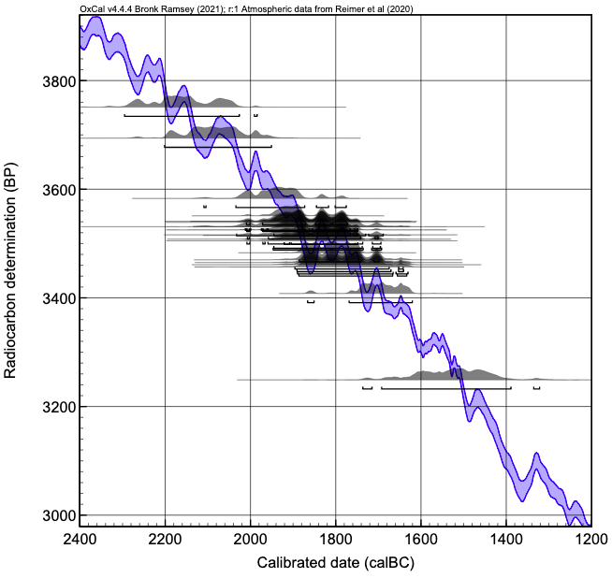

Figure S17 – Hajdučka Česma and Borsko Jezero models in which the ‘Cremation’ model of Rose et al. (2020) is applied to results measured on cremated bone, and the Charcoal Plus model to results on charcoal pieces. Left: The prior scaling is set to a uniform distribution between 10 and 1000 i.e. U(1,3). Right: The scaling is limited to 10 and 100 i.e. U(1,2).
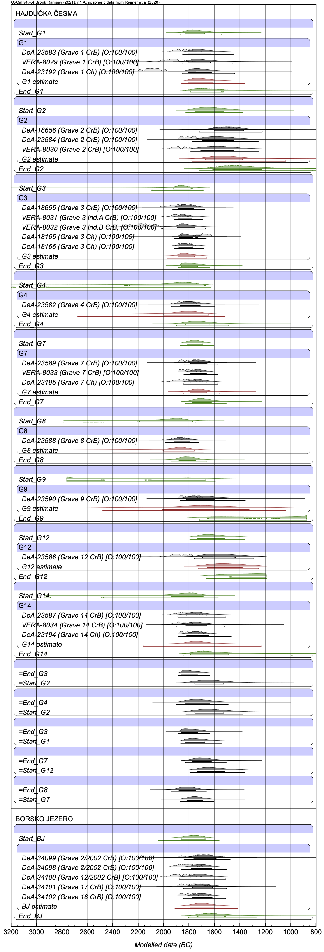 | 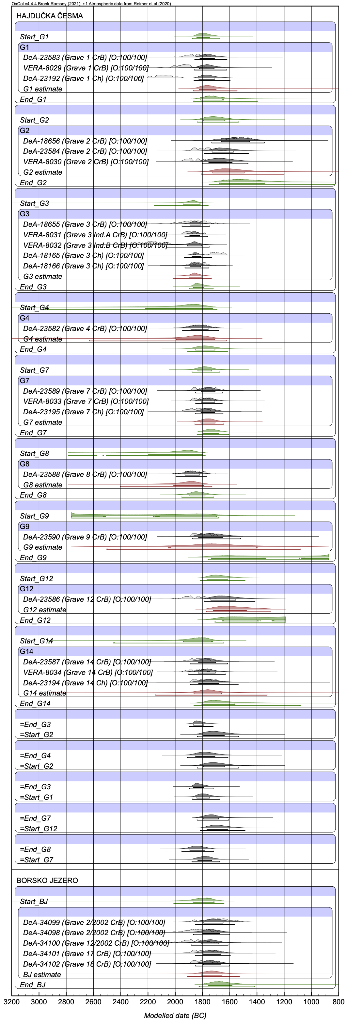
Figure S18 – Posterior outlier distribution for the ‘Cremation’ model of Rose et al. (2020) applied to Hajdučka Česma and Borsko Jezero (model shown in Figure S2 left).
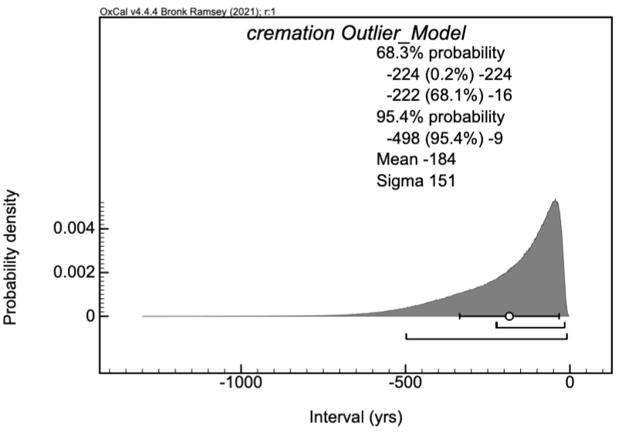

Figure S19a – Prior and posterior scaling factor for the ‘Cremation’ model of Rose et al. (2020) applied to Hajdučka Česma and Borsko Jezero (model shown in Figure S2 left), where the prior scaling factor is a uniform distribution from 1 to 3 (i.e. 10 to 1000).
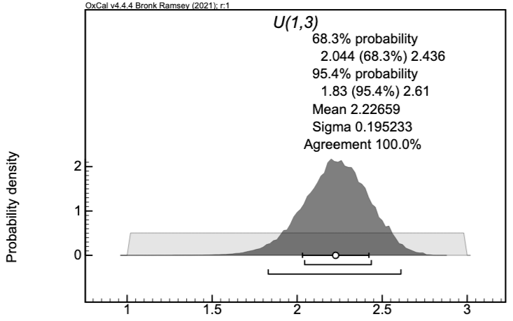
Figure S19b – Prior and posterior scaling factor for the ‘Cremation’ model of Rose et al. (2020) applied to Hajdučka Česma and Borsko Jezero (model shown in Figure S2 right), where the prior scaling factor is a uniform distribution from 1 to 2 (i.e. 10 to 100).
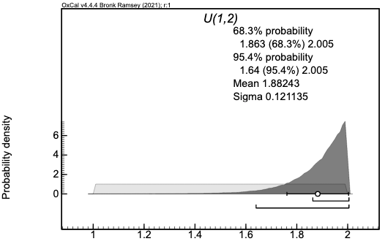

Figure S20 – Left: Hajdučka Česma and Borsko Jezero model in which the cremated bone data is assumed to follow a normal distribution with an offset: -30 ± 15 years. Right: For comparison, a model that [optimistically] treats the cremated data with a “General” outlier model. (Both models use the ‘Charcoal Plus’ outlier distribution for measurements on charcoal.)
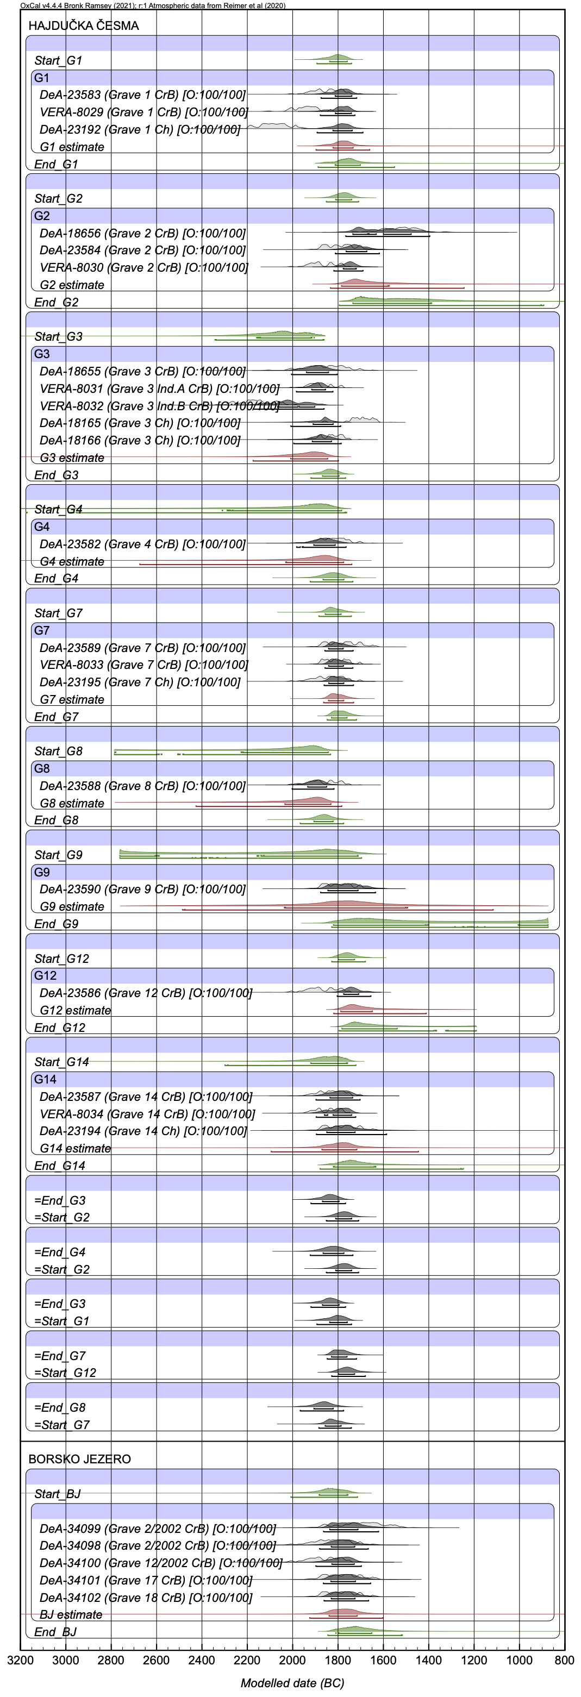 | 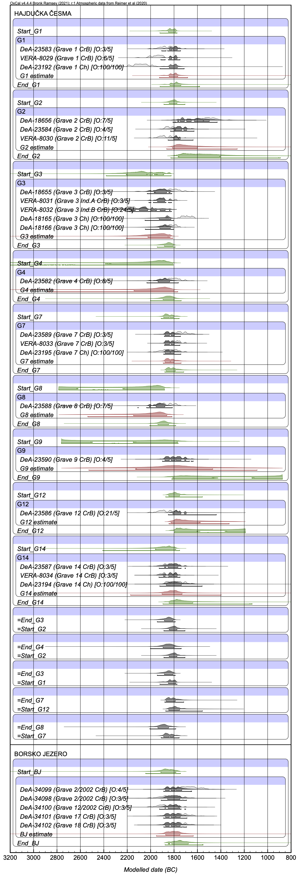
OXCAL CODE

Hajdučka Česma and Borsko Jezero Bayesian model with the ‘Cremation’ outlier distribution of Rose et al. (2020) applied to cremated bone data. The ‘Charcoal’ plus outlier distribution is applied to dates measured on charcoal. All dates are given a prior outlier probability of 100%.

Options()
{
Resolution=1;
};
Plot()
{
Outlier_Model("Charcoal_p",Prior("Charcoal_p.prior"),U(0,3),"t");
Outlier_Model ("cremation", Exp(0.9,-10,-0.1), U(1,2),"t");
Label("HAJDUČKA ČESMA");
Sequence()
{
Boundary("Start_G1");
Phase("G1")
{
R_Date("DeA-23583 (Grave 1 CrB)", 3525, 40)
{
Outlier("cremation", 1);
};
R_Date("VERA-8029 (Grave 1 CrB)", 3583, 38)
{
Outlier("cremation", 1);
};
R_Date("DeA-23192 (Grave 1 Ch)", 3694, 44)
{
Outlier("Charcoal_p", 1);
};
};
Boundary("End_G1");
};
Sequence()
{
Boundary("Start_G2");
Phase("G2")
{
R_Date("DeA-18656 (Grave 2 CrB)", 3249, 74)
{
Outlier("cremation", 1);
};
R_Date("DeA-23584 (Grave 2 CrB)", 3465, 40)
{
Outlier("cremation", 1);
};
R_Date("VERA-8030 (Grave 2 CrB)", 3541, 31)
{
Outlier("cremation", 1);
};
//R_Date("DeA-18167 (Grave 2 Ch)", 1094, 23);
//R_Date("DeA-18168 (Grave 2 Ch)", 1116, 22);
};
Boundary("End_G2");
};
Sequence()
{
Boundary("Start_G3");
Phase("G3")
{
R_Date("DeA-18655 (Grave 3 CrB)", 3531, 62)
{
Outlier("cremation", 1);
};
R_Date("VERA-8031 (Grave 3 Ind.A CrB)", 3551, 26)
{
Outlier("cremation", 1);
};
R_Date("VERA-8032 (Grave 3 Ind.B CrB)", 3751, 45)
{
Outlier("cremation", 1);
};
R_Date("DeA-18165 (Grave 3 Ch)", 3408, 28)
{
Outlier("Charcoal_p", 1);
};
R_Date("DeA-18166 (Grave 3 Ch)", 3515, 25)
{
Outlier("Charcoal_p", 1);
};
};
Boundary("End_G3");
};
Sequence()
{
Boundary("Start_G4");
Phase("G4")
{
R_Date("DeA-23582 (Grave 4 CrB)", 3505, 44)
{
Outlier("cremation", 1);
};
};
Boundary("End_G4");
};
Sequence()
{
Boundary("Start_G7");
Phase("G7")
{
R_Date("DeA-23589 (Grave 7 CrB)", 3457, 42)
{
Outlier("cremation", 1);
};
R_Date("VERA-8033 (Grave 7 CrB)", 3483, 27)
{
Outlier("cremation", 1);
};
R_Date("DeA-23195 (Grave 7 Ch)", 3516, 46)
{
Outlier("Charcoal_p", 1);
};
};
Boundary("End_G7");
};
Sequence()
{
Boundary("Start_G8");
Phase("G8")
{
R_Date("DeA-23588 (Grave 8 CrB)", 3539, 38)
{
Outlier("cremation", 1);
};
};
Boundary("End_G8");
};
Sequence()
{
Boundary("Start_G9");
Phase("G9")
{
R_Date("DeA-23590 (Grave 9 CrB)", 3470, 40)
{
Outlier("cremation", 1);
};
};
Boundary("End_G9");
};
Sequence()
{
Boundary("Start_G12");
Phase("G12")
{
R_Date("DeA-23586 (Grave 12 CrB)", 3541, 40)
{
Outlier("cremation", 1);
};
};
Boundary("End_G12");
};
Sequence()
{
Boundary("Start_G14");
Phase("G14")
{
R_Date("DeA-23587 (Grave 14 CrB)", 3508, 42)
{
Outlier("cremation", 1);
};
R_Date("VERA-8034 (Grave 14 CrB)", 3531, 28)
{
Outlier("cremation", 1);
};
R_Date("DeA-23194 (Grave 14 Ch)", 3461, 45)
{
Outlier("Charcoal_p", 1);
};
};
Boundary("End_G14");
};
// define the internal constraints
// Trench 1
End_G3 < Start_G2;
End_G4 < Start_G2;
End_G3 < Start_G1;
// Trench 2
End_G7 < Start_G12;
End_G8 < Start_G7;
Axis(-3200,-800);
};

Hajdučka Česma and Borsko Jezero Bayesian model with a Normal outlier distribution applied to cremated bone data (-30 ± 15 years, clipped to 0 for x>0). The ‘Charcoal’ plus outlier distribution is applied to dates measured on charcoal. All dates are given a prior outlier probability of 100%.

Options()
{
Resolution=1;
};
Plot()
{
Outlier_Model("Normal",Prior("Nminus3015below0.prior"),0,"t");
//N(-30,15) saved as a prior and then with the small part above zero removed.
Outlier_Model("Charcoal_p",Prior("Charcoal_p.prior"),U(0,3),"t");
Label("HAJDUČKA ČESMA");
Sequence()
{
Boundary("Start_G1");
Phase("G1")
{
R_Date("DeA-23583 (Grave 1 CrB)", 3525, 40)
{
Outlier("Normal", 1);
};
R_Date("VERA-8029 (Grave 1 CrB)", 3583, 38)
{
Outlier("Normal", 1);
};
R_Date("DeA-23192 (Grave 1 Ch)", 3694, 44)
{
Outlier("Charcoal_p", 1);
};
};
Boundary("End_G1");
};
Sequence()
{
Boundary("Start_G2");
Phase("G2")
{
R_Date("DeA-18656 (Grave 2 CrB)", 3249, 74)
{
Outlier("Normal", 1);
};
R_Date("DeA-23584 (Grave 2 CrB)", 3465, 40)
{
Outlier("Normal", 1);
};
R_Date("VERA-8030 (Grave 2 CrB)", 3541, 31)
{
Outlier("Normal", 1);
};
//R_Date("DeA-18167 (Grave 2 Ch)", 1094, 23);
//R_Date("DeA-18168 (Grave 2 Ch)", 1116, 22);
};
Boundary("End_G2");
};
Sequence()
{
Boundary("Start_G3");
Phase("G3")
{
R_Date("DeA-18655 (Grave 3 CrB)", 3531, 62)
{
Outlier("Normal", 1);
};
R_Date("VERA-8031 (Grave 3 Ind.A CrB)", 3551, 26)
{
Outlier("Normal", 1);
};
R_Date("VERA-8032 (Grave 3 Ind.B CrB)", 3751, 45)
{
Outlier("Normal", 1);
};
R_Date("DeA-18165 (Grave 3 Ch)", 3408, 28)
{
Outlier("Charcoal_p", 1);
};
R_Date("DeA-18166 (Grave 3 Ch)", 3515, 25)
{
Outlier("Charcoal_p", 1);
};
};
Boundary("End_G3");
};
Sequence()
{
Boundary("Start_G4");
Phase("G4")
{
R_Date("DeA-23582 (Grave 4 CrB)", 3505, 44)
{
Outlier("Normal", 1);
};
};
Boundary("End_G4");
};
Sequence()
{
Boundary("Start_G7");
Phase("G7")
{
R_Date("DeA-23589 (Grave 7 CrB)", 3457, 42)
{
Outlier("Normal", 1);
};
R_Date("VERA-8033 (Grave 7 CrB)", 3483, 27)
{
Outlier("Normal", 1);
};
R_Date("DeA-23195 (Grave 7 Ch)", 3516, 46)
{
Outlier("Charcoal_p", 1);
};
};
Boundary("End_G7");
};
Sequence()
{
Boundary("Start_G8");
Phase("G8")
{
R_Date("DeA-23588 (Grave 8 CrB)", 3539, 38)
{
Outlier("Normal", 1);
};
};
Boundary("End_G8");
};
Sequence()
{
Boundary("Start_G9");
Phase("G9")
{
R_Date("DeA-23590 (Grave 9 CrB)", 3470, 40)
{
Outlier("Normal", 1);
};
};
Boundary("End_G9");
};
Sequence()
{
Boundary("Start_G12");
Phase("G12")
{
R_Date("DeA-23586 (Grave 12 CrB)", 3541, 40)
{
Outlier("Normal", 1);
};
};
Boundary("End_G12");
};
Sequence()
{
Boundary("Start_G14");
Phase("G14")
{
R_Date("DeA-23587 (Grave 14 CrB)", 3508, 42)
{
Outlier("Normal", 1);
};
R_Date("VERA-8034 (Grave 14 CrB)", 3531, 28)
{
Outlier("Normal", 1);
};
R_Date("DeA-23194 (Grave 14 Ch)", 3461, 45)
{
Outlier("Charcoal_p", 1);
};
};
Boundary("End_G14");
};
// define the internal constraints
// Trench 1
End_G3 < Start_G2;
End_G4 < Start_G2;
End_G3 < Start_G1;
// Trench 2
End_G7 < Start_G12;
End_G8 < Start_G7;
Axis(-3200,-800);
};

Hajdučka Česma and Borsko Jezero Bayesian model with a ‘General’ outlier distribution and prior probabilities of 5% applied to cremated bone data. The ‘Charcoal Plus’ distribution is applied to dates measured on charcoal.

Make the following changes to the model above:
- Replace the line Outlier_Model("Normal",Prior("Nminus3015below0.prior"),0,"t");
with Outlier_Model("General",T(5),U(0,4),"t");
- For each cremated bone measurement replace Outlier("Normal", 1) with Outlier(“General”, 0.05)

