<Supplementary material>

Figure S1. DD-ES Estimates of the Effects of the Basic Pension Scheme on Relative Poverty
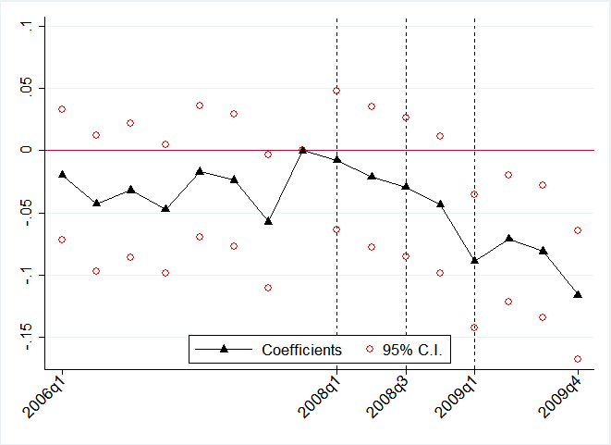Relative income poverty rate | 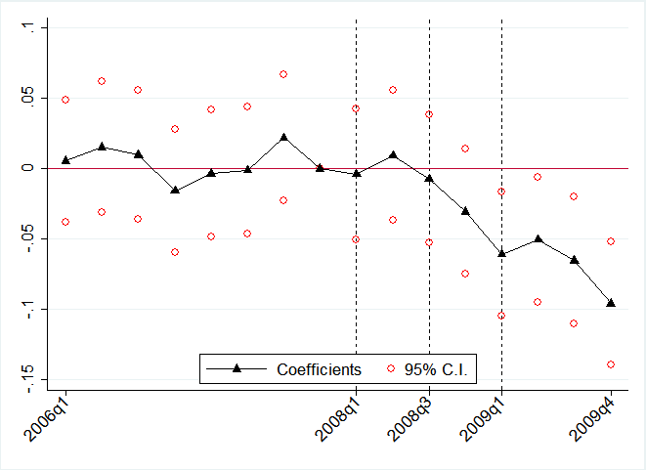Relative consumption poverty rate
- Phasing-in the Basic Pension in 2008-2009

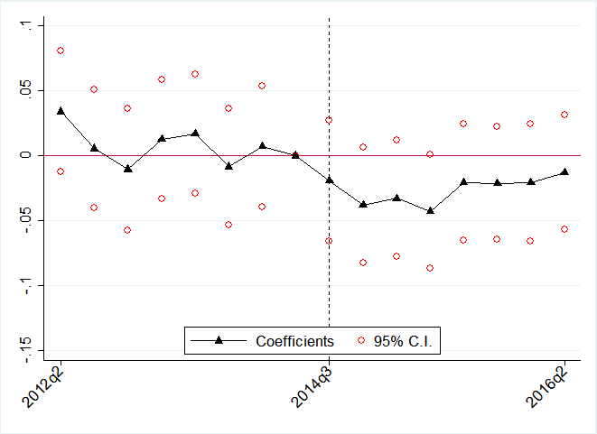 Relative income poverty rate | 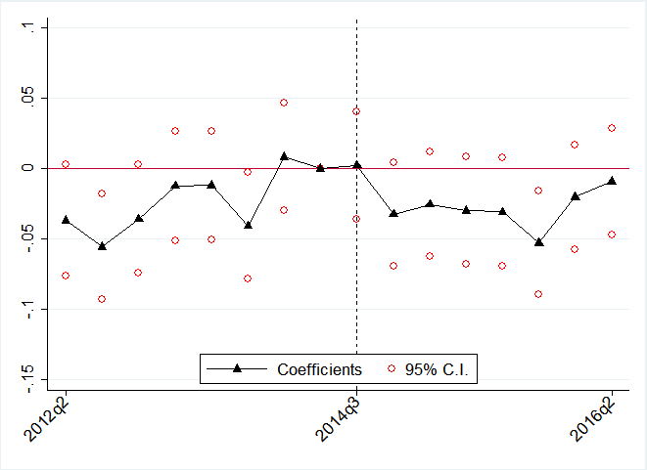 Relative consumption poverty rate
(B) Benefit Increase in the Basic Pension in 2014

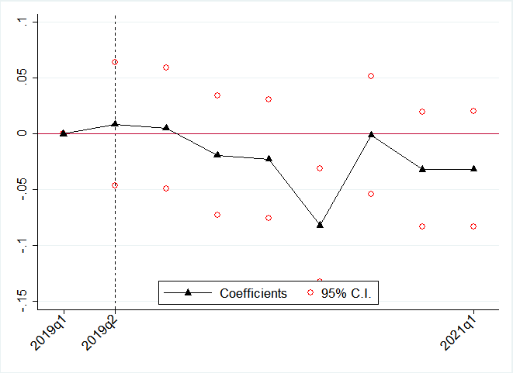 Relative income poverty rate | 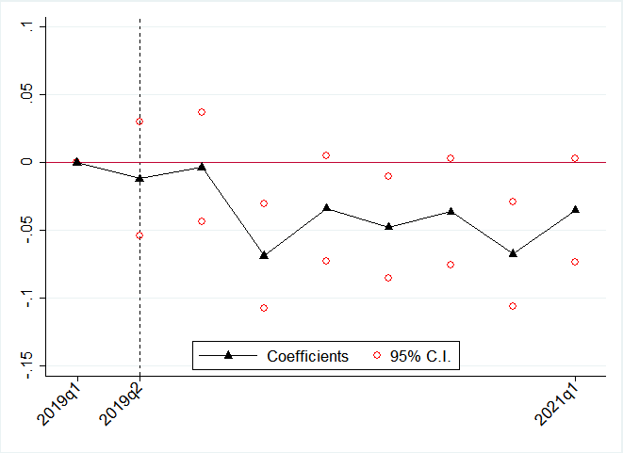 Relative consumption poverty rate
(C) Benefit Increase in the Basic Pension in 2019-2021

Table S1. Main Parameters of the Basic Pension Scheme
 | 2008.1 | 2008.7 | 2009.1 | 2014.7 | 2018.9 | 2019.4~2020.1 | 2021.1
Benefit eligibility | Age 70+ | Age 65+
 | Bottom 60% in the joint distribution of income and assets |  | Bottom 70% in the joint distribution of  income and assets
Assessment of income and assets of applicants | Income formula  (labour income - deduction) + business income + property income + public transfer  Asset formula  (Assets - debt)$×$ income conversion rate $÷$ 12 months |  |  | Income formula  0.7 $×$(labour income - deduction) + business income + property income + public transfer + free rental income  Asset formula  [{(General assets – basic deductions) + (financial assets - 20 million KRW) - debt} $×$ income conversion rate $÷$ 12] + P*
Maximum benefit (thousand KRW) | 84 |  |  | 200 | 250 | 250~  300 | 300
Annual adjustment of maximum benefit (thousand KRW) | Wage increase rate (88 in April 2009 to 99.9 in April 2014) |  |  | Inflation rate (202.6 in April 2015 to 209.96 in April 2018)
Benefit reduction
1) reduction for pensioners | n/a |  |  | If the National Pension benefit exceeds 150% of the maximum benefit, reduce the BPS benefit up to a half of the maximum benefit
2) reduction for couple recipients | Reduce the benefit for each recipient by 20%
3) reduction for recipients with high income | If (recognized income + BP benefit) $>$ the income eligibility threshold, reduce the benefit by the difference
Note: P stands for the prices of luxury cars and other expensive luxury goods.
Source: Korean Ministry of Health and Welfare (2009, 2014), https://basicpension.mohw.go.kr(2020)
Table S2. DD-ES Estimates of the Effects of the Basic Pension Reform in 2008
 | Income poverty |  | Consumption poverty
 | (1) | (2) | (3) | (4)
Group | 0.064***(0.021) | 0.041**(0.017) | 0.028*(0.017) | 0.025*(0.015)
group × 2006q1 | -0.009(0.027) |  | -0.014(0.022)
group × 2006q2 | -0.028(0.028) |  | 0.025(0.024)
group × 2006q3 | -0.021(0.028) |  | 0.015(0.023)
group × 2006q4 | -0.041(0.026) |  | -0.033(0.022)
group × 2007q1 | -0.011(0.027) |  | -0.029(0.022)
group × 2007q2 | -0.013(0.027) |  | 0.015(0.023)
group × 2007q3 | -0.046*(0.027) |  | 0.009(0.023)
group × 2008q1 | -0.003(0.028) | 0.016(0.026) | -0.015(0.023) | -0.015(0.021)
group × 2008q2 | -0.007(0.029) | 0.012(0.028) | 0.015(0.024) | 0.014(0.024)
group × 2008q3 | -0.025(0.028) | -0.007(0.029) | -0.022(0.023) | -0.022(0.024)
group × 2008q4 | -0.042(0.028) | -0.025(0.031) | -0.030(0.023) | -0.031(0.026)
group × 2009q1 | -0.076***(0.027) | -0.059*(0.033) | -0.049**(0.023) | -0.050*(0.028)
group × 2009q2 | -0.059**(0.026) | -0.043(0.034) | -0.045*(0.023) | -0.046(0.030)
group × 2009q3 | -0.070***(0.027) | -0.054(0.037) | -0.065***(0.023) | -0.067**(0.032)
group × 2009q4 | -0.113***(0.026) | -0.097**(0.039) | -0.093***(0.022) | -0.095***(0.033)
group ×  linear trend |  | 0.000(0.003) |  | 0.000(0.003)
N | 56440 | 56440 | 56440 | 56440
Notes: 1. Year-fixed effects, quarter-fixed effects, sex, age, age squared, education, and receipt of public pension benefits are also included in all the models. 2. *p<.10, **p<.05, ***p<.01
Source: Household Income and Expenditure Survey

Table S3. IV Estimates of the Effects of the Basic Pension Reform in 2014
 | Income poverty | Consumption poverty | 1st stage
 | IV | IV
group × 2012q3 |  |  | -0.037* (0.021)
group × 2012q4 |  |  | -0.038* (0.021)
group × 2013q1 |  |  | -0.033 (0.021)
group × 2013q2 |  |  | 0.002 (0.021)
group × 2013q3 |  |  | -0.003 (0.021)
group × 2013q4 |  |  | -0.010 (0.021)
group × 2014q1 |  |  | -0.023 (0.021)
group × 2014q3 |  |  | 0.620*** (0.032)
group × 2014q4 |  |  | 0.617*** (0.032)
group × 2015q1 |  |  | 0.615*** (0.031)
group × 2015q2 |  |  | 0.773*** (0.032)
group × 2015q3 |  |  | 0.807*** (0.031)
group × 2015q4 |  |  | 0.764*** (0.032)
group × 2016q1 |  |  | 0.780*** (0.031)
group × 2016q2 |  |  | 0.735*** (0.033)
BP amount | -0.058*** | -0.005
 | (0.010) | (0.008)
R squared | 0.116 | 0.125
F for IV |  |  | 284.811
N | 77480 | 77480 | 77480
Notes: 1. The BPS benefit amount received is instrumented by interactions between a treatment group indicator and year-quarter dummies. The reference point is the second quarter of 2014 before the benefit increase in the BPS. 2. The first-stage model includes the benefit amount received, year-fixed effects, quarter-fixed effects, sex, age, age squared, education, receipt of public pension benefits, a treatment group indicator and year-quarter dummies. 3. All monetary values are expressed in a hundred thousand KRW converted to 2006 values.
Significance levels: *p<.10, **p<.05, ***p<.01

Table S4. RD Estimates of the Effects of the Basic Pension
 | Basic Pension in 2009
 | Anchored Income Poverty |  |  | Anchored Consumption Poverty
 | 55-74 | 60-69 | 62-67 | 55-74 | 60-69 | 62-67
Estimates | 0.016 | -0.001 | 0.069 | -0.033 | -0.070 | -0.082
 | (0.026) | (0.044) | (0.088) | (0.023) | (0.040) | (0.075)
N | 14996 | 5989 | 4472 | 14996 | 5989 | 4472
 | Basic Pension in 2015
 | Anchored Income Poverty |  |  | Anchored Consumption Poverty
 | 55-74 | 60-69 | 62-67 | 55-74 | 60-69 | 62-67
Estimates | 0.000 | -0.056 | -0.182*** | -0.020 | -0.071** | -0.055
 | (0.022) | (0.039) | (0.069) | (0.018) | (0.030) | (0.062)
N | 17065 | 8156 | 4742 | 17065 | 8156 | 4742
 | Basic Pension in 2019
 | Anchored Income Poverty |  |  | Anchored Consumption Poverty
 | 55-74 | 60-69 | 62-67 | 55-74 | 60-69 | 62-67
Estimates | 0.005 | 0.000 | -0.081 | 0.008 | -0.002 | -0.035
 | (0.018) | (0.029) | (0.053) | (0.009) | (0.015) | (0.024)
N | 11695 | 5869 | 3494 | 11695 | 5869 | 3494
Notes: 1. RD coefficients are estimated using the pooled sample of all four quarters in 2009. 2. Age is centred at the cut-off (65). 3. Covariates are not included. 4. The functional form of the model is based on a quadratic interaction regression.
Significance levels: *p<.10, **p<.05, ***p<.01

