SOME EXAMPLES OF THE WEIGHTING PROCEDURE

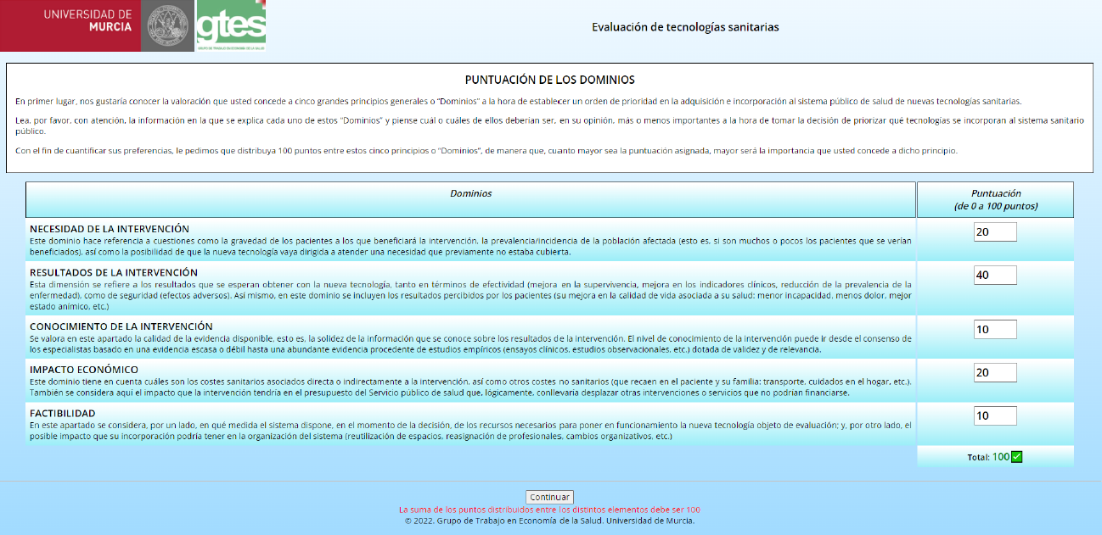
Figure 1. Example of distribution of the 100 points among the 5 domains

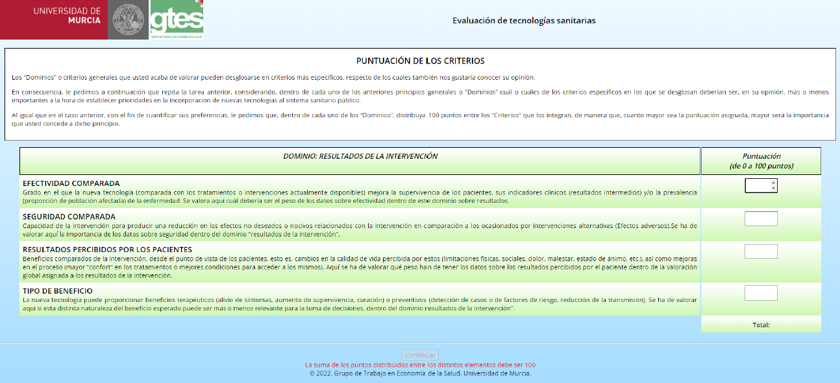
Figure 2. Weighting task of the criteria of the “Results of the intervention” domain.

