**SUPPLEMENTAL MATERIAL**

**SUPPLEMENTARY FIGURE S1: STUDY FLOW DIAGRAM**

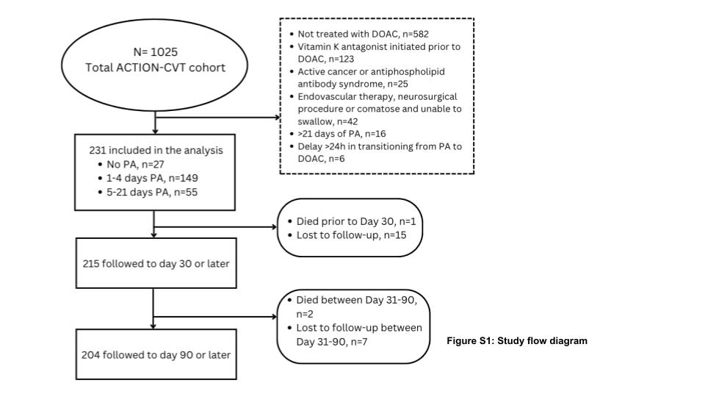

**SUPPLEMENTARY TABLE S1: Differences in demographic and clinical characteristics between early and delayed groups**

|  |  |  |  |
| --- | --- | --- | --- |
| **Characteristic (n/N, % unless otherwise specified)** | **Earlier initiation of DOAC (0-5 days of lead-in PA)**  **N = 176** | **Delayed initiation (5-21 days of lead-in PA)**  **N = 55** | ***p*-value^** |
| Age (mean, SD) | 44.9±17.3 | 48.3 ± 18.3 | NS |
| Sex (% female) | 121/176 (68.8%) | 37/55(67.3%) | NS |
| Race* |  |  |  |
| White | 129/174 (74.1%) | 33/54 (61.1%) | NS (0.07) |
| Black | 21/174 (12.1%) | 13/54 (24.1%) | 0.03 |
| Asian | 11/174 (6.3%) | 2/54 (3.7%) | NS |
| Other | 13/174 (7.5%) | 6/54 (11.1%) | NS |
| Ethnicity  Hispanic  Non-Hispanic/unknown | 14/174 (8.0%)  162/176 (92.0%) | 7/54 (13.0%)  48/55 (87.2%) | NS  NS |
| Body mass index (mean, SD) | 30.1 ± 8.2 | 27.9 ± 8.1 | NS |
| Prior VTE | 23/176 (13.1%) | 8/55 (14.5%) | NS |
| Family history of VTE | 24/174 (13.8%) | 6/55 (10.9%) | NS |
| Recent head trauma | 12/176 (6.8%) | 4/55 (7.3%) | NS |
| Recent sinusitis/mastoiditis | 17/176 (9.7%) | 9/55 (16.4%) | NS |
| Within 12 weeks post-partum | 4/175 (2.3%) | 2/55 (3.6%) | NS |
| Hormonal treatment | 46/175 (26.3%) | 10/55(18.2%) | NS |
| Active smoking | 16/174 (9.2%) | 6/55 (10.9%) | NS |
| Presenting features |  |  |  |
| Isolated headache | 80/176 (45.5%) | 16/55 (29.1%) | 0.03 |
| Focal deficit | 63/176 (35.8%) | 27/55 (49.1%) | NS (0.08) |
| Seizure | 32/176 (18.2%) | 17/55 (30.9%) | 0.0002 |
| Encephalopathy | 22/176 (12.5%) | 12/55 (21.8%) | NS (0.09) |
| Imaging features at baseline |  |  |  |
| Venous infarct | 32/176 (18.2%) | 12/55 (21.8%) | NS |
| Edema | 35/176 (19.9%) | 21/55 (38.2%) | 0.006 |
| Hemorrhage | 50/176 (28.4%) | 29/55 (52.7%) | 0.0009 |
| Deep cerebral vein involvement | 40/176 (22.7%) | 15/55 (27.3%) | NS |
| UFH prior to DOAC | 126/176 (71.6%) | 44/55 (80.0%) | NS |
| LMWH prior to DOAC | 35/176 (19.9%) | 25/55 (45.5%) | 0.0002 |
| Intubation | 6/176 (3.4%) | 7/55 (12.7%) | 0.009 |
| PEG tube placement | 1/176 (0.06%) | 3/55 (5.5%) | <0.05 |

VTE - venous thromboembolism; PEG - percutaneous endoscopic gastroscopy

*Abstracted from charts based on self-reported data[[7]](https://paperpile.com/c/UEp7cJ/D13z)

^ p-values are from Chi-square, Fisher’s Exact test, or unpaired T-tests as appropriate, and are not corrected for multiple comparisons. NS - non-significant (p>0.05); NS *p*-values <0.10 are included in the text in parentheses