**Economic valuation of changes in ecosystem services of 74 Ramsar wetlands in West Asia over 37 years (1984-2021)**

**Qadir Ashournejada*, Fateme Garshasbia**

* Corresponding author email: ashournejad@umz.ac.ir

aDepartment of Geography and Urban Planning, Faculty of Humanities and Social Sciences, University of Mazandaran, Babolsar, Iran

Table S1.This table shows the characteristics of wetlands, indicating which country each wetland is located in. It also shows the level of importance of the wetland and its type.

|  |  |  |  |  |
| --- | --- | --- | --- | --- |
| Classification of the Ramsar Convention | Protection level | THE NAME OF WETLAND | COUNTRY |  |
| Inland | State Sanctuary | Khor Virap | Armenia | 1 |
| Inland | National Park | Lake Arpi | Armenia | 2 |
| Inland | National Park | Lake Sevan | Armenia | 3 |
| Inland | ProtectedPlanet, National Park | Agh-Ghol | Azerbaijan | 4 |
| coastal/marine | Nationalreserve, protected area | Ghizil-Agaj | Azerbaijan | 5 |
| coastal/marine | protected area | Hawar Islands | Bahrain | 6 |
| coastal/marine | natural reserve | Tubli Bay | Bahrain | 7 |
| Inland | Protected Area | Al Wathba | united arab emirates | 8 |
| coastal/marine | Nature Reserve (Protected Area) | Al-Zora | united arab emirates | 9 |
| coastal/marine | Marine Protected Area | Bul Syayeef | united arab emirates | 10 |
| Inland | Protected area | Hatta Mountain | united arab emirates | 11 |
| coastal/marine | Protected area as per Local, Marine Reserve | Jabal Ali | united arab emirates | 12 |
| coastal/marine | Protected Area | Mangrove and Alhafeya | united arab emirates | 13 |
| Inland | Wildlife Sanctuary | Ras Al Khor | united arab emirates | 14 |
| coastal/marine | National Protected Area | Sir Bu Nair Island | united arab emirates | 15 |
| Inland | National Park | Wadi Wurayah | united arab emirates | 16 |
| Inland | Protected Area, Nature Reserve | Wasit | united arab emirates | 17 |
| Inland | Hunting is prohibited | Ajigol | Iran | 18 |
| Inland | Hunting is prohibited | Alagol | Iran | 19 |
| Inland | Hunting is prohibited | Ulmagol | Iran | 20 |
| Inland | wildlife shelter | Amirkelayeh | Iran | 21 |
| coastal/marine | wildlife shelter | Anzali | Iran | 22 |
| Inland | Protected area, biosphere reserve | Arjan | Iran | 23 |
| Inland | Hunting is prohibited | Choghakhor | Iran | 24 |
| coastal/marine | Protected area | Deltas of Rud-e-Gaz and Rud-e-Hara | Iran | 25 |
| coastal/marine | Protected area | Deltas of Rud-e-Shur, Rud-e-Shirin and Rud-e-Minab | Iran | 26 |
| Inland | Hunting is prohibited | Dorgeh Sangi | Iran | 27 |
| artificial | wildlife shelter | Fereydoon Kenar, Ezbaran & Sorkh Ruds Ab-Bandans | Iran | 28 |
| Inland | Protected area | Gavkhouni | Iran | 29 |
| Inland | Hunting is prohibited | Lake Kobi | Iran | 30 |
| Inland | Protected area | Lake Gori | Iran | 31 |
| coastal/marine | Hunting is prohibited | Gomishan | Iran | 32 |
| coastal/marine | Protected area | Govater Bay and Hur-e-Bahu | Iran | 33 |
| Inland | wildlife shelter | Hamun | Iran | 34 |
| Inland | wildlife shelter | Kanibarazan | Iran | 35 |
| coastal/marine | Protected area | Khuran Straits | Iran | 36 |
| coastal/marine | Wildlife sanctuary, biosphere reserve | Miankaleh | Iran | 37 |
| Inland | Protected area, biosphere reserve | Parishan | Iran | 38 |
| coastal/marine | wildlife shelter | Shadegan | Iran | 39 |
| Inland | Hunting is prohibited | Shurgol | Iran | 40 |
| coastal/marine | Hunting is prohibited | Bujagh | Iran | 41 |
| Inland | National Park, Biosphere Reserve | Lake Urmia | Iran | 42 |
| Inland | Hunting is prohibited | Yadegarlu | Iran | 43 |
| Inland | wildlife shelter | Zarivar | Iran | 44 |
| Inland | National park, wildlife sanctuary | Neiriz Lakes & Kamjan | Iran | 45 |
| Inland | Protected Area | Barm Alvan | Iran | 46 |
| coastal/marine | Protected Area, Wildlife Refuge, Important Bird Area | Sheedvar Island | Iran | 47 |
| Inland | National Park | Central Marshes | Iran | 48 |
| Inland | Protected Planet | Hammar Marsh | Iraq | 49 |
| Inland | Protected Planet | Hawizeh Marsh | Iraq | 50 |
| Inland | Protected Planet | Sawa Lake | Iraq | 51 |
| Inland | Natural reserve | Azraq Oasis | Jordan | 52 |
| Inland | Protected Area - Nature Reserve | Fifa | Jordan | 53 |
| coastal/marine | Nature Reserve | Mubarak Al-Kabeer | Kuwait | 54 |
| Inland | Protected area, biosphere reserve | Ammiq | Lebanon | 55 |
| coastal/marine | Protected Area | Deir el Nouriyeh cliffs | Lebanon | 56 |
| coastal/marine | nature reserve | Palm Islands | Lebanon | 57 |
| coastal/marine | National Park | Tyre Beach | Lebanon | 58 |
| Inland | Protected Area | Al Ansab Wetland | Oman | 59 |
| coastal/marine | Nature reserve | Qurm | Oman | 60 |
|  | Protected Area | Wetlands Reserve in Al Wusta | Oman | 61 |
| Inland | nature reserve | Sabkhat al-Jabbul | Syria | 62 |
| coastal/marine | wildlife protection area | Akyatan | Turkiye | 63 |
|  |  | Gediz Delta | Turkiye | 64 |
| coastal/marine | Natural Site special environment protection area - wild life protection area | Göksu Delta | Turkiye | 65 |
| coastal/marine | wildlife protection area | Kizilirmak Delta | Turkiye | 66 |
| Inland | Protected Area | Kizören Obrouk | Turkiye | 67 |
| Inland | wild life protection area | Lake Burdur | Turkiye | 68 |
| Inland | National Park Permanent Wildlife Reserve | Lake Kus | Turkiye | 69 |
| Inland | Wildlife Reserve | Lake Kuyucuk | Turkiye | 70 |
| Inland | Nature Conservation Zone | Lake Seyfe | Turkiye | 71 |
| Inland | Protected Area | Lake Uluabat | Turkiye | 71 |
| Inland | Natural Monument | Meke Maar | Turkiye | 73 |
| Inland | Nature Monument | Nemrut Caldera | Turkiye | 74 |
| Inland | Natural Park, Wildlife | Sultan | Turkiye | 75 |
| coastal/marine | Nature Conservation Site | Yumurtalik | Turkiye | 76 |
| coastal/marine | wild life protection area | Detwah | Yemen | 77 |

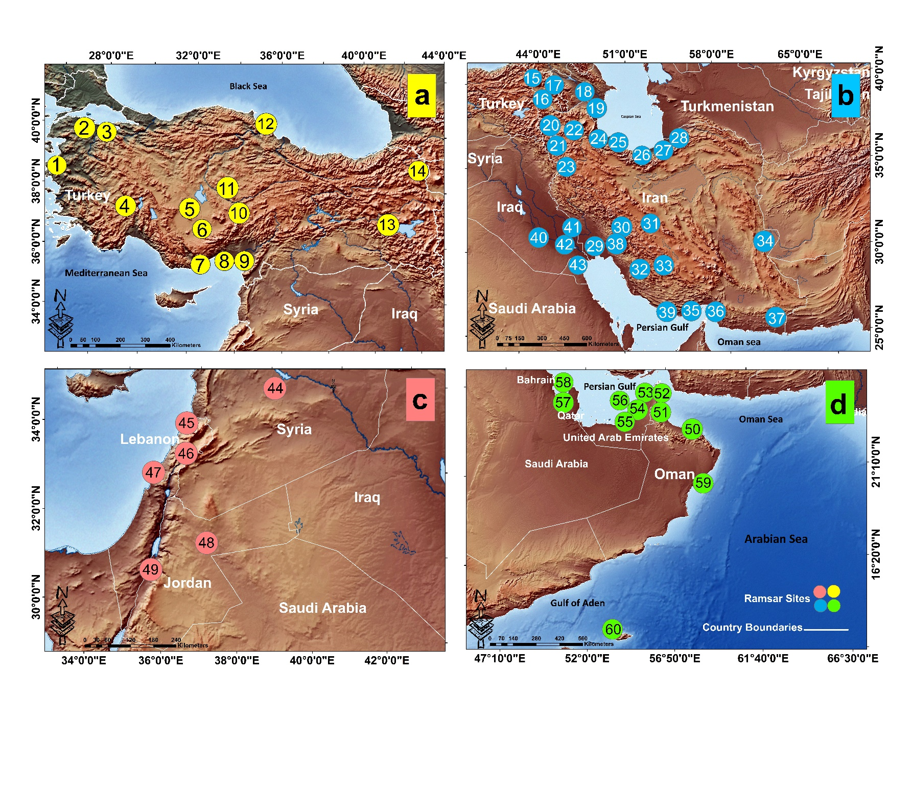

Fig S1: Spatial distribution of study wetlands in four regions a, b, c, d

Ramser sites section a: 1- Gediz Delta (Turkey) 2- Lake Kus (Turkey) 3- Lake Uluabat (Turkey) 4- Lake Burdur (Turkey) 5- Kizören Obrouk (Turkey) 6- Meke Maar (Turkey) 7- Göksu Delta (Turkey) 8- Akyatan Lagoon (Turkey) 9- Yumurtalik Lagoons (Turkey) 10- Sultan Marshes (Turkey) 11- Lake Seyfe (Turkey) 12- Kizilirmak Delta (Turkey) 13- Nemrut Caldera (Turkey) 14- Lake Kuyucuk (Turkey)

Ramser sites section b: 15- Lake Arpi (Armenia) 16- Khor Virap Marsh (Armenia) 17- Lake Sevan (Armenia) 18- Ghizil Agaj (Azerbaijan) 19- Agh Ghol (Azerbaijan) 20- Lake Urmia (Iran) 21- Shurgol, Kanibarazan, Yadegarlu, Dorgeh Sangi Lakes, Lake Kobi (Iran) 22- Lake Gori (Iran) 23- Zarivar (Iran) 24- Anzali Wetland Complex (Iran) 25- Amirkelayeh Lake, Bujagh National Park (Iran) 26- Fereydoon Kenar & Ezbaran (Iran) 27- Miankaleh, Gomishan Lagoon (Iran) 28- Alagol, Ulmagol and Ajigol Lakes (Iran) 29- Shadegan Marshes (Iran) 30- Chogakhor Wetland (Iran) 31- Gavkhouni Lake (Iran) 32- Lake Parishan and Dasht e Arjan (Iran) 33- Bakhtegan (Iran) 34- Hamun (Iran) ) 35- Khuran Straits (Iran) 36- Deltas of & Rud e Shur, Rud e Shirin and Rud e Minab Deltas of Rud e Gaz and Rud e Hara (Iran) 37- Govater Bay and Hur e Bahu (Iran) 38- Barm Alvan (Iran) 39- Sheedvar Island (Iran) 40- Sawa Lake (Iraq) 41- Hawizeh Marsh (Iraq) 42- Hammar Marsh & Central Marshes (Iraq) 43- Mubarak Al Kabeer Reserve (Kuwait)

Ramser sites section c: 44- Sabkhat al Jabbul Nature Reserve (Syria) 45- Deir el Nouriyeh cliffs of Ras Chekaa and Palm Islands Nature Reserve (Lebanon) 46- Ammiq Wetland (Lebanon) 47- Tire Beach (Lebanon) 48- Azraq Oasis (Jordan) 49- Fifa Nature Reserve (Jordan)

Ramser sites section d: 50- Qurm Nature Reserve & Ansab Wetland Al (Oman) 51- Mangrove and Alhafeya Protected Area in Khor Kalba, Hatta Mountain Reserve (UAE) 52- Wadi Wurayah National Park (UAE) 53- Al Zora Protected Area & Wasit Nature Reserve ( UAE) 54- Jabal Ali Wetland Sanctuary (UAE) 55- Al Wathba & Bul Syayeef (UAE) 56- Sir Bu Nair Island Protected Area (UAE) 57- Hawar Islands (Bahrain) 58- Tubli Bay (Bahrain) 59- Wetlands Reserve in Al Wusta Governorate (Oman) 60 Detwah Lagoon (Yemen)

Table S2 - Specifications and main features of the Global Surface Water (GSW) dataset

|  |  |  |
| --- | --- | --- |
| 30 meters | Pixel size | |
| 99.6% | Landsat-5 | accuracy |
| 99.5% | Landsat-7 |
| 99.7% | Landsat-8 |
| 10 classes | Number of classes | |
| Free | Cost of use | |
| Decision tree | Classification algorithm | |
| Global | Geographic coverage | |
| GCS_WGS_1984 | Coordinate system | |
| 1984 to 2021 | Time Frame | |
| Inaccessible | Google Earth Engine | |
| GeoTIFF | Format | |
| <https://global-surface-water.appspot.com/download> | Access | |

Table S3 - Value of Ecosystem Services from Wetlands This table shows the value of each service provided by wetland ecosystems in dollars per hectare per year. based on the Costanza Ecosystem Services Valuation Model

|  |  |
| --- | --- |
| Average economic value  (US$ per ha/year) | Ecosystem services |
| 200 | Climate Regulation |
| 4596 | Disturbance Regulation |
| 1789 | Water Regulation |
| 959 | Water supply |
| 3507 | Erosion control |
| 577 | Nutrient Cycling |
| 111345 | Waste treatment |
| 303 | Biological control |
| 12452 | Habitat/Refugia |
| 952 | Food production |
| 416 | Raw materials |
| 243 | Genetic resource |
| 2199 | Recreation |
| 636 | Cultural |
| 147174 | Total |

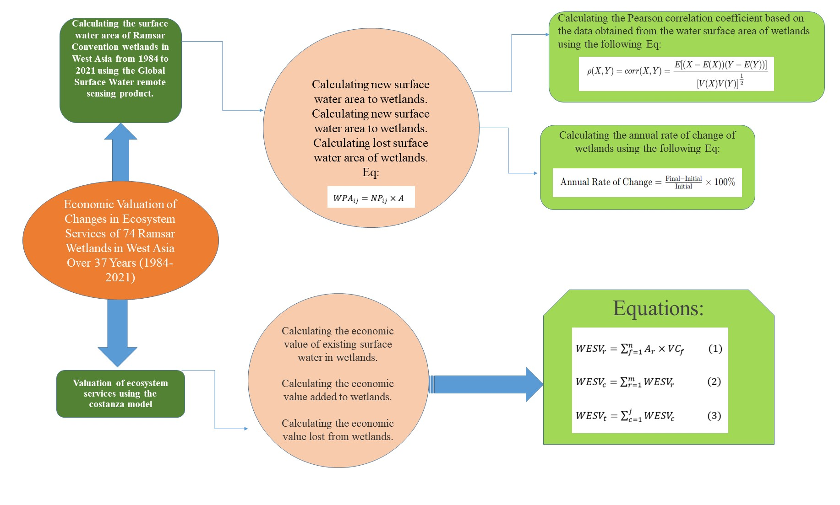

Fig S2. Conceptual model of the study method.

Table S4. Amount of surface water in Ramsar Convention wetlands in West Asian countries, based on km²

|  |  |  |  |  |  |  |  |  |  |  |  |
| --- | --- | --- | --- | --- | --- | --- | --- | --- | --- | --- | --- |
| Ephemeral seasonal | Ephemeral permanent | Permanent to seasonal | Seasonal to permanent | Lost seasonal | New seasonal | Seasonal | Lost permanent | New permanent | Permanent | WETLAND | COUNTRY |
| 0 | 0 | 0 | 0.0873 | 0 | 0 | 0 | 0.0009 | 0.144 | 0 | Khor Virap | Armenia |
| 0.1008 | 0.0018 | 6.4485 | 0.4842 | 0.3546 | 5.3514 | 0.1107 | 0.0405 | 1.7289 | 19.8558 | Lake Arpi | Armenia |
| 28.3527 | 0.0315 | 0.2205 | 3.8223 | 0.1377 | 0.3672 | 0.0459 | 0.0459 | 0.2952 | 1905.282 | Lake Sevan | Armenia |
| 25.3557 | 1.9809 | 50.1489 | 170.6598 | 41.9409 | 1.575 | 17.901 | 4.7457 | 212.1849 | 66.618 | Agh-Ghol | Azerbaijan |
| 15.6843 | 101.8782 | 190.2798 | 224.7993 | 213.5295 | 1.0737 | 89.5824 | 138.0906 | 284.2011 | 36.1377 | Ghizil-Agaj | Azerbaijan |
| 0.5526 | 0.1251 | 1.7424 | 1.6848 | 0.1791 | 0.3942 | 0.5427 | 0.0126 | 2.6154 | 3.1707 | Hawar Islands | Bahrain |
| 0.0693 | 0.8856 | 0.2907 | 0.8775 | 0.4662 | 0.0045 | 1.4661 | 0.0657 | 0.1539 | 12.6306 | Tubli Bay | Bahrain |
| 0.2619 | 0 | 0.0063 | 2.6883 | 0.0189 | 0.0477 | 0.0027 | 0.0324 | 3.546 | 0 | Al Wathba | united arab emirates |
| 0 | 0.0504 | 0.0729 | 0.009 | 1.4751 | 0 | 0.1179 | 0 | 0.0126 | 0.1449 | Al-Zora | united arab emirates |
| 4.6134 | 10.7514 | 14.4234 | 6.4251 | 5.8806 | 8.2314 | 8.5041 | 0.0018 | 1.3959 | 175.1049 | Bul Syayeef | united arab emirates |
| 0.2763 | 0 | 0 | 0.1737 | 0 | 0 | 0 | 0 | 0.0054 | 0 | Hatta Mountain | united arab emirates |
| 0 | 0.0504 | 0.0729 | 0.009 | 1.4751 | 0 | 0.1179 | 0 | 0.0126 | 0.1449 | Jabal Ali | united arab emirates |
| 0.0315 | 0.0486 | 0.0612 | 0.9612 | 0.0576 | 0.0018 | 0.1647 | 0.0009 | 0.2061 | 1.5381 | Mangrove and Alhafeya | united arab emirates |
| 0.3393 | 0.5175 | 0.1584 | 0.378 | 0.3888 | 0.1116 | 0.1638 | 0.6237 | 1.2123 | 0.2313 | Ras Al Khor | united arab emirates |
| 0.1809 | 0.0234 | 0.0783 | 0.1287 | 0.0153 | 0.0351 | 0.0477 | 0 | 0.0036 | 0.6012 | Sir Bu Nair Island | united arab emirates |
| 0.0729 | 0 | 0.0036 | 0.3906 | 0 | 0 | 0 | 0 | 0.3645 | 0 | Wadi Wurayah | united arab emirates |
| 0.2133 | 0.0054 | 0.0288 | 1.5075 | 0.0153 | 0 | 0.0198 | 0.0198 | 0.279 | 0 | Wasit | united arab emirates |
| 0.2367 | 0.1242 | 1.9944 | 2.7261 | 0.8586 | 0.0063 | 0.7866 | 0 | 1.1493 | 0.0585 | Ajigol | Iran |
| 1.0305 | 0.0036 | 1.3023 | 24.1992 | 1.4562 | 0.0117 | 4.4136 | 1.3905 | 31.9338 | 7.5762 | Alagol | Iran |
| 0.0045 | 0.0927 | 0.6426 | 0.4104 | 0.4923 | 0.0261 | 1.3869 | 0.0135 | 1.5102 | 0.7128 | Ulmagol | Iran |
| 0 | 0 | 3.6756 | 0.5544 | 0.1593 | 0 | 0.1233 | 0 | 0.0477 | 0.0009 | Amirkelayeh | Iran |
| 0.0738 | 2.8161 | 2.5695 | 6.3135 | 6.9255 | 0.009 | 48.4866 | 4.1094 | 9.2439 | 4.5171 | Anzali | Iran |
| 0 | 0.0045 | 4.7457 | 0.7146 | 6.2811 | 0 | 0.0009 | 0.0018 | 15.1974 | 0 | Arjan | Iran |
| 0.5103 | 0 | 0.8595 | 10.7343 | 0.0027 | 0.1503 | 4.9626 | 0 | 0.3402 | 2.4381 | Choghakhor | Iran |
| 0.5823 | 0.0666 | 23.4783 | 26.6499 | 1.224 | 1.3815 | 8.4402 | 0 | 0.1584 | 8.1972 | Deltas of Rud-e-Gaz and Rud-e-Hara | Iran |
| 4.5846 | 0.8343 | 26.8767 | 102.5208 | 1.9854 | 4.5684 | 10.3185 | 0 | 1.386 | 33.2082 | Deltas of Rud-e-Shur, Rud-e-Shirin and Rud-e-Minab | Iran |
| 0 | 0.0603 | 1.9638 | 1.1547 | 0.6156 | 0.0441 | 0.4518 | 0 | 0.0684 | 2.5515 | Dorgeh Sangi | Iran |
| 0.3771 | 0 | 14.7807 | 12.312 | 4.5396 | 0.1341 | 0 | 0 | 5.2965 | 0.0675 | Fereydoon Kenar, Ezbaran & Sorkh Ruds Ab-Bandans | Iran |
| 0 | 3.6702 | 27.7443 | 285.6978 | 12.7215 | 0 | 9.6525 | 50.2506 | 274.1724 | 0 | Gavkhouni | Iran |
| 0 | 0.2421 | 3.6027 | 0.0144 | 2.5848 | 0 | 0.2079 | 0 | 0.7011 | 0 | Lake Kobi | Iran |
| 0 | 0 | 1.2825 | 0.0045 | 0.0828 | 0 | 0.7605 | 0 | 0 | 0 | Lake Gori | Iran |
| 0.7695 | 67.086 | 1.2636 | 33.84 | 6.8319 | 0.0018 | 86.0391 | 57.9834 | 33.633 | 2.3553 | Gomishan | Iran |
| 1.7046 | 0.0009 | 21.4839 | 106.2027 | 1.1187 | 0.7344 | 1.6812 | 0 | 29.502 | 9.3222 | Govater Bay and Hur-e-Bahu | Iran |
| 0 | 370.0791 | 51.309 | 31.1679 | 534.942 | 0 | 17.5788 | 914.2515 | 1826.4699 | 0 | Hamun | Iran |
| 0.1341 | 0.0108 | 1.0359 | 8.3007 | 0.7884 | 0.0558 | 0.8847 | 0.0018 | 2.9304 | 0.1107 | Kanibarazan | Iran |
| 0.6228 | 0.2034 | 41.8869 | 8.5095 | 11.6496 | 1.044 | 8.0892 | 0 | 3.1878 | 175.1166 | Khuran Straits | Iran |
| 2.0088 | 83.5308 | 1.2321 | 16.7643 | 9.3105 | 0.1125 | 72.9522 | 109.7766 | 75.5217 | 515.1294 | Miankaleh | Iran |
| 0 | 33.2118 | 0.0153 | 0 | 2.8719 | 0 | 0.0018 | 7.0884 | 12.5226 | 0 | Parishan | Iran |
| 46.2159 | 2.0412 | 1135.593 | 684.3537 | 432.2097 | 72.0711 | 20.1888 | 0.2484 | 861.9093 | 96.7383 | Shadegan | Iran |
| 3.2985 | 0 | 0.3582 | 5.0967 | 0.2565 | 5.0724 | 0 | 0.0441 | 1.6614 | 9.7119 | Shurgol | Iran |
| 0.0846 | 3.0312 | 0.5535 | 1.0728 | 1.1313 | 0.0099 | 0.6354 | 1.1448 | 2.9151 | 0.4284 | Bujagh | Iran |
| 1.9998 | 1144.7406 | 197.9172 | 285.678 | 315.4293 | 0.5679 | 2601.5166 | 39.7062 | 599.0643 | 3420.7929 | Lake Urmia | Iran |
| 0 | 0 | 0 | 0.0459 | 0.0207 | 0 | 0 | 0 | 1.8891 | 0 | Yadegarlu | Iran |
| 0.4986 | 0.0054 | 1.7802 | 5.0679 | 0.3033 | 0.0414 | 0.0315 | 0.0567 | 1.9152 | 11.5992 | Zarivar | Iran |
| 0 | 54.2709 | 102.753 | 228.7053 | 573.4089 | 0 | 80.1333 | 307.3599 | 564.8985 | 1.3563 | Neiriz Lakes & Kamjan | Iran |
| 0 | 0 | 0.0243 | 0.1638 | 0 | 0.0045 | 0.0018 | 0 | 0.0198 | 0.1332 | Barm Alvan | Iran |
| 0.0675 | 0 | 0.0036 | 0.0234 | 0 | 0 | 0.0018 | 0 | 0 | 0.0603 | Sheedvar Island | Irai |
| 100.0494 | 85.149 | 319.3308 | 971.235 | 579.5568 | 47.4606 | 70.7265 | 23.4972 | 1240.9416 | 59.4477 | Central Marshes | Iraq |
| 213.4278 | 35.631 | 384.9021 | 726.2019 | 529.956 | 108.1809 | 138.4434 | 9.4761 | 800.5311 | 280.8747 | Hammar Marsh | Iraq |
| 97.4133 | 120.3435 | 528.1452 | 302.3415 | 625.8717 | 80.2431 | 160.3539 | 45.0432 | 828.8649 | 343.3671 | Hawizeh Marsh | Iraq |
| 0 | 3.132 | 0 | 0 | 0.2457 | 0 | 1.0602 | 0.009 | 0.2034 | 2.115 | Sawa Lake | Iraq |
| 0.009 | 0 | 2.4543 | 54.3141 | 0.0027 | 0 | 0 | 0 | 18.306 | 0 | Azraq Oasis | Jordan |
| 0 | 0 | 0 | 0.0099 | 0 | 0 | 0 | 0 | 0.0009 | 0 | Fifa | Jordan |
| 1.0503 | 0 | 9.8298 | 21.0708 | 0.1224 | 12.4002 | 3.6576 | 0 | 3.9816 | 154.908 | Mubarak Al-Kabeer | Kuwait |
| 0.0018 | 0 | 0.0612 | 0.2349 | 0.747 | 0.0117 | 0 | 0 | 3.7575 | 0 | Ammiq | Lebanon |
| 0.0126 | 0.0018 | 0.0513 | 0.072 | 0.0054 | 0.0117 | 0.009 | 0 | 0.0009 | 0.1098 | Deir el Nouriyeh cliffs | Lebanon |
| 0.009 | 0 | 0.0189 | 0.045 | 0.0117 | 0.0207 | 0.0081 | 0 | 0.0036 | 0.0333 | Palm Islands | Lebanon |
| 0.0864 | 0.0036 | 0.0027 | 0.0432 | 0.0054 | 0.0306 | 0.0108 | 0 | 0.0108 | 0.0864 | Tyre Beach | Lebanon |
| 0.0099 | 0 | 0 | 0.0225 | 0 | 0 | 0 | 0 | 0.0027 | 0 | Al Ansab Wetland | Oman |
| 0.0657 | 0.0027 | 0.009 | 0.1134 | 0.0189 | 0.0027 | 0.0207 | 0.0036 | 0.1701 | 0.1377 | Qurm | Oman |
| 3.5739 | 0.4869 | 40.1805 | 66.6819 | 16.7823 | 2.178 | 34.11 | 0.1242 | 93.8709 | 96.9822 | Wetlands Reserve in Al Wusta | Oman |
| 55.1196 | 23.9841 | 90.3177 | 138.2364 | 10.0125 | 16.5366 | 3.9258 | 0.0729 | 16.1775 | 2.4777 | Sabkhat al-Jabbul | Syria |
| 5.1183 | 0.1134 | 1.2096 | 8.2296 | 3.0447 | 0.6444 | 0.4293 | 0.0234 | 12.9996 | 76.9761 | Akyatan | Turkiye |
| 22.2372 | 0.0081 | 1.935 | 14.2542 | 0.5679 | 7.2702 | 0.2709 | 0.0261 | 2.6568 | 29.0781 | Gediz Delta | Turkiye |
| 1.5723 | 1.9845 | 1.5345 | 4.6017 | 2.4102 | 0.9648 | 1.3959 | 0.3879 | 1.4769 | 17.1189 | Göksu Delta | Turkiye |
| 1.7199 | 0.3915 | 13.3299 | 33.4386 | 3.2517 | 2.232 | 0.9558 | 0.0279 | 6.5529 | 38.3085 | Kizilirmak Delta | Turkiye |
| 0 | 0 | 0.0009 | 0.0036 | 0 | 0.0018 | 0 | 0 | 0.0108 | 0.0189 | Kizören Obrouk | Turkiye |
| 0.0837 | 91.3608 | 2.0061 | 0.1719 | 9.1926 | 0 | 20.5641 | 0 | 0.8667 | 179.9874 | Lake Burdur | Turkiye |
| 0.3276 | 0.3078 | 6.7644 | 10.7712 | 10.5075 | 0.1566 | 2.1591 | 0 | 14.9319 | 222.4251 | Lake Kus | Turkiye |
| 0 | 0.4518 | 1.1979 | 0.0162 | 0.9684 | 0 | 0.1008 | 0.0108 | 0.9522 | 0 | Lake Kuyucuk | Turkiye |
| 0 | 1.179 | 9.2295 | 3.4488 | 36.2844 | 0 | 20.8773 | 0.0387 | 29.5461 | 0.0009 | Lake Seyfe | Turkiye |
| 0.1494 | 0.0999 | 28.4067 | 23.0292 | 12.4209 | 0.1008 | 2.7486 | 0.0018 | 6.9642 | 169.3773 | Lake Uluabat | Turkiye |
| 0 | 0.6444 | 0.0009 | 0.0036 | 0.1296 | 0 | 0.0279 | 0.0117 | 0.144 | 0 | Meke Maar | Turkiye |
| 0.0072 | 0.1611 | 0.1377 | 0.2205 | 0.0783 | 0.0036 | 0.3555 | 0.0198 | 0.1278 | 18.0891 | Nemrut Caldera | Turkiye |
| 0.7371 | 3.2607 | 52.0533 | 13.9725 | 63.2169 | 0.4149 | 16.4826 | 0.0351 | 13.3038 | 0.3969 | Sultan | Turkiye |
| 0.8784 | 0.2916 | 13.977 | 22.0824 | 7.6257 | 2.3517 | 1.2915 | 0.0306 | 7.3395 | 44.9946 | Yumurtalik | Turkiye |
| 0.1512 | 0.0063 | 0.6471 | 0.3717 | 0.126 | 0.1143 | 0.4698 | 0.0108 | 0.054 | 2.1654 | Detwah | Yemen |

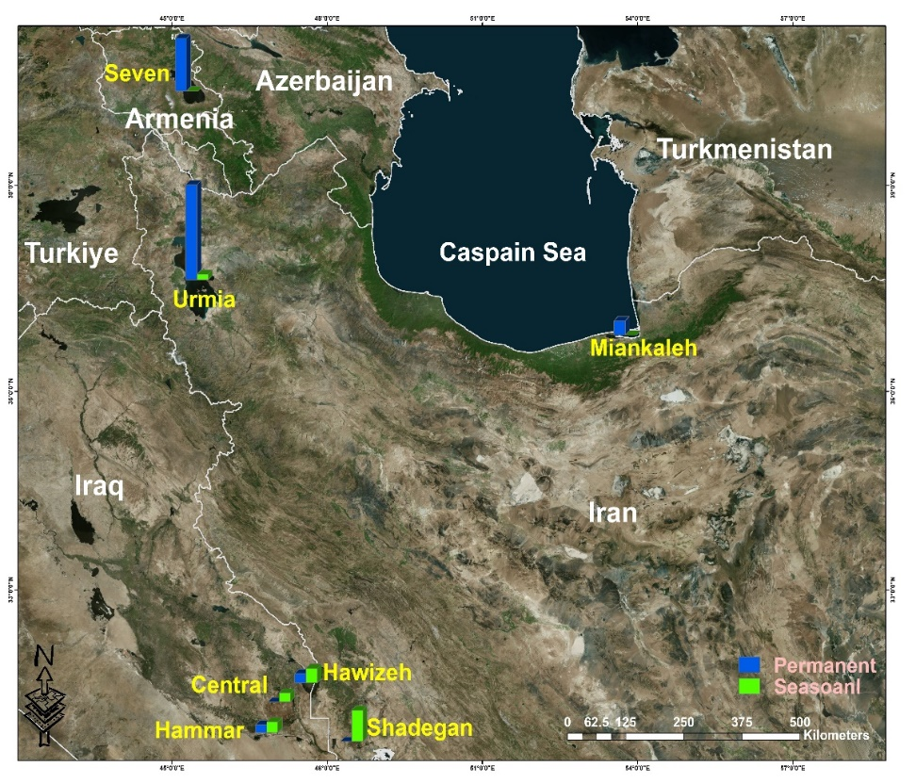

Fig S3- Five wetlands with the highest permanent and seasonal surface water.

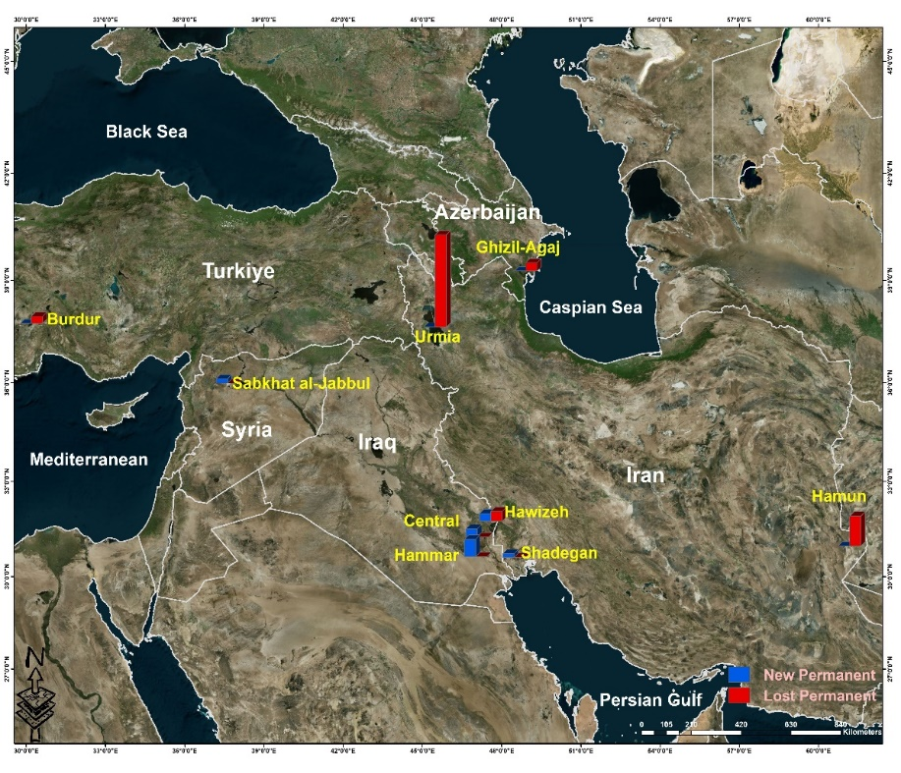

Fig S4- Five wetlands with the highest amount of new and lost permanent surface water.

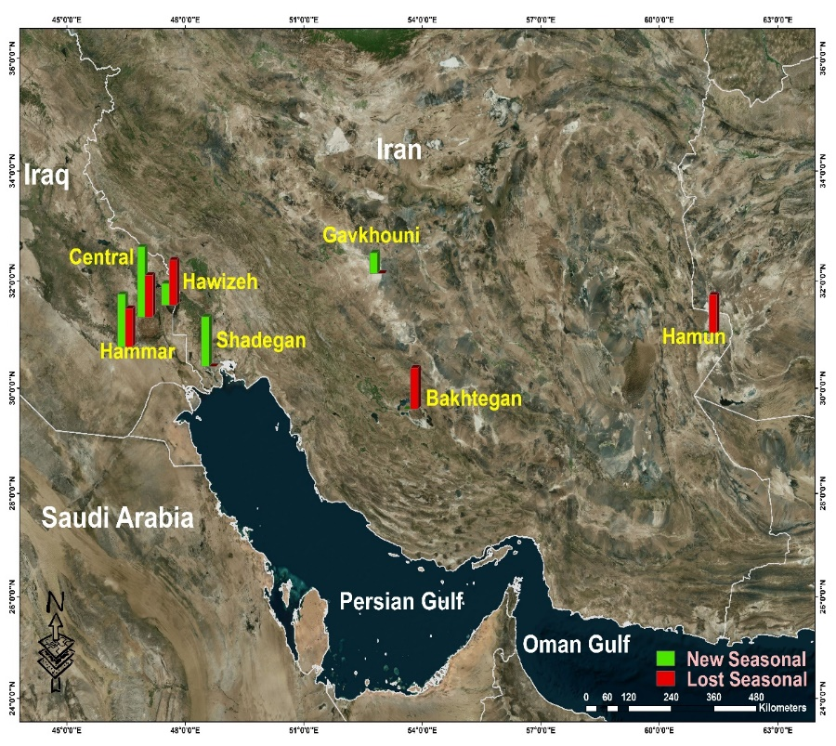

Fig S5- Five wetlands with the highest rate of new and lost seasonal surface water.

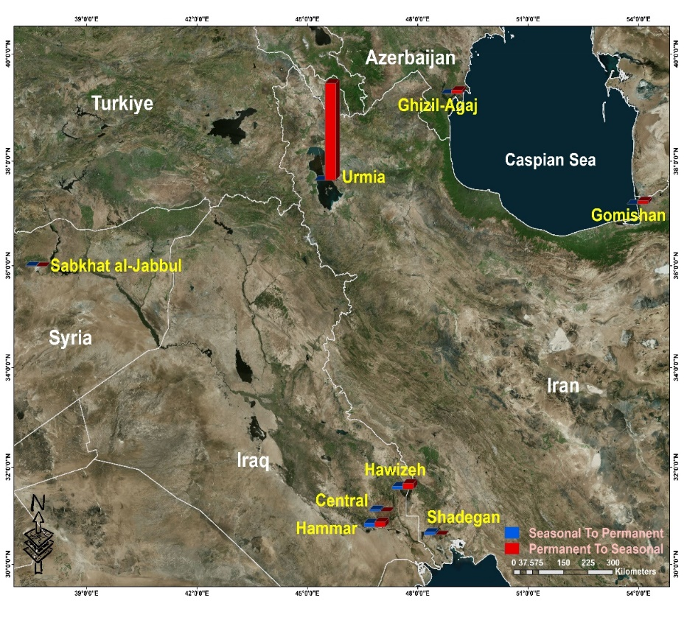

Fig S6- Five wetlands with the highest seasonal to permanent and permanent to seasonal changes in surface water.

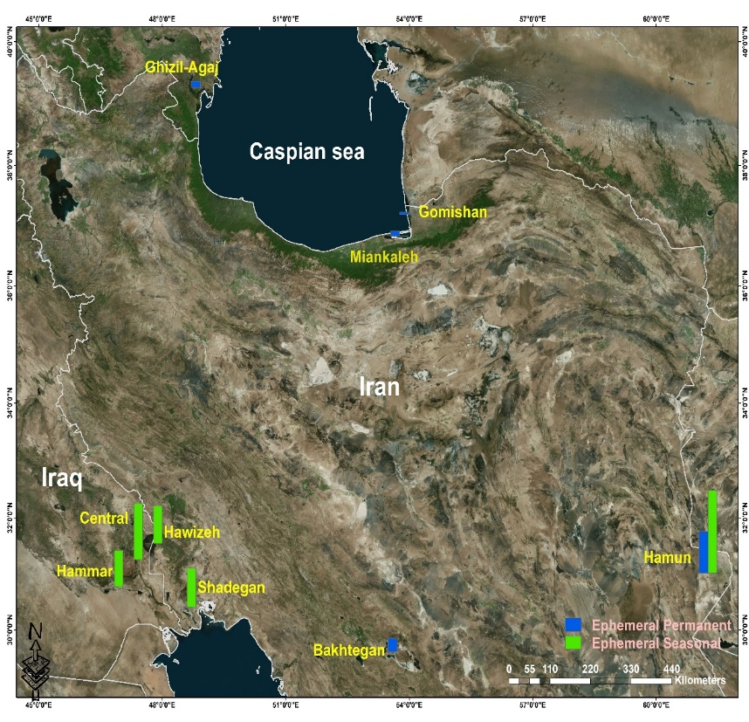

Fig S7- Five wetlands with the highest permanent and seasonal ephemeral surface water.

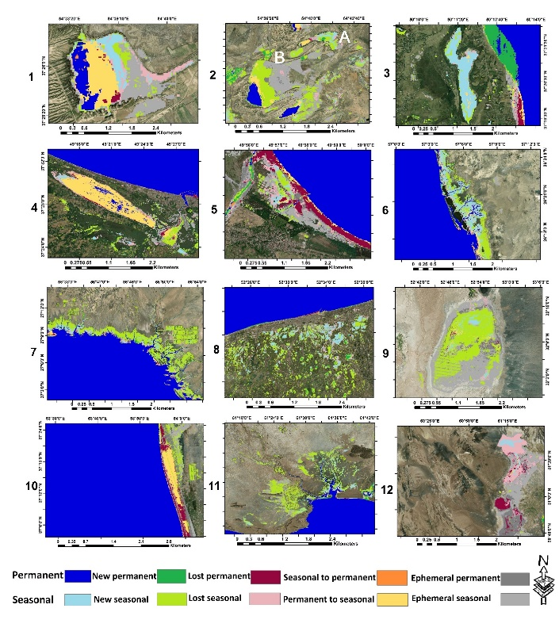

Fig S8: Iran:1- Alagol 2- A: Ajigol B: Ulmagol 3- Amirkelayeh Lake 4- Anzali Wetland Complex 5- Bujagh National Park 6- Deltas of Rud-e-Gaz and Rud-e-Hara 7- Deltas of Rud-e-Shur, Rud-e-Shirin and Rud-e-Minab 8- Fereydoon Kenar & Ezbaran 9- Gavkhouni Lake 10- Gomishan 11- Govater Bay and Hur-e-Bahu 12- Hamun

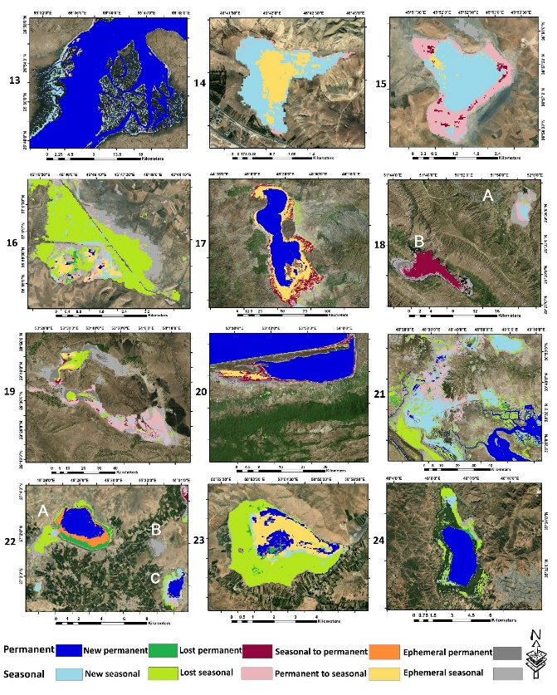

Fig S9: Iran:13- Khuran Straits 14- Lake Gori 15- Lake Kobi 16- Kanibarazan Wetland 17- Lake Urmia 18- A:Dasht-e-Arjan B:Lake Parishan 19- Bakhtegan 20- Miankaleh 21- Shadegan 22- A:Shurgol B:Yadegarlu C:Dorgeh Sangi

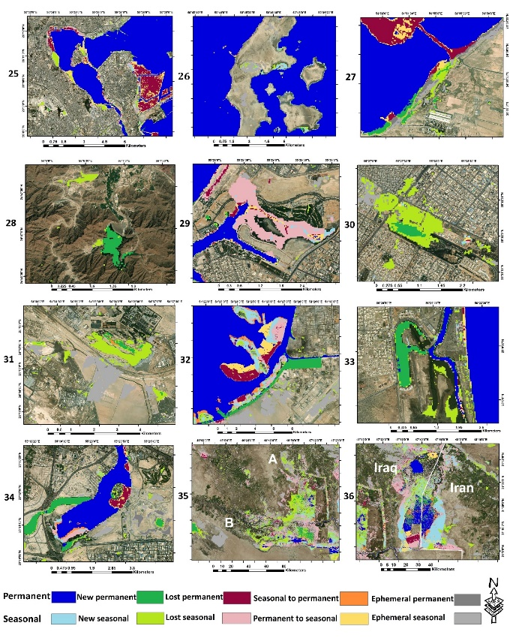

Fig S10: Bahrain: 25- Tubli Bay 26- Hawar Islands

United Arab Emirates: 27- Jabal Ali Wetland Sanctuary 28- Hatta Mountain Reserve 29- Al-Zora Protected Area 30- Wasit Nature Reserve 31- Al Wathba Wetland Reserve 32- Bul Syayeef 33- Mangrove and Alhafeya Protected Area in Khor Kalba 34- Ras Al Khor Wildlife Sanctuary Iraq: 35- A: Central Marshes B: Hammar Marsh 36- Hawizeh Marsh

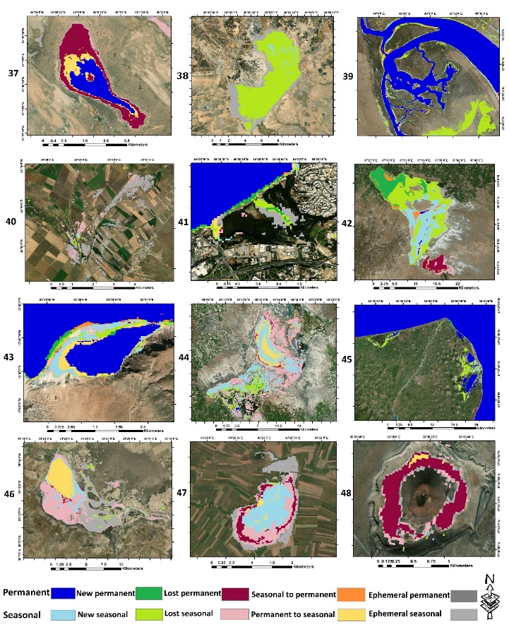

Fig S11: Iraq:37- Sawa Lake Jordan:38- Azraq Oasis Kuwait:39- Mubarak Al-Kabeer Reserve Lebanon:40- Ammiq Wetland Oman:41- Qurm Nature Reserve Syria:42- Sabkhat al-Jabbul Nature Reserve Yemen:43- Detwah. Turkey:44- Sultan Marshes 45- Kizilirmak Delta 46- Lake Seyfe 47- Lake Kuyucuk 48- Meke Maar

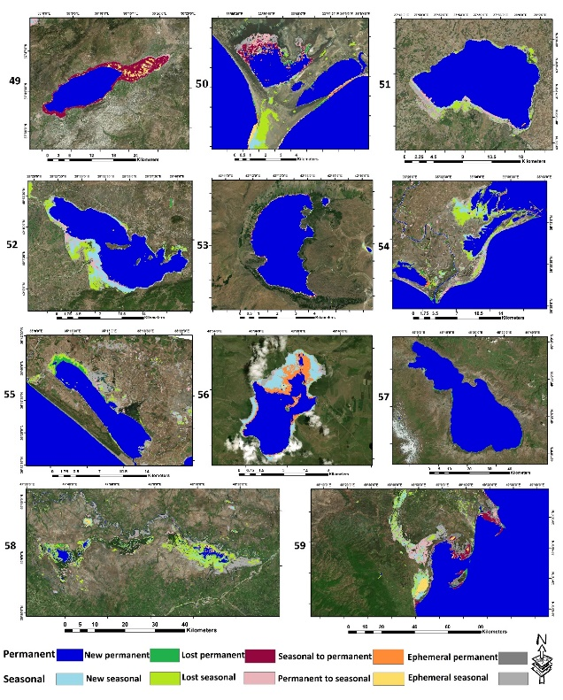

Fig S12: Turkey: 49- Lake Burdur 50- Göksu Delta 51-Lake Kus 52- Lake Uluabat 53- Nemrut Caldera 54- Yumurtalik 55- Akyatan. Armenia:56- Lake Arpi 57- Lake Sevan Azerbaijan:58- Agh-Ghol 59- Ghizil-Agaj

Table S5. The monetary value of ecosystem services provided by Ramsar wetlands and their monetary losses due to the loss of wetland water levels.) US$ per year)

|  |  |  |  |  |  |  |  |  |  |
| --- | --- | --- | --- | --- | --- | --- | --- | --- | --- |
| **Total** | **Ephemeral permanent** | **Permanent to seasonal** | **Lost permanent** | **Total** | **Seasonal to permanent** | **New permanent** | **Permanent** | **WETLAND** | **COUNTRY** |
| 12.615 | 12.615 | 0 | 0 | 0 | 0 | 0 | 0 | Khor Virap | Armenia |
| 2.144.662 | 567.704 | 1.551.726 | 25231.32 | 354.752.359 | 75.012.714 | 1.412.953 | 278.326.690 | Lake Arpi | Armenia |
| 1.728.345 | 643.398 | 643.398 | 441548.1 | 27.109.678.233 | 5.147.189 | 397.431.137 | 26.707.099.907 | Lake Sevan | Armenia |
| 345.214.920 | 66.522.375 | 250.925.477 | 27767067.66 | 1.311.309.547 | 22.077.405 | 355.420.989 | 933.811.153 | Agh-Ghol | Azerbaijan |
| 4.619.450.991 | 1.935.671.176 | 1.255.712.334 | 1428067481 | 741.460.185 | 15.050.482 | 219.853.106 | 506.556.596 | Ghizil-Agaj | Azerbaijan |
| 9.537.438 | 176.619 | 7.607.242 | 1753576.74 | 57.716.644 | 5.525.659 | 7.746.015 | 44.444.970 | Hawar Islands | Bahrain |
| 33.885.662 | 920.943 | 20.550.910 | 12413809.44 | 178082656.6 | 63.078 | 971.405 | 177.048.172 | Tubli Bay | Bahrain |
| 492.010 | 454.163 | 37.846 | 0 | 4.339.787 | 668.629 | 3.671.157 | 0 | Al Wathba | united arab emirates |
| 2.359.128 | 0 | 1.652.651 | 706476.96 | 2.031.121 | 0 | 0 | 2.031.121 | Al-Zora | united arab emirates |
| 269.937.277 | 25.231 | 119.205.371 | 150706674.4 | 2.634.566.125 | 115.382.826 | 64.667.873 | 2.454.515.425 | Bul Syayeef | united arab emirates |
| 0 | 0 | 0 | 0 | 3.873.007 | 0 | 3.873.007 | 0 | Hatta Mountain | united arab emirates |
| 2.359.128 | 0 | 1.652.651 | 706476.96 | 2.031.121 | 0 | 0 | 2.031.121 | Jabal Ali | united arab emirates |
| 3.002.527 | 12.615 | 2.308.665 | 681245.64 | 22.026.942 | 25.231 | 441.548 | 21.560.162 | Mangrove and Alhafeya | united arab emirates |
| 18.292.707 | 8.742.652 | 2.296.050 | 7254004.5 | 9.562.670 | 1.564.341 | 4.756.103 | 3.242.224 | Ras Al Khor | united arab emirates |
| 996.637 | 0 | 668.629 | 328007.16 | 11.455.019 | 492.010 | 2.535.747 | 8.427.260 | Sir Bu Nair Island | united arab emirates |
| 0 | 0 | 0 | 0 | 1.021.868 | 0 | 1.021.868 | 0 | Wadi Wurayah | united arab emirates |
| 630.783 | 277.544 | 277.544 | 75693.96 | 2.989.911 | 0 | 2.989.911 | 0 | Wasit | united arab emirates |
| 12.767.047 | 0 | 11.026.086 | 1740961.08 | 4.226.246 | 88.309 | 3.317.918 | 820.017 | Ajigol | Iran |
| 81.408.853 | 19.491.194 | 61.867.196 | 50462.64 | 120.807.560 | 164.003 | 14.444.930 | 106.198.625 | Alagol | Iran |
| 20.929.379 | 189.234 | 19.440.732 | 1299412.98 | 10.420.535 | 365.854 | 63.078 | 9.991.602 | Ulmagol | Iran |
| 1.728.345 | 0 | 1.728.345 | 0 | 12.615 | 0 | 0 | 12.615 | Amirkelayeh | Iran |
| 776.733.570 | 57.603.103 | 67.965.606 | 39474400.14 | 64.478.638 | 126.156 | 1.034.484 | 63.317.997 | Anzali | Iran |
| 100.925 | 25.231 | 12.615 | 63078.3 | 0 | 0 | 0 | 0 | Arjan | Iran |
| 69.562.749 | 0 | 69.562.749 | 0 | 43.435.717 | 2.106.815 | 7.153.079 | 34.175.822 | Choghakhor | Iran |
| 119.243.218 | 0 | 118.309.659 | 933558.84 | 142.430.801 | 19.365.038 | 8.162.332 | 114.903.431 | Deltas of Rud-e-Gaz and Rud-e-Hara | Iran |
| 156.333.258 | 0 | 144.638.541 | 11694716.82 | 593.793.884 | 64.037.090 | 64.264.172 | 465.492.622 | Deltas of Rud-e-Shur, Rud-e-Shirin and Rud-e-Minab | Iran |
| 7.178.310 | 0 | 6.333.061 | 845249.22 | 36.383.563 | 618.167 | 0 | 35.765.396 | Dorgeh Sangi | Iran |
| 0 | 0 | 0 | 0 | 8.111.869 | 1.879.733 | 5.285.961 | 946.174 | Fereydoon Kenar, Ezbaran & Sorkh Ruds Ab-Bandans | Iran |
| 891.132 | 704.382 | 135.302 | 51.446.661 | 0 | 0 | 0 | 0 | Gavkhouni | Iran |
| 6.307.830 | 0 | 2.914.217 | 3.393.612 | 0 | 0 | 0 | 0 | Lake Kobi | Iran |
| 10.660.232 | 0 | 10.660.232 | 0 | 0 | 0 | 0 | 0 | Lake Gori | Iran |
| 2.959.192.288 | 812.776.511 | 1.206.044.480 | 940.371.296 | 43.826.802 | 25.231 | 10.786.389 | 33.015.182 | Gomishan | Iran |
| 23.578.668 | 0 | 23.566.052 | 12.615 | 164.861.444 | 10.294.378 | 23.894.060 | 130.673.006 | Govater Bay and Hur-e-Bahu | Iran |
| 18.249.384.824 | 12.815.428.976 | 246.409.071 | 5.187.546.776 | 0 | 0 | 0 | 0 | Hamun | Iran |
| 12.577.813 | 25.231 | 12.401.193 | 151387 | 4.213.630 | 782.170 | 1.879.733 | 1.551.726 | Kanibarazan | Iran |
| 116.240.691 | 0 | 113.389.552 | 2.851.139 | 2.478.043.631 | 14.634.165 | 8.730.036 | 2.454.679.429 | Khuran Straits | Iran |
| 3.732.267.317 | 1.538.782.513 | 1.022.600.168 | 1.170.884.636 | 7.250.509.962 | 1.576.957 | 28.158.153 | 7.220.774.852 | Miankaleh | Iran |
| 564.929.254 | 99.360.938 | 25.231 | 465.543.085 | 0 | 0 | 0 | 0 | Parishan | Iran |
| 315.088.724 | 3.481.922 | 282.994.485 | 28.612.316 | 3.014.095.640 | 1.010.249.437 | 647.826.756 | 1.356.019.446 | Shadegan | Iran |
| 618.167 | 618.167 | 0 | 0 | 253.473.840 | 71.101.859 | 46.236.393 | 136.135.587 | Shurgol | Iran |
| 67.443.318 | 16.047.119 | 8.906.655 | 42.489.542 | 7.329.698 | 138.772 | 1.185.872 | 6.005.054 | Bujagh | Iran |
| 53.069.363.363 | 556.577.687 | 36.466.498.789 | 16.046.286.886 | 47.986.614.874 | 7.960.481 | 28.031.996 | 4.795.062.239 | Lake Urmia | Iran |
| 0 | 0 | 0 | 0 | 0 | 0 | 0 | 0 | Yadegarlu | Iran |
| 1.312.028 | 794.786 | 441.548 | 75.693 | 170.160.022 | 580.320 | 6.989.075 | 162.590.626 | Zarivar | Iran |
| 6.192.384.095 | 4.308.386.662 | 1.123.260.519 | 760.736.913 | 19.011.799 | 0 | 0 | 19.011.799 | Neiriz Lakes & Kamjan | Iran |
| 1.123.260.519 | 0 | 1.123.260.519 | 0 | 1.930.195 | 63.078 | 0 | 1.867.117 | Barm Alvan | Iran |
| 25.231 | 0 | 25.231 | 0 | 1.791.423 | 0 | 845.249 | 946.174 | Sheedvar Island | Iran |
| 2.514.338.885 | 329.369.651 | 991401641 | 1.193.567.593 | 2.901.008.864 | 665.274.214 | 1.402.432.460 | 833.302.190 | Central Marshes | Iraq |
| 2.572.900.779 | 132.830.284 | 1.940.616.515 | 499.453.979 | 8.445.250.811 | 1.516.414.948 | 2.991.702.844 | 3.937.133.020 | Hammar Marsh | Iraq |
| 4.566.036.286 | 631.388.551 | 2.247.744.758 | 1.686.902.977 | 7.303.394.809 | 1.124.799.630 | 136.5481.191 | 4.813.113.988 | Hawizeh Marsh | Iraq |
| 58.889.900 | 126.156 | 14.861.247 | 43.902.496 | 29.646.801 | 0 | 0 | 29.646.801 | Sawa Lake | Iraq |
| 0 | 0 | 0 | 0 | 126.156 | 0 | 126.156 | 0 | Azraq Oasis | Jordan |
| 0 | 0 | 0 | 0 | 0 | 0 | 0 | 0 | Fifa | Jordan |
| 51.270.042 | 0 | 51.270.042 | 0 | 2.359.948.438 | 173.818.563 | 14.722.475 | 2.171.407.399 | Mubarak Al-Kabeer | Kuwait |
| 0 | 0 | 0 | 0 | 189.234 | 164.003 | 25.231 | 0 | Ammiq | Lebanon |
| 151.387 | 0 | 126.156 | 25.231 | 1.879.733 | 164.003 | 176.619 | 1.539.110 | Deir el Nouriyeh cliffs | Lebanon |
| 113.540 | 0 | 113.540 | 0 | 883.096 | 290.160 | 126.156 | 466.779 | Palm Islands | Lebanon |
| 201.850 | 0 | 151.387 | 50.462 | 2.851.139 | 428.932 | 1.211.103 | 1.211.103 | Tyre Beach | Lebanon |
| 0 | 0 | 0 | 0 | 138.772 | 0 | 138.772 | 0 | Al Ansab Wetland | Oman |
| 378.469 | 50.462 | 290.160 | 37. 846 | 2.888.986 | 37.846 | 920.943 | 1.930.195 | Qurm | Oman |
| 486.699.547 | 1.740.961 | 478.133.514 | 6.825.072 | 1.440.064.973 | 30.529.897 | 1.359.438.290 | 50.096.785 | Wetlands Reserve in Al Wusta | Oman |
| 392.246.100 | 1.021.868 | 55.029.508 | 336.194.723 | 1.039.164.530 | 231.800.136 | 772.633.481 | 34.730.911. | Sabkhat al-Jabbul | Syria |
| 7.935.250 | 328.007 | 6.017.669 | 1.589.573 | 1.159.782.855 | 9.032.812 | 71.745.258 | 1079004784 | Akyatan | Turkiye |
| 4.276.708 | 365.854 | 3.797.313 | 113.540 | 821.216.387 | 101.909.301 | 311.707.727 | 407599358.9 | Gediz Delta | Turkiye |
| 52.821.768 | 5.437.349 | 19.566.888 | 27.817.530 | 275.526.014 | 13.523.987 | 22.039.558 | 239962468.9 | Göksu Delta | Turkiye |
| 19.276.728 | 391.085 | 13.397.830 | 5.487.812 | 592.380.931 | 31.286.836 | 24.108.526 | 536985567.9 | Kizilirmak Delta | Turkiye |
| 0 | 0 | 0 | 0 | 290.160 | 25.231 | 0 | 264928.86 | Kizören Obrouk | Turkiye |
| 1.568.896.093 | 0 | 288.255.215 | 1.280.640.878 | 2.524.128.637 | 0 | 1.173.256 | 2.522.955.381 | Lake Burdur | Turkiye |
| 34.579.524 | 0 | 30.264.968 | 4.314.555 | 3.124.608.822 | 2.195.124 | 4.592.100 | 3.117.821.597 | Lake Kus | Turkiye |
| 7.897.403 | 151.387 | 1.412.953 | 6.333.061 | 0 | 0 | 0 | 0 | Lake Kuyucuk | Turkiye |
| 309.714.453 | 542.473 | 292.645.465 | 16.526.514 | 12.615 | 0 | 0 | 12.615 | Lake Seyfe | Turkiye |
| 39.953.795 | 25.231 | 38.528.225 | 1.400.338 | 2.377.736.519 | 1.412.953 | 2.094.199 | 2.374.229.365 | Lake Uluabat | Turkiye |
| 9.587.901 | 164.003 | 391.085 | 9.032.812 | 0 | 0 | 0 | 0 | Meke Maar | Turkiye |
| 7.518.933 | 277.544 | 4.983.185 | 2.258.203 | 253.713.538 | 50.462 | 100.925 | 253.562.150 | Nemrut Caldera | Turkiye |
| 277.241.744 | 492.010 | 23.104.3197 | 45.706.536 | 21.711.550 | 5.815.819 | 10.332.225 | 5.563.506 | Sultan | Turkiye |
| 2.2619.878 | 428.932 | 18.103.472 | 4.087.473 | 675.984.909 | 32.964.719 | 12.312.884 | 630.707.306 | Yumurtalik | Turkiye |
| 6.825.072 | 151.387 | 6.585.374 | 88.309 | 34.074.897 | 1.602.188 | 2.119.430 | 30.353.277 | Detwah | Yemen |