Supplemental Materials

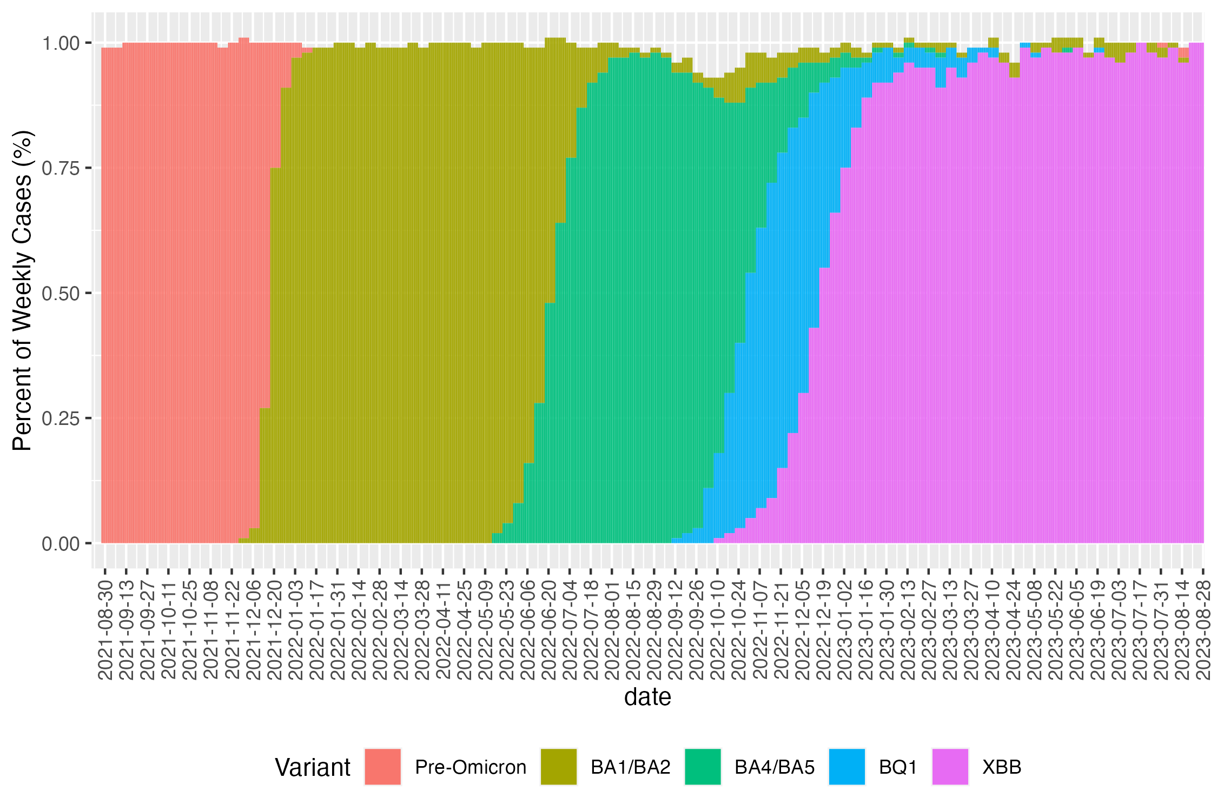
XBB/EG5/FL1

Supplemental Figure 1: Variant distributions reported by NYC department of health were used as weights for MSKCC variant burden estimates. NYC distributions are based on a subset of randomly sampled specimens collected from confirmed COVID-19 cases that meet their technical criteria (e.g. sufficient levels of virus in the sample).⁸ All positive tests prior to plot start were categorized as “pre-omicron”. Several omicron sublineages were grouped together and newer variants FL1 and EG5 were grouped with XBB. BF7 and uncategorized/unknown variants were removed due to small sample sizes.

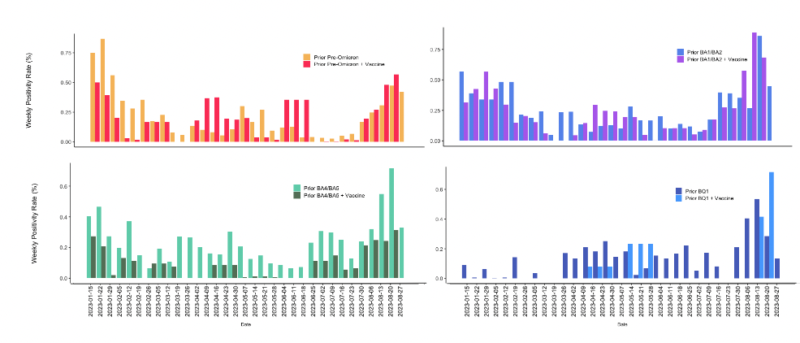
Supplemental Figure 3: Weekly positivity rates for XBB infections per prior variant infection group, stratified by bivalent vaccine status. Rate bars are calculated using a variable moving window (between 7 and 20 days) to stabilize estimates when test counts are low.

