# Revealing complexity: Segmentation of hippocampal subfields in adolescents with major depressive disorder reveals specific links to cognitive dysfunctions

Yixin Zhang1#, Xuan Liu1#, Ying Yang2#, Yihao Zhang1, Qiang He2, Feiyu Xu2, Xinjuan Jin3, Junqi Gao3, Yuan Yao3, Dexin Yu3, Bernhard Hommel1, Xingxing Zhu4*, Kangcheng Wang1,2*, Wenxin Zhang1

1.School of Psychology, Shandong Normal University, Jinan, China

2. Shandong Mental Health Center, Jinan, China

3. Radiology Department of Qilu Hospital, Shandong University, Jinan, China

4. Institute of Health and Wellbeing, University of Glasgow, UK

# These authors contributed equally

* Corresponding authors

**Supplemental methods**

Clinical assessments

Cognitive measurements

MRI data acquisition

Structural preprocessing and segmentation of hippocampal subfields

**Supplemental figures**

Supplemental Figure S1—S8

**Supplemental tables**

Supplemental Table S1 — S6

# Supplemental methods

**Clinical assessments**

The overall severity of depression in these adolescent participants was assessed using the Child Depression Inventory (CDI) [1]. This scale consists of 27 items, each describing a certain symptom of depression. The total score ranges from 0 to 54, with higher scores indicating a higher level of depression. The Chinese version of the CDI has been proven to be reliable and valid in Chinese participants [1]. We categorized our current depressed adolescents into two levels of depressive severity according to a prior study [2]: scores < 25 indicated relative mild depression, scores ≥ 25 indicated relative severe depression.

The presence and intensity of suicidal ideation was assessed using the total score of Beck Scale for Suicide Ideation (BSI), a 19-item instrument. This scale evaluates the suicidal thoughts of participants a week age [3]. Each item is scored based on an ordinal scale from 0 to 2, resulting in a total score ranging from 0 to 38. Participants initially answer the first 5 items, and if they score positively on the fifth item (score 1 and 2), they proceed to answer the remaining items. If the fifth item is answered negatively (0), the questionnaire is completed. No cut-point was used to categorize the scores. Instead, we utilized the median score of 10 to classify participants. Hence, we identified two levels of depressive severity: scores < 10 indicated relative mild depression, while scores ≥ 10 indicated severe depression.

Suicide risk was quantified using the total score of nurses’ global assessment of suicide risk (NGASR) scale. Developed by Cutcliffe et al, (2004), this NGASR scale identifies those psychosocial stressors strongly linked to suicide risk [4]. It includes 15 items, each with a different weigh, resulting in a maximum total score of 25. As suggested in Cutcliffe et al.’s findings, scores of 0-5 indicate low-risk individuals, while scores above 6 indicate intermediate and high-risk individuals. To further define levels of depressive severity, we used this cut-off criteria: scores ≤5 for relative mild depression and scores > 5 for severe depression.

**Cognitive measurements**

Nback task

In this study, the Nback task was used to assess working memory of all participants [5]. This task consisted of 3 conditions: 0 back (20 trials, 1 loop), 1 back (60 trials, 2 loops) and 2 back (60 trials, 2 loops). The stimuli used in this task were numbers ranging from 0 to 9. In the 0back condition, the stimuli appeared once each, and the subject was required to respond. In the 1back condition, they had to decide whether the current stimulus matched the prior stimulus. In the 2back condition, participants had to respond based on whether the current trial’s stimulus matched the stimulus presented 2 trials back. Each trial began with a focus point “+”, appearing for 1000ms, followed by a number appearing for 1000ms. Participant had 3000ms to respond, if no response was received, this trial was skipped. Mean reaction time (RT) in 1back and 2back conditions were utilized for our further statistical analysis.

Spatial memory task

This study utilized the 4 mountain test described in Hartley et al., (2007) [6] to assess the spatial memory abilities [7]. This task consisted of three types of scene recognition, each consisting of 20 trials. In each trial, a focus point “+” appeared on the screen for 1s. Following this, a scene picture featuring four mountains was displayed at the center of the screen for 4s, allowing participants to memorize the image. After 2s blank screen, two alternative scene images were shown for 10 seconds. Participants had to select the image that matched the learning picture. In the first type of task (direction), participants were required to identify which image had the same projected direction of the mountains as the learning image. In the second type of task (position), participants were instructed to identify which image had the same locations of four mountains as the learning image. In the third type of task (arrangement), participants had to identify which one had the same arrangement of the four mountains as the learning image. The correct rate for each type of scene recognition were used in further statistical analysis.

Digit span test

The digit span test is a classic measure of short-term memory storage. The basic idea is as follows: participants are presented with a sequence of digits and are required to repeat it. If the sequence is repeated correctly, a longer sequence is presented. This process continues until the participant can no longer repeat the sequence accurately. The longest sequence that can be remembered is known as the digit span. It is commonly believed that the average person can remember seven digits, based on the pioneering work of George A. Miller [8]. In the current study, we performed this task in both sequential and reverse orders. The sequence length was increased only after the participant successfully remembered the current length on at least two occasions. This modification enhanced the reliability of the digit span measure.

Facial emotion recognition task

To evaluate participants' ability to recognize emotions, we conducted a facial emotional recognition task. This task involves presenting individuals with a series of visual stimuli, human faces from the FACES database [9], that transition gradually from a neutral expression to a specific emotion. The goal is to assess the participants' accuracy in recognizing and identifying the portrayed emotion. We have assessed six primary facial expressions: neutral emotion, sadness, disgust, fear, anger, and happiness. Each emotion was tested across 24 trials, providing a comprehensive assessment of the participants' ability to discern and categorize different emotional states. In this study, we only included RT data for sadness and happiness, as these emotions were more likely to elicit more sensitivity from depressed patients.

Dot-probe task

The dot-probe task is the commonly used task for assessing emotional attention biases. In this study, we implemented the attentional bias task as described in Kim et al. (2014) [10], using emotional images from the FACES database [9]. The present study consisted of 84 trials (42 trials for 2 loops) divided into seven different conditions: sadness-happiness (12 trials), happiness-sadness (12 trials), sadness-neutral (12 trials), neutral-sadness (12 trials), happiness-neutral (12 trials), neutral-happiness (12 trials), and neutral-neutral (10 trials). During each trial, two lateralized cues of two emotional faces were presented on the screen, with one of the faces subsequently replaced by a dark block. Participants were instructed to maintain central fixation during the cue period and respond to the location of the dark dot probe as quickly as possible. The mean RT to the probes were recorded and used for further analysis.

Go/No-Go task

We utilized both classic Go/No-Go task [11] and the modified emotional Go/No-Go task to assess the inhibition factor of the cognitive control abilities in this study. Both tasks consisted of two loops, each containing 96 trials. In the classic Go/No-Go task, three types of conditions were included: frequent-go (green light), infrequent-go (yellow light), and no-go trials (red light). The percentage of each type as follows: 12.5% for no-go trials, 12.5% for infrequent-go trials, and 75.0% for frequent-go trials. These three types of trials were presented in a random order. For the emotional Go/No-Go task, the frequent-go condition (75.0% trials) involved the happiness emotional faces, the infrequent-go condition (12.5% trials) involved the neutral emotional faces, and the no-go condition (12.5% trials) involved sadness emotional faces.

In both the frequent-go and infrequent-go trials, participants were required to press a button, while in the no-go trials, they were required to withhold the response and not press the button. Each trial consisted of a fixation cross presented for 400 ms, followed by a light stimulus or emotional face for 2000ms. Participants were required to respond to each type of condition. The correct rates for no-go conditions were used for further statistical analysis.

Flanker task

To assess the cognitive monitoring factor of cognitive control abilities, we used the Erikson Flanker Task in this study [12]. During this task, participants were asked to focus on the direction of a central arrow and make a response, while ignoring peripheral arrows. The task consisted of congruent and incongruent conditions, with each condition including 40 trails. In the congruent condition, the stimuli were >>>>> or <<<<<; in the incongruent condition, the stimuli were <<><< or >><>>. In each trial, it started with a central cross on a gray background for 1000ms. After that, the flanker arrows were shown for 200ms, followed by a blank gray screen with a maximum response time of 2000ms. A jittered intertrial interval of 500, 750, 1000, 1250 or 1500ms preceded the next trial. We used the difference in response time between incongruent and congruent condition for our further analysis.

Stroop task

The Stroop task is a widely used method for measuring response selection of cognitive control abilities, by using color words [13]. In this study, three types of stimuli were used across 48 trails (24 trials with 2 repetitions): congruent (12 trials), incongruent (24 trials) and neural (12 trials). Trials from three conditions were presented randomly. In the congruent stimuli, the ink color and the word presented the same color (e.g., the word “红” ，which means red, written in red). In the incongruent stimuli, the ink color and the meaning of the word differed (e.g., the word “红” written in green ink). For the neutral stimuli, words without color meaning were used (e.g., the word “张”, which is a first name) but had same length as the color words in Chinese. Three colors (red, yellow and blue) were used, and participants were instructed to responded to the words in red with left button, words in yellow with upper button, words in blue with right button. Each trial began with participants focusing on a white cross at the center of a computer screen for 1000ms. Then, the cross was replaced by a stimulus for 3000ms, during which the participants needed to respond. To analyze the data, the mean RT for the congruent condition was subtracted from the mean RT for the incongruent condition. The difference was used for subsequent statistical analysis.

Task switching

To assess the target selection abilities of cognitive control, we utilized a task switching paradigm, as described in Cubillo et al., (2010) [14]. This task involves shifting between two cognitive performances. If the center arrow was horizontal, participants needed to indicate whether the dot was on the left or right of the grid. If the central arrow was vertical, they had to indicate whether the dot was in the lower or upper part of the grid. Each trial began with a “+” for 1000ms. Then, a red target dot appeared in a grid with two rows, two columns and an arrow in the middle for 3000ms. The participants had 3000s to respond. If the requirement of two consecutive trials remained the same, we defined it as a non-switching condition (68 trials total in our study). If the requirement changed between two consecutive trials, we defined it as a switching condition (32 trials total in our study). For the subsequent analysis, we calculated the difference between mean RT of switching trials minus and non-switching trials and used for subsequent analysis.

Availability of these cognitive tasks

The battery of these cognitive tasks of this study are openly available in Github at https://github.com/Brinks0211/cognitive_paradigms_patients.

**MRI data acquisition**

Structural MRI images were acquired on a SIMENS Verio 3.0T magnetic resonance system (16-channel head coil) at the Shandong University Qilu Hospital. 3D-T1 weighted images were acquired in sagittal scanning with a magnetization-prepared rapid gradient-echo (MPRAGE) imaging sequence (echo time = 2.19ms; repetition time = 2400ms; inversion time = 1000ms; flip angle = 8°; slices = 208; field of view = 224 x 224mm2; matrix = 256 x 256; voxel size = 0.875 x 0.875 x 0.90mm3). In addition, sagittal scans of 3D-T2 weighed images were acquired using SPACE sequence (echo time = 543ms; repetition time = 3500ms; flip angle = 120°; slices = 208; field of view = 224 x 224mm2; matrix = 512 x 512; voxel size = 0.438 x 0.438 x 0.90mm3).

**Structural preprocessing and segmentation of hippocampal subfields**

Both T1 and T2 weighted images were first included into the automatic preprocessing of cortical reconstruction and volumetric segmentation using the completed recon-all pipeline in FreeSurfer v.6.0 (<https://surfer.nmr.mgh.harvard.edu>) [15] with the following command.

recon-all -subject SUBID -i /path/to/T1_volume -T2 /path/to/T2_volume -T2pial -all

In brief, the pipeline involved intensity normalization, skull stripping, Talairach transform, segmentation of white matter and gray matter volumetric regions, and surface extraction [16]. Then, we performed the segmentation of hippocampus subfields; FreeSurfer could interrogate contrast differences between substructures using previously defined in vivo and ex vivo hippocampal atlases to determine 12 substructures [17-19]. By combining T1-weighted and T2-weighted input images, characteristics of 12 substructures were accurately computed. These twelve subfields consisted of CA1, CA2/3, CA4, dentate gyrus, subiculum, presubiculum, parasubiculum, fimbria, fissure, molecular layer, tail and HATA.

We have also re-run the recon-all pipeline of automatic preprocessing of brain reconstruction with T1 weighted images alone using the below command. This pipeline also involved intensity normalization, skull stripping, talairach transform, segmentation of white matter and gray matter volumetric regions, and surface extraction. We then segmented hippocampus subfields into 12 substructures and also got the subfield volumes.

recon-all -subject SUBID -i /path/to/T1_volume -all

# Supplemental figures

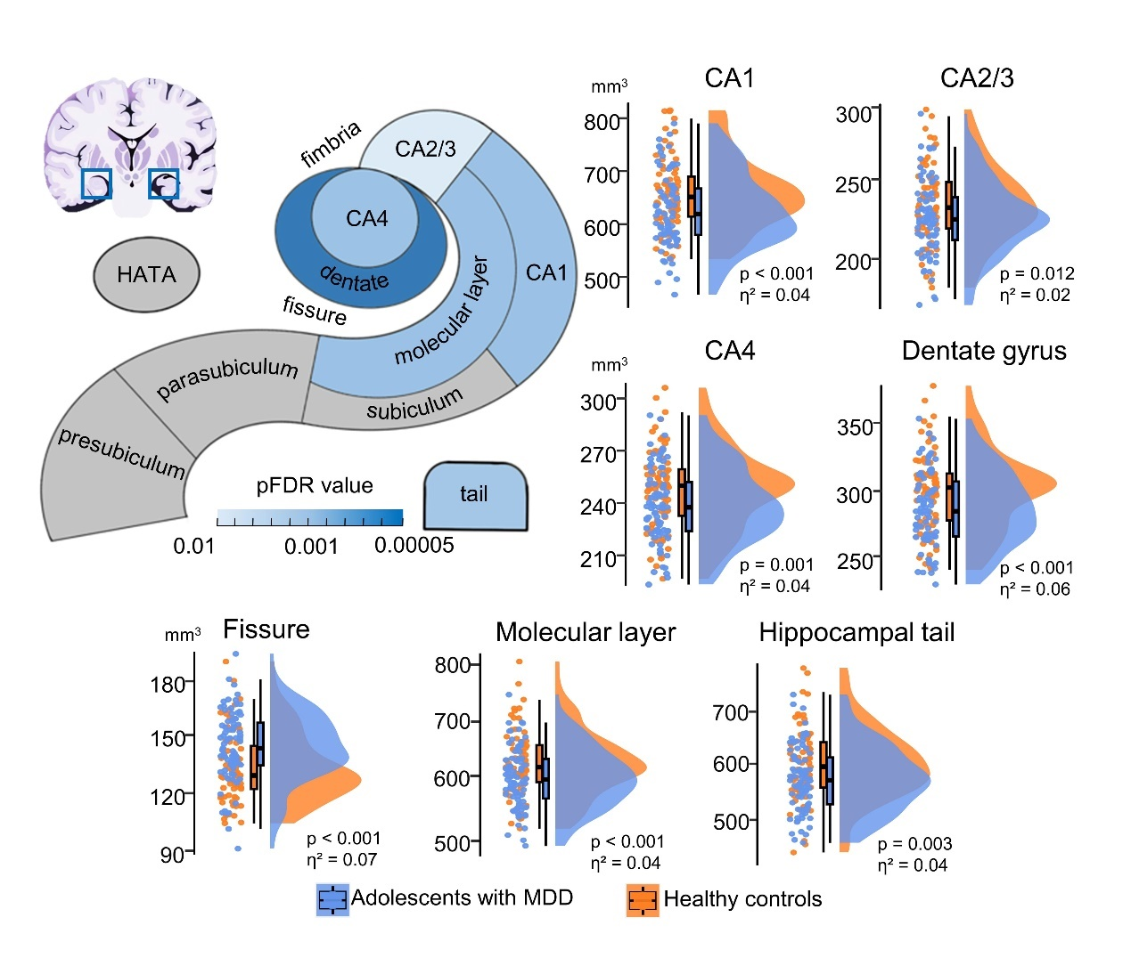

**Figure S1. Volumetric differences in 12 hippocampal subfields between all adolescents with MDD (n = 77) and healthy controls (n = 70), after excluding participants with values beyond 3 standard deviations from the mean.** The subfield volumes were obtained using both T1 and T2 weighted images. The significance (after FDR correction) of these substructure was presented graphically on a Freesurfer hippocampus segmentation schematic. MDD, major depressive disorder; CA, cornu ammonis; HATA, hippocampal amygdalar transition area.

**Figure S2. Progressive abnormalities in volumes of the hippocampal subfields initiated from the core CA regions as disease severity increased (excluding participants with values beyond 3 standard deviations from the mean).** The subfield volumes were obtained using both T1 and T2 weighted images. We assessed disease progression through five measurements, including overall severity (A), illness duration (B), suicidal ideation (C), suicide risk (D), and self-injury behaviour (E). Regardless of the methods used to assess severity, hippocampal substructures consistently demonstrated a tendency to exhibit progressive decreases, starting from the CA region and extending towards more severe peripheral regions. CA, cornu ammonis; HATA, hippocampal amygdalar transition area; NGASR, nurses' global assessment of suicide risk; NSSI, nonsuicidal self-injury.

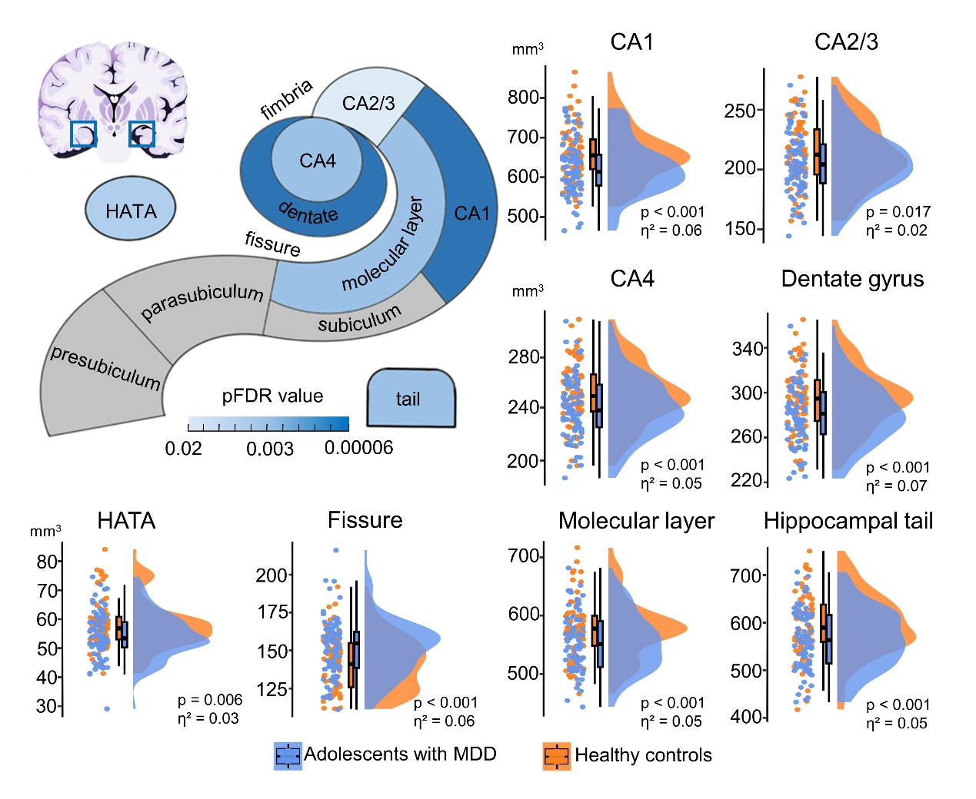

**Figure S3. Volumetric differences in 12 hippocampal subfields between all adolescents with MDD and healthy controls, with only T1 images used for segmentation.** The significance (after FDR correction) of these substructure volume changes in depression was presented graphically on a Freesurfer hippocampus segmentation schematic. MDD, major depressive disorder; CA, cornu ammonis; HATA, hippocampal amygdalar transition area; FDR, false discovery rate.

**Figure S4. Progressive abnormalities in volumes of the hippocampal subfields initiated from the core CA regions as disease severity increased, with only T1 images used for segmentation.** We assessed disease progression through five measurements, including overall severity (A), illness duration (B), suicidal ideation (C), suicide risk (D), and self-injury behaviour (E). Regardless of the methods used to assess severity, hippocampal substructures consistently demonstrated a tendency to exhibit progressive decreases, starting from the CA region and extending towards more severe peripheral regions. CA, cornu ammonis; HATA, hippocampal amygdalar transition area. NGASR, nurses' global assessment of suicide risk; NSSI, nonsuicidal self-injury; FDR, false discovery rate.

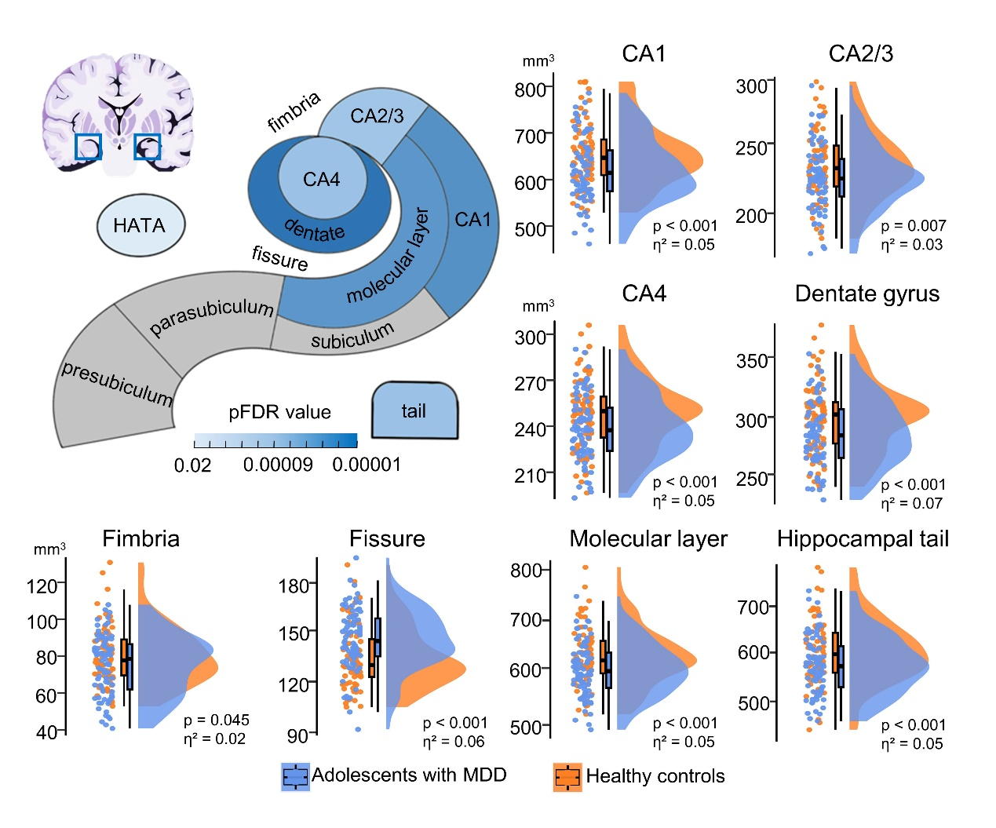

**Figure S5. Volumetric differences in 12 hippocampal subfields between all adolescents with MDD and healthy controls, with only eTIV included as the covariate.** The subfield volumes were obtained using both T1 and T2 weighted images. The significance (after FDR correction) of these substructure volume changes in depression was presented graphically on a Freesurfer hippocampus segmentation schematic. MDD, major depressive disorder; CA, cornu ammonis; HATA, hippocampal amygdalar transition area; FDR, false discovery rate; eTIV, estimated total intracranial volume.

**Figure S6. Progressive abnormalities in volumes of the hippocampal subfields initiated from the core CA regions as disease severity increased, with only eTIV included as the covariate.** The subfield volumes were obtained using both T1 and T2 weighted images. We assessed disease progression through five measurements, including overall severity (A), illness duration (B), suicidal ideation (C), suicide risk (D), and self-injury behaviour (E). Regardless of the methods used to assess severity, hippocampal substructures consistently demonstrated a tendency to exhibit progressive atrophy, starting from the CA region and extending towards more severe peripheral regions. CA, cornu ammonis; HATA, hippocampal amygdalar transition area; NGASR, nurses' global assessment of suicide risk; NSSI, nonsuicidal self-injury; FDR, false discovery rate; eTIV, estimated total intracranial volume.

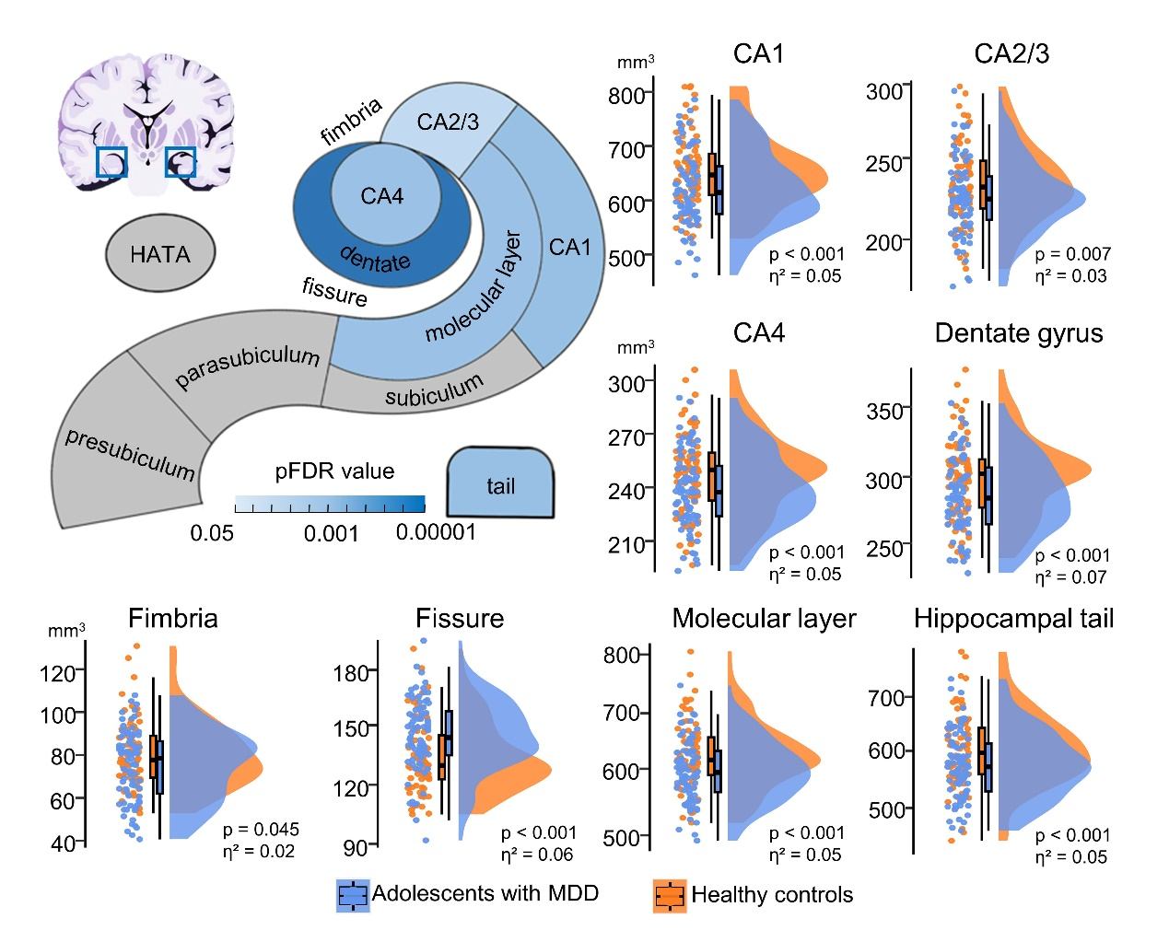

**Figure S7. Volumetric differences in 12 hippocampal subfields between all adolescents with MDD and healthy controls, with BMI included as an additional covariate (age, gender, eTIV and BMI).** The subfield volumes were obtained using both T1 and T2 weighted images. The significance (after FDR correction) of these substructure volume changes in depression was presented graphically on a Freesurfer hippocampus segmentation schematic. MDD, major depressive disorder; CA, cornu ammonis; HATA, hippocampal amygdalar transition area; FDR, false discovery rate; BMI, body mass index; eTIV, estimated total intracranial volume.

**Figure S8. Progressive abnormalities in volumes of the hippocampal subfields initiated from the core CA regions as disease severity increased, with BMI included as an additional covariate (age, gender, eTIV and BMI).** The subfield volumes were obtained using both T1 and T2 weighted images. We assessed disease progression through five measurements, including overall severity (A), illness duration (B), suicidal ideation (C), suicide risk (D), and self-injury behaviour (E). Regardless of the methods used to assess severity, hippocampal substructures consistently demonstrated a tendency to exhibit progressive atrophy, starting from the CA region and extending towards more severe peripheral regions. CA, cornu ammonis; HATA, hippocampal amygdalar transition area; NGASR, nurses' global assessment of suicide risk; NSSI, nonsuicidal self-injury; FDR, false discovery rate; BMI, body mass index; eTIV, estimated total intracranial volume.

# Supplemental tables

**Table S1.** Descriptive values (mean ± standard deviation) of left and right hippocampus subfields for healthy controls and adolescents with major depressive disorder (segmentation with T1 and T2 weighted images)

|  |  |  |
| --- | --- | --- |
| Subfields | Adolescents with MDD (N = 79) | Healthy controls (N = 71) |
| **Left Substructure** |  |  |
| Tail | 565.01±65.37 | 593.28±67.90 |
| Dentate gyrus | 281.88±30.47 | 294.95±30.11 |
| CA1 | 606.90±70.46 | 627.26±71.40 |
| CA2/3 | 214.79±26.75 | 223.73±27.89 |
| CA4 | 230.59±24.28 | 239.83±23.89 |
| Molecular layer | 586.79±53.73 | 607.41±58.73 |
| Presubiculum | 310.10±37.74 | 309.79±30.66 |
| Parasubiculum | 67.42±12.07 | 69.07±10.52 |
| Subiculum | 420.01±45.42 | 427.30±44.02 |
| Fimbria | 76.83±18.18 | 82.69±17.59 |
| HATA | 54.78±8.84 | 57.69±10.20 |
| Fissure | 144.26±20.51 | 133.58±21.88 |
| left whole hippocampus | 3415.10±308.06 | 3533.01±322.71 |
| **Right Substructure** |  |  |
| Tail | 565.01±65.37 | 614.60±71.13 |
| Dentate gyrus | 281.88±30.47 | 303.76±33.36 |
| CA1 | 606.90±70.46 | 678.47±69.38 |
| CA2/3 | 214.79±26.75 | 240.16±28.54 |
| CA4 | 230.59±24.28 | 247.57±26.29 |
| Molecular layer | 586.79±53.73 | 645.20±62.73 |
| Presubiculum | 310.10±37.74 | 302.46±36.21 |
| Parasubiculum | 67.42±12.07 | 65.29±10.11 |
| Subiculum | 420.01±45.42 | 422.70±48.43 |
| Fimbria | 76.83±18.18 | 76.77±18.77 |
| HATA | 54.78±8.84 | 59.64±8.48 |
| Fissure | 144.26±20.51 | 136.66±19.35 |
| right whole hippocampus | 3415.10±308.06 | 3656.61±338.33 |

MDD, major depressive disorder; CA, cornu ammonis; HATA, hippocampus-amygdala-transition-area

**Table S2.** Hippocampus substructure results with the 2x2 mixed factorial ANOVA model

|  |  |  |  |  |  |  |  |  |  |
| --- | --- | --- | --- | --- | --- | --- | --- | --- | --- |
| Substructure | Hemisphere | | | Diagnosis | | | Diagnosis X Hemisphere | | |
| HC vs. MDD,  *p* Value | Effect Size,  HC vs. MDD, η² | F Value,  HC vs. MDD | HC vs. MDD,  *p* Value | Effect Size,  HC vs. MDD, η² | F Value,  HC vs. MDD | HC vs. MDD,  *p* Value | Effect Size,  HC vs. MDD, η² | F Value,  HC vs. MDD |
| Tail | 0.005* | 0.030 | 9.041 | <0.001* | 0.045 | 13.797 | 0.980 | <0.0001 | 0.003 |
| Dentate gyrus | 0.014* | 0.022 | 6.653 | <0.0001* | 0.066 | 20.618 | 0.973 | 0.001 | 0.261 |
| CA1 | <0.0001* | 0.103 | 33.555 | <0.001* | 0.050 | 15.276 | 0.973 | 0.010 | 2.855 |
| CA2/3 | <0.0001* | 0.099 | 32.246 | 0.007* | 0.028 | 8.509 | 0.973 | <0.001 | 0.073 |
| CA4 | 0.004* | 0.032 | 9.706 | <0.001* | 0.046 | 14.099 | 0.973 | <0.001 | 0.078 |
| Molecular layer | <0.0001* | 0.094 | 30.417 | <0.001* | 0.050 | 15.393 | 0.973 | 0.003 | 0.934 |
| Presubiculum | 0.004* | 0.033 | 10.080 | 0.802 | 0.000 | 0.063 | 0.973 | 0.003 | 0.995 |
| Parasubiculum | 0.004* | 0.034 | 10.307 | 0.272 | 0.005 | 1.332 | 0.980 | <0.0001 | 0.001 |
| Subiculum | 0.193 | 0.006 | 1.701 | 0.205 | 0.006 | 1.887 | 0.973 | <0.001 | 0.058 |
| Fimbria | 0.011* | 0.024 | 7.283 | 0.045* | 0.016 | 4.772 | 0.973 | 0.001 | 0.213 |
| HATA | 0.026* | 0.018 | 5.345 | 0.133 | 0.009 | 2.721 | 0.973 | <0.001 | 0.093 |
| Fissure | 0.135 | 0.008 | 2.388 | <0.0001* | 0.062 | 19.326 | 0.973 | <0.001 | 0.062 |

HC, health control; MDD, major depressive disorder. *p* values indicated the results with FDR correction. *p* values with “*” indicated the significant results. 2x2 model: Diagnosis (2 factors): HC and MDD; Hemisphere (2 factors): left and right.

**Table S3.** Abnormalities of hippocampal subfield volumes in adolescents with MDD and its associations with severity, after excluding participants with values beyond 3 standard deviations from the mean

|  |  |  |  |  |  |  |  |  |  |  |  |  |  |  |  |  |  |  |  |  |  |  |  |  |  |  |  |
| --- | --- | --- | --- | --- | --- | --- | --- | --- | --- | --- | --- | --- | --- | --- | --- | --- | --- | --- | --- | --- | --- | --- | --- | --- | --- | --- | --- |
|  | Overall differences | |  | Overall severity | | | |  | Illness duration | | | |  | Suicidal ideation | | | |  | Suicide risk | | | |  | Self-injurious behaviour | | | |
| Hippocampal  subfields | All patients  vs. HC | |  | Patients with  CDI score  (<25)  vs. HC | | Patients with  CDI score  (≥25)  vs. HC | |  | Patients with  illness duration  (< 15.3 months)  vs. HC | | Patients with  illness duration  (≥ 15.3 months)  vs. HC | |  | Patients with  BSI score  (< 10)  vs. HC | | Patients with  BSI score  (≥ 10)  vs. HC | |  | Patients with  NGASR score  (≤ 5)  vs. HC | | Patients with  NGASR score  (> 5)  vs. HC | |  | Patients with  NSSI time  (< 1)  vs. HC | | Patients with  NSSI time  (≥ 1)  vs. HC | |
| *p* value | η² |  | *p* value | η² | *p* value | η² |  | *p* value | η² | *p* value | η² |  | *p* value | η² | *p* value | η² |  | *p* value | η² | *p* value | η² |  | *p* value | η² | *p* value | η² |
| Tail | 0.003* | 0.04 |  | 0.092 | 0.02 | 0.002* | 0.05 |  | 0.004* | 0.06 | 0.010* | 0.04 |  | 0.237 | 0.01 | 0.005* | 0.05 |  | 0.418 | 0.01 | 0.003* | 0.04 |  | 0.159 | 0.01 | 0.005* | 0.04 |
| Dentate gyrus | < 0.001* | 0.06 |  | 0.011* | 0.04 | 0.001* | 0.07 |  | 0.097 | 0.02 | < 0.001* | 0.13 |  | 0.003* | 0.06 | 0.003* | 0.05 |  | 0.006* | 0.06 | 0.003* | 0.05 |  | 0.004* | 0.06 | 0.005* | 0.05 |
| CA1 | < 0.001* | 0.04 |  | 0.039* | 0.03 | 0.001* | 0.06 |  | 0.106 | 0.02 | < 0.001* | 0.08 |  | 0.026* | 0.04 | 0.010* | 0.04 |  | 0.148 | 0.02 | 0.003* | 0.05 |  | 0.077 | 0.02 | 0.005* | 0.05 |
| CA2/3 | 0.012* | 0.02 |  | 0.294 | 0.01 | 0.002* | 0.06 |  | 0.204 | 0.01 | 0.002* | 0.05 |  | 0.157 | 0.01 | 0.016* | 0.03 |  | 0.418 | 0.01 | 0.008* | 0.03 |  | 0.130 | 0.02 | 0.024* | 0.02 |
| CA4 | 0.001* | 0.04 |  | 0.039* | 0.03 | 0.002* | 0.05 |  | 0.204 | 0.01 | < 0.001* | 0.10 |  | 0.027* | 0.03 | 0.010* | 0.04 |  | 0.032* | 0.04 | 0.009* | 0.03 |  | 0.052 | 0.03 | 0.005* | 0.04 |
| Molecular layer | <0.001* | 0.04 |  | 0.039* | 0.03 | 0.001* | 0.07 |  | 0.044* | 0.03 | < 0.001* | 0.07 |  | 0.082 | 0.02 | 0.003* | 0.06 |  | 0.280 | 0.01 | 0.002* | 0.06 |  | 0.052 | 0.03 | 0.005* | 0.04 |
| Presubiculum | 0.873 | < 0.01 |  | 0.815 | < 0.01 | 0.981 | < 0.01 |  | 0.957 | < 0.01 | 0.893 | < 0.01 |  | 0.891 | < 0.01 | 0.758 | < 0.01 |  | 0.975 | < 0.01 | 0.658 | < 0.01 |  | 0.552 | < 0.01 | 0.630 | < 0.01 |
| Parasubiculum | 0.310 | < 0.01 |  | 0.815 | < 0.01 | 0.038* | 0.02 |  | 0.198 | 0.01 | 0.595 | < 0.01 |  | 0.891 | < 0.01 | 0.072 | 0.02 |  | 0.975 | < 0.01 | 0.158 | 0.01 |  | 0.552 | < 0.01 | 0.297 | < 0.01 |
| Subiculum | 0.375 | < 0.01 |  | 0.329 | < 0.01 | 0.752 | < 0.01 |  | 0.976 | < 0.01 | 0.066 | 0.02 |  | 0.535 | < 0.01 | 0.732 | < 0.01 |  | 0.949 | < 0.01 | 0.422 | < 0.01 |  | 0.552 | < 0.01 | 0.437 | < 0.01 |
| Fimbria | 0.077 | 0.01 |  | 0.026* | 0.03 | 0.901 | < 0.01 |  | 0.204 | 0.01 | 0.066 | 0.02 |  | 0.055 | 0.03 | 0.472 | < 0.01 |  | 0.454 | < 0.01 | 0.097 | 0.01 |  | 0.071 | 0.03 | 0.318 | < 0.01 |
| HATA | 0.194 | < 0.01 |  | 0.613 | < 0.01 | 0.131 | 0.01 |  | 0.976 | < 0.01 | 0.048* | 0.02 |  | 0.158 | 0.01 | 0.530 | < 0.01 |  | 0.766 | < 0.01 | 0.202 | < 0.01 |  | 0.144 | 0.02 | 0.379 | < 0.01 |
| Fissure | < 0.001* | 0.07 |  | < 0.001* | 0.11 | 0.012* | 0.03 |  | 0.002* | 0.07 | < 0.001* | 0.08 |  | < 0.001* | 0.10 | 0.003* | 0.05 |  | < 0.001* | 0.13 | 0.003* | 0.04 |  | < 0.001* | 0.11 | 0.005* | 0.04 |

η² describes effect size; MDD, major depressive disorder; HC, healthy controls; CDI, children depression inventory; NSSI, non-suicidal self-injury; BSI, beck scale for suicide ideation; NGASR, nurses’ global assessment of suicide risk scale; CA, cornu ammonis; HATA, hippocampal amygdalar transition area; the *p* value is corrected with FDR method and “*” indicated the significance with p < 0.05.

**Table S4.** Abnormalities of hippocampal subfield volumes in adolescents with MDD and its associations with severity, with only T1 images used for segmentation

|  |  |  |  |  |  |  |  |  |  |  |  |  |  |  |  |  |  |  |  |  |  |  |  |  |  |  |  |
| --- | --- | --- | --- | --- | --- | --- | --- | --- | --- | --- | --- | --- | --- | --- | --- | --- | --- | --- | --- | --- | --- | --- | --- | --- | --- | --- | --- |
|  | Overall differences | |  | Overall severity | | | |  | Illness duration | | | |  | Suicidal ideation | | | |  | Suicide risk | | | |  | Self-injurious behaviour | | | |
| Hippocampal  subfields | All patients  vs. HC | |  | Patients with  CDI score  (< 25)  vs. HC | | Patients with  CDI score  (≥ 25)  vs. HC | |  | Patients with  illness duration  (< 15.3 months)  vs. HC | | Patients with  illness duration  (≥ 15.3 months)  vs. HC | |  | Patients with  BSI score  (< 10)  vs. HC | | Patients with  BSI score  (≥ 10)  vs. HC | |  | Patients with  NGASR score  (≤ 5)  vs. HC | | Patients with  NGASR score  (> 5)  vs. HC | |  | Patients with  NSSI time  (< 1)  vs. HC | | Patients with  NSSI time  (≥ 1)  vs. HC | |
| *p* value | η² |  | *p* value | η² | *p* value | η² |  | *p* value | η² | *p* value | η² |  | *p* value | η² | *p* value | η² |  | *p* value | η² | *p* value | η² |  | *p* value | η² | *p* value | η² | |
| Tail | < 0.001* | 0.05 |  | 0.024* | 0.03 | < 0.001* | 0.06 |  | < 0.001* | 0.08 | 0.005* | 0.04 |  | 0.138 | 0.01 | < 0.001* | 0.07 |  | 0.214 | 0.01 | < 0.001* | 0.06 |  | 0.114 | 0.02 | 0.002* | 0.05 |
| Dentate gyrus | < 0.001* | 0.07 |  | 0.003* | 0.05 | < 0.001* | 0.07 |  | 0.048* | 0.03 | < 0.001* | 0.13 |  | 0.005* | 0.05 | < 0.001* | 0.06 |  | 0.004* | 0.06 | < 0.001* | 0.05 |  | 0.002* | 0.07 | 0.003* | 0.05 |
| CA1 | < 0.001* | 0.06 |  | 0.019* | 0.03 | < 0.001* | 0.09 |  | 0.006* | 0.05 | < 0.001* | 0.08 |  | 0.011* | 0.04 | < 0.001* | 0.06 |  | 0.077 | 0.03 | < 0.001* | 0.06 |  | 0.011* | 0.04 | 0.002* | 0.05 |
| CA2/3 | 0.017* | 0.02 |  | 0.158 | 0.01 | 0.010* | 0.04 |  | 0.392 | 0.01 | 0.001* | 0.06 |  | 0.212 | 0.01 | 0.016* | 0.03 |  | 0.214 | 0.01 | 0.016* | 0.03 |  | 0.093 | 0.02 | 0.064 | 0.02 |
| CA4 | < 0.001* | 0.05 |  | 0.010* | 0.04 | 0.004* | 0.05 |  | 0.128 | 0.02 | < 0.001* | 0.11 |  | 0.028* | 0.03 | 0.002* | 0.05 |  | 0.012* | 0.05 | 0.004* | 0.04 |  | 0.011* | 0.04 | 0.007* | 0.03 |
| Molecular layer | < 0.001* | 0.05 |  | 0.019* | 0.03 | < 0.001* | 0.06 |  | 0.026* | 0.03 | < 0.001* | 0.08 |  | 0.028* | 0.03 | 0.002* | 0.05 |  | 0.083 | 0.02 | < 0.001* | 0.05 |  | 0.030* | 0.03 | 0.003* | 0.04 |
| Presubiculum | 0.787 | < 0.01 |  | 0.901 | < 0.01 | 0.522 | < 0.01 |  | 0.893 | < 0.01 | 0.979 | < 0.01 |  | 0.701 | < 0.01 | 0.968 | < 0.01 |  | 0.742 | < 0.01 | 0.502 | < 0.01 |  | 0.937 | < 0.01 | 0.641 | < 0.01 |
| Parasubiculum | 0.485 | < 0.01 |  | 0.817 | < 0.01 | 0.090 | 0.02 |  | 0.408 | < 0.01 | 0.520 | < 0.01 |  | 0.855 | < 0.01 | 0.082 | 0.02 |  | 0.894 | < 0.01 | 0.371 | < 0.01 |  | 0.937 | < 0.01 | 0.317 | < 0.01 |
| Subiculum | 0.739 | < 0.01 |  | 0.769 | < 0.01 | 0.668 | < 0.01 |  | 0.753 | < 0.01 | 0.550 | < 0.01 |  | 0.993 | < 0.01 | 0.718 | < 0.01 |  | 0.901 | < 0.01 | 0.733 | < 0.01 |  | 0.937 | < 0.01 | 0.732 | < 0.01 |
| Fimbria | 0.744 | < 0.01 |  | 0.124 | 0.01 | 0.287 | < 0.01 |  | 0.753 | < 0.01 | 0.602 | < 0.01 |  | 0.629 | < 0.01 | 0.998 | < 0.01 |  | 0.450 | < 0.01 | 0.898 | < 0.01 |  | 0.427 | <0.01 | 0.907 | < 0.01 |
| HATA | 0.006* | 0.03 |  | 0.068 | 0.02 | 0.011* | 0.03 |  | 0.128 | 0.02 | 0.010* | 0.03 |  | 0.035* | 0.03 | 0.020* | 0.03 |  | 0.117 | 0.02 | 0.016* | 0.03 |  | 0.011* | 0.05 | 0.064 | 0.02 |
| Fissure | < 0.001* | 0.06 |  | < 0.001* | 0.08 | 0.005* | 0.04 |  | <0.001* | 0.07 | 0.002* | 0.05 |  | < 0.001* | 0.08 | 0.002* | 0.05 |  | < 0.001* | 0.09 | 0.001* | 0.05 |  | < 0.001* | 0.10 | 0.003* | 0.04 |

η² describes effect size; MDD, major depressive disorder; HC, healthy controls; CDI, children depression inventory; NSSI, non-suicidal self-injury; BSI, beck scale for suicide ideation; NGASR, nurses’ global assessment of suicide risk scale; CA, cornu ammonis; HATA, hippocampal amygdalar transition area; the *p* value is corrected with FDR method and “*” indicated the significance with p < 0.05.

**Table S5.** Abnormalities of hippocampal subfield volumes in adolescents with MDD and its associations with severity, with only eTIV included as the covariate

|  |  |  |  |  |  |  |  |  |  |  |  |  |  |  |  |  |  |  |  |  |  |  |  |  |  |  |  |
| --- | --- | --- | --- | --- | --- | --- | --- | --- | --- | --- | --- | --- | --- | --- | --- | --- | --- | --- | --- | --- | --- | --- | --- | --- | --- | --- | --- |
|  | Overall differences | |  | General severity | | | |  | Illness duration | | | |  | Suicidal ideation | | | |  | Suicide risk | | | |  | Self-injurious behaviour | | | |
| Hippocampal  subfields | All patients  vs. HC | |  | Patients with  CDI score  (< 25)  vs. HC | | Patients with  CDI score  (≥ 25)  vs. HC | |  | Patients with  illness duration  (< 15.3 months)  vs. HC | | Patients with  illness duration  (≥ 15.3 months)  vs. HC | |  | Patients with  BSI score  (< 10)  vs. HC | | Patients with  BSI score  (≥ 10)  vs. HC | |  | Patients with  NGASR score  (≤ 5)  vs. HC | | Patients with  NGASR score  (> 5)  vs. HC | |  | Patients with  NSSI time  (< 1)  vs. HC | | Patients with  NSSI time  (≥ 1)  vs. HC | |
| *p* value | η² |  | *p* value | η² | *p* value | η² |  | *p* value | η² | *p* value | η² |  | *p* value | η² | *p* value | η² |  | *p* value | η² | *p* value | η² |  | *p* value | η² | *p* value | η² | |
| Tail | < 0.001* | 0.05 |  | 0.017* | 0.03 | < 0.001* | 0.07 |  | < 0.001* | 0.08 | 0.002* | 0.05 |  | 0.067 | 0.02 | < 0.001* | 0.07 |  | 0.183 | 0.02 | < 0.001* | 0.07 |  | 0.133 | 0.02 | < 0.001* | 0.06 |
| Dentate gyrus | < 0.001* | 0.08 |  | 0.006* | 0.05 | < 0.001* | 0.09 |  | 0.013* | 0.04 | < 0.001* | 0.12 |  | 0.001* | 0.06 | < 0.001* | 0.07 |  | 0.002* | 0.07 | < 0.001* | 0.06 |  | 0.004* | 0.06 | < 0.001* | 0.06 |
| CA1 | < 0.001* | 0.06 |  | 0.012* | 0.03 | < 0.001* | 0.09 |  | 0.007* | 0.04 | < 0.001* | 0.09 |  | 0.006* | 0.05 | < 0.001* | 0.06 |  | 0.051 | 0.03 | < 0.001* | 0.07 |  | 0.035* | 0.03 | < 0.001* | 0.06 |
| CA2/3 | 0.001* | 0.04 |  | 0.129 | 0.01 | < 0.001* | 0.07 |  | 0.040* | 0.02 | 0.002* | 0.05 |  | 0.066 | 0.02 | 0.002* | 0.05 |  | 0.239 | 0.01 | 0.001* | 0.05 |  | 0.055 | 0.02 | 0.006* | 0.03 |
| CA4 | < 0.001* | 0.06 |  | 0.016* | 0.03 | < 0.001* | 0.07 |  | 0.040* | 0.02 | < 0.001* | 0.10 |  | 0.011* | 0.04 | < 0.001* | 0.06 |  | 0.012* | 0.05 | 0.001* | 0.05 |  | 0.035* | 0.03 | < 0.001* | 0.05 |
| Molecular layer | < 0.001* | 0.06 |  | 0.012* | 0.04 | < 0.001* | 0.08 |  | 0.006* | 0.05 | < 0.001* | 0.08 |  | 0.024* | 0.03 | < 0.001* | 0.07 |  | 0.123 | 0.02 | < 0.001* | 0.07 |  | 0.030* | 0.04 | < 0.000* | 0.06 |
| Presubiculum | 0.422 | < 0.01 |  | 0.934 | < 0.01 | 0.231 | < 0.01 |  | 0.142 | 0.01 | 0.897 | < 0.01 |  | 0.942 | < 0.01 | 0.310 | < 0.01 |  | 0.417 | < 0.01 | 0.641 | < 0.01 |  | 0.383 | < 0.01 | 0.713 | <0.01 |
| Parasubiculum | 0.205 | < 0.01 |  | 0.682 | < 0.01 | 0.005* | 0.04 |  | 0.068 | 0.02 | 0.666 | < 0.01 |  | 0.837 | < 0.01 | 0.020* | 0.03 |  | 0.872 | < 0.01 | 0.095 | 0.01 |  | 0.524 | < 0.01 | 0.170 | <0.01 |
| Subiculum | 0.085 | 0.01 |  | 0.129 | 0.01 | 0.246 | < 0.01 |  | 0.327 | < 0.01 | 0.040* | 0.02 |  | 0.237 | < 0.01 | 0.246 | < 0.01 |  | 0.417 | < 0.01 | 0.118 | 0.01 |  | 0.415 | < 0.01 | 0.137 | 0.01 |
| Fimbria | 0.015* | 0.02 |  | 0.012* | 0.04 | 0.246 | < 0.01 |  | 0.040* | 0.02 | 0.056 | 0.02 |  | 0.024* | 0.03 | 0.102 | 0.01 |  | 0.246 | 0.01 | 0.016* | 0.03 |  | 0.035* | 0.03 | 0.075 | 0.01 |
| HATA | 0.015* | 0.02 |  | 0.370 | < 0.01 | 0.002* | 0.05 |  | 0.215 | < 0.01 | 0.040* | 0.02 |  | 0.066 | 0.02 | 0.034* | 0.02 |  | 0.394 | < 0.01 | 0.007* | 0.03 |  | 0.035* | 0.03 | 0.058 | 0.02 |
| Fissure | < 0.001* | 0.07 |  | < 0.001* | 0.09 | 0.002* | 0.05 |  | < 0.001* | 0.08 | < 0.001* | 0.07 |  | < 0.001* | 0.09 | < 0.001* | 0.05 |  | < 0.001* | 0.11 | 0.001* | 0.05 |  | < 0.001* | 0.13 | 0.004* | 0.04 |

η² describes effect size; MDD, major depressive disorder; HC, healthy controls; CDI, children depression inventory; NSSI, non-suicidal self-injury; BSI, beck scale for suicide ideation; NGASR, nurses’ global assessment of suicide risk scale; CA, cornu ammonis; HATA, hippocampal amygdalar transition area; eTIV, estimated total intracranial volume; the *p* value is corrected with FDR method and “*” indicated the significance with p < 0.05.

**Table S6**. Abnormalities of hippocampal subfield volumes in adolescents with MDD and its associations, with BMI included as an additional covariate (age, gender, eTIV and BMI)

|  |  |  |  |  |  |  |  |  |  |  |  |  |  |  |  |  |  |  |  |  |  |  |  |  |  |  |  |
| --- | --- | --- | --- | --- | --- | --- | --- | --- | --- | --- | --- | --- | --- | --- | --- | --- | --- | --- | --- | --- | --- | --- | --- | --- | --- | --- | --- |
|  | Overall differences | |  | overall severity | | | |  | Illness duration | | | |  | Suicidal ideation | | | |  | Suicide risk | | | |  | Self-injurious behaviour | | | |
| Hippocampal  subfields | All patients  vs. HC | |  | Patients with  CDI score  (< 25)  vs. HC | | Patients with  CDI score  (≥ 25)  vs. HC | |  | Patients with  illness duration  (< 15.3 months)  vs. HC | | Patients with  illness duration  (≥ 15.3 months)  vs. HC | |  | Patients with  BSI score  (< 10)  vs. HC | | Patients with  BSI score  (≥ 10)  vs. HC | |  | Patients with  NGASR score  (≤ 5)  vs. HC | | Patients with  NGASR score  (> 5)  vs. HC | |  | Patients with  NSSI time  (< 1)  vs. HC | | Patients with  NSSI time  (≥ 1)  vs. HC | |
| *p* value | η² |  | *p* value | η² | *p* value | η² |  | *p* value | η² | *p* value | η² |  | *p* value | η² | *p* value | η² |  | *p* value | η² | *p* value | η² |  | *p* value | η² | *p* value | η² |
| Tail | 0.001* | 0.04 |  | 0.030* | 0.03 | 0.003* | 0.05 |  | 0.006* | 0.06 | 0.005* | 0.04 |  | 0.080* | 0.02 | 0.010* | 0.04 |  | 0.142 | 0.02 | 0.005* | 0.04 |  | 0.113 | 0.02 | 0.009* | 0.04 |
| Dentate gyrus | < 0.001* | 0.06 |  | 0.007* | 0.05 | 0.003* | 0.06 |  | 0.109 | 0.02 | < 0.001* | 0.10 |  | 0.004* | 0.06 | 0.010* | 0.04 |  | 0.002* | 0.07 | 0.008* | 0.04 |  | 0.015* | 0.05 | 0.009* | 0.04 |
| CA1 | 0.001* | 0.04 |  | 0.023* | 0.03 | 0.003* | 0.05 |  | 0.109 | 0.02 | < 0.001* | 0.07 |  | 0.017* | 0.04 | 0.020* | 0.03 |  | 0.084 | 0.03 | 0.007* | 0.04 |  | 0.084 | 0.03 | 0.009* | 0.04 |
| CA2/3 | 0.022* | 0.02 |  | 0.242 | 0.01 | 0.003* | 0.05 |  | 0.210 | 0.01 | 0.004* | 0.05 |  | 0.148 | 0.01 | 0.024* | 0.03 |  | 0.336 | 0.01 | 0.017* | 0.03 |  | 0.141 | 0.02 | 0.048* | 0.02 |
| CA4 | 0.001* | 0.04 |  | 0.023* | 0.03 | 0.006* | 0.04 |  | 0.210 | 0.01 | < 0.001* | 0.09 |  | 0.022* | 0.03 | 0.020* | 0.03 |  | 0.009* | 0.05 | 0.022* | 0.03 |  | 0.084 | 0.03 | 0.012* | 0.03 |
| Molecular layer | 0.001* | 0.04 |  | 0.030* | 0.03 | 0.003* | 0.06 |  | 0.099 | 0.02 | < 0.001* | 0.07 |  | 0.052 | 0.02 | 0.010* | 0.05 |  | 0.142 | 0.02 | 0.005* | 0.05 |  | 0.065 | 0.03 | 0.009* | 0.04 |
| Presubiculum | 0.721 | < 0.01 |  | 0.903 | < 0.01 | 0.782 | < 0.01 |  | 0.524 | < 0.01 | 0.762 | < 0.01 |  | 0.855 | < 0.01 | 0.850 | < 0.01 |  | 0.622 | < 0.01 | 0.770 | < 0.01 |  | 0.282 | < 0.01 | 0.566 | < 0.01 |
| Parasubiculum | 0.242 | < 0.01 |  | 0.903 | < 0.01 | 0.058 | 0.02 |  | 0.175 | 0.01 | 0.755 | < 0.01 |  | 0.954 | < 0.01 | 0.085 | 0.02 |  | 0.622 | < 0.01 | 0.246 | < 0.01 |  | 0.529 | < 0.01 | 0.320 | < 0.01 |
| Subiculum | 0.242 | < 0.01 |  | 0.242 | 0.01 | 0.782 | < 0.01 |  | 0.886 | < 0.01 | 0.088 | 0.02 |  | 0.366 | < 0.01 | 0.746 | < 0.01 |  | 0.622 | < 0.01 | 0.409 | < 0.01 |  | 0.529 | < 0.01 | 0.431 | < 0.01 |
| Fimbria | 0.035* | 0.02 |  | 0.011* | 0.04 | 0.782 | < 0.01 |  | 0.124 | 0.02 | 0.088 | 0.02 |  | 0.052 | 0.02 | 0.276 | 0.01 |  | 0.415 | < 0.01 | 0.058 | 0.02 |  | 0.111 | 0.02 | 0.195 | < 0.01 |
| HATA | 0.188 | 0.01 |  | 0.469 | 0.00 | 0.193 | 0.01 |  | 0.886 | < 0.01 | 0.071 | 0.02 |  | 0.187 | 0.01 | 0.478 | < 0.01 |  | 0.622 | < 0.01 | 0.211 | < 0.01 |  | 0.164 | 0.01 | 0.381 | < 0.01 |
| Fissure | < 0.001* | 0.05 |  | < 0.001* | 0.08 | 0.069 | 0.02 |  | 0.007* | 0.05 | 0.002* | 0.05 |  | 0.002* | 0.07 | 0.020* | 0.03 |  | < 0.001* | 0.10 | 0.022* | 0.03 |  | 0.005* | 0.07 | 0.013* | 0.03 |

η² describes effect size; MDD, major depressive disorder; HC, healthy controls; CDI, children depression inventory; NSSI, non-suicidal self-injury; BSI, beck scale for suicide ideation; NGASR, nurses’ global assessment of suicide risk scale; CA, cornu ammonis; HATA, hippocampal amygdalar transition area; BMI, body mass index; eTIV, estimated total intracranial volume; the *p* value is corrected with FDR method and “*” indicated the significance with p < 0.05.

# References

[1] Knight D, Hensley VR, Waters B. Validation of the Children's Depression Scale and the Children's Depression Inventory in a prepubertal sample. J Child Psychol Psychiatry. 1988;29(6):853-63. <https://doi.org/10.1111/j.1469-7610.1988.tb00758.x>.

[2] Bang YR, Park JH, Kim SH. Cut-Off Scores of the Children's Depression Inventory for Screening and Rating Severity in Korean Adolescents. Psychiatry Investig. 2015;12(1):23-8. <https://doi.org/10.4306/pi.2015.12.1.23>.

[3] Li X-Y, Phillips MR, Zhang Y-L, Xu D, Tong Y-S, Yang F-D, et al. Reliability and validity of the Chinese version of Beck Scale for Suicide Ideation (BSI-CV) among university students. Chinese Mental Health Journal. 2011. <https://doi.org/10.3969/j.issn.1000-6729.2010.04.003>.

[4] Cutcliffe JR, Barker P. The Nurses' Global Assessment of Suicide Risk (NGASR): developing a tool for clinical practice. J Psychiatr Ment Health Nurs. 2004;11(4):393-400. <https://doi.org/10.1111/j.1365-2850.2003.00721.x>.

[5] Zhu DF, Wang ZX, Zhang DR, Pan ZL, He S, Hu XP, et al. fMRI revealed neural substrate for reversible working memory dysfunction in subclinical hypothyroidism. Brain. 2006;129:2923-30. <https://doi.org/10.1093/brain/awl215>.

[6] Hartley T, Bird CM, Chan D, Cipolotti L, Husain M, Vargha-Khadem F, et al. The hippocampus is required for short-term topographical memory in humans. Hippocampus. 2007;17(1):34-48. <https://doi.org/10.1002/hipo.20240>.

[7] Chan D, Gallaher LM, Moodley K, Minati L, Burgess N, Hartley T. The 4 Mountains Test: A Short Test of Spatial Memory with High Sensitivity for the Diagnosis of Pre-dementia Alzheimer's Disease. J Vis Exp. 2016(116). <https://doi.org/10.3791/54454>.

[8] Miller GA. The magical number seven, plus or minus two: Some limits on our capacity for processing information. Psychological review. 1956;63(2):81-97. <https://doi.org/10.1037/h0043158>.

[9] Ebner NC, Riediger M, Lindenberger U. FACES--a database of facial expressions in young, middle-aged, and older women and men: development and validation. Behav Res Methods. 2010;42(1):351-62. <https://doi.org/10.3758/BRM.42.1.351>.

[10] Kim YR, Oh SM, Corfield F, Jeong DW, Jang EY, Treasure J. Intranasal Oxytocin Lessens the Attentional Bias to Adult Negative Faces: A Double Blind within-Subject Experiment. Psychiatry Investig. 2014;11(2):160-6. <https://doi.org/10.4306/pi.2014.11.2.160>.

[11] Hirose S, Chikazoe J, Watanabe T, Jimura K, Kunimatsu A, Abe O, et al. Efficiency of go/no-go task performance implemented in the left hemisphere. J Neurosci. 2012;32(26):9059-65. <https://doi.org/10.1523/JNEUROSCI.0540-12.2012>.

[12] Huyser C, Veltman DJ, Wolters LH, de Haan E, Boer F. Developmental aspects of error and high-conflict-related brain activity in pediatric obsessive-compulsive disorder: a fMRI study with a Flanker task before and after CBT. J Child Psychol Psychiatry. 2011;52(12):1251-60. <https://doi.org/10.1111/j.1469-7610.2011.02439.x>.

[13] Stroop JR. Studies of interference in serial verbal reactions. Journal of experimental psychology. 1935;18(6):643-62. <https://doi.org/10.1037/h0054651>.

[14] Cubillo A, Halari R, Ecker C, Giampietro V, Taylor E, Rubia K. Reduced activation and inter-regional functional connectivity of fronto-striatal networks in adults with childhood Attention-Deficit Hyperactivity Disorder (ADHD) and persisting symptoms during tasks of motor inhibition and cognitive switching. J Psychiatr Res. 2010;44(10):629-39. <https://doi.org/10.1016/j.jpsychires.2009.11.016>.

[15] Fischl B. FreeSurfer. Neuroimage. 2012;62(2):774-81. <https://doi.org/10.1016/j.neuroimage.2012.01.021>.

[16] Fischl B, Salat DH, van der Kouwe AJ, Makris N, Segonne F, Quinn BT, et al. Sequence-independent segmentation of magnetic resonance images. Neuroimage. 2004;23 Suppl 1:S69-84. <https://doi.org/10.1016/j.neuroimage.2004.07.016>.

[17] Roddy DW, Farrell C, Doolin K, Roman E, Tozzi L, Frodl T, et al. The Hippocampus in Depression: More Than the Sum of Its Parts? Advanced Hippocampal Substructure Segmentation in Depression. Biol Psychiatry. 2019;85(6):487-97. <https://doi.org/10.1016/j.biopsych.2018.08.021>.

[18] Wang K, Li X, Wang X, Hommel B, Xia X, Qiu J, et al. In vivo analyses reveal hippocampal subfield volume reductions in adolescents with schizophrenia, but not with major depressive disorder. J Psychiatr Res. 2023;165:56-63. <https://doi.org/10.1016/j.jpsychires.2023.07.012>.

[19] Iglesias JE, Augustinack JC, Nguyen K, Player CM, Player A, Wright M, et al. A computational atlas of the hippocampal formation using ex vivo, ultra-high resolution MRI: Application to adaptive segmentation of in vivo MRI. Neuroimage. 2015;115:117-37. <https://doi.org/10.1016/j.neuroimage.2015.04.042>.