SUPPLEMENTARY MATERIAL

Risk of infection
The risk of infection term (p(Intro)) for this model is defined by the fitted values from a mixed logistic regression model using the methodology described in Bessell et al [18]. The outcome was whether each herd recorded a breakdown in each year between 2002 and 2008. This was tested against a number of putative predictors including the x and y coordinates of the holding (from VetNet), the type of herd (beef, dairy, fattening, suckler or store – from VetNet), the number of animals on the holding on the 1st January that year (from CTS), the number of batches of animals the holding received from high incidence parishes (1 or 2 year testing parishes) in England and Wales in the previous year, and separately whether the holding received animals that originated in Ireland. To allow for clustering at the level of the herd, spatial clustering and temporal clustering, herd nested in parish and the year were included as random effects. The model was reduced and just the predictors that were significant at p < 0.05 were included in the final model, interactions and associations between variables were monitored and allowed for where necessary.

The Final model is presented in Table 1. The x and y coordinates were both protective – meaning that the further south and west the greater the risk, however they also had an interaction to allow of clustering in the north-east. Fattening herds were at significantly greater risk than other herd types, as were herds with greater than 100 animals, and herds that received animals from high risk areas including from England and Wales and from Ireland were at increased risk. This includes all cattle that would have spent any time in these areas, including both direct and indirect exposure (i.e. via one or more other premises).

Predictor | Unit | Odds (95% CIs) | Z value | P
Intercept |  |  | 3.948 | <0.001
x-coordinate | x/100000 | 0.010 (0.003, 0.040) | -6.565 | <0.001
y-coordinate | y/100000 | 0.094 (0.046, 0.191) | -6.536 | <0.001
Herd type | Other | 1
 | Fattening | 2.127 (1.293, 3.501) | 2.971 | <0.001
Size | 0 - 9 | 1
 | 10 - 99 | 0.839 (0.367, 1.921) | -0.414 | 0.346
 | >=100 | 3.445 (1.749, 6.784) | 3.577 | <0.001
Movements from HRAs | 0 | 1
 | 1 – 10 | 1.407 (0.883, 2.243) | 1.436 | 0.145
 | >10 | 4.203 (2.503, 7.058) | 5.430 | <0.001
Irish imports | No | 1
 | Yes | 6.248 (4.133, 9.445) | 8.691 | <0.001
x * y |  | 1.851 (1.518, 2.258) | 6.075 | <0.001
Table S1. Risk factor model for breakdowns in Scotland.

Derivation of p_{star}
From the data the actual number of reactors on each holding (d) is described by Figure 1a and the herd prevalence (p_{star}) by Figure 1b.
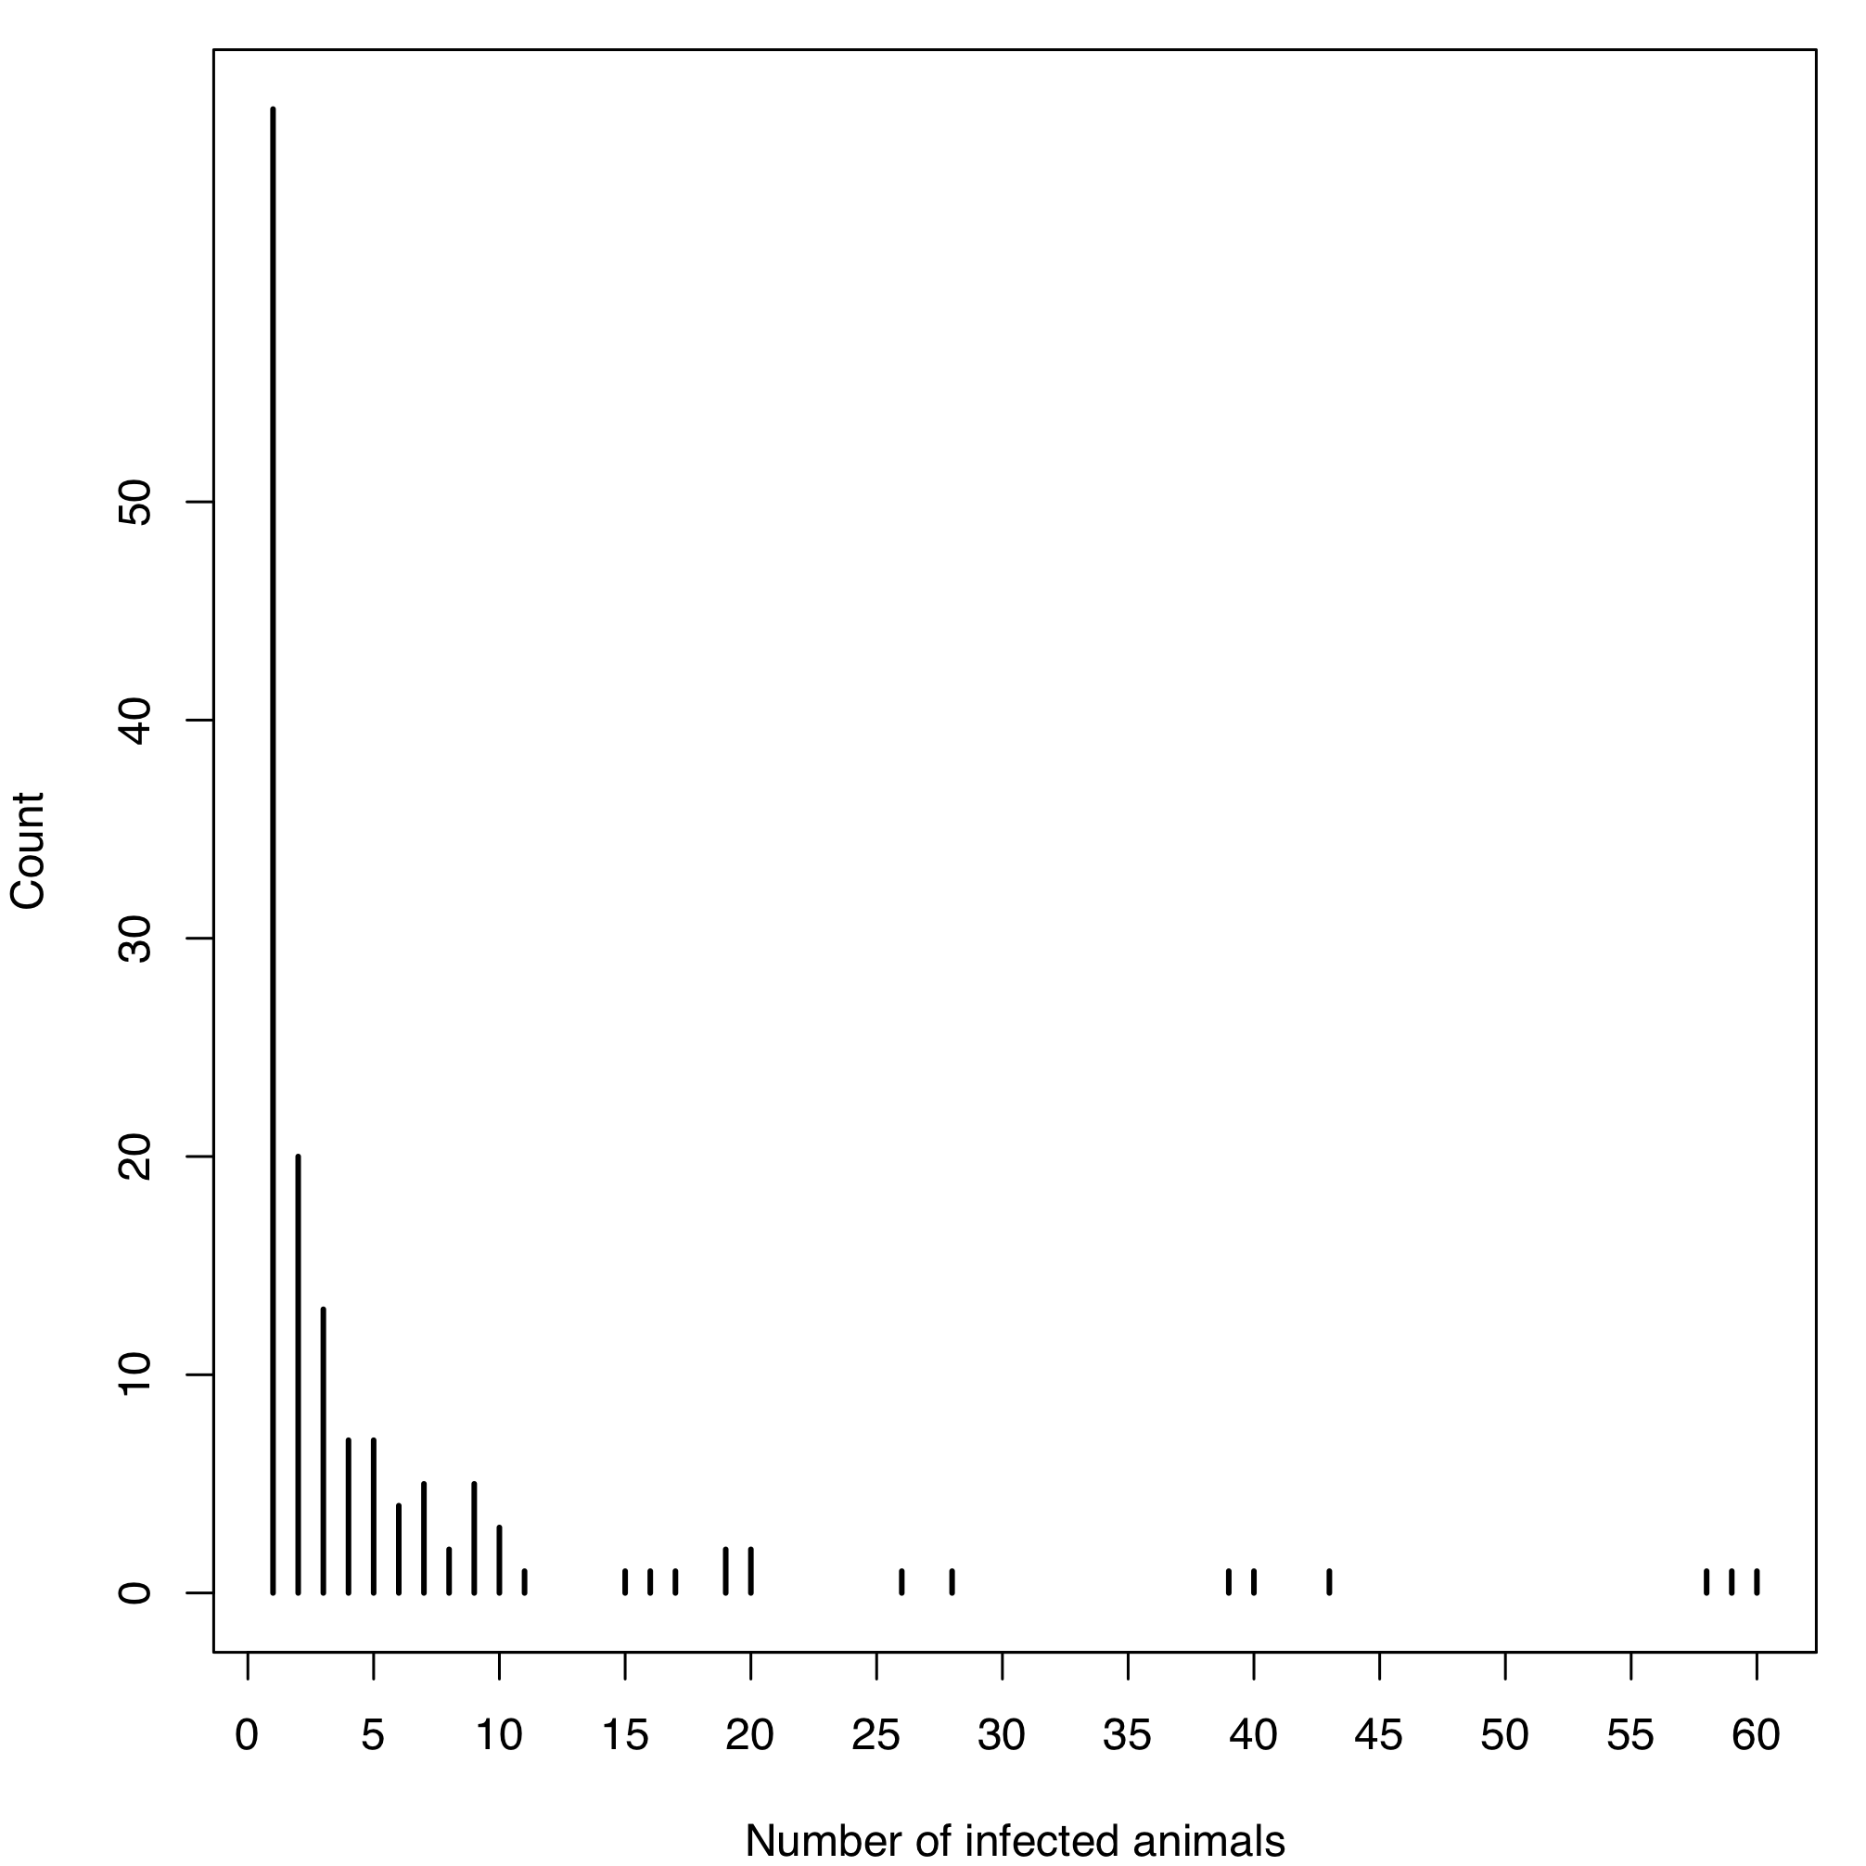
Figure S1a. The number of reactors or culture positive animals on Scottish holdings with confirmed bTB. For holdings with animals that reacted to the tuberculin skin test the number of reactors is presented, otherwise, the number of culture positive animals is presented.

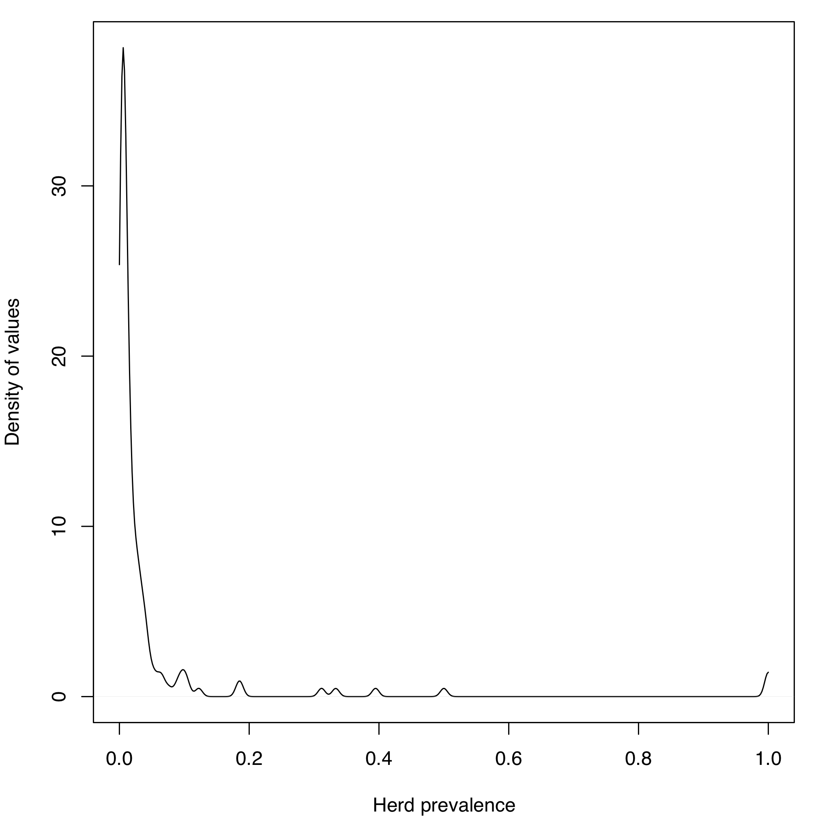
Figure S1b. The herd prevalence for breakdown herds in Scotland.

The parameter d was determined by sampling a value from a beta(2, 90) distribution, multiplying by the number of animals on the farm in the herd (N) and rounding up. Subsequently p_{star} =d/N. The fitted parameter is shown by Figure 2.

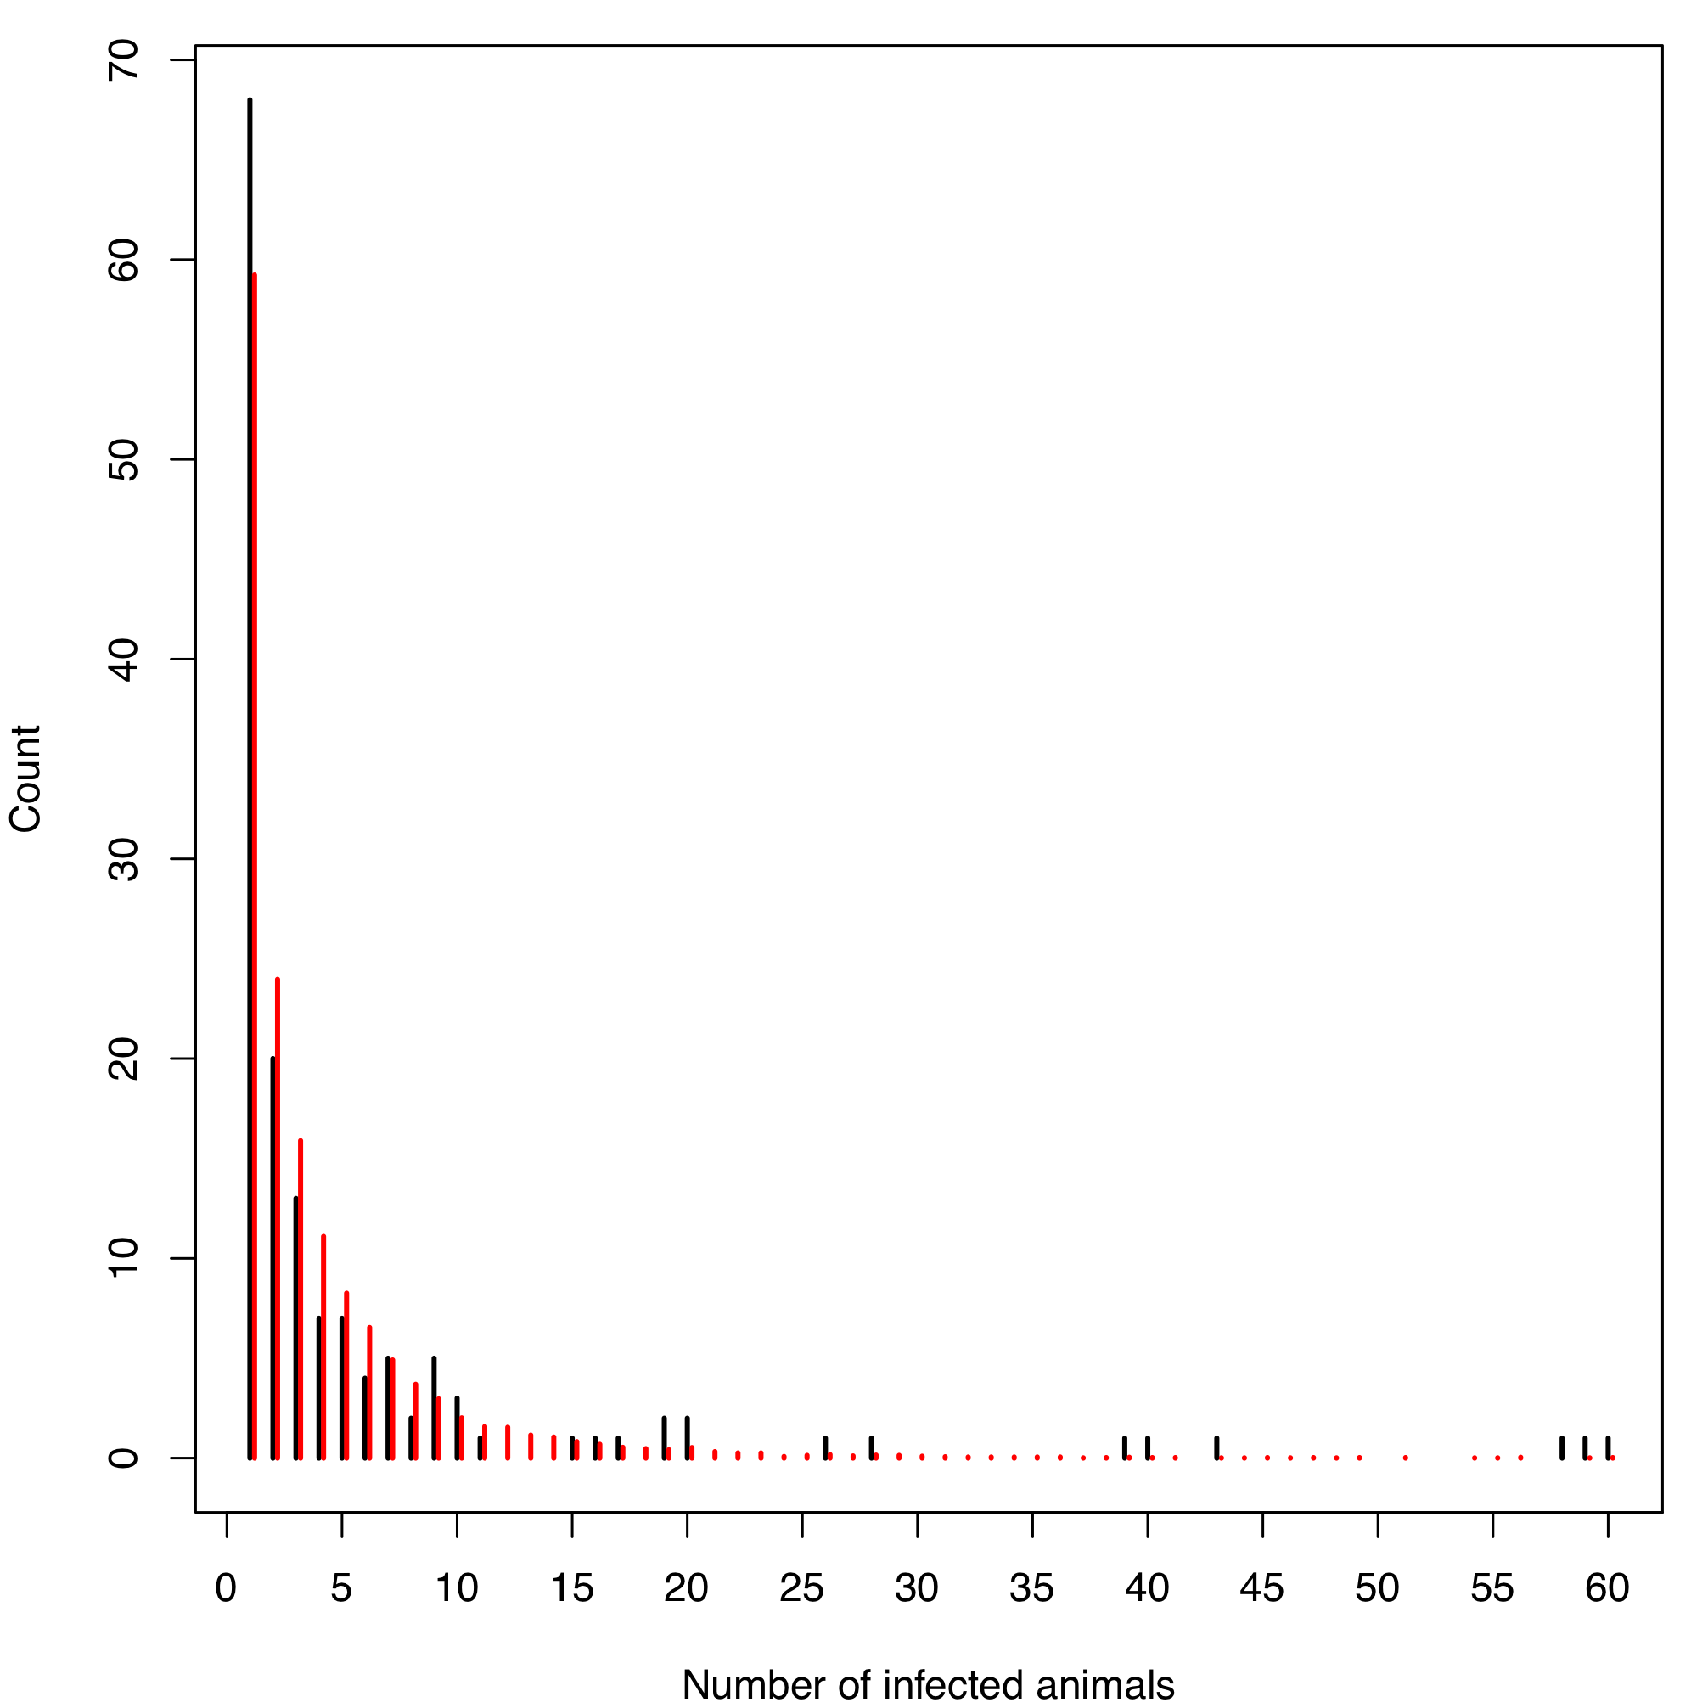
Figure S2. The distribution of the fitted number of infected animals (red lines) against the actual data for Scotland (Black lines – Figure 1a).

Risk combination searching
In order to find the best combination of these risk factors for surveillance, the relationship of these factors was analysed against the probability of freedom following slaughterhouse only surveillance. Subsequently, the combinations of these factors were analysed by constructing matrices in which:
- The rows are cut-offs for the ratio of stock to slaughter. Herds below the cut-off are tested.
- The columns are the herd size cut-offs. Herds larger than the cut-off are tested.
The systems are explored using a simple point system in which points are assigned for having the risk factor in question. Four different combinations of the risk factors were explored:
- A baseline matrix in which the surveillance criteria are the ratio slaughtered and herd size only (one point for each) - a two point scale.
- Three matrices incorporating herd size, ratio slaughtered and the number of batches of movements from high incidence areas between 2002 and 2008 – 1, 2 and 3 batches (one point for: being below the ratio, being above the herd size and having imported more than the number of batches of animals).
- The ratio slaughtered, herd size and the optimal high risk move cut-off identified above (one point for each). This is reduced by 1 point for having slaughtered more than 25% of stock.
- The ratio slaughtered, whether the herd is a dairy herd and the optimal high risk move cut-off identified above (one point for each). –
These scenarios will be explored across three different temporal windows:
- Four year testing for all herds that score > 0 on the risk scale above.
- Four year testing for all herds scoring one point, two year testing for those scoring two or three.
- Four year testing for all herds scoring one point, two year testing for those scoring two, one year testing for those scoring three.
This produces 18 separate analyses – each of the six analyses replicated for each of the three temporal windows. The following statistics will be calculated for each of the 18 matrices:
- The annual mean number of latently infected premises for each year between 2003 to 2008.
- The number of herds tested in each year.
- The number of animals tested each year.
- The number of bTB incidences and the number of RHT detected breakdowns that would have tested under these criteria between 2003 and 2008.
These matrices will be evaluated in terms of the three scenarios– the improved detection, similar surveillance and lower detection surveillance. These will be identified through analysis of the mean latent infections and the number of herds tested and the number of breakdown identified.

Factors for risk-based models
The characteristics of herds that have a low probability of freedom from slaughterhouse surveillance alone must be analysed in order to identify the types if herd that require surveillance. The following are analysed in relation to the probability of freedom from slaughterhouse surveillance only:
- The herd size.
- The herd type.
- The proportion of the herd that is slaughtered.
- Receiving animals from high incidence areas either directly or indirectly.

When plotted against the probability of freedom of infection following slaughterhouse only surveillance, holdings that slaughter a smaller proportion of their stock have a lower probability of freedom (Figure 3).

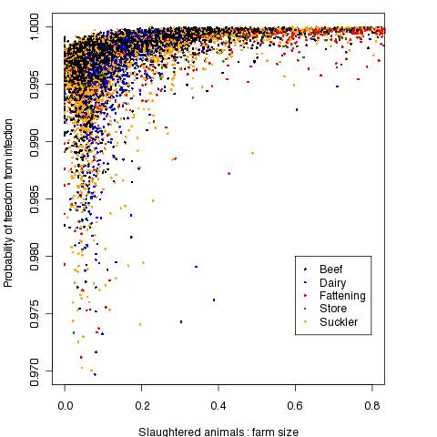
Figure S3. Plot of the ratio of slaughtered animals to probability of freedom from infection. Note the axes on this plot have been truncated to ease interpretation.
While not a particular risk group for acquiring infection, when the probability of freedom is broken down by farm type from VetNet it is clear that this probability is substantially lower for dairy holdings, than for the other holding types (Figure 4).

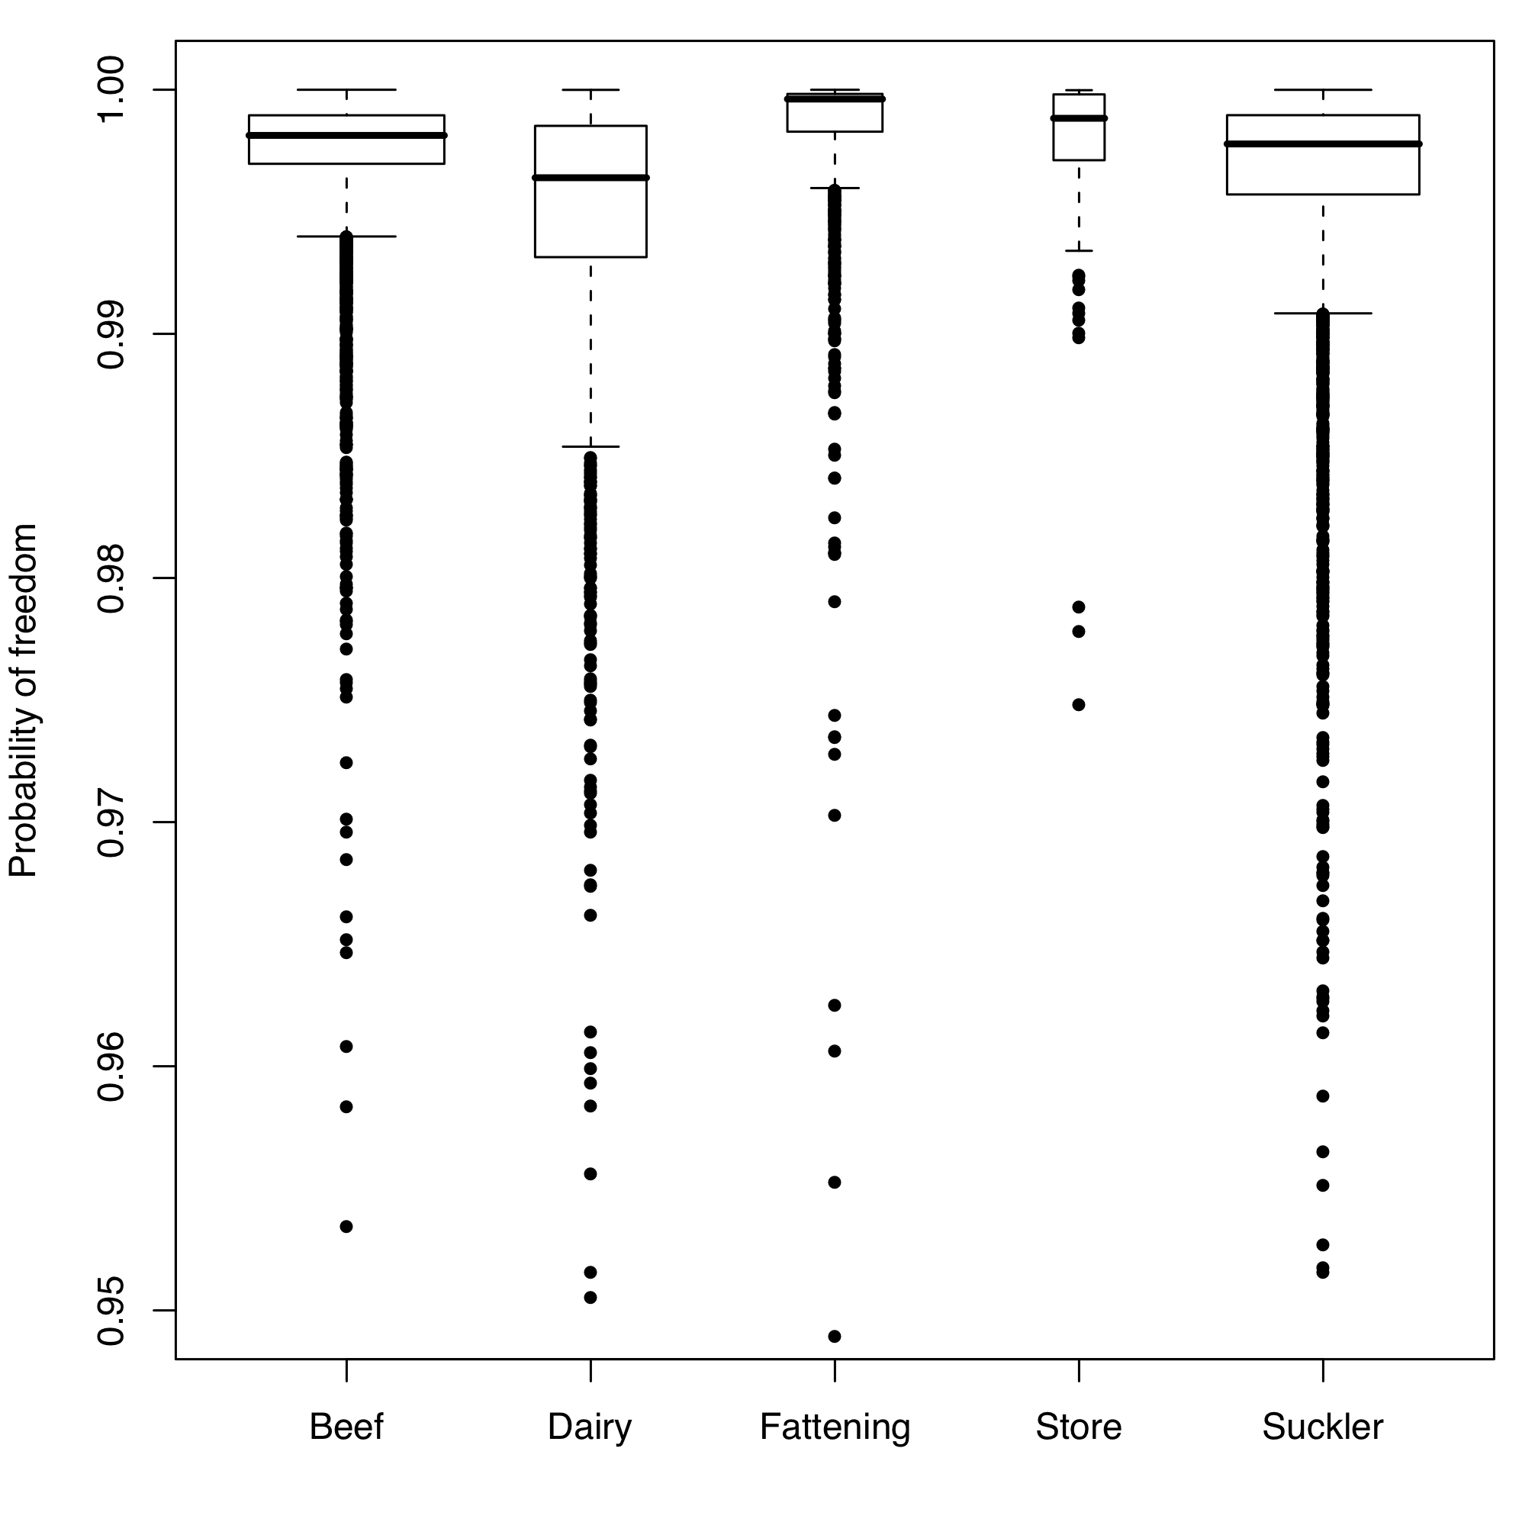
Figure S4. Boxplot of probability of freedom from the slaughterhouse only model in 2008 by herd type. Box widths represent the proportion of data in that category. The y-axis has been truncated for clarity.
Furthermore, and not independent of the dairy relationship (dairy farms generally having greater numbers of animals) larger farms also have a lower probability of freedom (Figure 5). However, this is not as important as might be expected considering that herds with more than 100 animals have more than a 3 times greater probability of infection from the risk factor model (Table 1).

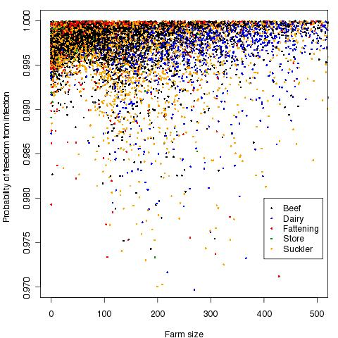
Figure S5. Scatterplot of the farm size categories by probability of freedom in 2008 from slaughterhouse only surveillance. Axes have been truncated for clarity.

An analysis of the number of years in which holdings received animals from high incidence areas in England, Wales and Ireland shows a decrease in the probability of freedom as the number of years goes up (Figure 6). Furthermore, there is a marked step increase in risk (particularly noting the tail of the distribution) at 3 batches.

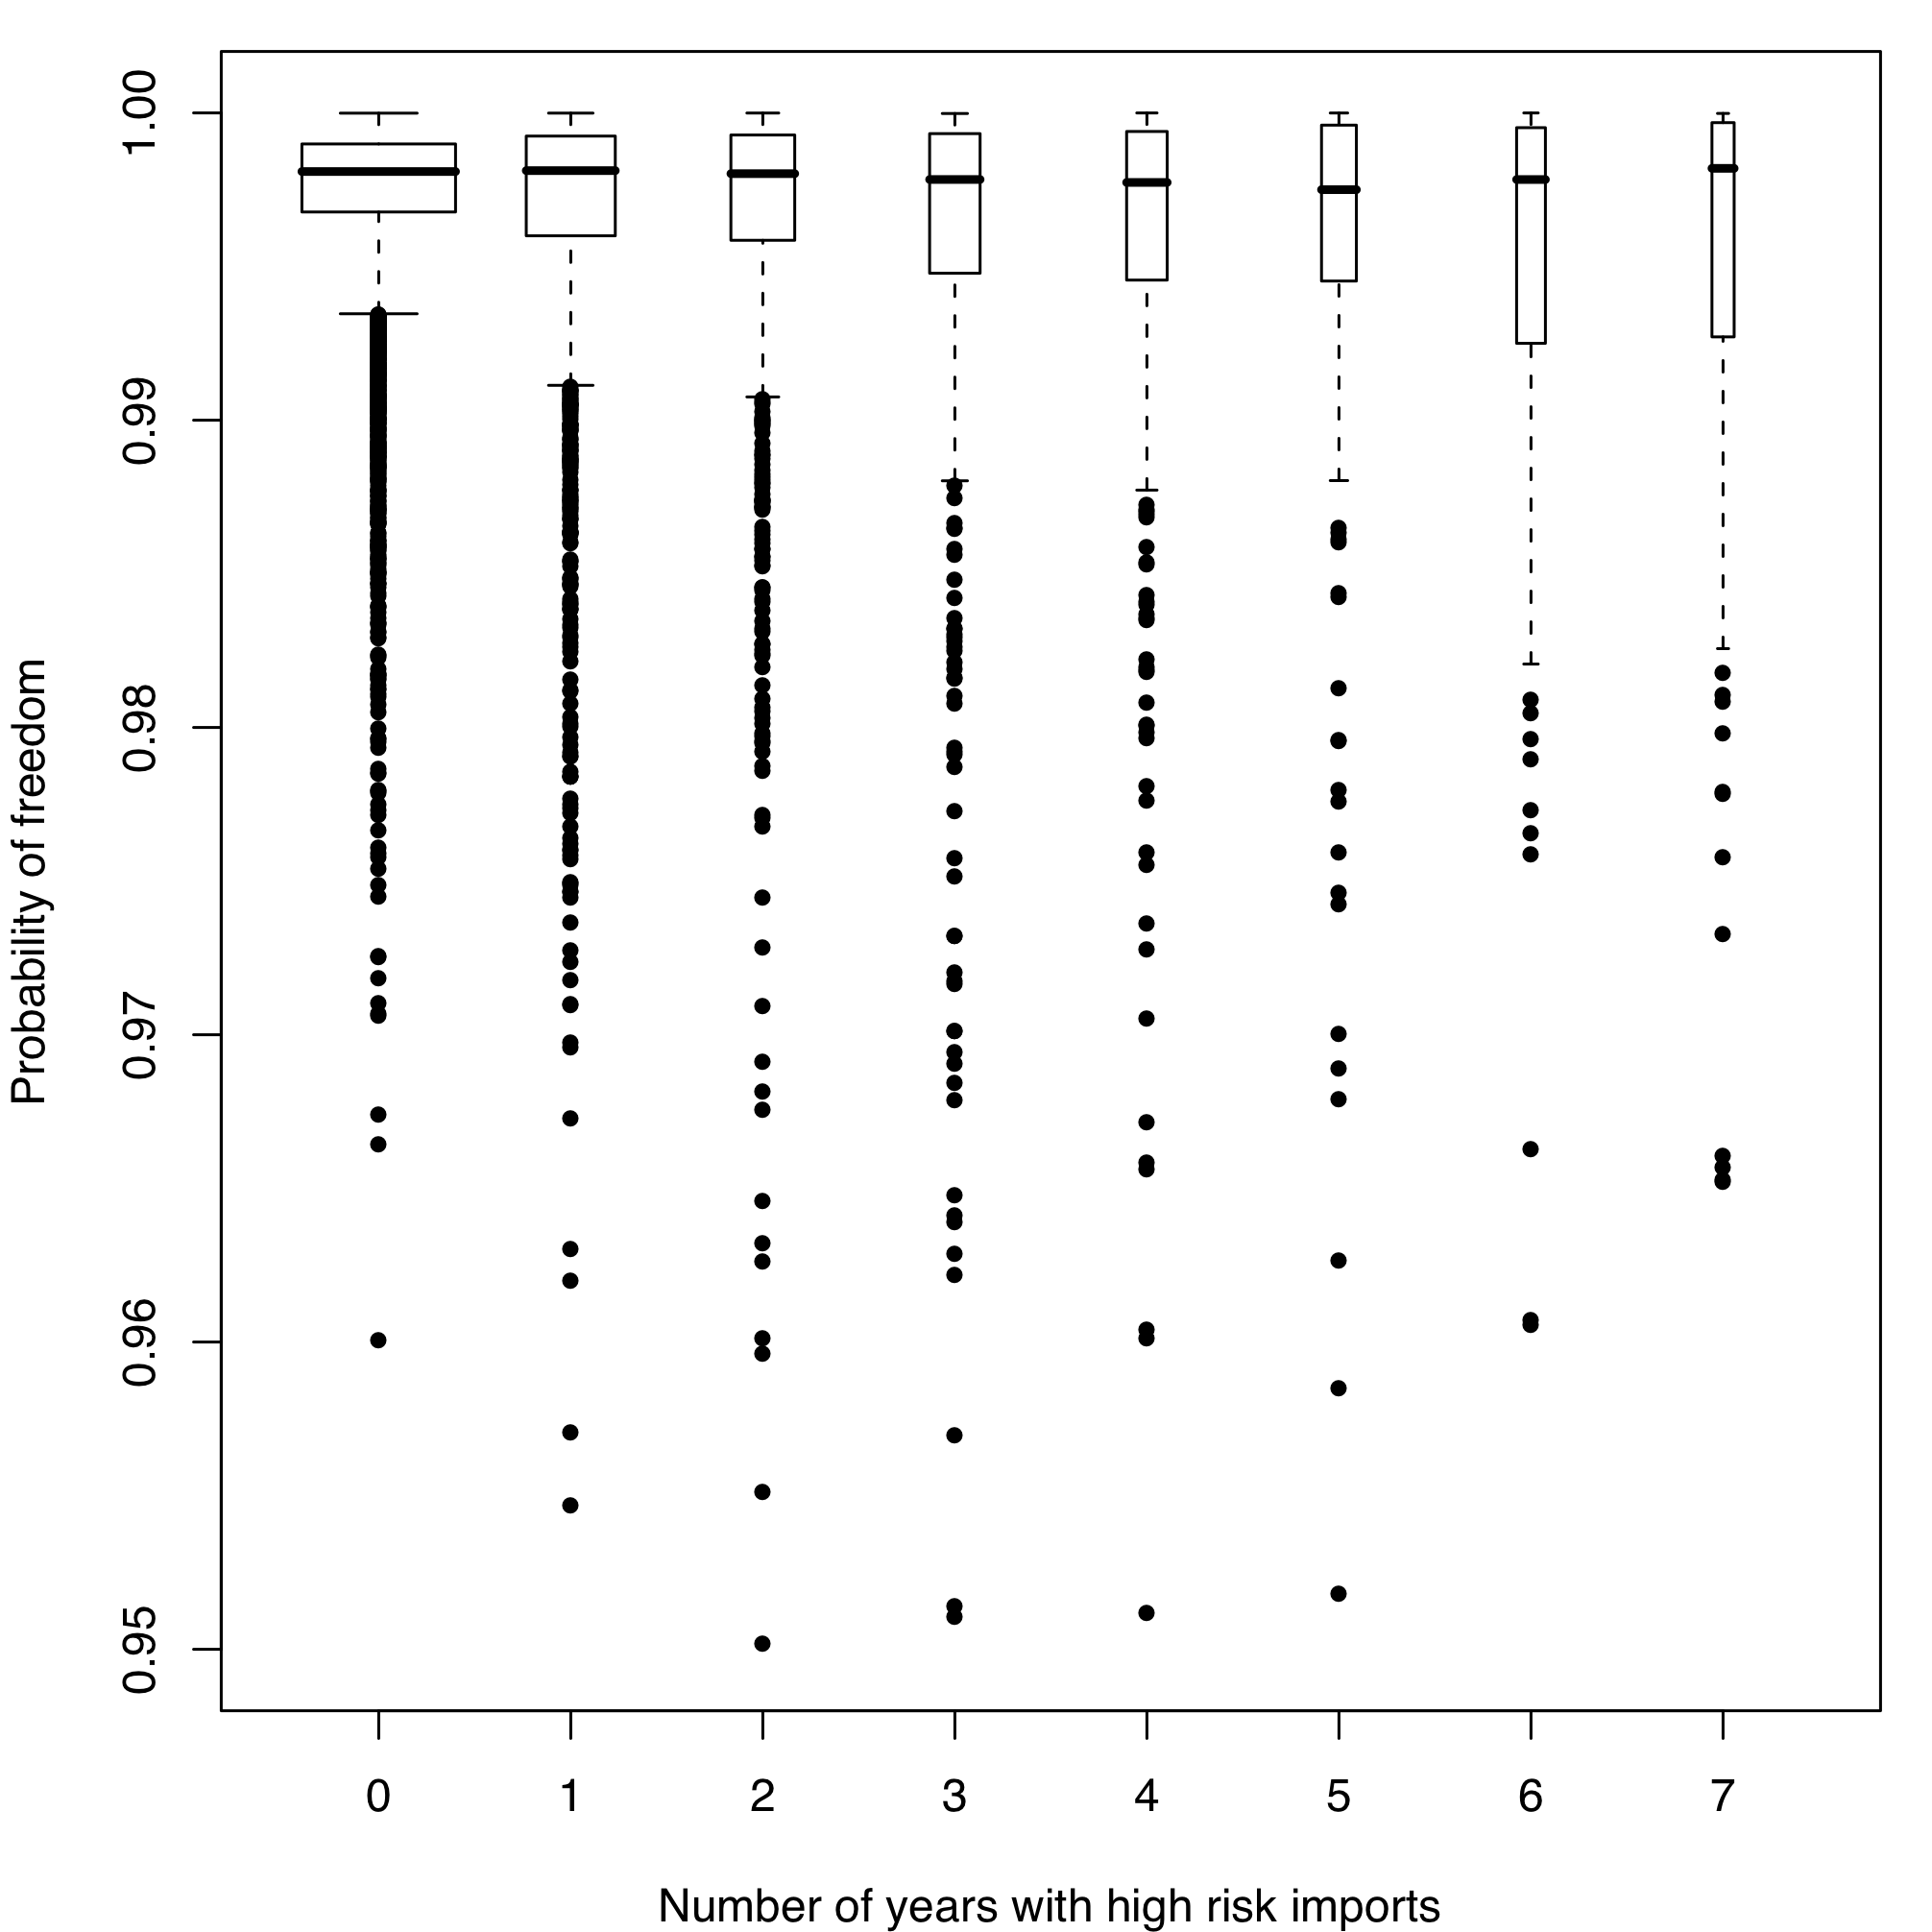
Figure S6. The probability of freedom by slaughterhouse surveillance in 2008 by the number of years in which animals were bought on to the farm from high incidence areas. The box widths represent the relative proportion of data points in each group. The y-axis has been truncated for clarity. When these categories are analysed in terms of the number of bTB breakdowns and the number that were identified by RHT whilst the proportion in each category declines, the percentage of bTB incidences remains similar (Table 2).

Number of years HR animal imports | Number of herds (%) | bTB (%) | RHT
0 | 6677 (56.9) | 18 (18.4) | 7
1 | 2119 (18.1) | 9 (9.2) | 4
2 | 1097 (9.4) | 15 (15.3) | 7
3 | 690 (5.9) | 8 (8.2) | 3
4 | 438 (3.7) | 6 (6.1) | 1
5 | 333 (2.8) | 12 (12.2) | 8
6 | 224 (1.9) | 11 (11.2) | 3
7 | 152 (1.3) | 19 (19.4) | 3
bTB is the number of bTB incidences recorded by herds in that row: RHT is the number of those incidences that were detected by RHT.
Table S2. The numbers of years with high risk imports on to a holding by whether the holding had recorded a confirmed incidence of bTB.

