Supplementary Table 1
Correlation Table without Controlling for Age
Variable | M | SD | 1 | 2 | 3 | 4 | 5 | 6 | 7 | 8 | 9 | 10 | 11 | 12 | 13 | 14 | 15 | 16 | 17 | 18 | 19 | 20 | 21 | 22 | 23 | 24 | 25
1. Child Age | 7.15 | 2.27
2. Child Sex | .48 | .50 | .04
3. Maternal Education | .03 | .98 | -.03 | -.04
4. Household Income | .02 | .98 | .04 | -.03 | .55**
5. Health Insurance | .71 | .46 | .11* | .00 | .52** | .54**
6. Depression | .00 | .98 | -.01 | .01 | -.08 | -.22** | -.14**
7. Trait Anxiety | .01 | 1.01 | -.01 | -.05 | -.10* | -.22** | -.16** | .72**
8. State Anxiety | .00 | 1.00 | .01 | -.07 | -.06 | -.19** | -.15** | .55** | .66**
9. N2 Amplitude | 1.56 | 2.69 | -.15** | .05 | .16** | -.02 | .05 | -.07 | -.06 | -.04
10. P3 Amplitude | 1.78 | 4.46 | .14** | .08 | -.04 | .01 | -.04 | .01 | .00 | -.07 | -.33**
11. Theta Power | .47 | .90 | .16** | .14** | .08 | .13** | .07 | .00 | -.02 | -.05 | .05 | .01
12. Delta Power | .29 | 1.02 | .13** | .07 | -.07 | .02 | -.01 | -.02 | -.03 | -.06 | .01 | .09* | .39**
13. Theta ITPS | .02 | 1.00 | -.01 | -.07 | -.06 | -.06 | .01 | .00 | .03 | .04 | .00 | -.04 | .04 | .03
14. Delta ITPS | .00 | 1.01 | .13** | -.05 | -.01 | .00 | .01 | -.07 | -.06 | -.03 | -.13** | .12** | .06 | .27** | .17**
15. N2 Latency | .00 | 1.01 | -.26** | .05 | -.11* | -.09 | -.20** | .00 | .03 | -.03 | -.14** | .14** | -.04 | -.08* | .05 | -.08
16. P3 Latency | .01 | 1.00 | -.25** | -.04 | .03 | .02 | -.02 | .03 | .03 | -.04 | .06 | .10* | .00 | -.09* | -.11** | -.11** | .10*
17. Theta Latency | .00 | 1.00 | -.13** | .00 | -.04 | -.03 | .03 | .02 | .01 | -.05 | -.01 | .02 | .13** | .13** | -.08* | -.01 | .11* | .23**
18. Delta Latency | .00 | 1.00 | -.22** | .03 | -.01 | .00 | -.02 | -.02 | -.01 | -.04 | .11* | -.04 | .05 | .23** | .10* | -.11* | .09* | .04 | .21**
19. External | 4.27 | 3.31 | -.13** | .23** | -.09 | -.24** | -.15** | .23** | .20** | .18** | -.11* | -.03 | -.13* | .00 | .01 | -.08 | .06 | .05 | .00 | .00
20. Internal | 2.86 | 2.58 | .03 | .00 | -.18** | -.29** | -.19** | .26** | .25** | .23** | -.03 | -.09 | -.06 | .07 | .03 | -.04 | -.02 | .06 | .02 | -.07 | .40**
21. Go Trials RT | 571.59 | 97.74 | -.77** | -.11** | .00 | -.03 | -.09 | .01 | .01 | .00 | .12** | -.15** | -.15** | -.09 | .02 | -.15** | .18** | .31** | .16** | .20** | .10** | .03
22. No-go Trials RT | 462.65 | 93.43 | -.69** | -.11** | .01 | -.02 | -.10** | -.03 | -.01 | -.02 | .08 | -.13** | -.11** | -.08 | .02 | -.12** | .18** | .31** | .17** | .19** | .15** | .03 | .85**
23. Go Trials Accuracy Rate | .93 | .09 | .61** | .03 | .08 | .16** | .20** | -.05 | -.07 | -.07 | -.15** | .18** | .19** | .06 | -.03 | .14 | -.18** | -.18** | -.12** | -.13** | -.17** | -.09 | -.69** | -.64**
24. No-go Trials Accuracy Rate | .72 | .13 | .29** | -.23** | .01 | .06 | .11** | -.03 | -.04 | -.04 | .06 | .00 | .09 | .11 | -.05 | .03 | -.10** | -.06 | -.07 | -.02 | -.23** | -.02 | .00 | -.15** | .21**
25 Go Trial numbers | 162.11 | 54.05 | .51** | .03 | .08 | .15** | .20** | -.05 | -.05 | -.08 | -.04 | -.01 | .15** | .13** | .04 | .04 | -.18** | -.10* | -.06 | -.11* | -.23** | -.06 | -.46** | -.45** | .59** | .22**
26 No-go Trial numbers | 41.94 | 16.23 | .47** | -.08 | .09 | .17** | .23** | -.06 | -.06 | -.09* | .03 | -.05 | .15** | .11* | .01 | .02 | -.15** | -.09* | -.07 | -.10* | -.29** | -.06 | -.29** | -.35** | .45** | .62** | .85**
Note. M = mean; SD = standard deviation; External = children’s externalizing problems; Internal = children’s internalizing problems; RT = reaction time. For Child Sex, 0 = female, 1 = male; For Health Insurance, 0 = public assistance, 1 = commercial health insurance. Maternal education, household income, maternal depression, maternal trait anxiety, maternal state anxiety, theta ITPS, delta ITPS, and all latency measures were standardized by their means and standard deviations.
*p < .05. **p < .01.
Supplementary Table 2
Theta Power’s Mediating Role in The Prediction from Prenatal SES to Children’s Externalizing Problems with Theta Power and Externalizing Problems
Outcome | Predictor | B | β | p-value | CI (lower) | CI (upper)
Theta Power | SES | .13 | .16 | .021 | .025 | .303
Theta Power | Child Sex | .14 | .25 | .001 | .101 | .393
Theta Power | Child Age | .15 | .06 | < .001 | .027 | .093
Externalizing | Theta Power | -.11 | -.42 | .025 | -.785 | -.052
Externalizing | SES | -.19 | -.91 | .003 | -1.501 | -.317
Externalizing | Child Sex | .24 | 1.61 | < .001 | .979 | 2.249
Externalizing | Child Age | -.11 | -.17 | .025 | -.312 | -.021
Note. The results are the same as Figure 4. Externalizing = children’s externalizing problems; CI = confidence interval; For Child Sex, 0 = female, 1 = male.
Supplementary Table 3
Theta Power’s Mediating Role in The Prediction from Prenatal SES, Prenatal Maternal Psychopathology, and Their Interaction Effect to Children’s Externalizing Problems
Outcome | Predictor | B | β | p-value | CI (lower) | CI (upper)
Theta Power | SES | .11 | .35 | .032 | .030 | .666
Theta Power | Maternal Psychopathology | 0 | 0 | .981 | -.100 | .103
Theta Power | Interaction | -.02 | -.09 | .634 | -.469 | .286
Theta Power | Child Sex | .14 | .25 | .001 | .099 | .393
Theta Power | Child Age | .15 | .06 | < .001 | .028 | .093
Externalizing | SES | -.12 | -1.45 | .013 | -2.588 | -.305
Externalizing | Maternal Psychopathology | .22 | 1.01 | < .001 | .565 | 1.445
Externalizing | Interaction | -.03 | -.45 | .548 | -1.918 | 1.018
Externalizing | Theta Power | -.12 | -.44 | .013 | -.796 | -.093
Externalizing | Child Sex | .25 | 1.7 | < .001 | 1.09 | 2.312
Externalizing | Child Age | -.11 | -.17 | .022 | -.308 | -.025
Note. Externalizing = children’s externalizing problems; CI = confidence interval; For Child Sex, 0 = female, 1 = male.

Supplementary Table 4
Theta Power’s Mediating Role in The Prediction from Prenatal SES to Children’s Externalizing Problems with Theta Power and Externalizing Problems Collected Concurrently
Outcome | Predictor | B | β | p-value | CI (lower) | CI (upper)
Theta Power | SES | .13 | .16 | .023 | .023 | .301
Theta Power | Child Sex | .14 | .25 | .001 | .100 | .392
Theta Power | Child Age | .15 | .06 | < .001 | .027 | .093
Externalizing | Theta Power | -.09 | -.35 | .082 | -.739 | .044
Externalizing | SES | -.17 | -.82 | .018 | -1.490 | -.143
Externalizing | Child Sex | .28 | 1.94 | < .001 | 1.216 | 2.666
Externalizing | Child Age | -.15 | -.22 | .012 | -.394 | -.050
Note. Externalizing = children’s externalizing problems; CI = confidence interval; For Child Sex, 0 = female, 1 = male.

Supplementary Table 5
Theta Power’s Mediating Role in The Prediction from Prenatal SES to Children’s Externalizing Problems Controlling for Trial Numbers of Go and No-go Conditions
Outcome | Predictor | B | β | p-value | CI (lower) | CI (upper)
Theta Power | SES | .11 | .14 | .062 | -.007 | .279
Theta Power | Child Sex | .15 | .26 | < .001 | .118 | .409
Theta Power | Child Age | .11 | .04 | .026 | .005 | .083
Theta Power | Go Trial Number | -.02 | .00 | .853 | -.003 | .002
Theta Power | No-go Trial Number | .10 | .01 | .188 | -.003 | .014
Externalizing | SES | -.10 | -.38 | .032 | -.735 | -.032
Externalizing | Theta Power | -.15 | -.73 | .016 | -1.326 | -.135
Externalizing | Child Sex | .21 | 1.43 | < .001 | .781 | 2.076
Externalizing | Child Age | -.01 | -.02 | .808 | -.177 | .138
Externalizing | Go Trial Number | -.03 | .00 | .802 | -.015 | .011
Externalizing | No-go Trial Number | -.19 | -.04 | .054 | -.079 | .001
Note. Externalizing = children’s externalizing problems; Go Trial Number = trial number of Go conditions; No-go Trial Number = trial number of No-go conditions; CI = confidence interval; For Child Sex, 0 = female, 1 = male; mediation estimate effect = -.052; 10,000 bootstrapping 95% CIs [-.168, -.001].

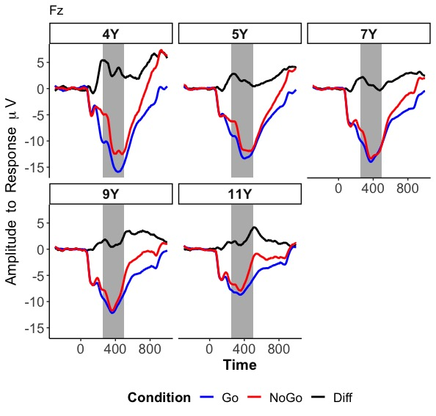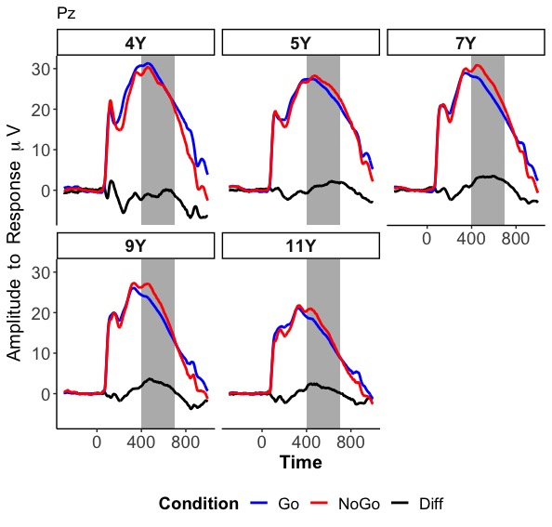
Supplementary Figure 1. ERP measures: N2 and P3. Average waveforms across all participants for the N2 (FCz) and the P3 (Pz) by age.

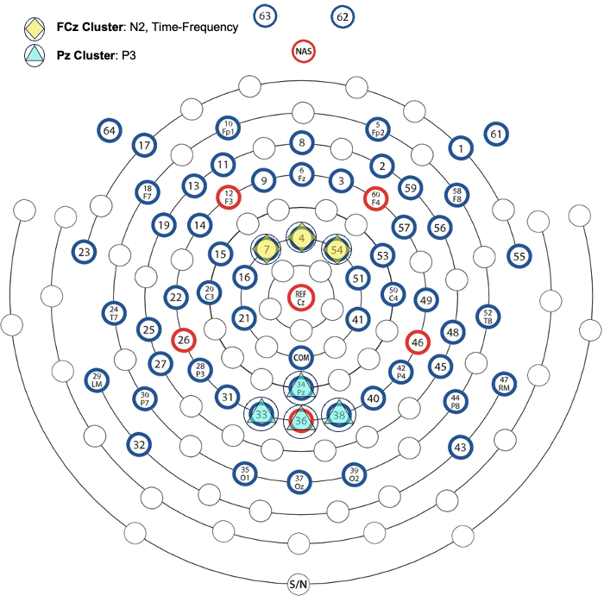
Supplementary Figure 2. Topographical representation of the clusters used for electrophysiological measures.

