**Supplement 3**

**Figure S1: A)** Cumulative relative abundances (by sample percentiles) of the eight most prevalent bacterial genera. Most prevalent genera were defined as genera being present at 50% of the samples at some non-zero relative abundance. The most prevalent genera, in decreasing order, were *Lactobacillus, Staphylococcus, Corynebacterium, Prevotella, Anaerococcus, Bacteroides, Stenotrophomonas, Streptococcus.* The most prevalent genera alone, *Lactobacillus*, constituted at least 54% of the entire microbiome in 50% of the samples, whereas all eight most prevalent genera constituted at least 78% of the entire microbiome in 50% of the samples (upper limit of the red band). **B)** Relative abundances of 14 bacterial genera with mean relative abundance >1% across all samples. Each stacked bar represents one sample. Most genera were rare and present only in 1-5 samples (not included in the figure).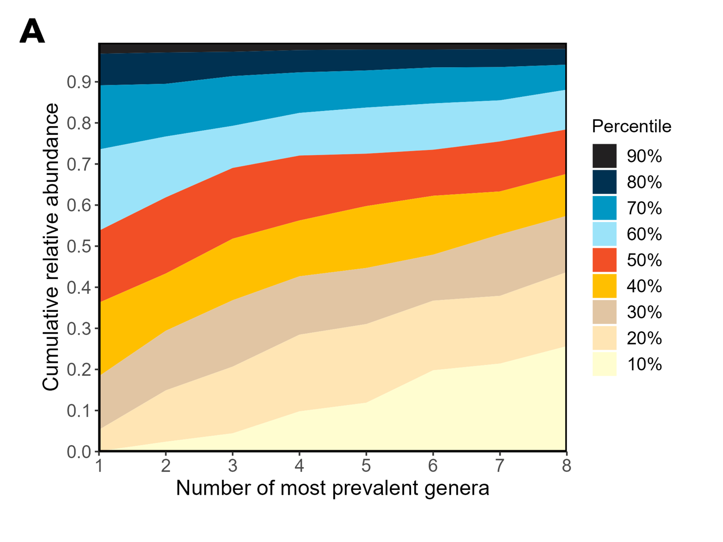

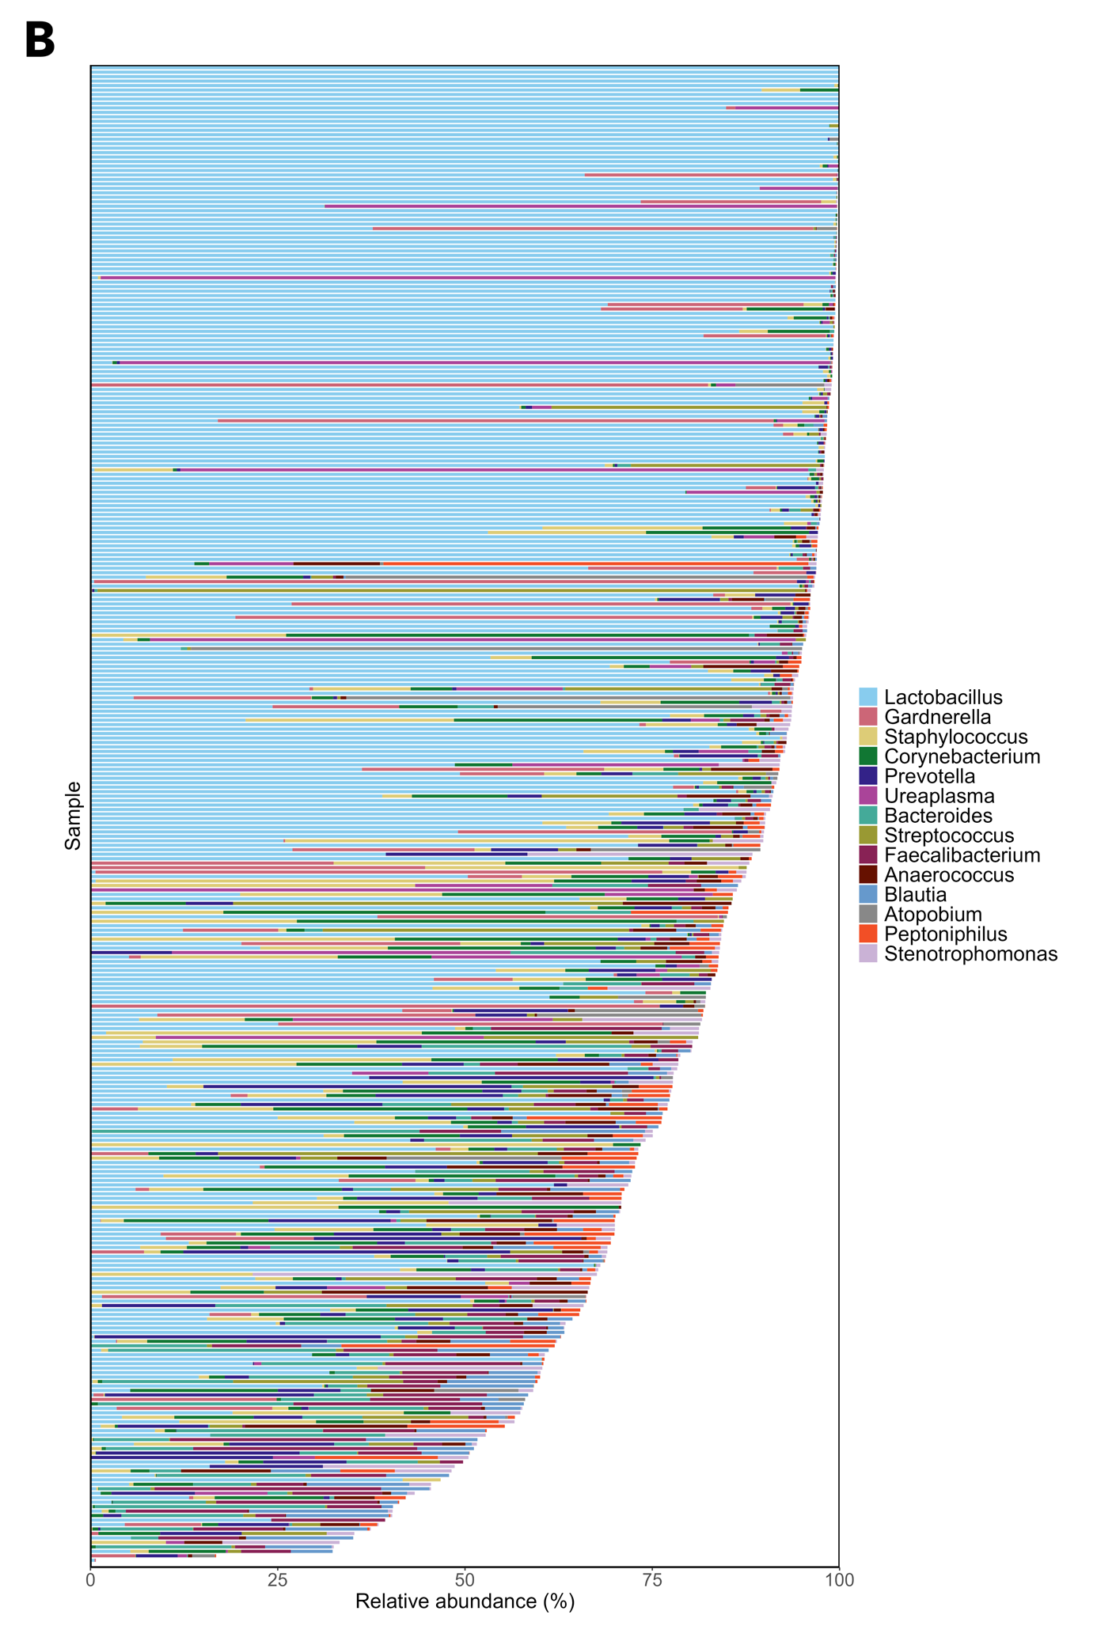

**Figure S2:** Scree plots for the alpha diversity principal components and beta diversity principal coordinates. Only the first ten beta diversity principal coordinates were plotted. For both diversity metrics, two first principal components or coordinates were chosen, resulting in a total of 98.3% (alpha diversity) and 62.6% (beta diversity) of the variance explained.

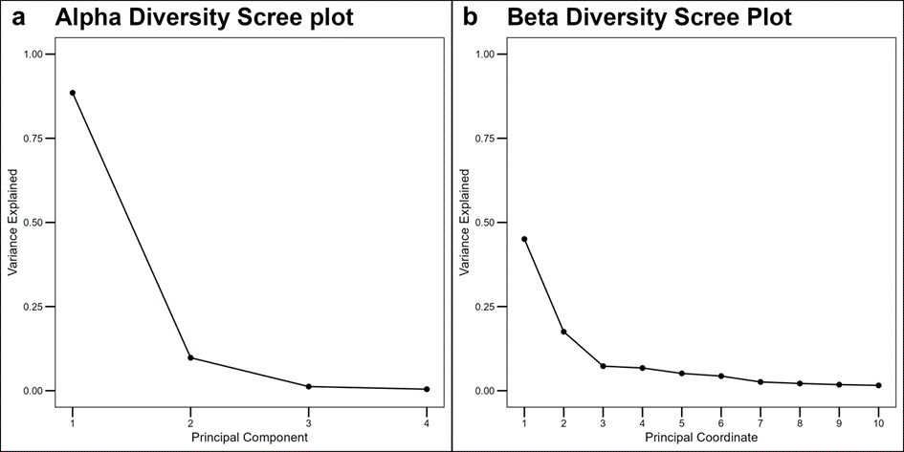

**Figure S3:** Two first beta diversity principal coordinates for each newborn oral swab sample grouped by antibiotic use during birth. Higher values of beta PCo1 were associated with samples exposed to healthy, *Lactobacilli*-dominant vaginal microbiota, whereas samples with lower values of beta PCo1 were characterized with increased diversity, fecal genera and use of AB during birth. Higher values of beta PCo2 were associated with exposure to mixed vaginal microbiota and dominance of other then *Lactobilli* (*Gardnerella*, *Corynebacterium*) suggesting bacterial imbalance potentially caused by bacterial vaginosis. Lower values of beta PCo2 were associated with samples exposed to fecal genera.

