## Supplementary materials

**Table S1.**

The nodewise regression matrix for MNMs in wave 1.

|  |  |  |  |  |  |  |  |  |  |  |  |
| --- | --- | --- | --- | --- | --- | --- | --- | --- | --- | --- | --- |
|  | ODD_1 | ODD_2 | ODD_3 | ODD_4 | ODD_5 | ODD_6 | ODD_7 | ODD_8 | SC | ER | EL |
| ODD_1 | 0 |  |  |  |  |  |  |  |  |  |  |
| ODD_2 | 0.086 | 0 |  |  |  |  |  |  |  |  |  |
| ODD_3 | 0.172 | 0.202 | 0 |  |  |  |  |  |  |  |  |
| ODD_4 | 0.087 | 0.000 | 0.271 | 0 |  |  |  |  |  |  |  |
| ODD_5 | 0.000 | 0.647 | -0.065 | 0.064 | 0 |  |  |  |  |  |  |
| ODD_6 | 0.312 | 0.000 | 0.000 | 0.081 | 0.202 | 0 |  |  |  |  |  |
| ODD_7 | 0.166 | 0.074 | 0.122 | 0.000 | 0.195 | 0.266 | 0 |  |  |  |  |
| ODD_8 | 0.000 | 0.076 | 0.183 | 0.113 | 0.166 | 0.000 | 0.106 | 0 |  |  |  |
| SC | -0.181 | 0.000 | -0.083 | -0.068 | -0.054 | -0.127 | 0.000 | 0.000 | 0 |  |  |
| ER | 0.000 | 0.109 | -0.330 | 0.000 | -0.083 | 0.000 | 0.000 | 0.000 | 0.000 | 0 |  |
| EL | 0.116 | 0.053 | 0.016 | 0.278 | 0.000 | 0.000 | 0.059 | 0.000 | -0.458 | -0.289 | 0 |

***Note.*** The coefficients have been aggregated using the AND rule. ODD_1, Temper; ODD_2, Argues; ODD_3, Defies; ODD_4, Annoys; ODD_5, Blames; ODD_6, Touchy; ODD_7, Angry; ODD_8, Spiteful; SC, Self-control; EL, Emotion lability/negativity; ER, Emotion regulation.

**Table S2.**

The nodewise regression matrix for MNMs in wave 2.

|  |  |  |  |  |  |  |  |  |  |  |  |
| --- | --- | --- | --- | --- | --- | --- | --- | --- | --- | --- | --- |
|  | ODD_1 | ODD_2 | ODD_3 | ODD_4 | ODD_5 | ODD_6 | ODD_7 | ODD_8 | SC | ER | EL |
| ODD_1 | 0 |  |  |  |  |  |  |  |  |  |  |
| ODD_2 | 0.096 | 0 |  |  |  |  |  |  |  |  |  |
| ODD_3 | 0.214 | 0.165 | 0 |  |  |  |  |  |  |  |  |
| ODD_4 | 0.059 | 0.050 | 0.285 | 0 |  |  |  |  |  |  |  |
| ODD_5 | 0.000 | 0.416 | 0.041 | 0.134 | 0 |  |  |  |  |  |  |
| ODD_6 | 0.304 | 0.000 | 0.000 | 0.067 | 0.201 | 0 |  |  |  |  |  |
| ODD_7 | 0.203 | 0.063 | 0.155 | 0.000 | 0.282 | 0.287 | 0 |  |  |  |  |
| ODD_8 | 0.000 | 0.058 | 0.162 | 0.150 | 0.118 | 0.045 | 0.113 | 0 |  |  |  |
| SC | -0.164 | 0.000 | 0.040 | -0.096 | -0.025 | -0.066 | 0.000 | 0.000 | 0 |  |  |
| ER | 0.000 | 0.000 | -0.139 | 0.000 | -0.053 | 0.000 | 0.000 | 0.000 | 0.000 | 0 |  |
| EL | 0.121 | 0.032 | 0.017 | 0.241 | 0.012 | 0.000 | 0.045 | 0.000 | -0.465 | -0.328 | 0 |

***Note.*** The coefficients have been aggregated using the AND rule. ODD_1, Temper; ODD_2, Argues; ODD_3, Defies; ODD_4, Annoys; ODD_5, Blames; ODD_6, Touchy; ODD_7, Angry; ODD_8, Spiteful; SC, Self-control; EL, Emotion lability/negativity; ER, Emotion regulation.

**Table S3.**

The matrix of interaction terms associated for MNMs in wave 1.

|  |  |  |  |  |  |  |  |  |  |  |  |
| --- | --- | --- | --- | --- | --- | --- | --- | --- | --- | --- | --- |
|  | ODD_1:gender | ODD_2:gender | ODD_3:gender | ODD_4:gender | ODD_5:gender | ODD_6:gender | ODD_7:gender | ODD_8:gender | SC:gender | ER:gender | EL:gender |
| ODD_1:gender | 0.000 | 0.000 | 0.000 | 0.000 | 0.000 | 0.000 | 0.000 | 0.000 | 0.000 | 0.000 | 0.000 |
| ODD_2:gender | 0.000 | 0.000 | 0.000 | 0.000 | **-0.422** | 0.000 | 0.000 | 0.000 | 0.000 | 0.000 | 0.000 |
| ODD_3:gender | 0.000 | 0.000 | 0.000 | 0.000 | 0.000 | 0.000 | 0.000 | 0.000 | 0.000 | **0.199** | 0.000 |
| ODD_4:gender | 0.000 | 0.000 | 0.000 | 0.000 | 0.000 | 0.000 | 0.000 | 0.000 | 0.000 | 0.000 | -**0.211** |
| ODD_5:gender | 0.000 | **-0.278** | 0.000 | 0.000 | 0.000 | 0.000 | 0.000 | 0.000 | 0.000 | 0.000 | 0.000 |
| ODD_6:gender | 0.000 | 0.000 | 0.000 | 0.000 | 0.000 | 0.000 | 0.000 | 0.000 | 0.000 | 0.000 | 0.000 |
| ODD_7:gender | 0.000 | 0.000 | 0.000 | 0.000 | 0.000 | 0.000 | 0.000 | 0.000 | 0.000 | 0.000 | 0.000 |
| ODD_8:gender | 0.000 | 0.000 | 0.000 | 0.000 | 0.000 | 0.000 | 0.000 | 0.000 | 0.000 | 0.000 | 0.000 |
| SC:gender | 0.000 | 0.000 | 0.000 | 0.000 | 0.000 | 0.000 | 0.000 | 0.000 | 0.000 | 0.000 | 0.000 |
| ER:gender | 0.000 | 0.000 | **0.177** | 0.000 | 0.000 | 0.000 | 0.000 | 0.000 | 0.000 | 0.000 | 0.000 |
| EL:gender | 0.000 | 0.000 | 0.000 | **-0.158** | 0.000 | 0.000 | 0.000 | 0.000 | 0.000 | 0.000 | 0.000 |

***Note.*** The coefficients have been aggregated using the AND rule. ODD_1, Temper; ODD_2, Argues; ODD_3, Defies; ODD_4, Annoys; ODD_5, Blames; ODD_6, Touchy; ODD_7, Angry; ODD_8, Spiteful; SC, Self-control; EL, Emotion lability/negativity; ER, Emotion regulation.

**Table S4.**

The matrix of interaction terms associated for MNMs in wave 1.

|  |  |  |  |  |  |  |  |  |  |  |  |
| --- | --- | --- | --- | --- | --- | --- | --- | --- | --- | --- | --- |
|  | ODD_1:gender | ODD_2:gender | ODD_3:gender | ODD_4:gender | ODD_5:gender | ODD_6:gender | ODD_7:gender | ODD_8:gender | SC:gender | ER:gender | EL:gender |
| ODD_1:gender | 0.000 | 0.000 | 0.000 | 0.000 | 0.000 | 0.000 | 0.000 | 0.000 | 0.000 | 0.000 | 0.000 |
| ODD_2:gender | 0.000 | 0.000 | 0.000 | 0.000 | **-0.182** | 0.000 | 0.000 | 0.000 | 0.000 | 0.000 | 0.000 |
| ODD_3:gender | 0.000 | 0.000 | 0.000 | 0.000 | 0.000 | 0.000 | 0.000 | 0.000 | 0.000 | 0.000 | 0.000 |
| ODD_4:gender | 0.000 | 0.000 | 0.000 | 0.000 | 0.000 | 0.000 | 0.000 | 0.000 | 0.000 | 0.000 | **-0.183** |
| ODD_5:gender | 0.000 | **-0.193** | 0.000 | 0.000 | 0.000 | 0.000 | 0.000 | 0.000 | 0.000 | 0.000 | 0.000 |
| ODD_6:gender | 0.000 | 0.000 | 0.000 | 0.000 | 0.000 | 0.000 | 0.000 | 0.000 | 0.000 | 0.000 | 0.000 |
| ODD_7:gender | 0.000 | 0.000 | 0.000 | 0.000 | 0.000 | 0.000 | 0.000 | 0.000 | 0.000 | 0.000 | 0.000 |
| ODD_8:gender | 0.000 | 0.000 | 0.000 | 0.000 | 0.000 | 0.000 | 0.000 | 0.000 | 0.000 | 0.000 | 0.000 |
| SC:gender | 0.000 | 0.000 | 0.000 | 0.000 | 0.000 | 0.000 | 0.000 | 0.000 | 0.000 | 0.000 | 0.000 |
| ER:gender | 0.000 | 0.000 | 0.000 | 0.000 | 0.000 | 0.000 | 0.000 | 0.000 | 0.000 | 0.000 | 0.000 |
| EL:gender | 0.000 | 0.000 | 0.000 | **-0.152** | 0.000 | 0.000 | 0.000 | 0.000 | 0.000 | 0.000 | 0.000 |

***Note.*** The coefficients have been aggregated using the AND rule. ODD_1, Temper; ODD_2, Argues; ODD_3, Defies; ODD_4, Annoys; ODD_5, Blames; ODD_6, Touchy; ODD_7, Angry; ODD_8, Spiteful; SC, Self-control; EL, Emotion lability/negativity; ER, Emotion regulation.

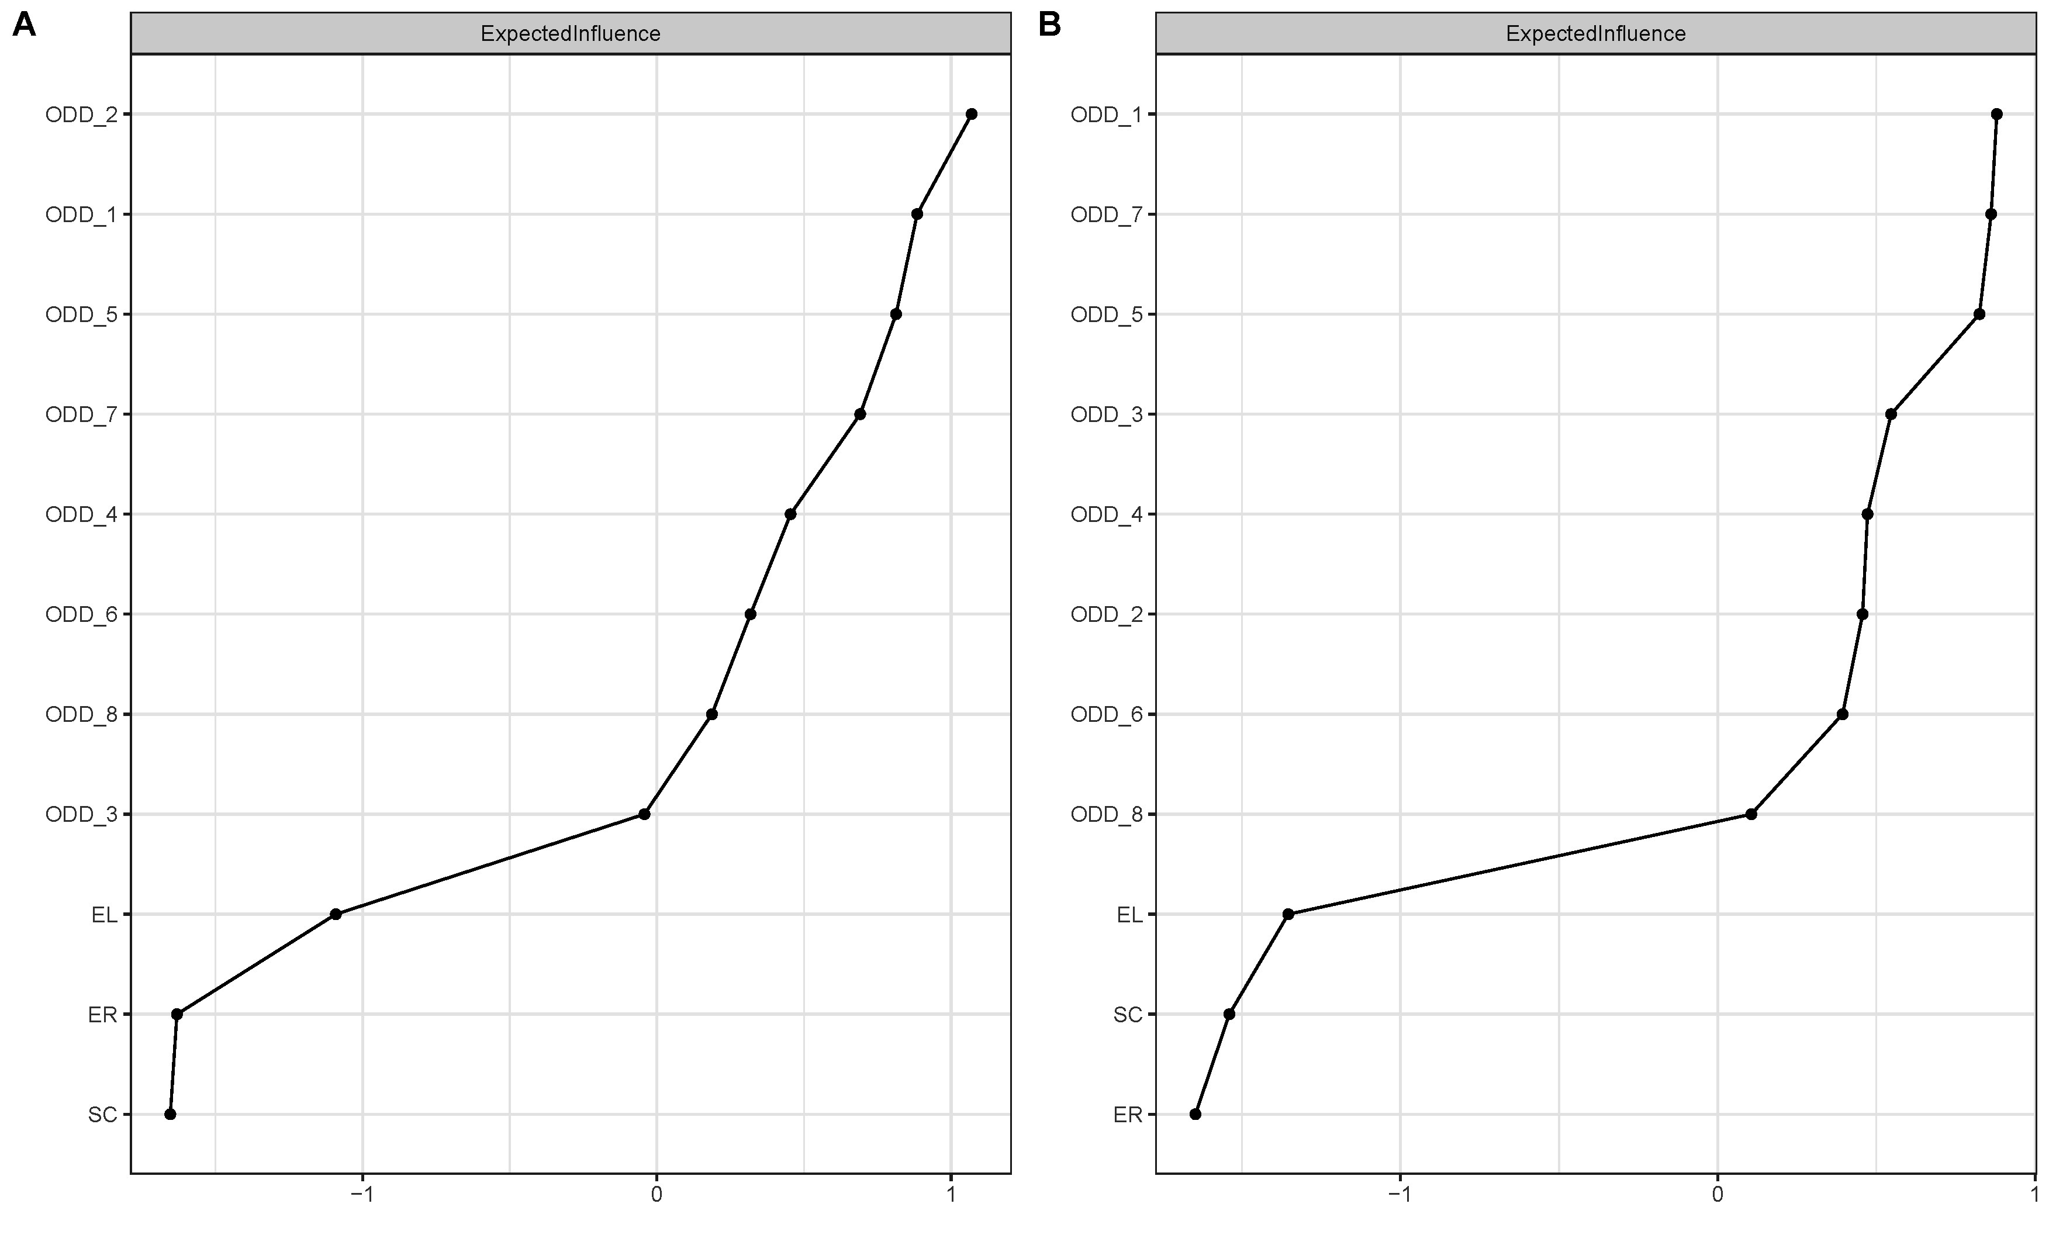

**Fig. S1. The Expected Influence centrality of z-scores in waves 1 (A) and 2 (B).**

ODD_1, Temper; ODD_2, Argues; ODD_3, Defies; ODD_4, Annoys; ODD_5, Blames; ODD_6, Touchy; ODD_7, Angry; ODD_8, Spiteful; SC, Self-control; EL, Emotion lability/negativity; ER, Emotion regulation.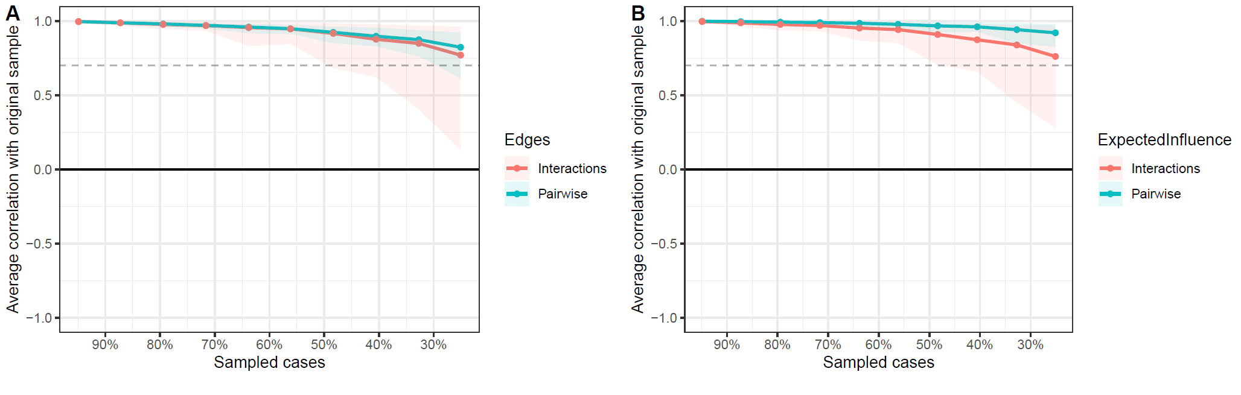

**Fig. S2. Average correlations were plotted with** **95% coverage intervals for each subsample size (number of bootstrapped samples = 1000) in wave 1.**

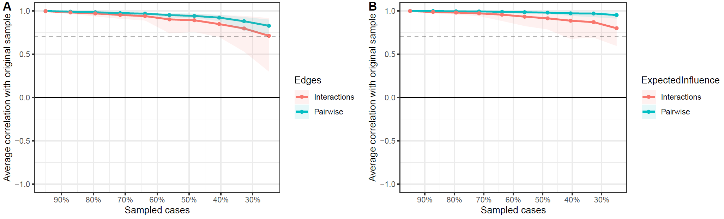

**Fig. S3. Average correlations were plotted with 95% coverage intervals for each subsample size (number of bootstrapped samples = 1000) in wave 2.**