Supplementary Materials for

Identifying biomarkers and trajectories of executive functions and language development in the first 3 years of life: design, methods, and findings of the Germina cohort study

Daniel Fatori, Elizabeth Shephard, Danilo Benette, Nathalia Ferrazzo Naspolini, Grover Castro Guzman, Jaqueline Yu Ting Wang, Pedro Tótolo, Anthonieta Looman Mafra, Caio Isaias, Davi Pereira dos Santos, Fabiele Baldino Russo, Gerson Kobayashi, Adriana Argeu, Monike Teixeira, Ana Claudia Mattiello-Sverzut, Maria Teresa Bechere Fernandes, Danila Cristina Petian-Alonso, Helena Brentani, Marilia Scliar, Paulo Alfonso Schüroff, Pedro Zuccolo, Rogério Lerner, Stephania Geraldini, Veronica Luiza Vale Euclydes, Alicia Matijasevich, Alline Cristina de Campos, André Carlos Ponce de Carvalho, André Fujita, Carla R. Taddei, Maria Rita Passos-Bueno, Patricia Beltrão-Braga, Guilherme Vanoni Polanczyk

Correspondence to: daniel.fatori@usp.br

Developmental and Psychopathology
Supplementary methods

Table S1. Score composition of the risk profiles for EF impairment at 36 months of age based on data from the 2004 Pelotas Cohort.
Characteristics | Score
Total family income (number of minimum wages)
<1 | 8
1-2 | 5
3-5 | 2
6-9 | 1
>10 | 0
Maternal education (in years)
0-4 | 13
5-8 | 6
9-12 | 4
>13 | 0
Maternal skin color (non-white) | 2
Recipient of cash-transfer program | 8
Tobacco smoking during pregnancy | 1
Single mother | 1
Having 2 or more children | 2
Maximum score | 35

Table S2. References of measures used in the Germina cohort.
Family, mother, environment | Measures | Reference
Sociodemographic | Brazilian economic classification criteria | (ABEP, 2022)
 | MacArthur scale | (Ferreira et al., 2018)
Food insecurity | Escala brasileira de insegurança alimentar (EBIA; Brazilian scale of food insecurity) | (L. P. dos Santos et al., 2014)
Trauma history | Childhood trauma questionnaire (CTQ) | (Grassi-Oliveira et al., 2014)
Mental health | Adult ADHD self-report scale (ASRS) | (Polanczyk et al., 2010)
 | Alcohol, smoking and substance involvement screening test (ASSIST) adaptation | (Henrique et al., 2004)
 | Edinburgh postnatal depression scale (EPDS) | (I. S. Santos et al., 2007)
 | Generalized anxiety disorder-7 (GAD-7) | (Moreno et al., 2016)
 | Perceived stress scale (PSS) | (Siqueira Reis et al., 2010)
 | Parenting stress index-IV-short form (PSI-IV-SF) | (Pereira et al., 2016)
 | Single item sleep quality scale | (Snyder et al., 2018)
Temperament | Adult temperament questionnaire (ATQ) | (Evans & Rothbart, 2007)
Cognition | Wechsler abbreviated scale of intelligence (WASI-II) | (Axelrod, 2002; Heck et al., 2009)
Intimate partner violence | WorldSAFE questionnaire | (Miranda et al., 2010)
Social support | Multidimensional Scale of Perceived Social Support (MSPSS) 3-item version | (Slavin et al., 2020; Zimet et al., 1988)
Home environment | Affordances in the home environment for motor development - Infant scale (AHEMD-IS) | (P. Caçola et al., 2011; P. M. Caçola et al., 2015)
 | Chaos, Order and Hubbub Scale (CHAOS) | (Matheny et al., 1995)
Mother-infant interaction | 10-minute video recorded interaction between mother and infant (toy and no toy conditions); coding schemes: (1) entropy of maternal signals | (Davis et al., 2017)
 | (2) coding interactive behavior | (Feldman, 1998)
Infant/child
Anthropometry | Weight, height/length, head, and chest circumference | (Schumacher, 2021)
Abuse and neglect | Conflict tactics scales: parent-child version (CTSPC) | (Bonfim et al., 2011)
Sleep | Brief infant sleep questionnaire (BISQ) | (Del-Ponte et al., 2020)
Temperament | Infant behavior questionnaire-Revised (IBQ-R) | (Klein et al., 2009)
 | Early childhood behavior questionnaire (ECBQ) | (Putnam & Rothbart, 2006)
Developmental milestones and social emotional development | Bayley scales of infant and toddler development 3rd Edition (Bayley-III) | (Madaschi et al., 2016)
Handgrip pressure | Dualpex Plus | (Quark, 2023)
Executive functions | NEPSY-II | (Argollo, 2010; Barros et al., 2016)
 | Reverse Categorization task | (Carlson et al., 2004)
 | Spin the Pots | (Hughes & Ensor, 2005)
 | Prohibition Task | (Friedman et al., 2011)
 | Wechsler Preschool and Primary Scale of Intelligence (WPPSI-IV) | (Raiford & Coalson, 2014)
 | Stroop Day-Night | (Montgomery & Koeltzow, 2010)
 | Dimensional Change Card Sort (DCCS) | (Doebel & Zelazo, 2015)
 | Behavior Rating Inventory of Executive Function - Preschool Version (BRIEF-P) | (Sherman & Brooks, 2010)
Mental health | Child behavior checklist (CBCL) for Ages 1 1⁄2-5 | (Bordin et al., 2013)
Screen time | ScreenQ | (Hutton et al., 2020)
Physical activity | Preschool-age Children’s Physical Activity Questionnaire (Pre-PAQ) | (Dwyer et al., 2011)
Adaptive behavior | Vineland adaptive behavior scales 3rd Edition | (Sparrow et al., 2019)
Polygenic Scores | EF | (Hatoum et al., 2022)
 | General intelligence | (Savage et al., 2018)
 | Educational attainment | (Okbay et al., 2022)
 | Language | (Eising et al., 2022)

Mother-infant interaction

Predictability of maternal behavior

Mother-infant dyads participated in a semi-structured social interaction activity comprised of two segments: (1) mothers were asked to play and talk with the infants as they would do at home for 5 minutes without objects/toys; (2) mothers were asked to choose among culturally-appropriate objects/toys to play with the infants for 5 minutes. The 10-minute mother-infant interaction was recorded using three smartphone cameras (1080p, 60fps) set up on fixed tripods. One camera faced the mother, another faced the infant, and the last one recorded a side view of the activity. The videos were later synchronized. Dyadic behaviors were then coded using Datavyu (Datavyu Team, 2014). A protocol based on studies of predictability of maternal behavior (Davis et al., 2017) is used to code the following behaviors: (1) mother is holding the baby; (2) mother is touching the baby; (3) mother is touching or holding a toy or other object; (4) the mother points towards object to draw infant’s attention to it; (5) infant is ​​looking at the mother, or the object the mother is holding/playing with; (6) maternal vocalization directed towards the infant.

All coders of mother-infant interactions in our study undertook extensive training with researchers who are experienced in coding. For establishing reliability, they coded 10 different records of videos with mother-infant interactions as follows: Each coder coded an entire video and an experienced coder did two minutes of it. Next, they met to check and discuss discrepancies. If reliability for any instance was below 85%, both of them have to go through the entire behavior column with low reliability and recode it. Once reliability reached or exceeded 85% for each behavior in each video for at least eight consecutive ones, the coder was allowed to start coding independently. During our study, the coding team met frequently to verify the reliability of all behaviors at all time-points when mother-infant interaction was recorded. The reliability reached 85% or more for all behaviors for all videos (except for maternal vocal at T1: 75%).

Coding interactive behavior (CIB)

We also used the CIB (Feldman, 1998) to quantify the following constructs, divided in three domains: caregiver behaviors (overriding-intrusiveness, acknowledgement, vocal appropriateness, consistency of style, affectionate touch), infant behaviors (child gaze, joint attention, negative emotionally, withdrawal, vocalization, verbal output, initiation), and dyadic interaction (dyadic reciprocity, adaptation regulation).

For the CIB coding, we used the 5-minute segment videos of mother-infant interaction with culturally-appropriate objects/toys. Following the CIB guidelines (Feldman, 1998), each behavior was coded in a 5-point scale. In general 1 implies a minimal level of the specific behavior or attitude and 5 implies a maximum level, regardless of whether 1 or 5 is optimal. Overall, coders had to be cognizant of the nature of affective/attentive states of the dyad, the reciprocity, as well as constant adaptive behaviors between mother and infant. Thus, it is based on the coders’ experience which requires intensive training prior to using the CIB. Coders did not code more than four or five scales in the same session to avoid bias derived from fatigue. Both coders undertook CIB training before our study and had previous experiences using its coding guidelines. They met multiple times to check reliability. The videos that they coded were recorded at three different timepoints (T1, T2, and T3). CIB reliability reached >85%.

EF measures across T1-T5

Behavioral measures of EF

In addition to the parent-rated measures of self-regulation, we assess the children’s EF abilities using three behavioral tasks (Reverse Categorization, Spin the Pots, Prohibition) at T4-T5. The Reverse Categorization task (Carlson et al., 2004), measures cognitive flexibility and consists of two stages. In stage 1, the child’s objective is to sort red and blue wooden blocks into red and blue containers by matching the colors of the blocks to those of the containers (i.e., red blocks into a red container and blue blocks into a blue container). The experimenter demonstrates the categorization rule by sorting one block of each color into the matching container while stating the sorting rule on each trial “the blue block goes into the blue container”. The child is then given one practice trial per color, with feedback if they sort the block incorrectly, before completing 12 experimental trials (6 per color, with color alternated across trials). The experimenter reminds the child of the sorting rule at the beginning of each trial “remember, we are playing the matching game”. In stage 2, the child is asked to sort the blocks according to the reverse categorization rule (sort red blocks into the blue container and blue blocks into the red container). This requires suppression of the conflicting information presented by the colors of the block and container plus the engagement of cognitive flexibility to overcome the previously-learned categorization rule. The experimenter demonstrates the reverse categorization stage by sorting one block of each color into the container of the opposing color while stating the sorting rule “we are playing the opposite game - red blocks go in the blue container”. The child then completes one practice trial per color, with feedback if they sort incorrectly, before completing 12 experimental trials (6 per color, with color alternated across trials). The experimenter reminds the child of the sorting rule at the beginning of each trial “remember, we are playing the opposite game”. The child’s performance is scored in terms of the number of correct trials (out of 12) in the Categorization phase and in the Reverse Categorization phase.

The Spin the Pots task (Hughes & Ensor, 2005) is a visuospatial working memory task in which the child is presented with five pots of different colors (purple, green, red, blue, yellow) placed in a row on a table. The researcher shows three small animal toys to the child and explains that the animal friends like to play hide-and-seek. The researcher “hides” each animal under three of the pots (one under the pot to the child’s far left, one under the pot to the child’s far right and one under the pot in the middle), covers the pots with a cloth and then invites the child to try to find where the animals are hiding. The child can search under one pot on each trial and can continue to search for the animals for a maximum of 10 trials or until they have found all locations. Between each trial, the researcher covers the pots with the cloth and reminds the child that the aim is to try and find another animal. Performance is indexed by three measures: (a) Working memory score, which is the number of trials (10) minus the number of errors, (b) Correction score, which the number of times the child begins to choose an incorrect pot but corrects themself and chooses a correct pot, and (c) Perseveration score, which is the number of times the child chooses the same incorrect pot on a successive trial.

The Prohibition task (Friedman et al., 2011) measures inhibitory control. The researcher presents the child with an attractive toy with light and sound features and explains that the child may play with the toy only if they can wait. The researcher places the toy on a table in front of the child and begins to time how long the child can wait before reaching to touch the toy. Inhibitory control is measured in terms of how long the child can wait, in seconds, for a maximum of 30 seconds. If the child waits for 30 seconds without touching the toy, the researcher praises the child and lets them play with the toy. If the child touches the toy before the 30 seconds is up, the researcher lets the child continue playing. This task is accomplished with a single trial.

EEG

Electroencephalography (EEG) provides a real-time measure of electrophysiological brain activity from electrodes placed on the scalp. This technique is widely used for investigating neurodevelopment across the first months and years of life because it is non-invasive, places fewer demands on the participant than other neuroscience techniques such as magnetic resonance imaging and produces well-established measures of neural activity (Nelson & McCleery, 2008; Saby & Marshall, 2012). EEG can be combined with experimental passive viewing or listening tasks to stimulate specific neurocognitive processes in infants as young as a few days old, without the need for an explicit response from the infants (Nelson & McCleery, 2008). In this study, we use EEG to examine neurodevelopmental trajectories associated with the development of EF and LS.

At each assessment time-point, infants complete a short (10-minute) battery of experimental tasks while their EEG data are recorded using a 128-channel HydroCel Geodesic Sensor Net and a Net Amps 400 amplifier (Electrical Geodesics Inc., Oregon, USA) in one of our two laboratories. Data are referenced online to electrode Cz and sampled at 500 Hz. Electrode impedances are kept below 50 kΩ wherever possible. Infants are seated on their caregiver’s lap approximately 60 cm in front of a computer monitor throughout recording. Recording takes place in a dimly lit room without electrical shielding; recording environments are comparable across the two EEG laboratories. The infant is video-recorded throughout EEG recording using a camera placed above or below the computer monitor and which is synchronized with the EEG recording.

Experimental tasks were programmed in E-Prime (Psychology Software Tools, Inc., Sharpsburg, PA) and are presented to infants on a 30 × 45.5 cm (1440 × 900 pixel resolution) monitor. The experimental task battery at every time-point (T1-T5) begins with a baseline/resting task (Shephard et al., 2019), in which infants are presented with a 2-minute video of abstract shapes. The purpose of this task is to measure spontaneous or non-event-related electrophysiological activity. At all assessment time-points (T1-T5), infants also complete a passive viewing face processing task (Haartsen et al., 2021) in which they are presented with images of faces with a neutral expression and images of non-social stimuli (black and white checkerboard patterns). The objective of this task is to measure neural processing of social (face) versus non-social (checkerboard) stimuli. At T1 and T2, infants complete a visual evoked potential (VEP) task in which pattern-reversal checkerboard stimuli are presented to measure basic neural processing in occipital cortices (Jensen et al., 2019). The face processing and VEP tasks are described in full below.

EEG tasks

Description of the face processing task: colored photographs of female faces with a neutral expression taken from the NimStim set of facial expressions are displayed (Tottenham et al., 2009); four face images are used, each of a different ethnicity. The task consists of 40 presentations of faces (10 per image) and 40 presentations of checkerboards. Images (faces and checkerboards) subtend 10.1 × 8.7 degrees of visual angle and are presented on a black background. Each trial begins with the presentation of an attention-grabbing cartoon animal image (8 x 8 degrees of visual angle) in the center of the computer screen; this stimulus remains on the screen until the infant attends, as monitored by the experimenter via video camera. Next, one of the face or checkerboard stimuli is presented for a fixed duration of 500 ms, after which a black fixation cross is presented for a jittered duration of 500-1200 ms and the trial ends. Engaging child-friendly music is presented throughout the task to encourage attention. Total task time is approximately 3-4 minutes. Offline, the video-recording of the infant is manually reviewed and periods of EEG data in which the infant was crying or not attending to the tasks are marked for exclusion from further processing.

EEG analysis

EEG processing will be conducted using MATLAB (MathWorks, Inc.). EEG data will be semi-automatically preprocessed using the latest version of the HAPPE software, which was developed to standardize and optimize processing of EEG collected from developmental populations (Gabard-Durnam et al., 2018) and is built on the EEGLAB toolbox (Delorme & Makeig, 2004). The preprocessing will include the 98 most superior channels, excluding the 30 peripheral channels of the outer rim of the 128-channel net. Resting state data will be segmented into 2-second epochs and sessions with fewer than 20 usable segments or more than 80% of interpolated channels will be excluded from further analysis.

Indices of EEG data will be computed on a task-by-task basis, yielding a single average value per session or across trials/segments. The analysis will focus on electrodes in the 10-20 system, with additional channels included depending on the relevance of spatial information or computational efficiency. Most metrics will be analyzed within standard frequency bands commonly defined for developmental populations: delta (2-4 Hz), theta (4-6 Hz), low alpha (6-9 Hz), high alpha (9-12 Hz), beta (12-30 Hz), gamma (30-45 Hz), and high gamma (65-90 Hz). Power spectral density will be estimated based on the BEAPP software (Levin et al., 2018). The resulting average power spectra will be parametrized to separate the aperiodic (“neural noise”) and periodic (“real oscillatory”) components using the SpecParam function in Python (Donoghue et al., 2020), modified for developmental populations (Wilkinson et al., 2024). This approach will provide the measures of power and peak frequency of the periodic components and the offset and exponent of the aperiodic ones. Additionally, brain asymmetry metrics will be calculated by subtracting the log-transformed power of right-side electrodes from their left counterparts (e.g. F4-F3) (Allen et al., 2004).

Functional connectivity will be estimated using the debiased weighted phase lag index (dwPLI; (Vinck et al., 2011) as implemented in the FieldTrip toolbox (Oostenveld et al., 2011). To enhance the spatial precision of long-range synchrony measures, surface Laplacian filtering will be applied before dwPLI computations. The development of overall functional network topology will be assessed through graph theoretical measures, including average path length, clustering coefficient, and global efficiency, compared to statistically equivalent random networks, using the Brain Connectivity Toolbox (Rubinov & Sporns, 2010). Additionally, phase-amplitude coupling will be calculated following the approach for developmental populations (Mariscal et al., 2021).

For the stimulus-locked EEG tasks, we will compute the N1 and P1 event-related potential components at occipital electrode sites for the VEP task (Jensen et al., 2019) and the N290 event-related potential component at parieto-temporal sites for the face processing task (Halit et al., 2003). Finally, the EEG indices will be analyzed in relation to EF and language outcomes.

For the model presented here, 9 indices of resting-state EEG activity per frequency band were computed, including the log10-transformed average power across major regions-of-interest: (1) frontocentral (E6/FCz, E13, E112, E12, E5); (2) right-hemisphere (RH) lateral frontal (E122/F8, E123, E116, E117, E124/F4); (3) left-hemisphere (LH) lateral frontal (E33/F7, E27, E34, E28, E24/F3); (4) RH parietal (E92/P4, E86, E85, E91, E78); (5) LH parietal (E52/P3, E59, E60, E53, E61); (6) RH temporal (E108/T4, E109, E102, E103, E104/C4); (7) LH temporal (E45/T3, E40, E46, E41, E36/C3); and (8) occipital (E70/O1, E75/Oz, E83/O2, E71, E76). Additionally, we included the (9) band dwPLI averaged across all possible pairs of 99 channels. For each metric, outlier values exceeding 3.5 standard deviations from the mean were excluded from the analysis.

Genetics

Quality control of sequencing is applied with Plink2 to filter variants with minor allele frequency < 1%, missingness in variant (> 10%) and in a sample (> 10%), or showing departure from Hardy-Weinberg equilibrium at p < 1 × 10⁻⁵. Coverage analysis is performed with DepthOfCoverage from GATK (v3.7), considering MMQ 17 and including SRY and chrX to infer sex. Kinship and genetic principal components are calculated with Plink2 (Chang et al., 2015) and an in-house script. Ancestrality/admixture will be calculated using ADMIXTURE.

Epigenetics

The Meffil package pipeline is employed for quality control (QC), normalization, and analysis of the methylome data (Min et al., 2018). The QC helps identify probes and samples of poor quality. Meffil will accomplish this by examining detection P-values, dye bias, number of beads, unmethylated/methylated signal ratio, and evaluating control probes. Cellular composition estimation and sex prediction through X/Y chromosome signals are used in the QC. Meffil recommendations and default parameters are followed for QC. Additionally, cross-reactive probes are filtered out from the analysis.

Probes background and dye-bias signal are corrected using the noob method, while functional normalization, implemented in the Meffil package, is used to reduce technical variation further. To address any additional batch effects, comprehensive reports generated by Meffil are employed to assess the data, and corrections are done using surrogate variable analysis (SVA).

The Meffil framework for Epigenome-Wide Association Studies (EWAS) and standard methods for Differentially Methylated Probes (DMP) and Differentially Methylated Regions (DMR) are being used to investigate key targets associated with the phenotypes of interest.

Microbiome

Fecal samples are collected from a diaper during assessments using sterile collector tubes (Feces Tube 76x20mm, Sarstedt, Germany), then stored at −20°C for a few hours until it is finally stored at −80°C. When the above procedures are not feasible, mothers are instructed to collect the stool samples at home and store them at −20°C for a few hours at home until pick up (when they are stored at −80°C in our lab). For milk sample collection, mothers are asked to manually express the milk into a sterile collection vial using the same storage condition. Stool samples are being collected at T1, T2, and T4, while milk was collected at T1.

Genomic DNA is extracted from stool samples using the ZymoBIOMICS™ DNA Miniprep Kit (Zymo Research, USA), according to the manufacturer’s instructions. In all extractions, the ZymoBIOMICS® Microbial Community Standard (ZMCS, Catalog D6300, Zymo Research) is employed as a microbiome mock community. The verification of genomic DNA integrity and concentration/purity is measured using the electrophoresis in 0.8% agarose gel with Tris-Borate-EDTA buffer and NanoDrop™ ND-2000 Spectrophotometer (Thermo Fisher, USA), respectively. For milk, genomic DNA is isolated by the QIAamp DNA Blood Mini Kit (QIAGEN, Germany) with some necessary adaptations described in the supplementary methods.

Infant gut microbiome diversity, taxonomic and functional profiling are estimated with metagenomic sequencing (Illumina NextSeq 2000 shotgun). Human milk microbiome diversity and taxonomic profiling are assessed with 16S rRNA sequencing (Illumina MySeq platform).

The shotgun metagenomic (for fecal samples) sequencing is performed using the Illumina NextSeq 2000 platform (Illumina, USA). Samples are run with paired-end sequencing (2×150) at the technological services and expertise of the NGS Soluções Genômicas (Piracicaba, Brazil).

Bioinformatic tools from bioBakery workflows (Beghini et al., 2021) are used for meta-omics data analyses of microbial taxonomic profiles and functional composition. The bioBakery pipelines include: i) The KneadData (v.0.10.0) used for quality control of metagenomic sequencing data, following the parameter: reads aligned and filtered with Homo sapiens Bowtie 2 hg37 database; ii) MetaPhlAn (v3.1.0, database “mpa_v31_CHOCOPhlAn_201901”) employed for taxonomic composition of the microbial community; and iii) HUMAnN (v3.6) applied to generate the pathway abundance and gene families annotation using the MetaCyc and UniRef90 databases, respectively.

Alpha diversity or within-sample diversity is measured using Shannon index, Chao1 and Simpson. The Bray-Curtis similarity data are calculated to obtain the pairwise beta diversity. Both diversity measures are calculated using the Phyloseq R package (McMurdie & Holmes, 2013).

The PCR 16S rRNA gene sequencing is performed (in milk samples) on an Illumina MiSeq platform (Illumina). All procedures are standardized following the Illumina-16S Metagenomic Sequencing Library Preparation. The V3-V4 region of the bacterial 16S ribosomal segments is amplified (more details in Supplementary Methods) and indexed with the Nextera XT adapters resulting in a PCR fragment of 630 bp. Subsequently, samples are pooled and loaded onto the MiSeq Reagent Kit v2 (500-cycles) for paired-end sequencing (2×250) at the final concentration of 8 pM.

The QIIME2 software (Bolyen et al., 2019) is used for analyses of raw read files, the workflow include: i) Removal of Chimeric and sequences with quality less than Q30; ii) Rarefaction for adjusts of differences in library sizes across samples; iii) Grouping of the remaining sequences into amplicon sequencing variants (ASVs) and the taxonomic assignment using the SILVA database (Quast et al., 2013), based on 99% similarity. Alpha diversity for each sample and distances between samples (beta diversity) are calculated using the same pipeline. Alpha diversity is measured using Shannon index, Chao1 and Simpson. The unweighted/weighted UniFrac distances and the Bray-Curtis similarity data are calculated to obtain the pairwise beta diversity. UniFrac incorporates phylogenetic information when determining the distance between ASVs; weighted UniFrac also takes relative abundance into account, while Bray-Curtis is aware of relative abundance but not phylogeny.

Milk extraction procedure and analysis

Milk samples collected at T1 were expressed into sterile vials and stored at -80 C. Milk samples underwent 16S rRNA sequencing (Illumina MiSeq) for taxonomic profiling (V3-V4 region, paired-end 2x250bp). Using the SILVA database, QIIME2 software was used for analysis, including chimera removal, rarefaction, amplicon sequencing variant (ASV) generation, and taxonomic assignment (Caporaso et al., 2010).

Adaptation on human milk extraction procedure: human milk sample is centrifuged at 15,700x g for 15 min, and the pellet is washed in Tris EDTA buffer (10 mM Tris-HCl [pH 8.0], 0.5 mM EDTA [pH 8.0]) and centrifuged. Then, the samples are lysed in 200 µL of TELS buffer (20 mg/mL lysozyme: 1 M Tris-HCl [pH 8.0], 0.5 M EDTA [pH 8.0], 20% sucrose) and incubated for 60 min at 37 °C. The next steps are performed following the manufacturer’s protocol.

Primers used to amplification of bacterial DNA for PCR 16S rRNA gene sequencing: V3-V4 forward primer: 5’ -TCG TCG GCA GCG TCA GAT GTG TAT AAG AGA CAG CCT ACG GGN GGC WGC AG -3’; V3-V4 reverse primer: 5’- GTC TCG TGG GCT CGG AGA TGT GTA TAA GAG ACA GGA CTA CHV GGG TAT CTA ATC C -3’ (Klindworth et al., 2013).

Handgrip Pressure

The assessment of manual pressure is being carried out using the Dualpex Plus® - Quark Medical equipment, operated by the Dualpex Plus application, installed on a tablet intended for data collection. We use pressure sensors of two sizes and three assessment protocols, which are chosen according to the child's age on the date of the assessment. The pressure sensor is positioned on the child's right hand, with the hose connecting the sensor to the equipment positioned between the thumb and 2nd finger. Data collection takes place over a period of 3 minutes.

Data analysis

Table S3. Selected variables of each data modality included in our model.
Data modality | Measures
Outcome | Bayley-III Latent Factor (composed of 5 domains)
Socioeconomic and demographic | Maternal age (number of years)
 | Maternal skin color
 | Maternal educational level
 | Enrolled in social welfare program
 | Brazilian Food Insecurity Scale total score
 | Infant sex
 | Infant age (in months)
Maternal mental health | Edinburgh Postnatal Depression Scale (EPDS) total score
 | Perceived Stress Scale (PSS) total score
 | Generalized anxiety disorder-7 (GAD-7) total score
 | Single-item sleep quality scale score
 | Parenting Stress Index IV - Short version (PSI-IV-SF) Parental Distress total score
 | PSI-IV-SF Parent-child Dysfunctional Interaction total score
 | Multidimensional Scale of Perceived Social Support - Short Version total score
Home environment | Affordances in the Home Environment for Motor Development (AHEMD) Physical space quality total score
 | AHEMD Variety of stimulation total score
 | AHEMD Availability of gross motor toys total score
 | AHEMD Availability of fine motor toys total score
 | Chaos, Order and Hubbub Scale (CHAOS) total score
Infant behavior | PSI-IV-SF Difficult Child total score
 | Infant Behavior Questionnaire Revised (IBQ-R) Orienting/Regulation total score
 | IBQ-R Surgency/Extraversion total score
 | IBQ-R Negative Affectivity total score
 | Total amount of day sleep (minutes)
 | Total amount of night sleep (minutes)
 | Vineland adaptive behavior Communication skills total score
 | Vineland adaptive behavior Daily living skills total score
 | Vineland adaptive behavior Socialization total score
 | Vineland adaptive behavior Adaptive behavior total score
Anthropometry | Body mass index (BMI) z-score based on age
 | Height z-score based on age (WHO Child Growth Standards)
 | Weight z-score based on age (WHO Child Growth Standards)
 | Weight-for-length z-score based on age (WHO Child Growth Standards)
Genetics | Attention deficit hyperactivity disorder (ADHD) Polygenic Score (PGS)
 | Cognitive Functioning PGS
 | Executive Function PGS
 | Schizophrenia PGS
Epigenetics | Scaled glucocorticoid exposure score
 | Scaled epigenetic score of low-grade inflammation exposure with European genetic background
EEG Delta | Connectivity (dwPLI) and Power: Delta band (9 variables)
EEG Theta | Connectivity (dwPLI) and Power: Theta band (9 variables)
EEG Low Alpha | Connectivity (dwPLI) and Power: Low Alpha band (9 variables)
EEG High Alpha | Connectivity (dwPLI) and Power: High Alpha band (9 variables)
EEG Beta | Connectivity (dwPLI) and Power: Beta band (9 variables)
EEG Gamma | Connectivity (dwPLI) and Power: Gamma band (9 variables)
Microbiome Diversity and Abundance of species | Alpha diversity of species (432 variables)
Microbiome Functional Pathways | Microbiome Functional Pathways (500 variables)

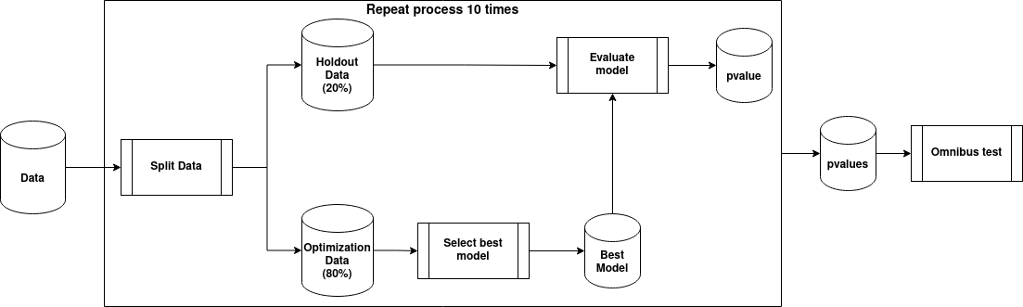

Figure S1. Illustration of the multiple holdout framework for single- and multi-view data. We first split the data into two sets: Holdout data (20%) and Optimization data (80%). The Optimization data is then used to build/select the best model; in this step, we employed ddsPLS to select the model with the best generability and stability. Once the top-performing model is selected, its performance is assessed using the Holdout data, and a p-value is computed via a permutation test. The entire procedure is repeated ten times, yielding ten p-values. Finally, an omnibus test is applied to these p-values to draw a definitive conclusion.

Supplementary results

Infant development latent factor

Table S4. Latent factor models of infant development measured by the Bayley-III at baseline (3 months of age).
Model | Number of parameters | Degrees of freedom | CFI | TLI | RMSEA | SRMR
1 | 10 | 5 | 0.967 | 0.935 | 0.073 | 0.035
2 | 15 | 10 | 1.000 | 1.000 | <0.001 | <0.001

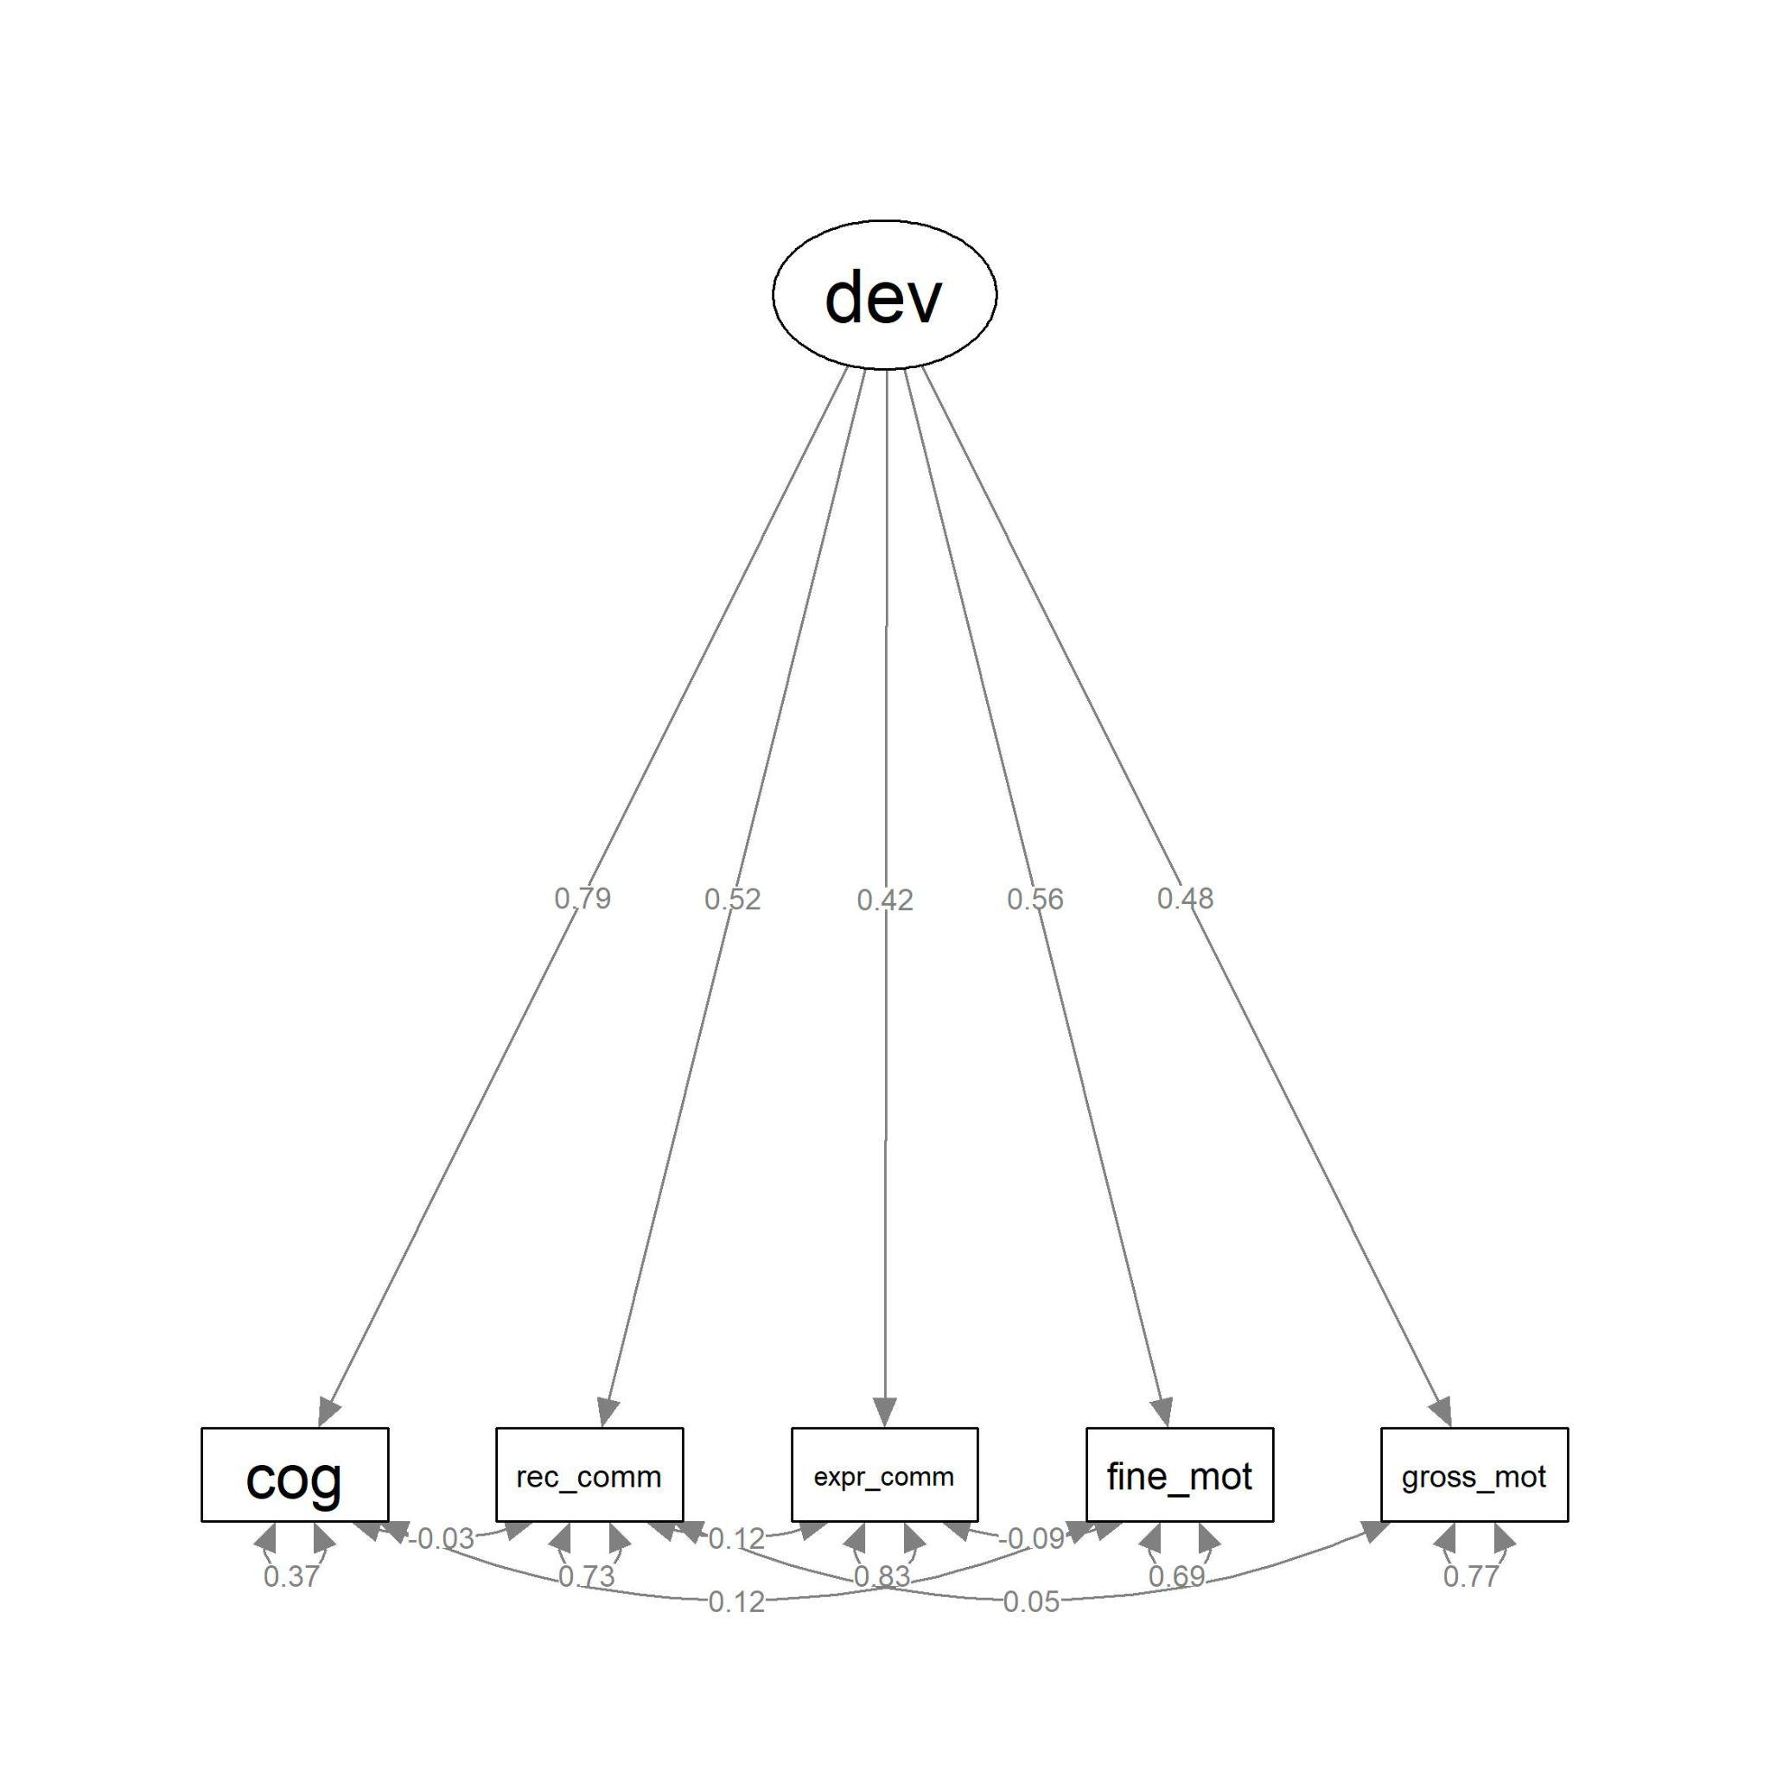
Figure S2. Diagram indicating the structure, factor loadings, and residuals of the final infant development model measured by the Bayley-III at baseline. Abbreviation: dev=infant development, cog=cognition, rec_comm=receptive communication/language, expr_comm=expressive communication/language, fine_mot=fine motor, gross_mot=gross motor.

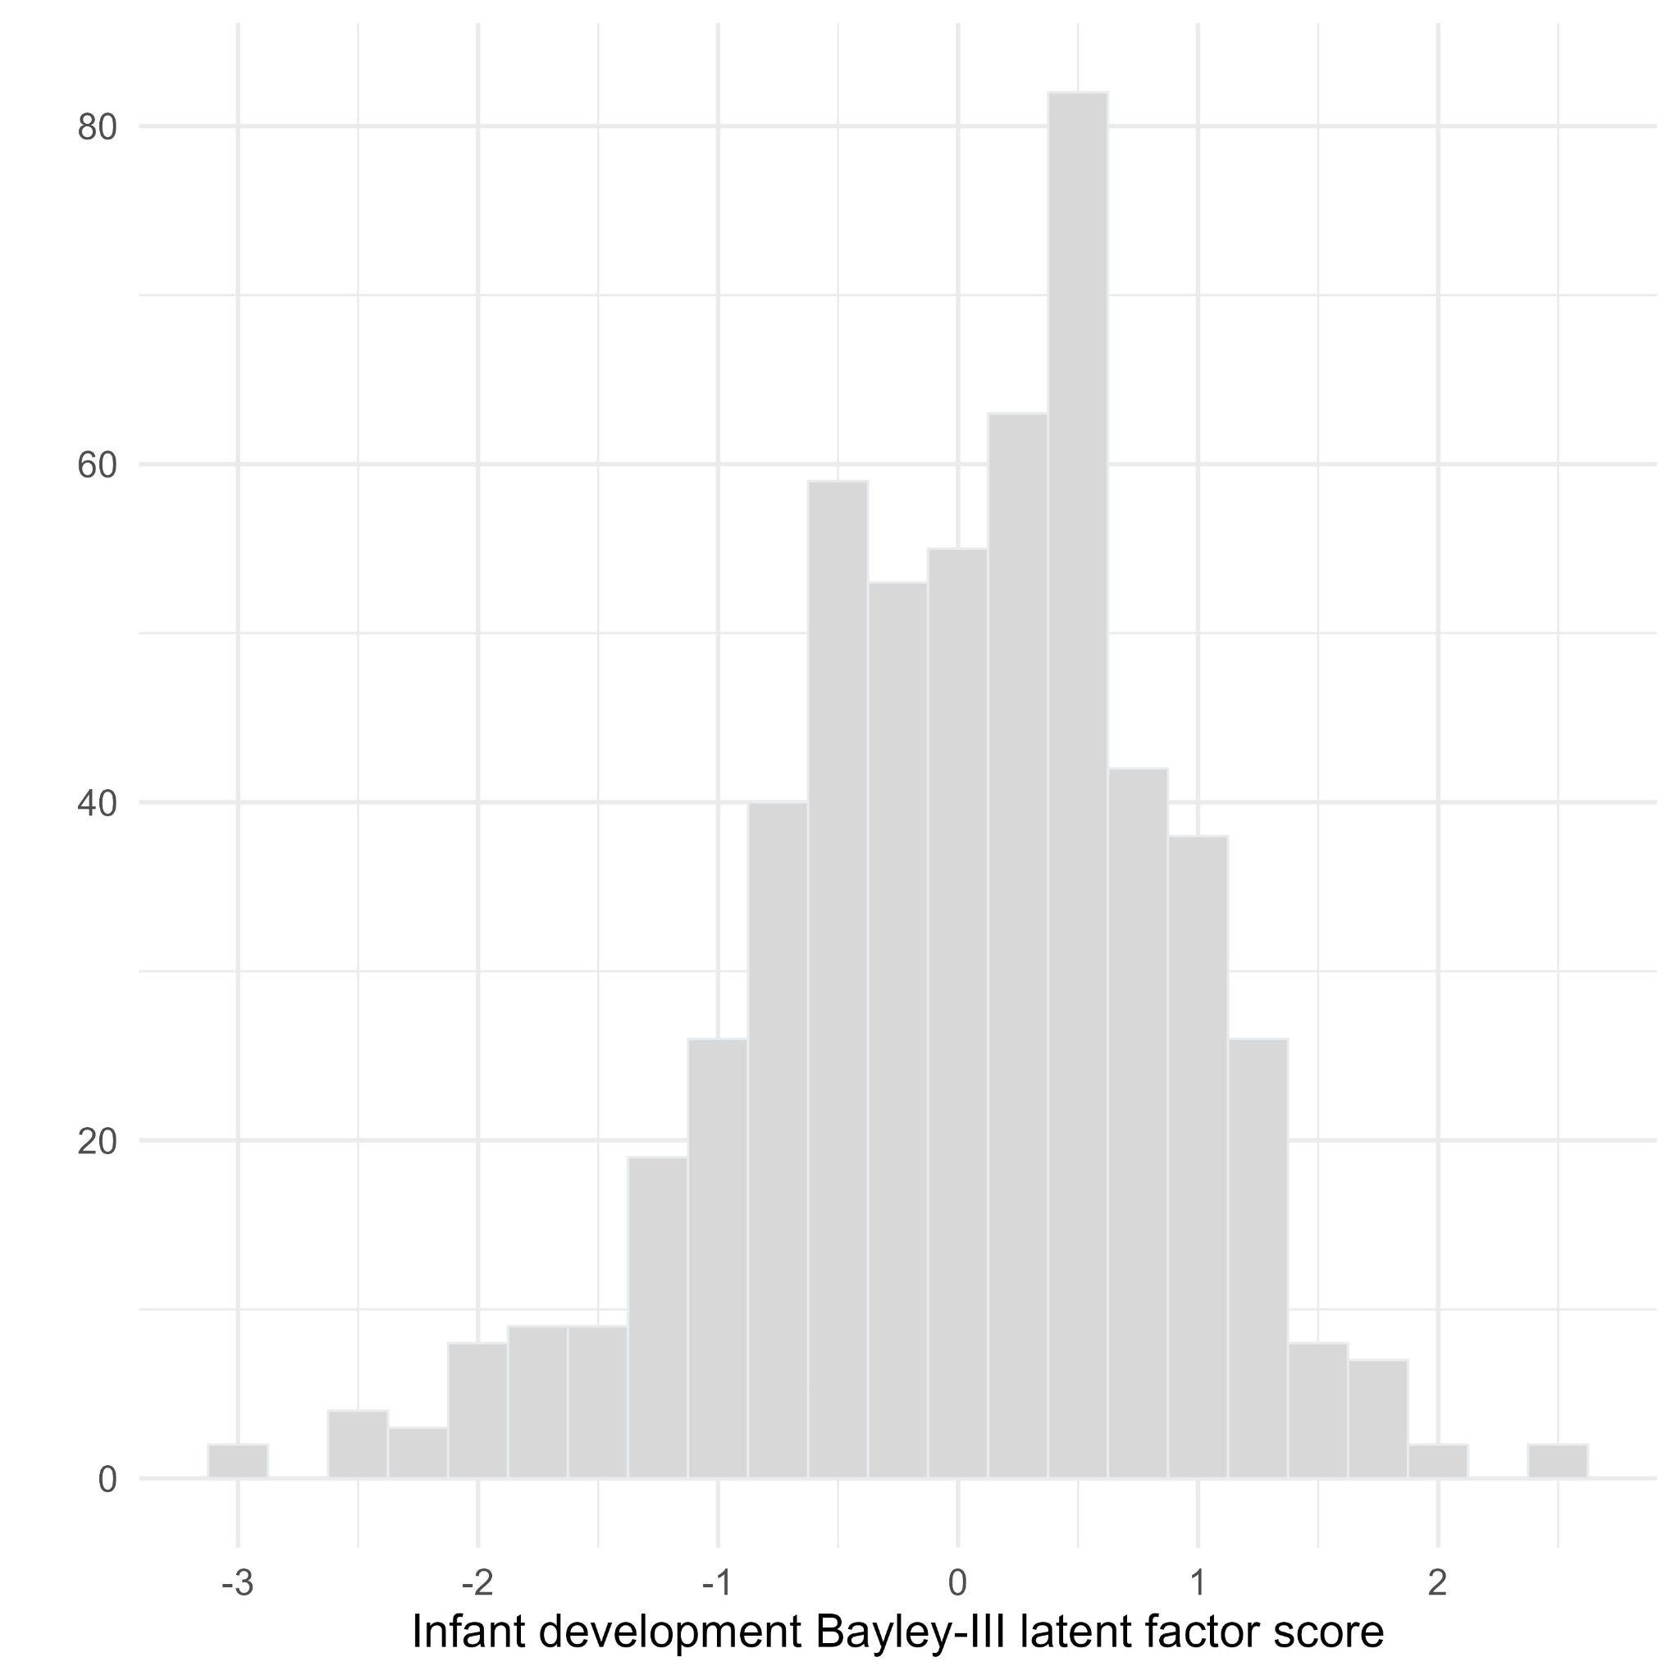
Figure S3. Histogram of latent factor score of infant development measured by the Bayley-III at baseline (3 months of age) derived from the final CFA model.

All CFA-related procedures were conducted using lavaan 0.6 (Rosseel, 2012).

Table S5. Regression model findings.
Variable | Coefficient | 95% CI LB | 95% CI UB | p-value
Intercept | -0.011 | -0.085 | 0.062 | 0.761
Socioeconomic and demographic | 0.295 | 0.219 | 0.372 | <0.001
Maternal mental health | 0.058 | -0.018 | 0.133 | 0.133
Home environment | 0.061 | -0.014 | 0.137 | 0.108
Infant behavior | 0.030 | -0.044 | 0.106 | 0.419
Anthropometry | 0.044 | -0.031 | 0.119 | 0.251
Genetics | 0.026 | -0.048 | 0.102 | 0.484
Epigenetics | 0.108 | 0.033 | 0.182 | 0.005
EEG Delta | 0.000 | 0.000 | 0.000 | 0.635
EEG Theta | 0.145 | 0.054 | 0.235 | 0.002
EEG Low Alpha | 0.000 | 0.000 | 0.000 | 0.342
EEG High Alpha | -0.018 | -0.110 | 0.075 | 0.707
EEG Beta | 0.107 | 0.027 | 0.187 | 0.009
EEG Gamma | 0.024 | -0.070 | 0.118 | 0.611
Microbiome Diversity | 0.000 | 0.000 | 0.000 | 0.653
Microbiome Functional Pathways | 0.077 | 0.002 | 0.151 | 0.044

Table S6. Relative importance of data modalities.
Mode | Importance (%)
Socioeconomic and demographic | 61.20
Maternal mental health | 2.40
Home environment | 2.75
Infant behavior | 0.69
Anthropometry | 1.40
Genetics | 0.52
Epigenetics | 8.54
EEG Delta | <0.01
EEG Theta | 10.42
EEG Low Alpha | <0.01
EEG High Alpha | 0.15
EEG Beta | 7.30
EEG Gamma | 0.27
Microbiome Diversity | <0.01
Microbiome functional pathways | 4.32

References
ABEP. (2022). Critério de Classificação Econômica: Critério Brasil 2022. Associação Brasileira de Empresas de Pesquisa. http://www.abep.org/criterio-brasil
Allen, J. J. B., Coan, J. A., & Nazarian, M. (2004). Issues and assumptions on the road from raw signals to metrics of frontal EEG asymmetry in emotion. Biological Psychology, 67(1-2), 183–218. https://doi.org/10.1016/j.biopsycho.2004.03.007
Argollo, N. (2010). NEPSY-II Avaliação neuropsicológica do desenvolvimento. In L. F. Malloy, D. Fuentes, P. Mattos, & N. Abreu (Eds.), Avaliação Neuropsicológica (pp. 367–373). Artmed.
Axelrod, B. N. (2002). Validity of the Wechsler abbreviated scale of intelligence and other very short forms of estimating intellectual functioning. Assessment, 9(1), 17–23. https://doi.org/10.1177/1073191102009001003
Barros, P. M., Metta, L. R., Peralba, C. T., Vilar, C. B., Guerra, A. B., de Paula, A. P., Argollo, N. S., & Hazin, I. (2016). Perfil desenvolvimental das funções executivas utilizando o NEPSY-II em crianças de 5 a 8 anos. Neuropsicología Latinoamericana, 8(2). https://www.neuropsicolatina.org/index.php/Neuropsicologia_Latinoamericana/article/view/295
Beghini, F., McIver, L. J., Blanco-Míguez, A., Dubois, L., Asnicar, F., Maharjan, S., Mailyan, A., Manghi, P., Scholz, M., Thomas, A. M., Valles-Colomer, M., Weingart, G., Zhang, Y., Zolfo, M., Huttenhower, C., Franzosa, E. A., & Segata, N. (2021). Integrating taxonomic, functional, and strain-level profiling of diverse microbial communities with bioBakery 3. eLife, 10. https://doi.org/10.7554/eLife.65088
Bolyen, E., Rideout, J. R., Dillon, M. R., Bokulich, N. A., Abnet, C. C., Al-Ghalith, G. A., Alexander, H., Alm, E. J., Arumugam, M., Asnicar, F., Bai, Y., Bisanz, J. E., Bittinger, K., Brejnrod, A., Brislawn, C. J., Brown, C. T., Callahan, B. J., Caraballo-Rodríguez, A. M., Chase, J., … Caporaso, J. G. (2019). Reproducible, interactive, scalable and extensible microbiome data science using QIIME 2. Nature Biotechnology, 37(8), 852–857. https://doi.org/10.1038/s41587-019-0209-9
Bonfim, C. B., Santos, D. N., Menezes, I. G., Reichenheim, M. E., & Barreto, M. L. (2011). Um estudo sobre a validade de construto da Parent-Child Conflict Tactics Scale (CTSPC) em uma amostra populacional urbana do Nordeste brasileiro. Cadernos de Saúde Pública, 27(11), 2215–2226. https://doi.org/10.1590/S0102-311X2011001100015
Bordin, I. A., Rocha, M. M., Paula, C. S., Teixeira, M. C. T. V., Achenbach, T. M., Rescorla, L. A., & Silvares, E. F. M. (2013). Child Behavior Checklist (CBCL),Youth Self-Report (YSR) and Teacher’s Report Form(TRF): an overview of the development of the original and Brazilian versions. Cadernos de Saúde Pública, 29(1), 13–28. https://doi.org/10.1590/S0102-311X2013000100004
Caçola, P., Gabbard, C., Santos, D. C. C., & Batistela, A. C. T. (2011). Development of the Affordances in the Home Environment for Motor Development-Infant Scale. Pediatrics International: Official Journal of the Japan Pediatric Society, 53(6), 820–825. https://doi.org/10.1111/j.1442-200X.2011.03386.x
Caçola, P. M., Gabbard, C., Montebelo, M. I. L., & Santos, D. C. C. (2015). The new affordances in the home environment for motor development - infant scale (AHEMD-IS): Versions in English and Portuguese languages. Brazilian Journal of Physical Therapy, 19(6), 507–525. https://doi.org/10.1590/bjpt-rbf.2014.0112
Caporaso, J. G., Kuczynski, J., Stombaugh, J., Bittinger, K., Bushman, F. D., Costello, E. K., Fierer, N., Peña, A. G., Goodrich, J. K., Gordon, J. I., Huttley, G. A., Kelley, S. T., Knights, D., Koenig, J. E., Ley, R. E., Lozupone, C. A., McDonald, D., Muegge, B. D., Pirrung, M., … Knight, R. (2010). QIIME allows analysis of high-throughput community sequencing data. Nature Methods, 7(5), 335–336. https://doi.org/10.1038/nmeth.f.303
Carlson, S. M., Mandell, D. J., & Williams, L. (2004). Executive function and theory of mind: stability and prediction from ages 2 to 3. Developmental Psychology, 40(6), 1105–1122. https://doi.org/10.1037/0012-1649.40.6.1105
Chang, C. C., Chow, C. C., Tellier, L. C., Vattikuti, S., Purcell, S. M., & Lee, J. J. (2015). Second-generation PLINK: rising to the challenge of larger and richer datasets. GigaScience, 4, 7. https://doi.org/10.1186/s13742-015-0047-8
Datavyu Team. (2014). Datavyu: A Video Coding Tool. Databrary Project, New York University. http://datavyu.org
Davis, E. P., Stout, S. A., Molet, J., Vegetabile, B., Glynn, L. M., Sandman, C. A., Heins, K., Stern, H., & Baram, T. Z. (2017). Exposure to unpredictable maternal sensory signals influences cognitive development across species. Proceedings of the National Academy of Sciences of the United States of America, 114(39), 10390–10395. https://doi.org/10.1073/pnas.1703444114
Delorme, A., & Makeig, S. (2004). EEGLAB: an open source toolbox for analysis of single-trial EEG dynamics including independent component analysis. Journal of Neuroscience Methods, 134(1), 9–21. https://doi.org/10.1016/j.jneumeth.2003.10.009
Del-Ponte, B., Xavier, M. O., Bassani, D. G., Tovo-Rodrigues, L., Halal, C. S., Shionuma, A. H., Ulguim, K. F., & Santos, I. S. (2020). Validity of the Brief Infant Sleep Questionnaire (BISQ) in Brazilian children. Sleep Medicine, 69, 65–70. https://doi.org/10.1016/j.sleep.2019.12.018
Doebel, S., & Zelazo, P. D. (2015). A meta-analysis of the Dimensional Change Card Sort: Implications for developmental theories and the measurement of executive function in children. Developmental Review: DR, 38, 241–268. https://doi.org/10.1016/j.dr.2015.09.001
Donoghue, T., Haller, M., Peterson, E. J., Varma, P., Sebastian, P., Gao, R., Noto, T., Lara, A. H., Wallis, J. D., Knight, R. T., Shestyuk, A., & Voytek, B. (2020). Parameterizing neural power spectra into periodic and aperiodic components. Nature Neuroscience, 23(12), 1655–1665. https://doi.org/10.1038/s41593-020-00744-x
Dwyer, G. M., Hardy, L. L., Peat, J. K., & Baur, L. A. (2011). The validity and reliability of a home environment preschool-age physical activity questionnaire (Pre-PAQ). The International Journal of Behavioral Nutrition and Physical Activity, 8(1), 86. https://doi.org/10.1186/1479-5868-8-86
Eising, E., Mirza-Schreiber, N., de Zeeuw, E. L., Wang, C. A., Truong, D. T., Allegrini, A. G., Shapland, C. Y., Zhu, G., Wigg, K. G., Gerritse, M. L., Molz, B., Alagöz, G., Gialluisi, A., Abbondanza, F., Rimfeld, K., van Donkelaar, M., Liao, Z., Jansen, P. R., Andlauer, T. F. M., … Fisher, S. E. (2022). Genome-wide analyses of individual differences in quantitatively assessed reading- and language-related skills in up to 34,000 people. Proceedings of the National Academy of Sciences of the United States of America, 119(35), e2202764119. https://doi.org/10.1073/pnas.2202764119
Evans, D. E., & Rothbart, M. K. (2007). Developing a model for adult temperament. Journal of Research in Personality, 41(4), 868–888. https://doi.org/10.1016/j.jrp.2006.11.002
Feldman, R. (1998). Coding interactive behavior manual. Bar-Ilan University.
Ferreira, W. de A., Giatti, L., Figueiredo, R. C. de, Mello, H. R. de, & Barreto, S. M. (2018). Concurrent and face validity of the MacArthur scale for assessing subjective social status: Brazilian Longitudinal Study of Adult Health (ELSA-Brasil). Ciencia & Saude Coletiva, 23(4), 1267–1280. https://doi.org/10.1590/1413-81232018234.16972016
Friedman, N. P., Miyake, A., Robinson, J. L., & Hewitt, J. K. (2011). Developmental trajectories in toddlers’ self-restraint predict individual differences in executive functions 14 years later: a behavioral genetic analysis. Developmental Psychology, 47(5), 1410–1430. https://doi.org/10.1037/a0023750
Gabard-Durnam, L. J., Mendez Leal, A. S., Wilkinson, C. L., & Levin, A. R. (2018). The Harvard Automated Processing Pipeline for Electroencephalography (HAPPE): Standardized Processing Software for Developmental and High-Artifact Data. Frontiers in Neuroscience, 12, 97. https://doi.org/10.3389/fnins.2018.00097
Grassi-Oliveira, R., Cogo-Moreira, H., Salum, G. A., Brietzke, E., Viola, T. W., Manfro, G. G., Kristensen, C. H., & Arteche, A. X. (2014). Childhood Trauma Questionnaire (CTQ) in Brazilian samples of different age groups: findings from confirmatory factor analysis. PloS One, 9(1), e87118. https://doi.org/10.1371/journal.pone.0087118
Haartsen, R., Mason, L., Braithwaite, E. K., Del Bianco, T., Johnson, M. H., & Jones, E. J. H. (2021). Reliability of an automated gaze-controlled paradigm for capturing neural responses during visual and face processing in toddlerhood. Developmental Psychobiology, 63(7), e22157. https://doi.org/10.1002/dev.22157
Halit, H., de Haan, M., & Johnson, M. H. (2003). Cortical specialisation for face processing: face-sensitive event-related potential components in 3- and 12-month-old infants. NeuroImage, 19(3), 1180–1193. https://doi.org/10.1016/s1053-8119(03)00076-4
Hatoum, A. S., Morrison, C. L., Mitchell, E. C., Lam, M., Benca-Bachman, C. E., Reineberg, A. E., Palmer, R. H. C., Evans, L. M., Keller, M. C., & Friedman, N. P. (2022). Genome-wide Association Study Shows That Executive Functioning Is Influenced by GABAergic Processes and Is a Neurocognitive Genetic Correlate of Psychiatric Disorders. Biological Psychiatry. https://doi.org/10.1016/j.biopsych.2022.06.034
Heck, V. S., Yates, D. B., Poggere, L. C., Tosi, S. D., Bandeira, D. R., & Trentini, C. M. (2009). Validação dos subtestes verbais da versão de adaptação da WASI. Avaliação Psicológica, 8(1), 33–42. http://pepsic.bvsalud.org/scielo.php?script=sci_abstract&pid=S1677-04712009000100004&lng=pt&nrm=iso&tlng=pt
Henrique, I. F. S., De Micheli, D., Lacerda, R. B. de, Lacerda, L. A. de, & Formigoni, M. L. O. de S. (2004). Validação da versão brasileira do teste de triagem do envolvimento com álcool, cigarro e outras substâncias (ASSIST). Revista da Associacao Medica Brasileira, 50(2), 199–206. https://doi.org/10.1590/S0104-42302004000200039
Hughes, C., & Ensor, R. (2005). Executive function and theory of mind in 2 year olds: a family affair? Developmental Neuropsychology, 28(2), 645–668. https://doi.org/10.1207/s15326942dn2802_5
Hutton, J. S., Huang, G., Sahay, R. D., DeWitt, T., & Ittenbach, R. F. (2020). A novel, composite measure of screen-based media use in young children (ScreenQ) and associations with parenting practices and cognitive abilities. Pediatric Research, 87(7), 1211–1218. https://doi.org/10.1038/s41390-020-0765-1
Jensen, S. K. G., Kumar, S., Xie, W., Tofail, F., Haque, R., Petri, W. A., & Nelson, C. A. (2019). Neural correlates of early adversity among Bangladeshi infants. Scientific Reports, 9(1), 3507. https://doi.org/10.1038/s41598-019-39242-x
Klein, V. C., Putnam, S. P., & Linhares, M. B. M. (2009). Assessment of temperament in children: Translation of instruments to Portuguese (Brazil) language. Revista Interamericana de Psicologia = Interamerican Journal of Psychology, 43(3), 552–557. http://pepsic.bvsalud.org/scielo.php?script=sci_abstract&pid=S0034-96902009000300015&lng=pt&nrm=iso&tlng=en
Klindworth, A., Pruesse, E., Schweer, T., Peplies, J., Quast, C., Horn, M., & Glöckner, F. O. (2013). Evaluation of general 16S ribosomal RNA gene PCR primers for classical and next-generation sequencing-based diversity studies. Nucleic Acids Research, 41(1), e1. https://doi.org/10.1093/nar/gks808
Levin, A. R., Méndez Leal, A. S., Gabard-Durnam, L. J., & O’Leary, H. M. (2018). BEAPP: The Batch Electroencephalography Automated Processing Platform. Frontiers in Neuroscience, 12, 513. https://doi.org/10.3389/fnins.2018.00513
Madaschi, V., Mecca, T. P., Macedo, E. C., & Paula, C. S. (2016). Bayley-III Scales of Infant and Toddler Development: Transcultural Adaptation and Psychometric Properties. Paidéia (Ribeirão Preto), 26(64), 189–197. https://doi.org/10.1590/1982-43272664201606
Mariscal, M. G., Levin, A. R., Gabard-Durnam, L. J., Xie, W., Tager-Flusberg, H., & Nelson, C. A. (2021). EEG phase-amplitude coupling strength and phase preference: Association with age over the first three years after birth. eNeuro, 8(3), ENEURO.0264–20.2021. https://doi.org/10.1523/ENEURO.0264-20.2021
Matheny, A. P., Wachs, T. D., Ludwig, J. L., & Phillips, K. (1995). Bringing order out of chaos: Psychometric characteristics of the confusion, hubbub, and order scale. Journal of Applied Developmental Psychology, 16(3), 429–444. https://doi.org/10.1016/0193-3973(95)90028-4
McMurdie, P. J., & Holmes, S. (2013). phyloseq: an R package for reproducible interactive analysis and graphics of microbiome census data. PloS One, 8(4), e61217. https://doi.org/10.1371/journal.pone.0061217
Min, J. L., Hemani, G., Davey Smith, G., Relton, C., & Suderman, M. (2018). Meffil: efficient normalization and analysis of very large DNA methylation datasets. Bioinformatics , 34(23), 3983–3989. https://doi.org/10.1093/bioinformatics/bty476
Miranda, M. P. de M., de Melo Miranda, M. P., de Paula, C. S., & Bordin, I. A. (2010). Violência conjugal física contra a mulher na vida: prevalência e impacto imediato na saúde, trabalho e família. Revista Panamericana de Salud Publica = Pan American Journal of Public Health, 27(4), 300–308. https://doi.org/10.1590/s1020-49892010000400009
Montgomery, D. E., & Koeltzow, T. E. (2010). A review of the day–night task: The Stroop paradigm and interference control in young children. Developmental Review: DR, 30(3), 308–330. https://doi.org/10.1016/j.dr.2010.07.001
Moreno, A. L., DeSousa, D. A., Souza, A. M. F. L. P., Manfro, G. G., Salum, G. A., Koller, S. H., Osório, F. L., & Crippa, J. A. S. (2016). Factor Structure, Reliability, and Item Parameters of the Brazilian-Portuguese Version of the GAD-7 Questionnaire. Temas Em Psicologia, 24(1), 367–376. https://doi.org/10.9788/TP2016.1-25
Nelson, C. A., 3rd, & McCleery, J. P. (2008). Use of event-related potentials in the study of typical and atypical development. Journal of the American Academy of Child and Adolescent Psychiatry, 47(11), 1252–1261. https://doi.org/10.1097/CHI.0b013e318185a6d8
Okbay, A., Wu, Y., Wang, N., Jayashankar, H., Bennett, M., Nehzati, S. M., Sidorenko, J., Kweon, H., Goldman, G., Gjorgjieva, T., Jiang, Y., Hicks, B., Tian, C., Hinds, D. A., Ahlskog, R., Magnusson, P. K. E., Oskarsson, S., Hayward, C., Campbell, A., … Young, A. I. (2022). Polygenic prediction of educational attainment within and between families from genome-wide association analyses in 3 million individuals. Nature Genetics, 54(4), 437–449. https://doi.org/10.1038/s41588-022-01016-z
Oostenveld, R., Fries, P., Maris, E., & Schoffelen, J.-M. (2011). FieldTrip: Open source software for advanced analysis of MEG, EEG, and invasive electrophysiological data. Computational Intelligence and Neuroscience, 2011(1), 156869. https://doi.org/10.1155/2011/156869
Pereira, L. M., Viera, C. S., Toso, B. R. G. de O., Carvalho, A. R. da S., & Bugs, B. M. (2016). Validação da escala Índice de Estresse Parental para o português do Brasil. Acta Paulista de Enfermagem, 29(6), 671–677. https://doi.org/10.1590/1982-0194201600094
Polanczyk, G., Laranjeira, R., Zaleski, M., Pinsky, I., Caetano, R., & Rohde, L. A. (2010). ADHD in a representative sample of the Brazilian population: estimated prevalence and comparative adequacy of criteria between adolescents and adults according to the item response theory. International Journal of Methods in Psychiatric Research, 19(3), 177–184. https://doi.org/10.1002/mpr.319
Putnam, S. P., & Rothbart, M. K. (2006). Development of short and very short forms of the Children’s Behavior Questionnaire. Journal of Personality Assessment, 87(1), 102–112. https://doi.org/10.1207/s15327752jpa8701_09
Quark, P. M. (2023). Dualpex Plus. https://consultas.anvisa.gov.br/#/saude/25351415855201810/
Quast, C., Pruesse, E., Yilmaz, P., Gerken, J., Schweer, T., Yarza, P., Peplies, J., & Glöckner, F. O. (2013). The SILVA ribosomal RNA gene database project: improved data processing and web-based tools. Nucleic Acids Research, 41(Database issue), D590–D596. https://doi.org/10.1093/nar/gks1219
Raiford, S. E., & Coalson, D. L. (2014). Essentials of WPPSI-IV assessment [PDF]. John Wiley & Sons. https://books.google.com/books/about/Essentials_of_WPPSI_IV_Assessment.html?id=yoFPAwAAQBAJ
Rosseel, Y. (2012). lavaan: An R Package for Structural Equation Modeling. Journal of Statistical Software, Articles, 48(2), 1–36. https://doi.org/10.18637/jss.v048.i02
Rubinov, M., & Sporns, O. (2010). Complex network measures of brain connectivity: uses and interpretations. NeuroImage, 52(3), 1059–1069. https://doi.org/10.1016/j.neuroimage.2009.10.003
Saby, J. N., & Marshall, P. J. (2012). The utility of EEG band power analysis in the study of infancy and early childhood. Developmental Neuropsychology, 37(3), 253–273. https://doi.org/10.1080/87565641.2011.614663
Santos, L. P. dos, Lindemann, I. L., Motta, J. V. dos S., Mintem, G., Bender, E., & Gigante, D. P. (2014). Proposal of a short-form version of the Brazilian Food Insecurity Scale. Revista de Saúde Pública, 48(5), 783–789. https://doi.org/10.1590/S0034-8910.2014048005195
Santos, I. S., Matijasevich, A., Tavares, B. F., Barros, A. J. D., Botelho, I. P., Lapolli, C., Magalhães, P. V. da S., Barbosa, A. P. P. N., & Barros, F. C. (2007). Validation of the Edinburgh Postnatal Depression Scale (EPDS) in a sample of mothers from the 2004 Pelotas Birth Cohort Study. Cadernos de Saude Publica, 23(11), 2577–2588. https://doi.org/10.1590/S0102-311X2007001100005
Savage, J. E., Jansen, P. R., Stringer, S., Watanabe, K., Bryois, J., de Leeuw, C. A., Nagel, M., Awasthi, S., Barr, P. B., Coleman, J. R. I., Grasby, K. L., Hammerschlag, A. R., Kaminski, J. A., Karlsson, R., Krapohl, E., Lam, M., Nygaard, M., Reynolds, C. A., Trampush, J. W., … Posthuma, D. (2018). Genome-wide association meta-analysis in 269,867 individuals identifies new genetic and functional links to intelligence. Nature Genetics, 50(7), 912–919. https://doi.org/10.1038/s41588-018-0152-6
Schumacher, D. (2021). Computation of the WHO Child Growth Standards [R package anthro version 1.0.0]. Comprehensive R Archive Network (CRAN). https://CRAN.R-project.org/package=anthro
Shephard, E., Fatori, D., Mauro, L. R., de Medeiros Filho, M. V., Hoexter, M. Q., Chiesa, A. M., Fracolli, L. A., Brentani, H., Ferraro, A. A., Nelson, C. A., Miguel, E. C., & Polancyk, G. V. (2019). Effects of maternal psychopathology and education level on neurocognitive development in infants of adolescent mothers living in poverty in Brazil. Biological Psychiatry: Cognitive Neuroscience and Neuroimaging. https://doi.org/10.1016/j.bpsc.2019.05.009
Sherman, E. M. S., & Brooks, B. L. (2010). Behavior rating inventory of executive function – preschool version (BRIEF-P): Test review and clinical guidelines for use. Child Neuropsychology: A Journal on Normal and Abnormal Development in Childhood and Adolescence, 16(5), 503–519. https://doi.org/10.1080/09297041003679344
Siqueira Reis, R., Ferreira Hino, A. A., & Romélio Rodriguez Añez, C. (2010). Perceived Stress Scale: Reliability and Validity Study in Brazil. Journal of Health Psychology, 15(1), 107–114. https://doi.org/10.1177/1359105309346343
Slavin, V., Creedy, D. K., & Gamble, J. (2020). Single Item Measure of Social Supports: Evaluation of construct validity during pregnancy. Journal of Affective Disorders, 272, 91–97. https://doi.org/10.1016/j.jad.2020.03.109
Snyder, E., Cai, B., DeMuro, C., Morrison, M. F., & Ball, W. (2018). A New Single-Item Sleep Quality Scale: Results of Psychometric Evaluation in Patients With Chronic Primary Insomnia and Depression. Journal of Clinical Sleep Medicine: JCSM: Official Publication of the American Academy of Sleep Medicine, 14(11), 1849–1857. https://doi.org/10.5664/jcsm.7478
Sparrow, S. S., Cicchetti, D. V., & Saulnier, C. A. (2019). Escalas de Comportamento Adaptativo Vineland Terceira Edição. Pearson.
Tottenham, N., Tanaka, J. W., Leon, A. C., McCarry, T., Nurse, M., Hare, T. A., Marcus, D. J., Westerlund, A., Casey, B. J., & Nelson, C. (2009). The NimStim set of facial expressions: judgments from untrained research participants. Psychiatry Research, 168(3), 242–249. https://doi.org/10.1016/j.psychres.2008.05.006
Vinck, M., Oostenveld, R., van Wingerden, M., Battaglia, F., & Pennartz, C. M. A. (2011). An improved index of phase-synchronization for electrophysiological data in the presence of volume-conduction, noise and sample-size bias. NeuroImage, 55(4), 1548–1565. https://doi.org/10.1016/j.neuroimage.2011.01.055
Wilkinson, C. L., Yankowitz, L. D., Chao, J. Y., Gutiérrez, R., Rhoades, J. L., Shinnar, S., Purdon, P. L., & Nelson, C. A. (2024). Developmental trajectories of EEG aperiodic and periodic components in children 2-44 months of age. Nature Communications, 15(1), 5788. https://doi.org/10.1038/s41467-024-50204-4
Zimet, G. D., Dahlem, N. W., Zimet, S. G., & Farley, G. K. (1988). The Multidimensional Scale of Perceived Social Support. Journal of Personality Assessment, 52(1), 30–41. https://doi.org/10.1207/s15327752jpa5201_2

