Supplementary Material A
Images and Details of Other Oiled Paper Sketches
Portrait of Geup Yun  18th Century  Unknown  Color on Oiled paper  38.3cm × 33.5cm  Front and Back | 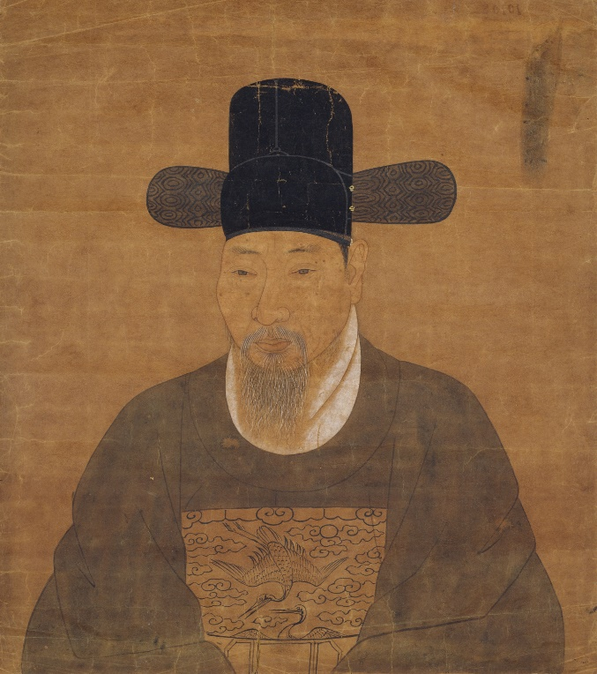 | 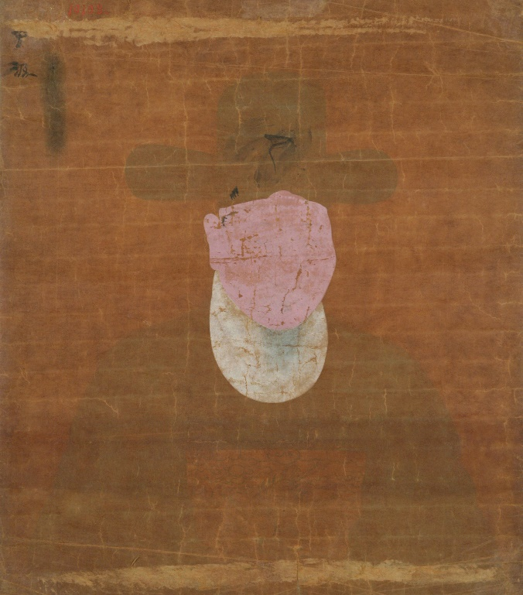
Portrait of Bong Han Hong  18th Century  Unknown  Color on Oiled paper  47.1cm × 32.8cm  Front and Back | 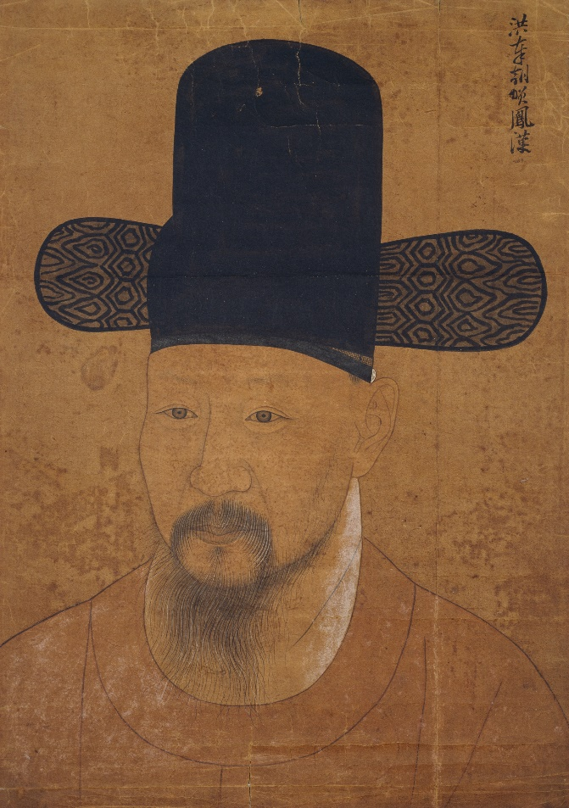 | 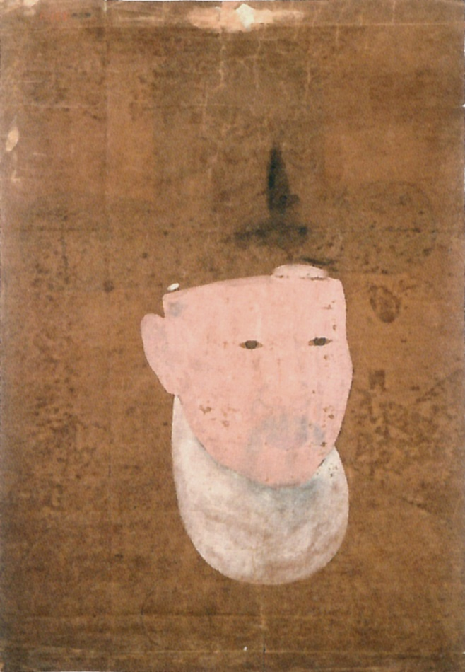
Portrait of Jeong Im  1749  Hui Su Im  Color on Oiled paper  31.3cm × 22.0cm  Front and Back  (The back image appears distorted because the sketch is bound into an album.) | 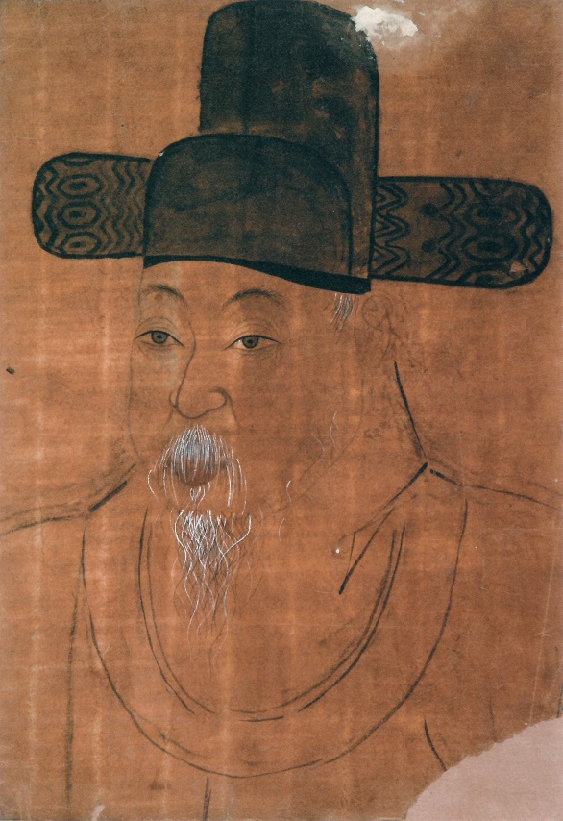 | 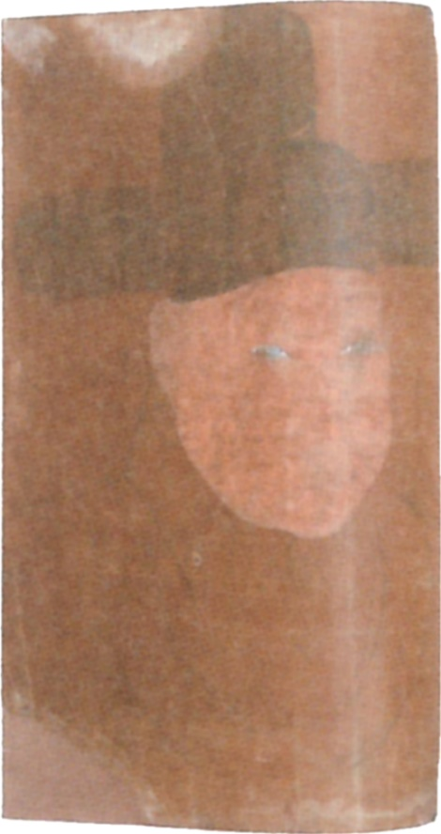
Note. High resolution images of Portrait of Geup Yun and Portrait of Bong Han Hong provided by the National Museum of Korea. Other data and images from W. B. Lee and H. J. Cho, Joseon Portraits III, p. 107, 123, 93. All images used with permission. Further reproduction of images is prohibited.

Supplementary Material B
Pigment Analysis for Portrait of Yi Bok Shin Sketch 2
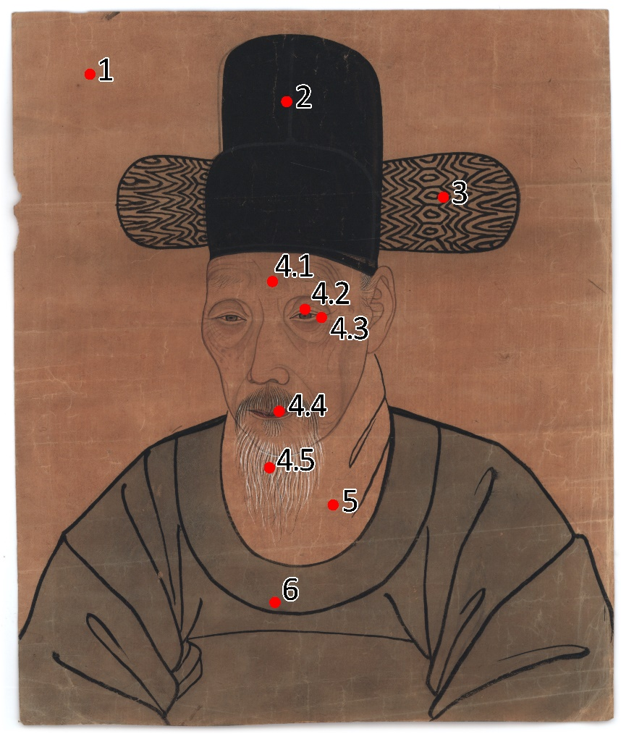  Jeonchae | 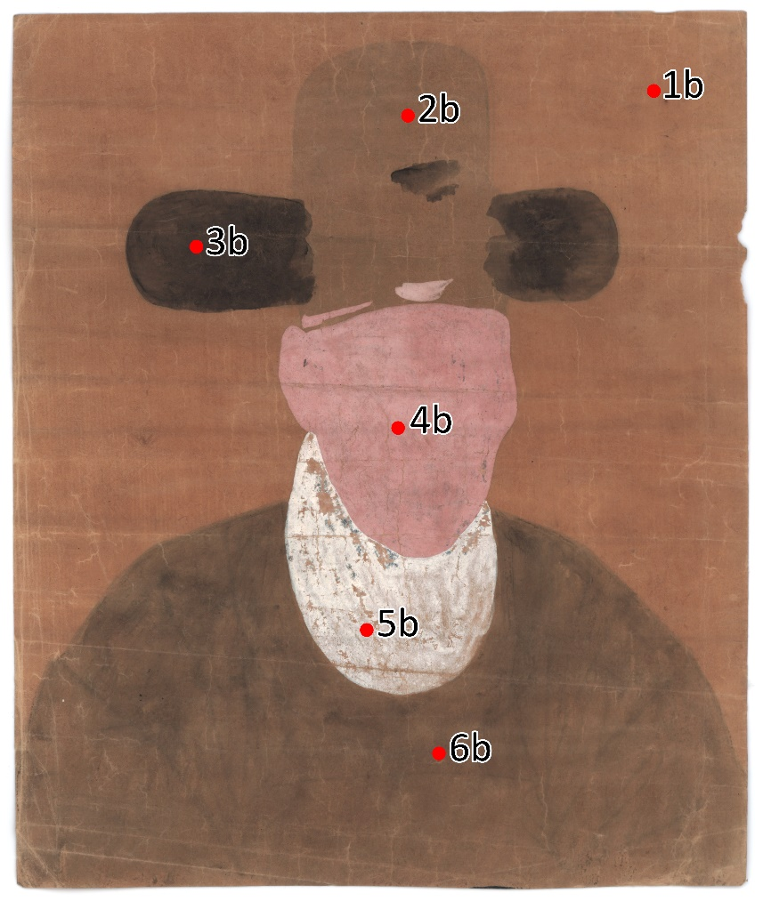  Baechae

Number | Area Examined | Colour | XRF Results (Elements with greater than 1,000 PPM) | Microscopic Image | Pigment Identified
1 | Paper | - | Ca, Mg | 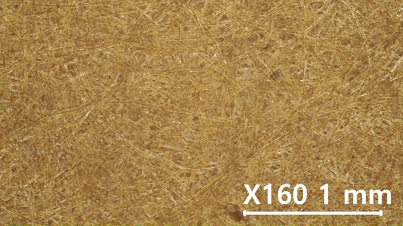 | -
1b | Paper | - | Ca | 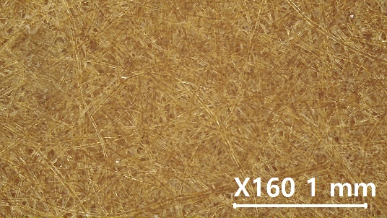 | -
2 | Samo | Black | Si, Ca, Al, Mg | 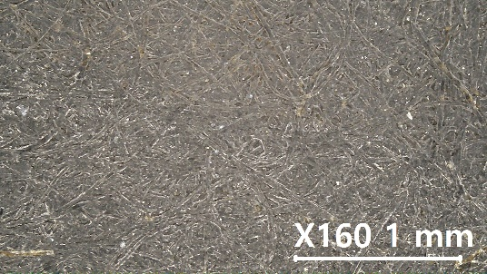 | Plant oil soot (ink) (organic)
2b | Samo | - | Ca | 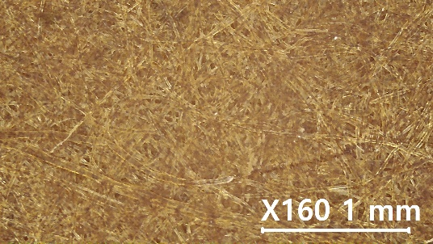 | -
3 | Yang-gak (pattern lines) | Black | Ca, Mg | 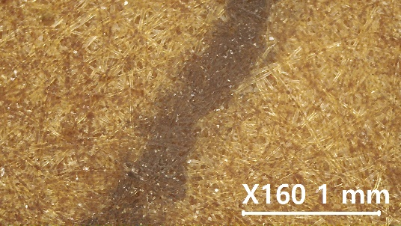 | Plant oil soot (ink) (organic)
3b | Yang-gak | Black | Ca | 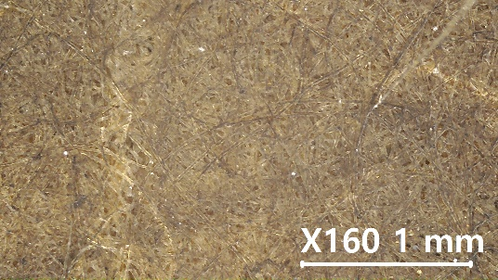 | Plant oil soot (ink) (organic)
4.1 | Skin | Red | S, Pb, Ca, Mg, As, Fe | 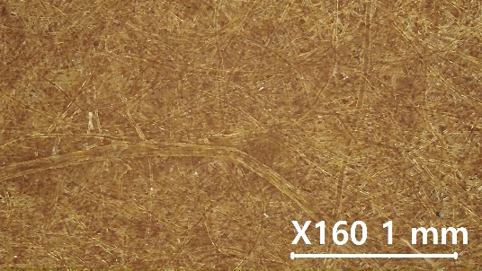 | Iron oxide red
4.2 | Eye | Black | S, Pb, Si, Ca, As, Mg, Fe | 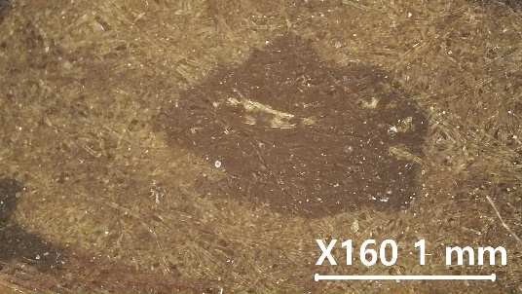 | Plant oil soot (ink) (organic)
4.3 | Eye | White | S, Pb, Mg,  Ca, As, Fe | 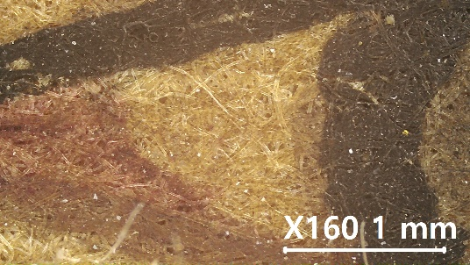 | Lead white
4.4 | Lip | Red | S, Pb, Mg, As,  Ca, Si, Fe | 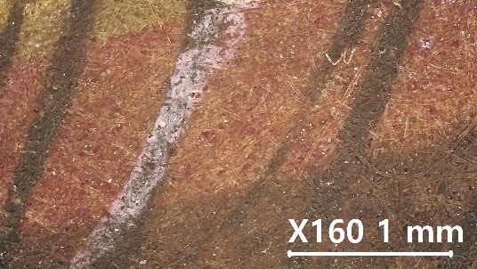 | Yeonji (organic)
4.5 | Beard | White | S, Pb, Mg, As,  Ca, Si | 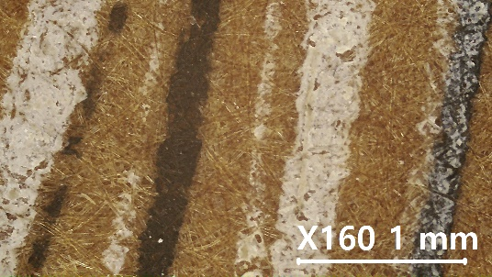 | Lead white
4b | Face | Pink | S, Pb, Si, As, Mg, Fe, Al,  Hg | 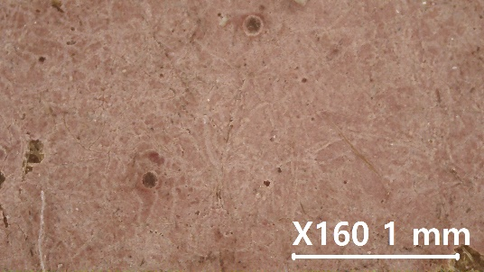 | Lead white, Cinnabar
5 | Collar | - | S, Pb, Ca, As | 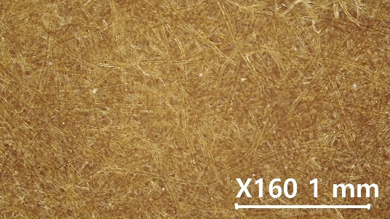 | -
5b | Collar | White | S, Pb, Si, As | 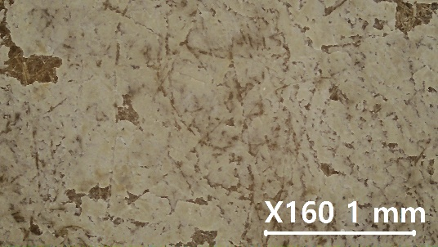 | Lead white
6 | Dal-lyeong | Green | Ca | 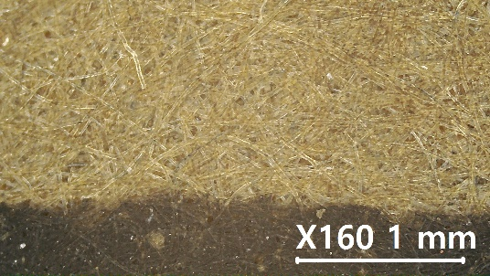 | Indigo (organic)
6b | Dal-lyeong | Green | Ca, Mg | 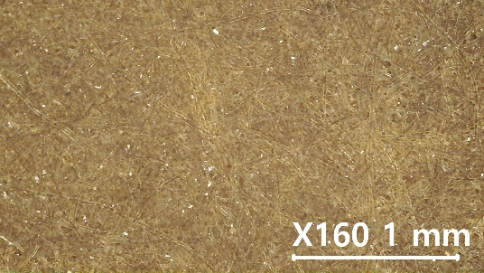 | Indigo  (organic)
Note. The analysis was performed on a table that gave XRF results of S, Si, Al.

