AppendixS1. List of treatment stimuli included in data analyses.

|  |
| --- |
| arándano |
| cubeta |
| delantal |
| ganso |
| capucha |
| golondrina |
| pinzón |
| pinza |
| frasco |
| buitre |
| medias |
| cucharón |
| patineta |
| zarzamora |
| chaleco |
| nutria |
| perejil |
| pezuña |
| codorniz |
| alcachofa |
| alondra |
| cigüeña |
| choza |
| mariquita |
| pulgar |
| sierra |
| foca |
| rábano |
| pozo |
| destornillador |
| nabo |
| almeja |
| pata |
| maleta |
| oveja |
| sartén |
| calzoncillos |
| botella |
| corbata |
| batata |
| chaqueta |
| casco |
| uvas |
| bucket |
| turkey |
| vest |
| suitcase |
| crab |
| parsley |
| wolf |
| potato |
| strawberry |
| pot |
| screwdriver |
| radish |
| grapefruit |
| fountain |
| ship |
| calabaza |
| baúl |
| castor |
| halcón |
| traje |
| tobillo |
| morsa |
| langosta |
| pasamontañas |
| luciérnaga |
| formón |
| garrapata |
| grillo |
| hurón |
| cangrejo |
| mejillón |
| ardilla |
| toronja |
| fuente |
| camote |
| ear |
| sink |
| spoon |
| necklace |
| suit |
| sprouts |
| beetle |
| trunk |
| vulture |
| plum |
| turnip |
| artichoke |
| box |
| loon |
| stork |
| dill |
| squash |
| finch |
| wing |
| cranberry |
| otter |
| wheat |
| kettle |
| hormiga |
| zorro |
| tubo |
| zanahoria |
| durazno |
| fresa |
| serrucho |
| lavamanos |
| tina |
| escarabajo |
| garza |
| ciruela |
| arete |
| squirrel |
| ladybug |
| hawk |
| blackberry |
| wrench |
| basil |
| teapot |
| lark |
| fox |
| walrus |
| hat |
| owl |
| tail |
| butter |
| peach |
| shirt |
| muñeca |
| taladro |
| tejón |
| romero |
| lobster |
| horse |
| goose |
| stove |
| knife |
| jar |
| pepper |
| hammer |
| swallow |
| fig |
| barn |
| weasel |
| pliers |
| beret |
| aleta |
| brotes |
| granada |
| badger |
| talon |
| shower |
| tweezers |
| basket |
| robe |
| wasp |
| clam |
| mouse |
| firefly |
| eagle |
| wrist |
| flipper |
| window |
| root |
| mockingbird |
| ferret |
| chisel |
| lavabo |
| estufa |
| cerca |
| dátil |
| berenjena |
| woman |
| hand |
| oven |
| bag |
| coat |
| onion |
| cheese |
| house |
| tiburón |
| lanza |
| remolacha |
| beaver |
| shrimp |
| chalk |
| opener |
| grill |
| moth |
| cherry |
| tent |
| jacket |
| cup |
| goat |
| duck |
| cricket |
| bottle |
| cauliflower |
| eggplant |
| stool |
| zorrillo |
| trigo |
| cereza |
| bata |
| albahaca |
| eel |
| pulley |
| crossbow |
| yam |
| pan |
| sling |
| caterpillar |
| sloth |
| seal |
| spear |
| robin |
| funnel |
| opossum |
| tick |
| nut |
| clog |

Table S1. *Descriptive statistics for psycholinguistic variables*.

|  |  |  |  |  |  |  |  |  |  |
| --- | --- | --- | --- | --- | --- | --- | --- | --- | --- |
|  | Log Frequency | | | Word Length | | | Log Neighborhood Density1 | | |
|  | English | | Spanish | English | | Spanish | English | | Spanish |
| Mean | 0.71 | 0.39 | | 4.49 | 6.47 | | 0.87 | 0.39 | |
| SD | 0.64 | 0.55 | | 1.40 | 1.82 | | 0.53 | 0.36 | |
| Min | -0.41 | -0.74 | | 2.00 | 4.00 | | 0.00 | 0.00 | |
| Max | 2.71 | 2.11 | | 9.00 | 13.00 | | 1.70 | 1.48 | |

*Note.* WordLength (in phonemes) and neighborhood density are phonological measures; 1Neighborhood density values were shifted by 1 and then a log transformation was applied to avoid generating NA values. Log density values of 0 correspond to a phonological neighborhood of 0.

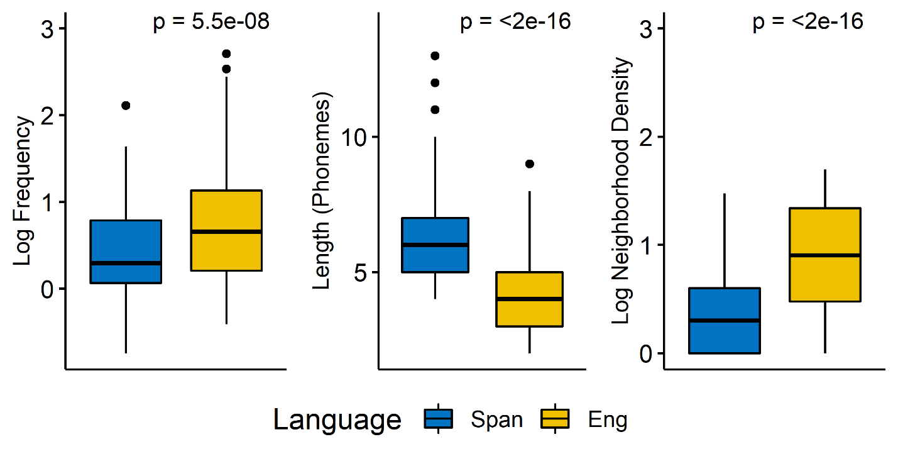Figure S1.Boxplots and independent samples t-tests for psycholinguistic comparisons.

Figure S1.Boxplots and independent samples t-tests for psycholinguistic comparisons. Boxplots show the distribution of all three psycholinguistic variables (log frequency, word length and log neighborhood density) according to language (Spanish and English). Statistical significance (p values at the .05 level) is reported for comparisons between languages using independent samples t-tests.

Table S2. *Model output for research aims*.

|  |  |  |  |  |  |
| --- | --- | --- | --- | --- | --- |
| **Model 1a** | **Fixed Effects** | **Estimate** | **SE** | **z-value** | ***p-value*** |
| **Treated** | (Intercept) | -2.45 | 0.33 | -7.23 | < .001 |
| **Lang** | Session | 0.17 | 0.02 | 6.70 | < .001 |
|  | Set [Contrast Coded] | 0.49 | 0.06 | 7.90 | < .001 |
|  | TxLanguage [Contrast Coded] | 0.72 | 0.32 | 2.21 | .02 |
|  | Session:Set | 0.13 | 0.006 | 22.16 | < .001 |
|  | Session:Tx Language | 0.04 | 0.02 | 1.66 | .09 |
|  | Set:TxLanguage | -0.31 | 0.05 | -5.53 | < .001 |
|  | Session:Set:TxLanguage | 0.02 | 0.005 | 3.45 | < .001 |
|  | **Random Effects** | **Variance** | **SD** |  |  |
|  | (1|item) | 4.86 | 2.20 |  |  |
|  | (1|participant) | 3.24 | 1.80 |  |  |
|  | (Session|participant) | 0.02 | 0.14 |  |  |

|  |  |  |  |  |  |
| --- | --- | --- | --- | --- | --- |
| **Model 1b** | **Fixed Effects** | **Estimate** | **SE** | **z-value** | ***p-value*** |
| **Untreated** | (Intercept) | -6.21 | 0.68 | -9.07 | < .001 |
| **Lang** | Session | 0.06 | 0.03 | 2.00 | .04 |
|  | Set [Contrast Coded] | -0.07 | 0.10 | -0.68 | 0.49 |
|  | TxLanguage [Contrast Coded] | 0.89 | 0.32 | 2.75 | < .01 |
|  | Session:Set | 0.04 | 0.008 | 5.63 | < .001 |
|  | Session:Tx Language | 0.002 | 0.02 | 0.09 | .92 |
|  | Set:TxLanguage | -0.01 | 0.09 | -0.17 | .85 |
|  | Session:Set:TxLanguage | 0.01 | 0.008 | 1.68 | .09 |
|  | **Random Effects** | **Variance** | **SD** |  |  |
|  | (1|item) | 10.26 | 3.24 |  |  |
|  | (1|participant) | 13.55 | 3.68 |  |  |
|  | (Session|participant) | 0.02 | 0.15 |  |  |

|  |  |  |  |  |  |
| --- | --- | --- | --- | --- | --- |
| **Model 2a** | **Fixed Effects** | **Estimate** | **SE** | **z-value** | ***p-value*** |
| **Treated** | (Intercept) | -2.36 | 0.34 | -6.91 | < .001 |
| **Lang** | Session | 0.43 | 0.06 | 6.18 | < .001 |
|  | BNT (z-score) | 0.87 | 0.30 | 2.84 | < .01 |
|  | TxLanguage [Contrast Coded] | 0.37 | 0.44 | 0.85 | .39 |
|  | Age (mean-centered) | -0.31 | 0.16 | -1.89 | .05 |
|  | Session:BNT | 0.28 | 0.06 | 4.43 | < .001 |
|  | Session:TxLanguage | -0.03 | 0.09 | -0.40 | .68 |
|  | BNT:TxLanguage | -0.26 | 0.43 | -0.59 | .55 |
|  | Session:BNT:TxLanguage | -0.14 | 0.09 | -1.52 | .12 |
|  | **Random Effects** | **Variance** | **SD** |  |  |
|  | (1|item) | 2.67 | 1.63 |  |  |
|  | (1|participant) | 1.06 | 1.03 |  |  |
|  | (Session|participant) | 0.05 | 0.23 |  |  |

|  |  |  |  |  |  |
| --- | --- | --- | --- | --- | --- |
| **Model 2b** | **Fixed Effects** | **Estimate** | **SE** | **z-value** | ***p-value*** |
| **Untreated** | (Intercept) | -5.22 | 0.38 | -13.64 | < .001 |
| **Lang** | Session | 0.08 | 0.03 | 2.29 | .02 |
|  | BNT (z-score) | 1.73 | 0.29 | 5.89 | < .01 |
|  | Age (mean-centered) | 0.01 | 0.01 | 1.11 | .26 |
|  | Session:BNT | 0.11 | 0.03 | 3.52 | < .001 |
|  | **Random Effects** | **Variance** | **SD** |  |  |
|  | (1|item) | 7.19 | 2.68 |  |  |
|  | (1|participant) | 1.48 | 1.21 |  |  |
|  | (Session|participant) | 0.02 | 0.14 |  |  |

|  |  |  |  |  |  |
| --- | --- | --- | --- | --- | --- |
| **Model 3a** | **Fixed Effects** | **Estimate** | **SE** | **z-value** | ***p-value*** |
|  | (Intercept) | -2.67 | 0.32 | -8.28 | < .001 |
|  | Session | 0.37 | 0.05 | 6.38 | < .001 |
|  | LogFrequency | 0.92 | 0.22 | 4.09 | < .001 |
|  | StimLanguage [Contrast Coded] | 0.01 | 0.28 | 0.05 | .95 |
|  | Session:LogFrequency | 0.004 | 0.01 | 0.26 | 0.79 |
|  | **Random Effects** | **Variance** | **SD** |  |  |
|  | (1|item) | 2.21 | 1.48 |  |  |
|  | (1|participant) | 2.24 | 1.49 |  |  |
|  | (Session|participant) | 0.10 | 0.32 |  |  |

|  |  |  |  |  |  |
| --- | --- | --- | --- | --- | --- |
| **Model 3b** | **Fixed Effects** | **Estimate** | **SE** | **z-value** | ***p-value*** |
|  | (Intercept) | -2.42 | 0.40 | -6.03 | < .001 |
|  | Session | 0.51 | 0.06 | 8.01 | < .001 |
|  | Length | 0.06 | 0.08 | 0.85 | .39 |
|  | StimLanguage [Contrast Coded] | -0.16 | 0.30 | -0.55 | .57 |
|  | Session:Length | -0.03 | 0.005 | -7.05 | < .001 |
|  | **Random Effects** | **Variance** | **SD** |  |  |
|  | (1|item) | 2.61 | 1.61 |  |  |
|  | (1|participant) | 2.05 | 1.43 |  |  |
|  | (Session|participant) | 0.11 | 0.34 |  |  |

|  |  |  |  |  |  |
| --- | --- | --- | --- | --- | --- |
| **Model 3c** | **Fixed Effects** | **Estimate** | **SE** | **z-value** | ***p-value*** |
|  | (Intercept) | -2.14 | 0.33 | -6.35 | < .001 |
|  | Session | 0.32 | 0.06 | 5.21 | < .001 |
|  | LogDensity | -0.02 | 0.28 | -0.09 | .92 |
|  | StimLanguage [Contrast Coded] | -0.08 | 0.29 | -0.28 | .77 |
|  | Session:LogDensity | 0.09 | 0.02 | 4.64 | < .001 |
|  | **Random Effects** | **Variance** | **SD** |  |  |
|  | (1|item) | 2.51 | 1.58 |  |  |
|  | (1|participant) | 2.00 | 1.41 |  |  |
|  | (Session|participant) | 0.11 | 0.34 |  |  |

*Note. TxLanguage* = Treatment Language (L1 or L2); *LogFrequency* = Log-transformation of lexical frequency; *StimLanguage* = Stimulus Language (Spanish or English); *LogDensity* = Log-transformation of phonological neighborhood density; *Set*, *TxLanguage*, and *StimLanguage* were contrast-coded in the models to enable interpretation of the predictors as main effects. All other predictors were continuous measures.