# Appendix B

## Example Exposure and Test Trials by Condition for Order A

*Gonepe Tinuf*

*Basim Dofege*

*Gonepe Kemig*

*Tinuf*

**Low Variability Condition –** Female Speaker 1 produced all the words

**Exposure Phase Trials**

**Test Phase Triala**

Novel Object Exemplars

**High Variability Condition** – Words produced by a different set of 5 Female and 5 Male Speakers

*Botak (F8) Kotase (M4)*

*Gesud (F10) Botak (M3)*

*Gesud (M4) Kotase (F9)*

*Gesud*

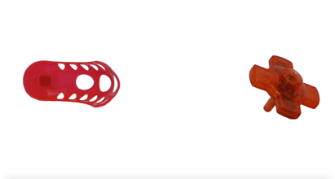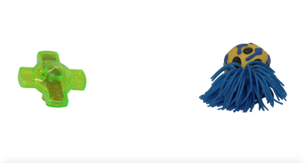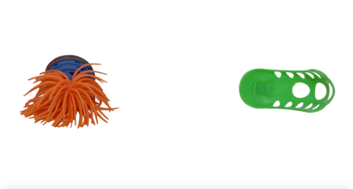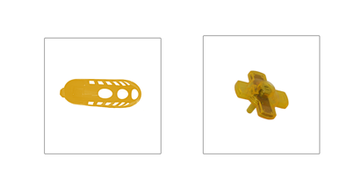

*Note*. This graphic depicts three exposure trials and one test trial for each condition for Order A. The first word produced in each trial did not always label the left-centered object first. In these instances, the first word produced labeled the right-centered object and the second word produced labeled the left-centered object.

a Female Speaker 13 produced all test words

b (F3) = Female Speaker 3

c (M1) = Male Speaker 1