Appendix to accompany:

“Contracting inside an organization: an experimental study”

Paul J. Healy, John O. Ledyard, Charles Noussair,

Harley Thronson, Peter Ulrich, and Giulio Varsi

This appendix contains the instructions given and read to subjects in the experiment for the Cost Cap and MCCS systems. The instructions for SCCS were simplified from those for MCCS included here. Appendix A1 contains the instructions that describe the general environment and context. These instructions were used in all experiments. Appendix A2 contains the specific instructions describing the MCCS process and A3 consists of the instructions for the Cost Cap process.

A.1 Instructions describing the environment

This is an experiment in decision-making. There are two types of decisionmakers in the experiment, Headquarters and Centers. Whether you are a Headquarters (HQ) or a Center (IC) will be indicated to you.

1. Missions

HQ and IC’s “scores” in the simulation depend on the science content of the missions successfully completed, and on which missions fail. For each unit of “science content” generated by a completed mission, HQ and IC each earn 1 “point”.

There are 2 fictitious missions in this simulation, named A and B, which Headquarters can assign to IC’s to construct. There are three possible designs available for each mission. A1, A2, and A3 are the three possible ways that mission A can be designed, and likewise for B1, B2, and B3. HQ can assign at most one A mission and one B mission at a time. HQ not required to assign missions and is permitted to assign only one or no missions if it feels that it is appropriate course of action.

Typically design 1 missions (A1, B1) yield the highest science content of the three designs if the mission is successfully completed, but also have the highest cost of reliability and the highest penalties for failure. It also typically costs more to construct design 1 missions than the other two designs. IC’s must often innovate in order to meet the cost target on design 1 missions. Design 2 typically yields lower science content than design 1, but achieving a high level of reliability is cheaper. Design 3 is a low budget design with lower science content than designs 1 or 2 and is well suited to a situation in which the anticipated budget is low.

If a mission does not achieve its minimum science content, which is given in column 2 of table 1 below, it cannot be launched and neither HQ nor IC receives any points.

If the mission fails, both HQ and the IC who built the mission will have points deducted from their scores. The penalties for failure are indicated in column 3 of table 1. Whether a mission succeeds or fails will only be known after launch.

An IC’s point total is the total of the science content minus the penalties for failure on the individual missions it constructs. HQ’s point total in each period is the total of the science content minus the penalties for failure on all missions that any IC constructs. IC also receives a bonus of 500 points for every design 1 mission it constructs that is successfully launched in addition to the point values indicated in table 1. HQ does not receive the bonus.

Table 1: The Possible Missions and Points Awarded for their Completion

Mission | Minimum Science Content (in pts) | Penalty for Failure (in pts)
A1 | 500 | 1500
A2 | 400 | 1200
A3 | 300 | 900
B1 | 1000 | 3000
B2 | 500 | 1500
B3 | 200 | 600

2. Cost of Missions

IC must incur costs to construct the missions it has been assigned. The budget assigned by HQ is the most IC can spend to complete the mission. IC can use the budget on the science content of the mission, on increasing reliability (the probability of success of the mission), or on innovation effort.

The cost of achieving the minimum science content of each mission is given in table 2. The cost of obtaining given amounts of science content can also be seen in chart 1 for the A missions and chart 2 for the B missions. The cost function is of the form

Cost of Science Content = a*S²,

where a differs between missions and designs and S denotes science content. The value of a for each mission is given in the third row of table 2.

Table 2: Cost of Minimum Science Content for each Mission (in millions of dollars)

 | A1 | A2 | A3 | B1 | B2 | B3
Minimum Science Content | 500 | 400 | 200 | 1000 | 500 | 200
Cost of Minimum Science Content | 800 | 500 | 200 | 1400 | 600 | 300
a | .0032 | .004375 | .005 | .0014 | .0024 | .0075

3. Reliability

IC must also spend some of the budget on reliability of the mission. The reliability of the mission is the probability that the mission is successful. The relationship between the amount IC spends on the reliability of each mission and the probability of success of the mission is given in table 3. A mission must be successful for HQ or IC to receive points for its completion. If the mission is not successful, both HQ and the IC constructing the mission must pay the penalty for failure given in the third column of table 1.

Table 3: Cost to IC of Reliability (in millions of dollars)

Mission | Cost of 70% Reliability | Cost of 80% Reliability | Cost of 90% Reliability | Cost of 95% Reliability | Cost of 99% Reliability | b
A1 | 72.2 | 96.6 | 138.2 | 179.7 | 276.3 | 60
A2 | 24.1 | 32.2 | 46.1 | 59.9 | 92.1 | 20
A3 | 36.1 | 48.3 | 69.1 | 89.9 | 138.2 | 30
B1 | 72.2 | 96.6 | 138.2 | 179.7 | 276.3 | 60
B2 | 24.1 | 32.2 | 46.1 | 59.9 | 92.1 | 20
B3 | 36.1 | 48.3 | 69.1 | 89.9 | 138.2 | 30

The cost of investing in each possible level of reliability for each mission can also be seen in chart 3. The cost of reliability is given by:

Cost of Reliability = b*ln(1/(1-R)),

Where b varies between designs and R is the probability of success of the mission. R ranges between 0 and 1. Reliability is cheapest for design 2, followed by design 3 and design 1.

4. Innovation

The IC will have two opportunities each period to make an investment in trying to obtain an innovation that would reduce its cost of adding science content to the mission. If the IC is successful in an innovation, it will be able to decrease the cost of adding science content by 1/3 (it decreases the coefficient a by 1/3). IC can use the savings to increase the mission’s reliability or to add more content to the mission. However, it will cost IC some francs from its budget for a given mission to get an innovation for that mission. The following table indicates how many francs IC must invest to have the probability of an innovation equal to that indicated in the columns of the table.

Table 4: Innovation Effort (in millions of dollars) and Probability of Innovation

Mission | Effort for 25% Prob. of Innovation | Effort for 50% Prob. of Innovation | Effort for 75% Prob. of Innovation | Effort for 90% Prob. of Innovation | Effort for 95% Prob. of Innovation
A1 | 28 | 70 | 139 | 231 | 301
A2 | 57.5 | 139 | 278 | 461 | 601
A3 | 57.5 | 139 | 278 | 461 | 601
B1 | 28 | 70 | 139 | 231 | 301
B2 | 57.5 | 139 | 278 | 461 | 601
B3 | 57.5 | 139 | 278 | 461 | 601

In chart 4, you can see how much you have to invest to achieve probabilities of innovation other than those shown in the table. Innovation is cheapest for design 1 missions. Innovation is equally costly for design 2 and 3 missions.

5. Random Changes in Cost (Cost Shocks)

IC will incur surprise additional costs or surprise cost savings twice during the mission acquisition process. These changes represent new information about costs that is learned by the IC over time that affects its costs. These changes are known to the IC, but not to HQ. These surprise additional costs or savings will range from –200 to +200 for missions A1 and B1, each time they occur. Each value in the interval is equally likely (the distribution is uniform on [-200,200]). The surprise additional costs or savings will range from –50 to +50 for the other missions, each time they occur. These also follow a uniform distribution on [-50,50]. The two random changes are independent. That is, the particular realization of the surprise change in costs does not affect the amount of the next surprise cost change.

A2. Instructions For The Cost Cap Process

The Timing of Activity

Phase A/B

Stage 1: Receiving Cost Estimates

Each design of each mission has a “bogey”, which is shown on the screens of both HQ and the IC’s. This is an estimate of how much it would cost a given IC to complete the mission with the value given in column 2 of table 1, a reliability level of 95%, no spending on innovation, and random changes in cost that average zero. HQ’s information will be displayed on the following screen. Its cost estimate is in the column entitled “Center 1”.

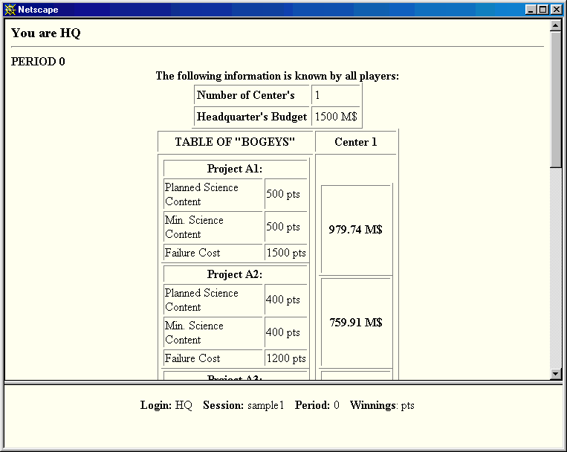

However, IC will have a more accurate estimate of its own cost of completing each project than that shown in table 1 or that is shown on HQ’s screen. It is as if the IC generates the estimate, taking into account experience and preliminary studies. This “estimated cost” can differ from the one displayed to HQ by up to 200 million francs for missions A1 and B1. The private cost estimate can differ from the one HQ has by up to 50 million francs for missions A2, A3, B2, and B3. The private cost estimate can be either higher or lower than HQ’s. IC’s information will be displayed on the following screen.

In the column labeled Center 1, there are three numbers accompanying each design for each mission. The top number is the bogey, HQ’s current estimate of the cost of building the mission. The second number (called internal info) is the difference between the cost estimate of HQ and the private cost estimate of the IC. If the number is positive (negative) the IC’s estimate is higher (lower). The third number is IC’s private cost estimate (called Est. Cost). While the bogey equals a*S² + b*ln(1/(1-R)), the IC’s estimated cost equals a*S² + b*ln(1/(1-R)) + internal info.

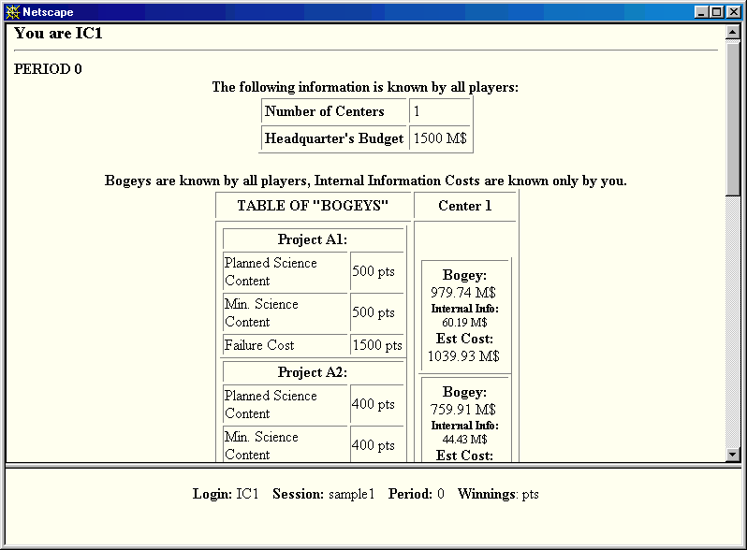

Stage 2: Negotiation and Assignment of Budgets

In the first negotiation phase, IC can propose a budget for each mission. This means that IC is proposing to complete the mission at the cost that it has indicated. IC will see a screen like the one shown below. The screen lists the name of each mission and the IC’s cost estimate for completing it. The screen also contains a column where IC can propose a design for the mission and a budget at which it can complete the mission.

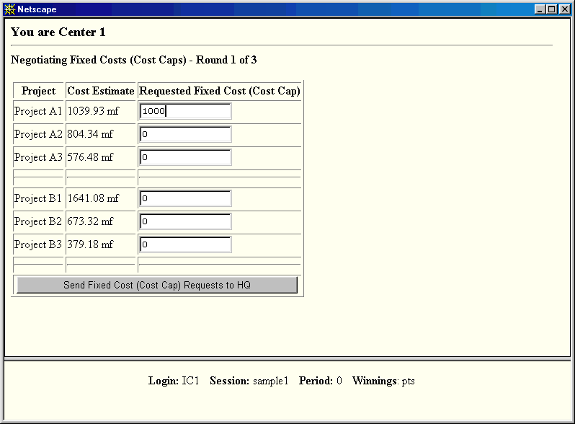

After IC has filled in its Negotiating Fixed Costs screen, a Negotiating Fixed Costs screen will appear for HQ. An example is given below. The screen has five columns. The first three list the potential missions, the IC making the proposals, and the bogeys of the mission. The fourth column displays the requests submitted by the Centers. In the fifth column, labeled Your Response, HQ can make a counteroffer to any center on any project. A counteroffer of 0 is a refusal to assign the mission to that center.

There are three rounds of offers and counteroffers. The third counteroffer of HQ is final. The budgets assigned by headquarters determine the maximum amount that can be spent by the IC during the first phase of construction. If HQ assigns 0 budget to a mission, it means that IC cannot try to construct the mission. HQ may not award more than 1,500 million dollars in any period.

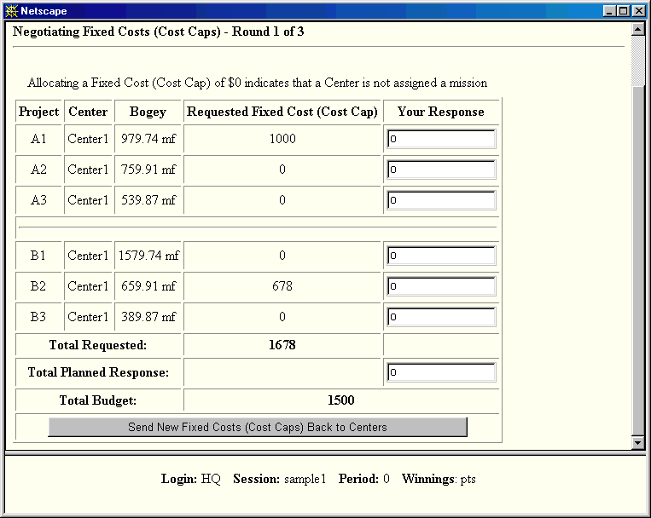

Stage 3: Innovation Opportunity

Each IC will have the possibility of spending some money to try to become more efficient at constructing the missions that have been assigned to it. IC will see the screen shown below.

The table in the screen is read in the following way. The first column lists the names of the missions IC has been assigned. The second column indicates the IC’s cost estimate. The third column indicates the current cost cap and the 4th column displays the current cost coefficient a. In the fifth column, labeled Innovation Effort, IC can fill in the amount of money it would like to spend on making an effort to innovate. After filling in numbers in column five, the percentage chance that IC gets an innovation is displayed in the sixth column. After IC has decided on how much effort it will expend, it can select the button at the bottom of the screen. The program then indicates whether or not IC has received an innovation.

If IC gets an innovation, the cost of adding value will decrease by 1/3 as the coefficient a declines by 1/3 This means that IC can get 50% more science content than previously for each dollar spent. The cost savings can be used to increase the reliability of the mission or saved for the second construction phase. Whether it receives an innovation or not, the IC’s dollar budget will be reduced by the cost of the innovation effort. After the IC selects the level of spending on innovation, it proceeds to a screen that displays the IC’s previous and the new cost estimates for completing the mission. HQ will be unaware of the new cost estimate of IC.

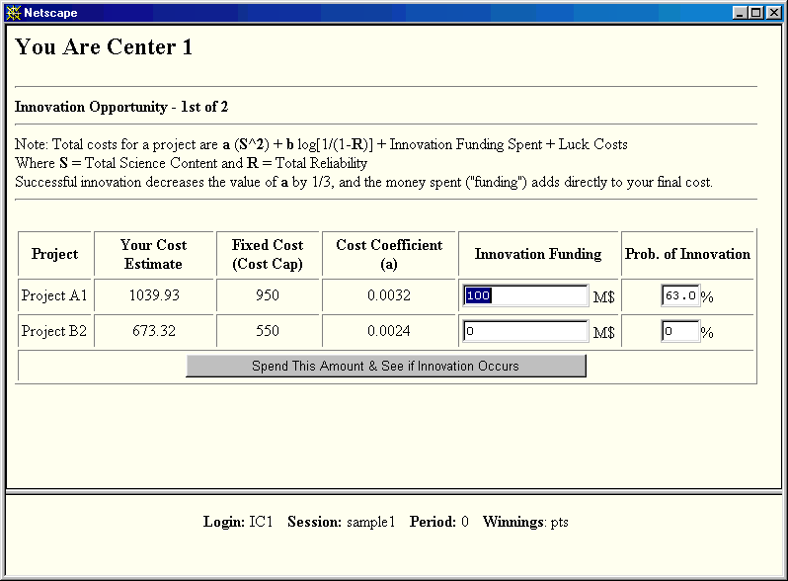

Phase C/D

Stage 4: First Construction Phase

After the first innovation phase, IC may begin to build its projects. This is the first of two phases of construction. If you are an IC, you will see the screen “Building – Phase A-C only”. In the table on the screen there are nine columns. The first column lists the missions, to which IC has been assigned. In the second column, IC specifies the science content it is building in to the mission in the current phase, measured in terms of “points” as well as in terms of “earned value”, the percentage of the minimum science content completed. If the mission has lower final science content than the amount in column three of the screen, the mission yields no payoff to HQ or to IC.

The fourth column indicates the reliability added to the mission at this stage. This can be viewed as adding and early testing of systems that increase the probability of success. The fifth column shows the money already spent on innovation.

Before IC decides how much to spend, it will have some good or bad luck with regard to costs. It might turn out to cost less or more to build in the science and the reliability selected than anticipated. This change, called “Luck Costs” is shown in column six of the table. The cost change will be between -200 million and +200 million francs (drawn from a uniform distribution) for missions A1 and B1. The cost change will be between -50 million and +50 million francs (drawn from a uniform distribution) for missions A2, A3, B2 and B3. On average the cost change will be 0 and is equally likely to be positive or negative.

IC can choose hypothetical levels of science content and reliability for the first stage of the construction process, and can see in column seven what the cost would be. Once IC decides on a level of science content and reliability, it selects the button at the bottom of the screen. In this first construction phase an IC may only spend 1/2 of its current cost cap, shown in column 8. Recall that IC will have another chance later on in the process to spend more money to complete construction of missions. Also, recall that no points are awarded until the mission is launched.

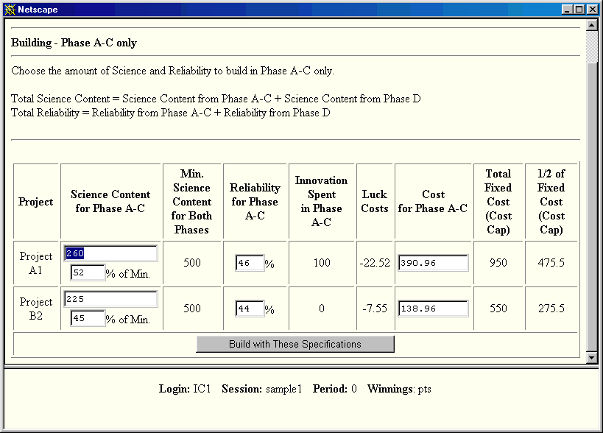

Stage 5: Second Negotiation and Reassignment of Budgets

After the first phase of construction, IC will have the opportunity to request changes in its budgets from HQ on any of the missions it has been assigned. However, HQ may turn down IC’s requests. HQ can also change the funding of a mission without a request to do so from the IC. HQ does not receive any additional funds to the $1,500 million it had in stage 2. This means that if it allocated its whole budget in stage 2, any increases in funding for missions in stage 5, means that the funding for other missions has to be reduced by the same amount.

If HQ or IC finds that an initial design for a mission is not appropriate because the budget available is too small to complete the mission, or because the budget is large enough to allow a design with a higher value to be completed, the design can be changed partway through the construction process. For example A1 may be changed to A2 to A3, or A3 may be changed to A2 or A1.

If a change in design occurs, 50% of the science content and the reliability already built in will be transferred from the former design to the new design. This means that half of the initial investment is lost if the design is changed at this point. However, despite this loss, there may still be situations in which it to your advantage to try to switch missions.

IC must fill in column five of the screen below when it appears. If an IC requests an increase in its budget for a mission, it must submit a detailed proposal specifying how much it proposes to spend on science content, reliability, innovation and how much will be kept in reserve. It submits this information by filling in columns 7 through 10. If it is requesting no change or a decrease in its budget, it does not need to submit information on how it will spend its remaining funds.

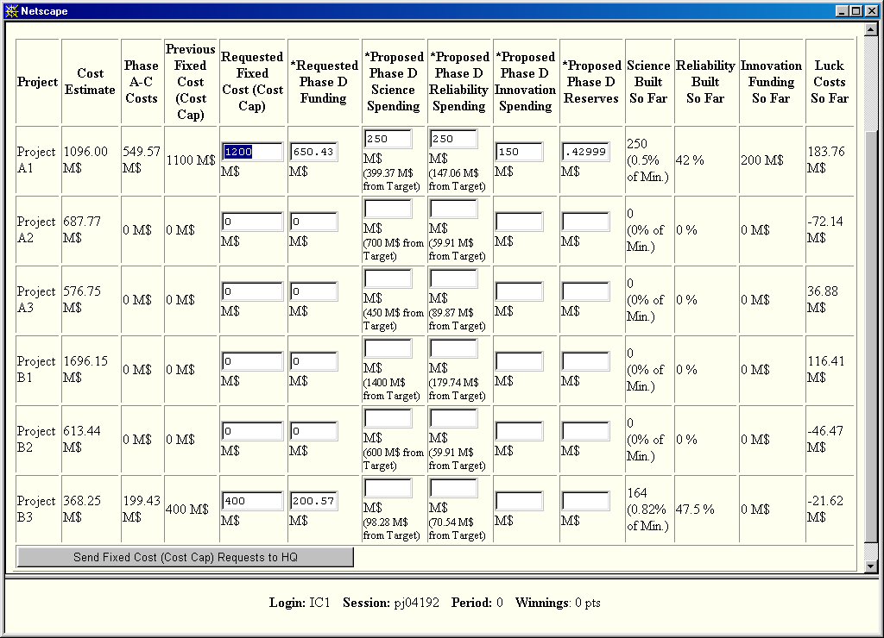

HQ then sees the screen below. The screen indicates the current status of the missions that have been undertaken. If a Center requested a new cost cap, the request information is also displayed in the table. Columns 13 and 14 contain the cost caps currently requested by IC’s and the original cost caps for the project. In column 15, HQ can assign new cost caps for each mission to the Center constructing it.

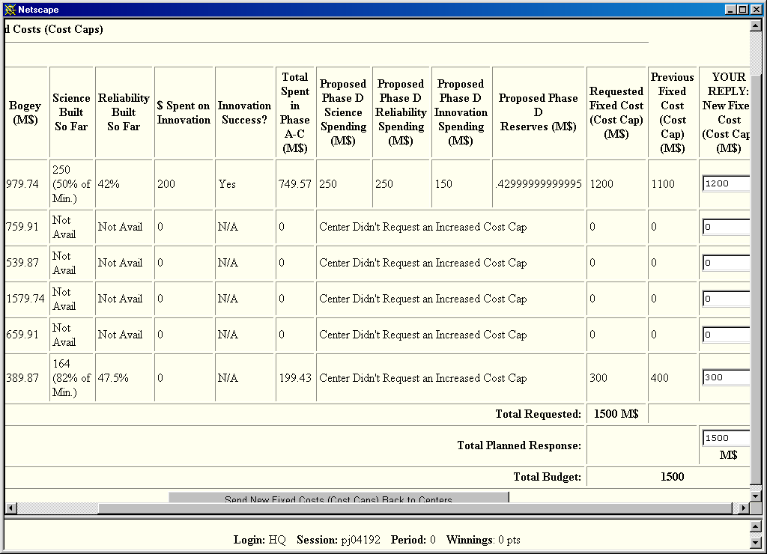

Stage 6: Second Innovation Opportunity

This stage is identical to stage 3 described above. There is another opportunity to invest money to try to acquire a cost-reducing innovation. Innovations are cumulative. This means that if you received the 50% increase in productivity in stage 2, you can receive another 50% increase in stage 6. Innovation at this stage reduces the cost coefficient a by 1/3 from its previous level.

Stage 7: Second Construction Phase

During this stage IC has the opportunity to complete construction of its missions. To do so, it uses the screen entitled Building Phase 2 of 2.

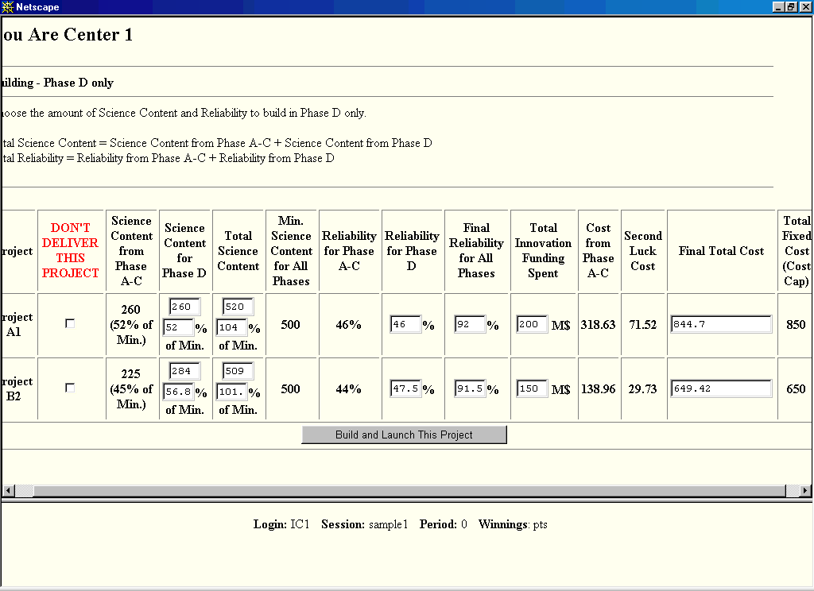

The table is read in the following manner. The first column lists the missions (projects) assigned to the IC. The third column gives the science content IC has already built into its mission in construction phase 1 (Phase A-C). The science content is expressed in points as well as in the percentage of earned value. In the fourth column IC can select the amount of science content it wants to add in the second construction phase (phase D). The fourth column is to be filled in by IC at this point. This amount gets added on to the amount produced in the first construction phase. The fifth and sixth columns in the screen indicate the total science content in the mission and the minimum allowable science content for that mission.

If the number in column five is smaller than the number in column six, the mission does not have any value and cannot be delivered. The seventh column indicates the reliability built into the mission during the first construction phase. This amount gets added on to the reliability resulting from additional testing and adding systems in the second phase. The eighth column is the reliability content added in the second phase, to be filled in by IC at this point. The ninth column is the total of the reliability from the two phases, which are cumulative. This is the probability of success of the mission if it is launched.

Before an IC decides how much to spend in the second construction phase, it will have some additional good or bad luck with regard to costs. It might turn out to cost less or more than anticipated. In column twelve of the table, the random change in cost in phase D is displayed. Like the other random changes in cost, on average the cost change will be 0, and the cost change is equally likely to be positive or negative. Column 13 indicates the total amount spent on the mission. The last column indicates the cost cap for the mission. IC cannot spend more on a mission than its cost cap.

At the end of this stage, IC has the option of not delivering the mission, by checking column 2 in the row corresponding to the mission. If the mission is not delivered at the end of the stage, a success or a failure is realized and HQ’s and IC’s payoffs determined accordingly. If IC does not deliver the mission, both HQ and IC receive a payoff of 0 for the mission.

A.3. Instructions for the MCCS System

a. Additional Concepts

Cost Sharing Contracts

HQ and IC must agree on a payment contract before IC can begin a mission. The IC is paid the amount specified in the contract for the mission, but the actual amount paid will not be known until phase D. The payment contact is a linear function determined by two numbers, X and Y. The payment to IC must be of the form: Total Payment = X +Y*C. C is the final cost of completing the project at the science content level given in table 2, and at 95% reliability, given the random changes in cost that the IC has experienced during the process, changes in cost due to innovation and expenditure on innovation. C will be referred to as the “final cost estimate”, and is defined as the cost estimate in phase D to build the project to the original specifications. It does not necessarily equal the actual final cost, which depends on the actual level of science content and the reliability put in the project, which may differ from the science content in table 1 and 95% reliability. C is calculated as

C = IC’s initial private cost estimate + random changes in cost –cost savings from innovation + spending on innovation

X is a fixed payment that HQ pays to IC regardless of the cost of the mission.

Y is a number between 0 and 1. Y indicates what percentage of the final cost of a mission with the original specifications will be given to the IC in addition to the fixed payment X. Y is the cost share parameter. It indicates the percentage of the cost beyond the fixed payment borne by HQ.

As before, there are two random changes in cost and two opportunities to innovate. The purpose of this cost-sharing contract is to provide an incentive to IC to reduce its costs by innovating. The lower the phase D cost estimate C, the greater the payment to IC in excess of its costs (X + Y*C – C = X – (1-Y)*C, where 1-Y is between 0 and 1). IC can keep the unspent portion of its payment for use on future projects in later rounds. The amount it keeps is greater, the lower its final cost estimate is.

If IC is able to complete the mission at a lower cost than its reimbursement, it can a) use the difference to increase the science content or the reliability of the current mission, or b) keep it to spend on missions in the future.If IC spends more on a mission than the budget it gets from HQ, it must either a) use previous savings from other missions, b) not launch the mission, c) go into debt that must be repaid before the end of the experiment.

The Menu of Contracts
Another feature of this alternative process is that three potential contracts of the form X + Y*C are generated. The list of contracts is decided in phase A but IC chooses a particular contract that it will be operating under at the end of phase C. The sequence of events is described in section b below. The three contracts are called “Low”, “Middle” and “High” and are characterized by parameters (X_{LOW}, Y_{LOW}), (X_{MIDDLE}, Y_{MIDDLE}), and (X_{HIGH}, Y_{HIGH}). These have the property that X_{LOW} > X_{MIDDLE} > X_{HIGH} and Y_{LOW} < Y_{MIDDLE} < Y_{HIGH}.

The payment contracts have the following properties:

- If IC’s cost estimate is well below the negotiated baseline cost, IC is usually better off if it accepts the “Low” contract.

- If IC’s cost estimate is well above the negotiated baseline cost, IC is usually better off if it accepts the “High” contract.

- If IC’s cost estimate is close to the negotiated baseline cost, IC is usually better off if it accepts the “Middle” contract.

Bankruptcy and Borrowing

IC can go into debt temporarily, that is it can spend more than its accumulated savings plus its reimbursement on current missions. However, it cannot go into debt for more than 1,000 million dollars at any time. Otherwise, it goes bankrupt. Any debts must be paid back in period 5, the last period. If an IC owes money at the end of period 5, it must pay a penalty of 3000 points.

Similarly HQ may be required to spend more than its budget of 1,500m to reimburse IC’s. It is allowed to go into debt up to 1,000m francs. However, if HQ is in debt at the beginning of the last period, its budget for the period will be reduced by the amount of its debts. The computer program will not allow more spending than the available funds in the last period. If HQ is in danger of spending more than its available funds in the last period, it will be required to cancel missions before the IC can complete their construction.

b. The Timing of Activity

Phase A/B

Stage 1: Receiving Cost Estimates

<<< Same text as in the section entitled “Stage 1” in appendix A2 >>>

Stage 2: Negotiation and Assignment of Budgets

To construct a mission IC has to contract with HQ for funds. At the beginning of the period, IC will see the screen below that lists the name of each mission and the estimated cost for completing it from stage 1. It can use the screen to negotiate a “cost baseline” from which all of the potential contracts will be computed. IC can verify the amount it would receive under each of the three contracts for any potential baseline cost for each design of each mission. It can do so by typing in hypothetical cost baselines in the field labeled “Cost Baseline for project ….”, and possible final costs in the field indicated as “For …. if the final cost estimate is…”, and selecting the [Try it] button. This will display the resulting menu of potential contracts, which are calculated from the baseline cost, in the lines marked “High”, “Middle” and “Low” contracts. It can then propose a design and a baseline cost estimate of completion to HQ by filling in the table at the bottom of the page.

After IC has decided which baseline cost estimate it is proposing, it can confirm the choice and send it to HQ. The proposal will then appear on HQ’s Negotiating Contract screen. HQ can then make a counteroffer. HQ’s screen is similar to the IC’s screen shown here. In the counteroffer, HQ can specify a different design for the mission than the design proposed by IC, and it can specify a different baseline cost for the design it proposes. HQ may also leave all fields blank, which indicates that HQ does not wish to assign IC to undertake any mission. HQ can also reply with the same proposed baseline cost indicating that it agrees with the IC’s proposal.

There are three rounds of offers and counteroffers. The third counteroffer of HQ is final. After the final counteroffer, the three potential contracts are displayed to IC.

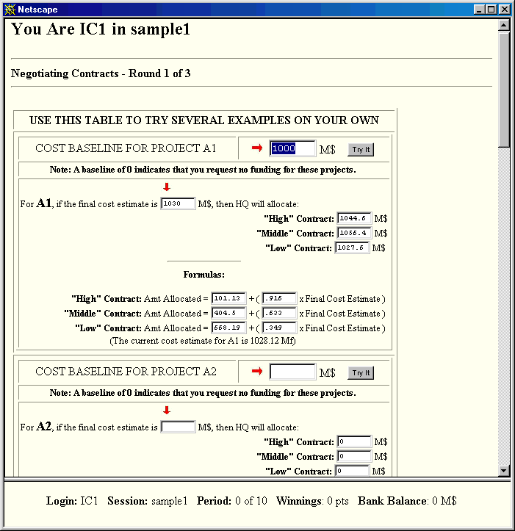
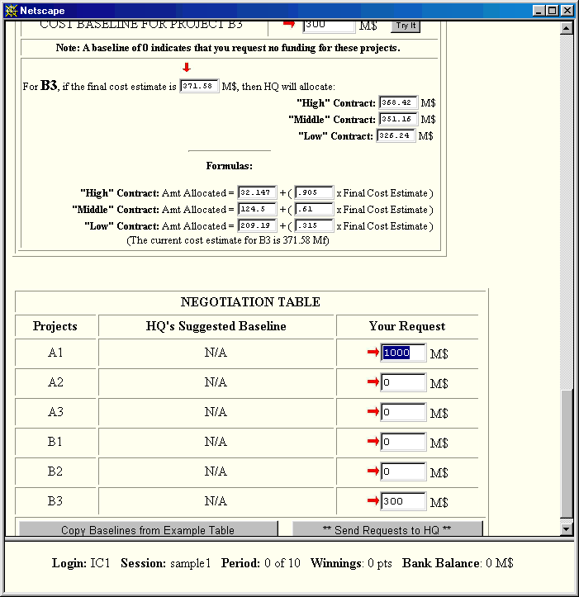

Stage 3: Innovation Opportunity

<<< Same text as in the section entitled “Stage 3” in appendix A2. >>>

At this point the IC will have some good or bad luck with regard to costs.

<<< Same text as that of appendix A2 concerning cost shocks >>>

Phase C/D
Stage 4: IC Chooses the Contract

IC must now choose one of the three contracts to operate under. It can do so by selecting one of the fields in the rightmost column on the Final Contract Selection screen, shown below. IC can see what the reimbursement would be under each of the three contracts at the current estimated cost in the column entitled “Current Formulas and Estimated Allocation”.

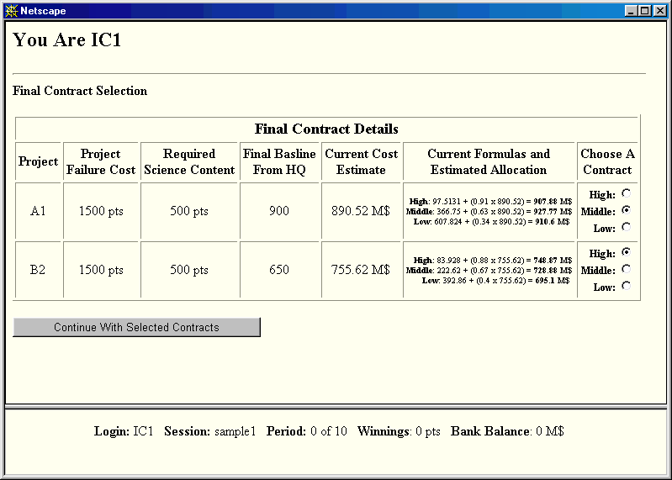

Stage 5: Second Innovation Opportunity

This stage is identical to stage 3 described above. Innovations are cumulative. This means that if IC received the 50% increase in productivity in stage 3, it can receive another 50% increase (over the current level) in stage 5.

Stage 6: IC receives budget

At the beginning of this stage, IC will have an additional random change in cost. The mission might turn out to cost less or more than anticipated. This random change follows the same process as in stage 3.

Then IC receives the funding for the project specified in the contract. These funds can be applied to construction of the project in stage 7.

Stage 7: Construction Phase

During this stage IC has the opportunity to construct its missions. There is only one such opportunity, so that all construction must be done at this stage. To do so, it uses the screen entitled Building the Projects, shown on the next page. The screen is read in the following way. The first column shows the projects IC has undertaken. The second displays the cost in points if a failure occurs. The third column, to be filled in by the IC, is the science content built into the mission. The fourth column is the minimum science content permitted for the mission. If the value in column three does not exceed that in column four the mission cannot be delivered.

The fifth column contains the reliability put into the mission. The IC must fill in this column at this point. The sixth and seventh columns display the previous expenditures on innovation and the overall “Luck” that the IC has incurred during the construction process. The eighth column is the overall cost of completing a mission with the science content and reliability specified in columns 3 and 5, taking into account the money already spent on innovation, the cost savings from innovations already made, and the random cost changes that have occurred.

Column nine contains the funds allocated to the IC under the cost-sharing contract and column ten displays the difference between the funds allocated and the actual expenditures on the project (a positive number in the column represents the project being under-budget).

At the end of this stage, IC has the option of canceling the mission, by checking “Don’t deliver this project” in column 11. If the mission is delivered, at the end of the stage, a success or a failure is realized and HQ’s and IC’s payoffs are determined accordingly.

Any funds that are unspent by the IC are credited to the IC for use in future periods. Any funds that are unspent by HQ are credited to HQ for use in future periods. Any funds that IC spends beyond its budget must be paid back before the end of the session. Any funds that HQ spends beyond its budget will be taken out of its budget in future periods.

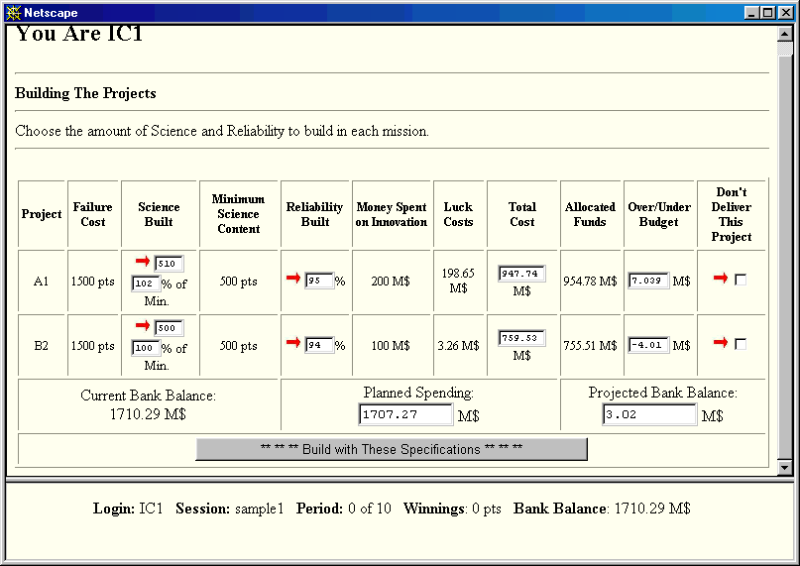

In the simulations conducted with student subjects when there was 1 Center, each point earned both the subject in the role of Headquarters and the subject in the role of the Center 1 cent. When there were two Centers, an IC earned 2 cents for each point. HQ earned 1 cent per point.

