EXAMPLE QUESTIONS
Text in square brackets appeared only in the UNIFORM treatment. Text in braces appeared only in the FIXED treatment.
Suppose there are 100 units for sale. Player A plays with the other players. Each player who bids for more than 100 units needs to pay a cost of 5 points. {The market price is predetermined as 2 points per unit}. Please answer the following questions:
If the number of good signals in this round is 2, the market value of each unit of the good is __.
[If in this round the players' bids are as those in the table below] {If in this round the numbers of units that players bid for are as below}, then
[The market price is__.]
The number of units that player A is allocated is__.
Suppose the value of each unit of the goods is 3, the point earnings that player A obtains are __:
Sample table in the UNIFORM treatment:
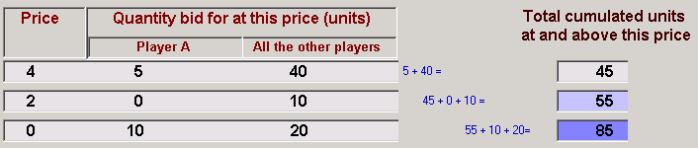
Sample table in the FIXED treatment:
