Submitted to Experimental Economics
Appendix to Coordination and Cooperation in Asymmetric Commons Dilemmas

Marco A. Janssen
School of Human Evolution and Social Change,
Center for the Study of Institutional Diversity
PO Box 872402, Tempe, AZ 85287-2402
Arizona State University
Phone: 480 965 4193 ; Fax: 480 965 7671
Email: Marco.Janssen@asu.edu

John M. Anderies
School of Human Evolution and Social Change,
Center for the Study of Institutional Diversity
School of Sustainability,
Arizona State University

Sanket R. Joshi
Center for the Study of Institutional Diversity, School of Computing and Informatics
Arizona State University

Experiments were performed in the Computer Assisted Research Laboratory (CARL) at the Institute for Social Science Research at Arizona State University. This facility has 17 desk tops and a dedicated server. Participants are recruited from a data base. This database, which consists of about 1500 undergraduate students, is populated by students who subscribed themselves to the database as a response to advertisements via email and flyers. When experiments are scheduled a subset of the population who has not participated in this experiment are invited to sign up until places are available.

When the number of students which show up can not be used for the experiment (say 12 students, when 10 or 15 are needed for 5-person experiments), the students who have showed up last receive the show up bonus and can be invited again.

Below you find the instructions for the experiment. A technician and an experimenter are available to answer questions and to schedule when groups go to new rounds.

General Instructions
Welcome. You have already earned 5 dollars by showing up for this exercise. You can earn more, up to an extra 25 dollars, by participating in the exercise which will last for about one hour. In this exercise you have been randomly assigned to FOUR other participants in the room. Thus each group has five participants. The amount of money you earn will depend on the decisions made by you and your group. That is, your earnings will depend on your decisions as well as the other members of your group.
During the exercise you will have the opportunity to download files, each of which is worth a certain number of tokens. Each token is worth 10 cents and you will be paid in cash in private at the end of the experiment based on the number of tokens you earned.
To go to the next page, please answer the following question:
How many OTHER people in the room will be in your group?
0
1
4
everybody
[next window] Chat
Each round will start with a chat session that will last for 60 seconds. During this chat session with the other participants, you can send text messages. You may communicate about any aspect of the exercise. However, you are not allowed to promise the other participants side-payments or threaten them with any consequence after the experiment is finished. You are also not allowed to reveal your real identity. We are monitoring the chat traffic while you chat. If we notice a violation of these rules, we will remove the group from the room until the exercise with the other groups is finished.
You will see a text box appear on your screen when a chat period starts. On left top of the screen the time left in the chat period is provided.
To go to the next page, please answer the following question:
What topic can you NOT chat about?:
- the weather
- your real identity
- the experiment
- what we will do with our earnings from the experiment
[next window] Creating bandwidth
At the beginning of each round, each participant will be awarded 10 tokens. You must then decide what to do with these tokens. You may decide to invest in creating bandwidth or to keep the tokens. For example, if you keep the tokens, you will earn at a minimum of 10 tokens X 10 cents = $1 for each round or $10 for the ten rounds. Your total earnings for participating in the experiment would be $10 plus your show-up fee of $5 which is $15. On the other hand, if you invest some tokens in the bandwidth, you may be able to earn more than this amount by downloading files.
If you decide to invest in bandwidth, you must decide on the amount as you will need bandwidth before you can download files. The investment of all five participants is added together and will amount to between 0 and 50. In the table below you will see the amount of bandwidth that will become available. When each participant invests 10 tokens in the bandwidth, 40 kb per second will be available. If less than a total of 20 tokens are invested, no bandwidth will be available for downloading files. For example, if both players invest 10 tokens, total bandwidth will be 40, which will enable participants to download between 6 and 10 files, which will yield between 15 and 20 tokens ($1.50 or $2) in a round depending on the actions of each participant.
Size of bandwidth for downloading files when you and the other make the following investment of tokens:
Total token investment | Bandwidth
< 20 | 0
20 | 1
21 | 1
22 | 2
23 | 3
24 | 4
25 | 6
26 | 8
27 | 10
28 | 13
29 | 17
30 | 20
31 | 23
32 | 26
33 | 29
34 | 31
35 | 33
36 | 34
37 | 36
38 | 37
39 | 37
40 | 38
41 | 38
42 | 39
43 | 39
44 | 39
45 | 39
46 | 40
47 | 40
48 | 40
49 | 40
50 | 40
Before the downloading part of the exercise starts each participant makes independently a decision how much to invest in bandwidth. If everybody made their decision, the total maximum amount of bandwidth available in the downloading part of the exercise is announced.
To go to the next page, please answer the following questions:

Question 1:

If 5 participants invest together a total of 40 tokens, what will be the bandwidth available?
[]

Question 2:

If two participants invests 10 tokens and the three other participants invests 2 tokens, what will be the bandwidth available?
[]
[next window] Downloading files
There are FIVE participants, each of which is randomly assigned to one of five positions, A, B, C, D and E. You will be in position A/B/C/D/E.
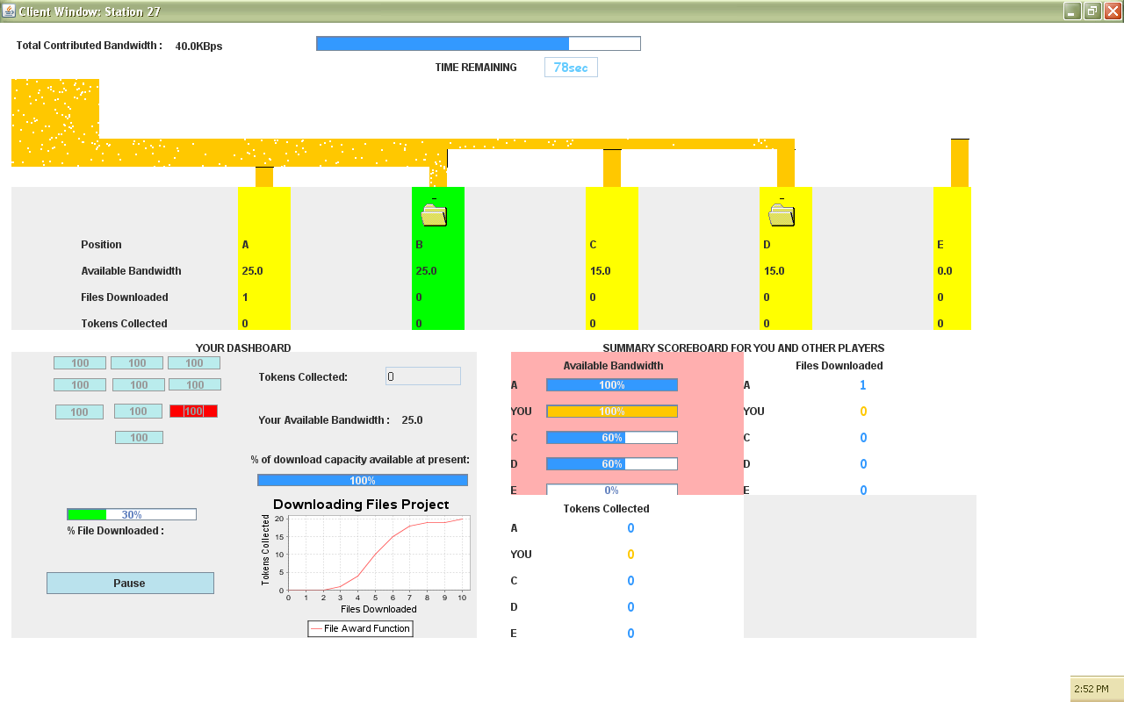

Each round will take 100 seconds and the amount of time left in the experiment is indicated at the top of the screen.
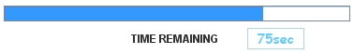
During this round you can download a maximum of 10 files. Each file is 100kb. Your maximum downloading bandwidth is 25 kb per second. Thus it will take at least 4 seconds to download a file. How fast you can download depends on the amount of bandwidth that is available. The maximum bandwidth for A, B, C, D and E together is 40 kb per second.
The bandwidth available for your downloading is shown as a number, and as a percentage of the maximum available bandwidth for downloading. When less then 100% of your maximum bandwidth of 25 kbps is available, downloading a file will take more than 4 seconds. For example, if the available bandwidth is 20 kbps, your maximum available bandwidth will be 20 kbps or 80% of your maximum.
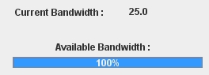
To go to the next page, please answer the following question:

What is the minimum time to download a file when maximum bandwidth is available?
4 seconds
10 seconds
25 seconds
100 seconds
Positions A, B, C, D and E
The access to downloadable files depends on your position as shown in the window. The information originates in the box at the upper left part of the screen and travels to the right. Thus, participant A will have first access to the available bandwidth. Bandwidth not used by participant A is then available to be used by participant B. Bandwidth not used by participants A and B is then available for C. Bandwidth not used by participants A, B and C is available for D. Finally, bandwidth not used by participants A, B, C and D is available for E.
Suppose that the bandwidth available is 40 kbs. If A downloads a file, at the maximum speed of 25 kbs, 15 kbs is left for B. Suppose on the other hand, A does not download a file, then a total of 40 kps is left for B, allowing B to download at the maximum rate of 25 kbps.
For another example, suppose that the total bandwidth available is 20 kbps. While A downloads a file, no bandwidth is available for B. If A is NOT downloading a file, 20 kbs is available for B.
To go to the next page, please answer the following questions?:
Question 1:
If the bandwidth available is 30 kbs and A downloads at 25kbs what is the available bandwidth for B?
- 30 kbs
- 25 kbs
- 15 kbs
- 5 kbs

Question 2:

If the bandwidth available is 25 kbs and A, B, C and D are not downloading a file, what is the available bandwidth for E?
- 40kbs
- 25 kbs
- 15 kbs
- 0 kbs

How to downloading files
To start downloading a file, click on one of the boxes with the number 100 on it.
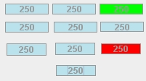
The file which is downloading is turned red. When the file is successfully downloaded the box will turn green.
The percentage of the File which has been downloaded at any point in time is indicated by the progress bar
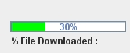
You cannot start multiple downloads at the same time. If you click “pause” you can resume your download when you click “start”. The pause button looks like:
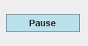
To go to the next page, please answer the following question:

If there are 4 green files and one red file, how many files have you downloaded successfully?
1
4
5
10
Tokens earned:
The number of tokens earned depends on how many files have been downloaded. The first few files you download do not lead to any tokens being earned. You must download 4 or more files before you begin to generate tokens as shown in the following graph.
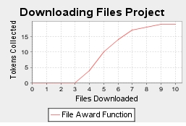
The amount of tokens earned by downloading files can also be represented as a table.
Number of files downloaded | 0 | 1 | 2 | 3 | 4 | 5 | 6 | 7 | 8 | 9 | 10
Tokens earned | 0 | 0 | 0 | 1 | 4 | 10 | 15 | 18 | 19 | 19 | 20

Your earnings at the end of the round depend on your investment and the number of files you have downloaded. For example, you get 10 tokens to start with, you invest 6 in the bandwidth, and you download 7 files. This leads to (10-6) plus 18, which is 22 tokens ($2.20).

Question 1:

If you invest 5 tokens of the 10 tokens endowment, and you downloaded 5 files, what is the amount of tokens at the end of the round?
- 5
- 10
- 15
- 20

Question 2:

If you invest 10 tokens of the 10 tokens endowment, and you downloaded 6 files, what is the amount of tokens at the end of the round?
- 5
- 10
- 15
- 20
Scores
The total number of tokens collected during the experiment is shown as

This is the total of tokens not invested in bandwidth plus additional tokens earned by downloading files.
You see the scores of the other participant summarized on the screen. You see the bandwidth available, the number of files downloaded and number of tokens collected.
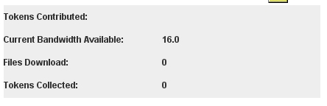
To go to the next page, please answer the following question:
Each token is worth 10 cents, thus if you collected 15 tokens in a round you earned:
$0.15
$0.50
$1.50
$2.50
Practice Round Instructions

We will now start with two practice rounds. This practice round will not contribute to your earnings – it is intended to acquaint you with the functioning of the exercise environment.
You will first chat via text with the other participant for 50 seconds, then make decisions on your level of investment in bandwidth availability and then make decisions on when to download files.
If you have any questions feel free to raise your hand and to ask your question. Do you have any questions so far?
[chat]
[investment]
You are endowed with 10 tokens. You have to make a decision about how much you wish to invest [0,10] in bandwidth availability. You can see the relation between total investment and bandwidth availability in the figure below. After you have typed in your decision, you click the button to confirm. When everybody has made their decision, the bandwidth availability is announced.
[example of results of investments]
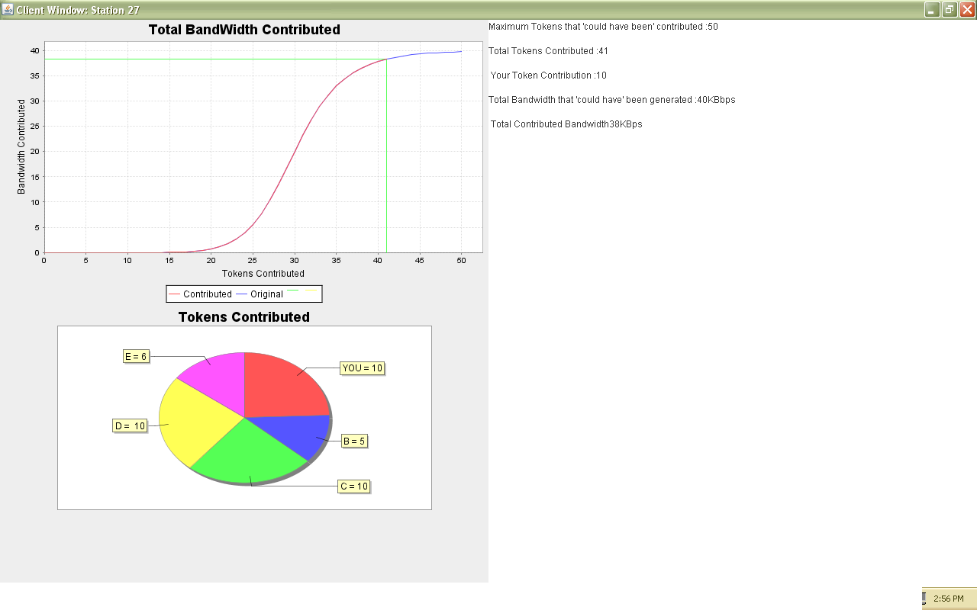
[download screen examples]
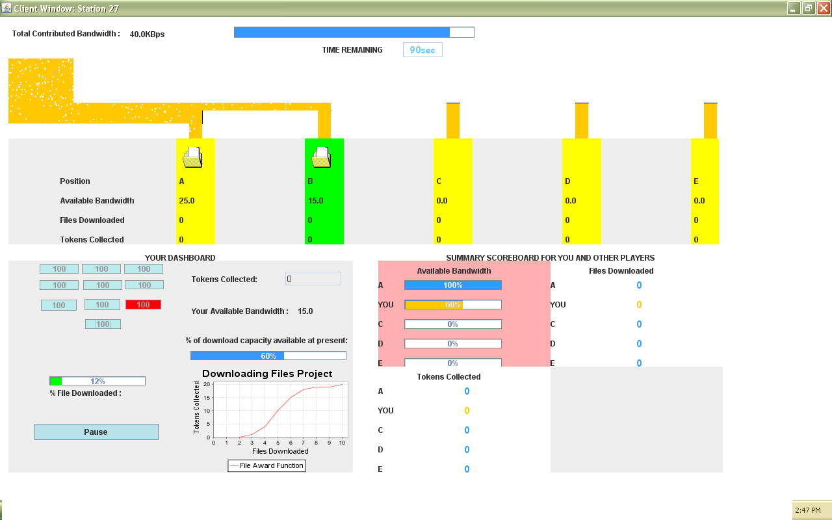

Round 1 Instructions

This is the first round of 10 rounds of the exercise. You will first chat via text with the other participant for 50 seconds, then make decisions on your level of investment in bandwidth availability and then make decisions on when to download files.
[chat]
[investment]
You are endowed with 10 tokens. You have to make a decision about how much you wish to invest [0,10] in bandwidth availability. You can see the relation between total investment and bandwidth availability in the figure below. After you have typed in your decision, you click the button to confirm. When everybody has made their decision, the bandwidth availability is announced.

[next screen]

Round 2 Instructions –Round 10 instructions the same as Round 1

